CWL1 Stress Awareness Day 2026
- Project Management -

Student: Roxana Plesca

Student ID: 2425030
Module code: BMSK5014

Lecturer: Christine Joy

Contents
AI Usage Acknowledgement 2
Introduction 3
Project Management Methodologies and Approach 3
Project Concept and Initiation 4
Environmental Analysis 5
Stakeholder Analysis and Communication 6
Project Scope 7
Project Planning, Scheduling and Resources 8
Risk Management 9
Monitoring and Control 10
Project Closure 11
Project Manager Skills, Self-Audit and Development 11
Conclusion 12
References 13
Appendices 16
Appendix A 16
Appendix B 17
Appendix C 18
Appendix D 19
Appendix E 20
Appendix F 21
Appendix G 22
Appendix H 23
Appendix I 24
Appendix J 24
Appendix K 25

AI Usage Acknowledgement

The following AI prompts were used:

“Hello Chat. Please have a look at the following documents and based on the assignment description and criteria found in the document titled 'Managing Projects 2026', create a simple assignment structure that follows the steps found in the document titled 'workbook idea 1'. The following parts are essential to be included in the whole of the assignment: Comparison between waterfall methodology and agile methodology, with my project using the Prince2 approach, defining the project concept, environmental analysis, pestle analysis, stakeholder analysis, project scope, work breakdown structures, mind map, critical path analysis, scheduling projects, resource management, risk management, RACI, Monitoring and control, Change control (scope creep; can just be mentioned in a different paragraph, doesn't require its own headline), project closure, project manager skills, a self-audit using SWOT, and a personal development planning.” (ChatGPT version 5.5 – time 12:47 – 29.08.2026 (documents supplied were the 9 PowerPoint sessions on BMSK5014, the assignment brief and document “workbook idea”).
“Hi Chat. I've done a mind map using a tool I found online: https://app.mural.co/t/chaos6142/m/chaos6142/1788092408431/1d5e065bf07008c5e2bfb17aee26558d99010633 how would I then reference this for my assignment using APA7 style?” (ChatGPT version 5.5 – time 14:09 – 30.08.2026)

Introduction
This report presents the proposed planning and delivery of CWL1 Stress Awareness Day 2026, a workplace event scheduled for 4 November 2026 and designed to raise awareness of stress while providing associates with practical opportunities to engage with different approaches to stress relief and wellbeing. The project is managed within a fixed delivery date and must account for external suppliers, health and safety requirements, operational staffing, financial constraints and the involvement of multiple internal stakeholders. The report critically examines the suitability of different project management approaches before applying PRINCE2 as the principal framework. It then considers project initiation, environmental and stakeholder analysis, scope, scheduling, resources, risk, communication, monitoring, change control and project closure. Supporting project-management tools include a mind map, SWOT and PESTLE analyses, stakeholder and communication plans, a WBS, Gantt chart with dependencies and critical path, resource plan, RACI matrix and risk register. The report concludes by evaluating the project manager’s existing competencies and identifying areas for future development through a Personal Development Plan.

Project Management Methodologies and Approach
Waterfall and Agile represent contrasting approaches to organising project activity. Waterfall follows a sequential structure in which requirements are established early, and work progresses through defined stages, creating greater predictability where the intended outcome and delivery date are known in advance (Aroral, 2021; Samaratova, 2024). Agile places greater emphasis on iteration, stakeholder feedback and the ability to adapt requirements throughout delivery (Thesing et al., 2021). Thesing et al. (2021) argue that neither approach is universally preferable, as suitability depends on factors such as scope, time, organisational context and the level of uncertainty surrounding requirements. For the proposed Stress Awareness Day event, a predominantly Waterfall-style delivery would provide advantages because the four principal activities are agreed in advance and the event must take place on 4 November 2026 (Thesing et al., 2021). Supplier enquiries, approval, procurement, communication, sign-up arrangements and final preparation therefore need to progress towards a fixed endpoint. However, a completely rigid approach would be unsuitable because some operational details may need adjustment during planning. Attendance limits could change, committee members may be reassigned between activities, materials or decorations may be substituted, and contingency arrangements may become necessary if a facilitator or supplier becomes unavailable. Agile principles would support this smaller degree of flexibility, although continually revising the core activities would create unnecessary uncertainty once Senior Management has approved the proposal. A structured approach with controlled flexibility is therefore more appropriate than applying either methodology in its pure form.
PRINCE2 has consequently been selected as the principal management approach for the project. Valadares et al. (2024) identify PRINCE2 as one of the main established project-management methods, while Sajid (2023) emphasises its capacity to be tailored to the environment in which a project is delivered. This is particularly relevant to the proposed event because responsibility is distributed across several parties rather than held entirely by the project manager. The project manager would research suppliers, coordinate planning and allocate activities, while the Fun Committee Manager would retain responsibility for contractor bookings and financial transactions, the receptionist would support purchasing and internal communications, and Senior Management would authorise the project and any substantial changes affecting cost, safety or scope. PRINCE2 also provides a staged process from initiation through delivery and closure, with continuing attention to risk, change, responsibilities and business justification (AXELOS, 2017). These controls suit an event with a fixed date, external contractors, health and safety requirements and several individual work packages. At the same time, PRINCE2 can be tailored so that minor decisions, such as decoration, staffing allocation or information-board content, remain within the project manager’s authority rather than requiring repeated escalation (Sajid, 2023; AXELOS, 2017). Its value within this project therefore lies in providing clear governance without preventing the practical adjustments required during event preparation, consistent with the principle of management by exception.

Project Concept and Initiation
The proposed CWL1 Stress Awareness Day 2026 project involves the planning and delivery of a one-day workplace event on 4 November 2026, designed to raise awareness of stress while providing associates with practical opportunities to explore different approaches to stress relief and management. The project responds to an identified gap within the CWL1 events calendar and supports the wider aim of creating a workplace environment in which associate wellbeing, inclusion and a stronger sense of community are considered alongside operational performance. LaMontagne et al. (2014) suggest that effective approaches to workplace mental health should not focus solely on responding to existing problems but should also promote positive aspects of work and strengthen employees’ capacity to manage their wellbeing. This supports the inclusion of activities that combine stress awareness with opportunities for participation and relaxation. The planned deliverables comprise a mobile rage room, paint splash activity, two mindfulness sessions, two stress-awareness workshops, themed reception decorations and an information board supported by internal communications. Previous mindfulness activities at CWL1 have received positive informal feedback through the Voice of the Associate board and management engagement groups, indicating existing interest in wellbeing-focused activities. Success would be measured through strong uptake of available places, positive post-event associate feedback, successful delivery of the planned activities and the absence of health and safety or behavioural incidents.
Project initiation would begin on 10 August 2026, providing approximately twelve weeks for research, approval, procurement, communication and preparation before the fixed delivery date. Kerzner (2017) emphasises the importance of clearly established objectives and systematic planning in providing direction throughout a project, while Samset and Volden (2015) identify the front-end stage as particularly important because weaknesses in early project definition and decision-making can contribute to problems during later delivery. The initial proposal would therefore establish the organisational justification, expected benefits, estimated expenditure, required resources, supplier availability and principal risks before being presented to CWL1 Senior Management for approval. Supplier research would include preliminary availability enquiries and quotations from preferred providers together with alternative options, while the proposed financial provision would include a contingency of approximately 10–20% above the anticipated cost. Following approval, authorized personnel would complete contractor bookings and financial transactions, while the project manager would coordinate implementation. An initial mind map (Appendix A) would organise the project around activities, stakeholders, resources, budget, communication, health and safety, scheduling and risk, creating a foundation from which the more detailed planning tools could subsequently be developed.

Environmental Analysis
A SWOT analysis (Appendix B) was undertaken to assess the internal and external conditions affecting the proposed CWL1 Stress Awareness Day 2026 project. Gürel and Tat (2017) describe SWOT as a framework that separates internal strengths and weaknesses from external opportunities and threats, allowing these factors to be considered together during planning. A key strength of the proposed event is the availability of existing internal resources, including the Fun Committee, Associate Committee, established communication channels and previous experience of delivering mindfulness activities. These reduce the need to obtain all resources externally and provide an existing structure through which responsibilities can be delegated. However, the project manager has limited financial authority, making successful delivery dependent on timely approval, procurement and contractor booking by authorised personnel. External threats are particularly significant because the fixed event date provides little opportunity to recover from supplier cancellation, poor weather or unexpected health and safety concerns. Conversely, successful delivery provides an opportunity to strengthen associate engagement and demonstrate visible organisational support for wellbeing. Although SWOT helps identify these conditions, it remains relatively subjective and does not establish their relative importance by itself, meaning that the findings require further analysis rather than being treated as a complete decision-making tool (Gürel & Tat, 2017).
PESTLE analysis (Appendix C) provides a wider assessment of external conditions by examining political, economic, social, technological, legal and environmental influences. Yüksel (2012) explains that PESTLE provides an overview of macro-environmental conditions, although the relationships between individual factors should also be considered. Within this project, economic and legal influences are particularly important because contractor charges, associate time away from operational tasks and contingency expenditure must remain acceptable to Senior Management, while the rage room and outdoor activities require appropriate risk assessment, insurance, supervision and PPE. Social considerations are equally relevant because participation depends on associates viewing the activities as accessible, inclusive and worthwhile, while differing preferences justify offering several approaches to stress awareness rather than a single intervention. Environmental considerations include weather exposure, disposal of waste generated by the activities and the selection of lower-impact paint and balloon materials where practicable. Technological factors mainly support delivery through existing internal communication systems, while wider political influences are comparatively limited. The PESTLE analysis therefore indicates that financial control, safety, associate participation and environmental conditions require the greatest attention during subsequent planning.

Stakeholder Analysis and Communication
Stakeholder analysis is particularly important for CWL1 Stress Awareness Day 2026 because different groups hold different forms of authority over its approval and delivery. A power-interest matrix can assist in prioritising stakeholders according to their ability to influence the project and the level of involvement they require, although these positions may change as delivery approaches (Maqbool et al., 2022). Senior Management, the Fun Committee Manager and Health and Safety represent particularly influential stakeholders. Senior Management controls overall approval and expenditure, while Health and Safety could prevent an activity proceeding where risks are considered unacceptable. The Fun Committee Manager also has significant involvement through contractor booking and authorised financial transactions. The project manager has high interest and considerable operational responsibility but more limited formal authority over expenditure. Area Managers require close engagement because business requirements may prevent individual associates leaving operational roles, while Team Leads would be responsible for arranging suitable cover. Associates have comparatively little formal power, but their participation and subsequent feedback are central to determining whether the event achieves its intended purpose. External contractors similarly require active management because failure to deliver on the fixed date could directly affect project success. A detailed stakeholder analysis can be found in Appendix D. Maqbool et al. (2022) also identify stakeholder satisfaction and communication as important influences on successful project delivery.
Communication would therefore be adapted according to stakeholder responsibility rather than relying on the same information for every group. Bourne (2016) argues that effective stakeholder engagement requires communication to reflect differing expectations, interests and levels of influence rather than adopting a uniform reporting approach. Senior Management and Finance would receive the initial proposal and subsequent updates where cost, scope or significant risk changes occur, while the Fun Committee Manager and project team would require regular planning updates throughout preparation. Health and Safety would receive supplier documentation, risk assessments and proposed control measures, with Security being informed of contractor access requirements and parking arrangements. Facilities would require sufficient notice of room and outdoor-area requirements and post-event cleaning. Area Managers and Team Leads would receive participant schedules to maintain operational staffing, while associates would be informed through ACID screens, weekly briefs, information displays and separate day and night sign-up sheets containing associate name or login, manager and allocated session. This targeted approach should reduce operational disruption while ensuring that information reaches those responsible for approving, supporting and participating in the event. The full communication plan can be seen in Appendix E.

Project Scope
The scope of CWL1 Stress Awareness Day 2026 covers the planning and delivery of the four approved activities on 4 November 2026, together with the supporting work required to enable their safe and effective delivery. This includes supplier research and coordination, procurement of activity materials and decorations, internal communications, participant registration, staffing arrangements, health and safety controls, contractor access, room and outdoor-area preparation, and the creation of a stress-awareness information board. The information displayed will also signpost associates towards Amazon’s existing Employee Assistance Program and the wellbeing support available to employees and their families, although the provision of counselling, clinical support or longer-term mental-health interventions remains outside the project. Participation will be limited to CWL1 employees, primarily Tier 1 to Tier 3 colleagues who are scheduled to work on the event date and are operationally available to attend. Associates who are absent through holiday or sickness, attending formal meetings, or required to perform essential operational roles will therefore not be included in activity attendance. Refreshments are similarly excluded from the project budget because existing workplace facilities remain available to participants. Although the completed paint canvases are intended for later display within the building, their installation is not a condition of successful project closure because drying time and future changes to the reception area may affect when this can occur. Clearly defining these boundaries is important because uncontrolled additions can increase complexity, expenditure and schedule pressure, with research identifying scope creep as having a negative relationship with project success (Ahmed & Jawad, 2022). Any request to introduce an additional major activity after approval would therefore require separate resources and budget rather than being incorporated informally into the agreed scope.

Project Planning, Scheduling and Resources
Project planning for CWL1 Stress Awareness Day 2026 would begin by turning the initial idea into clear activities and manageable work packages. Kerzner (2017) explains that a Work Breakdown Structure (WBS) can be used to divide project requirements into smaller elements, making it easier to organise tasks and allocate responsibility. The WBS developed for this project is presented in Appendix F and separates the work into ten main packages, from initial research and proposal development through to event delivery and project closure. Following identification of the calendar opportunity on 5 August, formal project development would begin on 10 August with activity research, preliminary supplier enquiries, indicative quotations and the collection of supporting health and safety information. The proposal would then be submitted to the Fun Committee Manager on 17 August and refined ahead of the Senior Management meeting on 26 August, with informal consultation taking place with Health and Safety beforehand to reduce the likelihood of delays at the approval stage. Once approval is given, several activities can progress at the same time. Contractor bookings and procurement can begin while the project manager delegates communications, sign-up administration, information-board preparation, decoration and operational arrangements. A Critical Path Analysis would then help identify the tasks where delays would have the greatest effect on the overall project timeline. Kerzner (2017) links network scheduling with dependencies, available slack and overall project duration. In this case, proposal completion, management approval, contractor confirmation and any required safety clearance are particularly important because the event date cannot be moved. The main limitation is that project work must be completed alongside normal operational responsibilities. Committee members, including the project manager, still have their usual workplace duties and generally only have ten allocated committee hours each month. This means that even where the plan appears to allow enough time, day-to-day business needs may reduce actual availability, making delegation and parallel working important to keeping the project on schedule.
Scheduling would begin immediately after approval on 26 August, with the most time-sensitive activities being prioritised while other preparation continues alongside them. A Gantt chart incorporating task dependencies and the identified critical path would be used to display planned start and completion dates, overlapping activities and those tasks where delay could affect the fixed event deadline. The proposed project schedule is presented in Appendix G and demonstrates how procurement, staffing, safety planning, communications and participant administration can progress simultaneously while working toward the fixed event date. Wilson (2003) explains that Gantt charts have historically been used to show start and finish dates, coordinate activities and identify how workloads are distributed over time, although their usefulness becomes more limited as project complexity increases. For this project, the Fun Committee Manager would contact the preferred suppliers on 27 August, with contracts, final Health and Safety review and deposits expected to be completed by 28 August. Existing materials would be checked during the following week before additional supplies are ordered in early October, allowing sufficient time for delivery while potentially taking advantage of seasonal offers. Promotion and participant registration would begin on 19 October, with a small waiting list maintained for limited-capacity activities. Registration would remain open until the event where spaces remain available, reflecting the possibility of late sign-ups, withdrawals or operational changes. External suppliers would be reconfirmed approximately seven to ten days before the event and again one or two days beforehand. Parking areas required for the outdoor activities would be cordoned off two shifts in advance, allowing associates time to adjust to the temporary restrictions. The final schedule would therefore contain several activities running simultaneously, which is appropriate because communication, staffing, procurement and safety preparation can progress independently while still working towards the fixed delivery date of 4 November.
Resource planning for CWL1 Stress Awareness Day 2026 needs to consider staff availability as well as physical and financial requirements because most internal contributors will continue performing their normal workplace duties throughout the project. Kerzner (2017) discusses the importance of organising and staffing project teams so that responsibilities are matched with the resources available to complete the required work. Within this project, the project manager and committee members would mainly use their allocated ten monthly committee hours for planning, preparation and delegated activities, while the internal mindfulness facilitator would complete both sessions within a normal paid shift rather than creating an external facilitation cost. Health and Safety supervision would be required throughout the rage room activity, although this could be shared between representatives in approximately two-hour periods, including a clear handover around the 17:30 shift change. The stress-awareness workshops would not require separate supervision where a Team Lead is already attending, while the mindfulness sessions would be managed by the trained internal facilitator. Existing site resources also reduce expenditure because rooms, tables, chairs, printers, paper, barriers and cones are already available. Direct costs are therefore concentrated around external contractors, paint, canvases, balloons and decorations, while associate participation and committee activity create an internal opportunity cost through time spent away from normal operational work. The proposed resource plan is shown in Appendix H, while the RACI matrix in Appendix I clarifies responsibility, accountability, consultation and information requirements across the main project activities.

Risk Management
Risk management for CWL1 Stress Awareness Day 2026 would begin during project initiation and continue until event delivery, as several uncertainties could affect cost, safety, participation or the ability to deliver activities as planned. A risk register was developed to record the principal risks, their estimated likelihood and impact, mitigation actions and ownership (Appendix J). Patterson and Neailey (2002) identify the risk register as a useful means of documenting project risks and developing mitigation plans for higher-level concerns. For this project, adverse weather represents the greatest overall uncertainty because the event takes place in November and both the paint splash and movement to and from the rage room involve outdoor areas. Mitigation would include monitoring forecasts, making umbrellas or rain ponchos available and considering temporary shelters where financially practical. However, severe weather may require the paint splash to be postponed rather than attempting to deliver an activity in unsuitable conditions. Participant injury during the rage room is less likely but potentially more serious. Controls would therefore include supplier safety procedures, PPE, participant briefings and continuous Health and Safety supervision, with representatives able to rotate during the six-hour activity. Supplier cancellation is also treated as a high-priority risk because the fixed event date provides little opportunity for recovery, making alternative suppliers and advance reconfirmation important. Operational staffing, material availability and cost increases are lower level but still require monitoring. Although scoring helps prioritise attention, risk assessment remains partly judgement based. Williams (1996) argues that likelihood and impact should both be considered and warns that simplistic numerical rankings can be misleading. The register should therefore be reviewed as the event approaches rather than treated as a fixed assessment, particularly where weather, staffing and supplier availability can change rapidly.

Monitoring and Control
Monitoring and control would continue throughout the project to identify delays, overspending or changes before they threaten delivery. A shared Quip tracker would provide a practical method of monitoring progress, listing the smaller tasks, their allocated owners and completion status, alongside brief updates such as materials ordered, information board completed or paint balloons prepared. Individual task owners would update the tracker as work is completed, while the project manager and Fun Committee Manager would remain in close contact and hold more structured progress reviews approximately every two to three weeks. A separate record of committed and actual expenditure would also be maintained against the approved budget. Monitoring would consider the relationship between time, cost and quality represented by the project management Iron Triangle. Atkinson (1999) identifies these as traditional measures of project management performance, while Pollack et al. (2018) show that time, cost and quality remain strongly associated within project management literature, although scope is also commonly used as an alternative constraint. For CWL1 Stress Awareness Day, the delivery date of 4 November is fixed, and safety or activity quality should not be reduced simply to save time or money. Consequently, scope provides greater flexibility where resources become constrained. Minor alterations, including decoration choices, communication wording or staff allocations, could be managed by the project manager without further approval. Changes affecting expenditure, safety, external contracts or the four approved core activities would instead be escalated to the Fun Committee Manager and other relevant decision-makers. This helps limit uncontrolled scope creep, which Ahmed and Jawad (2022) associate with changes to originally agreed project requirements. A proposed fifth major activity would therefore either be deferred to a future event or treated as a formal change requiring additional resources, budget and approval rather than being absorbed informally into the existing project.

Project Closure
Project closure would begin immediately after Stress Awareness Day and be completed within approximately one week. The project manager would confirm that the planned activities had been delivered, external suppliers had completed their contractual requirements, expenditure had been recorded and temporary event areas had been returned to normal use. Feedback would be gathered through existing workplace channels and compared with participation levels, cancellations and any safety or operational issues recorded during the event. A short review with the Fun Committee Manager would identify what worked well, what could be improved and whether any activities should be repeated in future events. This reflects the PRINCE2 emphasis on formally closing a project and capturing lessons that may benefit future work (AXELOS, 2017). The later display of the paint-splash canvases would not prevent project closure, as the artwork may require drying and suitable display space to become available. Closure would therefore focus on completion of the approved event, financial and operational follow-up, and recording lessons learned rather than requiring every longer-term outcome to be completed.

Project Manager Skills, Self-Audit and Development
Effective project management requires a combination of technical planning ability and interpersonal competencies rather than reliance on project management tools alone. Stevenson and Starkweather (2010) found that employers placed considerable importance on softer competencies including leadership, communication, attitude and the ability to manage ambiguity and change. Similarly, Müller and Turner (2010) identified critical thinking, influence, motivation and conscientiousness among competencies consistently demonstrated by successful project managers, while also finding that required leadership profiles vary according to project type. For CWL1 Stress Awareness Day, particularly relevant competencies therefore include leadership and delegation, communication and stakeholder management, planning and organisation, problem solving, adaptability and effective management of available resources.
The self-audit identifies communication, critical thinking and problem solving as particular strengths of the project manager. Communication channels are actively maintained and there is confidence when communicating with colleagues at different organisational levels, including senior leadership. However, the tendency towards an informal and highly communicative style may require greater adjustment according to the audience, particularly where concise or more formal communication is appropriate. Adaptability is another strength, as unexpected changes may initially cause frustration but are generally followed quickly by a focus on alternative solutions. Budget awareness is also reasonably developed, with consideration given to financial limits and the consequences of additional expenditure, although experience of formal project financial control remains more limited. The more significant development areas concern delegation and consistency in following project plans. There is a tendency to retain close control over delegated work because of uncertainty about whether tasks will be completed to the expected standard, particularly when team members work different shifts. Although this may protect quality in the short term, excessive monitoring can reduce the benefits of delegation and increase the project manager's own workload. Planning itself is comparatively strong, but maintaining the original plan becomes more difficult once competing priorities or unexpected changes occur. This suggests that development should focus less on creating more detailed plans and more on creating flexible plans that can be monitored and adjusted without becoming abandoned when circumstances change.
The resulting Personal Development Plan is presented in Appendix K. Priority is given to improving delegation, maintaining progress against agreed plans and adapting communication to different stakeholder groups. Development should occur through practical application rather than training alone, using defined task ownership, agreed checkpoints and regular progress reviews during future workplace projects. Planning could be strengthened through shorter milestones, visible task tracking and deliberate contingency time rather than relying on recovery once activities move off schedule. These actions would build upon existing communication, adaptability and problem-solving strengths while addressing areas that could become more significant when managing larger or more complex projects.

Conclusion
CWL1 Stress Awareness Day 2026 demonstrates how project management tools can be applied to a workplace event with a fixed deadline, multiple stakeholders and operational constraints. The use of structured planning, scheduling, risk management, communication and defined responsibilities supports delivery while allowing limited flexibility where circumstances change. The project also highlights the importance of balancing time, cost, quality and available resources rather than treating planning as a fixed process. Overall, successful delivery would depend not only on the project plan itself, but also on effective communication, adaptability and timely decision-making throughout the project.

References

Ahmed, R., & Jawad, M. (2022). Avoiding or disregarding: Exploring the relationship between scope creep, project complexity, and the success of construction projects. Project Leadership and Society, 3, 100064. https://doi.org/10.1016/j.plas.2022.100064
Aroral, H. K. (2021). Waterfall process operations in the fast-paced world: project management exploratory analysis. International Journal of Applied Business and Management Studies, 6(1), 91-99. https://journal.bauderpress.org.tr/index.php/ijabms/article/view/224/153

Atkinson, R. (1999). Project management: Cost, time and quality, two best guesses and a phenomenon, it’s time to accept other success criteria. International Journal of Project Management, 17(6), 337–342. https://doi.org/10.1016/S0263-7863(98)00069-6

AXELOS Limited. (2017). Managing Successful Projects with PRINCE2 2017 Edition. (6th edition, 2017 edition, 3rd impression 2021). The Stationery Office Ltd.
https://ebookcentral.proquest.com/lib/trinity/reader.action?docID=4863041&c=RVBVQg&ppg=16

Bourne, L. (2016). Targeted communication: The key to effective stakeholder engagement. Procedia - Social and Behavioral Sciences, 226, 431–438. https://doi.org/10.1016/j.sbspro.2016.06.208

Gürel, E., & Tat, M. (2017). SWOT analysis: A theoretical review. Journal of International Social Research, 10(51), 994–1006. SWOT analysis: A theoretical review

Kerzner, H. (2017). Project management: A systems approach to planning, scheduling, and controlling (12th edition). John Wiley & Sons.

LaMontagne, A. D., Martin, A., Page, K. M., Reavley, N. J., Noblet, A. J., Milner, A. J., Keegel, T., & Smith, P. M. (2014). Workplace mental health: Developing an integrated intervention approach. BMC Psychiatry, 14, Article 131. https://doi.org/10.1186/1471-244X-14-131

Maqbool, R., Rashid, Y., & Ashfaq, S. (2022). Renewable energy project success: Internal versus external stakeholders’ satisfaction and influences of power-interest matrix. Sustainable Development, 30(6), 1542–1561. https://doi.org/10.1002/sd.2327

Müller, R., & Turner, R. (2010). Leadership competency profiles of successful project managers. International Journal of Project Management, 28(5), 437–448. https://doi.org/10.1016/j.ijproman.2009.09.003

Patterson, F. D., & Neailey, K. (2002). A risk register database system to aid the management of project risk. International Journal of Project Management, 20(5), 365–374. https://doi.org/10.1016/S0263-7863(01)00040-0

Pollack, J., Helm, J., & Adler, D. (2018). What is the Iron Triangle, and how has it changed? International Journal of Managing Projects in Business, 11(2), 527–547. https://doi.org/10.1108/IJMPB-09-2017-0107

Sajid, J. (2023). Implementing the PRINCE2 Project Management Method in an Existing Project Environment (Master's thesis, Masarykova univerzita, Ekonomicko-správní fakulta). https://is.muni.cz/th/r2okf/Thesis_Full_Version__Non-public_.pdf

Samaratova, A. K. (2024). Features of using waterfall methodologies in project management. Вестник науки, 4(10 (79)), 39-48. https://cyberleninka.ru/article/n/features-of-using-waterfall-methodologies-in-project-management/viewer

Samset, K., & Volden, G. H. (2015). Front-end definition of projects: Ten paradoxes and some reflections regarding project management and project governance. International Journal of Project Management, 34(2), 297–313. https://hdl.handle.net/11250/2466440

Stevenson, D. H., & Starkweather, J. A. (2010). PM critical competency index: IT execs prefer soft skills. International Journal of Project Management, 28(7), 663–671. https://doi.org/10.1016/j.ijproman.2009.11.008

Thesing, T., Feldmann, C., & Burchardt, M. (2021). Agile versus waterfall project management: Decision model for selecting the appropriate approach to a project. Procedia Computer Science, 181(1), 746–756. https://doi.org/10.1016/j.procs.2021.01.227

Valadares, F. S., Moura, N. C. S., Pereira, T. N. F., & Arantes, M. D. O. (2024). Identification of the Main Traditional Project Management Methods Through a Systematic Literature Review. International Journal of Advanced Computer Science and Applications, 15(6). https://doi.org/10.14569/IJACSA.2024.0150697

Williams, T. M. (1996). The two-dimensionality of project risk. International Journal of Project Management, 14(3), 185–186. https://doi.org/10.1016/0263-7863(96)00030-0

Wilson, J. M. (2003). Gantt charts: A centenary appreciation. European Journal of Operational Research, 149(2), 430–437. https://doi.org/10.1016/S0377-2217(02)00769-5

Yüksel, İ. (2012). Developing a multi-criteria decision-making model for PESTEL analysis. International Journal of Business and Management, 7(24), 52–66. https://doi.org/10.5539/ijbm.v7n24p52

Appendices

Appendix A
Initial project mind map
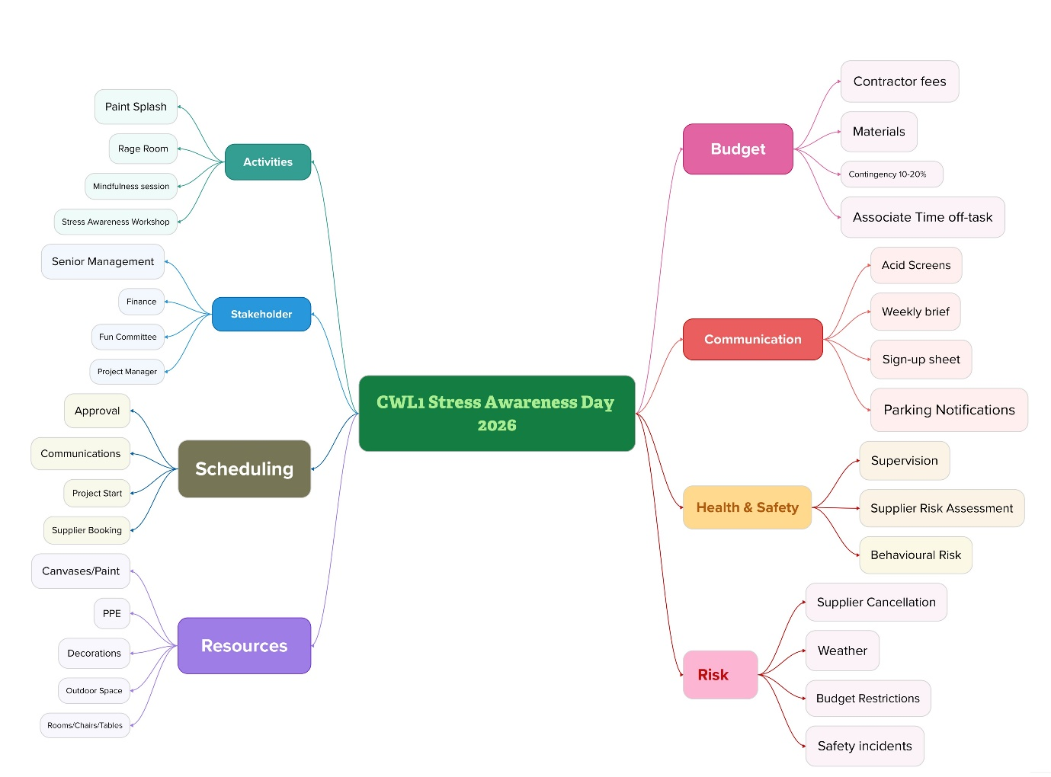
Note: Created by the author using Mural

Appendix B
SWOT Analysis
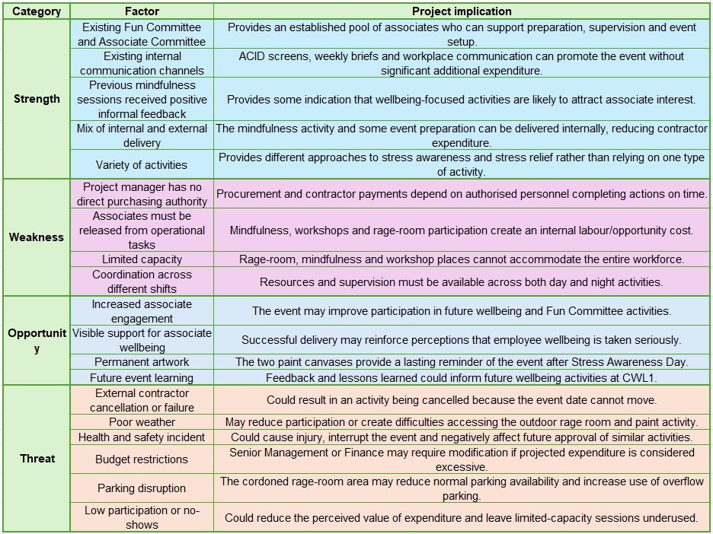

Appendix C
PESTLE Analysis
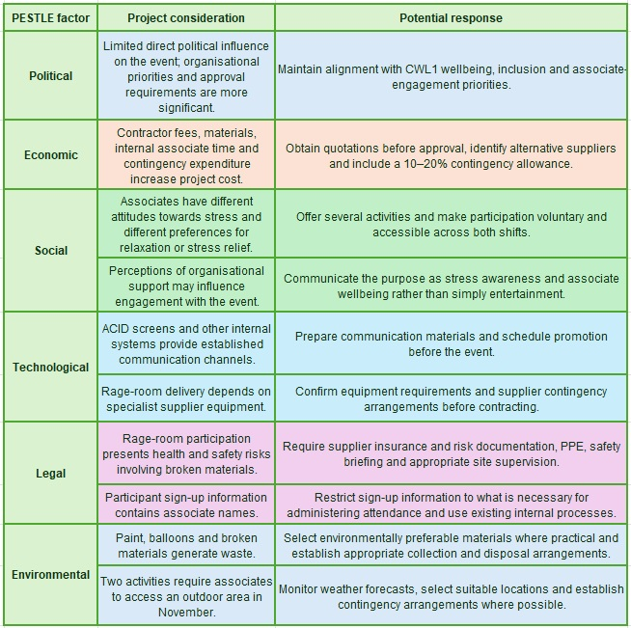

Appendix D
Stakeholder Analysis
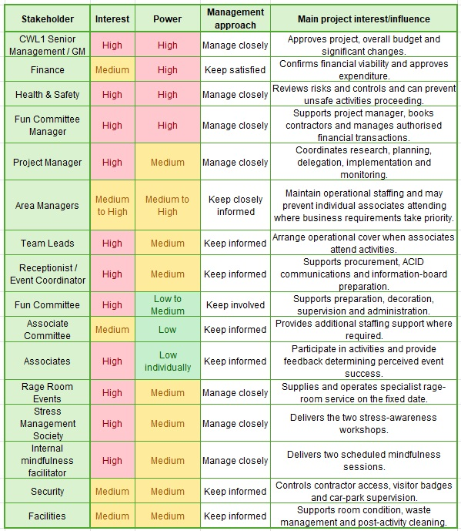

Appendix E
Communication Plan
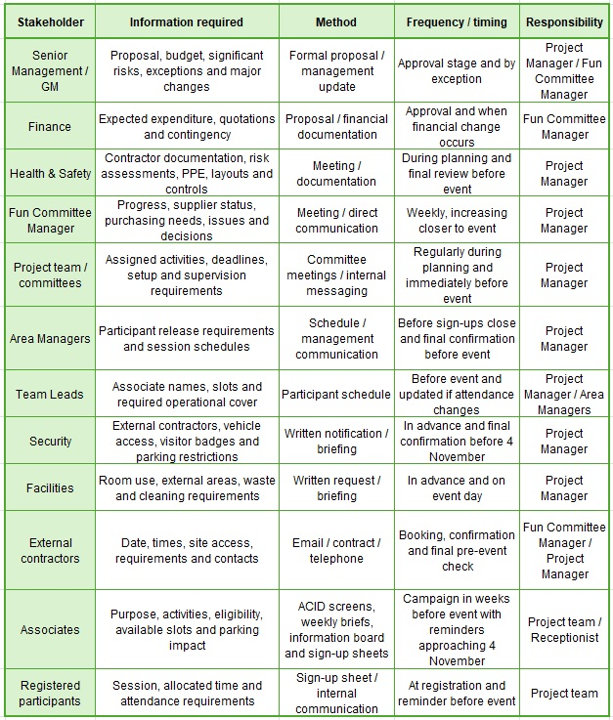

Appendix F
Work Breakdown Structure
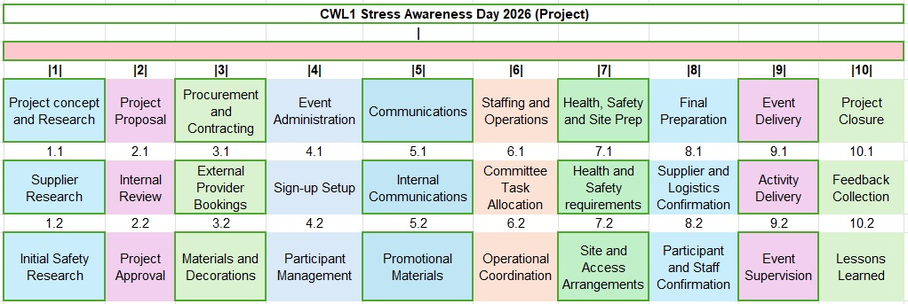
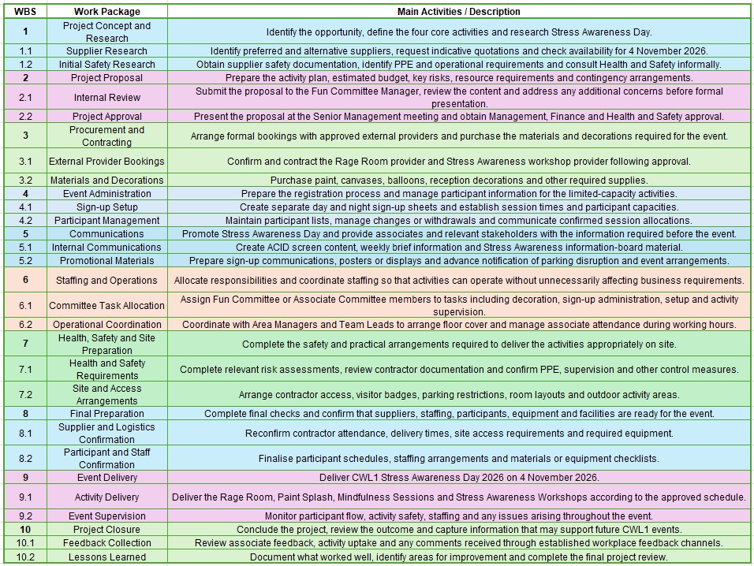

Appendix G
Gantt Chart with task dependencies and critical path identified
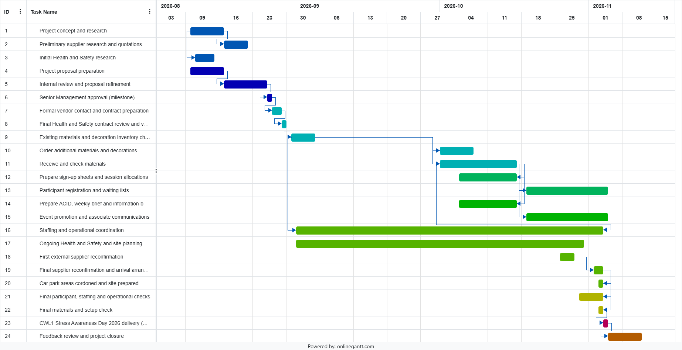
Note: Created by the author using onlinegantt.com

Appendix H
Resource Plan
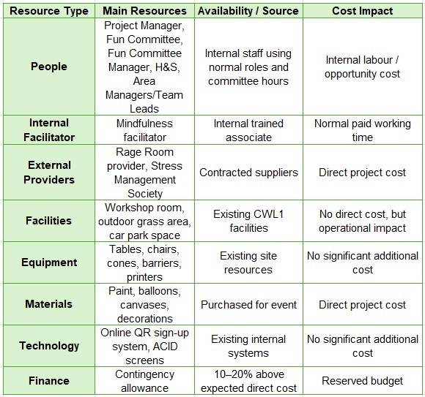

Appendix I
RACI matrix
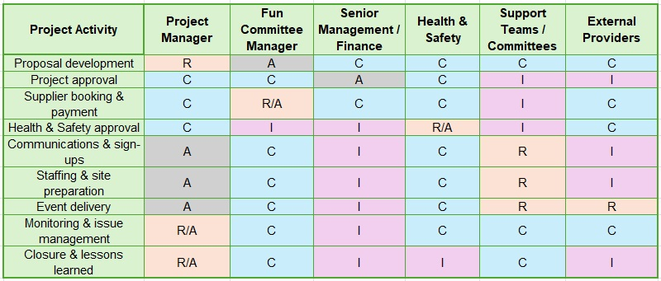

Appendix J
Risk Register
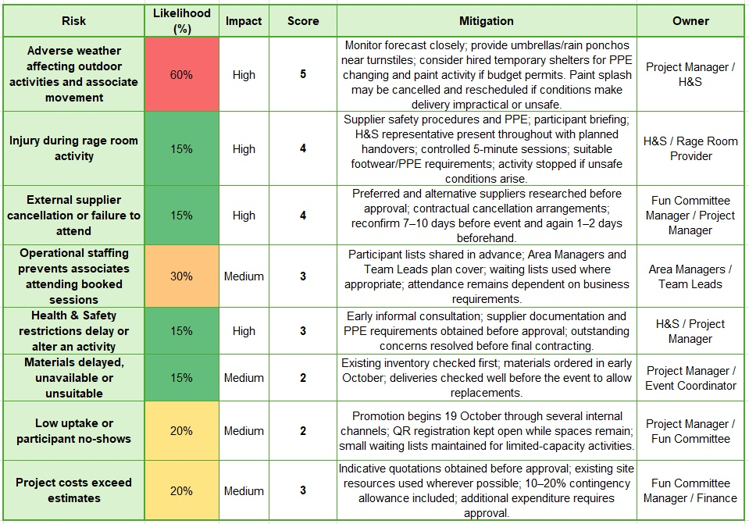

Appendix K
Personal Development Plan


