FINANCIAL MANAGEMENT FOR THE HOTEL INDUSTRY:
BMIH5007
Dale Clarke
Student Name: Delia Sandra Isaic
Student ID:2119909
SUSTAINABLE BUSINESS REVENUE GENERATION PLAN
Executive summary
Outsourcing refers to business activities performed by outside third parties. Marriott International is a key focus of the study and Outsourcing housekeeping is evaluated here based on the company. One supporting argument and another against the argument for outsourcing housekeeping is analysed here. Employee ability, sustainability, consistency, guest experience and other types of approaches are contextualised related to outsourcing housekeeping Marriott International.
Table of Contents
Introduction 3
The argument for OR Against outsourcing the Housekeeping department within Marriott International 3
Approaches for supporting and against the argument of outsourcing of Housing department 3
Comparison of insourced Housekeeping team Vs Outsourcing Housekeeping 3
Abilities of those employed 4
Cost implications 5
Results 6
Sustainability 7
Consistency 9
Guest experience 9
Conclusion 10
Reference list 11

Introduction
Outsourcing means a business practice in which a company hires a third party to conduct tasks or handle operations for the company. Outsourcing companies serve housekeeping services that assist their clients with efficient staff. In this report, the outsourcing of the housekeeping department of Marriott International is analysed here. One statement for supporting the argument of housekeeping department Outsourcing by Marriott International and another statement is evaluated here for the outsourcing housekeeping department of the chosen organisation. Abilities of employment, sustainability, consistency, comparison of in-source housekeeping versus outsourced housekeeping teams and other factors are also analysed here to support the argument.

The argument for OR Against outsourcing the Housekeeping department within Marriott International
Supporting argument: Outsourcing services in housekeeping reduces recruiting and training costs of employees of Marriott International
Against argument: Outsourcing can demotivate employees as they can feel being replaced and it may challenge the daily workflow of Marriott International

Approaches for supporting and against the argument of outsourcing of Housing department

Comparison of insourced Housekeeping team Vs Outsourcing Housekeeping
Housekeeping staff are liable to provide trim and spruce areas for guests which makes the housekeeping department backbone of Marriott International Hotel. As per descriptions of Drury (2015), outsourcing practice is undertaken by companies as a cost-cutting measure that can reduce overall operational cost of a company. In case Outsourcing housekeeping controversial decision is noticed with labour unions that are against it. The reason behind Outsourcing housekeeping is it saves the cost of the company for employees (Igoche, 2022). On the other hand, in-source housekeeping requires an initial investment by Marriott International which gives certain advantages that cannot be provided by Outsourcing housekeeping. In-source housekeeping staff has trained as per brand value and efficient hospitality Prime driver for Marriott International. However, outsourcing housekeeping has an economy of scale that reduces overall housekeeping cost establishment. Needless to say in comparison to in-source housekeeping, outsourcing housekeeping reduces the training and staff costs of Marriott International.
Budget is a big issue for an insourced housekeeping team that increases recruitment and staffing costs of a company. Increasing payroll for source Housekeeping and noticed that is not efficient for cost-cutting measurement. As defined by Gegeleso et al. (2021), internalised housekeeping requires training, supervision and management that increases administrative and managerial responsibility and expenses of the company. However, in case outsource housekeeping no control has been retained for Marriott International. Outsourcing housekeeping employees feel they are being replaced and it can make it difficult in following brand guidelines for housekeeping staff. It can be commented as for Marriott Hotels to maintain certain premises internal housekeeping is a better choice. However, from a cost-cutting point of view Outsourcing housekeeping is the best way for discussing business units.

Abilities of those employed
Outsourcing in housekeeping consists of efficient employees that provide better services to guests of Marriott International. According to Montes and Olleros (2020), an increase in efficiency and lower cost due to lower labour rates and economies of scale is noticed in outsourcing. Hence, employees of outsourcing housekeeping are efficient enough to satisfy consumers by access to resources in an effective manner. It also reduces internal training and staff costs of Marriott International which increases the flexibility of the business to meet changes. An increase in focus on core competencies and acceleration of time to market is observed in the Outsourcing of business (Paek et al. 2019). As a result, supplementary staffing is featured in outsourcing which indicates letting another company run Marriott International's housekeeping department. Discussing business units will benefit from improved efficiency, lower recruitment costs and increase speed of work in housekeeping. As opined by Guilding (2013), employees of outsourcing housekeeping know about customer service skills that are an important part of the hospitality industry. Hence, Marriott International gets positively influenced by Outsourcing housekeeping which increases business management skills.
Due to Outsourcing housekeeping, not having clear instructions is noticed on-premises. In contrast with Hayes and Miller (2012), revenue management refers to the analytical skill of data performing in the hotel industry to predict consumer behaviour. Outsourcing revenue management influences hotels to benefit from up-to-date knowledge, market insights, techniques and technology that help to stay ahead of the competition. Hence, outsourcing housekeeping staff decreases the motivation of housekeeping at Marriott International. Employees feel being replaced with efficient Outsourcing housekeeping employees that hamper the internal flow of the hotel. Moreover, Outsourcing is a cost-effective strategy that has some hidden costs such as legal costs that occur during signing between companies. It can be commented as Marriott International can suffer from a lack of customer focus due to outsourcing housekeeping.

Cost implications
Different types of costs are related to outsourcing: contractors' bid price, transition cost and administration cost of the contract. As stated by Atrill and McLaney(2015), cost management preface business costs and take action to track the budget and avoid exceeding the budget. Marriott International incur the direct cost and indirect costs during the sourcing of the housekeeping department. During outsourcing, Marriott International is required to pay salaries, collaboration costs, licence and management costs which are direct costs of outsourcing. Transition and I protection are indirect costs of outsourcing (Mukherjee et al. 2023). Outsourcing of housekeeping provides high-quality Services at low operational cost. It is useful for hotels to satisfy customers in an optimum way based on Outsourcing services. Needless to say, Outsourcing influences performing a task at minimum cost with much more efficiency.
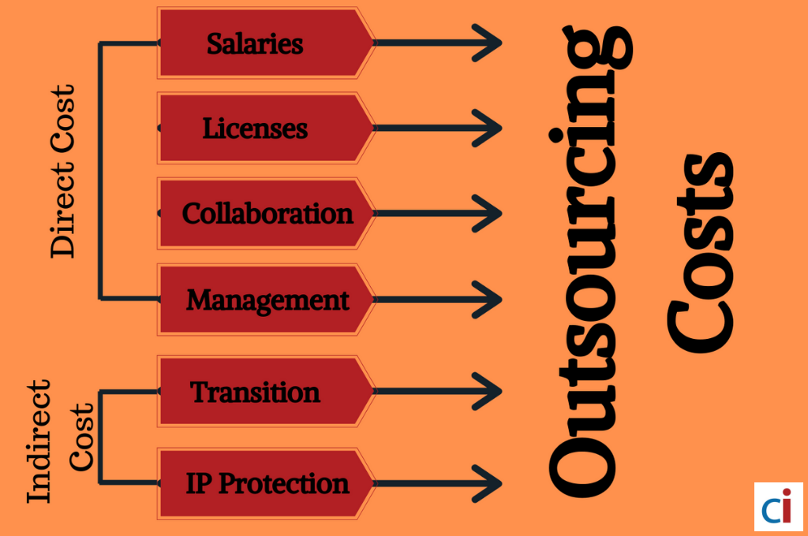
Figure 1: Outsourcing cost
(Source: Influenced by Mukherjee et al. 2023)
Hidden costs are also observed in Outsourcing such as the cost of selecting a vendor for outsourcing. As mentioned by Bhimani (2006),value chain analysis, quality costing, target costing, life cycle costing and activity-based costing are some contemporary issues in management accounting. Unforeseen and hidden costs in outsourcing increase risk for Marriott International which influences the cost structure of the business. Less control in outsourcing increases cost control inefficiency of the company. It has also been observed that privacy and security are a bigger risk of outsourcing. The discussing company may give less investment for privacy and security concerns of outsourcing that can increase issues of data leakage. Needless to say, contractors ' bid prices such as a summation of the direct and indirect costs of outsourcing may increase the overall hidden cost of Marriott International.

Results
Outsourcing influences the better experience of Hotel guests that increases customer attention power of the company. The increasing market size of outsourcing services worldwide has been noticed from 2000 to 2019. In 2000, outsourcing services incurred 45.6 billion US dollars which increased to 92.5 billion US dollars in 2019 (Statista Research Department, 2022). In addition to that, revenue from global outsourced services was unsteady in the last few years. In 2016the market size of the outsourcing industry dropped to 76.9 billion US dollars, the lowest figure in decades as per Statista. Hence, the increasing market size of outsourcing globally has been observed to reflect the positive impact of outsourcing on Marriott International. As agreed with Jagels (2007), outsourcing in the hospitality industry enables risk sharing that shifts legal risk associated with labour out of organisation. It can be stated as outsourcing of Marriott International employed outsourced staff that are employed by a partner farm, not Parent company. It reduces the overall recruitment and training cost of housekeeping staff which increases the profit margin of Marriott International.
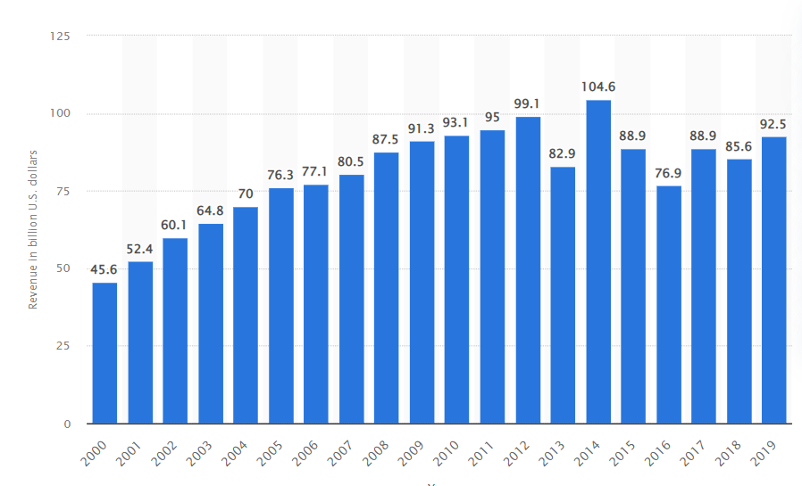
Figure 2: Global market size of outsourced services from 2000-2019
(Source: Statista Research Department, 2022)
Lower barriers to entry in Outsourcing industry influences increasing competition. Outsource employees may not focus on customers of organisations which can negatively influence customer relationship management (Chiguvi et al. 2019). Confidentiality and security may also be at risk as lack of flexibility. In case employees know about jobs that can be outsourced by external parties that may discourage conferences of employees.It also negatively influences loyalty of employees related to in-source housekeeping of Marriott International. Negative impacts on housekeeping employees are noticed due to outsourcing which make a lack of consistency. Employee retention rate may also decrease due to outsourcing as it can increase risk for employees about their job security.

Sustainability
Term sustainability in the hospitality industry indicates mindful use of resources that are not damaged or used up. As agreed with Tranter et al. (2013), revenue management is important for hoteliers as it enables maximisation of revenue by using big data and smart tech.Use of artificial intelligence (AI)is observed in housekeeping Technology solutions that automate predictable tasks and decreases the burden on employees. Outsourcing housekeeping companies use AI technology too automatically manual repeated tasks at increasing efficiency of overall hospitality services. Marriott International gets positively influenced by use of advanced technology in outsourcing housekeeping which increases overall efficiency of services. Multinational Marriott International Inc. employed nearly 1, 40,000 people worldwide in 2022 (Statista Research Department, 2023). In 2020, the total number of employees in Marriott International was121,000 employees as per Statistics. Additionally, in 2016 Marriott International was at its peak as they have employed over 226,000 employees. However, an increasing number of employees has been observed in the past year. This indicates efficiency in the human resource management of the company.
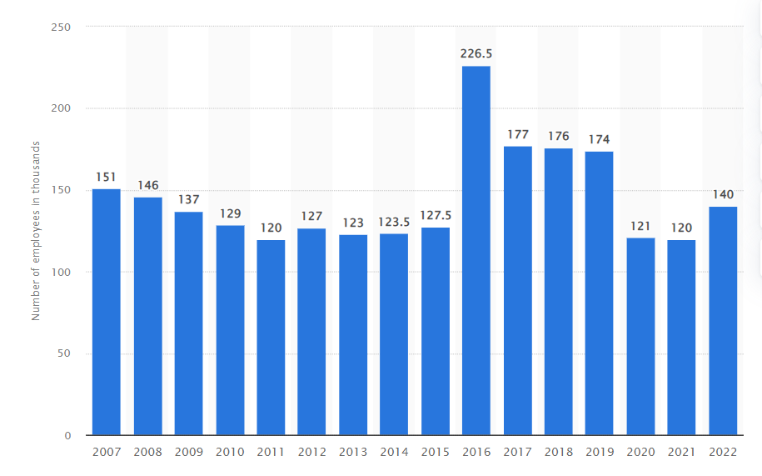
Figure 3: Number of employees in Marriott International worldwide from 2007 to 2022
(Source: Statista Research Department, 2023)
From 2007 the number of employees of Marriott International decreased in 2022. It also indicates lower engagement of employees due to Outsourcing of housekeeping reduces employee retention rate. As per views of Kurdi and Alshurideh (2020),low employee retention rate influences a decrease in productivity of company that may drive customers away. As a result, the retention of employees in Marriott International negatively influences the overall productivity of the company.

Consistency
Outsourcing housekeeping can finish work in less time which is highly effective in a competitive business environment. Budget in Outsourcing influences controlling spending for outsourcing activities by tallying with the savings of the company (Garbutt, 1992). Outsourcing of housekeeping services increases the reputation of multinational companies such as Marriott International. However, outsourcing of housekeeping services is sustainably cost-effective and also increases guest satisfaction. Outsourcing housekeeping services makes it a cost-effective service of Marriott International. It helps in fulfilling business goals that make effective interaction between guests and housekeeping staff. Hence, cost cutting is possible in outsourcing which can make consistency in business activities of Housekeeping.
During Outsourcing some challenges in traditional Outsourcing are observed that influence the transformation of businesses. In keeping to Bromwich and Bhimani (1994), management Accounting Outsourcing influences the decision to buy a product or pay someone to make a product from outsourcing. Marriott International may face disruption in choosing the wrong Outsourcing model which may give an unpleasant impact on employees. In addition to that, ambiguous cost has also been observed that may give a negative impact on past control of the business. A lack of expertise in Outsourcing tasks may affect the reputation of Marriott International. It also increases the risk of business due to a lack of control in Outsourcing business activities of housekeeping. Cost accounting is an important part of financial management accounting that influences the product and services of companies related to manufacturing or distribution (Horngren and Forster, 2003). As a result, transition costs and contractors’ bid prices may influence consistency in the Outsourcing services of Marriott International.

Guest experience
Overall satisfaction of guests in hotels is important and influences brand recognition of the company. In case customers get third-party services, it may affect customer interaction and communication with in-house employees of outsourcing. As defined by Sealet al. (2008), management accounting influences the hospitality industry to manage their resources in an optimum way. Hence, outsourcing staff have customer service skills that positively influence the guest experience of Marriott International.
Outsourcing housekeeping less connects with customers as outsource staff may not perceive the brand value of the company. Less quality control has been observed in outsourcing which can give a negative impact on employees and customer sources.

Conclusion
It can be concluded as Outsourcing services hired third parties to perform a task with efficiency. In source, housekeeping is effective for Marriott International to provide better services on the premises. Outsourcing housekeeping influences the cost-cutting of businesses that we also negatively influence the motivation of employees of Marriott International. The increasing global market size of outsourced services is observed from 2000 to 2019 and the number of employees of Marriott International has been reduced from 2007 to 2022. Outsourcing housekeeping gives a better experience to guests however it may feel employees are replaced without source employees.

Reference list
Atrill P, McLaney E (2015). Management Accounting for Decision Makers, FT Prentice Hall
Bhimani A, (Ed) (2006). Contemporary Issues in Management Accounting , Oxford
Bromwich M and Bhimani A (1994). (2nd Ed) Management Accounting, Pathways to Progress, London:CIMA
Chiguvi, D., Madondo, E. and Dube, Z., (2019). The Importance of Customer Relationship Management in the Local Government Authorities in Zimbabwe. Applied economics and finance, 6(6), pp.15-29.
Drury C (2015) (9th Ed) Management and Cost Accounting, London, Prentice Hall.
Garbutt Prof. D (1992) Making Budgets Work, London:CIMA
Gegeleso, O., Somuyiwa, A. and Ayantoyinbo, B., (2021). Effect Of Logistics Outsourcing Management On Cost Reduction And Companies Profitability Of Consumer Goods Industries. Business Logistics in Modern Management, 21, pp.493-506.
Guilding,C.(2013) Accounting Essentials for Hospitality Managers, London, Taylor and Francis
Hayes,M. & Miller, A. (2012) Revenue Management for the Hospitality Industry, London, Wiley
Horngren C T and Forster G (2003) (11th Ed) Cost Accounting, A Managerial Emphasis, London: Prentice Hall International
Igoche, F.O., Sani, G.S., Jerry, J.M., Mabadeje, J.A. and Umar, A.L., (2022). Outsourcing Cleaning Services as an Alternative to In-House Cleaning in an Organization: A Case Study of the Bank of Agriculture (BOA), Bauchi Plaza. African Journal of Management and Business Research, 6(1), pp.120-128.
Jagels,M. (2007) Hospitality Management Accounting, London, Wiley.
Kurdi, B. and Alshurideh, M., (2020). Employee retention and organizational performance: Evidence from banking industry. Management Science Letters, 10(16), pp.3981-3990.
Montes, J.O. and Olleros, F.X., (2020). Microfactories and the new economies of scale and scope. Journal of Manufacturing Technology Management, 31(1), pp.72-90.
Mukherjee, D., Nuruzzaman, N., Gaur, A.S. and Singh, D., (2023). Pro-market reforms and the outsourcing tradeoffs: Evidence from the transition economies. International Business Review, p.102105.
Paek, B., Kim, J., Park, J. and Lee, H., (2019). Outsourcing strategies of established firms and sustainable competitiveness: Medical device firms. Sustainability, 11(17), p.4550.
Seal W, Garrison RH, Noreen E (2008) Management Accounting, McGraw Hill
Statista Research Department, (2022). Global market size of outsourced services from 2000 to 2019. Statista. Available at: https://www.statista.com/statistics/189788/global-outsourcing-market-size/. [Accessed on: 16th May, 2023].
Statista Research Department, (2023). Number of Marriott International employees worldwide from 2007 to 2022. Statista. Available at: https://www.statista.com/statistics/297269/number-of-marriott-international-employees-worldwide/#:~:text=Multinational%20hotel%20company%20Marriott%20International,worked%20for%20Marriott%20International%2C%20Inc. [Accessed on: 16th May, 2023].
Tranter,K. Stuart-Hill,T. Parker,J. (2013) Introduction to Revenue Management for the Hospitality Industry, London, Pearson

