Data Handling & Business Intelligence

University name
University of Wales Trinity Saint David

Lecturer's name
Anupam Mazumdar

Student name
Stanislav Momchev Danailov

Student ID
2112418

Assessment 1- LCBB5000

Report 2150 words

Table of Contents
Introduction 1
Five Business Intelligence Trends 2
Artificial Intelligence 2
Data Security 2
Predictive and Prescriptive Analytics 3
Collaborative BI 4
Data Literacy 4
Conclusion 5
References 6

Introduction

According to Anthony (2022) Business intelligence (BI) has become an inseparable part of all business enterprises regardless their size as they utilise all available information and constitute it into appropriate solutions that can increase revenue, performance and even encourage company’s growth (Fig.1). As per Richards et. al., (2019) BI assists companies in combining management practices and information technology into creation of vital strategies for optimal organizational success (cited in Lim and Teoh, 2020). Lim and Teoh (2020) underline that BI is incorporated into standard work practices known as a tool which rapidly extracts ‘big data’ and in turn offers right decisions. Furthermore, fundamental components of BI are data warehousing, mining, querying and reporting (Maheshwari,2015)
Figure.1 Evolution of BI
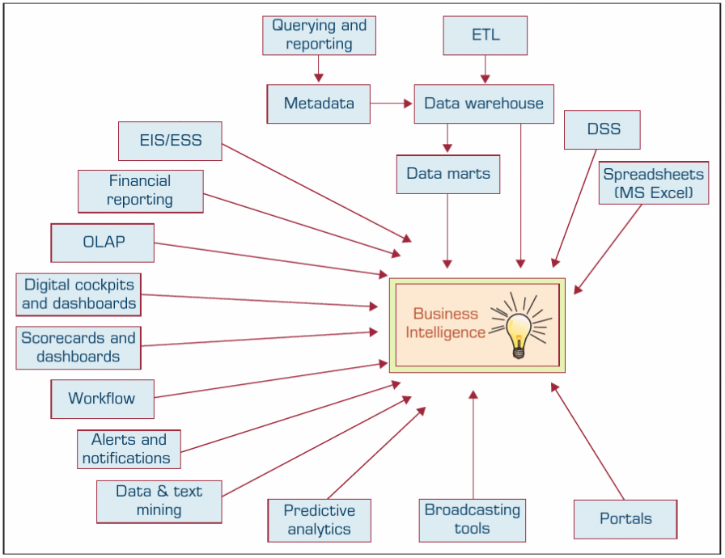

Source: Sharda et. al., 2018

This report aims to determine current trends of BI. Its objectives are to thoroughly represent and highlight five most important current trends for the year of 2022/2023 within data warehousing, mining and BI. Furthermore, the report is consisting of an Introductory part that is focused on Business Intelligence and its meaning to businesses, followed by the five major trends of BI as body of the report and proposed conclusion to establish closing comments to the matter.

Five Business Intelligence Trends

As already highlighted, BI plays a significant role in business survival, maintaining professional relationships with its rivals, cyberespionage, assists with achieving aims and objectives on short and long-term goals (Romero et. al., 2021). Moreover, BI is a comprehensive set of Information Technology tools, that allows businesses to gain clearer insights based on customers’ behaviour and preferences (Maheshwari,2015). Therefore, BI landscape is constantly evolving, and its future is based on the emerging customised trends.

Artificial Intelligence
The first trend to begin with is the so-called Artificial Intelligence (AI), which is expected to evolve into a responsible and adaptable technology systems, however these are set to use smaller datasets and adaptive machine learning along with new privacy regulations (Calzon,2022). To this day it is unclear how to properly utilise such systems, and often professionals unintentionally leave space for hackers to make breaches in the law or face financial losses (Calzon,2022). Nevertheless, AI proposes an algorithm based on advanced neural networks that in turn provides high accuracy in anomaly detection through historical patterns, thus any concern will be detected, and the user will be notified (Calzon,2022).
Furthermore, the need for real time online data analysis software is growing, hence Adaptive AI might be the answer. As highlighted by Gartner (2021) such system supports decision-making framework while remaining agile to any issues that arise (cited in Calzon,2022). Adaptive AI system provides information regarding behavioural patterns and adjust to world changes swiftly, allowing businesses to act and improve their decisions, ensuring that ethical and secure measures are implemented (Calzon,2022).

Data Security
According to Calzon (2022) companies are being forced to invest in security to remain compliant with new regulations and be protected from cybercrimes. In addition, it is expected that businesses will adopt a framework called ‘Zero Trust’ that remove the “implicit trust” from all computing infrastructure through verifying each stage of a digital contact from devices to consumers regardless their location. Hence, every user that aims to interact with company’s systems ought to be validated and verified.
Another trend engaged with cybersecurity is cybersecurity mesh architecture that provides security control and protect digital assets that reside in applications, in the digital cloud for storing data and others. Its aim is to establish a security perimeter, enabling users to gain access to specific data through their smartphones. According to Gartner (2021) businesses who adopt cybersecurity mesh architecture can reduce financial losses caused by breaches with 90% (cited in Calzon,2022).

Predictive and Prescriptive Analytics
Gilbert (2022) stated that the analytical market is rapidly changing accordingly with the type of analytics businesses demand. The author also suggested to segment the analytics market into four parts and their implementation (Fig.2)
Figure 2. Analytics Market shaped into four segments
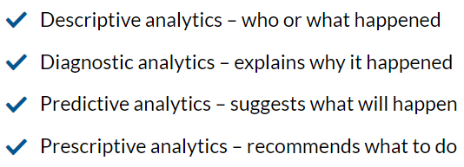
Source: Gilbert, N. 2022
However, according to Calzon (2022) businesses are more focused on Predictive and Prescriptive analytics due to their forecasting traits. For example, predictive analytics extract information from available data patterns to prognosticate forthcoming probabilities. In fact, predictive analytics provide not only eventual future chances for the business growth with significant level of reliability, but also includes alternative scenarios and risk assessments. Moreover, the practice allows businesses to learn about their customers’ behaviour, products, and partners by analysing existing data and historical facts (Calzon,2022).
Despite the reliable future forecasting of Predictive analytics, Prescriptive analytics go beyond near future probabilities and focus on what decisions ought to be taken to achieve a desired goal. Furthermore, the practice analyses the effect of future decisions and attempts to adjust to decisions before their implementation, hence future outcomes are predicted, and the risk is minimized (Calzon,2022).

Collaborative BI
Expectedly, businesses are facing constantly changing and competitive environment and they must adapt and change their business strategies. Thus, there is a need of a new kind Business intelligence tool as collaborative business intelligence. This tool allows workers and managers to share scheduled reports, dashboards, or create an alert. In fact, it does track meetings, calls, ideas or with other words – all written and spoken communication. Nonetheless, Calzon (2022) stated collaboration between BI users and providers is expected to become a priority for the year of 2023, as it provides numerous techniques that connects users on each level during their work, enhances unity and enable united communication and productive work environment.

Data Literacy
Coming to the last trend for 2022/2023, apparently Data Literacy is highlighted as the core element of BI due to the nature it possesses – the need to be exact, precise and accurate. As stated by Calzon (2022) data is fundamental when it comes strategic decisions for corporations and enterprises, thus comprehending data and utilising collaborative tool can be crucial for business success.
Data literacy is appreciated as the ability to understand information in a specific context by utilising different techniques and methods and therefore to analyse the data and the outcomes provided by those tools and methods (Calzon,2022). Moreover, Data Literacy is seen to be a success to the data culture, however the achievement of such might be challenging. For instance, to achieve success an assessment ought to identify gaps in workers’ abilities, that in turn provides information to managers who can design training course (Calzon,2022).
Nonetheless, (Maheshwari,2015) underlines that data is natural resource, and lies at the heart of BI. It can be modelled and stored according to certain categories, and it is stored at the data warehouse. Thereafter, the data there is mined through data mining tool and generate new reports and insights. Lastly, Data ought to be visualized and discussed for future competitive advantages.
Figure. 3 Data Processing Chain
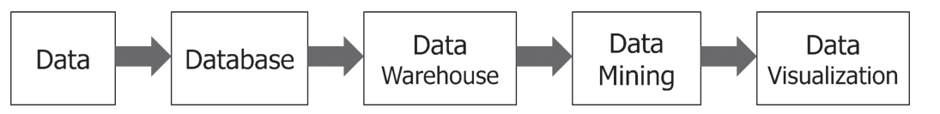
Source: Maheshwari, 2015

Conclusion

In conclusion ought to be mentioned that Business Intelligence incudes various tools, methods, systems and softwares that read, understand, store, organise big data for the success and future growth of all businesses in all sizes. With the data stored and sorted, there are many reports, analysis, and insights to be made and forecast as well. All these tools allow companies to asses their workers’ weaknesses and train them, observe customers’ buying behaviour, as well as monitor financial losses and breaches caused by intruders or unconfident professionals. In other words, the business world does need Business Intelligence to grow further, as well as keep records of the past, present, and future.

References

Anthony, J. (2022) 11 Business Intelligence Trends for 2022: Latest Predictions You Should Be Thinking About, Available at: https://financesonline.com/business-intelligence-trends/
Calzon, B. (2022) Top 10 Analytics And Business Intelligence Trends For 2023, Available at: https://www.datapine.com/blog/business-intelligence-trends/
Gilbert, N. (2022) 8 Business Intelligence Software Trends for 2022/2023: Predictions You Should Be Thinking About, Available at: https://financesonline.com/business-intelligence-software-trends/
Lim, Y. Y. & Teoh, A. P. (2020) Realizing the strategic impact of business intelligence utilization. Strategic direction (Bradford, England). [Online] 36 (4), 7–9.
Maheshwari, A. K. (2015) Business Intelligence and Data Mining, Available at: http://14.99.188.242:8080/jspui/bitstream/123456789/15214/1/Business%20Intelligence%20and%20Data%20Mining%20%5BMaheshwari%202014-12-31%5D.pdf
Romero et. al., (2021) "Business Intelligence: Business Evolution after Industry 4.0" Sustainability 13, no. 18: 10026. https://doi.org/10.3390/su131810026
Sharda et al., (2018) Business intelligence, analytics, and data science : a managerial perspective. Fourth, Global edition. Harlow, England: Pearson.

