Target 1 | Check your referencing technique as you should, for example, include page refs with direct quotes.
Target 2 | Consider your punctuation skills.
Target 3 | Ensure that you use your reading to shape and influence your views - or to reinforce what you are trying to say.
Target 4 | Proofread your work and use educational texts to model a more academic style of writing.

Cycle 1 Professional and Pedagogical Studies: Leading the Learning: what, how and why am I teaching?
Good teaching and learning means employing a blend of approaches including direct teaching.

Good teaching and learning sets tasks and selects resources that build on previous knowledge and experience and engage interest.

Good teaching and learning ranges within and across Areas of Learning and experience.
(Donaldson, 2015:68)

Consider the 3 pedagogic principles outlined above. Discuss these principles in relation to your experience in school showing secure understanding, identifying strengths and areas for development for each principle.

According to The Cambridge University Dictionary, “pedagogy is the study of the methods and activities of teaching” (Cambridge, 2020).
This definition is challenged by Professor Graham Donaldson whereby he states in his Successful Futures report that “pedagogy is about more than ‘teaching’ in the narrow sense of methods used in the classroom” (Donaldson, 2015, p. 63).

Donaldson is leading the way in reforming the Welsh education system and creating
drastic changes to the delivery and organisation of the curriculum. Donaldson hopes that the curriculum reform will place emphasis on The Areas of Learning Experience (AoLE) rather than individual watertight compartments. This transformation is intended to “organise the intentions for each child and young person’s learning, with decisions and plans for how these should translate into day-to-day activities taking place creatively at school level” (Donaldson, 2015, p. 39).

Donaldson outlines twelve pedagogical principles that underpin, what he deems to be, the most fundamental teaching and learning practices.
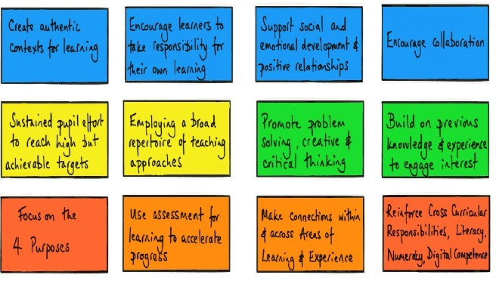
Image 1. The 12 pedagogical principles by Professor Graham Donaldson (2018)

These twelve pedagogical principles are also supported by Estyn (2018), who emphasise that they are the foundation of good teaching and learning strategies.
These twelve principles together, form the basis for effective teaching and learning to take place. It is imperative that not one principle is regarded more importantly than another, much like the ‘Te Whãriki’ (meaning woven mat in Maori) philosophy. This approach is used in New Zealand’s curriculum that prides itself on principles and strands being intertwined within their curriculum and therefore creating a sense of interdependence upon one another (Blaiklock , 2010).
The intention and purpose of these principles is to deliver good teaching and learning, which as discussed in a University lecture by Carys Jennings consists of:
- “Interaction with others
- Purposeful repetition
- Developing independence and thinking
- Problem solving
- Home/ school links
- Listening to the learner voice” (Jennings, 2020).

During this reflective task, I aim to discuss some of these pedagogical principles and the way they have been represented in my Professional Teaching Practice (PTE). To do this I will look at academic theorists and scholars who have conducted research and offered substantiated claims that inform a diverse range of opinions. I will then explore and put these pedagogical principles into practice with the intention of an honest scrutiny of these teaching methods.

The Foundation Phase (FP) in Wales is built largely upon:
the emphasis of the importance of every child experiencing equal opportunities and accessing a broad, balanced, relevant and differentiated curriculum which meets their needs. It also focuses on the impact of children’s pre-school experiences on their subsequent development and creating positive links between the home and providers of care and education, and an appreciation of parents/carers as the children’s ﬁrst educators (Government, 2008, p. 5).
It also emphasises the efficacy of “explorative pedagogies and continuous and enhanced ‘must-do challenges” (Taylor, et al., 2015, p. 79).
The FP is unique to Wales which follows a holistic approach whereby learning in the FP is child-centred and follows a curriculum based on the development of the child’s personal, social, emotional and conceptual skills (Government, 2012, p. 44). Holistic, child-centred learning is an approach, much like the Welsh FP, that Fredrich Frobel advocates in his work, whereby at the centre of his theory was the importance of developing the whole child (Government, 2008, p. 28).
Although, it could be argued that child-centred development relegates the role of adults in children’s learning to the side-lines (Langford, 2010).

During my PTE in the FP, I had the opportunity to develop my use of the twelve pedagogical principles within my teaching and learning. I was able to observe and practise a wide range of teaching strategies, some of which included; teaching and learning that ranged within and across AoLEs; teaching and learning that set tasks and selected resources that built on previous knowledge and experience and engaged interest; teaching and learning that employed a blend of approaches including direct teaching (Donaldson, 2015, pp. 65-68).
Although John Hattie states that,
teachers need to be aware of which of their teaching and learning strategies are working and must be prepared to understand and adapt to their learners and their situations (2009, p. 23).
I have decided to reflect upon three of the twelve pedagogical principles that I exercised on PTE, explore potential developments and ultimately improve my practice as a future professional teacher.

The first of these selected principles is ‘good teaching and learning ranges within and across Areas of Learning and experience’. This principle advocates the importance and ability for connection and transferable knowledge and understanding to be made across a variety of contexts. According to this principle, developing skills should not be carried out in isolation or with lack of meaningful connections but instead promote unity within the Areas of Learning and Experience. Thus, improvement and reinforcement of learning manifests (Donaldson, 2015, p. 68).
Trevor Kerry explains that “learning beyond subject boundaries provides learners with the opportunity to experience deep, challenging and relevant learning” (Kerry, 2015, p. 4).
Kerry’s thought supports this pedagogical principle by explaining that segregated subjects hinder effective and purposeful learning and therefore agree that there is a need to range across Areas of Learning and experience to create relevant learning. For example, mathematical skills are never used in isolation in everyday life, they always have a context to them, rather than abstract meaningless calculations. While on my PTE, I delivered a lesson that was underpinned by this pedagogical principle.

The activity I planned had a Mathematics and Numeracy focus whereby the learners were exercising their subtraction skills. The subtraction activity was built upon Languages, Literacy and Communication through the means of using a story as a stimulus. The children were aware of the story and characters, so by linking these two AoLEs, I was hopeful that greater understanding and meaning would be created in the learner’s mind. This idea is supported by Howard Gardner who, in his theory, explains that in order for children to achieve their potential, they should be exposed to a range of experiences (Government, 2008, p. 31).
The learners were specifically using and applying their Language, Literacy and Communication skills to provide explanation and method to the concept of subtraction. For example, rather than merely working out 4-2, I created a worksheet (see below) that used language, visual aids and concepts from the story to aid the notion of subtraction. Using the story as a stimulus also encouraged discussion which explored alternatives and themes in the storybook. Here, the learners were able to use their Language, Literacy and Communication skills as a tool to aid in completing the Numeracy and Mathematics element and allowed the children to enjoy discussions surrounding the story. These examples demonstrated the use of the pedagogical principle of ranging across Areas of Learning and experience. The learners could understand 4-2=2 by the sum being told as a worded problem- ‘George had 4 shirts, but he could not find 2 of them, so he had 2 left’. The understanding of subtraction was demonstrated by using the means of Literacy, Language and Communication skills.
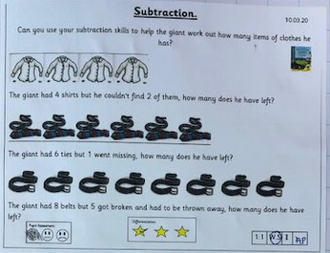
Image 2- Subtraction worksheet devised by Anna Podmore (2020)

Upon reflection of this pedagogical principle used in PTE, I feel it has had a beneficial impact on the learners. Had the learners not had a Literacy, Language and Communication input that contextualised the task in a way that they could understand, the subtraction task would have been much more challenging to teach in a discreet manner. This is supported by John Dewey who states that through contextualizing a problem it can provide additional cognitive and effective information to the learner beyond the targeted content (Giamellaro, 2017).

A development for this pedagogical principle, I believe, is that there could be a tendency for teachers to lose sight of the main outcome of a task by overcomplicating and attempting to include multiple AoLEs, therefore causing confusion rather than clarity as to what is required by the learner. For example, I planned to include three AoLEs- Literacy, Language and Communication; Numeracy and Mathematics and Expressive Arts in my lesson, but it soon became apparent that the learners grew distracted by the idea of physically acting out subtraction. An incidental change I decided to make was to be more concise with the task and only combine the two AoLEs instead of three. Although, Susan Isaacs would argue that play has an important role in a child’s learning (Government, 2008). Considering the aforementioned idea, it could be argued that allowing the children to use play within the concept of subtraction could have aided the understanding for the learners and therefore would reconsider my choice to remove this method from my activity.

The second pedagogical principle is ‘good teaching and learning sets tasks and selects resources that build on previous knowledge and experience and engage interest.’
Donaldson states that this principle acknowledges that all learners have individual interests and are diverse in their experiences and prior knowledge, therefore, good teaching utilises this idea to draw out progression of learning. Individuals will have a varied approach to learning and therefore a one-size-fits-all attitude will not reflect worthy consideration of the learners needs and abilities. Nevertheless, it is imperative to be aware that separating learners into groups based on teacher’s identification of needs could cause misjudgements.
Donaldson has proposed Progression Steps within the new curriculum which will support learners to receive teaching and learning that offers engaging experiences to learners that suit their specific needs (Donaldson, 2015, p. 67). This is a concept which Maria Montessori advocated by stating that children will enjoy learning if their needs are met (Pound, 2006). Additionally, Lev Vygotsky reinforced this idea by suggesting that matching learning activities, therefore meeting the needs of learners, would encourage development and progression (Government, 2008, p. 30).

Whilst on PTE, I applied this principle to my teaching by selecting resources from a story book that the children were familiar with. This approach had noticeable effects on the learner’s engagement and participation as they were evidently confident and interested in a task that they felt knowledgeable with. The context of subtraction became relevant to the children because the resources I had selected came from a context of which they had experience and understanding of. Another element of Montessori’s method “emphasises the importance of concrete experiences and materials to help children to understand abstract principles” (Pound, 2006, p. 39).

Reflecting on this pedagogical principle, I believe that it has strengths that contribute to good teaching and learning. For example, I observed effective use of this principle on my PTE where the class teacher was working alongside a child who presented with challenging behaviour and was disengaged with learning. In order to encourage participation, the class teacher used the child’s knowledge and interest to spark engagement. The focus of this good practice was not necessarily on what the teacher was teaching, but more specifically how she was teaching. Evidence from research suggests that “the question of how teachers engage their students in learning is of immense global importance” (Siraj, et al., 2014, p. 5)

The last principle to discuss is, ‘good teaching and learning means employing a blend of approaches including direct teaching.’ Donaldson explains that the new curriculum encourages the need for a broad repertoire of teaching and learning experiences for learners, including methods such as ‘direct teaching’ (Donaldson, 2015). Hattie defines direct teaching as,
the teacher decides the learning intentions and success criteria, makes them transparent to the students, demonstrates them by modelling, evaluates if they understand what they have been told by checking for understanding, and re-telling them what they have been told by tying it all together with closure (Hattie, 2009, p. 236).
Direct teaching involves the active engagement of the teacher in ‘scaffolding’ learning, a concept that Jerome Bruner explains to be the “person that is doing the teaching leads the child step by step in learning’”(Boyd & Bee, 2014, p. 21). Steiner Waldorf also states that “in watching adults, children will become willing to try out similar actions” (Pound, 2006, p. 35). This thought links to the idea of direct teaching, where teachers are scaffolding ideas for children to imitate.

With a great emphasis being placed on the new Digital Competence Framework, teachers are seeking to combine emerging technologies such as computer games or virtual worlds to design learning environments that are realistic, authentic, engaging and enjoyable (Wong, et al., 2013, p. 252). Teachers are therefore able to deliver content that is appealing and fun for the learners. This is an approach I used during PTE where I demonstrated the use of IT to deliver my whole class introduction to encourage collective participation in my Creative Development lesson. I intentionally made this decision because I soon realised that insisting the children were to sit still for long periods of time was an unfair expectation for four-year olds to achieve and would also dwindle engagement levels. The students engaged and interacted with the PowerPoint game (see below), exciting them for the lesson ahead.
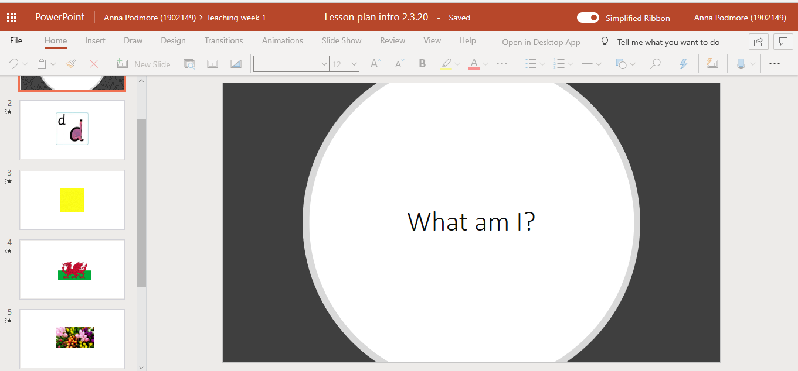
Image 3- Power-point Anna Podmore (2020)

I then employed a focus-group work approach to the lesson as I felt the learners would benefit from a more tailored and personal delivery. The use of strategies such as success criteria, modelling, Assessment for Learning (AFL) and questioning together contributed to test the efficacy of my lesson within a group-work approach. It has been evidenced that a brain’s motor regions are further increased if the observer (child) watches someone else's (teacher’s) actions with the intention of imitating them later (Blakemore & Frith, 2005).
I decided to lead the children by example and modelled how to complete the task successfully and outlined the success criteria by verbally acknowledging the steps as I carried them out. I then summarised the process in an easy to digest, chronological order to ensure the children understood how and when they needed to carry out each part of the task.
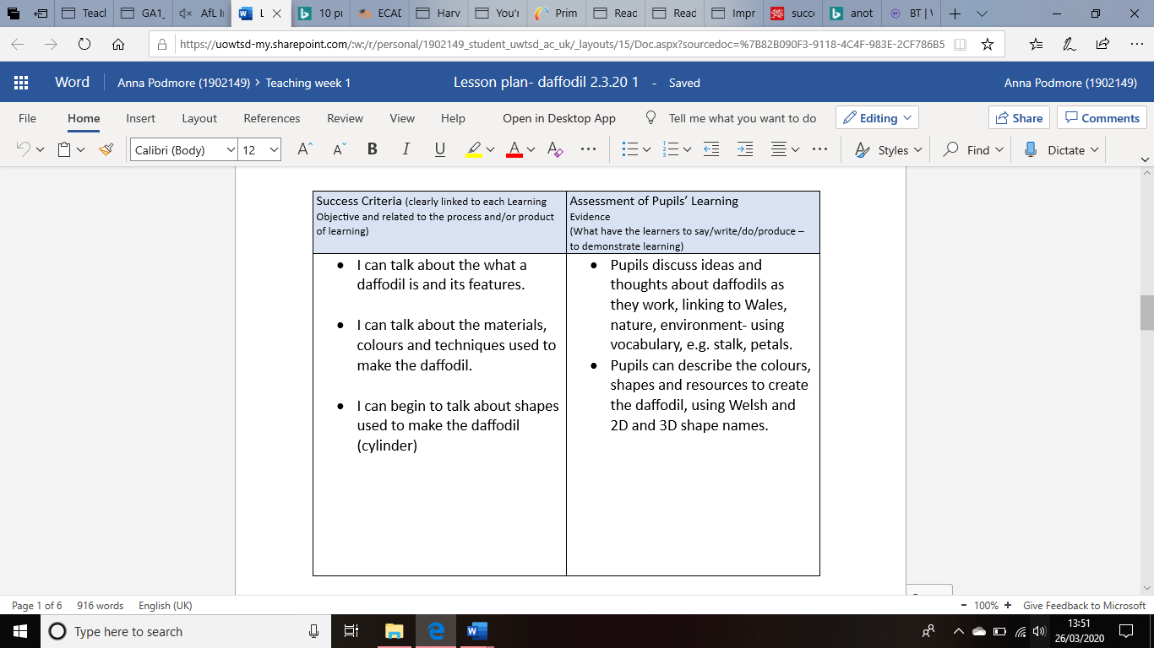
Image 4- Lesson Plan Anna Podmore (2020)

The use of referential questioning throughout my teaching and core learning section (see lesson plan section below) allowed the learners to begin to build a basis of understanding and topic-related vocabulary.
I believe the strengths of this pedagogical principle surround the flexibility of blended teaching, whereby the different ways and strategies that can be used to enhance learning lend a sense of variety and give freedom for creativity. During PTE, I discovered that using blends of approaches not only gave the learners an array of learning experiences, but it also challenged them in ways that created independence and the need to problem solve.
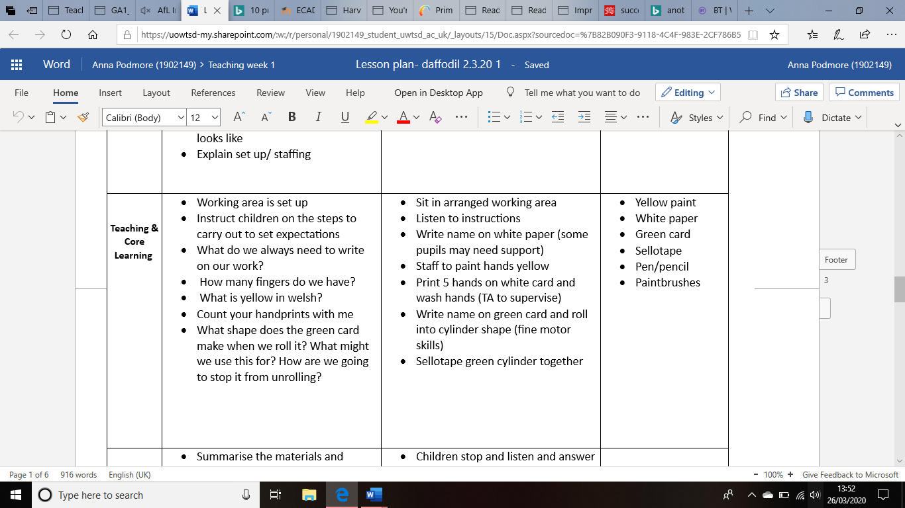

Image 5- Lesson Plan Anna Podmore (2020)
During my time teaching and observing in the FP on PTE I was immersed in learning environments that were utilising the twelve pedagogical principles. Upon reflection of time spent observing experienced teachers and then implementing strategies of my own, I have concluded that teaching strategies should not be taught in isolation. Learners should be offered a wide range of teaching and learning methods as outlined by Estyn (2018) and Professor Graham Donaldson (2015) in their emphasis of the twelve pedagogical principles.

Going forward, I intend on ensuring that my lessons contain a broad repertoire of teaching and learning methods where the children have the opportunity to access prior knowledge, use a variety of resources which support and encourage a deeper level of thinking, as supported by Bloom’s Taxonomy (Armstrong, Date unknown).
I will also provide regular opportunities for AFL such as questioning skills and self and peer-assessment. I have gained valuable insight into the importance of using a wide range of AoLEs in my teaching and learning. Furthermore, I understand that AoLEs should be used in an authentic manner which arise naturally without appearing contrived.
Basing my teaching and learning on the twelve pedagogical principles will ensure that effective learning occurs, purposeful lessons are taught and learners are instilled with relevant skills and knowledge that are applicable in their lives. Implementing these principles will aid the support of creating
ambitious, capable learners who are ready to learn throughout their lives, enterprising, creative contributors who are ready to play a full part in life and work, ethical informed citizens who are ready to be citizens of Wales and the world and healthy confident individuals who are ready to lead fulfilling lives as valued members of society’(Government, 2020).

References
Armstrong, P., Date unknown. Bloom’s Taxonomy. [Online]
Available at: https://cft.vanderbilt.edu/guides-sub-pages/blooms-taxonomy/
[Accessed 27 March 2020].
Blaiklock , K., 2010. Te Whariki, the New Zealand early childhood curriculum: is it effective?. 18(3), p. 1.
Blakemore, S.-J. & Frith, U., 2005. The learning brain: Lessons for education. Developmental Science, 8(6), pp. 459-465.
Boyd, D. G. & Bee, H. L., 2014. Developing Child, The: Pearson New International Edition. 13 ed. Essex: Pearson Education.
Cambridge, U., 2020. Cambridge Dictionary, Cambridge: Cambridge University Press.
Donaldson, G., 2015. Successful Futures. [Online]
Available at: https://gov.wales/sites/default/files/publications/2018-03/successful-futures.pdf
[Accessed 25 March 2020].
Donaldson, G., 2018. Impact Wales. [Online]
Available at: https://www.impact.wales/wp-content/uploads/2018/01/12-Pedagogical-Principles-1.pdf
[Accessed 25 March 2020].
Estyn, 2018. Improving Teaching, Cardiff: Crown Copyright.
Giamellaro, M., 2017. Contextualization as Input, Process, and Outcome of Learning Through Experience. Contextualization as a Crosscutting Measure of Experience in Education and Learning, 7(1).
Government, W., 2012. The Foundation Phase in Practice. [Online]
Available at: https://hwb.gov.wales/storage/a3c01c40-5179-44e7-ba80-e4390c962473/foundation-phase-in-practice-a-toolkit-for-museums-archives-and-libraries.pdf
[Accessed 26 March 2020].
Government, W., 2020. Developing a vision for curriculum design. [Online]
Available at: https://hwb.gov.wales/curriculum-for-wales/designing-your-curriculum/developing-a-vision-for-curriculum-design/#curriculum-design-and-the-four-purposes
[Accessed 27 March 2020].
Government, W. A., 2008. Learning and Teaching Pedagogy, Cardiff: Crown Copyright.
Hattie, J. A., 2009. Visible Learning- A Synthesis of over 800 Meta-analyses Realating to Achievement. London, New York: Routledge.
Jennings, C., 2020. Darlith Arweiniol ECAD4008 Lead lecture (3), s.l.: s.n.
Kerry, T., 2015. Cross-Curricular Teaching in the Primary School: Planning and facilitating imaginative lessons. Second ed. London; New York: Routledge.
Langford, R., 2010. Critiquing Child-Centred Pedagogy to Bring Children and Early Childhood Educators into the Centre of a Democratic Pedagogy. Contemporary Issues in Early Childhood, 11(1), p. 119.
Pound, L., 2006. How Children Learn. London: Practical Pre-School Books, A Division of MA Education Ltd.
Siraj, I. et al., 2014. Exploring Effective Pedagogy in Primary Schools: Evidence from Research, London: Pearson.
Taylor, C. et al., 2015. Evaluating the Foundation Phase: Final Report, Cardiff: Welsh Government .
Wong, S. C., Pang, L. W. & Wong, N. C., 2013. Reflection on Pedagogical Use of Blended Learning in Hospitality Education: A Case Study of Teaching Human Resources Management. Journal of Teaching in Travel & Tourism, pp. 251-281.

