Financial Management for the Hotel Industry
BMIH5007

Report Case Study: The Seacrest Lodge
Assignment 2

Student Name: Madalina Elena Buhus
Student ID: 2210857

Executive Summary
This report aims to analyse the case study of the "Seacrest Lodge" and show key turnaround strategy that can be implemented to salvage the resort. The major objectives of the present report are to analyse the financial performance of the resort over the past three years, identify major reasons behind the decline in profitability, and develop an inclusive turnaround strategy to revitalise the financial growth, restore reputation, and secure the future success of the resort. The findings indicate Seacrest Lodge’s financial performance is quite unstable because of its reducing profits, declining occupancy rates, ARR, ROCE, and several other financial indicates (proven from the calculations). Majorly, the resort is facing financial risks and the key reason behind this instability is the increasing competition that cause price wars. To mitigate this issue, the resort must apply a Hybrid turnaround strategy consisting of specific approaches/tactics including a dynamic pricing scheme and investment in marketing and online presence that may lead it to grow.

Table of Content
Executive Summary 2
Introduction 4
Market Research 4
Scope and Objectives 5
The Seacrest Lodge, Income Statement and Balance Sheet 5
Financial Performance of the Seacrest Lodge (2021-2023) 5
Profitability Ratios 5
Liquidity Ratios 5
Efficiency Ratios 6
Other Key Ratios 6
Key Reasons behind Diminished Profitability of The Seacrest Lodge (2021-2023) 7
Turnaround Strategy for Financial Revitalisation of the Seacrest Lodge 8
Hybrid Strategy: Financial Planning and Low-cost/price strategies 8
Conclusion 10
Reference List 11
Appendices 12
Appendix 1 12
Appendix 2 13
Appendix 3 14

Introduction
This report is mainly about the concept of financial management in the hotel industry. The case study selected to prepare the report is of the "Seacrest Lodge". As an expert, I have prepared this report and its main purpose is to assess if a turnaround strategy can be implemented and the resort can be salvaged using it. The key objectives of the report are analysing the financial performance of the resort over the past three years, identifying major reasons behind the decline in profitability, and developing an inclusive turnaround strategy (or most viable pathways) to revitalise its financial growth, restore reputation, and secure its future success.

Market Research
The case study (provided) confirms that the Seacrest Lodge-a resort has been serving travellers with a pleasing ambience of coastline location, bar, restaurant, and event and other facilities since past many years. Since its initiation, the hotel has been a famous tourist attraction and a thriving destination for travellers/vacationers who majorly want a relaxing and luxury spot due to which it is always known as a premier vacation destination. This success also contributed to its viable financial outcomes. Contrarily, in recent times, a downturn has been seen in the financial growth of the resort such as a reduction in its revenues, occupancy rates, and customer satisfaction, which increases the owner's concern about the resort's future viability.
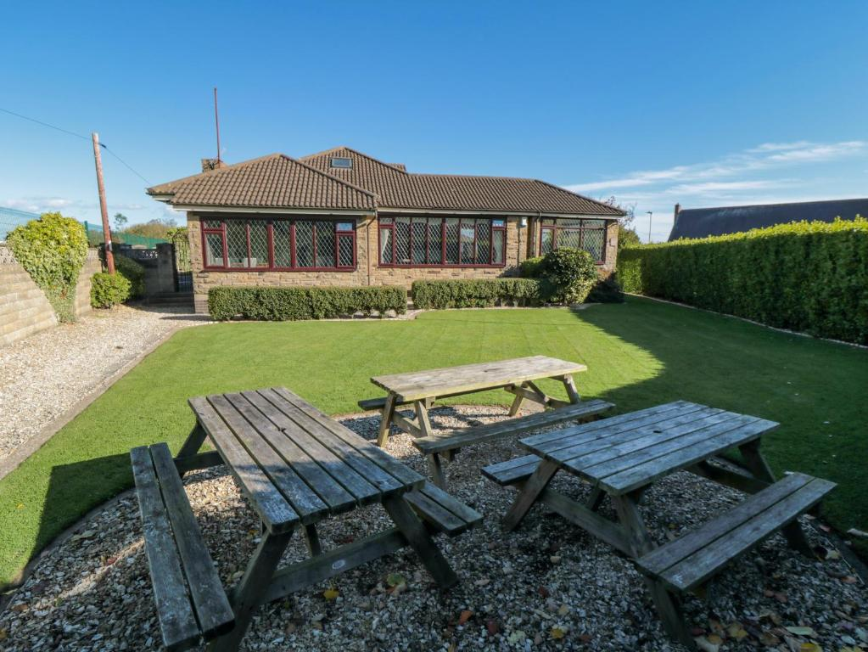
Figure 1: Seacrest Lodge View

Scope and Objectives
The following objectives have been met in this research:
- To analyze the Seacrest Lodge’s financial performance over the past three years
- To identify the key reasons behind the decline in profitability, taking into consideration, real-world events and the current economy
- To develop a comprehensive turnaround strategy to revitalize the lodge’s financial health and restore its reputation as a premier vacation destination or most viable financial outcomes.

The Seacrest Lodge, Income Statement and Balance Sheet

Financial Performance of the Seacrest Lodge(2021-2023)
The financial performance of the Seacrest Lodge for the periods 2021 to 2023 has been measured in this section using Ratio Analysis (see Appendix 1 for calculations) (Sueyoshi, 2005; Beaver & Ryan, 2000; Seal, 2019).
Return on Capital Employed (ROCE): Unfortunately, the ROCE of the Seacrest Lodge in 2021 was 48% that remained highly impressive by showing its robust profitability, but it decreased in 2022 to 25%. In the year 2023, it further decreased to -50%. Simply, it reflected the negative return on capital employed to the resort due to lack of cash in hand. However, to understand the root causes behind this decline warrants in-depth assessment(Andersson, et al., 2006).
Net Profit Margin: The calculations for the Seacrest Lodge in Appendix 1 show its net profit margin in the year 2021 was 25%, which indicates its efficient profitability. Conversely, it substantially decreased in the year 2022 (with a contracting margin 13%) and in 2023 (a negative net profit of -15%), which reflected a decreasing ability of the lodge to convert its revenue into profit. This situation requires the business to focus on current trends and demands a nuanced assessment regarding influencing factors.
Ratio’s and financial activity
Current Ratio: The calculation of the current ratio for the Seacrest Lodge shows a continuous decline. For instance, the current ratio in the year 2021 was 1.40. However, in the year 2022, it became 1.37 and in the year 2023, it became 1.19. It indicates the lodge cannot meet short-term obligations and alarms the movement of the business towards lack of efficient management of working capital in the given period. This declining current ratio can further cause delays in receivables, persistent increase in short-term liabilities, etc(Almeida, et al., 2004). However, successfully addressing the issues can lead the resort to enhance its short-term financial health, meet its obligations promptly, and sustainably manage working capital through an improved collection cycles and optimised inventory levels that will fortify its overall financial resilience.
Quick Ratio: The quick ratio of the Seacrest Lodge was 0.09 in 2021, 0.07 in 2022, and 0.03 in 2023. This persistent decrease depicted a gradual decrease in the ability of the lodge to respond quickly to the economic issues/environmental changes in a very short time. It is underscoring the resort’s potential vulnerabilities to manage short-term liquidity(Hovakimian & Hovakimian, 2009). To address this trend quickly, the business needs a detailed examination and identification of contributing factors like composition of current assets and liabilities. Moreover, implementation of effective actions like efficient receivables management and/or strategic reduction of short-term debt can enhance liquidity of the lodge.
Asset Turnover Ratio: The asset turnover ratio of the lodge has been decreasing continuously, as it was 0.55 in the year 2021, 0.518 in the year 2022, and 0.513 in the year 2023(Gaur, et al., 2005). It depicts the business is not efficiently utilising its assets to generate revenue. However, it is observed that this reduction has been mainly derived from the decreasing sales revenues of the resort. Resultantly, the resort’ assets became less productive to generate sales and lead to a lower Asset Turnover Ratio. Further investigation is required in this area to know whether strategic asset management and optimization can be effective actions to overcome this issue or not.
Gearing Ratio: The gearing ratio of the Seacrest Lodge is increasing (it was 70 in the year 2021, 72 in the year 2022, and 83 in the year 2023). It indicates a continuous increase in its debt proportion in the capital structure, which is a big financial risk. This increase is seen because of the increasing borrowing. To resolve the issue, further investigation regarding contributing factors like liquidity needs and acquisition is warranted.

Key Reasons behind Diminished Profitability of The Seacrest Lodge (2021-2023)
The given case study projects that market analysis carried out in the relevant context show high competitiveness, changing customer preferences, and negative customer reviews (see Appendix 2 and also discussed earlier) are key causes. However, individual research carried out on the Seacrest Lodge and its financial performance evaluation indicated the following key reason for its decline in profitability:
Price Wars due to Competition: The financial data indicates a drop in occupancy rates from 2021 to 2023. The decline went from 65% to 50%, which indicates a mismatch between the pricing of the services and their perceived value. The lodge also faced a declining trend in its Average Room Rates (ARR) from 2021 to 2023, which reduced from £260 to £210. It happened due to the increasing, which eventually intensified the price wars in the market (Kim et al., 2021). In other words, lodge’ room rates were relatively high as compared to other competitors in the same industry, which affected its sales. Herein, the Demand Model or Law of Demand can be applied, according to which prices are adversely related to the demands (ultimately sales and profits). More specifically, the law states consumers desire to buy and willing to pay as less as possible; therefore, if the prices of a product/service is high, they demand less and vice versa. Similarly, in the concerned case of the resort, the room rates remained high and moved from P1 to P2 and then P3 during the given period. Eventually, tourists started demanding less service and resultantly quantity demanded (room services reduced from Q1 to Q2, and Q3, respectively) (show in the following Graph). Although it was a signal for the lodge to deal with the potential challenges by adopting an effective pricing strategy but the business failed and could not survive the external pressures. It exerted a negative impact on the revenues of the Seacrest Lodge by reducing its ability to maintain a higher room rate, as compared to other hotels.
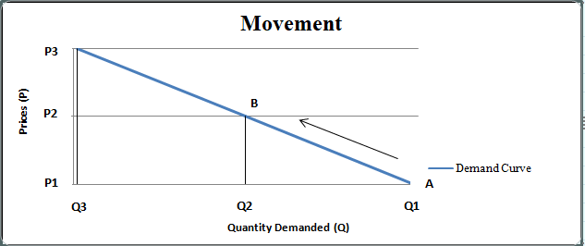
Figure 2: Law of Demand for the Seacrest Lodge

Turnaround Strategy for Financial Revitalisation of the Seacrest Lodge

Hybrid Strategy: Financial Planning and Low-cost/price strategies
Usually when large businesses face financial decline over time due to increasing competition in the vicinity, pricing issues, and other ineffective decisions of the responsible bodies; it becomes difficult for them to deal with the situation (Bibeault, 1998). In this case, most of the corporations are involved in adopting a turnaround strategy, which is a broad plan used for enterprises facing financial intricacies, loss, etc. This strategic plan allows businesses to bring improvements in their existing approaches and possible changes that can be productive for revitalising their operations and restoring profitability in a short span (Lohrke et al., 2004). In simple terms, turnaround strategies shake up organisational operations and lead firms to reverse their financial status through a fast rapid.
The positive result of a turnaround strategy has been seen in the case of a multinational corporation (Apple) (AI bees, 2023). Although Apple has always been the No.1 business in the technology sector but has faced several financial problems at different times. However, in every situation of financial instability, the management authorities of Apple employed a turnaround strategy. One of the cases was seen in the year 1985 when its CEO (Steve Jobs) left the corporation and the business experienced a sharp drop in its profitability(Dudovskiy, 2014; AI bees, 2023). To overcome this issue, the responsible authorities followed a lower-cost-based turnaround strategy when it reduced the prices of several products from its competitors (i.e. Microsoft Windows) and eventually soon Apple took over the personal computer market and came back to the top-ranking companies. Still, the business is inclined towards adopting a differentiation strategy for keeping its products (iPhone and iPad) designs unique and stylish that make customers happy and willing to pay for premium categories (see Appendix 3) (AI bees, 2023). A similar approach has been seen in the past when several businesses (named Netflix, and Tesla Motors) adopted turnaround strategies and their comebacks wrote their success stories (AI bees, 2023).
Thus, the comprehensive turnaround strategy (based on different zones of the strategy clock and three generic strategies) that can be used by the Seacrest Lodge is a Hybrid strategy that combines both Financial Planning and Low-cost/price strategies (Cost Leadership Lower cost/Focused Low-cost). This strategy allows using the following approaches depending on the needs and resolving the risk (financial risk) of the business:

Cost Efficiency Strategies
Dynamic Pricing Scheme:Since there has been a continuous decline in the Average Room Rate (ARR) of the business over the past three years, it suggests that Seacrest Lodge needs to mainly implement a more strategic pricing scheme, which balances both affordability and perceived value.At this level, the business must implement a dynamic pricing strategy that considers different factors such as seasonal trends, demand fluctuations, rivals’ pricing approach, etc. In this regard, the company may utilise data analytics, which assists in identifying optimal pricing points for profit maximisation and ensuring high occupancy rates. Simply, after in-depth research, the business must reduce its prices to stay competitive and demanding in the market.

Financial Planning
Investment in Marketing and Online Presence for Re-branding: To regain the corporate reputation of the lodge as a premier vacation destination, there is a need to revitalise through effective and attractive marketing. For this, the business is suggested to develop a robust digital marketing strategy, consisting of social media campaigns on social media platforms (like Facebook, Instagram, LinkedIn, etc), SEO optimisation, and online advertising. The business should also display its renovated amenities, positive feedback on customer experiences, and special promotions to regenerate the interest of travellers, get, and attract new guests.

Conclusion
The report concludes that the financial performance of the Seacrest Lodge is very unstable, as the resort did not make profits during the period 2021-2023. At the same time, the resort faced a huge decline in its occupancy rates, ARR, ROCE, and many other financial ratios. The key reason behind this financial instability is price wars due to high competition. To mitigate this issue and financially grow, the resort is suggested to apply a turnaround strategy consisting of specific approaches/tactics including a dynamic pricing scheme and investment in marketing and online presence.

Reference List
AI bees, 2023. Best Business Comebacks: Turnaround Stories That Inspire. [Online] Available at: https://www.ai-bees.io/post/best-business-turnaround-and-comeback-stories#:~:text=%E2%80%8DApple,over%20the%20personal%20computer%20market. [Accessed 14th February 2024].
Almeida, H., Campello, M. & Weisbach, M.S., 2004. The cash flow sensitivity of cash. The Journal of Finance , 59(4), pp.1777-804.
Andersson, T., Haslam, C. & Lee, E., 2006. Financialized accounts: Restructuring and return on capital employed in the S&P 500. In Accounting Forum, 30(1), pp.21-41.
Beaver, W.H. & Ryan, S.G., 2000. Biases and lags in book value and their effects on the ability of the book-to-market ratio to predict book return on equity. Journal of accounting research , 38(1), pp.127-48.
Bibeault, D.B., 1998. Corporate turnaround: How managers turn losers into winners! Beard Books.
Dudovskiy, J., 2014. Business Turnaround Strategies used in Apple by Tim Cook. [Online] Available at: https://research-methodology.net/business-turnaround-strategies-used-in-apple/ [Accessed 14th February 2924].
Expedia, Inc., 2024. Reviews of Sea Crest Resort. [Online] Available at: https://www.expedia.com/Myrtle-Beach-Hotels-Sea-Crest-Oceanfront-Resort.h893738.Hotel-Reviews [Accessed 14th February 2024].
Gaur, V., Fisher, M.L. & Raman, A., 2005. An econometric analysis of inventory turnover performance in retail services. Management science , 51(2), pp.181-94.
Hovakimian, A. & Hovakimian, G., 2009. Cash flow sensitivity of investment. European Financial Management , 15(1), pp.47-65.
Kim, J. et al., 2021. The impact of the COVID-19 threat on the preference for high versus low quality/price options. Journal of Hospitality Marketing & Management , 30(6), pp.699-716.
Lohrke, F.T., Bedeian, A.G. & Palmer, T.B., 2004. The role of top management teams in formulating and implementing turnaround strategies: a review and research agenda. International Journal of Management Reviews , 5(2), pp.63-90.
Seal, W., 2019. Management Accounting. 6th ed. London: McGraw-Hill Education.
Sueyoshi, T., 2005. Financial ratio analysis of the electric power industry. Asia-Pacific Journal of Operational Research , 22(3), pp.349-76.
Tripadvisor, 2023. Sea Crest Resort. [Online] Available at: https://www.tripadvisor.com/ShowUserReviews-g54359-d247994-r466180870-Sea_Crest_Oceanfront_Resort-Myrtle_Beach_South_Carolina.html [Accessed 14th February 2024].

Appendices

Appendix 1
Table 1: Ratio Analysis for the Seacrest Lodge (2021-2023)
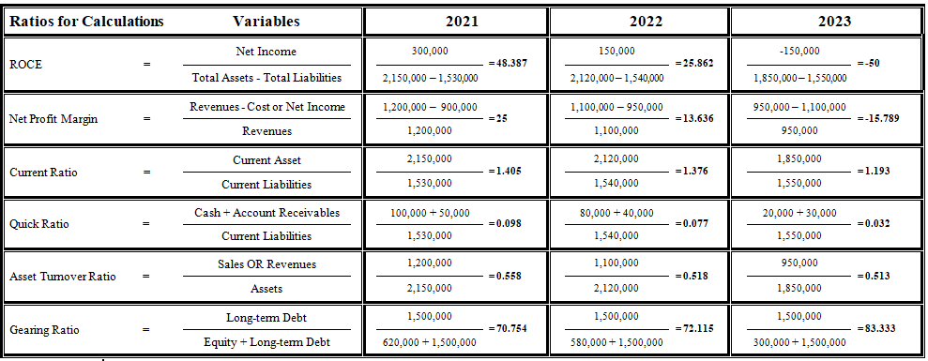
Table 2: Rates Provided in the Case Study


Appendix 2
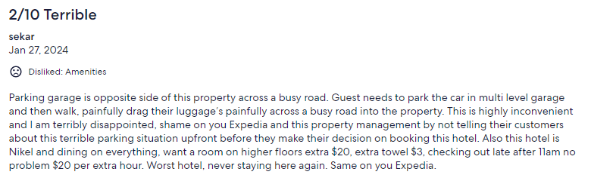
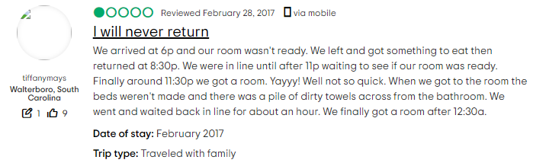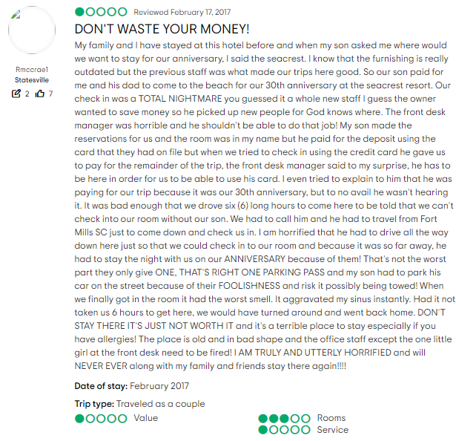
Figure 3: Negative Reviews of Customers (Tripadvisor, 2023; Expedia, Inc., 2024)

Appendix 3
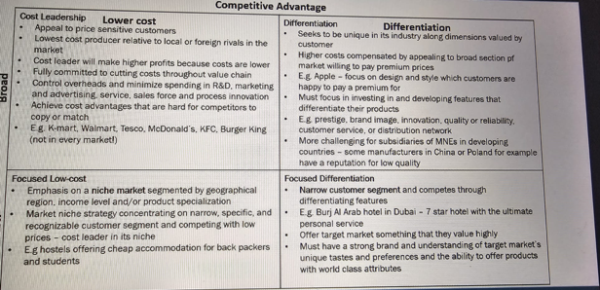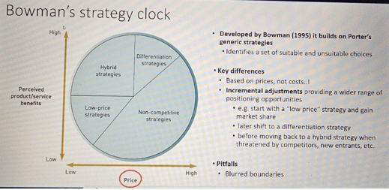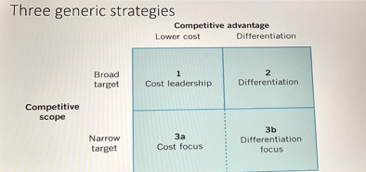
Figure 4: Turnaround Strategies (AI bees, 2023)

