Kallum Doyle
2237962
Applied Computing
Due 19/4/2024
Operating Systems
Computer Architecture and Operating Systems

Contents
Introduction Page 3
Key functions of general Operating Systems 4
Functionalities Overview 4
Hardware Management 4
Process Management 5
Memory Management: 6
Peripheral Management 7
Computer Security Management 8
Use of Windows OS CLI commands 9
dir 9
cls 10
mkdir 11
del 12
copy 13
write-output 13
tasklist 14
Get-Service 15
systeminfo 16
Type 16
date 16
Use of Linux OS CLI commands 17
cd 17
mkdir 17
man 17
ls 18
grep 18
rmdir 19
which 19
useradd 19
groupadd 20
usermod 20
chmod 20
Use of Windows OS scripts 22
Description 22
Code 24
Use of Linux OS scripts 28
Description 28
Code 30
Conclusion 33
Reference List 34
Appendices 36
Tutorial 1 36
Course Engagement 36
Course Link 36
Achievement Link 36
Evidence 37

Introduction Page
This report aims to demonstrate the key capabilities of multiple types of operating systems, such as the various types of management activities it enacts such as hardware and security management. Additionally, the report demonstrates various CLI commands a user can use to interact with their system in Bash and Batch/PowerShell that assist the user. These can be commands that enable the user to change where they are in the file system from the terminal or to view the running processes on the system. The demonstration consists of both images and text to show how PowerShell and Bash scripts can be utilized to assist users in tasks such as generating a secure password.

Key functions of general Operating Systems

Functionalities Overview
An operating system has a multitude of important functions it undertakes. Some of these functions include managing the host computers: [1]
- Hardware,
- Processes,
- Memory,
- Peripheral devices,
- Security

Hardware Management
[2] The operating system acts as a middleman between the user and the computer hardware. It communicates with computer components such as the “CPU, memory, storage devices” and peripherals. By communicating with all these components, the computer can perform various tasks such as running applications. The user can manage the hardware on Windows by using [21] the device manager. The application can be used to configure hardware devices and manage drivers appropriately, such as updating the driver for a hardware device.
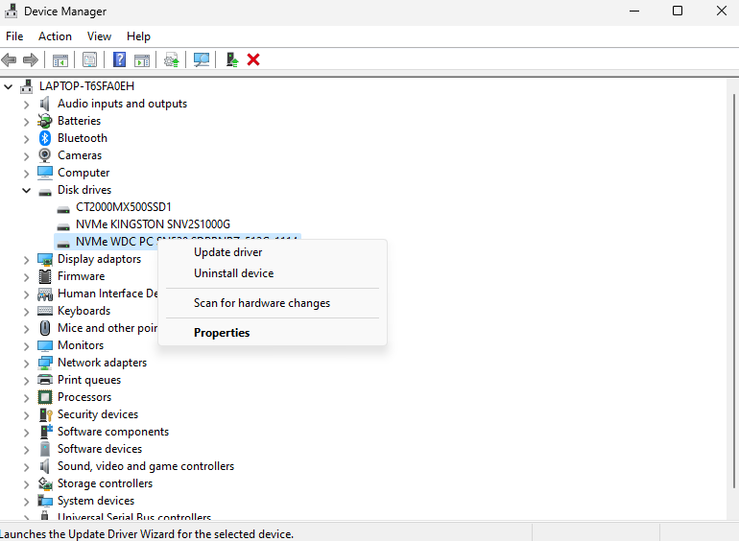

Process Management
Process management is [3] the management of entities that require system resources such as memory or CPU time. There are various tools that the operating system provides for the user to manage these processes. This includes providing facilities for monitoring the processes, the ability to reduce the priority of processes to reduce resource usage for certain processes and the ability to terminate processes. For example [4] you can change the priority of a process by opening task manager (ctrl + shift + escape), and right clicking on a process, then go to the details tab.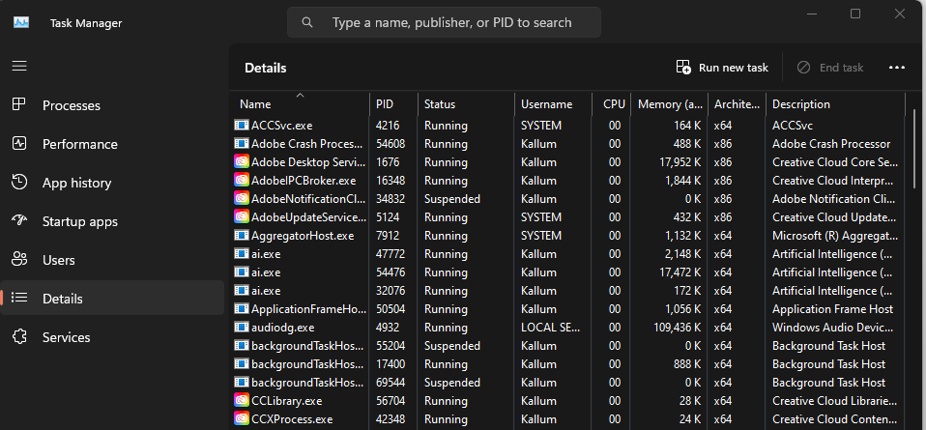
Once you are on the details tab, you can right click on a process, hover over set priority, and change to your desired level.

Memory Management:
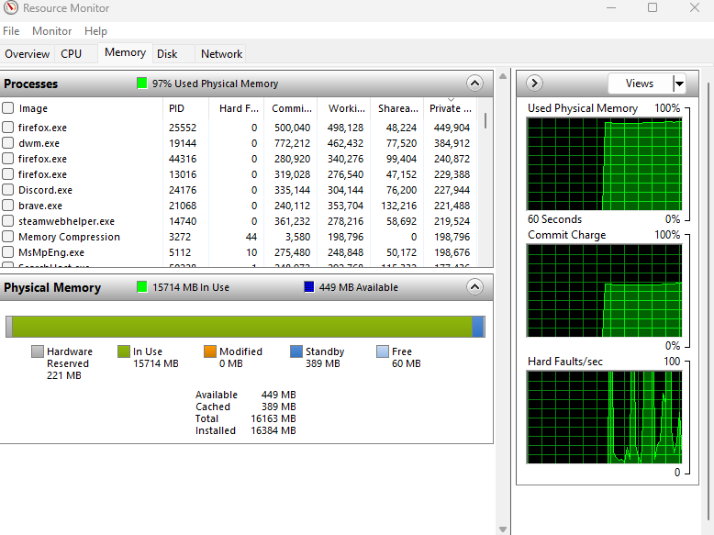
For a computer to be able to run multiple programs, [5] an operating system must be present with the capability of managing the systems memory. The operating system manages the system memory by dividing the available memory in terms of the required amount itself requires, and the amount the other processes requires. It allocates itself all the required amount of memory it needs to perform its tasks, before dividing the remaining memory amongst all the processes running on the system. Particularly, [20] resource monitor can be used to monitor the number of resources each process is using.

Peripheral Management
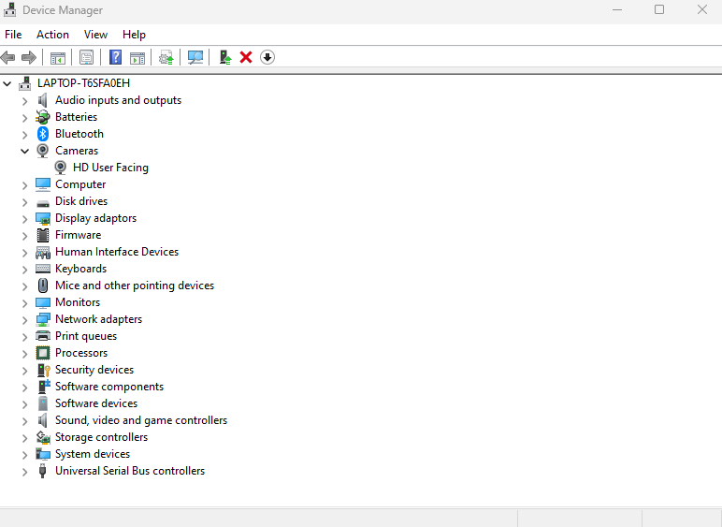
Modern operating systems maintain the task of [6] enabling communication between external devices and the system such as input/output devices like a mouse or a keyboard. The operating system will monitor all devices connected to the computer via the I/O controller. It will additionally monitor the statuses of all peripherals and controls the access each process gets to the peripheral. The operating system will also enable the user to disable any connected peripherals, this can be done on windows by pressing [7] Windows + X to open the device manager.

You can then right click on a device such as the camera and select disable device. This will prevent the device from working until you enable it again.

Computer Security Management
It is critical that an operating system is designed with [8] security and privacy in consideration. An operating system such as Windows provides various forms of security, such as protecting your system from the startup by ensuring the [9] firmware and kernel is digitally signed. It will also provide protection against viruses with built in software such as Microsoft Defender Antivirus, which monitors the computer for viruses regularly, alongside providing security when communicating over networks with various protocols such as TLS and provides facilities for encrypting stored data like BitLocker.
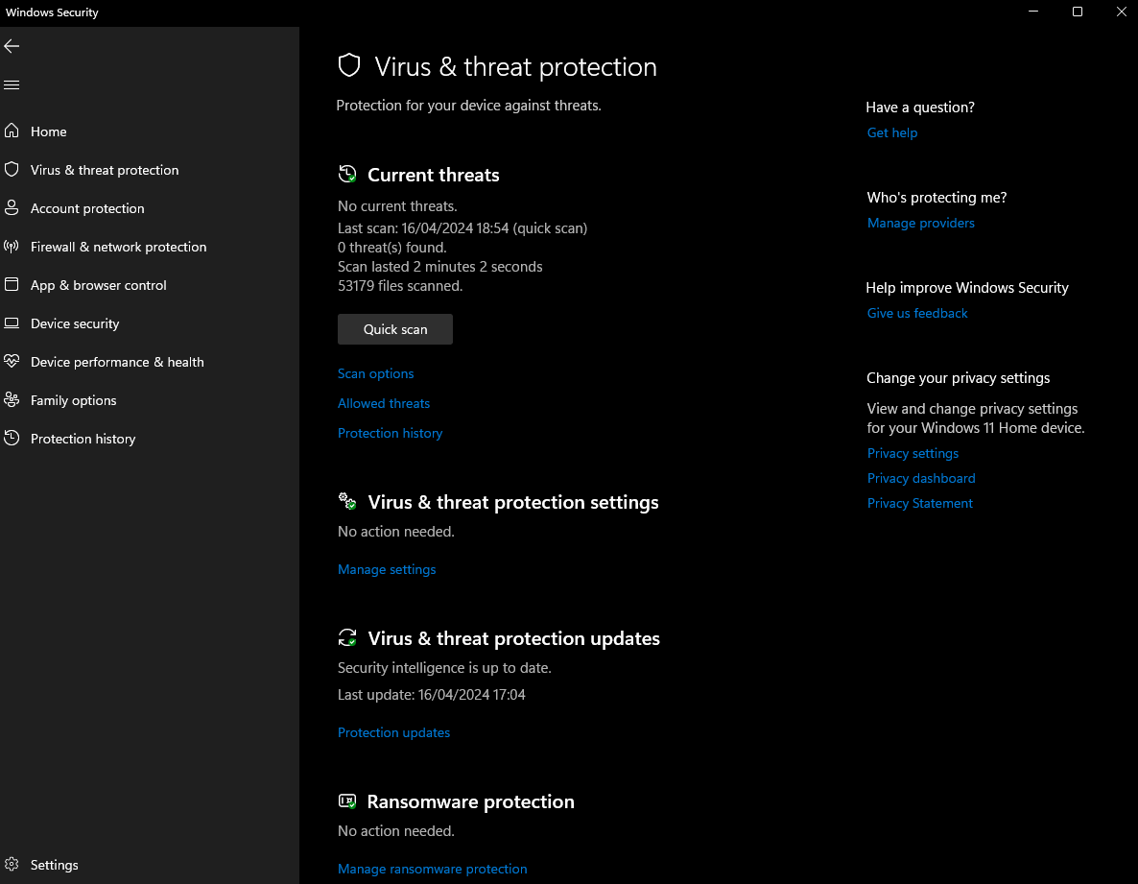

Use of Windows OS CLI commands

dir
[10] The dir command will display all the contents within a directory. It can be used without parameters to display the contents of the current directory, or with parameters for any available directory.
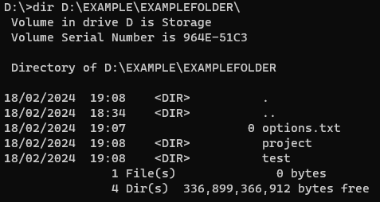
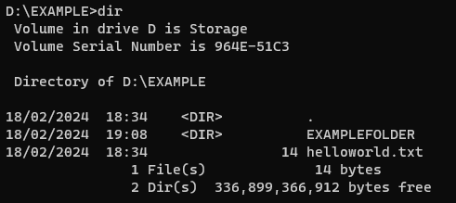
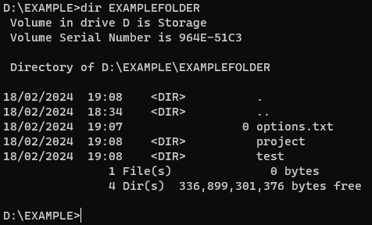

cls
The [10] cls command will clear the result of any previous commands displayed in the command prompt window.
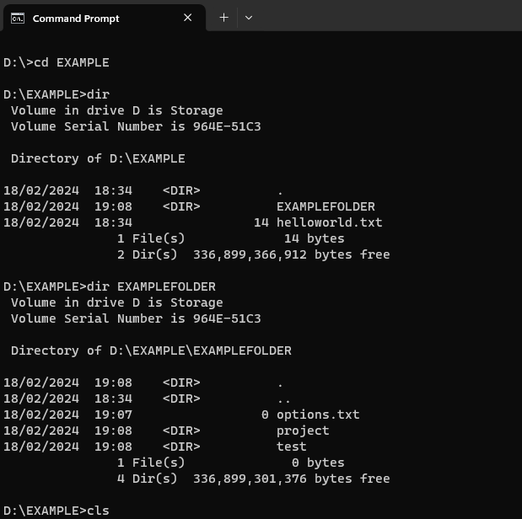
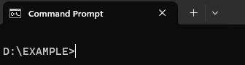

mkdir
mkdir is used [10] to create a directory or subdirectory in a specified directory or in the current directory. It can be created in a specific directory by adding the destination path to the end of the command, or in the current directory by specifying no path.
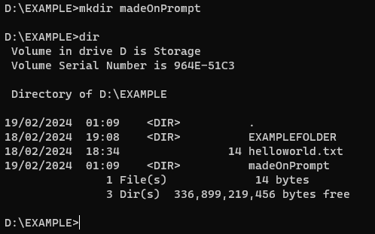
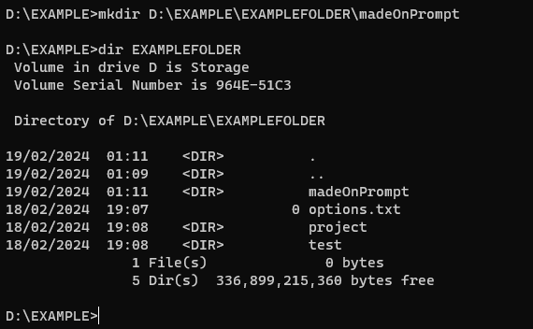

del
Del is used [10] for deleting files. It can be used to delete all files within a directory by specifying the directory. Parameters such as /f can be used to force delete read-only files.
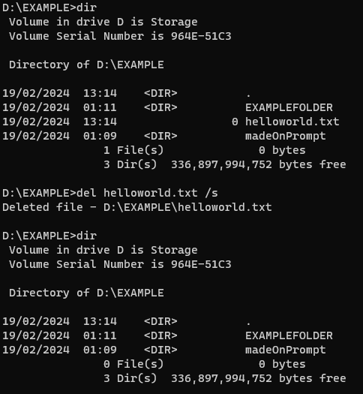

copy
Copy is used for [10] copying files from a source directory to a destination directory. Parameters can be used, one being /y which confirms if the file exists in the destination already it should be overwritten.
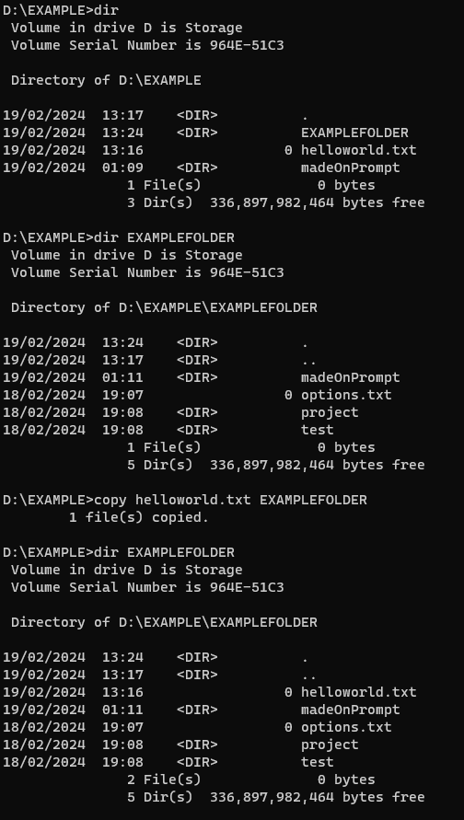

write-output
Write-output is used for [11] displaying an object to the user. This object can be a predefined value stored in the computer’s memory (e.g. The user that’s signed in) or a value passed at runtime.
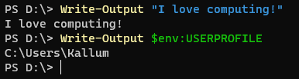

tasklist
Tasklist [12] displays all running processes, along with their memory usage and process ID. It is possible to filter by certain conditions by using /FI in the parameters, such as memory usage > 80,000 KB.
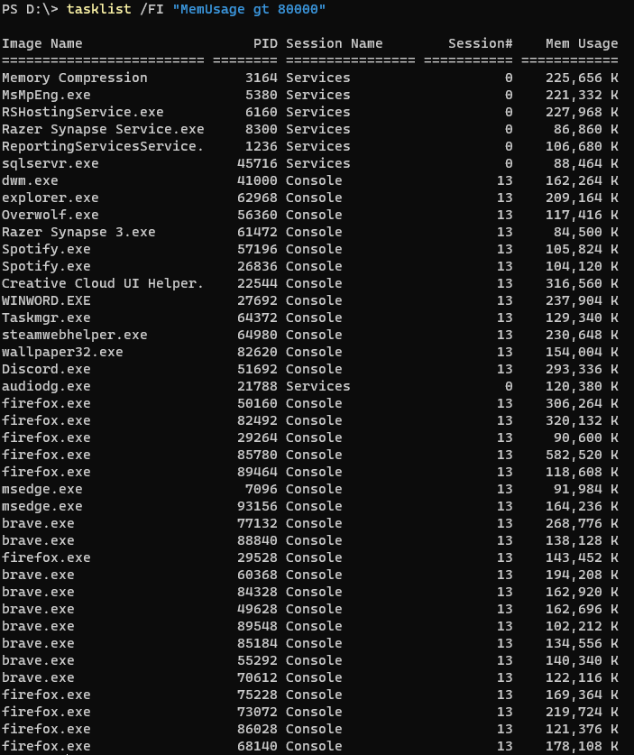

Get-Service
[11] Get-Service can be used to retrieve one or more or all services running and not running. Specific services can be found by passing a service name as a parameter, with or without a wildcard.
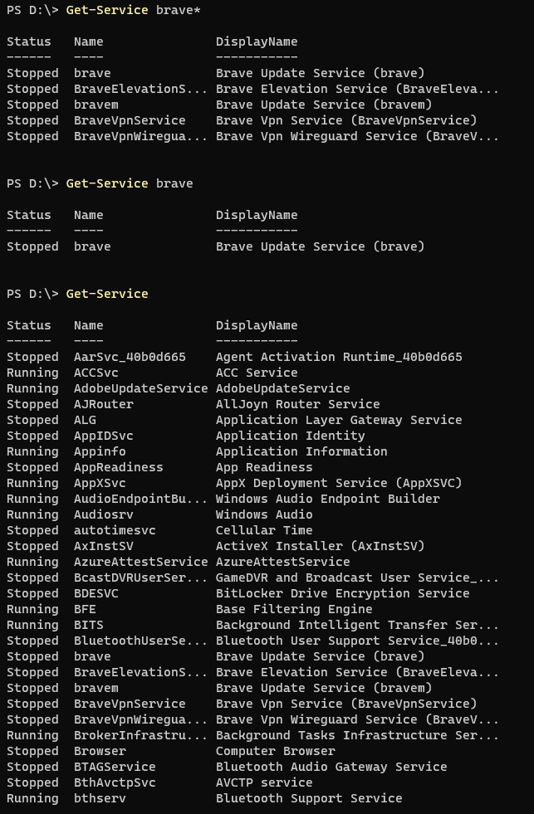

systeminfo
[10] Systeminfo displays a multitude of useful information regarding the host system, such as the operating system, the physical memory, network configurations, and more.
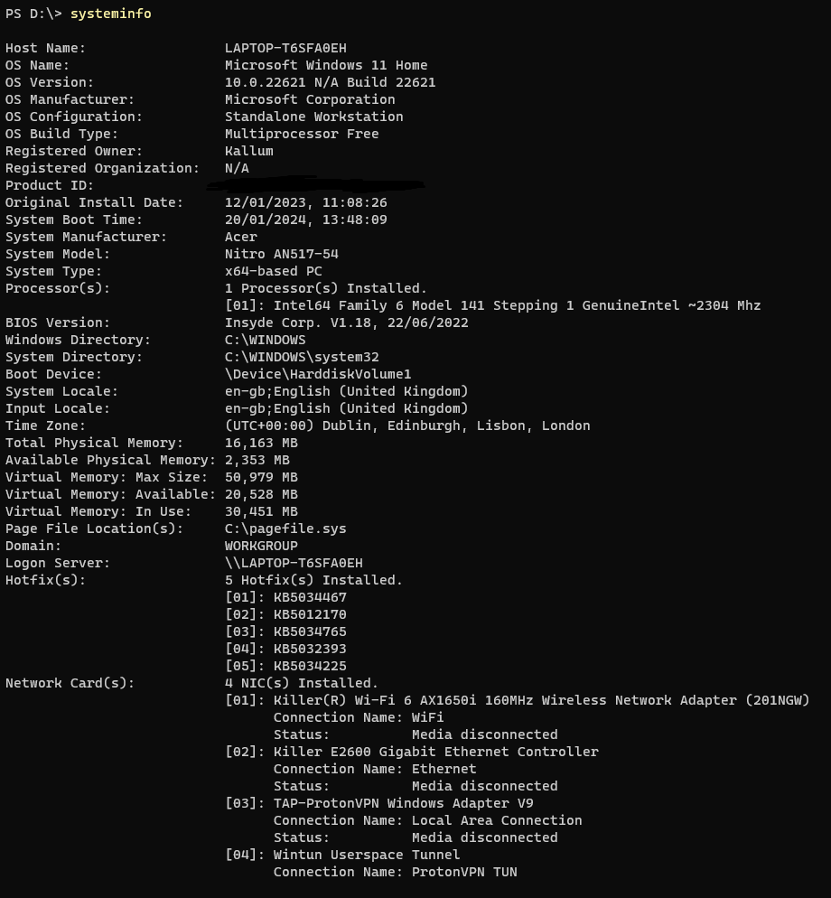

Type
[13] The type command presents a read only display of the text stored within a text file.
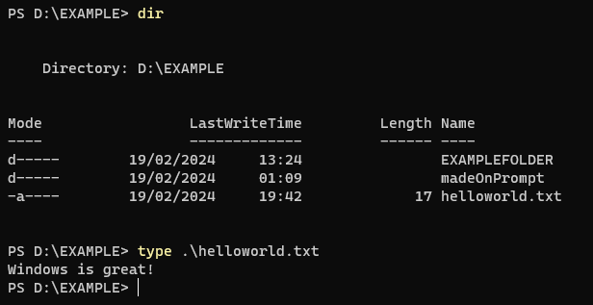

date
[10] The date command allows the user to display or set the system’s date. The date can be changed by entering the desired date in a month-day-year format as a parameter.

Use of Linux OS CLI commands

cd
[14] The cd command (short for change directory) is used for changing the directory the user is currently in. Users can use this command with either relative or absolute paths to change directory.
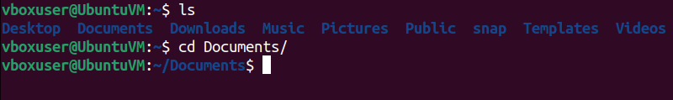

mkdir
[14] mkdir allows the user to create one or more directories using an absolute or relative path. These directories can either be nested or reside beside each other in a directory. Nested can be made by providing -p in the parameters.
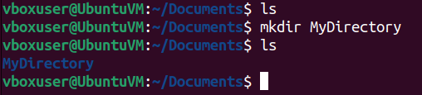
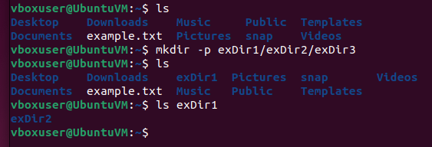

man
[15] The man command is useful for identifying the complete workings of a command. It gives a summary of what the command does and shows any optional arguments it takes.
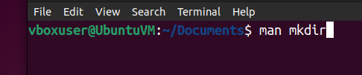
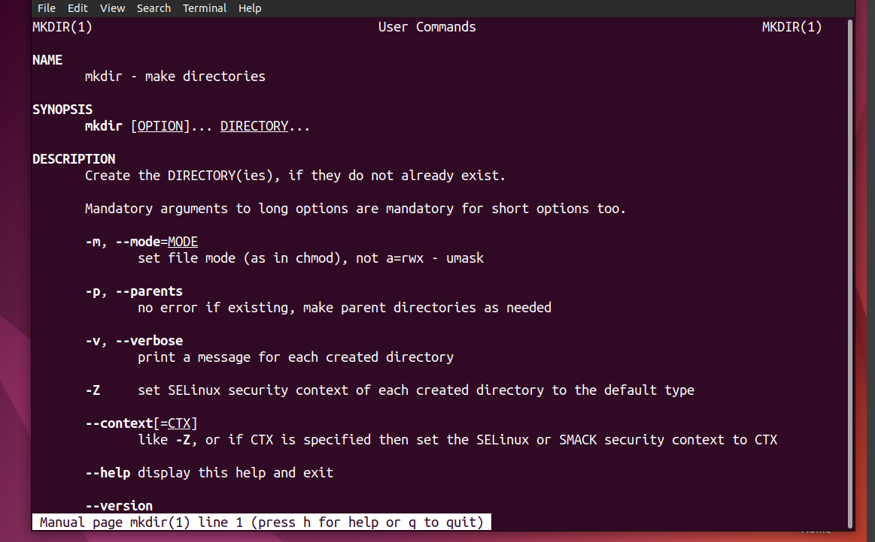

ls
[15] ls is used in order to identify what files/folders are within the directory the user is currently in or any other directory. -a can be used to also show files beginning with “.”.
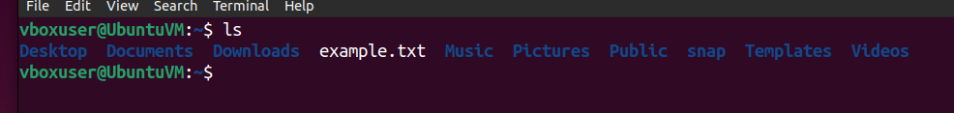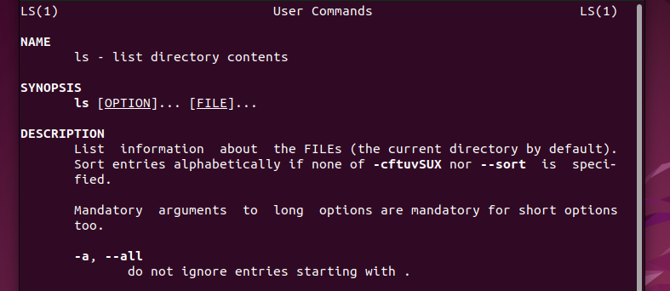

grep
[15] grep is used to search for specific text within readable files. In a text file for example, you can use grep to discover whether or not it contains ‘comp’.
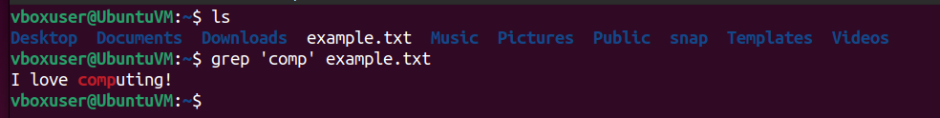

rmdir
[15] The rmdir command is useful for removing directories containing no data. The counterpart being rm, which will remove specified directories regardless of data stored. Using -p as an option will delete any empty parent directories additionally.
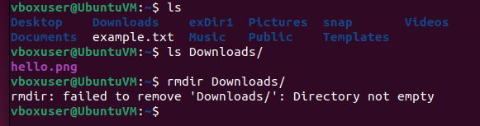
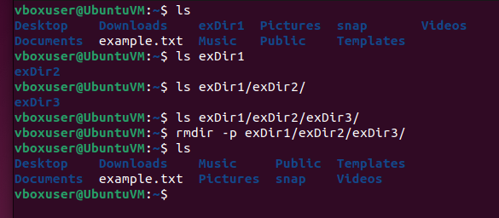

which
[16] The which command is useful for identifying the location of an executable, such as a web browser or other application.
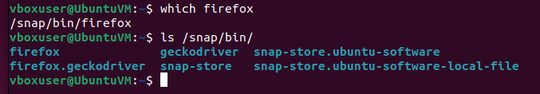

useradd
[17] Useradd is a command used to make a new user. The user does not have their own directory by default and the -m option must be used to create a directory for the user.
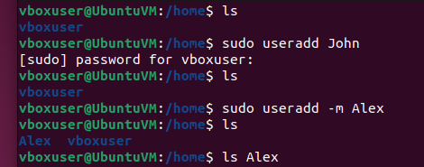

groupadd
[18] “In Linux, groups are collections of users.”. A group can be created with the groupadd command. Groups are useful when multiple users use the system and require different levels of permissions.
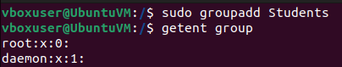
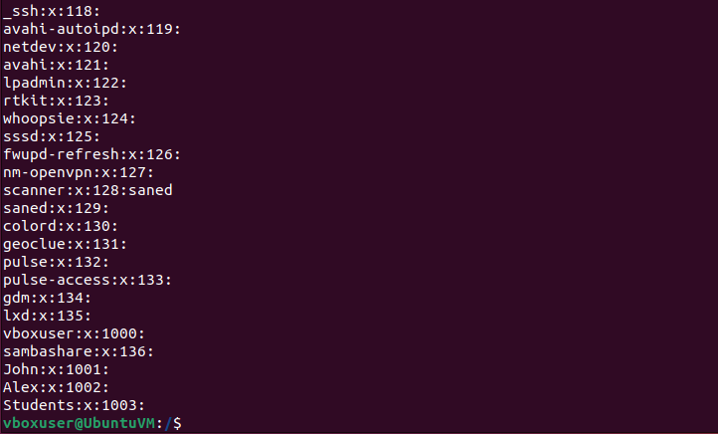

usermod
[18] A user can be added to a group by utilizing the usermod command. A user can belong to multiple different groups but may only have one primary group.
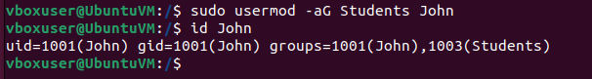

chmod
[19] To modify who can access a specified file, the chmod command can be used to change the access a user has to a file and the level of access.
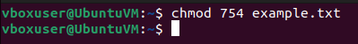
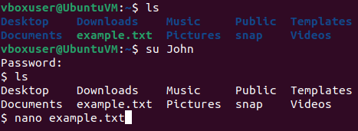
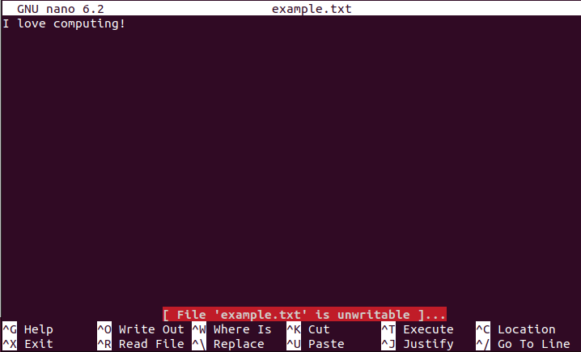

Use of Windows OS scripts

Description
The purpose of the script is to create a template for simple front-end web development [23], which consists of three languages:
- HTML
- CSS
- JavaScript
The script creates one folder and one file for each respective language, to ensure the programmer has an organized start to their web project. The script also allows the creation of one additional folder to store the project within if the user desires. It will validate the user inputs to ensure system paths are correct/existing and folder names are valid.
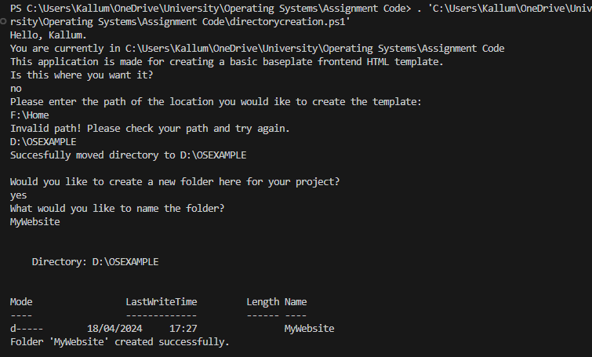
The PowerShell script utilizes PowerShell’s Object-Orientated Programming capabilities [22] through the usage of classes, which are objects that contain specific properties and functions to modify the object. In this instance, classes represent functions required to manipulate the directory the user is working in, alongside storing, and creating files of various types. The directory class is purely used for updating and changing the directory, while the FileType class stores information regarding a file name (e.g. index), file extension (e.g. .html) and file type name (e.g. HTML), alongside creating the file.
It also utilizes multiple loops, such as [24] a while loop, do-until loop, and foreach loop. The while and do-until loops are practically identical in terms of functionality, only differing slightly in syntax. In the script, they are used for testing and validating user input, they stop the code from executing any further until a valid input from the user is identified. Whereas the foreach loop is used for looping through arrays of objects to print out what files/folders will be created for the user, alongside actually using the object array to create the files and folders at the end of the program.
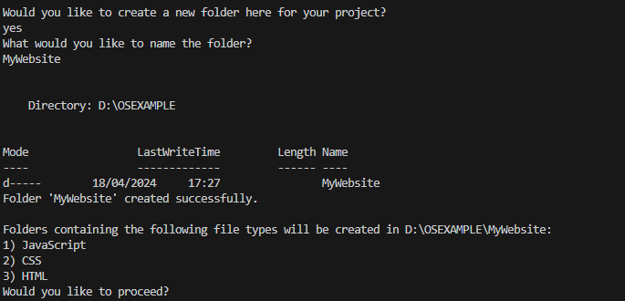
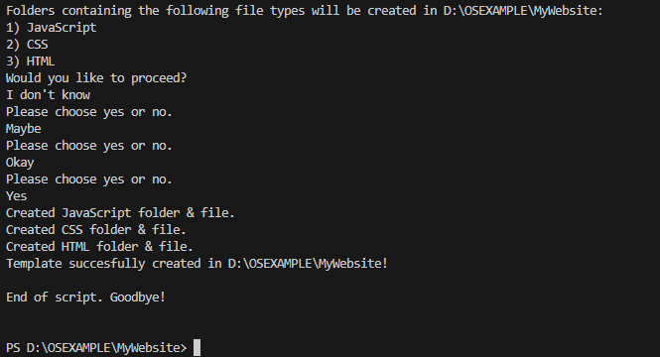
Additionally, the script makes use of [25] if, else and else if statements to identify whether the user would like to continue at multiple points throughout the script and to test whether a path is valid. This is showcased when ensuring the user responds yes or no to a new folder being created. An if and else if statement exists for yes or no, but if neither is chosen, the else statement causes the code to repeat.

Code
class Directory {
[string] UpdateDirectory() {
while ($true) {
$userinput = Read-Host
if (Test-Path -Path $userinput) {
Set-Location -Path $userinput
break
}
else {
Write-Host "Invalid path! Please check your path and try again."
}
}
return "Updated"
}
[string] ChangeDirectoryQuestion () {
while ($true) {
$userinput = Read-Host
switch ($userinput) {
"Yes" { return "Yes" }
"No" { return "No" }
Default {
Write-Host "Please choose 'Yes' or 'No'."
}
}
}
break
}
}
class FileType {
[string] $FileName
[string] $FileExtension
[string] $FileTypeName

FileType([string] $Name, [string] $Extension, [string] $TypeName) {
$this.FileName = $Name
$this.FileExtension = $Extension
$this.FileTypeName = $TypeName
}

[string] CreateSet() {
Start-Transaction
try {
$typeDirectory = New-Item -Path $PWD -Name $this.FileTypeName -ItemType Directory -ErrorAction Stop
$fileFullPath = Join-Path -Path $typeDirectory.FullName -ChildPath "$($this.FileName)$($this.FileExtension)"
New-Item -Path $fileFullPath -ItemType File | Out-Null
return "Created $($this.FileTypeName) folder & file."
Complete-Transaction
}
catch {
Undo-Transaction
throw "Error occurred while creating file and directory: $_"
}
}
}
function StartingText {
Write-Output "Hello, $Env:USERNAME."
Start-Sleep -Seconds 1
Write-Output "You are currently in $PWD"
"This application is made for creating a basic baseplate frontend HTML template.
Is this where you want it?"
}
function BreakAndWait ([int32] $time) {
Start-Sleep -Seconds $time
Write-Output ""
}

# Entry point
if (-Not(Test-Path -Path $pwd)) {
Write-Output "Please change directory location and try again."
exit
}

StartingText

$dir = [Directory]::new()
if ($dir.ChangeDirectoryQuestion() -eq "No") {
Write-Output "Please enter the path of the location you would like to create the template: "
if ($dir.UpdateDirectory() -eq "Updated") {
Write-Output "Successfully moved directory to $PWD"
}
}

$invalidNames = @(
"CON"
"PRN"
"AUX"
"NUL"
)
BreakAndWait(1)
do {
Write-Output "Would you like to create a new folder here for your project?"
$folderCreate = Read-Host
Start-Sleep -Seconds 1

if ($folderCreate -eq "Yes") {
Write-Output "What would you like to name the folder?"
$nonReservedName = $true
$folderName = Read-Host
foreach ($name in $invalidNames) {
if ($folderName -eq $name) {
$nonReservedName = $false
Write-Output "That folder name is reserved. Please try with a different name."
break
}
}
if ($nonReservedName) {
if ($folderName -like "*/*" -or
$folderName -like "*\*" -or
$folderName.ToUpper() -like "COM?" -or
$folderName.ToUpper() -like "LPT?" -or
$folderName[0] -eq "/" -or
$folderName[0] -eq "\") {
Write-Output "Invalid file name. Please try again!"
}
else {
try {
New-Item -Path $PWD -Name $folderName -ItemType Directory -ErrorAction Stop
Set-Location -Path $folderName
Write-Output "Folder '$folderName' created successfully."
break
}
catch {
Write-Output "Invalid file name! Please try again!"
}
}
}
}

elseif ($folderCreate -eq "No") {
Write-Output "A folder will not be created."
}
else {
Write-Output "Please choose either yes or no."
}
} until ($folderCreate -eq "No")

$arrayFiles = @(
[FileType]::new("app", ".js", "JavaScript"),
[FileType]::new("styles", ".css", "CSS"),
[FileType]::new("index", ".html", "HTML")
)

BreakAndWait(1)
Write-Output "Folders containing the following file types will be created in $($PWD):"
$x = 1
foreach ($file in $arrayFiles) {
Start-Sleep -Milliseconds 500
Write-Output "$($x)) $($file.FileTypeName)"
$x ++
}

Start-Sleep -Milliseconds 500
Write-Output "Would you like to proceed?"
while ($true) {
$proceedChoice = Read-Host
Start-Sleep -Seconds 1
if ($proceedChoice -eq "Yes") {
try {
foreach ($file in $arrayFiles) {
$file.CreateSet()
Start-Sleep -Milliseconds 750
}
Write-Output "Template successfully created in $PWD!"
BreakAndWait(1)
Write-Output "End of script. Goodbye!"
break
}
catch {
Write-Output "An error occurred: $($_.Exception.Message)"
Write-Output "Exiting programme. Please retry."
break
}
}
elseif ($proceedChoice -eq "No") {
Write-Output "Template will not be created. Goodbye."
break
}
else {
Write-Output "Please choose yes or no."
}
}

Use of Linux OS scripts

Description
The purpose of this bash script is to generate a password for a user of a specified length. When the script is first run, the user is presented with a welcoming message, prompting for input regarding whether the code should continue:
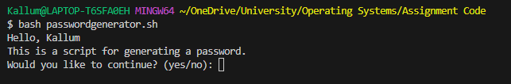
The script utilizes a function to do this, [26] which minimises repetitive code in the program. The function resolves around retrieving an input before testing the input in a [27] case statement to identify whether the user has chosen yes or no or something else. Case statements are useful when dealing with code where numerous inputs are possible. Ultimately, they can make code easier to understand.
The code will continue if either yes or no is chosen, otherwise, it will repeat prompting the user to enter a valid option as the code is under a while loop. If the user chooses no, the program will exit.
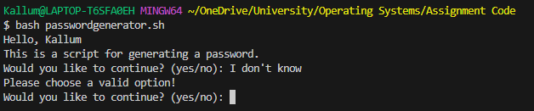
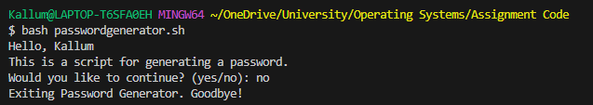
Otherwise, the program will continue. The next stage regards asking the user what password length they would like and providing a few example passwords.
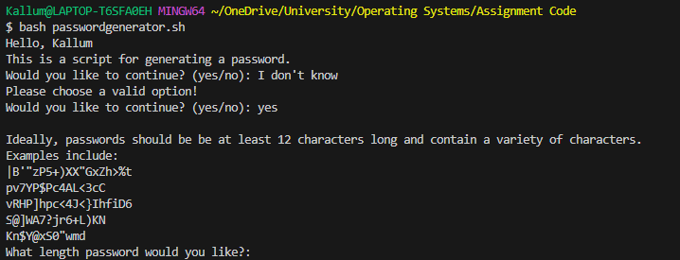
Multiple if/else statements are used [28] to validate the password, and until an input is valid, a while loop keeps the user attempting to input a length. If else statements are used in this situation over case statements as they can perform numerical comparisons. The code checks for multiple conditions, including:
- There is an input from the user.
- The input is a number by using regex.
- The number is greater than 12.
- The number is less than 1000.
- If the number is greater than 25 and less than 1000, ask if they want to continue, as it will be a long password.
If all these conditions pass, the password length is valid, and the loop breaks. Finally, a function designed to take the password length as an argument and generate a password of that length is activated. An indexed array [29] stores all valid characters to use in the password. A for loop loops over a random character in this array and appends it to a password variable returned from the function before it is shown to the user.
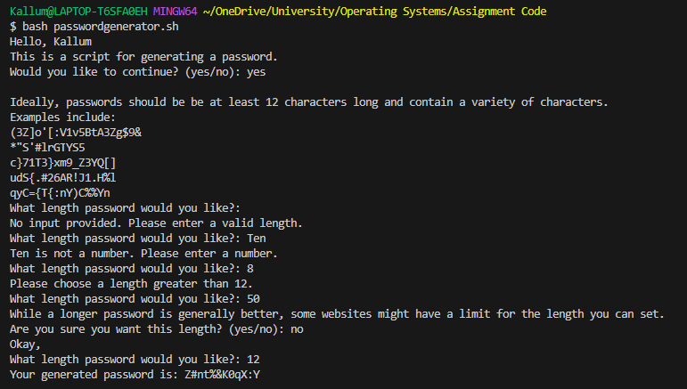

Code
current_user=$(whoami)
app_name="Password Generator"
example_passwords=()
re='^[0-9]+$'
numArray=( {0..9} )
specialCharArray=( '!' '@' '#' '$' '%' '^' '&' '*' '(' ')' '-' '_' '+' '=' '[' ']' '{' '}' ':' '<' '>' ',' '.' '?' '|' '"' "'" )
generatorArray=( {a..z} {A..Z} "${numArray[@]}" "${specialCharArray[@]}" )

generate_password() {
returnPass=""
if ! [[ $1 =~ $re ]] ; then
echo "$1 is not a number."
else
for ((i = 0 ; i < $1 ; i++ )); do
arrayChosenIndex=$(($RANDOM % ${#generatorArray[@]}))
letterChosen="${generatorArray[$arrayChosenIndex]}"

returnPass+=$letterChosen
done
fi

echo $returnPass
}

for i in $(seq 5); do
passLen=$((12 + $RANDOM % 10))
example_passwords+=("$(generate_password $passLen)")
done

if [ -n "$current_user" ]; then
echo "Hello, $current_user"
else
echo "Hello!"
fi

continue_function() {
while true
do
read -r -p "$1 (yes/no): " continue_script
continue_script=$(echo "$continue_script" | tr "[:upper:]" "[:lower:]")
case "$continue_script" in
yes)
continue_choice=1
break
;;
no)
continue_choice=0
break
;;
*)
echo "Please choose a valid option!"
;;
esac
done
}

password_length_function() {
while true;
do
read -r -p "What length password would you like?: " pass_len_input
if [[ -z "$pass_len_input" ]]; then
echo "No input provided. Please enter a valid length."
elif ! [[ $pass_len_input =~ $re ]] ; then
echo "$pass_len_input is not a number. Please enter a number."
elif [ "$pass_len_input" -lt 12 ]; then
echo "Please choose a length greater than 12."
elif [ "$pass_len_input" -gt 1000 ]; then
echo "Your password is too long. Please choose a password length of less than 1000."
elif [ "$pass_len_input" -gt 25 -a "$pass_len_input" -lt 1000 ]; then
echo "While a longer password is generally better, some websites might have a limit for the length you can set. "
continue_function "Are you sure you want this length?"
if [ "$continue_choice" -eq 1 ]; then
pass_len_good=1
break
else
echo "Okay,"
fi
else
pass_len_good=1
break
fi
done
}

# Entry point of the programme for user interaction.
echo "This is a script for generating a password."
continue_function "Would you like to continue?"
if [ "$continue_choice" -eq 1 ]; then
printf "\nIdeally, passwords should be at least 12 characters long and contain a variety of characters.\n"
echo "Examples include:"
for password in "${example_passwords[@]}"
do
echo "$password"
done

password_length_function
if [ "$pass_len_good" -eq 1 ]; then
password="$(generate_password $pass_len_input)"
echo "Your generated password is: $password"
else
echo "No password will be generated. Goodbye!"
fi
else
echo "Exiting $app_name. Goodbye!"
fi

Conclusion
Throughout the report, after thorough research regarding the key functionalities of operating systems, the usability of CLI commands on Windows and Linux, and creating scripts for both operating systems, multiple key findings can be extracted.
Firstly, the fact that the operating system is the mediator/interface between the user and the computer hardware becomes noticeable. By enabling the user to manage multiple different processes, such as memory allocation and communication with peripheral devices, the operating system is at the centre of interacting with the computer.
While Windows CLI and Linux CLI commands can differ in syntax, they both offer effective methods to interact with the computer. These interactions include navigating directories, file operations, and interaction with available processes. The user can increase their productivity and streamline system management tasks by utilizing CLI commands.
Additionally, the PowerShell and Bash scripts created can demonstrate the broad range of customisable operations the user can perform to interact with their system. In the case of the PowerShell script, the ability to streamline the creation of a basic web project template is demonstrated. Whereas with the Bash script, the convenience of generating a custom secure password is demonstrated. Both scripts show opportunities to automate otherwise repetitive tasks.
To conclude, by gaining sufficient knowledge of the key functions of an operating system, OS CLI commands and scripting opportunities, the user can efficiently manage their system and add automation to assist their daily tasks.

Reference List
[1] ‘Functions of operating systems - Computer systems - AQA - GCSE Computer Science Revision - AQA’, BBC Bitesize. Accessed: Feb. 25, 2024. [Online]. Available: https://www.bbc.co.uk/bitesize/guides/zkkkw6f/revision/5
[2] ‘Operating System: What is an Operating System and How Does it Work? | Lenovo UK’. Accessed: Feb. 25, 2024. [Online]. Available: https://www.lenovo.com/gb/en/glossary/operating-system/
[3] ‘IBM Documentation’. Accessed: Feb. 25, 2024. [Online]. Available: https://www.ibm.com/docs/en/aix/7.2?topic=administration-process-management
[4] J. Slater, ‘How to Select the Priority Level for a Program in Windows 11’, MUO. Accessed: Feb. 25, 2024. [Online]. Available: https://www.makeuseof.com/windows-11-set-program-priority/
[5] ‘Memory Management in Operating System’, GeeksforGeeks. Accessed: Feb. 25, 2024. [Online]. Available: https://www.geeksforgeeks.org/memory-management-in-operating-system/
[6] ‘Device Management in Operating System’, GeeksforGeeks. Accessed: Feb. 25, 2024. [Online]. Available: https://www.geeksforgeeks.org/device-management-in-operating-system/
[7] ‘How do you use Device Manager to troubleshoot Windows devices?’ Accessed: Feb. 25, 2024. [Online]. Available: https://www.linkedin.com/advice/3/how-do-you-use-device-manager-troubleshoot-windows
[8] vinaypamnani-msft, ‘Windows operating system security - Windows Security’. Accessed: Feb. 25, 2024. [Online]. Available: https://learn.microsoft.com/en-us/windows/security/operating-system-security/
[9] vinaypamnani-msft, ‘Secure Boot and Trusted Boot - Windows Security’. Accessed: Feb. 25, 2024. [Online]. Available: https://learn.microsoft.com/en-us/windows/security/operating-system-security/system-security/trusted-boot
[10] robinharwood, ‘Windows commands’. Accessed: Feb. 25, 2024. [Online]. Available: https://learn.microsoft.com/en-us/windows-server/administration/windows-commands/windows-commands
[11] ‘PowerShell commands - PowerShell - SS64.com’. Accessed: Feb. 25, 2024. [Online]. Available: https://ss64.com/ps/
[12] ‘An A-Z Index of Windows CMD commands - SS64.com’. Accessed: Feb. 25, 2024. [Online]. Available: https://ss64.com/nt/
[13] ‘Type Command’. Accessed: Feb. 25, 2024. [Online]. Available: https://www.computerhope.com/typehlp.htm
[14] ‘The Linux command line for beginners’, Ubuntu. Accessed: Feb. 26, 2024. [Online]. Available: https://ubuntu.com/tutorials/command-line-for-beginners
[15] ‘Bash cheat sheet: Top 25 commands and creating custom commands’, Educative. Accessed: Feb. 26, 2024. [Online]. Available: https://www.educative.io/blog/bash-shell-command-cheat-sheet
[16] ‘16 Bash Commands Data Scientists Must Know | Built In’. Accessed: Feb. 26, 2024. [Online]. Available: https://builtin.com/data-science/bash-commands
[17] ‘How to Create Users in Linux (useradd Command)’. Accessed: Feb. 29, 2024. [Online]. Available: https://linuxize.com/post/how-to-create-users-in-linux-using-the-useradd-command/
[18] sbiradar, ‘How to create, delete, and modify groups in Linux’. Accessed: Feb. 29, 2024. [Online]. Available: https://www.redhat.com/sysadmin/linux-groups
[19] ‘Chmod Command in Linux (File Permissions)’. Accessed: Mar. 04, 2024. [Online]. Available: https://linuxize.com/post/chmod-command-in-linux/
[20] ‘What is a Resource Monitor (Resmon) and How Does it Work? | Lenovo US’. Accessed: Apr. 16, 2024. [Online]. Available: https://www.lenovo.com/us/en/glossary/resource-monitor/
[21] ‘What Is Device Manager and It’s Use?’, Lifewire. Accessed: Apr. 16, 2024. [Online]. Available: https://www.lifewire.com/device-manager-2625860
[22] B. Stroustrup, ‘What is object-orientated programming?’, IEEE Software, vol. 5, p. 4 of 11, 1988. Available: https://librarysearch.uwtsd.ac.uk/permalink/44WHELF_UWTSD/1ir6fgh/cdi_proquest_journals_215841408
[23] ‘Beginner’s roadmap to web development’, freeCodeCamp.org. Accessed: Apr. 17, 2024. [Online]. Available: https://www.freecodecamp.org/news/beginners-roadmap-web-development/
[24] ‘PowerShell For Loop, ForEach-Object Loop and Other Loops’, business.com. Accessed: Apr. 17, 2024. [Online]. Available: https://www.business.com/articles/powershell-for-loop/
[25] ‘PowerShell If, If Else and Switch Examples’. Accessed: Apr. 17, 2024. [Online]. Available: https://www.mssqltips.com/sqlservertip/7188/powershell-if-if-else-switch-examples/
[26] ‘Functions’. Accessed: Apr. 17, 2024. [Online]. Available: https://tldp.org/LDP/abs/html/functions.html
[27] ‘Bash Case Statement’. Accessed: Apr. 17, 2024. [Online]. Available: https://linuxize.com/post/bash-case-statement/
[28] ‘Conditions in bash scripting (if statements)’. Accessed: Apr. 17, 2024. [Online]. Available: https://www.pluralsight.com/resources/blog/cloud/conditions-in-bash-scripting-if-statements
[29] N. Brousse, ‘A Complete Guide on How To Use Bash Arrays’, Shell Tips! Accessed: Apr. 17, 2024. [Online]. Available: https://www.shell-tips.com/bash/arrays/
[30] ‘General-Purpose Computer Operating Systems | Lenovo US’. Accessed: Apr. 18, 2024. [Online]. Available: https://www.lenovo.com/us/en/glossary/general-purpose-computer/
[31] B. Nancholas, ‘Names and types of computer operating systems’, Keele University - Study online. Accessed: Apr. 18, 2024. [Online]. Available: https://online.keele.ac.uk/names-and-types-of-computer-operating-systems/
[32] ‘Mobile Operating System - an overview | ScienceDirect Topics’. Accessed: Apr. 18, 2024. [Online]. Available: https://www.sciencedirect.com/topics/computer-science/mobile-operating-system
[33] ‘What is a Real-Time Operating System?’, Data Center. Accessed: Apr. 18, 2024. [Online]. Available: https://www.techtarget.com/searchdatacenter/definition/real-time-operating-system
[34] ‘Introduction to network operating system (Nos)’, Educative. Accessed: Apr. 18, 2024. [Online]. Available: https://www.educative.io/answers/introduction-to-network-operating-system-nos

Appendices

Tutorial 1
Multiple types of operating systems have been designed for specific purposes. These include:
- [30] General Purpose
- [31] Mobile
- [31] Real-time
- [31] Network
[30] A general-purpose operating system is designed with versatility at the centre of its operations. The user can run several different applications and run a broad range of tasks. They provide customization options to the user and allow for adaptation depending on what the user uses their computer for. They are the operating systems commonly found on computers at ”homes, offices and education institutions”. A commonly known general-purpose operating system is Windows.
A mobile operating system [32] works like the general-purpose operating system but instead is designed for use on mobile devices. They can manage multiple different hardware components of the mobile phone, such as memory management. A common mobile operating system would be Android, which contains a multitude of libraries that enable developers to build distinct types of applications.
On the other hand, a real-time operating system [33] is a type of operating system that is used in critical systems. They are designed so their processing times are as fast as possible, and due to being used in critical systems also as secure as possible. They are designed for use in devices such as microcontrollers. These operating systems are lightweight on the system and can execute tasks at various times depending on their priority level.
Finally, a network operating system [34] is another type of specialized operating system that manages all communications and resource sharing within a network. By managing these two core components, the operating system can provide smooth and uninterrupted data transfer by maximizing efficiency and reliability. The operating system also provides other vital features, such as network security. This is implemented by use of authentication, whenever access to some network resource is required, the user is required to log in with a valid username and password alongside the suitable authorization level.

Course Engagement

Course Link
https://learn.microsoft.com/en-gb/training/paths/powershell/

Achievement Link
https://learn.microsoft.com/api/achievements/share/en-gb/KallumDoyle-7154/9NT5VFSU?sharingId=ABB4282C28DAE268

Evidence



