Sharon Brown-Lee
2017639
Psychology in Health & Social Care Level 4
BMPH 4003
BMHP 4019
Lecturer: Rebecca Kavanagh

A CHILD’S EXPERIENCE BETWEEN THE AGES 0-5 CAN AFFECT THE REST OF THEIR LIVES

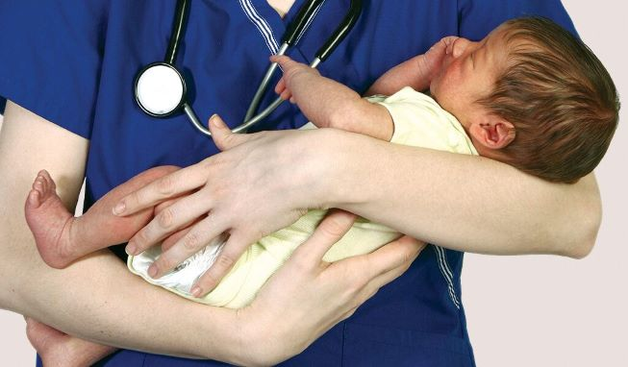
INTRODUCTION
During this presentation I will be showing & explaining how “A Child’s Experience from the ages of 0-5 years old, can affect the rest of their lives, In the discussion I will also use Piaget’s Cognitive Development theory and Erikson’s theory of lifespan development.

This presentation will focus on the development of the child from birth to aged five, and how their learning will grow at a fast pace, being able to grasp and using their cognitive skill without even realising.
Piaget’s Psychological Cognitive Theory’s
Piaget first becomes aware of his skills from a young age observing his own family members, he was aware of how advanced they were for their age noticing their capabilities before reaching an older age.
He was quick to notice how intelligent they were and based his findings on developing ways he could gain more depth into the cognitive behaviourism, he noticed that children were merely a mini version of their parents but, would learn & remember much quicker than them themselves
His theory implemented four stages of mental development, with this in mind he thought if he could use intelligent as his basis to understand how the child uses this at different stages of their growing, this is what he developed through observation. He also thought of three basic components to his theory.
Schemas- Think of this as using building blocks of Lego. Processes- like using assimilation to generate sounds copying that of animals or objects, they can try to accommodate the same thing being it repeating sound or words, although these are not connected. Stages of development the brain becomes more alert so the child thinks sucking its toes, is normal or trying to put their fist
into their mouth, this is all part of the growing & understanding process.
Erikson’s Stages of Psychosocial Development
Erik Erikson was an ego psychologist who developed one of the most popular and influential theories of development. He used his knowledge on psychosocial development instead that of psychosexual development: The stages he used for his theories were
Stage 1: Trust vs Mistrust = Can I trust the people that are around me
Stage 2: Autonomy vs Shame and Doubt = Potty/Toilet Training
Stage 3: Initiative vs Guilt =Choosing their own toys/Clothing
Stage 4: Industry vs Inferiority = Raising their hands in class if they know the answers
Stage 5: Identity vs Confusion = Why am I a different skin colour
Stage 6: Intimacy vs Isolation = This is at the age where they form relationships of the opposite sex
Stage 7: Generativity vs Stagnation = A feeling of achievement, Marriage/buying a home
Stage 8: Integrity vs Despair = Feeling Fulfilled by the life they had lived
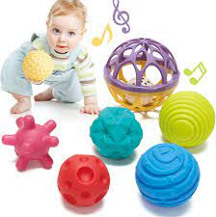
Sensory Toys For children aged 0-7= Soft Play Toys with Water

The Sensorimotor Stage aged 0-2: they are aware of grasping bottle/finger and moving themselves around
The pre-operational Stage aged 2-7: this is where they start to develop their own characteristics at, they assume that adults feel, hear & think the same way
Concrete Operational Stage aged:7-11 they start to think for themselves, & can engage through play

Formal Operational Stage aged 12+: Upwards where they can think logically, engage & understand education, speak freely on their opinions or thoughts.

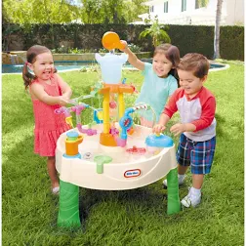

References
Gillibrand, R.et al (2016) Developmental Pschology, PearsonEducation Limited ProQuest Ebook Central.
Gross, R (2010). PschcologyThe Science of Mind and Behaviour. Sixth Edition
Piaget, J. (1971). The Theory of Stages in cognitive development in D.R.Green, M.P. Ford.& G.B. Flamer. Measurement and Piaget. McGraw-Hill.
McLead, S.A. (2018,May 03). Erik Erickson’s Stages of Psycholosocial Development. Simply Psychology. https://www.simplypsychology.org/Erik Erickson.httml
Google images

