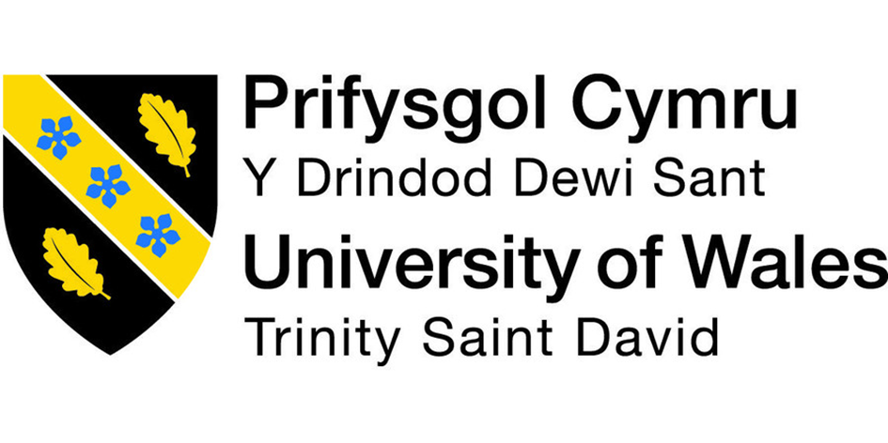

Student Name: Kitti Takacs
Student Number: 1906398
Lecture Name:
Module Title: Managing Projects in the Organisation (BMSW5104_LON)

“A true leader has the confidence to stand alone, the courage to make tough decisions, and the compassion to listen to the needs of others. He does not set out to be a leader, but becomes one by the equality of his actions and the integrity of his intent.” ~ Douglas MacArthur
What is Managing Projects in the Organisation? Project management is knowledge, tools, skills and techniques. Project management usually a one-time project not an ongoing activity. In my assignment I will use tools, skills and different management techniques. I will show different tools what my company is using in a daily bases such as the good old-fashioned to-do list or how we collaborate. How we report the details to each other. What techniques are we using to manage a better and more successful working environment. Let me introduce my company where I am working. The company called Manor Park Dental Practice. Manor park dental practice is a healthcare provider company who has contract with National Health Care or mostly called NHS. The company has over 100 employees as we have 8 practices around London. Manor park dental practice faced many difficulties through the global pandemic. To be able to manage any project through we have different type of collaboration and techniques such as involving every staff member in the meeting and discussing all sort of problems and finding solutions together. We have different ongoing project which I will write about in my assignment. I will focus on our re-branding project in Manor park dental practice and also how we managed through the global pandemic. Showing different type of trainings on how to operate and handle the organization.

