
PRINCIPLES AND CONCEPTS OF FINANCE
Student name: Sandra Gorolova


UNIVERSITY OF WALES TRINITY SAINT DAVID March 11, 2025

Contents
Introduction 4
Main Findings 5
(a) Stock Budget for the Six Months to 30 November 5
(b) Cash Budget for the Period to 30 November 7
(c) Budgeted Profit & Loss Account for the Six Months Ending 30 November 8
➢ Analysis of Cash Shortfall Issues 9
➢ Recommendations for Addressing Cash Flow Issues 10
(d) Problems and Solutions 10
➢ Financial Challenges Identified 10
➢ Proposed Management Actions 11
(e) Budgeting Conditions and Behaviours 12
➢ Conditions for Successful Budgeting 12
➢ Behavioural Factors 13
(f) Traditional Budgeting in a Fast-Changing Business Environment 14
➢ Flaws in Traditional Budgeting 14
➢ Alternative Budgeting Approaches 14
Conclusion 17
Bibliography 18

Executive Summary
Despite its constant development, Blue Thread Ltd., a textile firm established in the United Kingdom, is experiencing financial difficulties. When it comes to controlling cash flow, stock levels, and general financial stability, budgeting is an extremely important discipline to have. Traditional techniques of budgeting, on the other hand, are insufficient in a changing corporate environment, which has necessitated the implementation of other ways. The stock budget reveals that inventory levels are increasing, with the amount going from £90,000 in June to £370,000 in November. This upward trend implies that there may be problems with overstocking. Although this helps to plan for future demand, it also causes funds to be tied up and increases the risk of financial inefficiency. The cash budget discloses that there are ongoing financial shortfalls, with a negative balance that has increased from - 28 thousand pounds in June to - 79 thousand pounds in November. The company's capacity to meet its financial commitments is put in jeopardy by liquidity restrictions, which necessitates the implementation of enhanced cash management methods. Optimizing receivables collection and negotiating supplier payment conditions are examples. Profitability is evident from the profit and loss statement's prediction of 1.35 million pounds in sales and 300,500 pounds in net profit. Exorbitant operational costs and liquidity issues worsen financial system instability. Blue Thread Ltd. should use rolling, zero-based, and activity-based budgets to improve financial flexibility. Controlling expenses, improving stock management, and exploring additional financing options will boost cash flow and long-term growth. A deliberate switch to adaptive budgeting will help with financial sustainability and operational efficiency.

Introduction
Budgeting helps companies distribute resources, stay financially stable, and achieve strategic goals. Budgeting helps companies predict income, expenses, and risks. Fast-changing firms may not use incremental budgeting. These systems frequently use historical data and may not be adaptable to market changes or unanticipated obstacles ((Seal et al., 2018).
Blue Thread Ltd’s Financial Outlook
This research examines Blue Thread Ltd.'s six-month finances. Profit and loss forecasts, stock and cash budgeting, and main financial risks are prioritised. Cash flow management guarantees the firm can pay its bills and stay profitable. Inventory shortages and overstocking can affect financial performance, therefore stock budgeting eliminates them (Bganya, 2022). A careful evaluation of these components may show the firm's short-term financial health and sustainability.
Alternative Budgeting Methods
Traditional budgeting has limits, therefore organisations are using innovative ways to better financial planning and response. Flexibility and strategy alignment comes from rolling forecasts, activity-based, and zero-based budgeting. For cost-effective zero-based budgeting, spending must be detailed. Activity-based budgeting improves resource allocation by linking spending to company activity. Rolling projections help companies react to market changes. Company structure, financial goals, and industry climate determine these methods' applicability (Aljohani, 2023).
Conditions for Successful Budget Implementation
Budgets must fulfil certain requirements to succeed. Set clear financial goals, acquire correct data, communicate with employees, and involve them in budgeting. Budgets must match business financial objectives and plans with strong leadership and defined responsibilities. Budget planning and monitoring are more accurate and efficient with advanced financial software (Marr, 2013).
Behavioral Factors in Budgeting
Budgeting requires more than money conduct matters too. Management commitment, employee motivation, and company culture impact budget perception and implementation. Lack of transparency, change aversion, and excessive expectations can cause ineffective budgeting. Encourage participation and link budget objectives to performance awards to boost engagement and finances.
Critical Assessment of Traditional Budgeting
In today's fast-paced, competitive business environment, traditional budgeting practices are being questioned. Fast-changing sectors may struggle with incremental budgeting. Traditional budgeting takes time and may not achieve strategic goals. Even with formal financial planning, organisations must assess whether other methods are more adaptable and beneficial in a changing market (Ashta and Herrmann, 2021). Blue Thread Ltd.'s financial prediction will be examined using traditional and creative budgeting. The study shows how modern companies budget using financial data, behavioural traits, and strategic results. This evaluation's results will be researched (Horner, 2020).

Main Findings
Financial planning requires budgeting to manage resources, predict future needs, and maintain stability. Blue Thread Ltd.'s stock budget, cash budget, and planned profit and loss account must be analyzed to provide insight into its financial situation over the next six months. The stock budget, cash budget, and financial performance are examined here. The evaluation outlines development challenges and possibilities.

(a) Stock Budget for the Six Months to 30 November
When it comes to effective inventory management, the stock budget is crucial (Ramadan et al., 2024). It safeguards the business against operational disruptions caused by either an excess of inventory or a lack of stock by ensuring that the company maintains adequate stock levels. For the six months leading up to November 30th, the stock budget shows that stock levels have been steadily rising due to the buying and selling tendencies that have been observed throughout that time.

Table 1: Stock Budget
Month | Opening Stock (£000) | Stock Purchased (£000) | Cost of Stock Sold (£000) | Closing Stock (£000)
June | 90 | 150 | (60% of £200) = 120 | 120
July | 120 | 180 | (60% of £240) = 144 | 156
Aug | 156 | 190 | (60% of £210) = 126 | 220
Sept | 220 | 160 | (60% of £220) = 132 | 248
Oct | 248 | 200 | (60% of £230) = 138 | 310
Nov | 310 | 210 | (60% of £250) = 150 | 370

Interpretation:
- The business started with £90,000 in stock value in June and bought £150,000 worth of shares. There was a closing stock balance of £120,000 after deducting the cost of goods sold, which was £120,000 (or 60% of sales revenue). With an increase in stock purchases to £180,000 and a sale of £144,000 in July, the closing stock value was £156,000.
- With £190,000 in acquisitions and £126,000 in costs of stock sold, the closing stock balance for August was £220,000, continuing this rising trend. A stock balance of £248,000. This is because stock purchases in September dropped to £160,000, while sales of £220,000 caused the cost of goods sold to rise to £132,000.
- In preparation for expected increases in sales, stock purchases jumped to £200,000 in October and £210,000 in November. With a cost of stock of £138,000 in October and £150,000 in November, the corresponding closing stock balances were £310,000 and £370,000, respectively.
Blue Thread Ltd is likely raising its inventory in preparation for future increased demand, as seen by the rising stock levels. Nevertheless, this brings up the issue of overstocking, which might result in the squandering of funds and the risk of obsolescence if demand falls short of expectations. To maintain a healthy equilibrium between inventory levels and cash flow needs, effective stock management procedures should be put into place.

(b) Cash Budget for the Period to 30 November
To keep operations running smoothly and avoid financial crises, a business must have a well-thought-out cash budget (Gupta et al., 2023). Blue Thread Ltd is anticipated to have a cash deficit over the next six months, according to the cash budget analysis, which might provide liquidity issues for the firm.

Table 2: Cash Budgeting
Month | June | July | Aug | Sept | Oct | Nov
Cash receipts
Net Sales | 194 | 232 | 203 | 213 | 221 | 239
Cash payments
Administration | (22) | (23) | (24) | (25) | (26) | (28)
Stock purchased | (150) | (180) | (190) | (160) | (200) | (210)
Repayments of loan | (4) | (4) | (4) | (4) | (4) | (4)
Selling expenses | (5) | (6) | (7) | (8) | (9) | (6)
Taxation paid | - | - | (15) | - | - | -
Interest payments | (1) | (1) | (1) | (1) | (1) | (1)
Shop refurbishment | - | (12) | (10) | (14) | - | -
Cash surplus (deficit) | -3 | 13 | -38 | -6 | -13 | -7
Opening balance | (25) | (28) | (15) | (53) | (59) | (72)
Closing balance | (28) | (15) | (53) | (59) | (72) | (79)

Interpretation
- A net cash outflow of £3,000 was recorded in June as a consequence of cash revenues of £194,000 and cash payments of £197,000. The June balance was minus £28,000, down from an initial balance of negative £25,000. Cash revenues grew to £232,000 in July, while payments were reasonably restricted at £219,000. As a result, net cash flow turned positive at £13,000. Still, the business concluded the month with a negative cash position of £15,000 due to the initial loss of £28,000.
- A net cash outflow of £38,000 was recorded in August, as payments (£241,000) exceeded collections (£203,000). By the month's end, the deficit had ballooned to £53,000. Despite a decrease in the net cash outflow to £6,000 in September, the cumulative deficit increased to £59,000.
- With deficits of £13,000 in October and £7,000 in November, the downward trend in net cash flows persisted. The corporation anticipated a negative £79,000 cash balance by the end of November.
The chronic cash imbalance poses a serious financial risk to the firm, as it might impact its capacity to pay suppliers, and employees, and cover operational expenditures. Securing short-term borrowing to cover the shortfall, cutting discretionary spending, or negotiating better payment terms with suppliers are all methods the firm might pursue to boost cash flow. Another way to address liquidity concerns is by enhancing collection strategies to speed up client cash inflows.

(c) Budgeted Profit & Loss Account for the Six Months Ending 30 November
A summary of the company's expected financial performance for the six months is given by the planned profit and loss statement. It emphasises the creation of income, the control of costs, and the total profitability.

Table 3: Budgeted Profit and Loss Account
Description | Amount (£000)
Sales | (1,350)
Cost of Goods Sold | (810)
Gross Profit | 540
Selling Expenses | (43)
Admin Expenses | (150)
Credit Card Charges | (40.5)
Operating Profit | 306.5
Interest Payable | (6)
Profit for the Period | 300.5

Interpretation:
- The anticipated sales revenue for Blue Thread Ltd is £1,350,000. Estimates put the cost of goods sold (COGS) at £810,000, or 60% of the entire revenue from sales. This gives a gross profit of £540,000, which is a very profitable level of profitability.
- The ultimate profit amount will be affected by operating expenditures, too. The anticipated selling expenditure is £43,000, with administrative costs coming to £150,000. Credit card costs of £40,500 are also anticipated, which would further decrease operational profit. The operational profit is £306,500 when these expenditures are subtracted.
- An expected £6,000 in interest payments on borrowings leaves a £300,500 profit for the time being. The fact that the business is still able to turn a profit after accounting for operating expenditures and interest payments is indicative of solid financial performance. While the business may appear lucrative on paper, ongoing liquidity issues may be preventing it from fully realizing its potential, according to the cash budget study.

Analysis of Cash Shortfall Issues
The financial study mainly highlights the company's ongoing negative cash balances, even though it is profitable. This deficiency is caused by many factors:
Stock Accumulation – The corporation is putting a lot of money into shares, which means there is less cash available for other uses. Although the goal of this method is to guarantee product availability, keeping too much inventory on hand cuts into funds that could be used for other operating expenses (Keskar, 2024).
Mismatched Cash Receipts and Payments – Even when sales income is good, there are cash constraints because the timing of cash inflows and withdrawals is not synchronized (Drissi et al., 2023). This can be because of suppliers' urgent demands for payment or because consumers have extended credit terms.
Operational Expenses – Liquidity is impacted by operational expenses, which include high selling and administrative costs that lead to cash outflows. These expenditures are essential to running the firm, but if they could be better managed, it would ease financial pressure.
Interest Costs – Interest expenditures are evidence that the corporation has debts that need to be paid off. It may be possible to alleviate the financial strain by refinancing at a reduced interest rate and effectively managing the payments of existing debt (Wahaab and Ali, 2024).

Recommendations for Addressing Cash Flow Issues
To address the cash flow shortfall, Blue Thread Ltd should consider the following strategies:
- Improve Receivables Collection – Implement stricter credit policies, offer early payment incentives, and follow up on overdue payments to accelerate cash inflows.
- Manage Stock Levels Efficiently – Reduce excessive stock accumulation to free up cash while ensuring inventory levels align with demand forecasts.
- Optimize Payment Terms – Negotiate extended payment terms with suppliers to align outflows with expected cash inflows.
- Cost Reduction Measures – Identify areas where administrative and selling expenses can be minimized without affecting operational efficiency.
- Explore Financing Options – Consider short-term financing solutions such as overdrafts, credit lines, or factoring receivables to cover short-term cash deficits.

(d) Problems and Solutions
For a successful business to weather financial storms and cash flow problems, efficient financial management is essential (Ramírez, 2022). Problems with overdrafts, lack of funds, and excessive inventory levels plague Blue Thread Ltd. A comprehensive strategy incorporating supplier negotiations, sales promotion, alternative finance, and cost control is required to address these concerns. These financial challenges will be discussed in the following sections, along with practical remedies that may be implemented to enhance the company's financial stability.

Financial Challenges Identified
- Overdraft Issue
According to the cash budget, the company's financial situation has been steadily declining over the past six months. The overdraft has grown due to these deficits, endangering the banking system. If the overdraft amount increases, the company could have problems meeting its financial obligations or obtaining more funding, both of which could harm operations (Sah, 2021). To pay off the overdraft, you must immediately begin to raise cash inflows and decrease wasteful expenditure.
- Liquidity Constraints
If the cash balance keeps falling, the business may have trouble paying its short-term financial obligations. These include supplier payments, operating expenses, and debt repayments. Liquidity limits may affect corporate operations, making supplier relationships and cost management difficult (Cen and Dasgupta, 2021). If ignored, these issues might harm corporate operations and profits. Effective liquidity management ensures financial system resiliency and stability.
- High Stock Levels
If sales grow slower than stock levels, the firm's stock budget may raise surplus inventory expenses. Keeping a lot of stock wastes money, increases storage costs, and increases the risk of product obsolescence. Inefficient inventory turnover can affect cash flow and financial management. To prevent financial strain, the organisation must match stock levels to demand (Akinlabi, 2021).

Proposed Management Actions
- Cost Control Measures
Operating expense reduction is one of the best ways to improve the company's finances, therefore make it a priority. A thorough study of administrative and selling costs is needed to find ways to cut costs without hurting profitability (Rounaghi et al., 2021). Minimizing discretionary spending, optimizing workforce distribution, and using cost-cutting measures can lower total expenditures. If the organisation cuts costs, it can boost cash flow and reduce overdrafts.
- Alternative Financing
Since cash flow and overdraft issues persist, the organisation should explore alternative financing options. Negotiating with the bank for extended loan terms or restructuring debt may provide temporary financial relief. To fill the cash gap, consider invoice factoring, trade credit, or short-term corporate loans. Diversifying funding sources allows the business to fulfil operating expenses without overdrafts.
- Sales Promotion
Increasing sales revenue is crucial to boosting cash flow and managing liquidity issues. Sales may be increased by focused marketing efforts, discounts, and promotions. Revenue may increase by offering additional items, engaging consumers, and exploring new markets (Aydin et al., 2021). If executed properly, a sales plan can increase cash inflows, relieving financial strain caused by low cash levels.
- Supplier Negotiations
The company should renegotiate supplier payment terms to improve cash flow. Extending payment terms may give you additional time to make money before paying off debts. Building supplier relationships and negotiating advantageous credit terms can provide financial flexibility. Strategic supplier partnerships and bulk buy discounts can cut procurement costs, improving cost efficiency. Blue Thread Ltd. must move quickly to address financial challenges to ensure growth and stability. The company's financial health depends on addressing overdrafts, improving liquidity, and managing stock levels. Cost control, alternative financing, sales promotion, and supplier renegotiation can improve the company's cash position and financial sustainability.

(e) Budgeting Conditions and Behaviors
Budgeting helps firms plan, control, and distribute resources efficiently. However, a budgeting system must meet several characteristics and govern various behavioral factors to be effective. Budget efficacy may be increased by making credible estimates, preserving flexibility, incorporating stakeholders, and reviewing often (Wang et al., 2024). To address behavioral issues that may obstruct budgeting, employee resistance, management biases, performance expectations, and communication gaps must be considered.

Conditions for Successful Budgeting
- Realistic Forecasting
Budgets should be based on realistic sales and spending estimates. Overestimating earnings or underestimating expenditures can lead to financial mismanagement and inefficiencies. Consider accurate historical data, market trends, and economic situations while setting budget goals. This ensures that the organization's goals match its finances and surroundings.
- Flexibility
When the market or the company changes, so does the budgeting method. A strict budget might not work if outside factors, such as a drop in the economy or changes in customer demand, have an effect on how the business runs. Using rolling forecasts and emergency planning in a flexible budget can help businesses change their financial goals and stay stable when times get tough.
- Stakeholder Involvement
Budgeting becomes more accurate, ownership, and devotional when key stakeholders and employees are involved. Workers are more willing to work towards corporate objectives when they have a hand in establishing budget targets. By working together, we can improve financial planning and execution by making sure the budget assumptions are reasonable and represent activities correctly.
- Regular Reviews
Budget papers should be reviewed and updated regularly. Regular performance assessments help identify disparities between budgeted and actual data, allowing for prompt correction. Regular reviews reveal opportunities for improvement, ensuring that financial targets remain achievable and aligned with business strategy.

Behavioral Factors
Employee Resistance: Employees may regard budgets as restrictive or cost-cutting tools rather than strategic planning tools. Resistance may lead to disengagement and decreased motivation. To foster company ownership and accountability, management should explain budgeting's benefits and include employees in decision-making (Aragão and Fontana, 2022).
Management Bias: If management sets spending goals that are too high, people may lose drive and feel stressed. When a company's budget does not match its needs, it makes workers unhappy and less productive. Smart spending goals based on data may boost employee happiness and company success.
The Performance Pressure: To meet financial goals, budget limits may lead to cost trickery or underreporting. There may be changes to financial records and decisions. To avoid these kinds of problems, businesses should encourage open, honest planning that blends sound money sense with the realities of running a business.
Communication Gaps: Disagreements between departments could make it harder to stick to the budget. If financial goals are not stated, it might be hard for teams to stick to their budgets. By talking to each other freely, finance and operational management may be able to improve planning and teamwork. A good budget has correct predictions, room for change, involvement from all stakeholders, and close oversight. Budgeting could be hampered by opposition, bias, performance pressure, and communication gaps. If businesses deal with these issues, they can create a sensible and well-organised planning system that helps them stay financially stable and grow strategically (Tyagi et al., 2023).

(f) Traditional Budgeting in a Fast-Changing Business Environment
Standard budgeting has been used for years in financial planning. It keeps track of the company's income and expenses. When things change quickly at work, standard planning methods do not work. Traditional planning makes it harder to be flexible and competitive because it is rigid, focused on the short term, wasteful of resources, and does not encourage new ideas. There are different ways to handle money strategically, such as rolling, zero-based, activity-based, and beyond planning (Kolitz, 2017).

Flaws in Traditional Budgeting
Rigidity: Companies struggle to respond to market changes using traditional budgeting. Even if economic conditions, customer demand, or operational demands change, budgets seldom shift. Without flexibility, companies may miss opportunities and misallocate resources, making it impossible to adapt to new problems.
Short-Term Focus: Short-term financial aims frequently trump long-term strategic goals in a yearly budget. This can make companies prioritise short-term profits above long-term growth, innovation, and sustainability. Dynamic organisations that demand long-term adaptation may struggle with traditional budgeting. These strategies may impair financial planning (Sonjaya, 2024).
Resource Inefficiencies: Traditional budgeting emphasises "use it or lose it" spending, allowing departments to waste money to assure comparable or larger budgets next year. Resource inefficiency costs money and hinders cost-cutting. Departments may put economic limits before financial success. Because departments prioritise efficiency and value.
Lack of innovation: Traditional budgeting inhibits company innovation and flexibility. Financial resource fixedness hinders dynamic decision-making and resource reallocation for new possibilities. Departments may not be able to fund new projects, technologies, or strategic initiatives during the year. That can hamper innovation.

Alternative Budgeting Approaches

Rolling Budgets: Rolling budgets are made frequently rather than yearlyRolling budgets provide companies additional flexibility by adjusting predictions based on performance and market conditions. This method allows organisations to alter financial strategies without a budget.
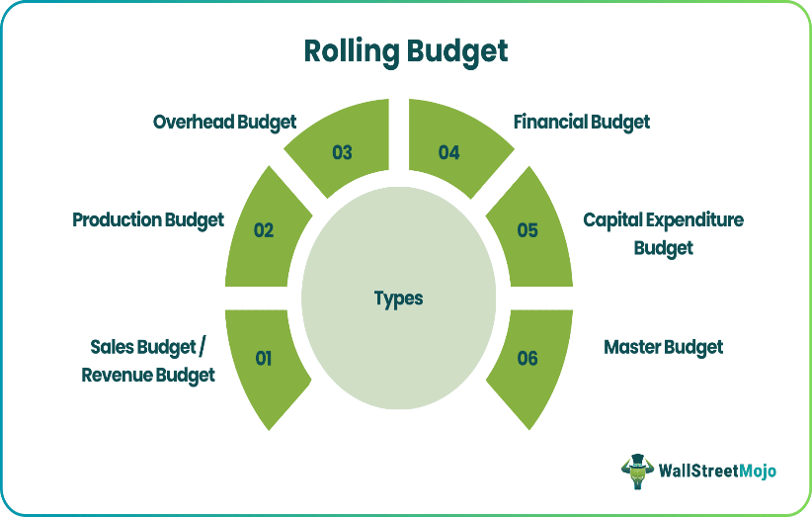
Figure 1: Rolling Budget
Zero-Based Budgeting: Each cycle of zero-based budgeting (ZBB) requires spending justification. Unlike previous spending trends. This strategy allocates funding to corporate needs and strategic goals, eliminating waste. ZBB needs extensive cost analysis for resource allocation and cost control (Allen and Clifton, 2024).


Figure 2: Zero-Based Budgeting

Activity-Based Budgeting: Activity-Based Budgets (ABB) link budgets to critical business activities. Not previous expenditures or department requests, ABB funds corporate expenditures. Cost-conscious, performance-driven organisations may use this method to promote transparency and guarantee finances support value-creating initiatives.

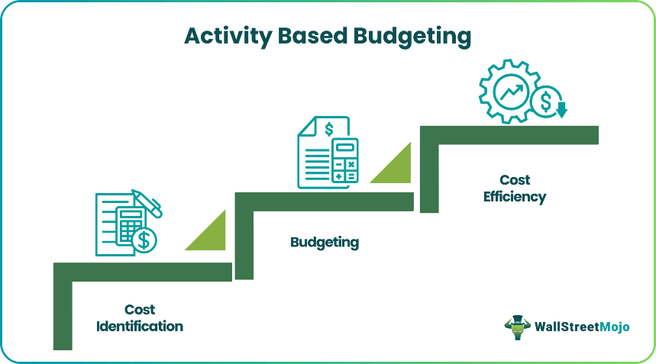
Figure 3: Activity-Based Budgeting

Beyond Budgeting: Modern financial management goes "beyond budgeting" by decentralising decision-making. Organisations prioritise strategic goals, performance metrics, and real-time financial adjustments above budgeting (Alam and Alam, 2022). This method allows managers to make business-driven decisions, boosting innovation and agility. Traditional budgeting fails in volatile markets. Rigidity, short-term focus, inefficiency, and lack of imagination can slow company growth. Rolling, zero-based, activity-based, and beyond budgeting are smarter financial planning methods. Modern budgeting may boost responsiveness, cost control, and long-term profitability. In competition, this is crucial.

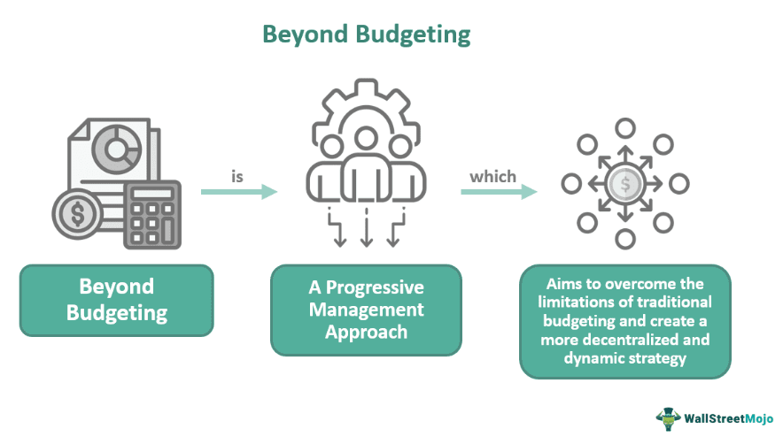
Figure 4: Understanding the Beyond Budgeting

Conclusion
Blue Thread Ltd. has trouble with cash flow. The overdraft will be hard to pay off by November because the company's budget research shows that it is still losing money. If this problem isn't fixed right away, it could hurt business processes, ties with suppliers, and growth. Because of these money problems, you need to cut costs proactively, plan your finances, and make a budget that can be changed as needed.
Addressing Cash Flow Constraints
The company is having a hard time with its negative cash situation. Strict cost management could cut down on needless spending and make sure that money is used well. Look at your selling and management costs, cut back on spending you don't have to, and save money to improve your cash flow. If the business can get longer payment terms from its suppliers, it may be able to improve its operations and cut down on its cash flow problems. One last thing to think about is alternative means of funding. Getting trade credit, bank extensions, or short-term loans can help when money is tight.
Enhancing Budgeting Effectiveness
To enhance their financial planning and responsiveness, Blue Thread Ltd. has to implement new budgeting procedures. In a dynamic company environment, conventional budgeting techniques, no matter how well-organised, might not be adaptable enough. Budgets that are activity-based, zero-based, or rolling allow for more financial responsiveness and efficiency. However, alternative budgeting programs must be planned for by the organisation. Management prejudice and staff resistance are two examples of problematic behaviors that need fixing if the project is to be a success. To increase involvement and budget efficiency, it is recommended that stakeholders participate actively, be transparent, and communicate openly. Financial health, cash flow management, and long-term planning may all benefit from Blue Thread Ltd.'s proactive and astute actions. In the long run, the company will be able to achieve its stability and growth objectives.

Bibliography
Akinlabi, B.H. (2021). Effect of inventory management practices on operational performance of flour milling companies in Nigeria. International Academy Journal of Management, Marketing and Entrepreneurial Studies, 8(2), pp.137-174.
Alam, A.M. and Alam, M. (2022). Decentralization, resource splitting and budgetary process: an empirical study. Journal of Public Budgeting, Accounting & Financial Management, 34(1), pp.67-95. https://doi.org/10.1108/JPBAFM-02-2020-0017
Aljohani, A. (2023). Predictive analytics and machine learning for real-time supply chain risk mitigation and agility. Sustainability, 15(20), p.15088. https://doi.org/10.3390/su152015088
Allen, R. and Clifton, R. (2024). From zero-base budgeting to spending review–achievements and challenges. Development Southern Africa, 41(5), pp.849-865. https://doi.org/10.1080/0376835X.2023.2226164
Aragão, J.P.S. and Fontana, M.E. (2022). Outsourcing strategies in public services under budgetary constraints: analyzing perceptions of public managers. Public Organization Review, 22(1), pp.61-77. https://doi.org/10.1007/s11115-021-00517-5
Ashta, A. and Herrmann, H. (2021). Artificial intelligence and fintech: An overview of opportunities and risks for banking, investments, and microfinance. Strategic Change, 30(3), pp.211-222.
Aydin, G., Uray, N. and Silahtaroglu, G. (2021). How to engage consumers through effective social media use—Guidelines for consumer goods companies from an emerging market. Journal of theoretical and applied electronic commerce research, 16(4), pp.768-790. https://doi.org/10.3390/jtaer16040044
Bganya, M. (2022). The effect of stock management on the financial performance of SMEs in the mobile industry in Cape Town, South Africa (Doctoral dissertation, Cape Peninsula University of Technology). https://etd.cput.ac.za/handle/20.500.11838/3769
Cen, L. and Dasgupta, S. (2021). The economics and finance of customer–supplier relationships. In Oxford Research Encyclopedia of Economics and Finance. https://doi.org/10.1093/acrefore/9780190625979.013.631
Drissi, H., Lamzaouek, H., Amellal, I. and Mialed, K. (2023). Cash flow bullwhip control mechanisms in a major crisis situation: a case study from the COVID-19 crisis. EuroMed Journal of Business, 18(4), pp.660-681. https://doi.org/10.1108/EMJB-02-2022-0026
Gupta, M.J., Makwana, C., Naik, S. and Rao, W.R. (2023). Fundamentals of Financial Management. AG PUBLISHING HOUSE (AGPH Books).
Horner, D. (2020), Accounting for Non Accountants, (Twelfth Edition), London; Kogan Press
Keskar, A. (2024). Driving operational excellence in manufacturing through generative AI: Transformative approaches for efficiency, innovation, and scalability. International Journal of Research and Analytical Reviews, 11, pp.245-261.
Kolitz, D. (2017), Financial Accounting – A Concepts-based Introduction, Oxon: Routledge
Marr, B. (2013), Key Performance Indicators (KPI), Harlow: Pearson
Ramadan, A., Alkhodary, D., Alnawaiseh, M., Jebreen, K., Morshed, A. and Ahmad, A.B. (2024). Managerial competence and inventory management in SME financial performance: A Hungarian perspective. Journal of Statistics Applications & Probability, 13(3), pp.859-870. http://dx.doi.org/10.18576/jsap/130301
Ramírez, J.G.C. (2022). Struggling Small Business in the US. The next challenge to economic recovery. International Journal of Business Intelligence and Big Data Analytics, 5(1), pp.81-91.
Rounaghi, M.M., Jarrar, H. and Dana, L.P. (2021). Implementation of strategic cost management in manufacturing companies: overcoming costs stickiness and increasing corporate sustainability. Future Business Journal, 7, pp.1-8. https://doi.org/10.1186/s43093-021-00079-4
Sah, G.G. (2021). Impact of working capital management on the profitability of smes through cash operation cycles in Kumasi. The Challenges of Analyzing Social and Economic Processes in the, 21, p.112. https://doi.org/10.14232/casep21c.8
Seal, W., Garrison, R.H, and Noreen, E. (2018), Management Accounting, (Sixth Edition), UK: McGraw Hill
Sonjaya, Y. (2024). Exploring the Evolution of Budgeting Practices from Traditional to Technology. Advances in Management & Financial Reporting, 2(1), pp.36-45. https://doi.org/10.60079/amfr.v2i1.265
Tyagi, A.K., Dananjayan, S., Agarwal, D. and Thariq Ahmed, H.F. (2023). Blockchain—Internet of Things applications: Opportunities and challenges for industry 4.0 and society 5.0. Sensors, 23(2), p.947. https://doi.org/10.3390/s23020947
Wahaab, N.A.R.A. and Ali, A.H. (2024). Impact of Public Debt Refinancing Techniques on Managing Public Budgeting in Iraq: An Analytical Study. Journal of Economics and Administrative Sciences, 30(141), pp.349-368. https://doi.org/10.33095/64gw4b47
Wang, Y., Kwak, Y.H. and Cui, Q. (2024). The power (lessness) of flexibility in public–private partnerships: Two capital projects from the national capital region. Project Management Journal, 55(6), pp.650-667. https://doi.org/10.1177/87569728241241301

