James Ball (1809296)
1809296@student.uwtsd.ac.uk
Software development Assignment
Feb 2019

Contents
Part A 3
A1. What is a variable and why are they important in writing programs? 3
A2. Explain why the for-loop can also be referred to as a counting-loop and give an example of when you would use it. 3
A3. Explain what an array is, what their features are, and give an example of when you would use one. 3
Part B 4
1 Exercise 1 4
1.1 Description 4
1.2 Identify problem 4
1.3 Pseudocode 4
1.4 Implementation 4
1.5 Testing 5
1.5.1 Normal values 5
1.5.2 Height out of range 6
1.5.3 Age out of range 7
1.5.4 Value of wrong type 8
2 Exercise 2 9
2.1 Description 9
2.2 Identify problem 9
2.3 Pseudocode 9
2.4 Implementation 10
2.5 Testing 11
2.5.1 Normal integer values 11
2.5.2 Normal decimal values 12
2.5.3 Negative values 12
2.5.4 Triangle larger than circle 13
2.5.5 Value of wrong type 13
3 Exercise 3 14
3.1 Description 14
3.2 Identify problem 14
3.3 Pseudocode 14
3.4 Implementation 14
3.5 Testing 15
3.5.1 Integer values 15
3.5.2 Decimal values 16
3.5.3 All zero cost 16
3.5.4 Negative values 17
3.5.5 Value of wrong type 17
4 Exercise 4 18
4.1 Description 18
4.2 Identify problem 19
4.3 Pseudocode 19
4.4 Implementation 20
4.5 Testing 21
4.5.1 User responds yes to “spin again?” 21
4.5.2 User responds no to “spin again?” 21
4.5.3 Only two numbers = 5 22
4.5.4 All numbers different 22
4.5.5 All numbers the same but not 5 22
4.5.6 All numbers the same and = 5 22
4.5.7 Value of wrong type 23
5 References 24

Part A

A1. What is a variable and why are they important in writing programs?
Variables are containers for data used in programs. The size of the container depends on the data type the variable has been assigned, for instance a char is stored in a single byte of memory, whilst a double is stored in eight bytes of memory[1]. The memory space is allocated at execution[2], but the data stored in the container can change at run-time[3]. This makes variables important in writing programs because they give human readable references for memory allocations and therefore make writing complex processes much easier.

A2. Explain why the for-loop can also be referred to as a counting-loop and give an example of when you would use it.
A for-loop can be referred to as a counting loop because it is based on a variable that is iterated a set number of times until a pre-determined condition is met. It has three parameters, the first being the initialisation statement, which is executed only once and usually sets the starting value for the counting variable. The second is the test expression, the logical statement that must be true for the loop to continue. The final parameter is the increment statement which is the part that changes the counting variable.
For-loops are used in scenarios when a section of code needs to be repeated a set number of times. This is compared to while-loops that are used when the loop must continue for an unknown number of iterations until some condition is met. For example, a for-loop would be used to find the average of an array of student’s grades by iterating through all the students, adding all the marks together and dividing by the number of students.

A3. Explain what an array is, what their features are, and give an example of when you would use one.
An array is a data structure that contains a collection of the same data type. Its size is defined when the array is declared and therefore cannot be changed once set[1]. The array’s data is stored in consecutive locations in storage, and for arrays of chars the last entry is a null character[4]. This means that when declaring an array of chars, you must declare it with one more entry than needed. The data in arrays can be referenced using the ‘index’, this is the place in the list starting at zero. For example, in the following array:
int test[] = {23, 56, 34, 45, 12}
The number 56 could be referred to using:
test[1]
Arrays can have multiple dimensions, a two-dimensional array would have two indices that would refer to a single entry of data, much like an x and y coordinate on a graph. An example of a two dimensional array that could store the ID numbers and marks of 20 students would be:
int Students[2][20]

Part B

Exercise 1

Description
The problem as stated was to show how variables can contain different types of values by declaring three variables that contain a name, a measure of height (e.g. 1.81cm) and a person's age (e.g. 32). Input these values and display them on the screen.

Identify problem
The steps identified in this problem are:
- Declare 3 variables of type string, float and integer
- Get user to input values for the three variables
- Display the user defined values on screen

Pseudocode
Set name to “x”
Set height to 0
Set age to 0

Print “enter name”
set name to input

print “enter height”
set height to input

print “enter age”
set age to input

print collated inputs

Implementation
// Name: Software Development Assignment
// Author: James Ball 1809296
// Date: 12/12/18
// Version: 1.0

#include <stdio.h>
#include <stdlib.h>

void Exercise_1()
{
char name[64] = "James"; // declare string of length 64 with default value "James"
float height = 1.81; // declare floating point number with value default 1.81
int age = 32; // declare integer with default value 32

printf("Please enter your name: "); // get user input and assign the value to 'name'
scanf("%s", &name);

printf("\nPlease enter your height in meters: "); // get user input and assign the value to 'height'
scanf("%f", &height);

printf("\nPlease enter your age: "); // get user input and assign the value to 'age'
scanf("%d", &age);

printf("\n\n%s is %.2fm tall and %d years old.\n\n", name, height, age); // print all three variables to screen
}

Testing

Normal values
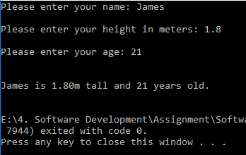
Result: Program ran and displayed values correctly.

Height out of range
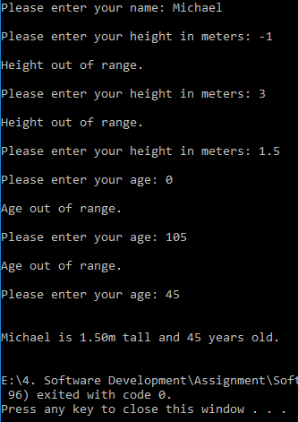
Result: Program ran, looped until valid values entered, and displayed values correctly.

Age out of range
Result: Program ran, looped until valid values entered, and displayed values correctly.

Value of wrong type
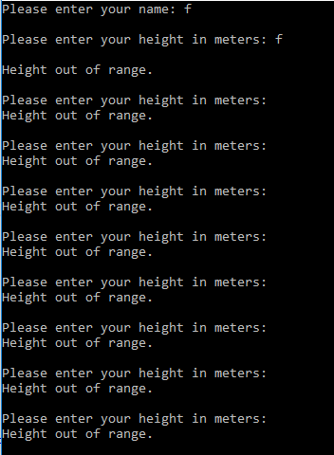
Result: Program stuck in infinite loop and doesn’t display values.

Exercise 2

Description
The problem as stated was to allow the user to enter the dimensions of shapes shown below (Figure 1), then calculate the area of the blue shaded part. Note: The triangular area in the centre is empty.

Figure 1 Calculate Shaded Area
Note:
Area of circle is given by $A=πr^{2}$
Area of triangle is given by $A=\frac{\left(b×h\right)}{2}$

Identify problem
The steps identified in this problem are:
- Get user dimensions for circle and triangle
- Calculate area of triangle
- Calculate area of circle
- Calculate shaded area
- Print shaded area to screen

Pseudocode
Set constant pi to 3.14…
Set triangle height, triangle base, triangle area to 0
Set circle radius, circle area to 0
Set total area to 0

Print “enter triangle height”
set triangle height to input

print “enter triangle base”
set triangle base to input

print “enter circle radius”
set circle radius to input

triangle area = triangle height * triangle base
triangle area = triangle area / 2

circle area = pi * circle radius * circle radius

total area = circle area – triangle area

if total area is negative
set total area to 0
end if

print total area

Implementation
void Exercise_2()
{
/* Define constants and variables */
const float PI = 3.141593;
float tri_Height = -1, tri_Base = -1, tri_Area = -1, circ_Radius = -1, circ_Area = -1, tot_Area = -1;
/* ------------------------------ */

/* Get user values for triangle and circle size */
while (tri_Height < 0) // loops until triangle height is +ive
{
printf("Please enter the height of the triangle: ");
scanf("%f", &tri_Height);

if (tri_Height < 0)
{
printf("\n\nThe value must be positive.\n");
}
}

while (tri_Base < 0) // loops until triangle base is +ive
{
printf("\nPlease enter the base of the triangle: ");
scanf("%f", &tri_Base);

if (tri_Base < 0)
{
printf("\n\nThe value must be positive.\n");
}
}

while (circ_Radius < 0) // loops until circle radius is +ive
{
printf("\nPlease enter the radius of the circle: ");
scanf("%f", &circ_Radius);

if (circ_Radius < 0)
{
printf("\n\nThe value must be positive.\n");
}
}

/* -------------------------------------------- */

tri_Area = ((tri_Height * tri_Base) / 2); // calculate triangle area using user values
circ_Area = (PI * circ_Radius * circ_Radius); // calculate circle area using user values
tot_Area = circ_Area - tri_Area; // calculate total area

if (tot_Area < 0) // if the triangle is larger than the circle the area is 0, because the area can't be negative
{
tot_Area = 0;
}

printf("\n\nThe shaded area is %.2f\n\n", tot_Area); // print total shaded area to screen
}

Testing

Normal integer values
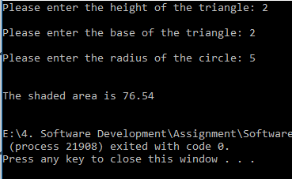
Result: Program ran and calculated shaded area correctly.

Normal decimal values
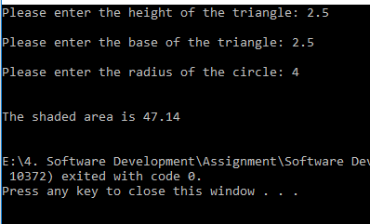
Result: Program ran and calculated shaded area correctly.

Negative values
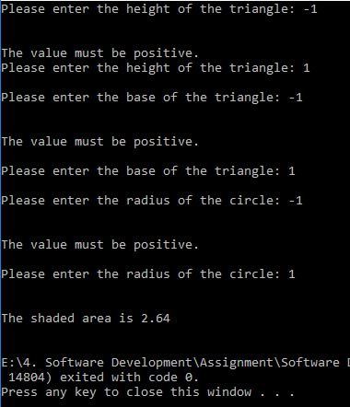
Result: Program ran, looped until positive values entered, and calculated shaded area correctly.

Triangle larger than circle
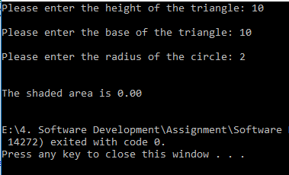
Result: Program ran and calculated shaded area correctly.

Value of wrong type
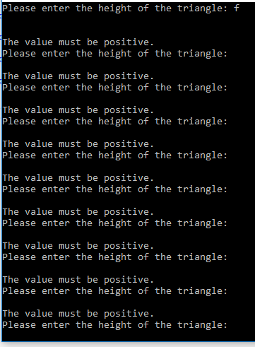
Result: Program stuck in infinite loop and doesn’t calculate shaded area.

Exercise 3

Description
The problem as stated was to write a program that allows the user to enter the price of 5 products into an array. Once all the prices are entered calculate the total price, and then calculate the total price plus 20% VAT.

Identify problem
The steps identified in this problem are:
- Get user input for product prices
- Sum all user prices
- Times total price by 1.2
- Print grand total

Pseudocode
Set constant VAT to 0.2
Set array products(5) to 0
Set total to 0
Set totalWithVat to 0

For each index in products()
Print “enter price of product”
Set product(index) to input
End for

For each index in products()
Total += products(index)
End for

TotalWithVat = total + (total * vat)

Print TotalWithVat

Implementation
void Exercise_3()
{
const float VAT = 0.2;
float products[5] = { -1,-1,-1,-1,-1 };
float total = 0, total_VAT = 0.1;
int count;

for (count = 0; count < 5; count += 1)
{
printf("Please enter the price of product %d: ", (count + 1));
scanf(" %f", &products[count]);
}

printf("\n\n");

for (count = 0; count < 5; count += 1)
{
printf("Product %d - %.2f \n", (count + 1), products[count]);
}

for (count = 0; count < 5; count += 1)
{
total += products[count];
}

total_VAT = total + (total * VAT);

printf("\n\n");

printf("Total price - %.2f\n", total);
printf("Total price with VAT - %.2f", total_VAT);
printf("\n\n");

}

Testing

Integer values
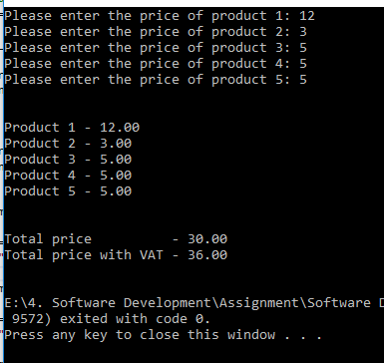
Result: Program ran and calculated total price and total price with VAT correctly.

Decimal values
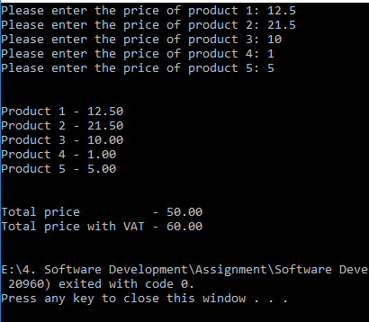
Result: Program ran and calculated total price and total price with VAT correctly.

All zero cost
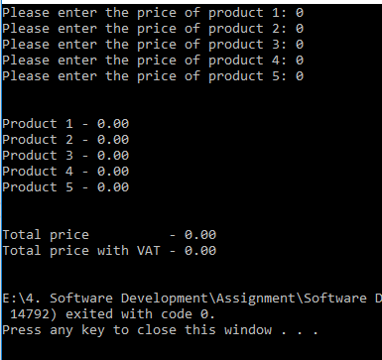
Result: Program ran and calculated total price and total price with VAT correctly.

Negative values
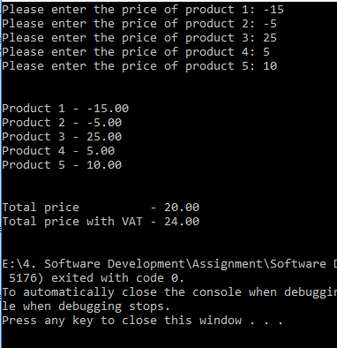
Result: Program ran and calculated total price and total price with VAT correctly.

Value of wrong type
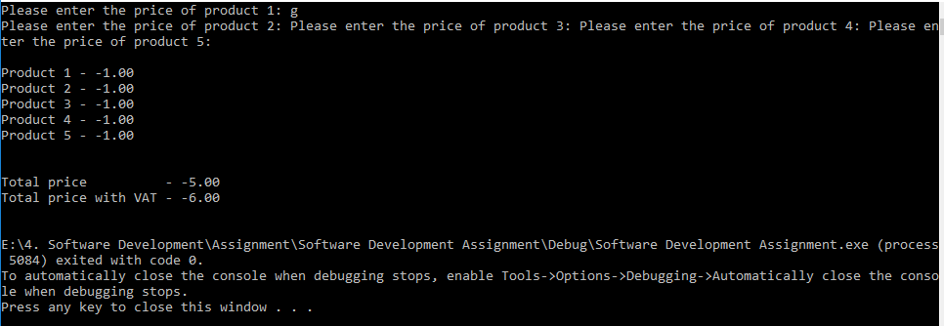
Result: Program interrupted and doesn’t calculate total price or total price with VAT correctly.

Exercise 4

Description
The problem as stated was to build a fruit machine game which represents the 3 reels of symbols using numbers ranging from 1 to 5. Allow the user to have as many goes as they like (the numbers are chosen randomly each time).

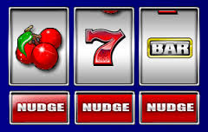

The value of 5 will be treated as the “Jackpot” symbol. The scoring will be as follows:

- Any three of the same numbers (excluding fives) will pay a bonus of 20 points e.g.
4 4 4
3 3 3
1 1 1, etc.

- Any combination of two fives will pay out 100 points e.g.
5 5 3
5 4 5
5 5 1, etc.

- Three fives pay out the big jackpot of 2000 points.

The points the player has scored should be displayed and the player should be asked if they wish to make another spin. It could look something like this:

Non-cumulative score version Cumulative score version
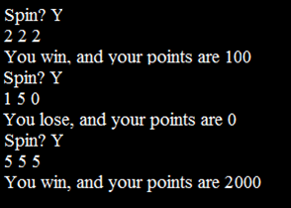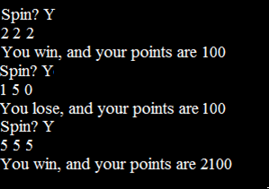

Identify problem
The steps identified in this problem are:
- Create three random numbers from 1 to 5
- Check if all numbers are the same
  - Check if they are 5’s – give 2,000 points
  - If not - give 20 points
- Check if two numbers are 5’s – give 100 points
- Print running total of points
- Ask user if they want to spin again and loop if yes

Pseudocode
Set num1, num2, num3 to 0
set continue to yes

while continue = yes
set num1 to random number from 1 to 5
set num2 to random number from 1 to 5
set num3 to random number from 1 to 5

print the three numbers

if all three numbers are the same
if all numbers are 5's
score += 2000
print new score
else
score += 20
print new score
end if

else if only two numbers are 5's
score += 100
print new score
else
print "bad luck", current score
end if

print "Spin again?"
set continue to input

end while

Implementation
void Exercise_4()
{
/* Define variables */
int num_1, num_2, num_3;
int count = 1, score = 0;
char spin = 'y';
/* ---------------- */

while (spin == 'y') // loop game whilst the user answers yes to "spin again?"
{
/* assign num_1 to num_3 as random numbers between 1 and 5 */
num_1 = (rand() % 5) + 1;
num_2 = (rand() % 5) + 1;
num_3 = (rand() % 5) + 1;
/* ------------------------------------------------------- */

/* print num_1 to num_3 to screen */
printf("\n%d", num_1);
printf(" %d", num_2);
printf(" %d", num_3);
/* ------------------------------ */

/* assess num_1 to num_3 and add respective score to total */
if (num_1 == num_2 && num_2 == num_3) // if all three numbers are the same
{
if (num_1 == 5) // if all the numbers are 5
{
score += 2000;
printf("\nJackpot! Your score is now %d\n", score);
}
else // if all the numbers are the same but not 5
{
score += 20;
printf("\nYou got three of the same number, your score is now %d\n", score);
}
}
else if (num_1 == num_2 && num_1 == 5) // if num_1 and num2 = 5
{
score += 100;
printf("\nYou got two 5's, your score is now %d\n", score);
}
else if (num_1 == num_3 && num_1 == 5) // if num_1 and num3 = 5
{
score += 100;
printf("\nYou got two 5's, your score is now %d\n", score);
}
else if (num_2 == num_3 && num_2 == 5) // if num_2 and num3 = 5
{
score += 100;
printf("\nYou got two 5's, your score is now %d\n", score);
}
else // if three numbers are not the same and no more than one is 5
{
printf("\nYou lose, your score is still %d\n", score);
}
/* ------------------------------------------------------- */

printf("Spin again? (y/n): "); // get user input for whether they want to go again
scanf(" %c", &spin);
spin = tolower(spin); // Make 'spin' lower case, in case they typed 'Y', all other chars will end loop
}
}

Testing

User responds yes to “spin again?”
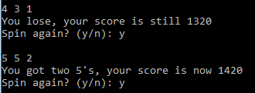
Result: Program ran and generated another set of random numbers.

User responds no to “spin again?”
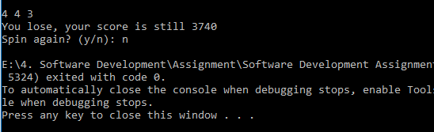
Result: Program ran and stops spinning as expected.

Only two numbers = 5
Result: Program ran and added 100 to the score as expected.

All numbers different
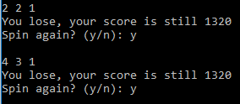
Result: Program ran and added nothing to the score as expected.

All numbers the same but not 5
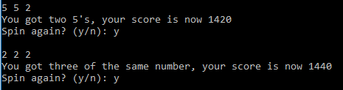
Result: Program ran and added 20 to the score as expected.

All numbers the same and = 5
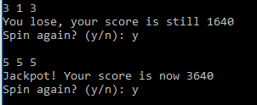
Result: Program ran and added 2000 to the score as expected.

Value of wrong type
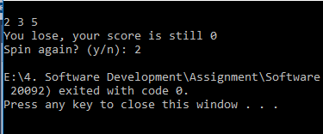
Result: Program ends.

References
[1] M. McGrath, C Programming in easy steps, 4th ed. Leamington Spa: In Easy Steps, 2014.
[2] “When is memory allocated to local variables in C - Stack Overflow,” Stack Overflow. [Online]. Available: https://stackoverflow.com/questions/15385411/when-is-memory-allocated-to-local-variables-in-c. [Accessed: 24-Feb-2019].
[3] “C Variables,” Tutorials Point, 2019. [Online]. Available: https://www.tutorialspoint.com/cprogramming/c_variables.htm. [Accessed: 21-Feb-2019].
[4] R. I. Pitts, “C Strings (Arrays vs. Pointers),” BU CAS CS, 2000. [Online]. Available: https://www.cs.bu.edu/teaching/cpp/string/array-vs-ptr/. [Accessed: 24-Feb-2019].

