Louise Davies 1906903 BMSP4005

DISTINCTIVENESS AND
REGENERATION

INTRODUCTION

This paper will give an appraisal of Blaenavon and will outline ideas for further opportunities for the regeneration of the area. The town is situated in South East Wales and lies at the source of the AfonLwyd River. Its name roughly translates as 'rivers source’ This appraisal will include the historical development and the town's changing fortunes over the years. In 1788 Thomas Hill and his two business partners started an ironworks erecting three blast furnaces. Many people migrated to the town with the prospect of work. In 1860 a shaft was sunk in what has been known as 'The Bit Pit'. It was one of the largest coal mines of its time. In 1870 Gilchrist and Thomas bought steel production to Blaenavon, and the town flourished. It exported steel, coal and iron around the world. Transport systems were put in place, including a tramroad to join Blaenavon with the canal in order to export these three commodities more effectively and efficiently. The fortunes of Blaenavon however, declined over the years but in recent years there has been innovative plans put into place to regenerate the area and give employment and investment opportunities for the community.
This appraisal will also highlight how Blaenavon has managed as a community throughout the years. It will discuss the closure of the Big Pit how this has affected the community of Blaenavon town. It will also include the regeneration of Blaenavon and how this connecting of the Big Pit area to the town to bring in more business and create jobs and money has helped the regeneration for the whole town. This will include the site of Bit Pit becoming a world heritage site in 2000.
Blaenavon harnessed the natural resources in the the Brecon Beacons which were rich in iron-ore, limestone and coal The revolution of Blaenavon started in 1870s, as stated before when Gilchrist and Thomas discovered a revolutionary method to produce steel transforming the industries of Europe and America. (The Blaenavon Story 2020). This steel production was used extensively during the Industrial Revolution for the construction of o railway lines, ships and bridges. Then in 1989 the Blaenavon ironworks harnessed the power of steam to blow air into the huge blast furnaces. Sidney Gilchrist changed the world’s steel industry with a method to remove phosphorus from the iron-ore. However, Blaenavon would not have been this prosperous without their workers of men, woman and children as young as six years old working 12-hour days in complete darkness with nothing but candlelight to keep them going. Visitors nowadays can now experience authentically finished cottages where they lived as to be close to work with no transport about at that time, and a small truck shop where they would spend most of their meagre wages. (Cadw, 2019). Without the use of transport and machines to carry the coal they had to rely on pit ponies to do most of the carrying and pulling of carts as a way of moving the coal around. These pit ponies was the housed down in the mine where they was feed and looked not seeing the light of day, the pit ponies were only let out on a field for two weeks a year where they would go wild, having plenty of room to run around in. the pit ponies was very well looked after more so than the workers as they was a very big part of Blaenavon and was very much needed within the industry. (Evans ,2020). Mining in Wales provided a significant income to its economy of. This use of the coal, iron ore was the key to the Industrial Revolution but this declined over the years and , the pit was closed on 2nd February 1980, with a loss of more than 250 jobs, Blaenavon was one of the last working mines leaving only Blaentillery no.2 drift mine, which closed in 2010 and the Johnson mine in 2013.(C Cleal 2020). However, Blaenavon in order keep jobs and still bring income to the area then re-opened as a museum in 1983. The furnaces are still standing today alongside the foundry, cast house and the water balance tower that would have raised wagons 80 feet in the air. In 2005 Blaenavon won the prestigious prize for being the museum of the year. Blaenavon is one of two remaining mines where it is possible for members of the public to journey underground some 300 ft below while using the same cages that would have transported the miners. While visiting Blaenavon recently I was able to go down the Big Pit and have the experience of what it was like back in the days as a miner and the conditions that the men woman and children had to work in,
FIGURE 1,2,3: Trip to Blaenavon
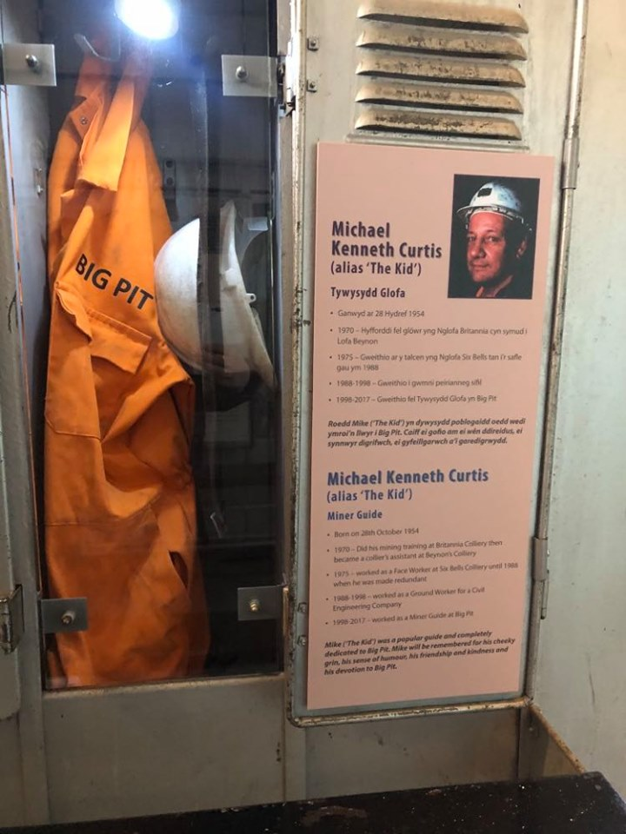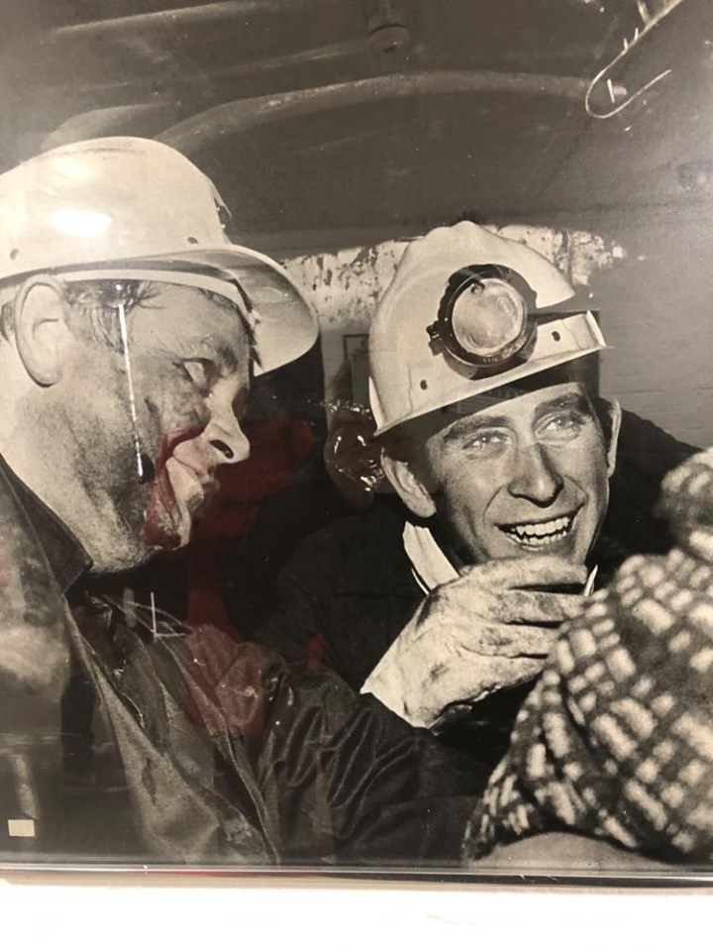
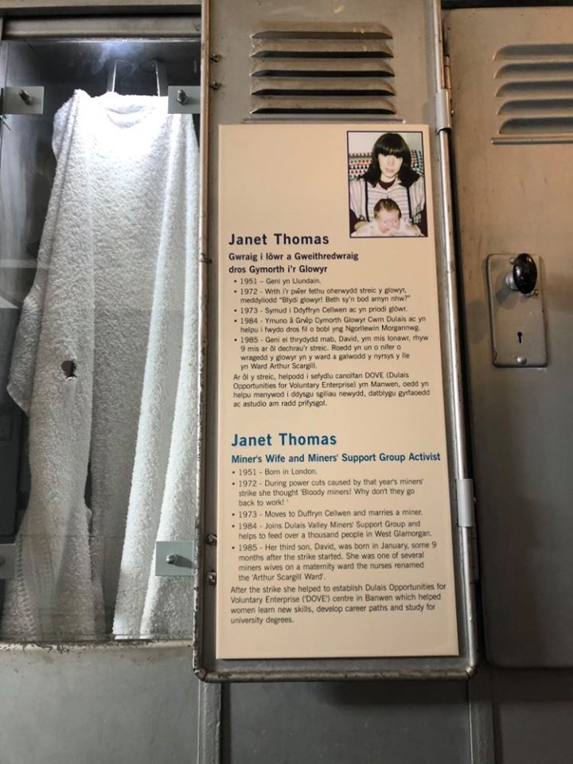

TOWN/TOWN CENTER
Blaenavon is a very small town with very few shops, but Blaenavon has everything they need. Board street has a number of niche traders as well as the sort of shops you would find on any high street, with some award- winning businesses,(Warren,2020) The Artie Craftie that doubles up as the town centre’s only post office, there is also Blaenavon’s cheddar company, The Lion Hotel and the butterflies bar and kitchen, that also runs alongside other stores raging from newsagents ,food, drink crafts jewellery , pet supplies, hair salons and barbers , beauticians, caterers, a florist, funeral directors, hardware and electrical supplies, there is also a tattooist, dog grooming, accountants and a graphic designer and also a photographer this is to just name a few, so as being a small town they have everything they need close by. Blaenavon also has 2 museums and the Big Pit that contributes to the town by bringing in visitors. The town also has a youth club for teenagers that run a different set of courses to help them with things like work, CVS and to help them to communicate if they have any problems they may need to talk about, they also run things for the elderly so they can get together to mix and meet new people, or just have a chat with someone if they are feeling lonely, as so many older people can feel quite isolated and lonely. (Warren, 2020)
Population of Blaenavon:

Further information about the population structure:
MalesFemales49.5%50.5%
Gender | Persons
Males | 2,958
Females | 3,013
Gender (E 2018)
Males | 2,958
Females | 3,013
0-17 years18-64 years65+ years22%19.1%58.9%
Age Groups | Persons
0-17 years | 1,315
18-64 years | 3,516
65+ years | 1,140
Age Groups (E 2018)
0-17 years | 1,315
18-64 years | 3,516
65+ years | 1,140
0-9 years10-19 years20-29 years30-39 years40-49 years50-59 years60-69 years70-79 years80+ years
Age Distribution | Persons
0-9 years | 741
10-19 years | 698
20-29 years | 806
30-39 years | 764
40-49 years | 743
50-59 years | 779
60-69 years | 616
70-79 years | 522
80+ years | 302
Age Distribution (E 2018)
0-9 years | 741
10-19 years | 698
20-29 years | 806
30-39 years | 764
40-49 years | 743
50-59 years | 779
60-69 years | 616
70-79 years | 522
80+ years | 302
UK Republic of Ireland EU (other)other passport tno passport30.3%68.4%
Passport | Persons
UK | 3,872
Republic of Ireland | 8
EU (other) | 28
other passport | 36
no passport | 1,715
Passport (C 2011)
UK | 3,872
Republic of Ireland | 8
EU (other) | 28
other passport | 36
no passport | 1,715
UK Republic of Ireland EU (other)Othercountry97.9%
Country of Birth | Persons
UK | 5,530
Republic of Ireland | 14
EU (other) | 39
Other country | 64
Country of Birth (C 2011)
UK | 5,530
Republic of Ireland | 14
EU (other) | 39
Other country | 64
White Asian Mixed/multipleOther98.6%
Ethnic Group | Persons
White | 5,566
Asian | 45
Black | 4
Arab | 2
Mixed/multiple | 27
Other ethnic group | 3
Ethnic Group (C 2011)
White | 5,566
Asian | 45
Black | 4
Arab | 2
Mixed/multiple | 27
Other ethnic group | 3
Christian Hindu Buddhist Other religion No religionOther43.9%55%
Religion | Persons
Christian | 2,887
Muslim | 2
Hindu | 15
Buddhist | 15
Other religion | 25
No religion | 2,303
Religion (C 2011)
Christian | 2,887
Muslim | 2
Hindu | 15
Buddhist | 15
Other religion | 25
No religion | 2,303
Figures from Blaenavon in Torfaen wales/ cymru
FEELINGS HARDSHIP WORKPLACE AND SUPPORTING EACHOTHER.
Blaenavon is a very close-knit community where they are there to help each other in their times of need they stand and support each other in the most difficult times. Blaenavon is a small and quiet town and they are happy with the way things are there, and are not very accommodating to change as they think that having more places like a big shopping centre and activity centres would not benefit the community as this would bring in more people, more houses being built and as they say, the crime rate would most defiantly go up. The people of Blaenavon love the small community as it is as for a lot of them have retired there after working there for many years within the big pit and with having all the memories there would not want things to change, even if this means bringing more money to the community as a whole.(survey 2020)
The people of Blaenavon say, after having a conversation with them, that a lot of people there have had bad experiences after working down the mine for many years, the shops are very dark and not very inviting, things like the museum need a lot of work doing on them that they just have not got the money there to have this done, not a lot to be done for the younger generation apart from hang around the streets.
How the closure of Blaenavon affected people, that had to move away for work due to the lack of transport.
After talking to the community of Blaenavon transport has always been a problem for most of the community who lived there, most people who worked within the big pit lived on site as there was not any transport about at that time, and because of the work pattern was easier for them as it was dark going to work and dark coming home, after the closure of the big pit a lot of people had to move away from Blaenavon closer to towns and cities for work as transport in Blaenavon was non-existent and this made it impossible for people to find work. Transport is better there now as they do have busses and a train station that is really helpful to the community of Blaenavon, so there is the opportunity for the community to find work out of the town, middle class and slandered class people, there living standard increased where the working class continued to struggle. (Rene,2019). At the start of the 2011/12 financial year, as a Council, we agreed a new Corporate Plan. This plan was needed as our first five-year Corporate Plan ended in March 2011. (Torfaen county borough 2013)

REGENERATE BLAENAVON
Blaenavon rest bite centre.
Blaenavon activity centre and camp site.
Blaenavon Them park.
The plan to regenerate Blaenavon is to use up some of the unused space to regenerate and build up business for the area of the Big Pit and to bring more to the town, with more job opportunities, more money and more tourism,
The plan that would benefit the town of Blaenavon best would be the Blaenavon activity centre and camp site, as this would bring in school for trips, family’s for holidays.
The plan to build a big glass dome with the activity centre inside so this could be used all year round, with log cabins/ chalets to give you that feel of the great outdoors, and to also fit in with the country feel of Blaenavon and the Big Pit. This would then bring more people to the town that has plenty to offer with open space and public paths to explore this beautiful town with a spot of lunch of back to the camp site for a lovely BBQ. This would benefit family’s that want to spend quality time together with plenty of fresh air and plenty of things to do.
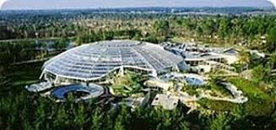

Figure 4: google images.
This would be the idea of the dome to have most of the activity’s inside, so it come be used throughout the year. With this being used would also make many more visitors come to Blaenavon and would benefit the town in so many ways.
The idea of the log cabins would be that families would have their own space to relax in and unwind, especially with having children.

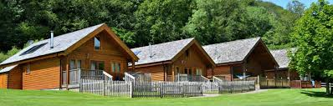

Figure 5: google images.

This would be talked about by funding form the local council, so planning permission would need to be discussed, if not maybe this could be funded by the national lottery or from a charity.

References
Cadw(2019) Visit Blaenavon Ironworks Available at
https://cadw.gov.wales/visit/places-to-visit/blaenavon-ironworks (Accessed on 30th April 2020)
Christopher Cleal (2020) Available at:
https://museum.wales/bigpit/ (Accessed on 12 May 2020)
Blaenavon in Torfaen wales/cymru 2020 Available at
https://www.citypopulation.de/php/uk-wales.php?cityid=W37000366 (Accessed on 11 May 2020)
Evans, J. (2020). Blaenavon Ironworks. Available at
http://cadw.gov.wales/daysout/blaenavonironworks/?lang=en (Accessed on 8thMay 2020)
Google images: Available at:
https://www.mumsnet.com/Talk/am_i_being_unreasonable/2201729-To-have-genuinely-thought-Center-Parcs-was-enclosed-in-a-giant-bubble (Accessed on 11 May 2020)
google images: Available at:
https://www.northcoastlogcabins.com/(Accessed on 11 May 2020)
Rene, O (2019). Blaenavon. Available athttps://www.heritagefund.org.uk/news/25-years-restoring-prosperity-and-pride-blaenavon. Last accessed 19/02/2020 (Accessed on 8 May 2020)
Survey from the community (2020)
The Blaenavon Story (2020) Available at
https://www.visitblaenavon.co.uk/en/WorldHeritageSite/TheBlaenavonStory/BlaenavonStory.aspx (Accessed on 11 May 2020)
Torfaen county borough 2013. Available at
https://www.torfaen.gov.uk/en/Home.aspx (Accessed on 30 May 2020)
Warren, K (2020) Events Available at
http://www.blaenavontowncouncil.co.uk/events/(Accessed on 6thMay 2020)

