AHHI6012 Imagining the City: The Urban Experience, c. 1851–Present
PART ONE: CAPITALS OF MODERNITY
Paris: Capital of the 19th Century (Weeks 2–3)
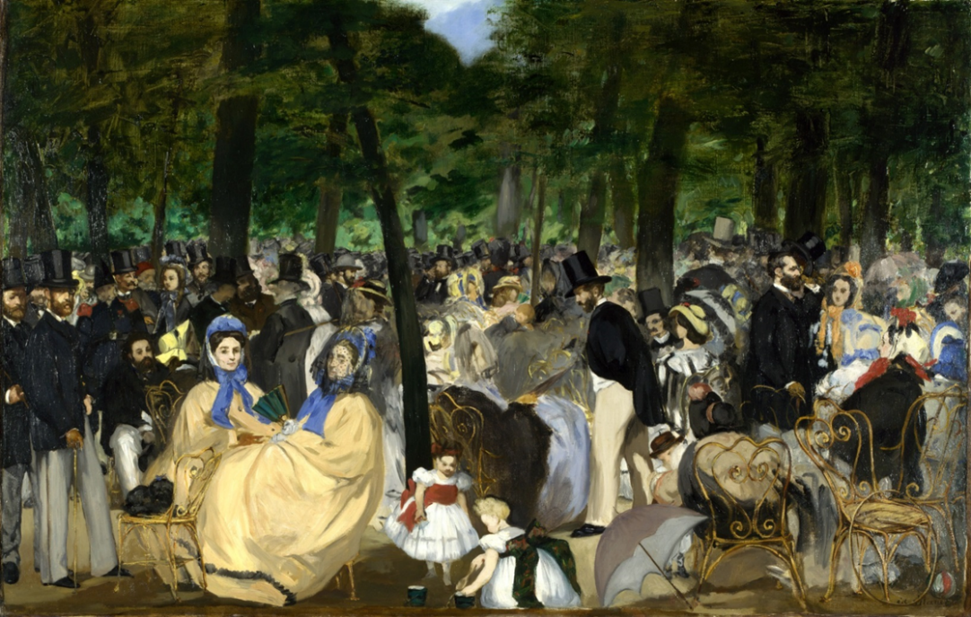
Édouard Manet, Music in the Tuileries Gardens, 1862
Lectures summary:
These lectures elaborate our exploration of the how cities – and one particular city, Paris – were conceptualised and understood as distinctively modern in the nineteenth century. In doing so, it concentrates on famous essays by Charles Baudelaire, the nineteenth-century Parisian poet who coined the term modernité (modernity), and Walter Benjamin, whose Arcades Project was structured around the idea that Paris was ‘Capital of the Nineteenth Century.’ This picks up from our analysis of Edgar Allan Poe’s story ‘The Man of the Crowd,’ which Baudelaire cited as a key inspiration for his ideas.
Our first lecture begins by enumerating some of the grand claims about Paris’s reputation as the capital of modern urban culture. While students are encouraged to retain scepticism about such lofty premises, the lecture then moves on to thinking the ways Victorian Paris can indeed be regarded as distinctive and paradigmatic – especially with regards the legacies of its status as a crucible of revolutions from the late eighteenth century and throughout the nineteenth-century (and, perhaps, beyond). We will pay specific attention to Paris during the Second French Empire (1852–1870), and the remaking of its cityscape under the stewardship of Baron Georges-Eugène Haussmann, Prefect of the Seine department. After contemplating Haussmanisation’s legacies, our focus shifts to the Third Republic era (1870 onwards) and contrasting how competing notions of the Belle Époque (a celebration of the city of light) versus the Fin de Siècle (end-of century, millennial anxiety) were imagined and performed during the decades prior to World War One.
The Friday lecture concentrates on Paris not as a staging ground for grand revolutions, but as a place in which new culture identities were expressed and enacted at a street level. Our entry route is provided by the writings of Charles Baudelaire. We will discuss Baudelaire’s theorisation of the flâneur as a metropolitan archetype, plus the ways literature and art responded to the challenge of ‘painting modern life.’ Here, we will look at paintings by Constantin Guys (aka ‘Monsieur G’), a favourite of Baudelaire’s, as well as lyric and prose poems penned by Baudelaire himself. In closing, the lecture problematizes the types of city-walking, city-watching and city-writing valorised by Baudelaire and other Parisian artists (e.g. the Impressionists) by contemplating the alternative viewpoint advocated by early feminists such as Marguerite Durand.

Required reading and other preparation:
Week 2 (February 8 lecture)
Background reading:
- Walter Benjamin, ‘Paris, Capital of the Nineteenth Century’ (1939 version) in Benjamin, The Arcades Project, translated and edited by Howard Eiland and Kevin McLaughlin (Harvard: Cambridge, Massachusetts, 1999), pp.14–26.
Week 3 (February 15 lecture)
Required reading and other preparation:
- Charles Baudelaire, Sections I–IV and IX–XIII from ‘The Painter of Modern Life’ in Baudelaire, The Painter of Modern Life and Other Essays, edited by Jonathan Mayne (Phaidon: London, 1995 [1863]), pp. 1–15, 27–40
- Charles Baudelaire, selections from Paris Spleen and The Flowers of Evil
- Constantin Guys paintings
Background reading:
- David Frisby, ‘The City Observed: The Flâneur in Social Theory,’ Cityscapes of Modernity: Critical Explorations (Malden, Massachusetts: Polity Press, 2001), pp. 27–51.
- Ben Highmore, ‘City of Attractions: Commodities, Shopping and Consumer Choreography,’ Cityscapes: Cultural Readings in the Material and Symbolic City (Basingstoke: Palgrave Macmillan, 2005), pp. 45–69.

Preparing for the lectures:
The required readings all gravitate around the ideas of Charles Baudelaire and his essay ‘The Painter of Modern Life,’ a formative enquiry into the distinctiveness of modernity (Baudelaire’s own phrase). A key reference point is Baudelaire’s essay is ‘The Man of the Crowd’: as such, having a good grasp of Poe’s ideas will help get a sense of what most interests Baudelaire about modern cities. Having read Baudelaire’s’ essay, try and relate the other materials to it. First, look to see whether Baudelaire applied his ideas about modernity, modern art and the modern city to his own writings – both the lyric poems in The Flowers of Evil and the experimental essay-style prose poems in Paris Spleen. Secondly, try and relate Baudelaire’s writings to the work of Constantin Guys, his eponymous ‘painter of modern life’: in what ways do Guys’ paintings exemplify or magnify Baudelaire’s theories about Paris?
Brave students may also wish to tackle the Walter Benjamin that is assigned as background reading. It is a difficult text. Benjamin is an enigmatic writer, and some of his references and turns of phrase go over the heads of even avid readers of his work. Do not worry if you cannot follow absolutely everything he has to say. The more important thing is to formulate a general sense of why Benjamin, a la his idol Baudelaire, thought nineteenth-century Paris was the apogee (if not birthplace) of industrial capitalism and consumer culture. Highmore and Frisby’s essays are more straightforward coverage of key ideas associated with Parisian modernity.
Students may also wish to consult the timeline below for some chronological context:

Questions to consider:
Baudelaire, ‘The Painter of Modern Life’
- Baudelaire begins his essay by discussing fashion. Why do you think he choose to do so? Why would fashion, and fashions, be a revealing characteristic of ‘modern life’ in the city?

- Baudelaire is famed for his valorisation of the flâneur as an ideal denizen of the modern metropolis. Who is ‘the flâneur’? What are the characteristic traits of a flâneur’s appearance and behaviour?

- Why does Baudelaire celebrate the practice of flânerie? What insight does he think it offers into the experience of ‘modern life’ in the city?

- ‘The Painter of Modern Life’ is renowned for Baudelaire’s coining of the term ‘modernity.’ How does he define modernity? What are its key features? In what ways does he think modernity has evinced a breakaway from previous modes of perceiving and experiencing the city?

- Baudelaire discusses Edgar Allan Poe’s ‘The Man of the Crowd’ in the essay (p. 7). Can you detect overlaps detect between Baudelaire’s ideas and those of Poe? Are their interpretations and descriptions of the city similar in any way? What insights does Baudelaire derive from Poe’s work, and how might they enable us to interpret Baudelaire’s own writing?

Baudelaire, Paris Spleen and The Flowers of Evil
- To what extent does Baudelaire’s own poetry exemplify the ideas forwarded in ‘The Painter of Modern Life’? Are the principles of that essay put into practice in Paris Spleen and The Flowers of Evil? If so, how and in which poems particularly?

Guys paintings
- Guys (‘Monsieur G’) is the eponymous ‘painter of modern life’ in Baudelaire’s essay? What does Baudelaire value about Guys’ paintings? Do his poems and Guys’ paintings share any similar subject matters or common artistic ‘sensibilities’?

- Do Guys’ paintings remind you of any other artworks? If so, which ones and why?

- What criticisms might be directed at the depiction of the city favoured by Guys and, by proxy, Baudelaire? Might different constituencies and social groups offer a different perspective on the city to the one advocated by ‘The Painter of Modern Life’ essay and Guys’ art?

Background reading
Benjamin, ‘Paris, Capital of the Nineteenth Century’
- Benjamin places great stock on the importance of Baudelaire’s work. Why? What does he appreciate in Baudelaire’s writing? What insights does he think he offers about nineteenth-century Paris? What does he say about flânuers and flânerie?

- Benjamin places great stock on the importance of the Parisian arcades as an exemplar of modern urban culture. What were the distinctive features of shopping arcades? What was on show there? How did people behave in the arcades? And why, in Benjamin’s eyes, does any of this make the arcades paradigmatic of modernity and nineteenth-century Paris?

- The phrase ‘phantasmagoria’ is used repeatedly by Benjamin. What do you understand by this term? What is a ‘phantasmagoria’? Why does Benjamin place such stock on it? How might phantasmagoria be important to the ideas forwarded in the rest of Benjamin’s essay?

- What significance does Benjamin to the following:
- Domestic interiors;
- International expositions;
- Haussmann’s renovation of Paris;
- Barricades?

TIMELINE OF FRENCH/PARIS HISTORY C. 19TH CENTURY
1789
Storming of Bastille; beginning of French Revolution.
Constitutional Monarchy installed under principles of Declaration of Rights of Man and the Citizen
1792
Monarchy falls and the First Republic is proclaimed.
The French First Republic (1792–1804)
1793
Louis XVI guillotined; Louvre becomes a public museum.
1793–1794
Robespierre’s Reign of Terror
1794
Robespierre and members of the revolutionary tribunal guillotined.
1799
Napoléon Bonaparte stages coup and imposes dictatorship.
1803–1815
Napoleonic Wars
The First French Empire (1804–1814, 1815)
1804
Napoleon declares himself Emperor of the French, formally abolishing First Republic; introduction of Napoleonic Code
1814–1815
Defeats in Europe lead to Napoleon being exiled to Elba
1815
Bapoleon returns to France; eventually defeated in Battle of Waterloo; monarchy re-established; Napoleon exiled to St Helena
Bourbon Restoration (1814 –1815, 1815–1830)
1830
July Revolution: Charles X is overthrown and replaced by Louis-Philippe, the Citizen King.
House of Orleans (1830–1848)
1832
June Rebellion (unsuccessful)
The French Second Republic (Feb1848–Dec1852)
1848
(February) Barricades erected during 3-day civil strife mark another revolution and the proclamation of the Second Republic.
June Days uprising (unsuccessful)
Napoleon III elected president (Dec 1848)
1851
Coup of 1851 – dissolution of National Assembly
Second French Empire (1852–1870)
1852
Empire re-established
1870
Abdication of Napoleon III
Defeat in Franco-Prussian War
The French Third Republic (1870–1940)
1871
Paris Commune (eventually suppressed)

Further reading:
Select bibliography
Atget, Eugène. Eugène Atget: A Selection of Photographs from the Collection of the Musée Carnavalet, Paris (London: Thames and Hudson, 1989).
Baudelaire, Charles. The Painter of Modern Life and Other Essays (London; Phaidon, 1995 [1863]).
—. Selected Poems (Harmondsworth, Middlesex: Penguin, 1975).
Benjamin, Walter. The Arcades Project (Cambridge, Massachusetts: Harvard University Press, 2002). Available: http://monoskop.org/images/e/e4/Benjamin_Walter_The_Arcades_Project.pdf).
—. Charles Baudelaire: A Lyric Poet in the Era of High Capitalism (London: Verso, 1983).
Brodersen, Momme. Walter Benjamin: A Biography (London: Verso, 1996).
Buck-Morss, Susan. The Dialectics of Seeing: Walter Benjamin and the Arcades Project (Cambridge, Massachusetts: MIT Press, 1989).
Charney, Leo and Vanessa R Schwartz, eds. Cinema and the Invention of Modern Life (Berkeley: University of California Press, 1995. Essays by Jonathan Crary, Marcus Verhagen, Jeannene M Przyblyski, and Vanessa R Schwartz.
Cohen, Margaret. Profane Illumination: Walter Benjamin and the Paris of Surrealist Revolution (Berkeley: University of California Press, 1993).
Harsin, Jill. Policing Prostitution in Nineteenth-Century Paris (Princeton, New Jersey: Princeton University Press, 1985).
Edwards, Stewart. The Paris Commune 1871 (London: Eyre and Spottiswoode, 1971).
Farwell, Beatrice. Manet and the Nude: a Study in Iconography in the Second Empire (New York: Garland Publishing, 1981).
Frascina, Francis. Modernity and Modernism: French Painting in the Nineteenth Century (New Haven, Connecticut: Yale University Press, 1993).
Fuchs, Rachel Ginnis. Poor and Pregnant in Paris: Strategies for Survival in the Nineteenth Century (New Brunswick, New Jersey: Rutgers University Press, 1992).
Gilloch, Graeme. Myth and Metropolis: Walter Benjamin and the City (Cambridge: Polity, 1996).
Greenhalgh, Paul. Ephemeral Vistas: The Expositions Universelles, Great Exhibitions and World’s Fairs, 1851–1939 (Manchester: Manchester University Press, 1988).
Harvey, David. Paris, Capital of Modernity (London: Routledge, 2003). **not in library. Available here: http://14.139.206.50:8080/jspui/bitstream/1/2389/1/Harvey,%20David%20-%20Paris%20Capital%20of%20Modernity.pdf.
Hazan, Eric. The Invention of Paris: A History in Footsteps (London: Verso, 2011 [2002]).** not in library
Heiting, Manfred. Man Ray, 1890–1976 (Los Angeles: Taschen, 2008).
Jones, Colin. Paris: A Biography of the City (London: Penguin, 2006).
Margadant, Jo Burr. The New Biography: Performing Femininity in Nineteenth-Century France (Berkeley : University of California Press, 2000).
Metropolitan Museum of Art. ‘Charles Marville: Photographer of Paris,’ exhibition and collection (http://www.metmuseum.org/exhibitions/listings/2014/charles-marville; http://www.metmuseum.org/exhibitions/objects?exhibitionId={21968755-5DDD-4FEA-81C5-000D8AAAF6B3}&rpp=60&pg=2).
—. ‘Paris as Muse: Photography, 1840s–1930s,’ exhibition and collection (http://www.metmuseum.org/exhibitions/listings/2014/paris-as-muse; http://www.metmuseum.org/exhibitions/objects?exhibitionId={3225B21D-CEF5-4AB9-89F4-E1094B1D24E4}&rpp=60&pg=1).
Miller, Michael B. The Bon Marché: Bourgeois Culture and the Department Store, 1869–1920 (Princeton, New .Jersey: Princeton University Press, 1981).
Olsen, Donald J. The City as a Work of Art: London, Paris, Vienna (New Haven: Yale University Press, 1986).
Prendergast, Christopher. Paris and the Nineteenth Century (Oxford: Blackwell, 1992).
Raymond, Marcel. From Baudelaire to Surrealism (London: Methuen, 1970).
Réda, Jacques. The Ruins of Paris (London: Reaktion Books, 1996).
Richardson, Joanna. ‘The Painter of Modern Times: Constantin Guys’ History Today (Vol. 24, No. 1, November 1974), pp. 789–793.
Roberts, Mary Louise. ‘Acting Up: The Feminist Theatrics of Marguerite Durand,’ French Historical Studies (Vol. 19, No. 4, Autumn 1996), pp. 1103–1138.
—. Civilization Without Sexes: Reconstructing Gender in Postwar France, 1917–1927 ( Chicago: University of Chicago Press, 1994).
Ross, Kristin. The Emergence of Social Space: Rimbaud and the Paris Commune (Basingstoke: Macmillan, 1988).
Schivelbusch, Wolfgang. Disenchanted Night: The Industrialization of Light in the Nineteenth Century (Berkeley: University of California Press, 1988).
Schlör, Joachim. Nights in the Big City: Paris, Berlin, London 1840–1930 ( London: Reaktion Books, 1998).
Silver, Kenneth E. Esprit de Corps: The Art of the Parisian Avant-Garde and the First World War, 1914–1925 (Princeton, New Jersey: Princeton University Press, 1989).
Sutcliffe, Anthony. Paris: An Architectural History (New Haven: Yale University Press, 1993).
Tester, Keith, ed. The Flâneur (London: Routledge, 1994).

