Task five – Fact sheet Learning and Development
Q1- AC 6.1:
Learning and development is about making sure that employees have the right skills and knowledge to fulfil their roles, meet the needs and vision of the business and for the employees’ successful future development and progression within the organisation. Learning and development (L&D) is about ‘building a culture of continuous learning throughout the organisation that emphasises the role of coaching, feedback, leadership and ownership’ (Baele, 2022) and it is key to the growth and success of any organisation.
There are many ways in which investing in learning and development will benefit both the Sales Assistants and Clean Quarter Ltd and these include:
Increased skills and knowledge: ‘Not providing employees with proper training is a cause for human error’ (Fitzgerald, 2023). Through providing training and learning opportunities to employees, you can identify specific areas that need improvement and address these quickly to prevent unnecessary future mistakes. Staff may not have previously worked in a similar position and therefore not have the required knowledge to fulfil their role, leading to potential big errors. Clean Quarter Ltd can adapt training to meet individual needs which will lead to a more skilled and competent Sales Team.
Enhanced behaviours: Research has shown that employees who feel that their employer is invested in their growth and professional development are happier, more engaged and motivated in their role. According to Culture Partners (2024), investing in employees’ development ‘shows that the organisation cares about their professional growth, leading to increased job satisfaction and decreased turnover rates’. Employees will feel empowered and confident in their abilities, be willing to go the extra mile and it will reduce poor behaviours which could result in disciplinary procedures. L&D helps to create a skilled and motivated workforce that contributes to the success of the organisation.
Enhanced organisational culture: Having a robust L&D plan in place, leads to employees feeling empowered to deal with workplace challenges and reduces their reliance on supervision. This fosters a trusting environment in which employees feel motivated to succeed, enhancing team performance and leading to a more efficient workforce. According to Wiltshire (2024), L&D has ‘more opportunity to impact culture than any other area within an organisation’. If Clean Quarter Ltd commits to their employees L&D, it will help employees understand the values visions and policies of the company. Customers will benefit from improved service quality, positively impacting their perception of the business and leading to positive word-of-mouth referrals, customer loyalty and increased profits.
Q2- AC 6.2:
There are many different learning needs, and it is important to identify these within Clean Quarter Ltd not just when performance issues arise but also because the work environment is ever-changing and external factors influence how businesses operate. PESTLE stands for the key external factors which affect business, and these are:
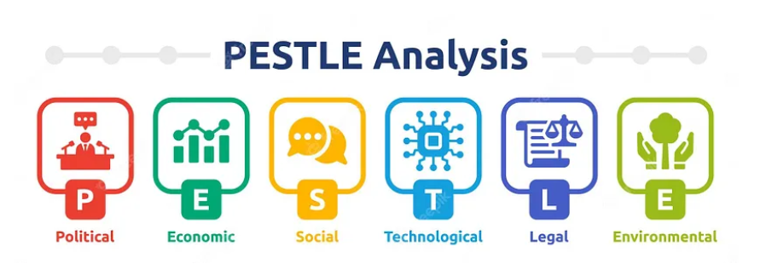
(Mukherjee, 2023).
Learning needs in a sales environment might include IT skills when dealing with online orders, complaint handling skills when issues arise with customers not being happy with a product, problem-solving skills when things do not go to plan and communication skills which are key to building a rapport with customers and encouraging them to shop with you again. According to CIPD, the most effective way of identifying these skills gaps is by knowing the business’s current and future capability needs, looking at the existing levels of skills in the team and knowing what their attitudes and knowledge are.
Q3- AC 6.3:
Once the learning needs have been identified, there are a variety of different L&D methods and when deciding on which one is best suited for the Sales Assistant role, it is not advisable to take a one size fits all approach as people have different learning styles. You can identify learning styles by getting employees to do a learning style quiz showing how everyone learns most effectively, and which approach will be most successful.
Different learning and development styles include:
Facilitation: This approach is about engaging the learner to take more responsibility for their own learning and development as it will be more effective. ‘The facilitator helps the group work better together by creating synergy, coming up with new ideas, and reaching agreements.’ (ald, 2024). The trainer essentially facilitates, organises and provides resources for the students to learn from each other and find solutions to problems.
Mentoring: Traditional mentorship is where a more experienced colleague provides direct support to a less experienced member of staff. This involves providing advice about the role and the business, giving feedback, helping to find solutions when problems arise and providing guidance on expected behaviour, values and attitude. This type of learning method has been shown to positively support an employee’s wellbeing and helps to improve employee retention. According to Cronin, ‘89% of those who have been mentored will also go on to mentor others, and so contribute to this cycle of learning and development within an organisation.’ (2023).
Coaching: This style is about focusing on an individual’s specific skills and goals and is aimed at optimising their performance at work. There is usually a set amount of time that the employee will be coached for to achieve the desired result and the coach should be trained in coaching skills. The goal is to ‘unlock a person's potential to maximise their performance (Imperial, 2024).
Training: This focuses on one person passing on their knowledge to another and it can be delivered face to face or online via e-learning, and both methods have their advantages and disadvantages. An advantage of face-to-face training is the immediate feedback available between the learner and instructor, it is a more dynamic and sociable setting and keeps the learner engaged which may lead to better retention. It also enables the instructor to assess and adapt their learning style dependent on the needs of the group.
Advantages of e-learning include reduced costs for the business as you do not have to pay for travel or an instructor, the training location is adaptable meaning more flexibility for employees and there is also the element of speed, you can log onto the training and complete it at any time which aids the process of onboarding.
Most organisations do not just stick to one style of learning and opt to take a blended learning approach which includes some online training and some in-person training to provide employees which both individual and group learning opportunities. According to Wait et al, ‘using different approaches is more likely to stimulate and interest learners which results in deeper learning’ (p. 218, 2023). By incorporating a blended approach to L&D, you can ensure that you are catering to different employees learning styles.
Q4- AC 6.4:
Employees have different ways of learning and according to Rusconi, ‘in the age of digital transformation and remote work, diversity in learning styles is as crucial as any other form of diversity’ (2023). By knowing the communication styles of your employees, you can tailor your L&D design and implementation not only to the specific needs of the employee but also deliver it in a way that they will best receive it. This approach is respectful and inclusive of preferences and helps to create a successful business and culture of communication awareness, collaboration, trust, and diversity.
The VARK model identifies 4 different types of learners:
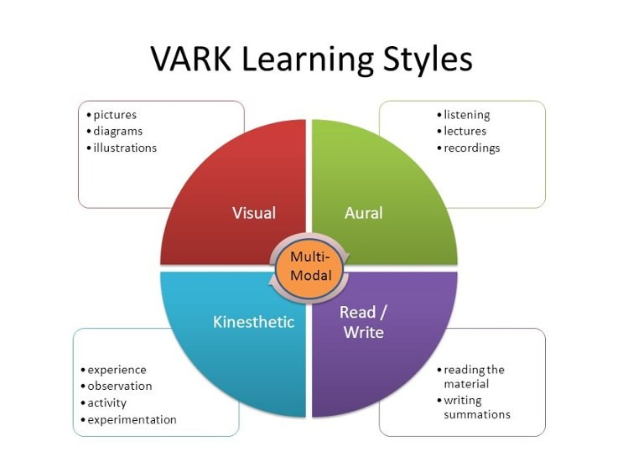

(Sessa, 2018)
Q5- AC 6.5:
Effectively evaluating L&D and its impact is important to the success of any business as it provides valuable information as to whether the organisational needs are being met, whether the money spent is justified and whether the methods in place are working.
To evaluate this effectively, two commonly used methods are:

The Kirkpatrick model:
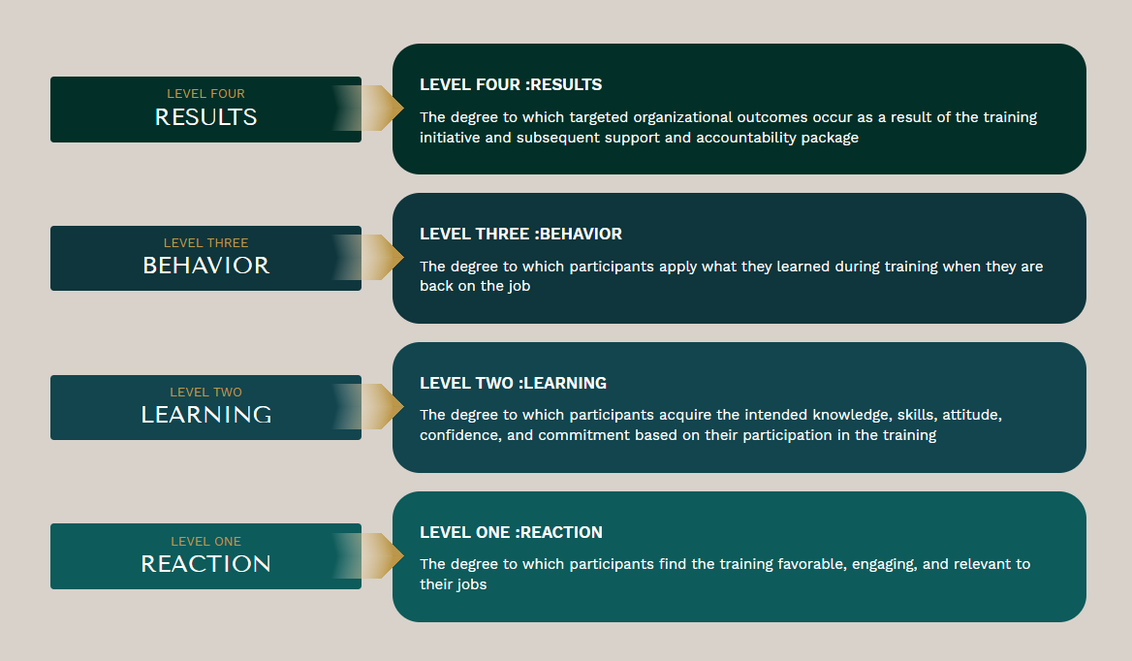
(Kirkpatrick, 2024)
This is a tool which helps businesses evaluate and analyse the results of L&D programs. The concept is that for each level you will ask the employee specific and targeted questions and once you have the answers you will have a precise measurement of the effectiveness.
Training feedback forms and surveys: These methods are commonly used ways of understanding how effective employees found the L&D program to be. The instructor can hand out feedback forms for completion to see which areas can be improved and surveys are a great way to capture people’s thoughts as these can also be anonymous meaning people will be more honest with their feedback.
Words: 1372

References
Ald (2023) What is facilitation? An introduction. Available at: https://www.td.org/talent-development-glossary-terms/what-is-facilitation (Accessed: 01 August 2024).
Baele, S. (2022) The ever-growing importance of L&D in the future of work. Available at: https://www.ey.com/en_be/workforce/the-ever-growing-importance-of-l-d-in-the-future-of-work (Accessed: 20 July 2024).
CIPD (2023) Learning evaluation, impact and transfer. Available at: https://www.cipd.org/uk/knowledge/factsheets/evaluating-learning-factsheet/ (Accessed: 20 July 2024).
Cronin, N. (2023) Mentoring in the Workplace: Why It Matters. Available at: https://guider-ai.com/blog/why-everyone-needs-mentoring-in-the-workplace/ (Accessed: 21 July 2024).
Culture Partners (2024) Employee Development: Investing in Growth Opportunities. Available at: https://culturepartners.com/insights/employee-development-investing-in-growth-opportunities/#:~:text=Employees%20who%20feel%20valued%20and,satisfaction%20and%20decreased%20turnover%20rates (Accessed: 20 July 2024).

Fitzgerald, A. (2023) Human Error Prevention: 11 Tips to Reduce Workplace Mistakes. Available at: https://secureframe.com/blog/human-error-prevention (Accessed: 01 August 2024).

Imperial (2024) Using a coaching approach. Available at: https://www.imperial.ac.uk/academics-success-guide/leading-your-research-group/managing-your-teams-performance/support-to-enhance-performance/using-a-coaching- approach/#:~:text=Coaching%20is%E2%80%A6%20%E2%80%9Cunlocking%20a%20person%27s,of%20%27Coaching%20for%20Performance%27%202017 (Accessed: 01 August 2024).

Kirkpatrick (2024) What is the Kirkpatrick Model? Available at: https://www.kirkpatrickpartners.com/the-kirkpatrick-model/ (Accessed: 26 July 2024).

Mukherjee, A. (2023). How to Conduct a PESTLE Analysis for Your Business. Available at: https://medium.com/@anirbanmukherjee1311/pestle-analysis-c6b822164d4 (Accessed: 01 August 2024).

Rusconi, G. (2023) How to Accommodate Different Learning Styles in the Workplace. Available at: https://cloudassess.com/blog/how-to-accommodate-different-learning-styles/ (Accessed: 21 July 2024).

Sessa, D. (2018) We All Learn Differently: VARK. Available at: https://www.linkedin.com/pulse/we-all-learn-differently-vark-davin-sessa/ (Accessed: 01 August 2024).

Waite, K. et al. (2021) People Practice a Complete Guide. London: Kogan Page Limited.

Wiltshire, V. (2024) Workforce development. Available at: https://trainingindustry.com/magazine/spring-2022/lds-role-in-developing-company-culture/ (Accessed: 01 August 2024).

