BMSK7004D FINAL Assessment.

Critical Reflection of a SL project/venture
For the final assessment of this module, you will need to select a project/venture from your local context that you feel is making a positive contribution (however small) to the concept of sustainable leadership.
In an essay format, provide a critical reflection of 3,500 words, in which you explain how and why the selected project/venture is a good example of sustainable leadership, supporting this with clear argumentation or evidence.
You may also wish to consider how actions are considered in the context of any theory acquired or practice you have identified throughout the course of the module. You could also consider key lessons, or recommendations for their approach in the future.

The Brynwhillach solar farm.
The project that I have chosen is Morriston hospital’s Brynwhillach solar farm, it is the first project of its kind in Wales that is purpose built to service the needs of the hospital, with the hopes in future of becoming self-sustainable.
The project was developed to supply the hospital with its own power supply, making the hospital more sustainable by reducing the costs that they would be paying to the energy companies, which are increasing dramatically at the moment, Swansea Bay spends around £6.9 million a year on electricity, gas water, and sewage treatment. This is expected to rise year on year, at a rate higher than inflation. (NHS Wales, 2021)
The investment in the solar farm and energy-reducing schemes will lead to a minimum guaranteed saving of more than £1.5 million a year. It will also reduce carbon emissions by around 3,000 tonnes a year.
The £5.7 million, 4MW (Mega Watt) solar farm is linked directly to the hospital via a 3km cable that has powered the hospital for fifty hours since November 2021, saving the hospital £120,000 on its electricity bill. It is projected to save the hospital £500,000 once fully operational and the health board hopes the sector will be operating at carbon-neutral by 2030.
In addition to powering the hospital, the solar farm has created an additional 30,000KWH that has been re-directed into the national grid, creating additional income for the hospital. (Lempriere, 2022)
Images of the Brynwhillach solar farm, and of its position in relation to the hospital can be found in Appendix’s 1 and 2.
Scott Lutton is quoted. “As energy security is paramount to the NHS, the solar farm underwent a rigorous testing period and met all the requirements of the local distribution network operator. Once it successfully passed these requirements the system went live and is now supplying zero-carbon electricity to the hospital.” (BBH Building Better Healthcare, 2021)
Chair of Swansea University Health Board, Emma Woollett, said: “The solar farm will play an important part in achieving that aim, but there is also an additional benefit in terms of cost savings. It is not only lowering our electricity costs every day, but on some days covering 100% of our electricity needs.
With the current volatile situation with energy prices, this really shows that the investment and the long-term thinking on behalf of the health board has paid off.” (gov.wales, 2022)
With the current price rises of electricity, Ofgem chief executive Jonathan Brearley told the Business, Energy and Industrial Strategy Committee that in October it will be "in the region of £2,800". (Marris, 2022) It is important to note that this figure is for the average UK household, businesses and sectors such as the NHS (National Health Service), will face significantly higher bills due to the amount of energy they require to operate.

Other hospitals.
So for a hospital to have such an asset, enabling them to reduce their electricity bills as much as possible, why cant other hospitals have access to such facilities that will help them as much as this project will help Morriston Hospital?
Other hospitals are looking to solar to help decarbonise their operations, including New Cross Hospital in Wolverhampton which is building a 6.9MWp solar farm on a landfill site and Hereford County Hospital which announced plans to install 106kWp of rooftop solar in August 2021. (Lempriere, 2022)
Some of the reasons limiting other hospitals are:
Space - The available space around other hospital locations, as seen in Appendix’s 1 and 2, the scale of the solar farm at Morriston creates and extensive footprint of 14 hectares, the hospital and its surrounding carparks and outbuildings are situated on an 18-hectare site.
It would be difficult, or impossible, for some hospitals to have access to this amount of “free” space to host such a project. Hospitals in cities are especially limited on available footprints, often borderline overflowing its capacity already.
Cost - Swansea Bay health board has been awarded a total of £13.5 million for the solar farm and other energy-saving and carbon-reducing measures, repayable on an invest to save basis. (NHS Wales, 2021)
The costs for future projects in other areas would be considerably higher due to inflation on materials, labour costs, and some hospitals may need to acquire a number of properties around them to facilitate such a project. This is all under the premise that their health boards could secure funding from their local, or national governments as applications for new European funding grants may have ended due to Brexit.
Regional position – It has been known for years that areas in the south of the UK get more sunlight compared to its neighbours in the north of the UK. With this in mind, it would be expected that solar farms in the south would generate a higher energy yield annually that those in the north.
A graph below

Renewables’ share of electricity generation – Q4 2020 and Q4 2021
The image below shows the percentage of electricity generated through renewable energy sources between Q4 2020 and Q4 2021. While indications of increased productivity are a welcome sight, the energy produced via Solar dropped due to a reduction of viable daily sunlight hours over this period.
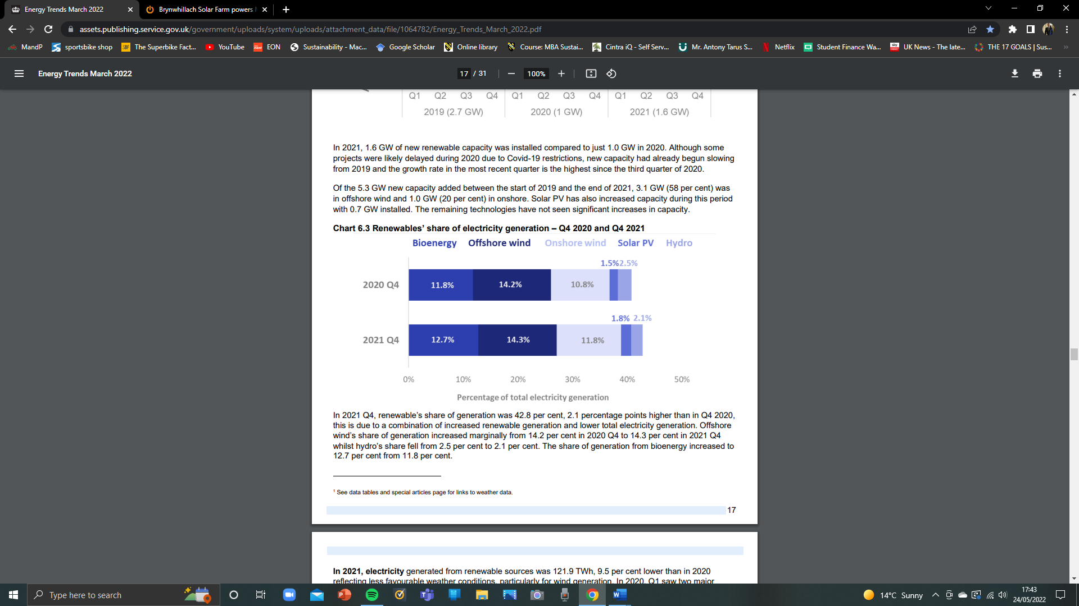 (Gov.uk, 2022)
In 2021 Q4, renewable’s share of generation was 42.8 per cent, 2.1 percentage points higher than in Q4 2020, this is due to a combination of increased renewable generation and lower total electricity generation. Offshore wind’s share of generation increased marginally from 14.2 per cent in 2020 Q4 to 14.3 per cent in 2021 Q4 whilst hydro’s share fell from 2.5 per cent to 2.1 per cent. The share of generation from bioenergy increased to 12.7 per cent from 11.8 per cent.
Despite an increase in capacity, Solar PV generation decreased by 5.9 per cent in 2021, mostly because of lower average daily sun hours. (Gov.uk, 2022)

Appendix 1. Brynwhillach solar farm. (BBH Building Better Healthcare, 2021)
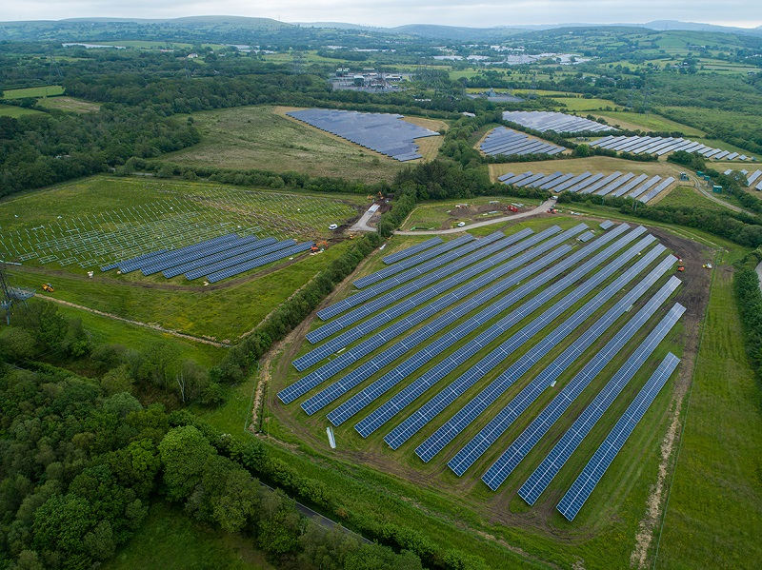
The Brynwhillach solar farm seen whilst still under construction 2020/21. (BBH Building Better Healthcare, 2021)

Appendix 2. (Google.maps, 2022)
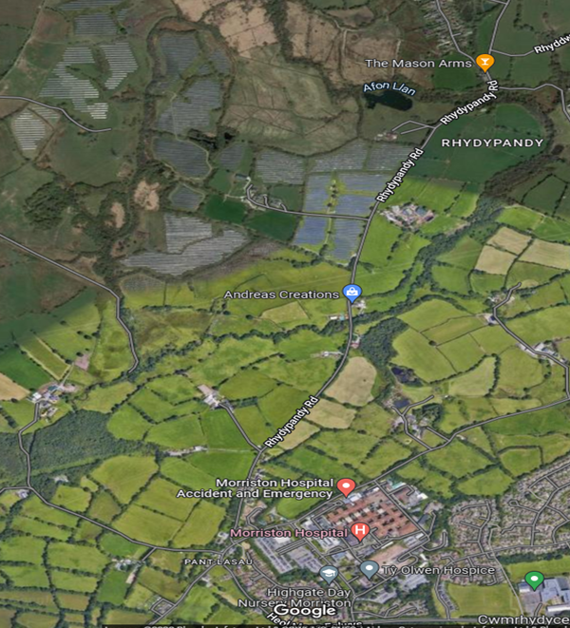
Morriston hospital can be seen at the bottom of the image, the Brynwhillach solar farm in its entirety can be seen at the top of the image.

