
ASSIGNMENT

Database design of
"Eco Bike Hubs"Management System
Based on SQL Server

BY
XIN FANG

Student ID: 2104902

January, 2022

ABSTACT

This paper designs an "Eco Bike Hubs" information management system based on SQL server, and verifies whether the use of the system meets the requirements of bicycle companies.
During the design work, combined with the actual situation of the bicycle company, we have formulated reasonable schemes for different types of services. It is believed that this design can improve the work efficiency of the bicycle company and reduce the confusion of various data management of the company to a certain extent. The original database is optimized and adjusted, and a set of distributed solutions is designed. However, there may be some imperfections in the system that need to be improved. It can be gradually optimized in the future.
Contents
ABSTACT 2
1. Introduction 4
2. SQL vs. NoSQL 4
3. Performance Tuning 6
4. Transaction 8
5. Distributed database solution 11
Conclusion 14
Reference 14

Introduction
Case background
"Eco Bike Hubs" has more than ten branches in different regions. They provide sales, leasing, maintenance and other services for users with different needs, which greatly facilitates the travel and entertainment of bicycle lovers around. However, the bicycle center does not have a convenient and complete database to manage different kinds of data, resulting in employees doing some redundant and chaotic work. Therefore, Eco Bike Hubs needs to design a complete database and corresponding operations to achieve different and convenient services for different types of customer groups.
Demand analysis
Due to various existing factors, the management of "Eco Bike Hubs" hopes that the center can develop while maintaining the service level. In order to improve the service level and obtain more and more customers, the company decided to add the function of rapid information retrieval and processing in database management. In addition to designing the database, they also need to solve their own problems, that is:
- Sometimes bicycle repair bookings are recorded but the details of the specific return date(s) as requested by customers are not registered in the system.
- Customers are able to book bicycle hire times that are not registered as possible schedules available.

SQL vs. NoSQL

SQL (Structured Query Language) database refers to a relational database. Some examples of SQL databases include PostgreSQL, mysql, Oracle, and Microsoft SQL server.
NoSQL (not only SQL) generally refers to non relational databases. NoSQL database examples include redis, ravendb, Cassandra, mongodb, BigTable, HBase, neo4j and CouchDB.
Nowadays, the society is constantly producing a large amount of data every day, which contains a large amount of valuable information that needs to be analyzed and mined. For example, data warehouse systems often contain a lot of valuable information for query and analysis, and the analysis of this information can help enterprises make decisions. How to quickly obtain these valuable information and save the cost of machine resources while improving the work efficiency of enterprises has become the focus of many researchers. The traditional RDBMS is no longer suitable for massive data query and analysis, mainly because of its fixed relationship. Model and inefficient table join operation limit the efficiency of query. The new NoSQL database is suitable to solve this kind of problem because they have more flexible storage mode and query mode. Next, I will compare the differences between SQL and NoSQL and their respective advantages and disadvantages.
Main differences
a. Type
SQL database is mainly called relational database (RDBMS); NoSQL database is mainly called non relational database or distributed database.
b. Language
SQL database defines and operates data-based structured query language SQL, which is very powerful. SQL is one of the most common and widely used options, which makes it a safe choice, especially for complex large queries. But on the other hand, this may be restrictive. SQL requires you to use a predefined schema to determine the structure of the data before using the data. Again, all your data must follow the same structure. This may require a lot of preliminary preparation, which means that structural changes are difficult and destroy the whole system.
NoSQL database has a dynamic architecture for unstructured data. Data is stored in many ways, which means that it can be document oriented, column oriented, graph based or organized as keyValue. This flexibility means that documents can be created without first defining the structure. Each document can also have its own unique structure. Syntax varies from database to database, and fields can be added at any time.
c. Scalability
In almost all cases, SQL databases are vertically scalable. This means that you can increase the load on a single server by adding something like ram, CPU, or SSD. On the other hand, NoSQL databases are horizontally scalable. This means that you can handle more traffic by sharding or adding more servers to the NoSQL database. This is similar to adding more floors to the same building rather than adding more buildings to the neighborhood. Therefore, NoSQL will eventually become larger and more powerful, making these databases the first choice for large or changing data sets.
d. Data coupling
External data that has been used cannot be deleted in SQL. If the data in a table has been assigned to another table, it will not be deleted in this table to ensure data integrity. In NoSQL, there is no such concept of strong coupling, and any data can be deleted at any time.
e. Business
In SQL, if the data of multiple tables needs to be updated in the same batch, that is, if one table fails to update, the other tables cannot be updated successfully. This scenario can be controlled through transactions, and transactions can be committed uniformly after all commands are completed. There is no transaction concept in NoSQL, and the operation of each dataset is atomic.
In short, although NoSQL performs better when the scenario is very complex, NoSQL is not very mature in technology and is not as convenient as SQL in related support. The advantage of using SQL is that it is easy to understand, high data consistency, low redundancy and easy to operate. Obviously, SQL technology is more mature. We only care about business and don't worry about the technology itself. So in this case, we choose to use SQL.

Performance Tuning
First, I want to briefly explain the creation of the table and the data I insert. The following three figures are shown. You can see my code and results from the picture. As can be seen from the typ field in the staff table, employees are divided into four categories: employees in charge of reservation, employees in charge of sales, employees in charge of leasing business and technicians in charge of maintenance. They share the same table. The user contacts the employee in charge of booking to book business, and adds a new piece of data in the business table, which records the service type required by the user. Update the remaining more detailed data after the customer arrives at the store. After arriving at the store, each user will be assigned a different type of employee according to his business type. Track the user's business in the whole process. Every business has a status. Every time the task status changes, the status in the database will be updated. Customers can also search the database to select their own bicycles or parts.
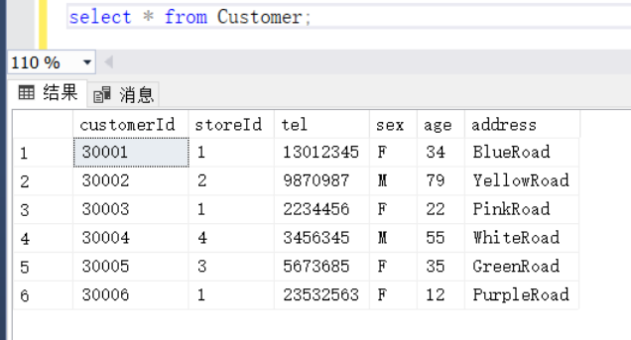
Fig. 1
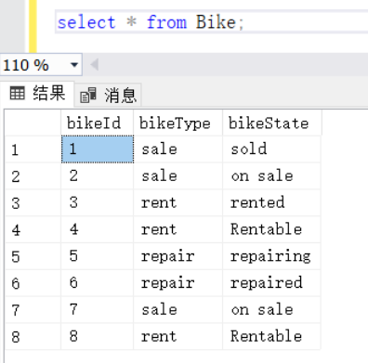
Fig. 2
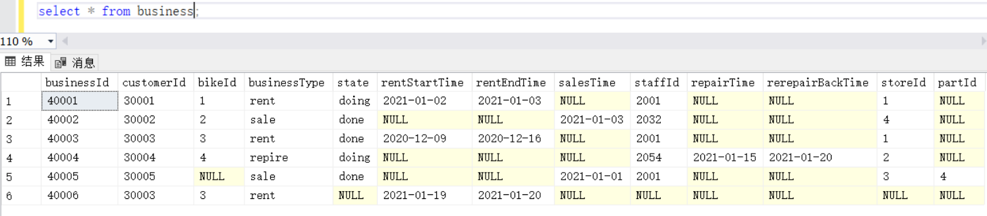
Fig. 3
In addition, the database diagram is shown in Figure 4.
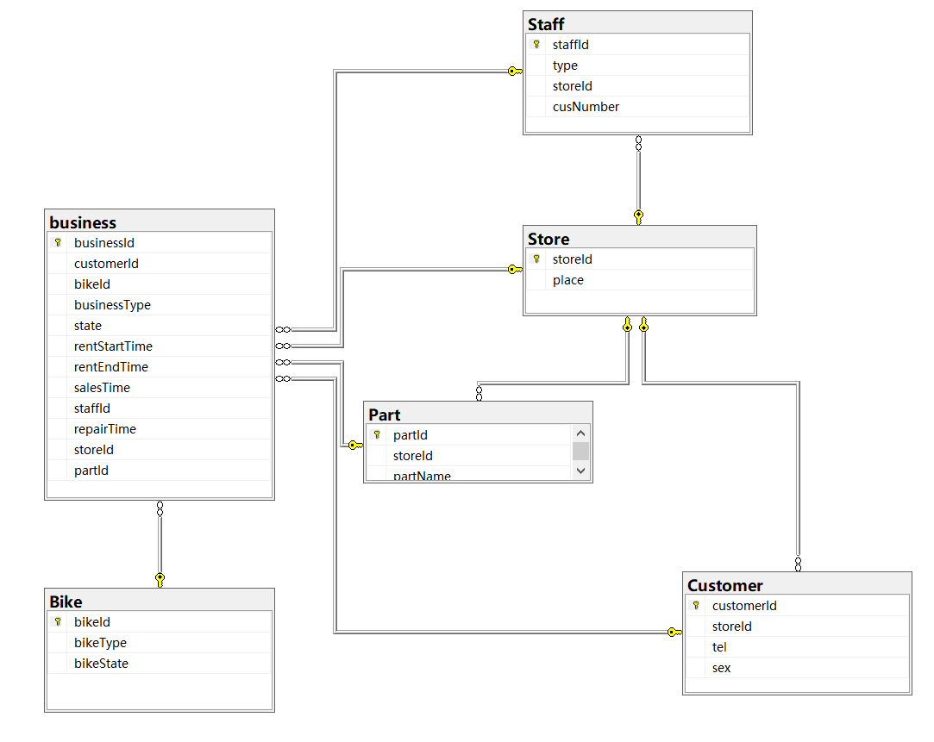
Fig. 4
Considering that some employees who want to ask familiar employees if there are any remaining reception location needs, we have established an index of employee number and the number of users currently received by employees to meet the needs of customers. We have established an index of user number and business number so that customers can easily view all their previous businesses in this company. If the customer wants to check the rental status of the bicycle he rented before, we have established the bicycle number and the index of all businesses related to the bicycle, as shown in Figure 5 below.
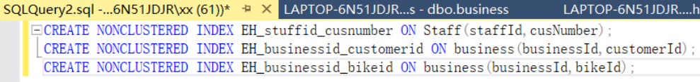
Fig. 5

Transaction
The question of "Eco Bike Hubs" is:
- Sometimes bicycle repair bookings are recorded but the details of the specific return date(s) as requested by customers are not registered in the system.
- Customers are able to book bicycle hire times that are not registered as possible schedules available.
--question A
BEGIN TRANSACTION NewRentBusiness
BEGIN TRY -- add try to catch any errors
-- Add new business
INSERT INTO business (businessId, customerId, rentStartTime, rentEndTime, staffId)
VALUES ('40006', '30001', '2022-1-19', '2022-1-21', 2001)

-- Add the new business managed by another customer
INSERT INTO business (businessId, customerId, rentStartTime, rentEndTime, staffId)
VALUES ('40006', '30002', '2022-1-19', '2022-1-21', 2001)

-- Commit ALL changes, inserts successful
COMMIT TRANSACTION NewRentBusiness;
END TRY
BEGIN CATCH -- add catch to handle error
-- Rollback ALL inserts, an error has occurred.
ROLLBACK TRANSACTION NewRentBusiness;
RAISERROR('Rolling back, an error occurred!', 16, 1);
END CATCH;
select * from business

Screenshot of the results.


Fig. 6

The business table remains unchanged. Therefore, when the registration time is empty, the code will implement the rollback operation.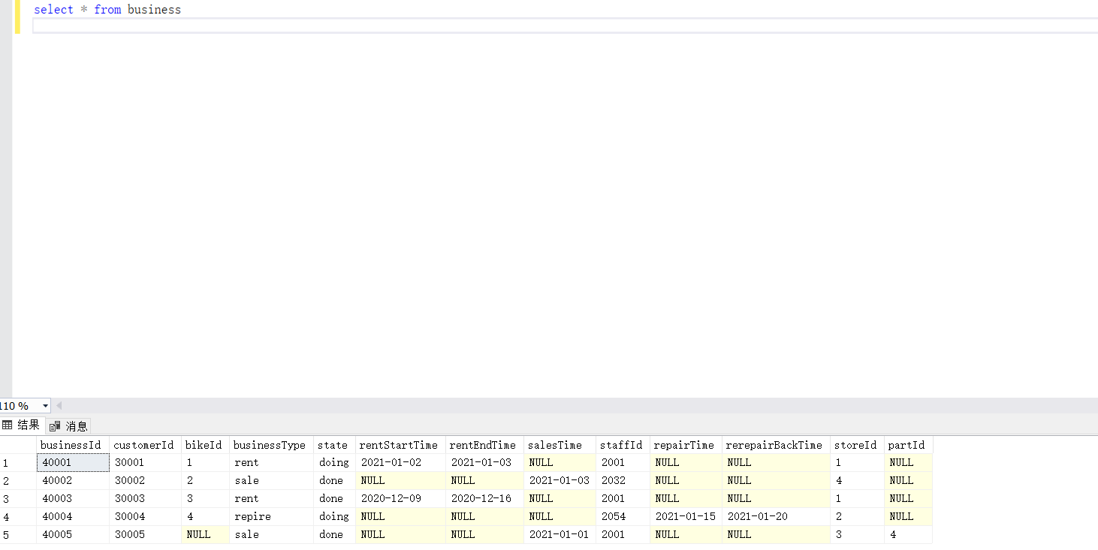
Fig. 7

--question B
CREATE PROCEDURE [dbo].[bikeRent1]
@BikeId BIGINT,
@CustomerID BIGINT,
@rentStartDate DATE,
@rentEndDate DATE
AS
BEGIN
BEGIN TRANSACTION
INSERT INTO business (businessId,businessType, bikeId,rentStartTime,rentEndTime,customerId) VALUES ( '40006','rent', @BikeId,@rentStartDate,@rentEndDate,@CustomerID);
UPDATE Bike set bikeState = 'rented' where bikeId = @BikeId
IF (
(SELECT COUNT(*) FROM business b1,Bike b2
WHERE b1.bikeId=b2.bikeId AND b2.bikeType = 'rent'
AND bikeState='rentable')=0
)
BEGIN
ROLLBACK TRANSACTION
END
ELSE
BEGIN
COMMIT TRANSACTION
END
END
GO
EXEC [dbo].[bikeRent1] '3', '30003', '2021-1-19','2021-1-20'
select * from business
40006 is an unregistered event. The successful results are shown in Figure 8.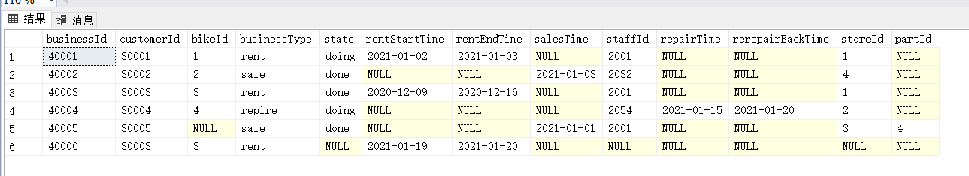
Fig. 8
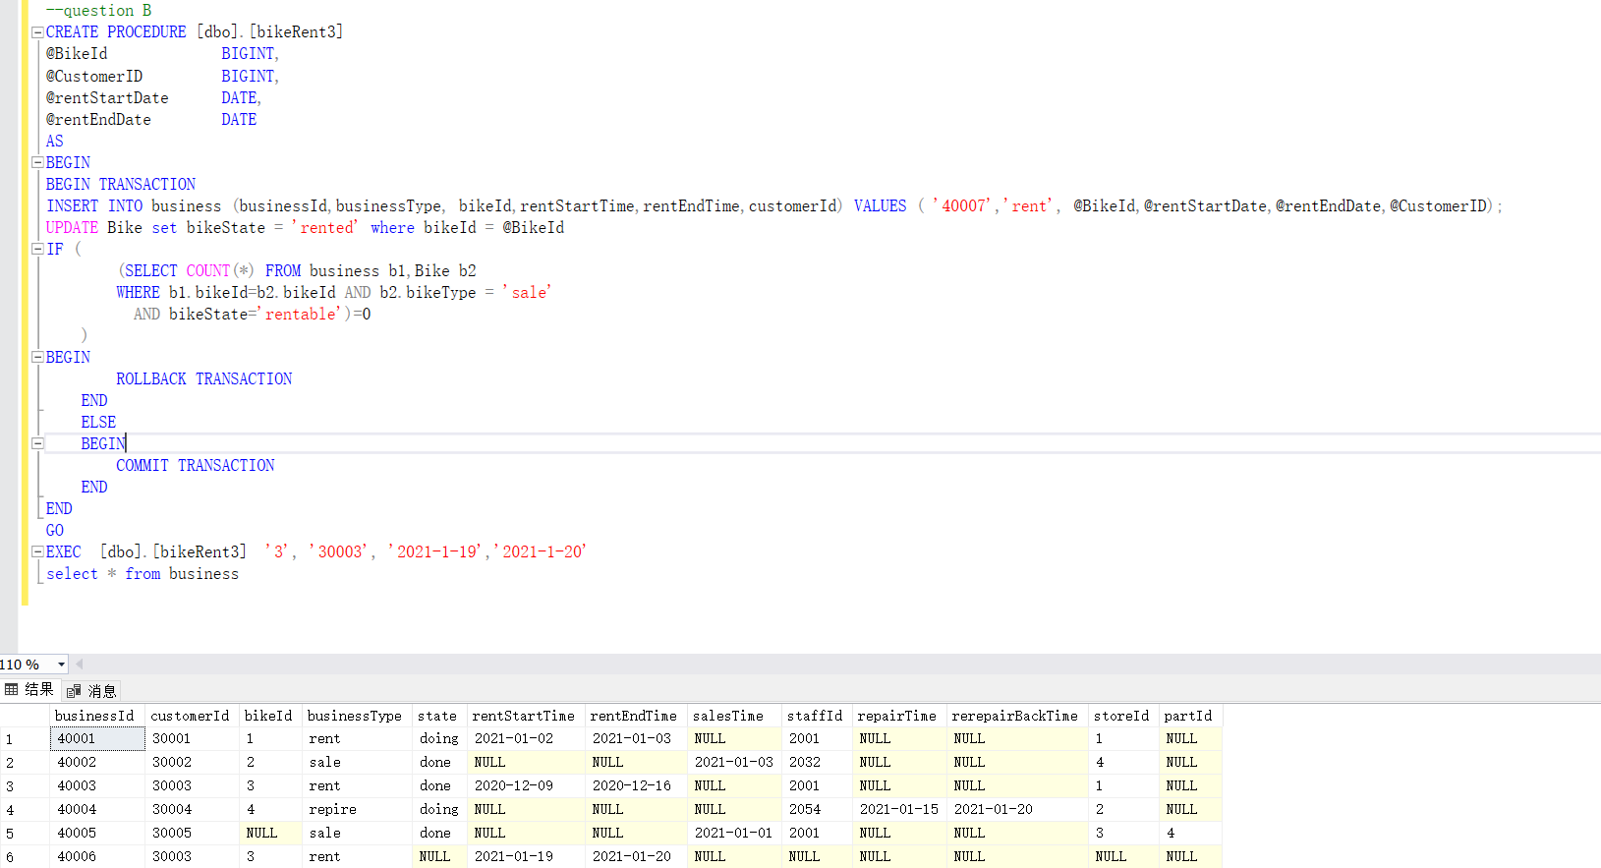
Fig. 9
When the conditions are not met, the program rolls back and does not execute the insertion operation
The database design has completed two questions raised by "Eco Bike Hubs".

Distributed database solution
With the continuous evolution of business demand for big data technology, distributed database plays an increasingly important role in the whole ecosystem. It can be predicted that it will become another core of the development of big data technology in the future.
According to the requirements of "Eco Bike Hubs", I need to design the database in a distributed manner. After learning this course, we know that fragmentation is to divide the database into disjoint fragments, and each fragment is assigned to a site. Ideally, the database should be distributed and transparent, hiding the details of where each file is physically stored in the system. Reliability is basically defined as the probability that the system operates at a specific time, while availability is defined as the probability that the system is continuously available for a period of time. When data and DBMS software are distributed on multiple sites, one site may fail while other sites continue to run, and we cannot only access the data existing in the failed site, which can basically improve reliability and availability. By decomposing the query into multiple sub queries that are basically executed in parallel, we can realize inter query and internal query parallelism by executing multiple queries at different sites, which can basically improve the performance.
For the case study of "Eco Bike Hubs", I designed a total of six tables. As shown in Figure 4, they are "bike", "customer", "store", "part", "business" and "staff".
For the first "bike" table, it can be horizontally distributed according to the type of bicycles, and bicycles for different purposes can be clearly divided. Fig. 10 shows the original bike table. Fig. 11, Fig. 12 and Fig. 13 are three tables after distribution.
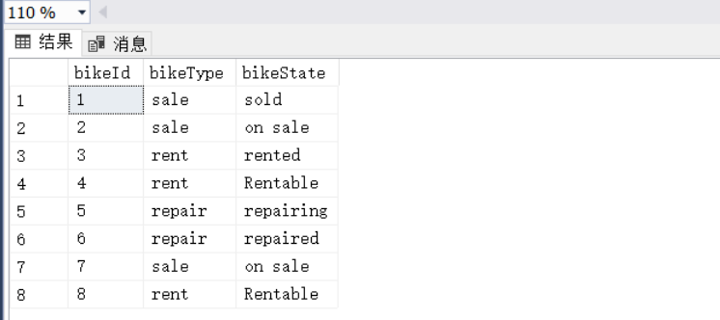
Fig. 10

BikeId | bikeType | ShowType
1 | sale | sold
2 | sale | on sale
7 | sale | on sale
Fig. 11

BikeId | bikeType | ShowType
3 | rent | rented
4 | rent | Rentable
8 | rent | Rentable
Fig. 12
BikeId | bikeType | ShowType
5 | repair | repairing
6 | repair | repaired
Fig. 13
The second customer table stores the basic information of customers and corresponding merchants, so it is not necessary to distribute them.
The third store table has only two properties. One is the store code and the other is the store location. These properties are fixed, so I don't think this table needs to be distributed. Similarly, in the fourth table, there are only three attributes in the part table, so I don't think it needs to be allocated
I will distribute the business table horizontally. This is the basis of horizontal distribution due to the difference between completion schedules. After distribution, we can see which businesses have been completed and which are in progress. Figure 13 shows the original business table. Figures 14 and 15 are the last two tables of distribution.
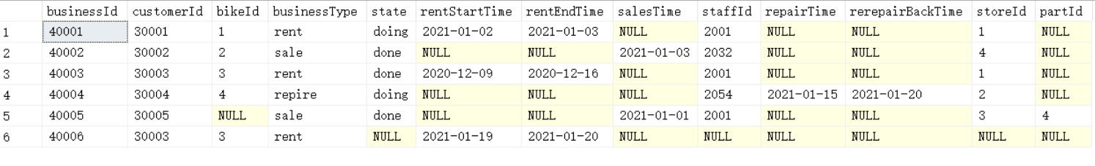
Fig. 13
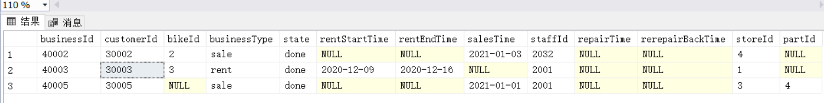
Fig. 14
Fig. 15

The "staff" table has the attribute "staff type". It has four types: employees in charge of booking, employees in charge of sales, employees in charge of renting and employees in charge of maintenance. So I divided it horizontally into four parts. After division, obtain different types of employees. Figure 16 shows the original staff table. Fig. 17, Fig. 18, FIG. 19 and FIG. 20 are four tables after distribution.
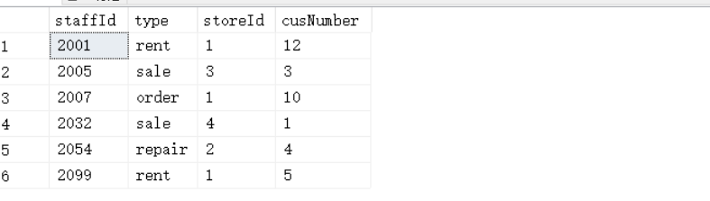
Fig. 16
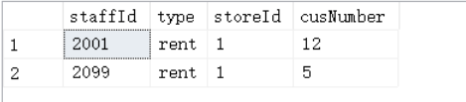
Fig. 17
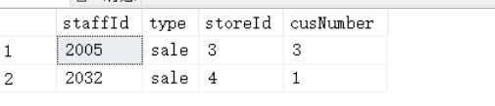
Fig. 18

Fig. 19
、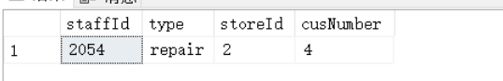
Fig. 20

Conclusion
This paper designs an "Eco Bike Hubs" information management system based on SQL server, and verifies whether the use of the system meets the requirements of bicycle companies.
In the actual design of "Eco Bike Hubs" SQL database system, the problems we face may be a little complex for us. However, during the design work, combined with the actual situation of the bicycle company, we have formulated reasonable schemes for different types of services. It is believed that this design can improve the work efficiency of the bicycle company and reduce the confusion of various data management of the company to a certain extent. The original database is optimized and adjusted, and a set of distributed solutions is designed. However, there may be some imperfections in the system that need to be improved. It can be gradually optimized in the future.

Reference
[1]Li Aiwu. Research on SQL Server Bulk Operation Mechanism[J]. Journal of Physics: Conference Series,2021,1952(4):
[2]Li Yunyun,Chen Lulu,Yu Dengchen,Gao Renhao. Research and Developing of Evaluation Information System Using B/S Structure and SQL Server Technology[J]. Journal of Physics: Conference Series,2021,1952(4):
[3]Rupali Chopade,Vinod Pachghare. Data Tamper Detection from NoSQL Database in Forensic Environment[J]. Journal of Cyber Security and Mobility,2021,10(2):
[4]Kotsilieris Theodore. An Efficient Agent Based Data Management Method of NoSQL Environments for Health Care Applications[J]. Healthcare,2021,9(3):
[5]Cristofer Zdepski,Tarcizio Alexandre Bini,Simone Nasser Matos. PDDM: A Database Design Method for Polyglot Persistence[J]. American Scientific Research Journal for Engineering, Technology, and Sciences (ASRJETS),2020,71(1):
[6]Cristofer Zdepski,Tarcizio Alexandre Bini,Simone Nasser Matos. New Perspectives for NoSQL Database Design: A Systematic Review[J]. American Scientific Research Journal for Engineering, Technology, and Sciences (ASRJETS),2020,68(1):
[7]ElDahshan Kamal A,AlHabshy AbdAllah A,Abutaleb Gaber E. Data in the time of COVID-19: a general methodology to select and secure a NoSQL DBMS for medical data.[J]. PeerJ. Computer science,2020,6:
[8]B. D. McCullough,Taha Mokfi,Mahsa Almaeenjad. Wilkinson&apos;s Tests and SQL Packages[J]. ACM SIGMOD Record,2019,48(3):
[9]Vincent Reniers,Dimitri Van Landuyt,Ansar Rafique,Wouter Joosen. Object to NoSQL Database Mappers (ONDM): A systematic survey and comparison of frameworks[J]. Information Systems,2019,85:
[10]Jared Hensle. Common SQL Server Wait Types to Improve Database Performance[J]. Database Trends and Applications,2019,33(4):
[11]Petrovečki, Martina,Kovačević, Željko. FEATURED CHARACTERISTICS OF SQL SERVER 2019[J]. Polytechnic and design,2019:
[12]Tim Ford. Polybase Expansion, Big Clusters Are Key Features in the New SQL Server 2019[J]. SQL Server Pro,2018:
[13]Li Yue. The comparison of Storage space of the two Methods used in SQL Server to Remove Duplicate records[J]. Procedia Computer Science,2018,131:
[14]ElDahshan Kamal A,AlHabshy AbdAllah A,Abutaleb Gaber E. Data in the time of COVID-19: a general methodology to select and secure a NoSQL DBMS for medical data.[J]. PeerJ. Computer science,2020,6:
[15]B. D. McCullough,Taha Mokfi,Mahsa Almaeenjad. Wilkinson&apos;s Tests and SQL Packages[J]. ACM SIGMOD Record,2019,48(3):
[16]Vincent Reniers,Dimitri Van Landuyt,Ansar Rafique,Wouter Joosen. Object to NoSQL Database Mappers (ONDM): A systematic survey and comparison of frameworks[J]. Information Systems,2019,85:
[17]A H Ali,R A Nugraha. Application of Distributed Databases for Information Systems Fertilizer Management[J]. IOP Conference Series: Materials Science and Engineering,2019,662(2):
[18]Jared Hensle. Common SQL Server Wait Types to Improve Database Performance[J]. Database Trends and Applications,2019,33(4):
[19]Petrovečki, Martina,Kovačević, Željko. FEATURED CHARACTERISTICS OF SQL SERVER 2019[J]. Polytechnic and design,2019:
[20]Tim Ford. Polybase Expansion, Big Clusters Are Key Features in the New SQL Server 2019[J]. SQL Server Pro,2018:
[21]Li Yue. The comparison of Storage space of the two Methods used in SQL Server to Remove Duplicate records[J]. Procedia Computer Science,2018,131:

