  Component One: What are the key skills required when working in the housekeeping team? | Student No: | 2207749
 | Module Title: | Operating Hotel Facilities
 | Module Code: | BMIH4006
 | Lecturer: | Kathryn Flynn
In the domain of hospitality, housekeeping team plays a very significant role. It is the aggregate of various members that are entrusted to perform cleanliness as well as other additional functioning in the hospitality domain. The housekeeping team comprises of various employees working in the housekeeping department who are responsible for maintaining cleanliness as well as good atmosphere in the hotel. Such a team is responsible for fulfilling various responsibility concerning different rooms and the hotel as a whole. Various functions like sweeping, vacuuming, maintaining cleanliness and orderliness etc., are fulfilled. Different types of skills are required in order to work efficiently in housekeeping team as a whole. These are as follows:
1. Honesty - High level of honesty is required in order to work within hospitality domain. The housekeeping team members need to be completely honest and must report appropriately to the supervisors (Dhaliwal and Misra, 2020). This helps in maintaining good relationship between the superior and the subordinates. For example, I have worked as an intern in the Premier Inn hotel where I have demonstrated high level of honesty. Once, the clothes of guests were damaged by me and I honestly accepted my fault and apologised from the core of my heart. This effort of mine was highly appreciated by the manager.
2. Skills of time management - This skill is very relevant for every individual working in the hospitality domain. Even the housekeeping team needs to be effective at time management so that various responsibilities and tasks can be timely completed. Also, all types of delay in activities related to waste disposal, cleaning, organizing etc., needs to be efficiently managed. All this requires effective time management (Ng, 2021).
3. High level of concentration and attentiveness - In order to work in housekeeping team, individuals need to be highly attentive. They need to follow all the instructions given by the superior as well as the guests. With respect to performing of different functions like cleaning of window, cleaning of floor, organizing several things, minute details are to be kept into account. Also, close attention needs to be provided with respect to the requirements of all the guests so that they are satisfied.
4. Possession of laundry skill - This skill is very relevant in order to work in the hospitality domain. The housekeeping team as a whole need to fulfil various functions like washing the clothes, folding and ironing the clothes etc. They need to be given to the guests in a very presentable manner after being washed (Singh and Jaykumar, 2019).
5. Skills of communication - These skills are very relevant for individuals working in the housekeeping team. It helps them to communicate with the guests as well as superiors effectively. Thus, all types of misunderstandings can be avoided and proper coordination is established.
6. High level of flexibility - Flexibility is a very essential skill and the housekeeping team members need to be completely flexible and agile. They need to cope up with the changes taking place in the hospitality organization in which they work. Also, changing rules and regulations need to be effectively complied by them. High level of agility makes the housekeeping team members perform their duties effectively.

Application of several theoretical knowledge for working in hospitality industry:
A strong theoretical knowledge about working in hospitality industry needs to be possessed by the housekeeping individuals. They need to know about various departmental functioning, they must be acquainted with their own roles and responsibilities etc. Also, relevant theories and concepts must be applied by them in order to enhance their functioning in the hospitality domain. This will help them to demonstrate high level of knowledge as well as skills even in complex circumstances (Subash, 2020).

Relevance of different skills for all individuals functioning within the housekeeping team
Different skills with respect to time management, laundry, attention and concentration, honesty, flexibility etc., need to be possessed by the housekeeping team (Tra, 2020). All these skills are very relevant and I possess many of these skills which helps me to discharge my responsibilities and roles as a housekeeping team member efficiently. The possession of these skills makes individuals highly confident and their skills and capabilities are improved.
Word Count | 700

References

Dhaliwal, R. S., and Misra, P. (2020). Employability skills needed in hospitality industry: a scopious review. Asian Journal of Education and Social Studies, 10(1), 18-34.
Ng, A. M. L. (2021). Housekeeping Skills Training for Independent Living Among Malaysian Adolescents with Special Needs: A Case Study. Journal of Special Needs Education, 11, 30-50.
Singh, A., and Jaykumar, P. (2019). On the road to consensus: key soft skills required for youth employment in the service sector. Worldwide Hospitality and Tourism Themes.
Subash, T. (2020). SKILL REQUIREMENT IN TRAVEL AND TOURISM INDUSTRY. GLOBAL JOURNAL OF BUSINESS MANAGEMENT.
Tra, T., (2020). Action plan for training new Housekeeping Employee: case: Hotel Indigo Helsinki.

Component Two:
Problem | Why did it happen? | What are you going to do? | How will you prevent this from happening in the future? | What measures would you introduce to improve team effectiveness?
Lack of tidiness and orderliness within hotel rooms. | Due to limited realisation of employee duties and roles. Also, it has resulted due to ineffective communication (Andrade, et al., 2021). | The action which will be taken is that proper communication channels will be used. | By implementing strict monitoring mechanisms (Cottrell, 2019). | To ensure compliance with rules and standards.
Limited action taken based on customer complaints. | The reason for its occurrence involves limited customer communication. Also, ineffective compliance with superior guidance is a problem (Cunha and Oliveira, 2021). | The action which will be taken is that customer communication will be improved. | By implementing strict monitoring mechanisms (Mullins and Dossor, 2013). | To ensure the use of modern technologies.
Lack of clean and tidy laundry services that have caused increased customer complaints. | Limited abidance by rules and policies of the hospitality organisation has led to occurrence of the problem (Cunha and Oliveira, 2021). | The action which will be taken is that strict laundry related rules and regulations will be imposed. | By implementing strict monitoring mechanisms (Verma, et al., 2020). | To ensure compliance with rules and standards.

References

Andrade, M. S., Miller, D., and Westover, J. H. (2021). Job satisfaction factors for housekeepers in the hotel industry: a global comparative analysis. International Hospitality Review, 35(1), 90-108.
Cottrell, S. (2019). The Study Skills Handbook. 5th ed. London: Red Globe Press.
Cunha, A., and Oliveira, M. (2021, May). Human Resources in the Housekeeping Department: A Case Study. In ICTR 2021 4th International Conference on Tourism Research (p. 158). Academic Conferences International.
Mullins, L. and Dossor, P. (2013). Hospitality Management and Organisational Behaviour. 5th ed. Harlow: Pearson.
Verma, P., Singh, M., and Aggarwal, N. (2020, June). The Effect of Next–Level Housekeeping via Technology on the Perceptions of the Hospitality Aspirants. In 2020 8th International Conference on Reliability, Infocom Technologies and Optimization (Trends and Future Directions)(ICRITO) (pp. 1150-1156). IEEE.

Component Three:


Introduction 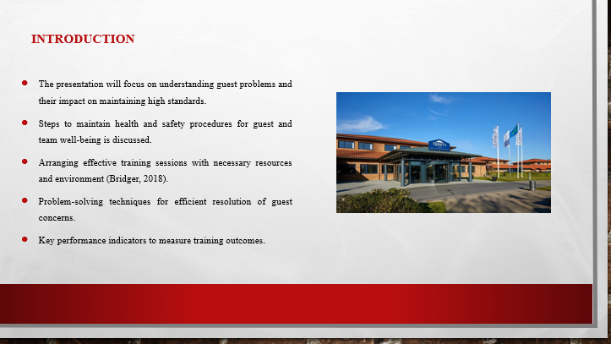
Training Notes:
This training presentation will cover essential topics to enhance housekeeping performance and ensure guest satisfaction. Firstly, it will delve into understanding the problems faced by the guests of Hotel Trinity, recognizing their importance in maintaining high standards (Bridger, 2018). Then outline the steps required to maintain health and safety procedures at the hotel, emphasizing the well-being of both our guests and team members. Next, it will discuss the arrangements needed to facilitate effective training sessions, ensuring that colleagues have the necessary resources and environment to excel. Additionally, the presentation will explore problem-solving techniques to address guest concerns efficiently and provide timely resolutions. Furthermore, the key performance indicators (KPIs) to measure the outcomes of our training efforts will be discussed.

Understanding the problem of the guest
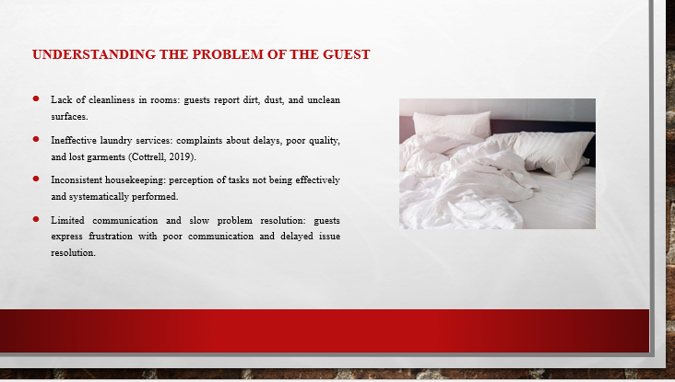
Training Notes:
Guests at Trinity hotel have reported several problems that require immediate attention. One prevalent issue is the lack of cleanliness in the rooms, with guests noticing dirt, dust, and unclean surfaces. Additionally, complaints have arisen regarding ineffective laundry services, including delays in laundry pickup, poor quality of laundered items, and misplaced or lost garments (Cottrell, 2019). Another concern is the perception that housekeeping tasks are not being effectively and systematically performed, resulting in inconsistent standards of cleanliness and maintenance. Moreover, guests have expressed frustration with limited communication and the slow resolution of their problems, leading to dissatisfaction and a negative overall experience. It is crucial to address these concerns to ensure guest satisfaction and maintain our reputation for excellence in hospitality.

Steps to be undertaken to maintain health and safety at hotel
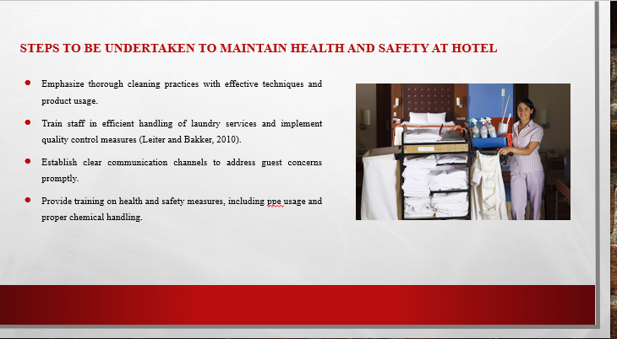
Training Notes:
During the ongoing training, the staff needs to undertake specific actions to address the determined problems faced by guests and ensure health and safety. Firstly, they should emphasize the importance of thorough cleaning practices, providing guidance on effective techniques and proper usage of cleaning products (Leiter and Bakker, 2010). Regular inspections and checklists can be implemented to ensure consistent cleanliness. Secondly, staff members should be trained in efficient and systematic handling of laundry services, including proper sorting, timely delivery, and quality control. Clear communication channels and protocols should be established to address guest concerns promptly and effectively. Moreover, training should cover health and safety measures, including the proper use of personal protective equipment (PPE), hand hygiene, and safe handling of chemicals (Mullins and Dossor, 2013). By implementing these relevant measures, the staff can effectively tackle challenges, enhance guest satisfaction, and maintain a safe and healthy environment.

Arrangement of Training facilities
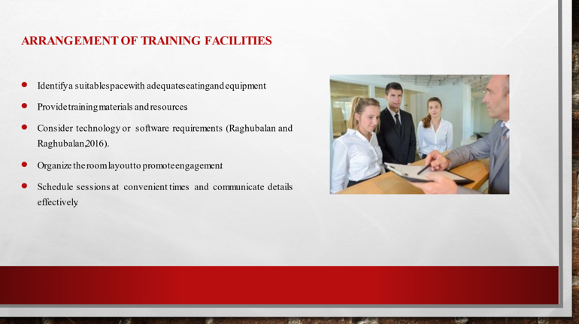
Training Notes:
Arranging suitable training facilities for staff is crucial to ensure effective learning and development. Firstly, identify a dedicated space that can accommodate the entire team comfortably, with adequate seating and equipment such as projectors or whiteboards (Raghubalan and Raghubalan, 2016). Ensure the room is well-lit and has good ventilation. Secondly, provide training materials and resources, including handouts, training manuals, and visual aids. Additionally, consider any specific technology or software requirements and ensure they are readily available. Moreover, organize the room layout in a way that promotes engagement and interaction among participants. Finally, schedule the training sessions at convenient times and communicate the details effectively to all staff members (Quick, 2020). By carefully arranging the training facilities, staff can engage in focused learning and maximize the benefits of the training sessions.

Problem solving steps
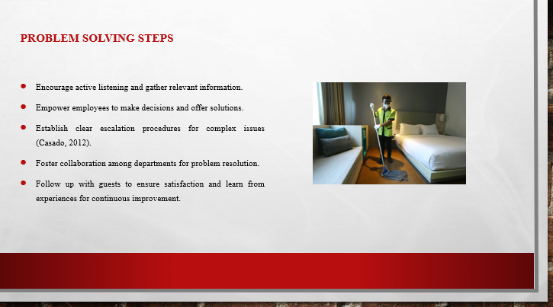
Training Notes:
When it comes to problem-solving, several measures can be implemented to address guest concerns effectively. Firstly, encourage active listening to fully understand the issue at hand. Staff should ask clarifying questions to gather all relevant information (Casado, 2012). Secondly, empower employees to make decisions and take ownership of resolving problems. Provide them with the necessary authority and resources to offer appropriate solutions. Thirdly, establish clear escalation procedures for complex issues that require higher-level intervention. Encourage collaboration and communication among different departments to facilitate problem resolution. Additionally, follow up with guests to ensure their satisfaction with the implemented solutions. Lastly, learn from past experiences and continuously improve processes to prevent similar issues from arising in the future (Fallon and Rutherford, 2010). By implementing these measures, the staff can effectively solve problems, enhance guest satisfaction, and maintain a positive reputation for the hotel.
Key Performance Indicators to measure outcome of training facilities
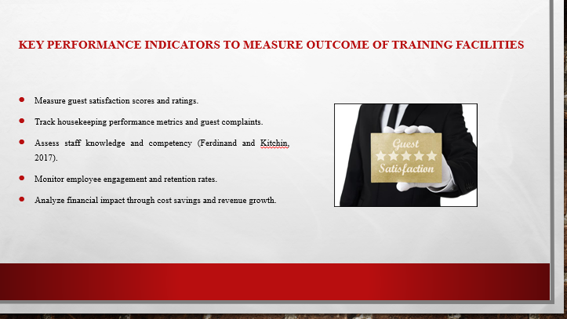
Training Notes:
To measure the outcome of training facilities, it is essential to establish key performance indicators (KPIs) that reflect the effectiveness and impact of the training. Firstly, track improvements in guest satisfaction scores or ratings related to cleanliness, laundry services, and problem resolution. Secondly, monitor housekeeping performance metrics such as room inspection scores, reduction in guest complaints, and increased efficiency in completing tasks (Ferdinand and Kitchin, 2017). Thirdly, assess staff knowledge and competency through post-training assessments and evaluations. Additionally, consider employee engagement and retention rates as indicators of the training's success. Lastly, analyze the financial impact of the training by tracking metrics such as cost savings, increased revenue from improved guest experiences, or reduced staff turnover costs. By monitoring these KPIs, the organization can gauge the effectiveness of the training facilities and make data-driven improvements.
Linking employee engagement model to the best industry practice example
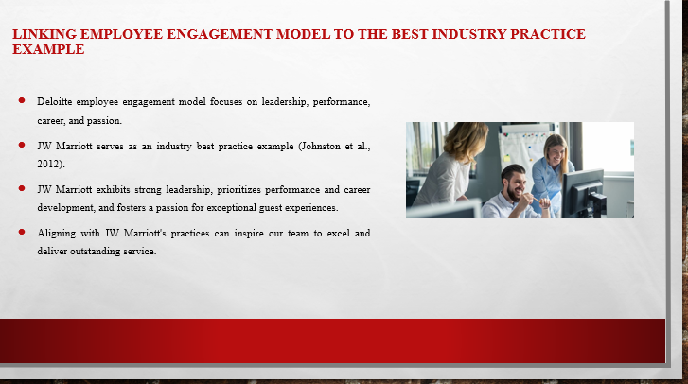
Training Notes:
By linking the Deloitte employee engagement model to the best industry practice example of JW Marriott, it is possible to understand how employee engagement drives excellence in the hospitality sector. The Deloitte model emphasizes four key dimensions: leadership, performance, career, and passion. JW Marriott, renowned for its exceptional service and employee satisfaction, serves as an exemplar. The hotel fosters a culture of strong leadership, providing guidance and support to its staff (Johnston et al., 2012). They prioritize performance through training and development programs that enhance skills and encourage growth. Career advancement opportunities are abundant, motivating employees to excel. Furthermore, JW Marriott nurtures a passion for delivering outstanding guest experiences, fueling employee engagement and loyalty. By aligning with industry best practices exemplified by JW Marriott, Trinity Hotel can also can inspire our team to deliver exceptional service and achieve excellence in their roles.

Conclusion
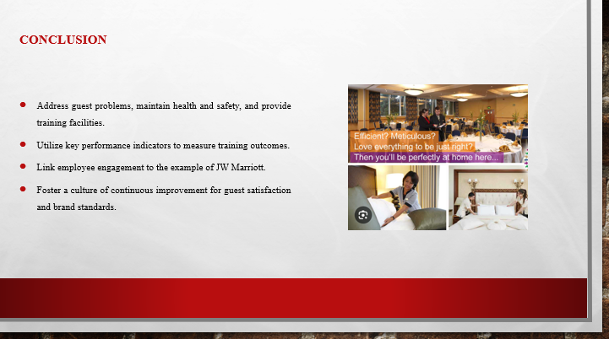
Training Notes:
In conclusion, this training presentation addresses the essential aspects of enhancing housekeeping performance and guest satisfaction. By understanding guest problems, maintaining health and safety, providing appropriate training facilities, and implementing effective problem-solving steps, Trinity hotel can improve our overall service quality. Key performance indicators allow to measure the outcomes of training efforts and make data-driven improvements. Additionally, by linking the Deloitte employee engagement model to the best industry practice example of JW Marriott, Trinity Hotel can inspire team to achieve excellence in their work. By implementing these measures and fostering a culture of continuous improvement, hotel can ensure brand standards are met, health and safety procedures are followed, and guest satisfaction is consistently elevated.

References
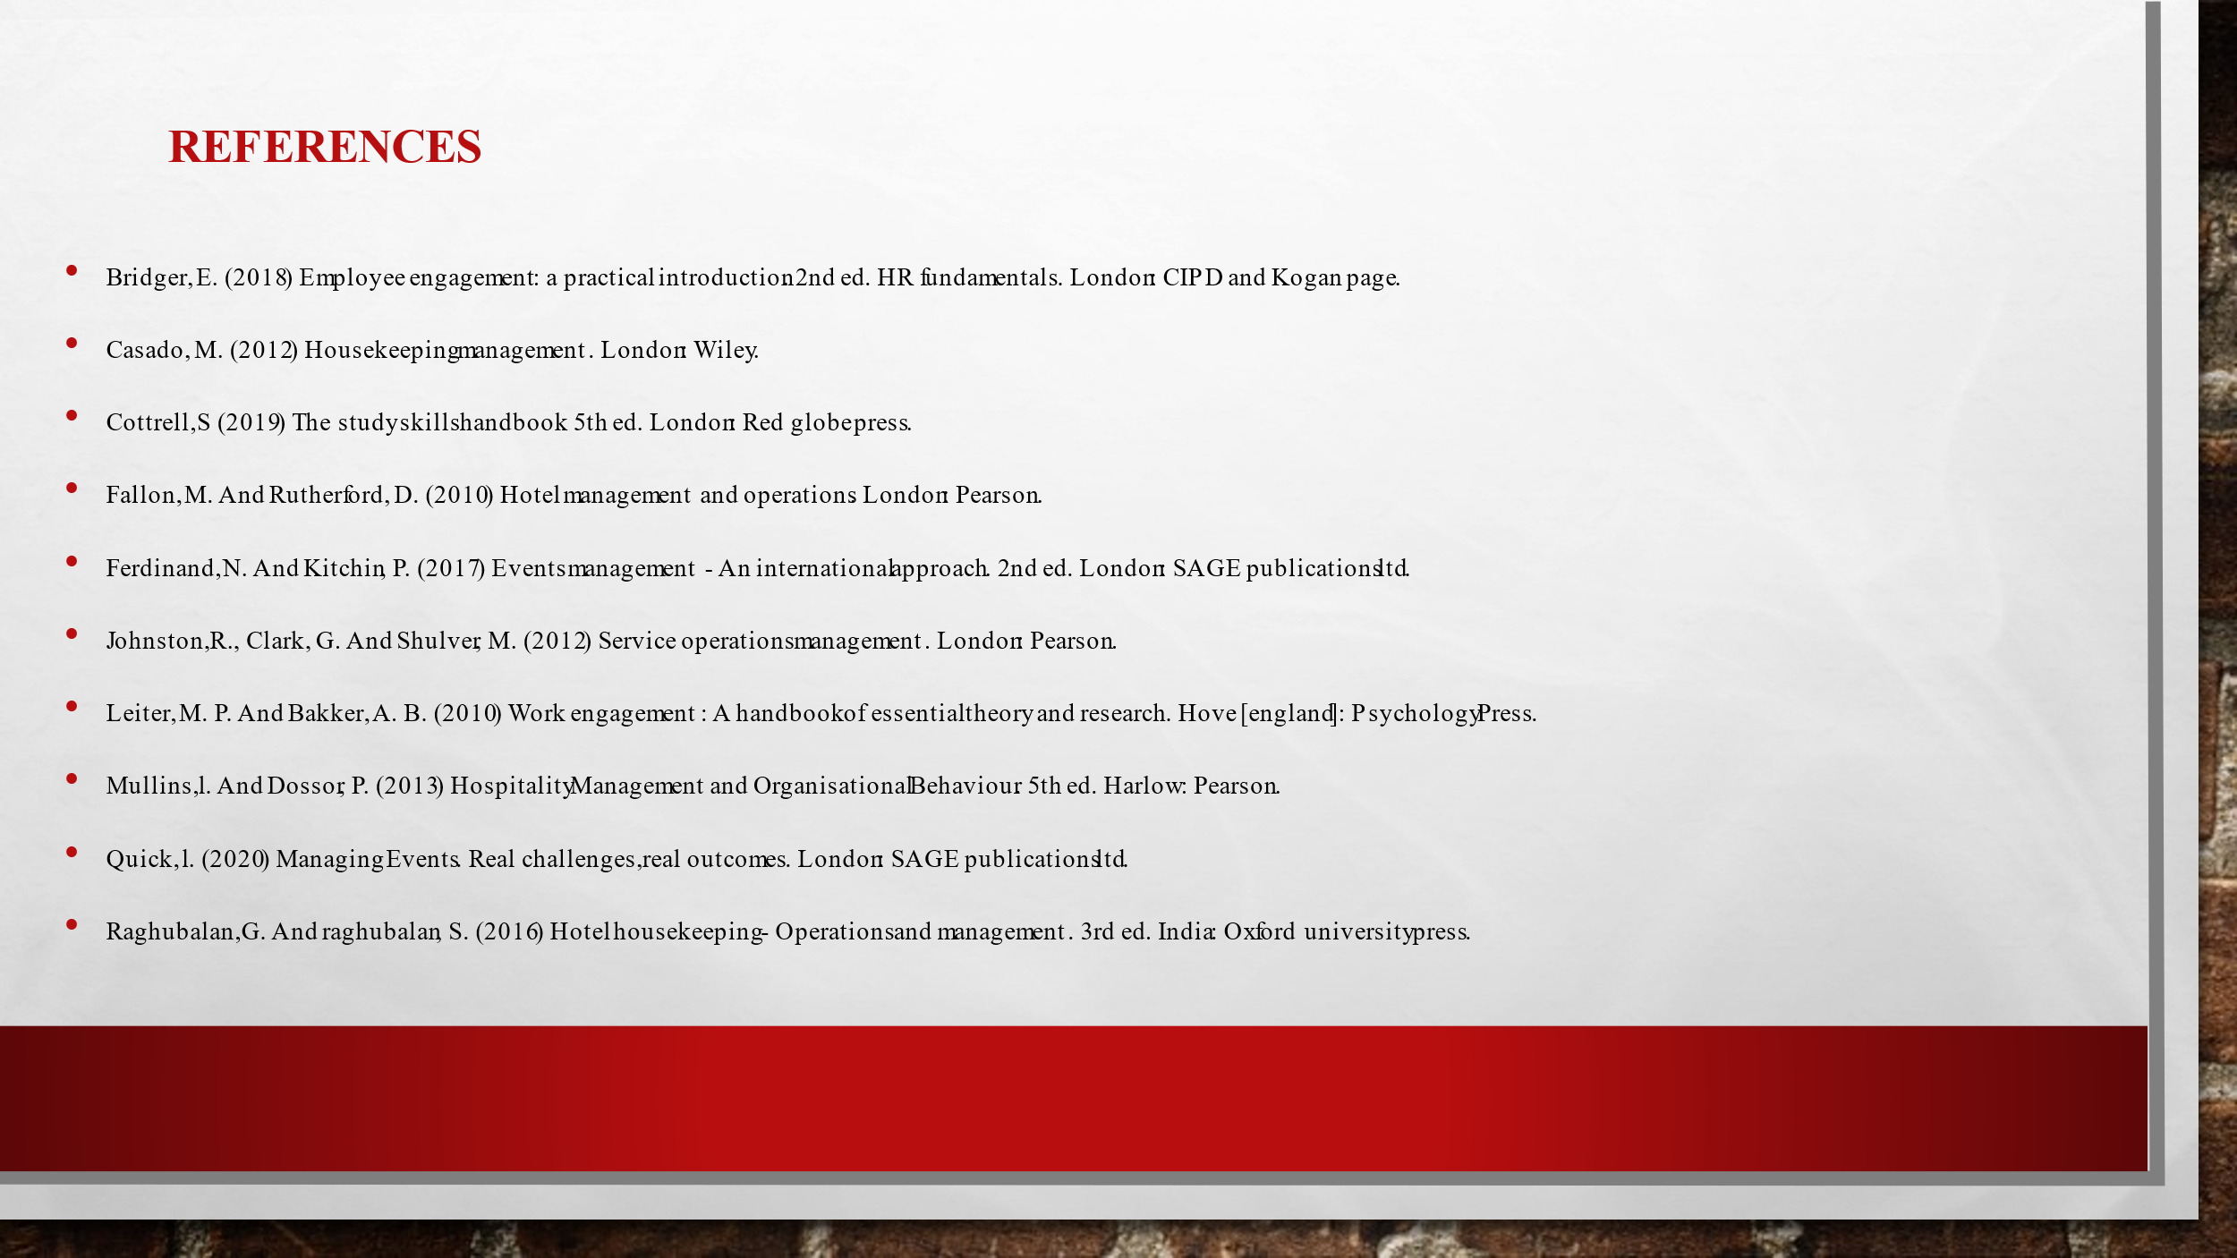
Bridger, E. (2018) Employee engagement: a practical introduction. 2nd ed. HR Fundamentals. London: CIPD and Kogan Page.
Casado, M. (2012) Housekeeping Management. London: Wiley.
Cottrell, S. (2019) The Study Skills Handbook. 5th ed. London: Red Globe Press.
Fallon, M. and Rutherford, D. (2010) Hotel Management and Operations. London: Pearson.
Ferdinand, N. and Kitchin, P. (2017) Events Management - An International Approach. 2nd ed. London: SAGE Publications Ltd.
Johnston, R., Clark, G. and Shulver, M. (2012) Service Operations Management. London: Pearson.
Leiter, M. P. and Bakker, A. B. (2010) Work Engagement : A Handbook of Essential Theory and Research. Hove [England]: Psychology Press.
Mullins, L. and Dossor, P. (2013) Hospitality Management and Organisational Behaviour. 5th ed. Harlow: Pearson.
Quick, L. (2020) Managing Events. Real Challenges, Real Outcomes. London: SAGE Publications Ltd.
Raghubalan, G. and Raghubalan, S. (2016) Hotel Housekeeping - Operations and Management. 3rd ed. India: Oxford University Press.

