Media (Social Media/Gaming) is a Malign on Society
Introduction
This report is a written debate on Media (Social Media/Gaming) is a Malign on Society. The writer will be debating for and against this title. This will include TV, social media and gaming. TV, social media and gaming are a big part of people’s lives, especially for leisure purposes, the writer is going to put forward two arguments to come to a conclusion. Media is used everyday for most things people need and want but this does not always mean it is a positive thing.
Against
The writer is going to start by arguing that this statement is incorrect.
Television
Televisions were developed in the 1930’s, BBC first started experimenting with televisions. In 1936 the world’s first public TV service was released this was suspended during the war. By 1950 there was a mass TV audience. Now TV is a very important part of daily lives, it is the most popular form of leisure pursuit, Tv’s help people keep up to date with leisure activities such as sport, arts, tourism channels, concerts and many more events.
In less than 50 years television has developed into a platform between TV and internet. Smart Tv’s are now the new must have for most people. These let you access the internet on the TV, people can use social media and gaming all through their Tv’s, 1.67 billion households worldwide had a TV in their house in 2018 (Most Fox, 2019), in 2019 there was 7.71 billion people in the world, that is a high percentage of people owning TV’s and it is only going to rise (Amy Watson, 2019).
Tv’s also give people access to news updates, political programmes and TV programmes such as, Soaps, Comedy, Horror, Documentaries and many more. These programmes entertain people, they help people unwind after a long day working or on a day off. There are a lot of educational shows for kids and adults, this is a positive for TV, some people learn from watching shows and videos and not just writing or reading.
Internet
Originally developed by the US Defence Dept for military usage in the early 1960’s. World Wide Web for commercial usage was developed by an English Physicist, Sir Tim Berners-Lee in 1989. The internet has grown at an exceptional rate in recent years, in March 2020 4,514,150,134 people were using internet, Asia 50.3%, Europe 15.9%, Africa 11.5%, Latin America/Caribbean 10.1%, North America 7.6%, Middle East 3.9% and Oceania/Australia 0.6% (Internet World Stats, 2020), these figures are mainly influenced by smart phones. 3.5 billion people own smartphones worldwide in 2020 (S. O’Dea, 2020).
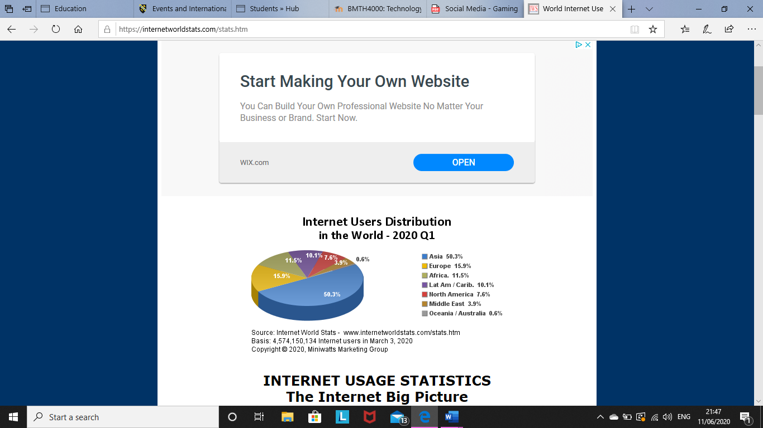
(Internet World Stats, 2020)
Advantages for Social Media and Gaming
- Education, there are learning opportunities for adults and children using social media and gaming. School children and students can connect with anyone at anytime on apps such as Facebook, Instagram, Twitter, WhatsApp and using their smartphones, tablets, laptops, TV’s and computers. They can share links, information about work, speak to tutors/teachers and send their work in. Finding concrete information online is also another advantage, students can be kept up to date and find relevant websites just from their news feed using social media. Sites such as Tumblr and Pinterest can help younger children with school projects and problem solving. Social media helps parents stay involved with their children’s learning, schools use Twitter, Facebook and Instagram to create pages that keep parents up to date on school activities and they also post pictures of the children’s day with the parent’s permission. Distance learning opportunities are also created using the internet and social media, even more now than ever before people are using the internet and social media to keep up to date with lectures and working from home (eLearning Industry, 2019). Gaming can also be educational, there are children’s games that teach them how to read, spell and also teach subjects such as, maths, science and plenty more.
- Social benefits, using social media/gaming anyone can keep in contact with anyone around the world. Family members that live miles away from each other or even in a different country can keep in contact, they can text, message, email, video call and phone whenever they have chance (Life Wire, 2020). Making new friends and meeting new people has been made even easier with social media, dating apps such as Tinder let people talk to someone over the internet so they can get to know them without actually meeting them. Groups such as Facebook groups can help people make new friends through common interests such as games or hobbies.
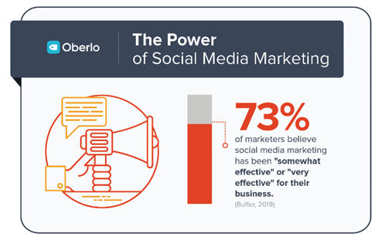
- Advertising, most businesses use social media and also games to advertise their products and brand. Instagram is a huge platform for marketing a business, by using catchy hashtags many businesses will gain thousands of followers. Facebook and Instagram also have a boost your post fee, businesses can pay a small amount of money to boost their post so more people on social media can view the posts. Adverts on social media and games are also used to advertise products and brands, people cannot avoid watching adverts they are on every TV channel, social media and game, meaning it is an obvious way to advertise.
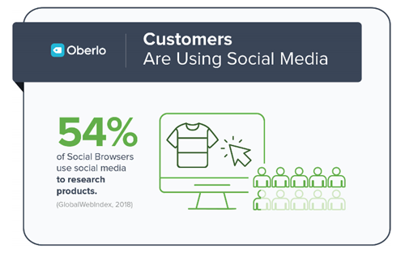

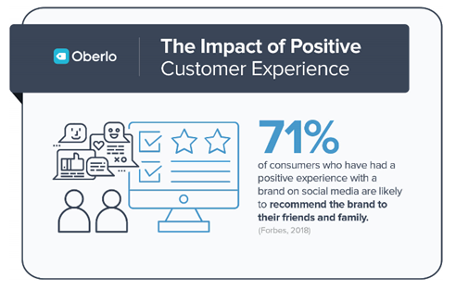

(Oberlo, 2020)
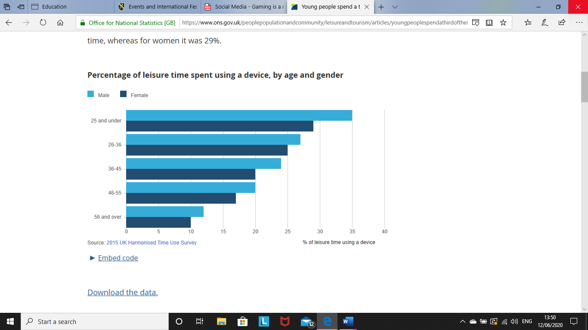
- Leisure, social media, TV and gaming are used for leisure, TV is the main form of leisure pursuit. Most people find time to sit down and watch a TV show, play a game on their phone or game console and use social media and other apps on their phone. The younger generation (under 25) are the main generation that use their phones and other devices for leisure, but other generations are not far behind them. Most people worldwide have access to a TV, phone, tablet, laptop, computer or game consoles, this makes it easier for these devices to be used for leisure time. Most people do not have the time to go out and participate in an activity, but they have enough time to sit down and look through their social media apps or play a game. Keeping up to date with friends and events while also having leisure time in the comfort of your own home.
(Office for National Statistics, 2017)
For
The writer is going to argue against this statement.
Disadvantages of Social Media and Gaming
- Promoting an unhealthy lifestyle, social media and gaming are stopping people from doing activities and sport. Most people would prefer to stay home or sit around on their phones or other devices than go out and meet friends and family. Before social media and gaming became a big part of people’s lives, they would have to go out to meet people and play sport. Sitting at home all day is not healthy and can be a cause of obesity, not getting enough exercise is unhealthy for the body and mind. Social media can also cause mental illness, some people compare them selves to others as they see a lot of information about other peoples lives, this can cause depression and anxiety, compared against people who use social media less frequently, people who use social media often are 2.7 times more likely to get depression (Forbes, 2016).
- Inappropriate content, these days children and young people have a huge amount of access to the internet and games, most parents can not always supervise or see everything their child is doing on the internet or games. Games promote violence, crime, sex and drugs, there are age limits on most games, but parents allow their children to play these games and they do not know what games they are playing over their friends houses or with other family members. TV programs can also promote violence, crime, sex and drugs, even children’s programmes show violence and crime, children are always learning, and these can affect their behaviour because they might think this is acceptable. Even adults can be influenced by the things they watch on TV or see on games or social media.
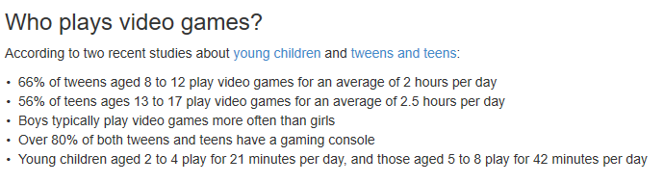
(Centre of Media and Child Health, 2019)
- Restricts social interactions, with apps such as Facebook, Twitter, Instagram, Snapchat and WhatsApp people can videocall, message and phone each other whenever they need or want to, this gives them less reason to actually go out and meet up with their friends or family. Another reason social media and gaming restrict social media is when people to meet up with friends or family they still use their phones or their other devices meaning they still don’t speak to each other.

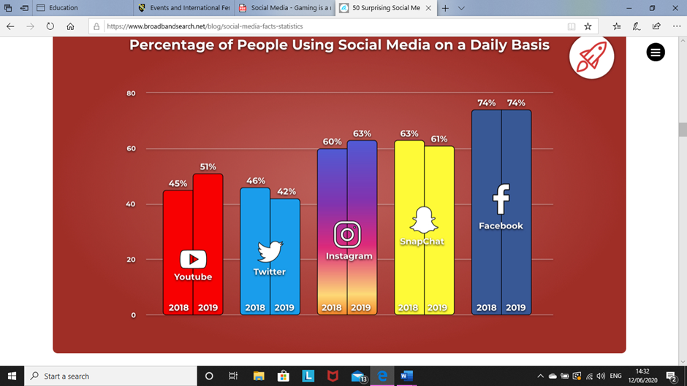

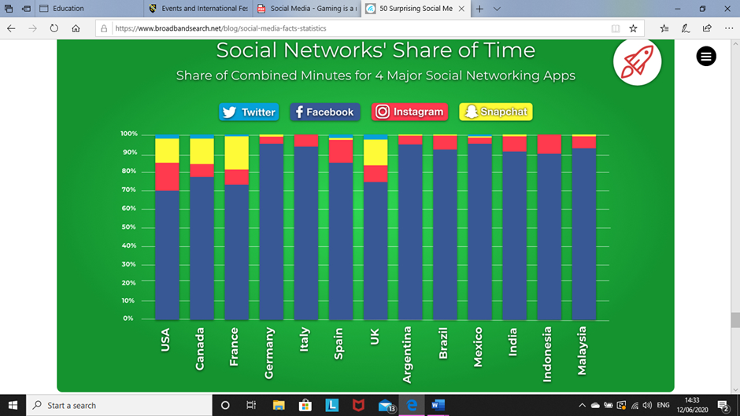
(Broadband Search, 2020)
- Excessive spend, as the writer wrote about before businesses use social media and games to promote their brand and products, this can cause people to overspend while using their devices. Online shopping can also be a lot easier than actually going to the shops and physically looking for items you need. Games cost money to purchase and once people buy the games it can cost money to buy certain extras on these games that young children will want to purchase. Social media has a big influence on people’s minds, people can get confused between a need and a want, if someone sees something someone else has, they might think they need this product or brand causing them to spend money unnecessarily. Gambling can also be made easier online, gambling websites advertise free games, extra money when you spend a certain amount and more chance of winning events. Gambling is an addiction and people lose huge amounts of money through their addiction. An estimated 26% of people worldwide gamble (Gambling.net, 2018).
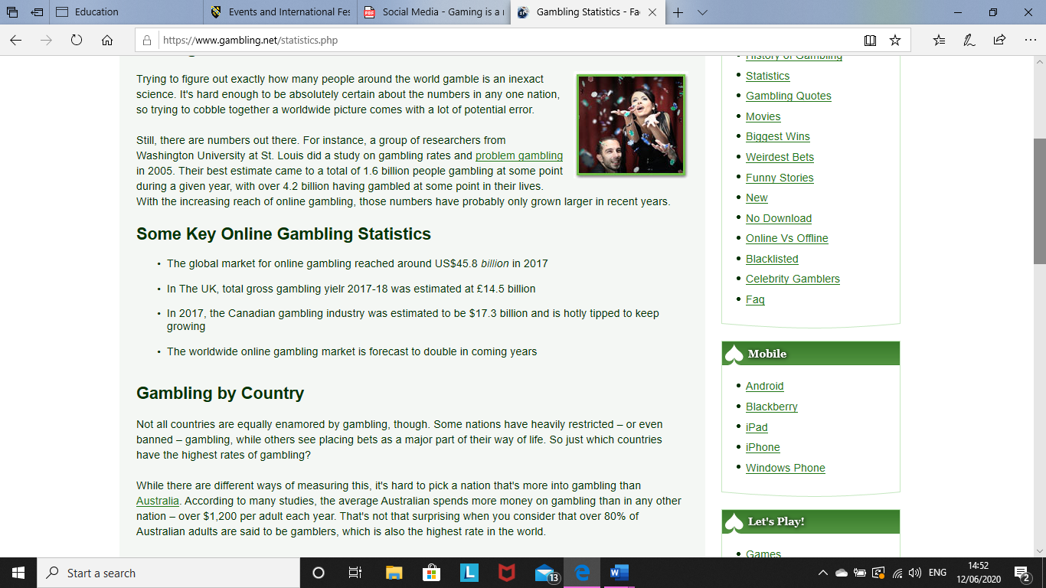
(Gambling.net, 2018)
Butler’s Life Cycle
Butler uses a life cycle model to show the growth of tourism destinations or attractions. This model could also be used to show the growth of media. 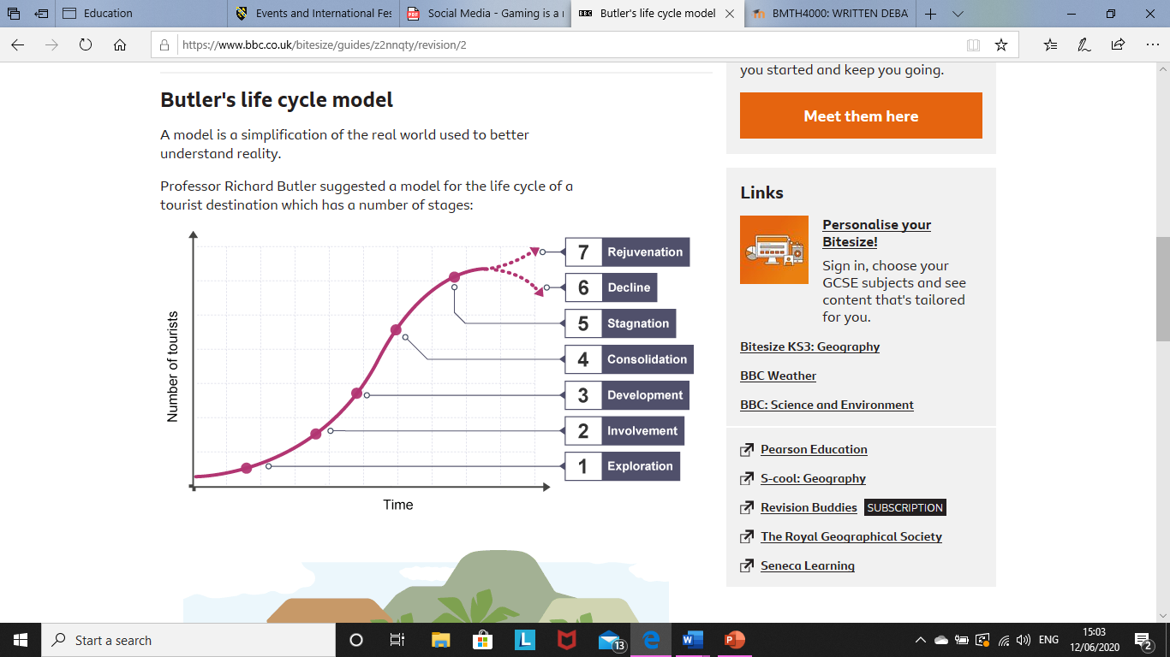
Media (social media and gaming) would be between, development and consolidation, it has developed massively over the years but still has the potential to develop even more in the coming years. Social media and gaming has billions of users, but this can cause hostility the same as tourist destinations.
(BBC Bitesize, 2020)
Maslow’s Hierarchy of Needs
Maslow’s hierarchy of needs is a five-tier model of human needs, the needs lower down need to be satisfied before individuals can satisfy the higher needs. From the bottom to the top these needs are psychological, safety, love and belonging, esteem and self-actualization (Simple Psychology, 2020).
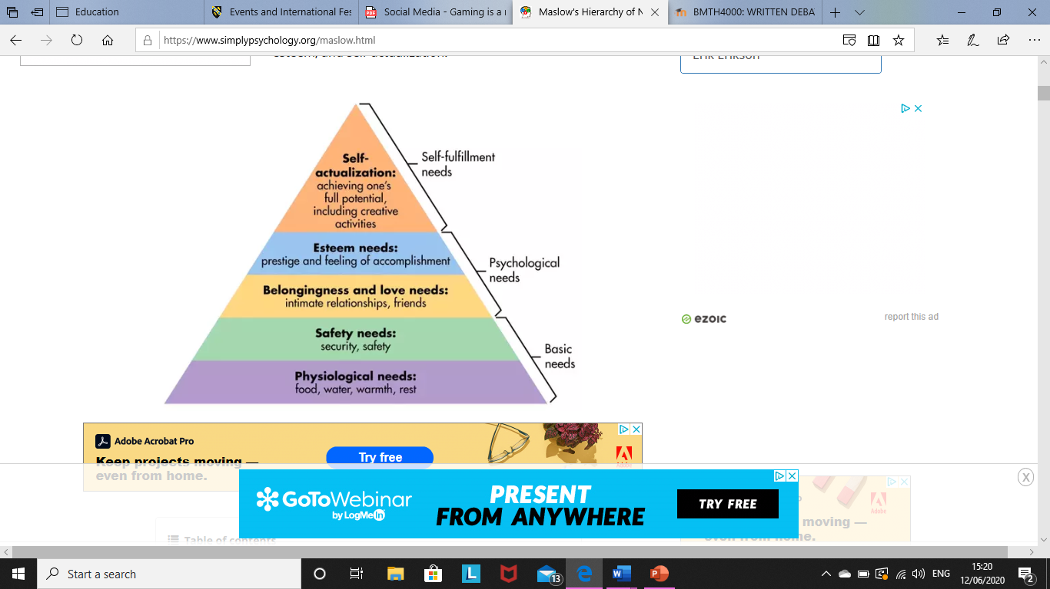

These are the needs of people. Anything else is a want, social media and gaming can confuse people in to thinking they need something when really, they just want it. This is another reason media can cause depression.
Doxey’s Index of Irritation
Doxey’s index of irritation is the process of irritation caused by tourism, but this can also be used to explain the process of irritation caused by social media and gaming.
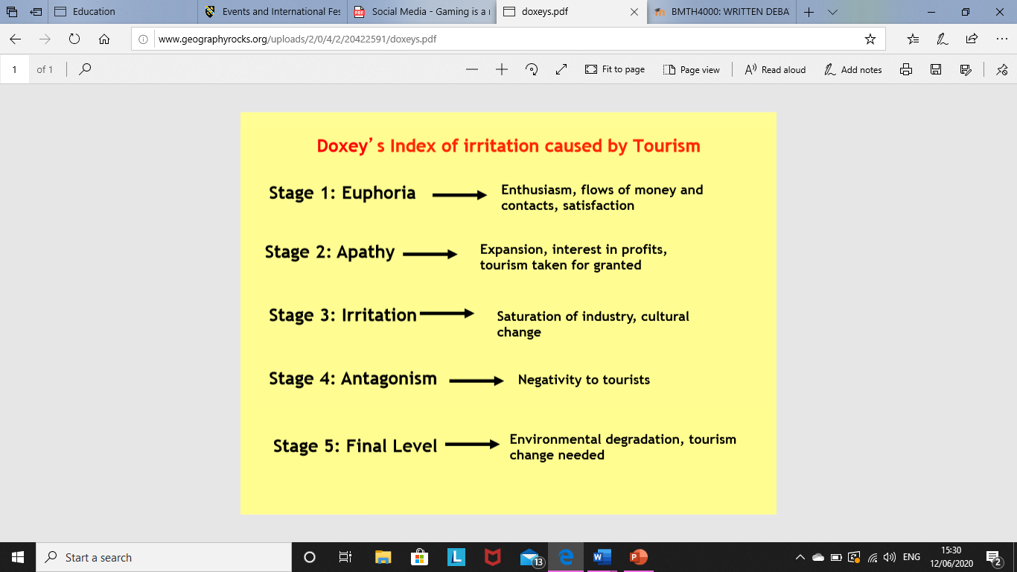
(Geography Rocks, 2020)
This could be a mixture of irritation caused, depending on the person and the reasons they use social media or gaming they might have a different level of irritation to someone else. The main stage of irritation worldwide is between stage 3: irritation and stage 4: antagonism, the amount of mental health issues caused by social media and gaming as well as bullying has caused a lot of negative opinions of social media and gaming.
Conclusion
The writer has come to the conclusion that this statement is true. Social media and gaming has both positive and negative effects on society, but the negative effects are more serious and life threatening so these are more important than the positive effects. Mental health, bullying, inappropriate content and unhealthy lifestyle can be life threatening causing people to commit suicide, hurt another person or commit crimes. People are going to continue to use social media and gaming even more so in the future as media develops more, all people can hope for is a safer way to use social media and games and improve their lifestyle as well as use the internet.

Bitesize, B. (2020), ‘BBC Bitesize’, [Online]. Available: www.bbc.co.uk, [2020, June, 12th].
Chowdhry, A. (2016), ‘Forbes’, [Online]. Available: www.forbes.com, [2020, June, 12th].
Fox, M. (2019), ‘Most Fox’, [Online]. Available: www.mostfox.com, [2020, June, 9th].
Health, C, A, M, O C. (2019), ‘Centre of Media and Child Health’, [Online]. Available: www.cmch.tv, [2020, June, 12th].
Industry, E. (2019), ‘eLearning Industry’, [Online]. Available: www.elearningindustry.com, [2020, June, 10th].
Net, G. (2018), ‘Gambling.net’, [Online]. Available: www.gambling.net, [2020, June, 12th].
O’Dea, S. (2020), ‘Statista’, [Online]. Available: www.statista.com, [2020, June, 9th].
Oberlo. (2020), ‘Oberlo’, [Online]. Available: www.oberlo.com, [2020, June, 11th].
Psychology, S. (2020), ‘Simple Psychology’, [Online]. Available: www.simplepsychology.org, [2020, June, 12th].
Rocks, G. (2020), ‘Geography Rocks’, [Online]. Available: www.geographyrocks.org, [2020, June, 12th].
Search, B. (2020), ‘Broadband Search’, [Online]. Available: www.broadbandsearch.net, [2020, June, 12th].
Statistics, N, F, O. (2017), ‘Office for National Statistics’, [Online]. Available: www.ons.gov.uk, [2020, June, 11th].
Stats, W, I. (2020), ‘Internet World Stats’, [Online]. Available: www.internetworldstats.com, [2020, June, 9th].
Watson, A. (2019), ‘Statista’, [Online]. Available: www.statista.com, [2020, June, 9th].
Wire, L. (2020), ‘Life Wire’, [Online]. Available: www.lifewire.com, [2020, June, 10th].

