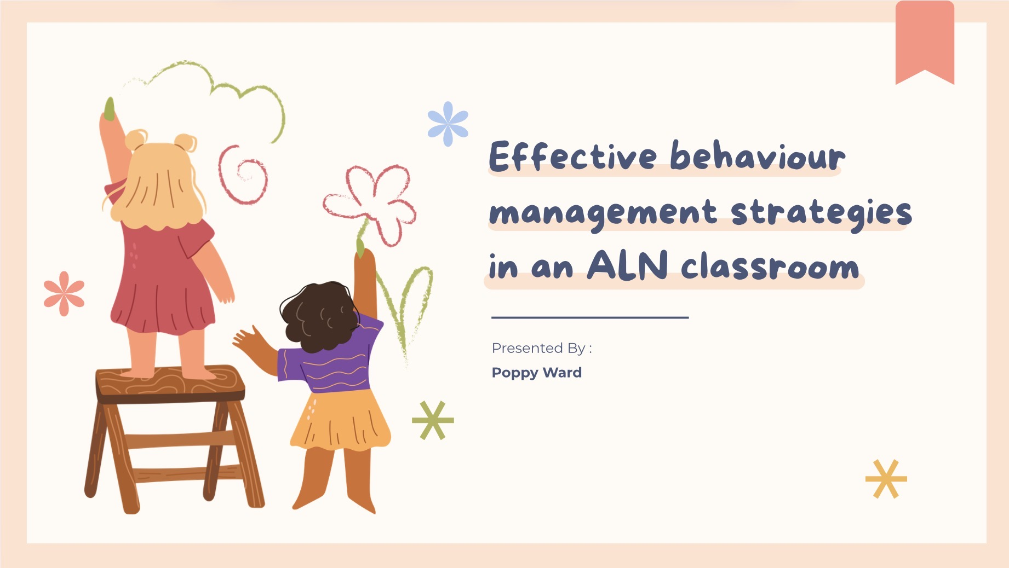
Link: Recap: Meeting with Poppy Ward (2504110) 25 October | Meeting | Microsoft Teams

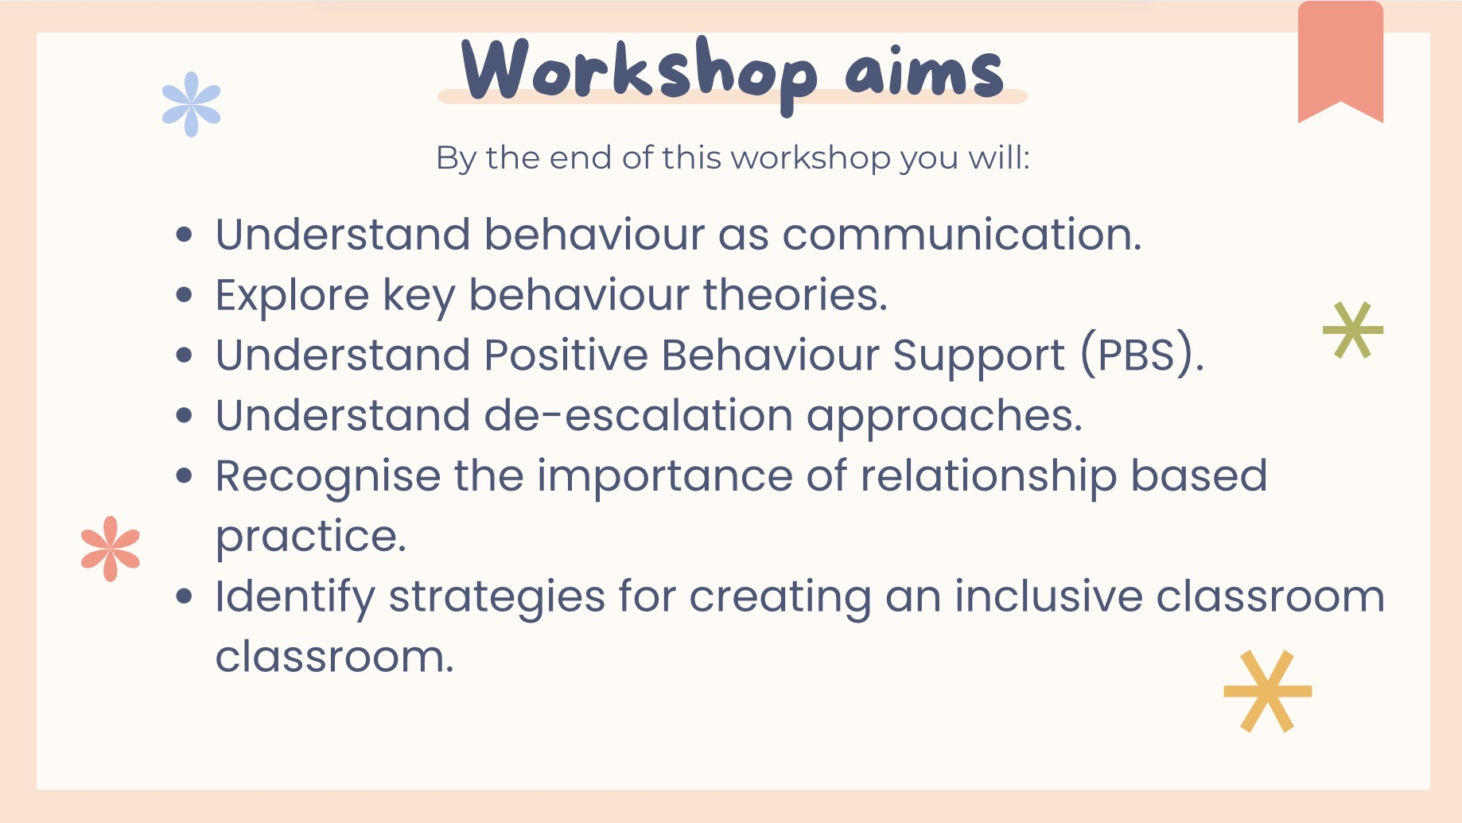

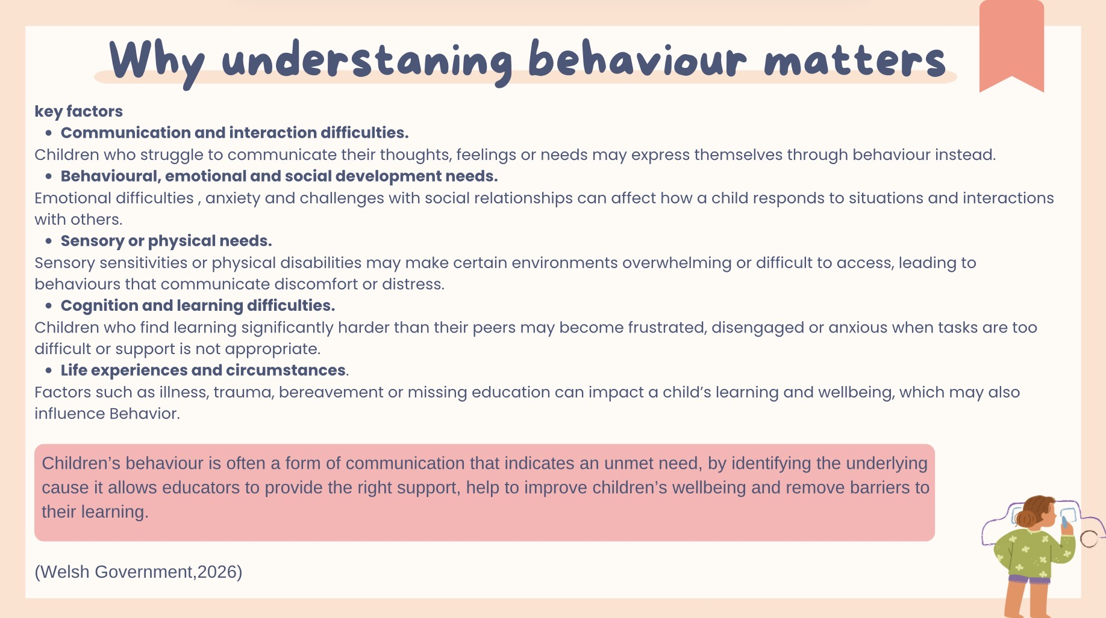
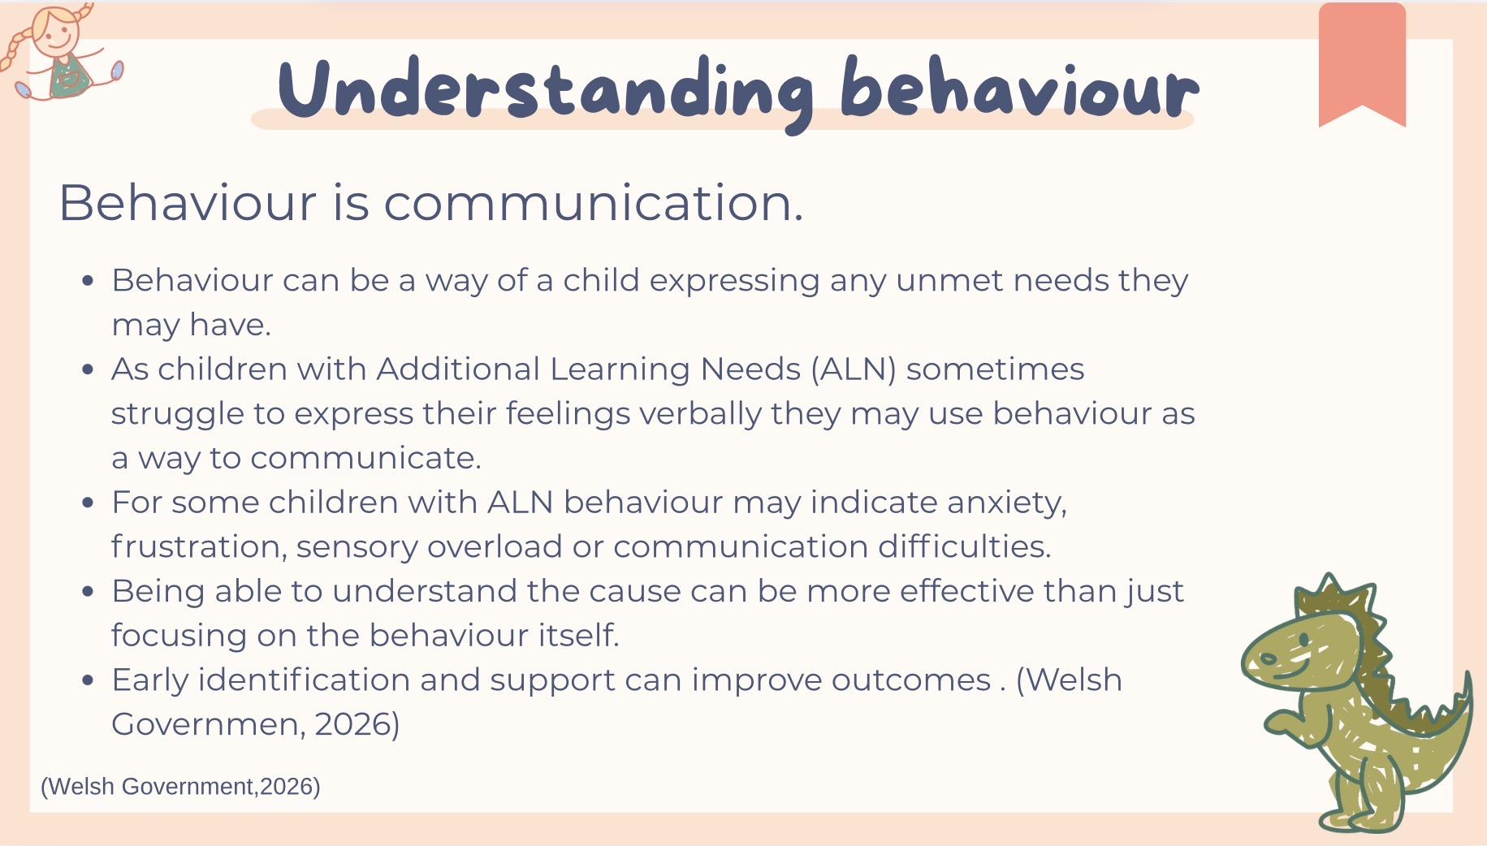

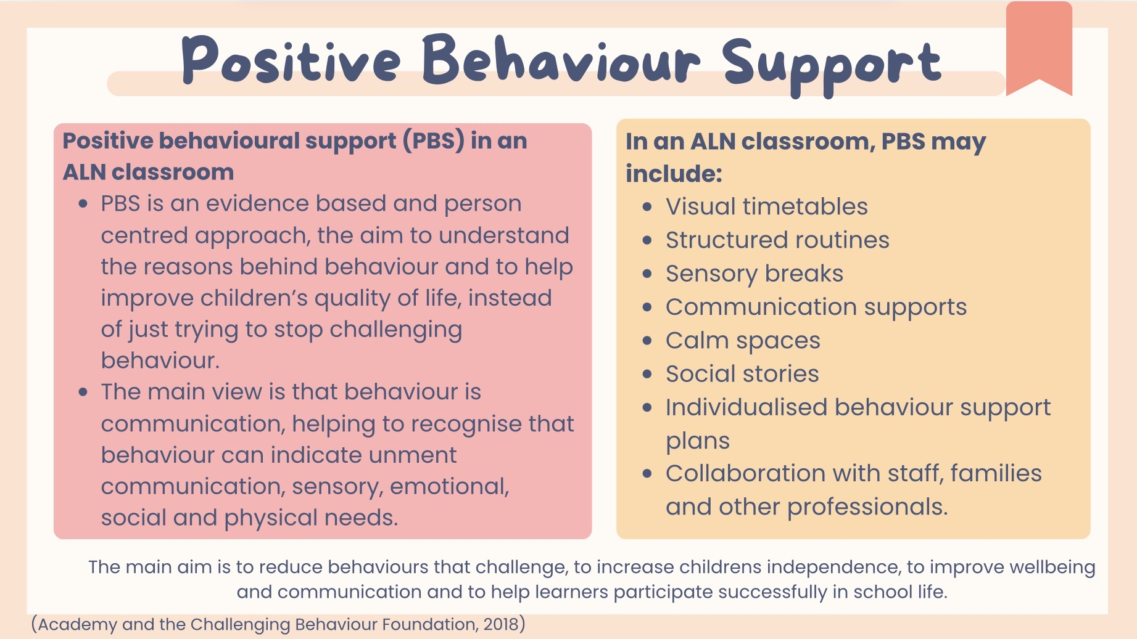
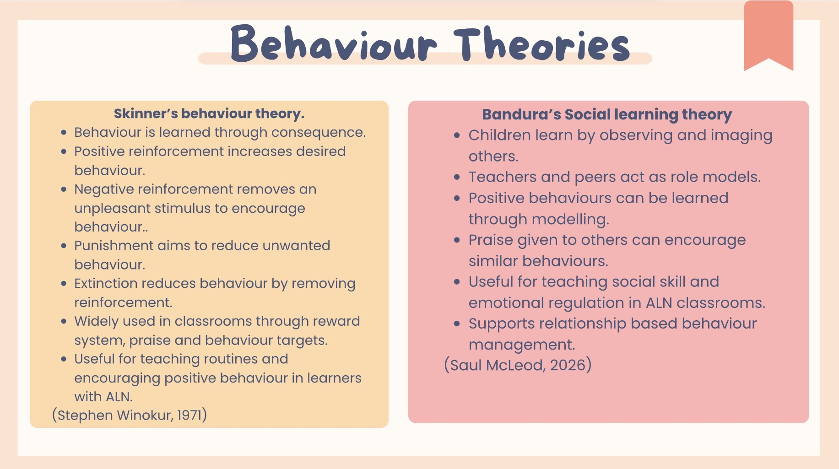

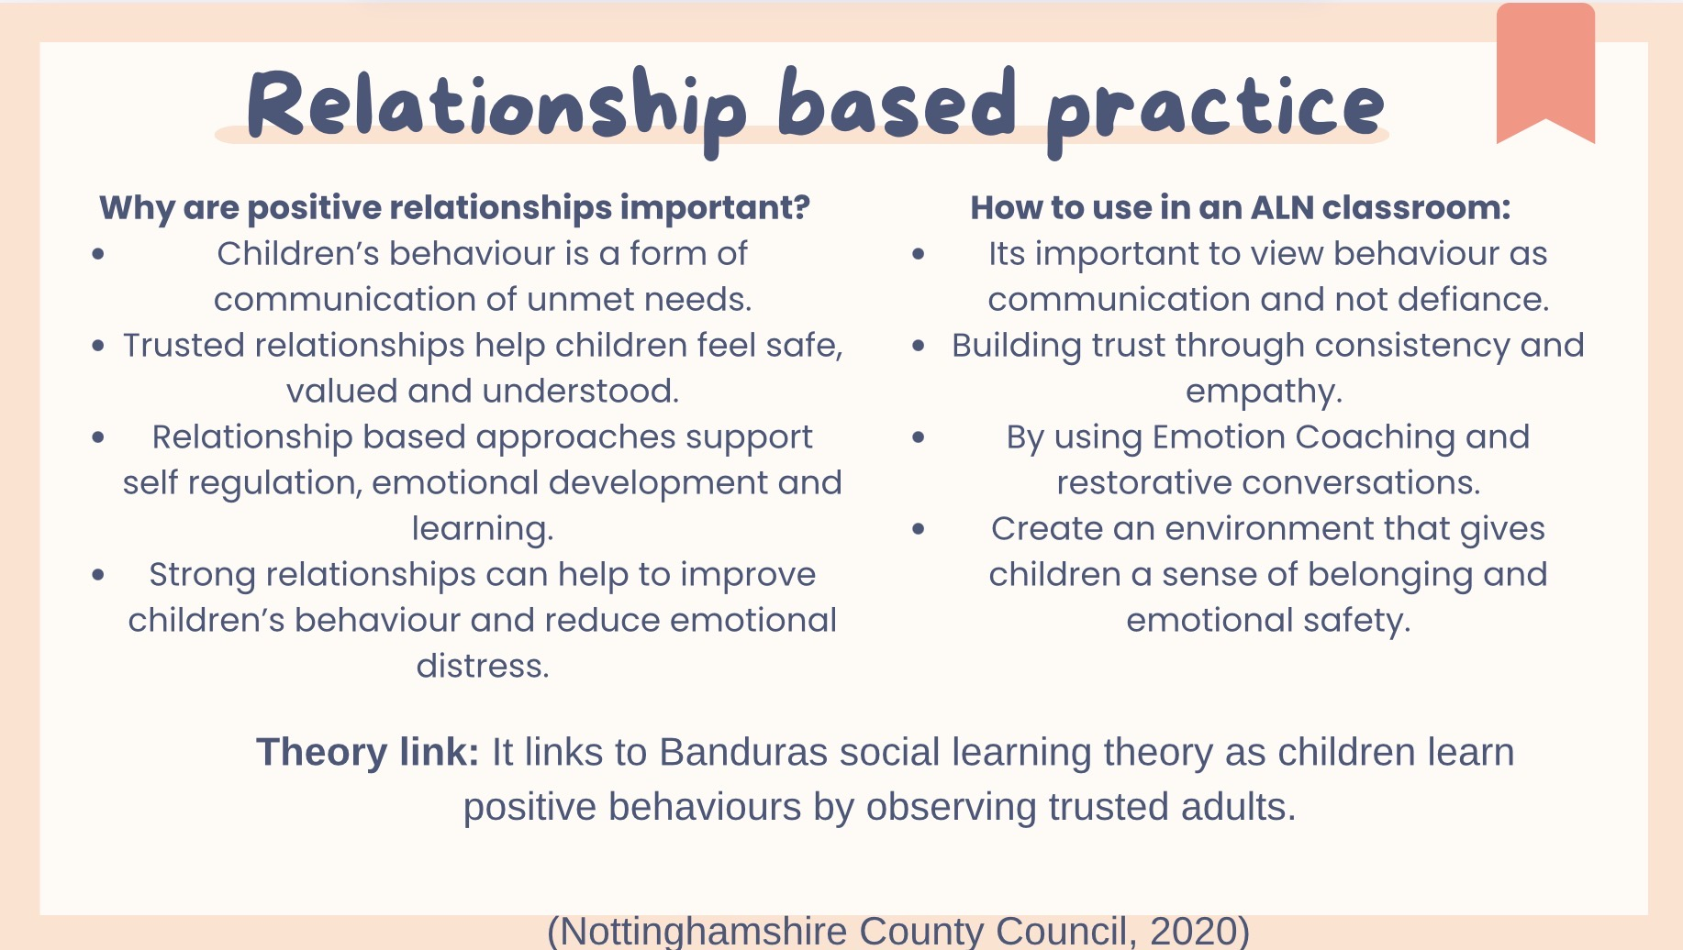
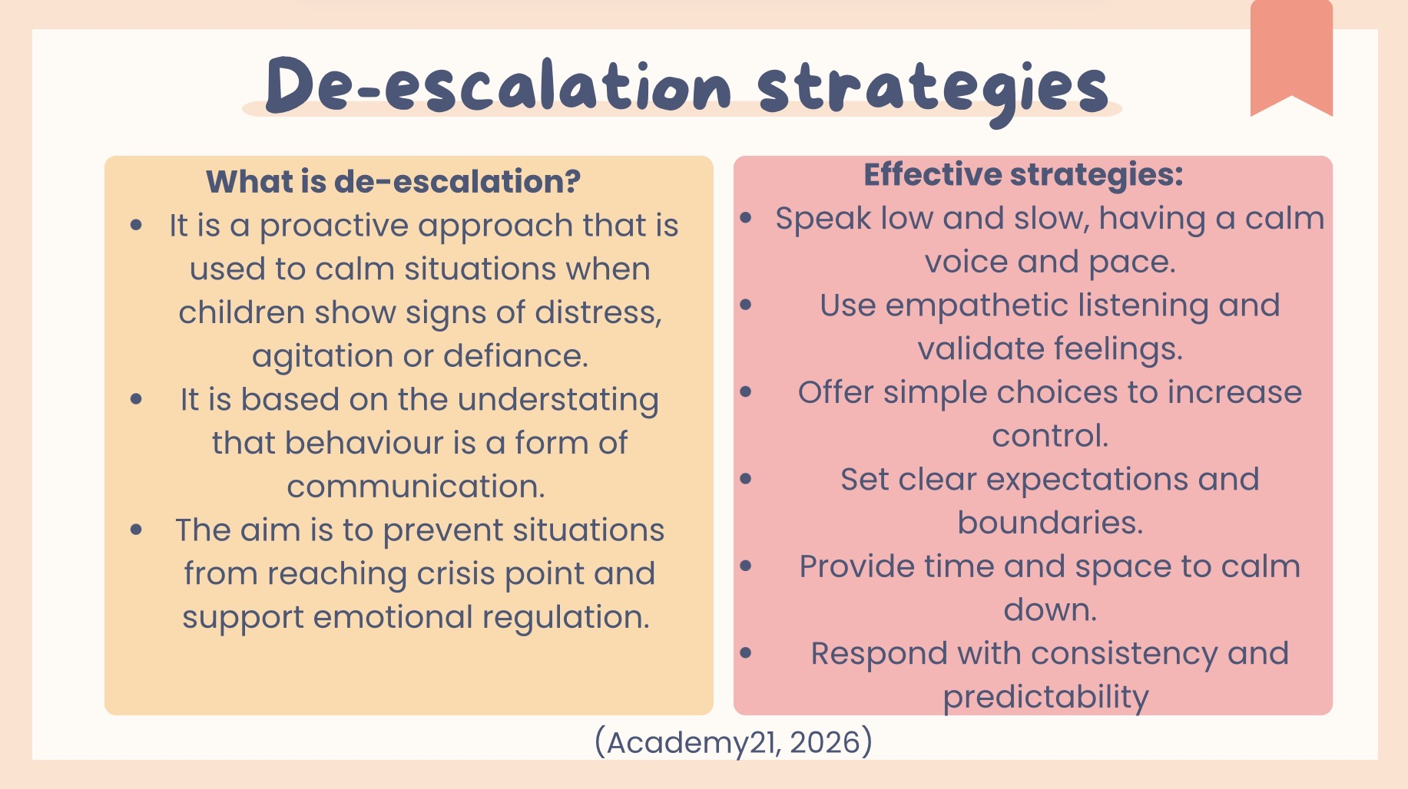
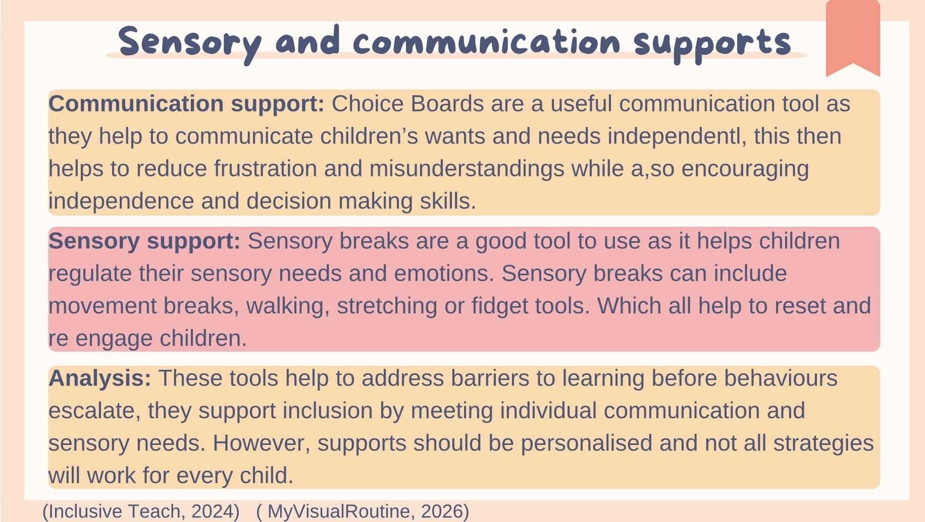
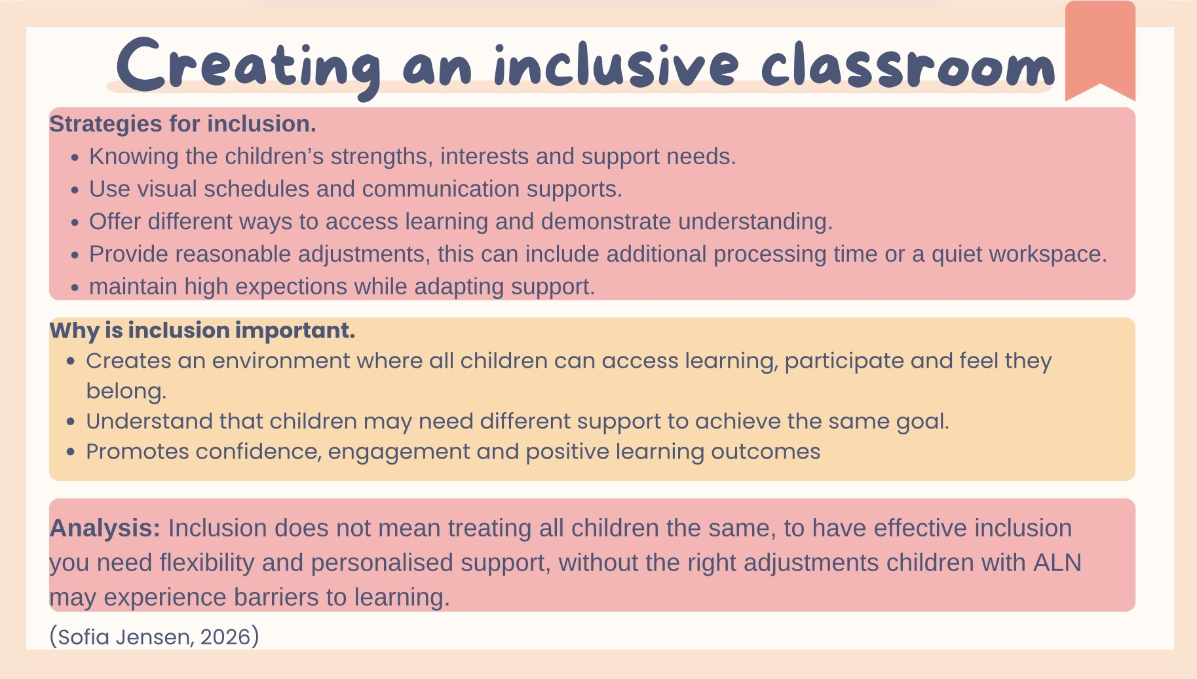

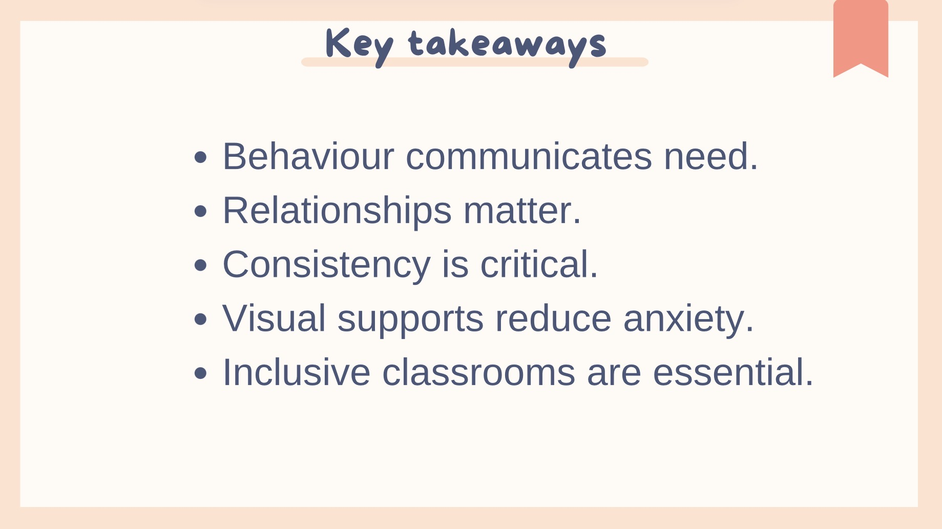
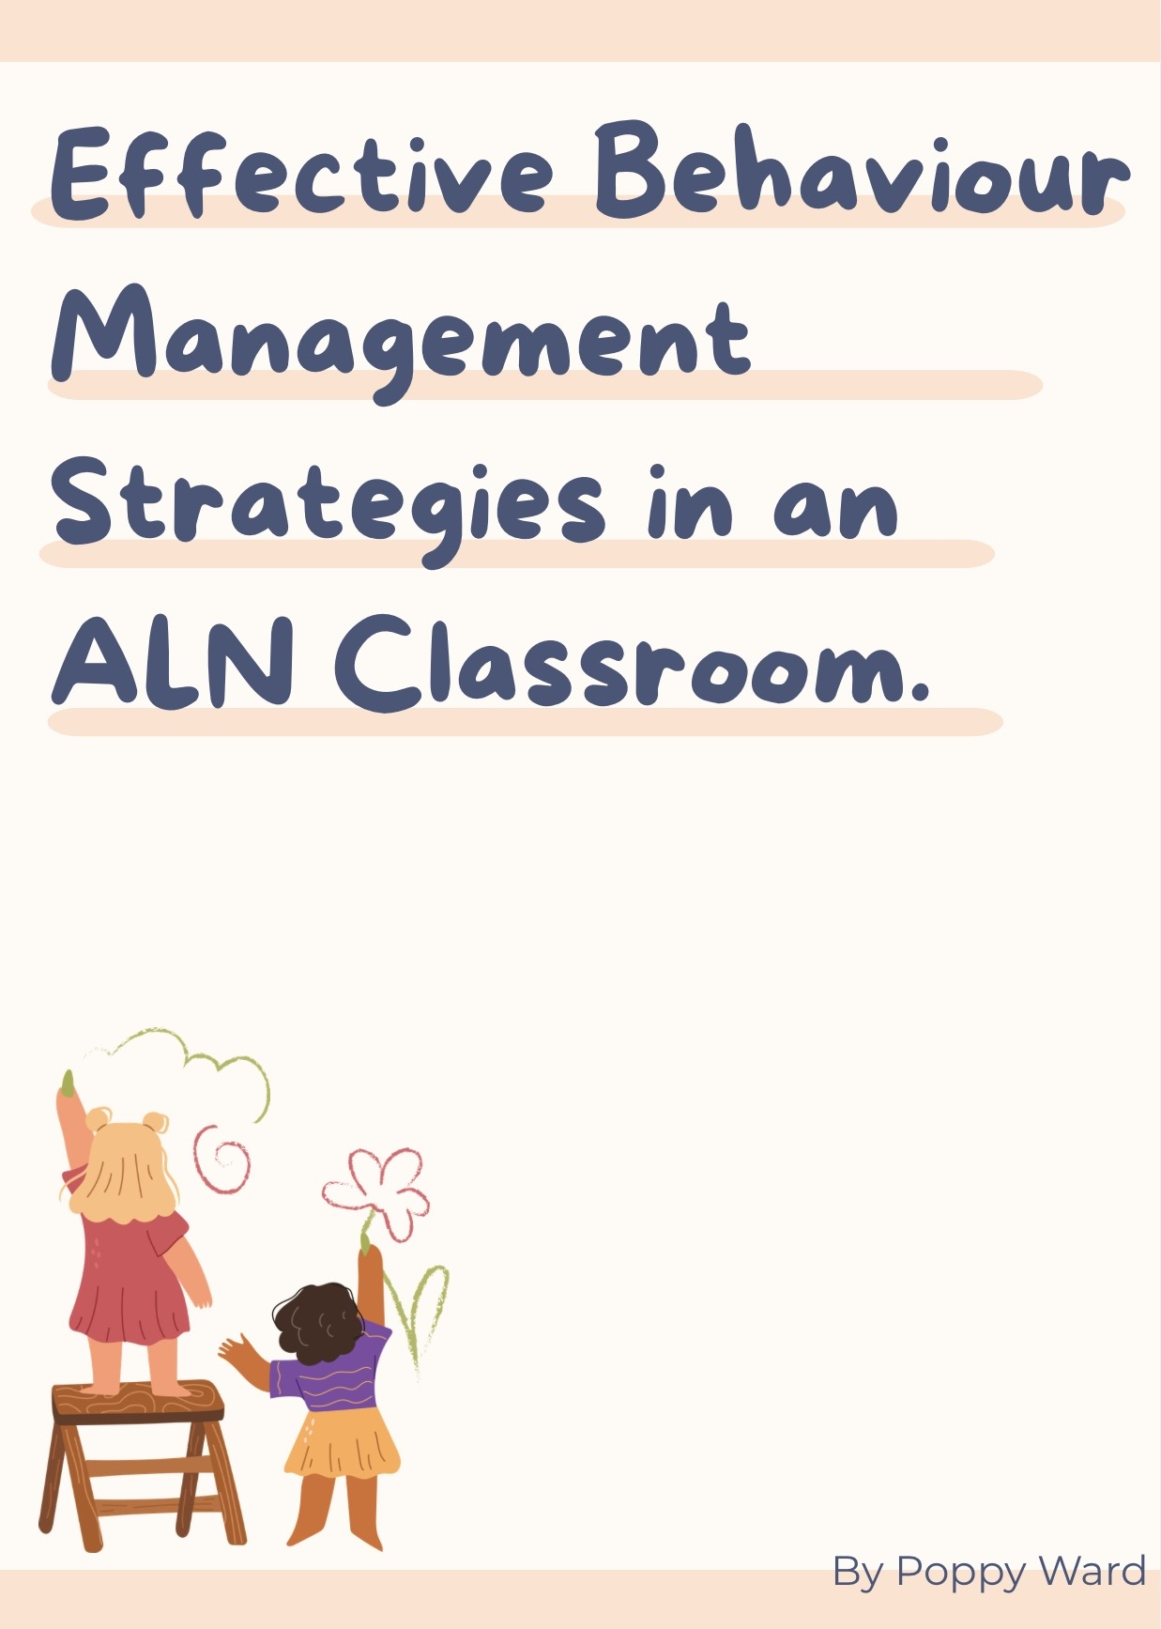
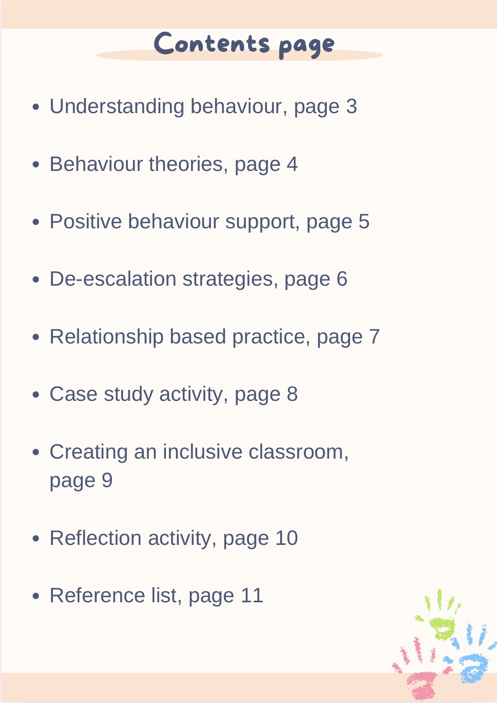
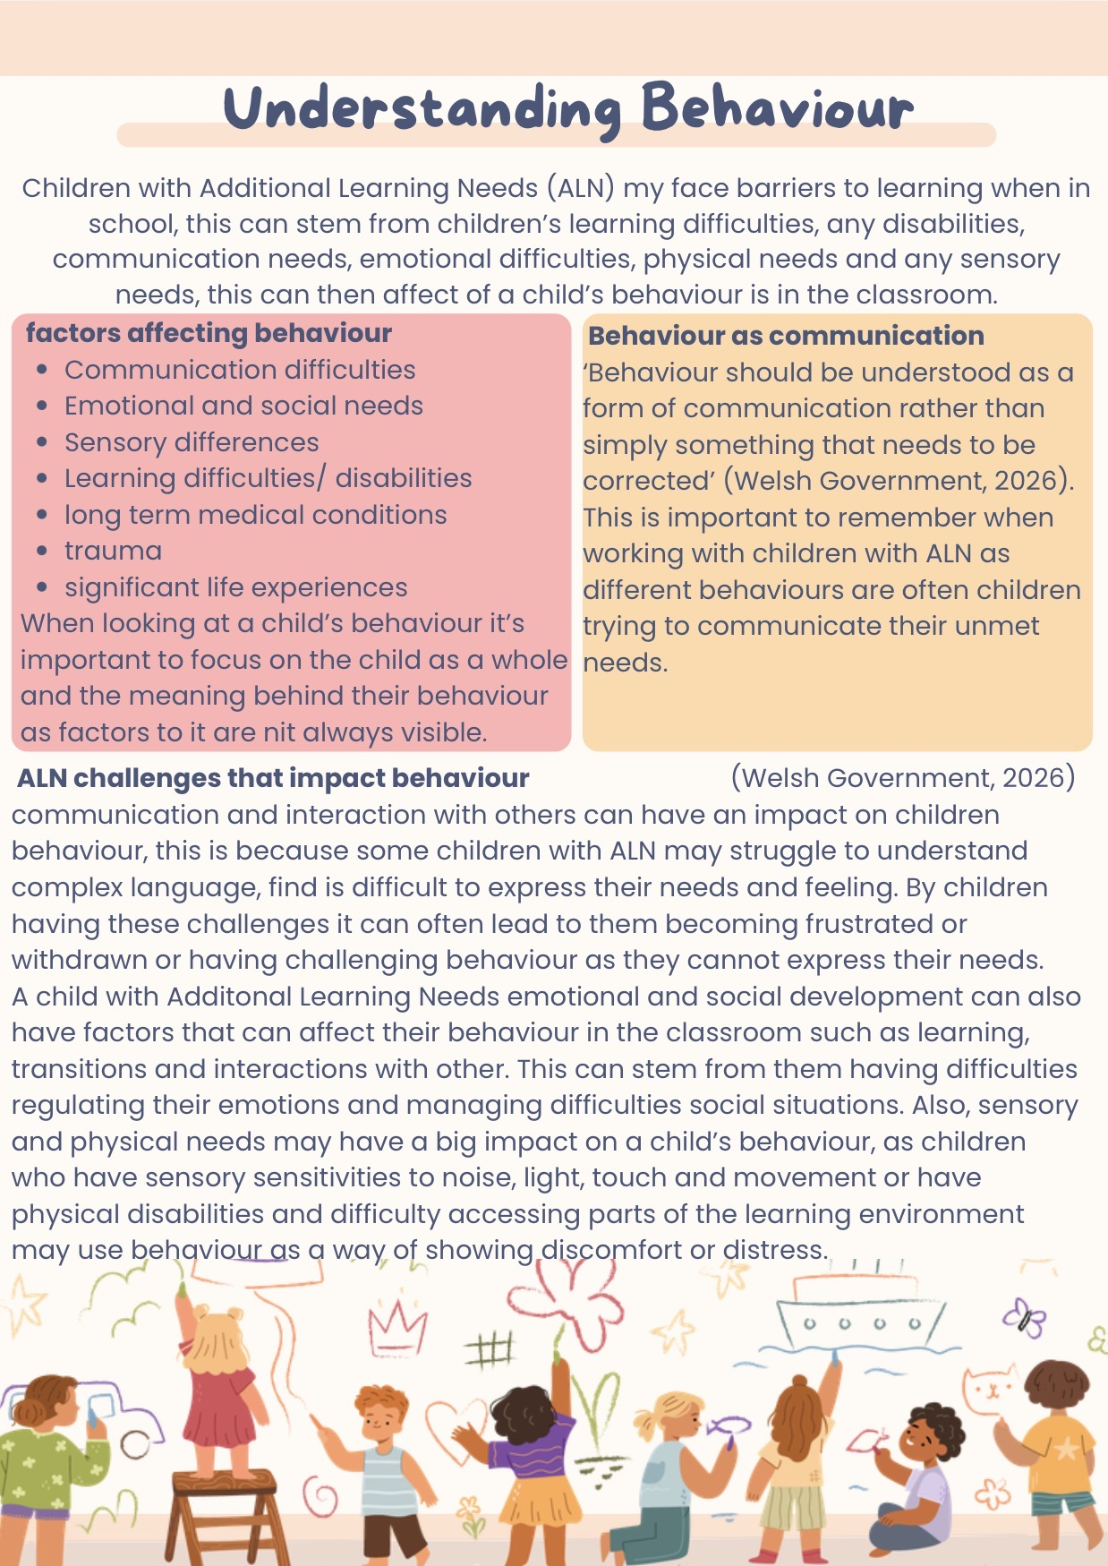
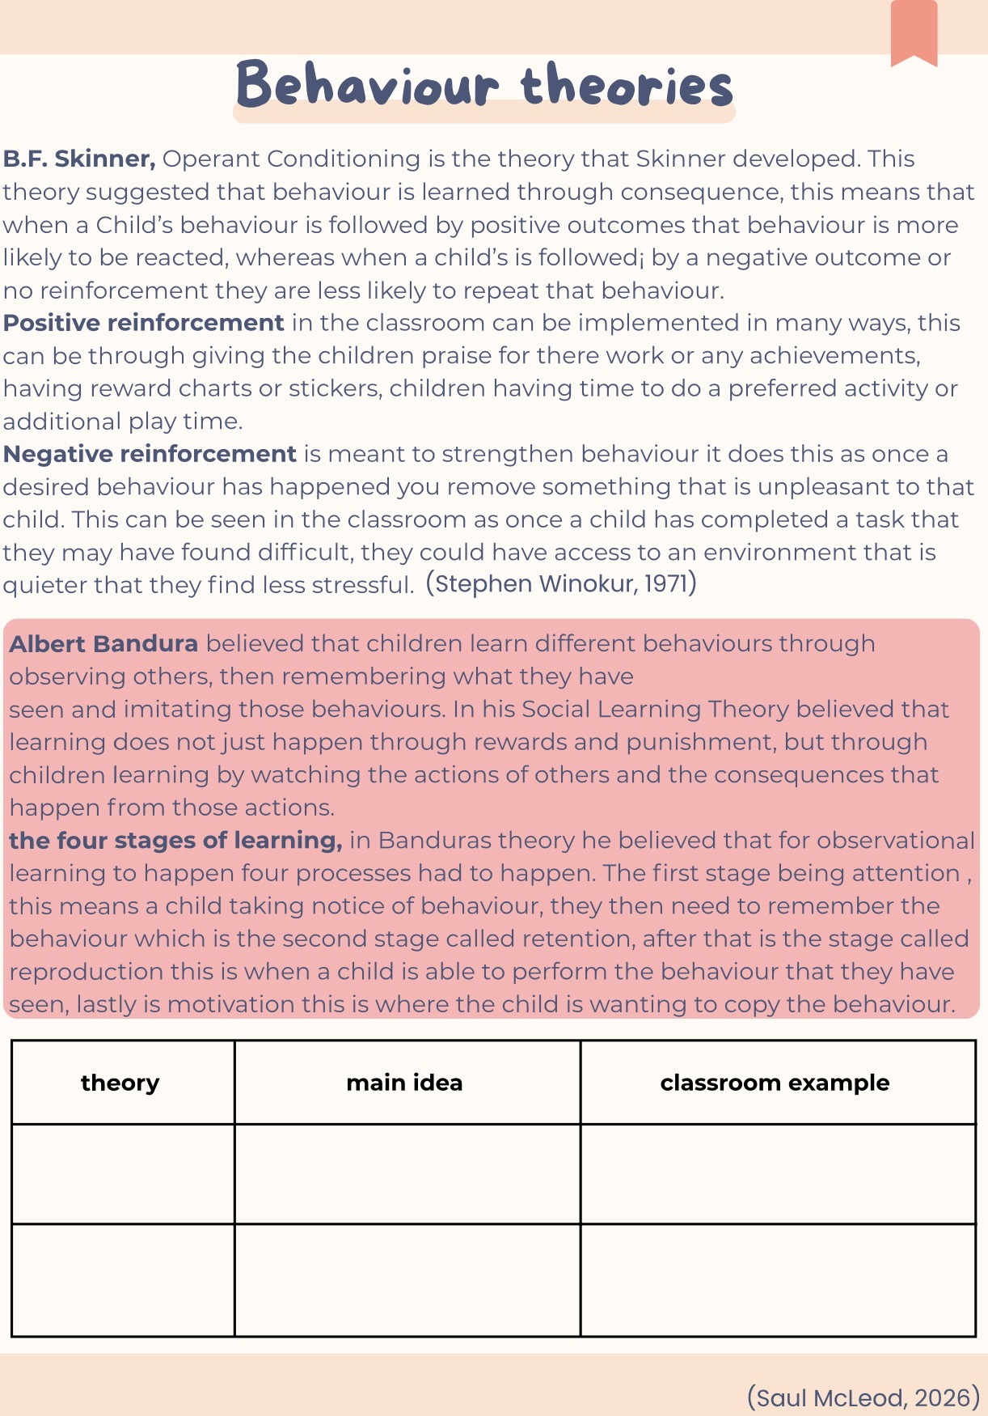
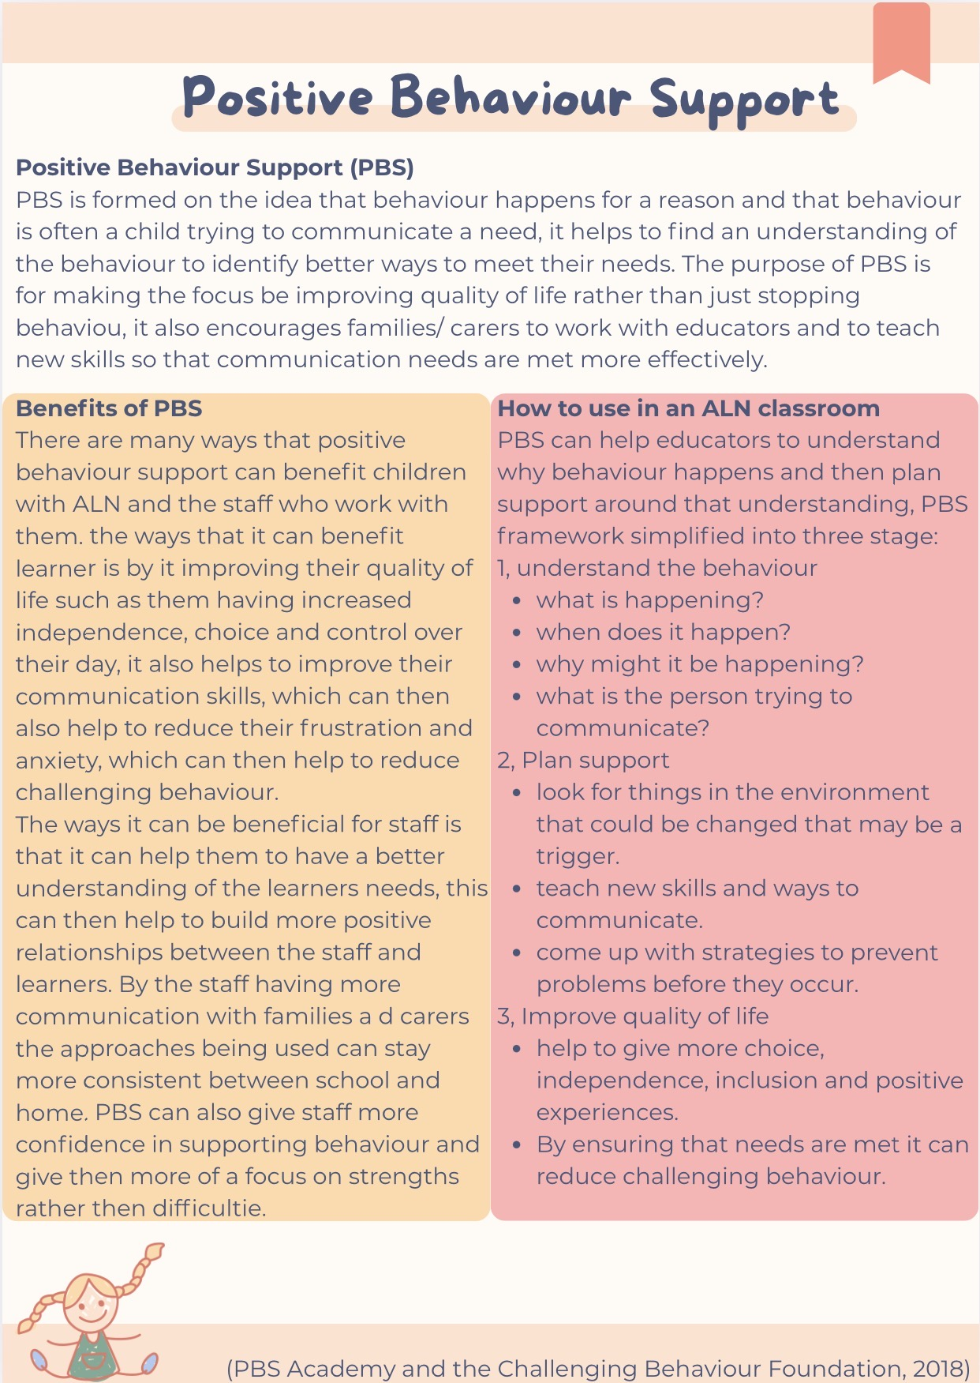
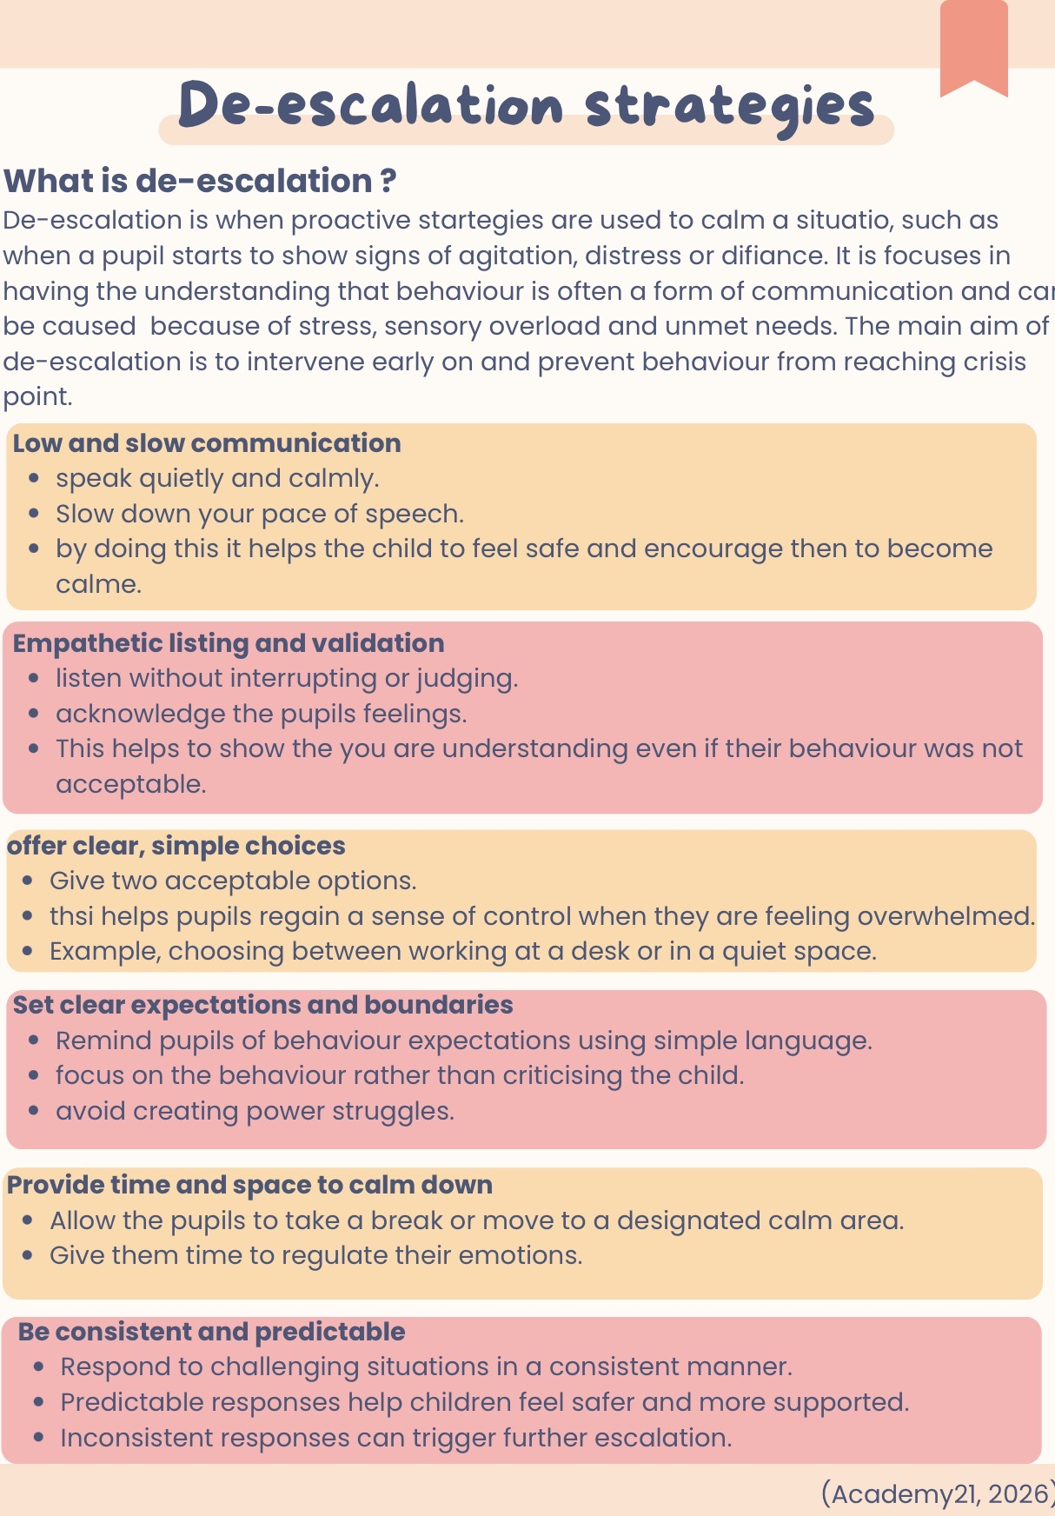
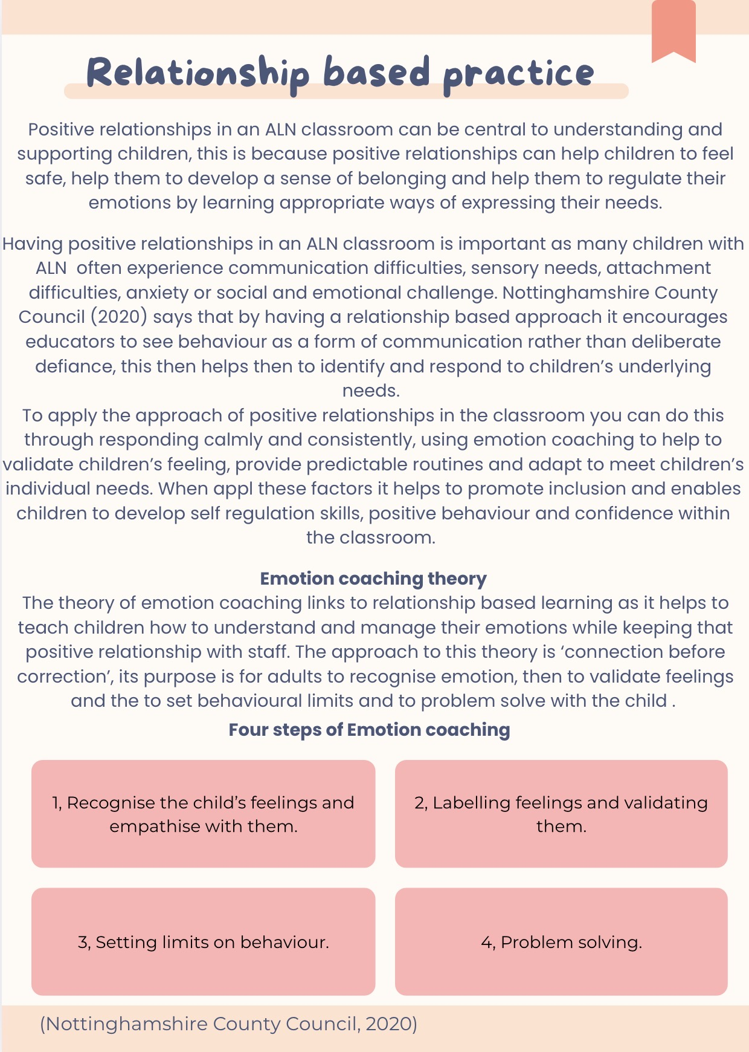
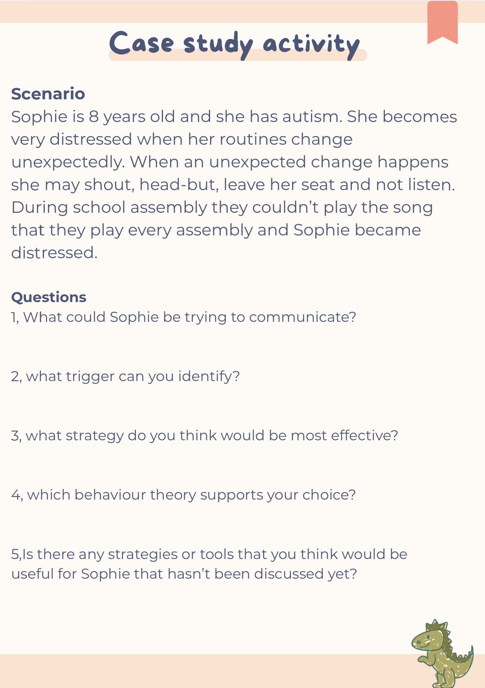
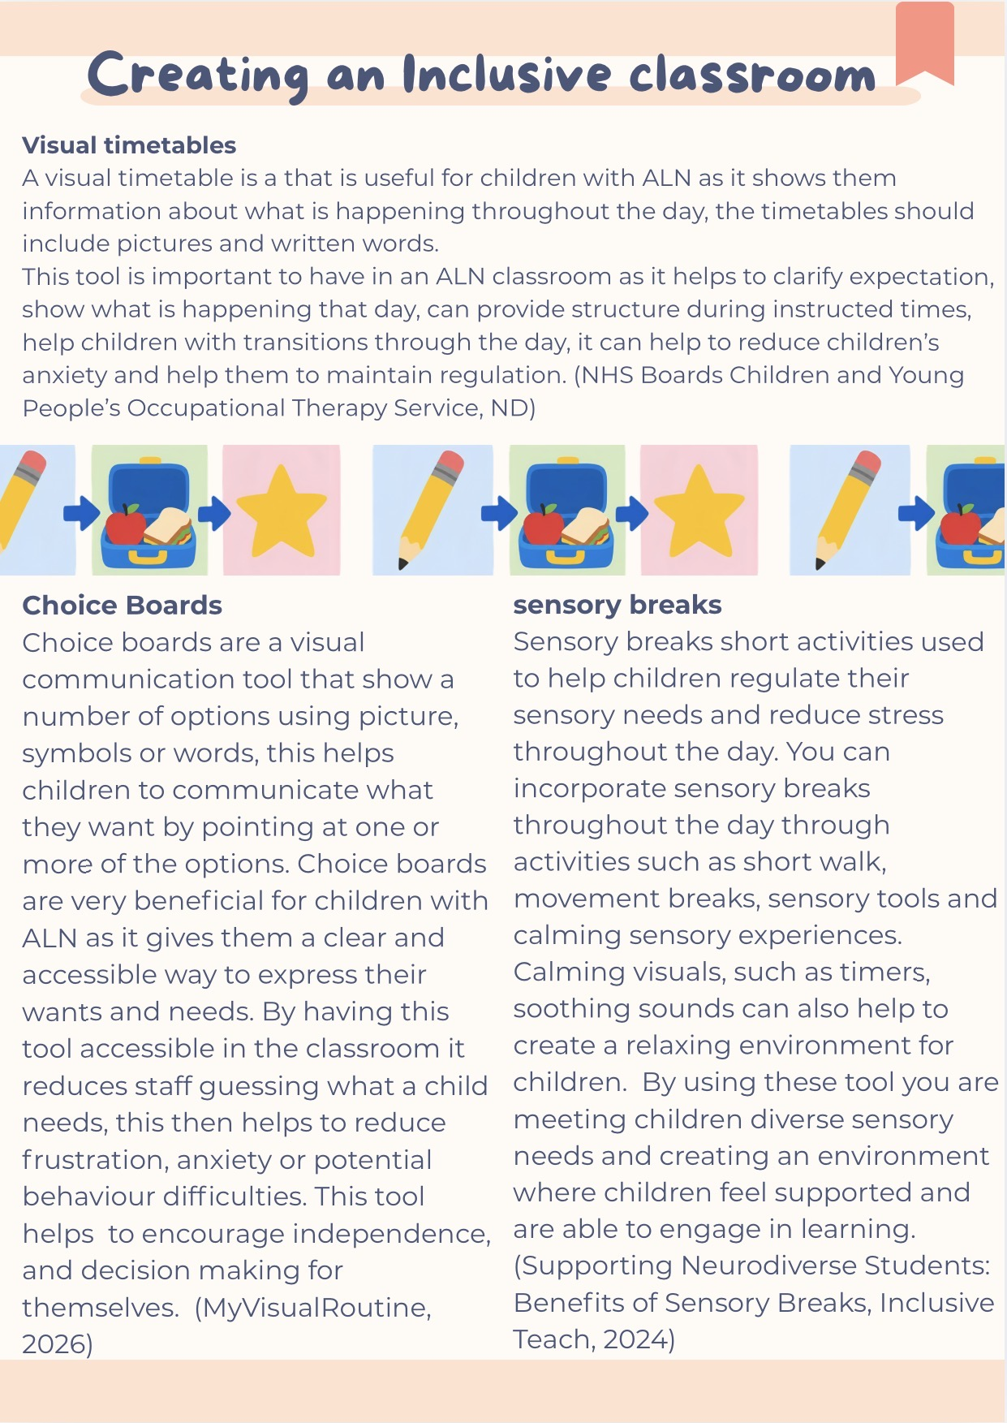
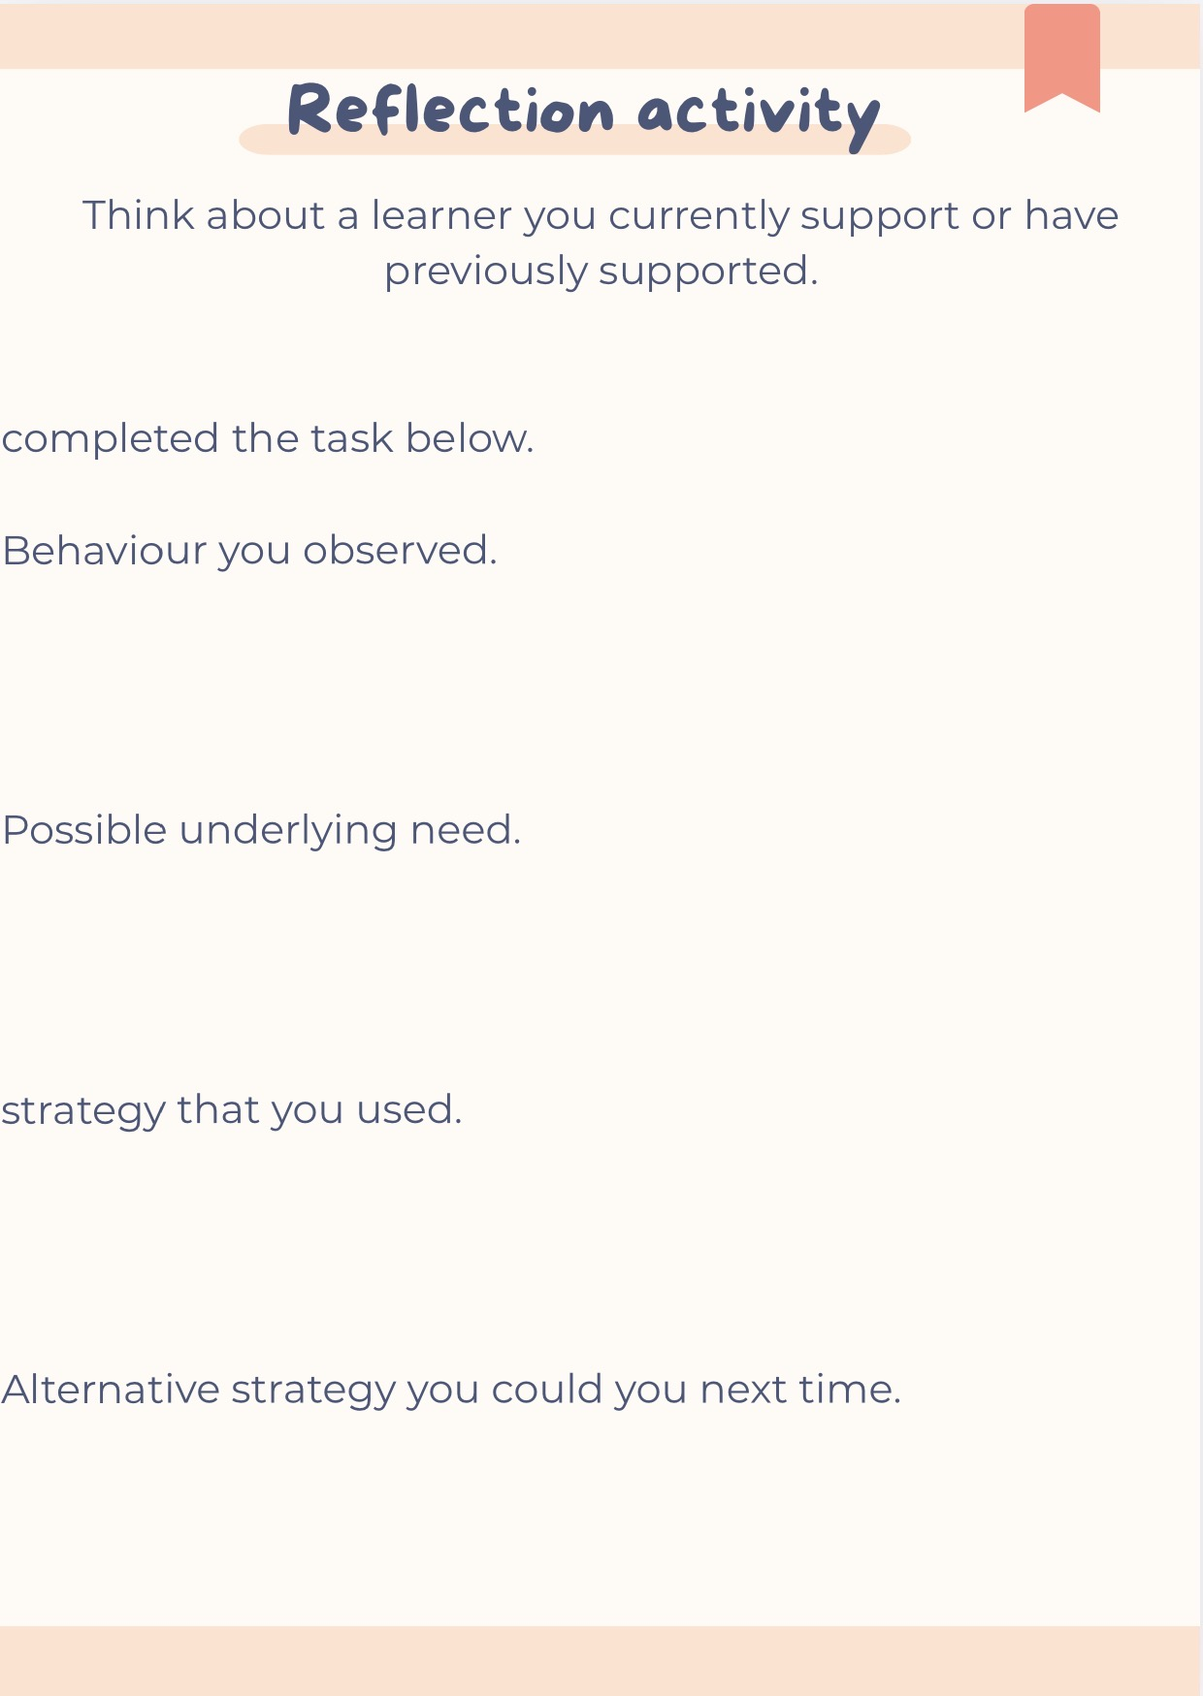

Reference list for booklet and presentation:

Academy21 (2026) De-escalation strategies in schools: Practical approaches that work. Academy21. Available at: https://academy21.co.uk/resource/blog/de-escalation-strategies-in-schools-practical-approaches-that-work/ (Accessed: 24 October 2026).

Inclusive Teach (2024) Supporting neurodiverse students: Benefits of sensory breaks. Inclusive Teach, 6 June. Available at: https://inclusiveteach.com/2024/06/06/supporting-neurodiverse-students-benefits-of-sensory-breaks/ (Accessed: 24 October 2026).

McLeod, S. (2025) Albert Bandura's Social Learning Theory. Simply Psychology. Available at: https://www.simplypsychology.org/bandura.html (Accessed: 24 October 2026).

MyVisualRoutine Team (2026) Choice boards for autism: A parent's complete guide. MyVisualRoutine. Available at: https://myvisualroutine.com/blog/choice-board-autism-guide/ (Accessed: 24 October 2026).

NHS Borders (n.d.) RFA handout: Visuals. NHS Borders. Available at: https://www.nhsborders.scot.nhs.uk/media/1011493/RFA-handout-Visuals-.pdf (Accessed: 24 October 2026).

Nottinghamshire County Council (2020) Understanding behaviour in schools. Version 1. Nottingham: Nottinghamshire County Council. Available. athttps://www.bing.com/ck/a?!&&p=06de48b5af0aeabfcf745d06ef5c098ac7cc4e280014e17fbafd41e586576478JmltdHM9MTc5MjgwMDAwMA&ptn=3&ver=2&hsh=4&fclid=0c904837-e9d5-6bf6-3893-5e6de86e6a68&psq=Understanding+Behaviour+in+Schools+Version+1+%e2%80%93+Nottinghamshire+County+Council+October+2020+&u=a1aHR0cHM6Ly9lbS1lZHN1cHBvcnQub3JnLnVrL1BhZ2VzL0Rvd25sb2FkLzBjOGRhN2YyLTk1YzktNDFlNS04ZjA4LTc5NDM5MzQzMjlkMS9QYWdlU2VjdGlvbkRvY3VtZW50cw&ntb=1 (Accessed: 25 October 2026).

PBS Academy and Challenging Behaviour Foundation (2018) Positive Behavioural Support (PBS): An Information Pack for Family Carers. Chatham: Challenging Behaviour Foundation. Available at: https://www.challengingbehaviour.org.uk/wp-content/uploads/2026/09/PBS-Information-Pack-.pdf (Accessed: 24 October 2026).

Sofia Jensen (2026) Creating inclusive classrooms: Practical tips for teachers. Childrens Needs. Available at: https://childrens-needs.com/pages/creating-inclusive-classrooms-practical-tips-for-teachers (Accessed: 24 October 2026).

Welsh Government (2026) Toolkit for parents and carers of children with additional learning needs. Available at: https://www.gov.wales/toolkit-parents-and-carers-children-additional-learning-needs-html (Accessed: 24 October 2026).

Winokur, S. (1971) ‘Skinner's theory of behaviour: An examination of B. F. Skinner's Contingencies of Reinforcement: A Theoretical Analysis’, Journal of the Experimental Analysis of Behaviour, 15(2), pp. 253-259. Available at: https://pmc.ncbi.nlm.nih.gov/articles/PMC1333812/ (Accessed: 24 October 2026).

