

Postgraduate/Distance Learning
Assignment coversheet & feedback form

THIS SHEET MUST BE THE FIRST PAGE OF THE ASSIGNMENT YOU ARE SUBMITTING (DO NOT SEND AS A SEPARATE FILE)

For completion by the student:
Student Name: Jesse Overton

Student University Email: 2214713@student.uwtsd.ac.uk

Module code: HPCA7015  Module title: Foundations in Cultural Astronomy and Astrology | Student ID number:  2214713 |  |  | Educational support needs:  No
Assignment title: 2000 word essay on a topic in the subject area
Assignment due date: 1 December 2022
This assignment is for the 1st 2nd 3rd 4th 5th 6th module of the degree
I confirm that this is my original work and that I have adhered to the University policy on plagiarism.
Signed ……………………………………………………………
Email submission: if you are submitting this form via email, please tick this box
(as a substitute for your signature) to confirm that you agree to the above declaration.
Assignment Mark
1st Marker’s Provisional mark
2nd Marker’s/Moderator’s provisional mark
External Examiner’s mark (if relevant)
Final Mark

NB. All marks are provisional until confirmed by the Final Examination Board.

For completion by Marker 1:
Comments:

Marker’s signature: |  |  | Date:
For completion by Marker 2/Moderator:

Comments:

Marker’s Signature: |  | Date:
External Examiner’s comments (if relevant)

External Examiner’s Signature: |  | Date:

Essay based on a Sky Journal
Word Count: 2,127

This essay considers the observations on the morning sky’s relationship to the Manhattan cityscape as documented in my sky journal during fall 2022 with regard to Alexandra Harris’ statement that `to think is to walk among clouds` from her book Weatherland: Writers & Artists under English Skies. London: Thames & Hudson, 2015.
Alexandra Harris is a writer and academic from West Sussex who has written several books exploring British art, literature, and history. Formerly a lecturer and professor at the University of Liverpool, in 2017 she became a Professorial Fellow at the University of Birmingham in the English literature department. She received a Bachelor of Arts in English at Christ Church, Oxford, an MA in art history at the Courtauld Institute of Art in London, and a doctorate back at Oxford where her thesis focused on art and literature in the 1930s.
In her book Weatherland, Harris delves into the fascinating relationship between the English weather and its impact on the art and literature of the nation. Throughout the book, Harris explores the many ways in which the English sky, atmosphere, and weather have influenced the creative works of artists and writers throughout history. She also examines the broader interplay between weather and culture and considers how Anglo-Saxon conceptions of the self were shaped by the natural world.
In the chapter six section “A Flight in Cloudland”, Harris explores the history of artistic and literary engagements with clouds. She discusses the works of 19th-century German Romantic landscape painter Caspar David Friedrich and English Romantic poet John Keats and argues that their use of clouds as a metaphor for the process of thought reflects a wider belief that "to think is to walk among clouds." This idea is not one that Harris herself asserts, but rather a summation of the perspective that misty clouds can be seen as a valid approximation of the way in which human beings think and process information.
For my part, I am a digital communications and marketing specialist from Alaska with a career in public service spanning United States political campaigns, serving in the White House during President Obama’s administration, the New York City Mayor’s Office, and other government and political roles. In late 2021, I left the public sector to join Google’s policy marketing team working on tech policy. I received a Bachelor of Arts in Anthropology from the University of Alaska, Anchorage in 2014. My undergraduate work focused on ethnography and anthropological linguistics.
My sky journal was written over thirty-one days between 15 October and 14 November 2022. The intended audience was primarily for myself and my own reflections as I observed various phenomena over time in the skies above Manhattan, while also serving as a primary document to be explored in this paper. My observations focused on the nature of sunrises above the cityscape along with cloud formations. I incorporated impressions of how the sky was influencing the experience of living in the city that day, whether it was an overcast day creating an atmosphere of gloominess or a brightly coloured sunrise imbuing the streets with a higher level of apparent energy and activity. The primary method of observation was achieved through time-lapse photography from a vantage point in Weehawken, New Jersey, looking across the Hudson River to a point along the midtown Manhattan waterfront that was near where I live. This process was automated, capturing a photo morning at the time of sunrise as determined by the U.S. National Weather Service sunrise calculator website.
Harris’ Weatherland quotation paints a picture of the act of thinking involving a journey into the realm of ideas and possibilities, that it is a process of exploration and discovery, where one wanders through a landscape of abstractions and concepts. It’s like wandering through a misty and uncertain world, where the path ahead is not always clear or easy to navigate.
In this sense, thinking is not a simple or straightforward process. It involves considering a wide range of possibilities and ideas and weighing their merits and drawbacks. In this conception, thinking is a fundamentally uncertain and unpredictable process. Just as one cannot predict the exact shape or form of a cloud, one cannot predict the exact outcome of their thought processes.
My sky journal’s central thesis revolved around attempting to gain an understanding through observation of how the sky can shape emotional realities during the day and over longer periods of time. One method it uses to gain insight into emotion is through colour analysis. Each journal entry includes a palette made up of the dominant colours in that day’s sunrise photograph with occasional commentary on how these colours impact perceptions of the city and of self on a given day.

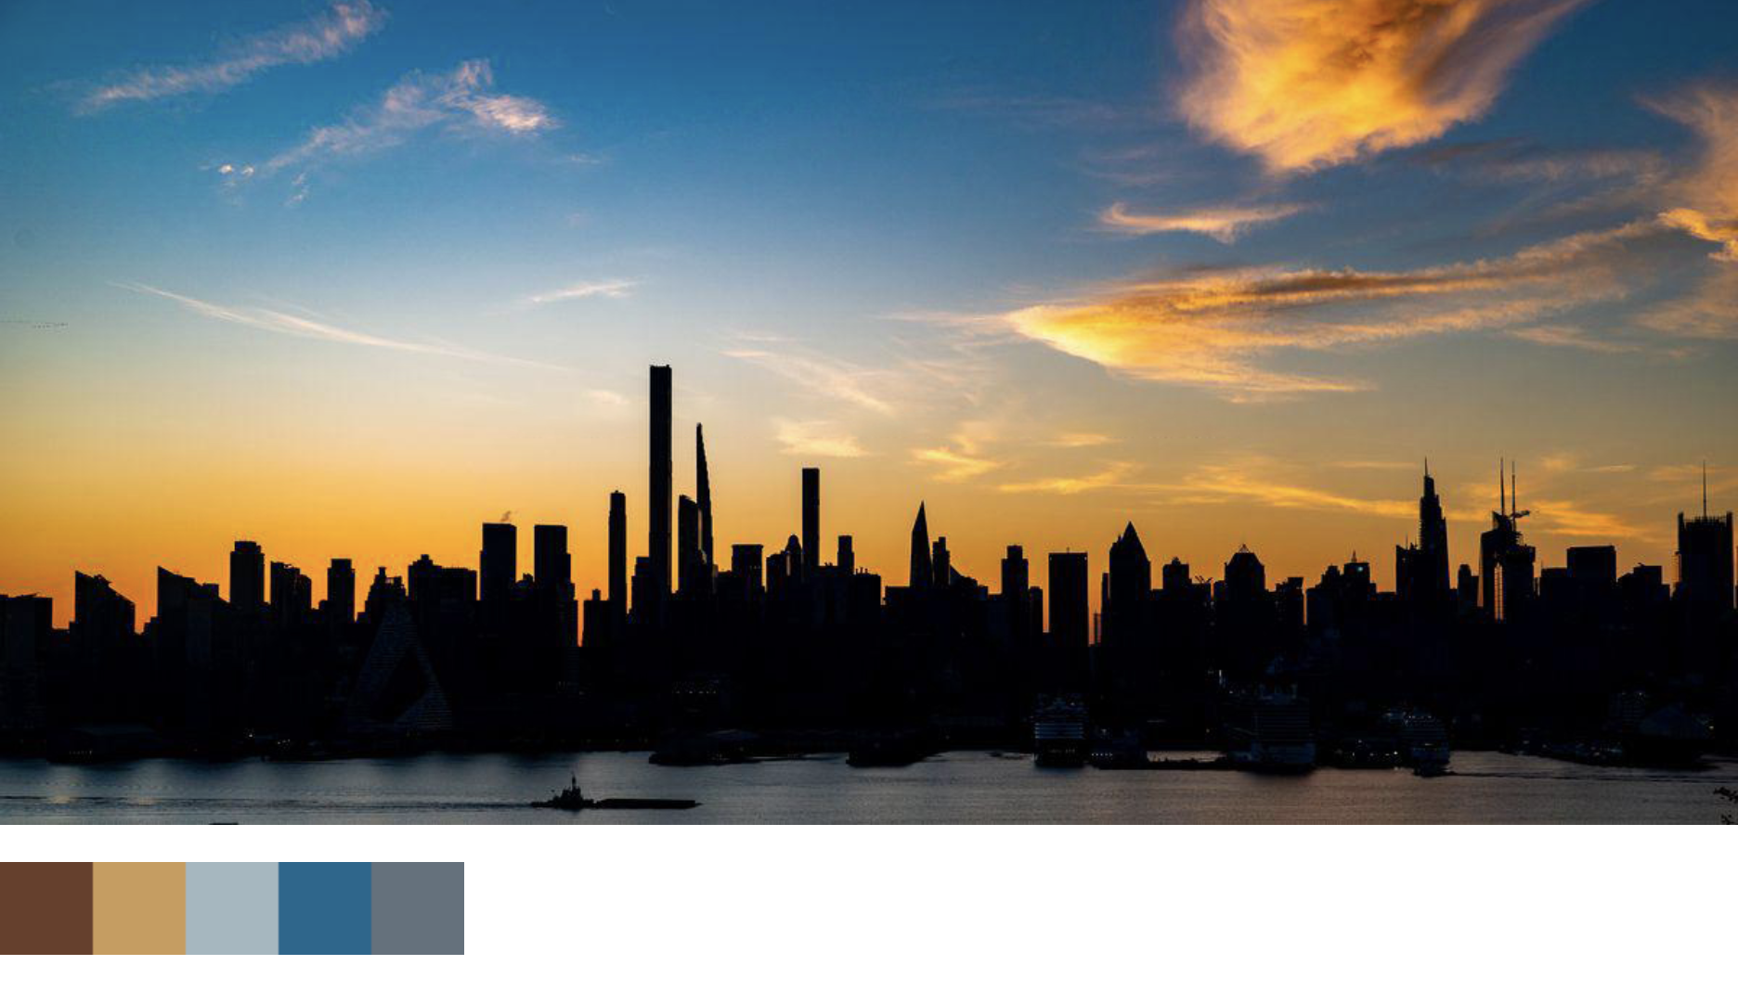
Figure 1. Jesse Overton, Sunrise photo and palette for Sky Journal Entry #2, 2022, Digital Photography, Weehawken, NJ
The Manhattan skyline is one of the most iconic and recognizable skylines in the world. It is defined by its towering skyscrapers, which reach high into the sky, creating a dramatic and impressive sight. The colors of the sunrise, on the other hand, are a natural phenomenon that serves as a stark contrast and reminder of the natural world that throws the artificiality of the cityscape into sharp relief. Because it can be difficult to acquire a long line of sight to fully take in a view of the sky when one is standing in more dense parts of the city, the journal notes that the average New Yorker’s relationship with the sky might be more nuanced and fleeting compared to other cities. In addition to the aesthetic contrasts of this relationship, there is also a symbolic significance.
The sky journal observes that skyscrapers of the Manhattan skyline could be seen to represent the power and energy of the city, while the colors of the sunrise symbolize the beauty and wonder of the natural world. The journal’s observations reveal the delicate balance between the built environment and the natural world, and the value of an awareness of how they both shape our experiences.
Harris’ quotation is an insightful and succinct characterization of the surrounding text and topics she’s exploring. In examining Friedrich’s attitude toward painting clouds, for example, he disagrees with a suggestion by Goethe that he follow a more structured approach. Following the quotation under discussion, Harris notes that for Friedrich “imagination alone would shape the clouds in his art”. Including this statement is highly reflexive upon the idea of thinking being akin to walking among clouds—indeed, for Friedrich, it seems the only possible way to do justice to the representation of clouds themselves is to remain wholly in one’s interior mental space, allowing his depiction of clouds to spring forth entirely from that inward experience.
In contrast, the sky journal by nature is a much less focused document, taking a catch-all approach to laying out whatever subjective experiences or sensory impressions happened upon the author. The experience of reading its entries feels itself like `walking among clouds` as ideas are clustered together without any obvious pattern. In some of the later entries, once a larger set of data had been accumulated, the sky journal notes the consistency of colours that appear during sunrise which are only interrupted by severely cloud or overcast days.
To better understand the patterns mentioned in the journal, all thirty-one sunrise images were analyzed by reducing them down to their primary colour palettes and merging them into a single time-based view. The resulting visualization confirms that consistency of colour, with interesting recurring patterns every few days of alternating clear sky and cloudiness, the latter of which is indicated by a palette of only blue hues (see Figure 2). It’s unclear based on observations in the journal if this pattern had any specific emotional or psychological impact.
Follow-up studies could investigate this question further by comparing with historical data sets to see if this alternating pattern is within the range of normal for this region and time of year. Taking it yet another step further, there have been several studies exploring possible links between psychology and weather in New York, with particularly compelling cases analyzing whether stock market performance is influenced by inclement weather.
In sky journal entry twelve, I recount an experience learning the history of Andy Warhol exhibitions in the city through the 1960s and 70s. While already contemplating the meaning of the sky in relation to the geography of New York, Warhol’s 1964 debut of his Silver Clouds (also known as Flotations) installation at the Castelli Gallery on the Upper East Side stood out as a significant event in exploring that relationship. The exhibit consists of a room filled with silver Mylar balloon “clouds” which were filled with differing levels of helium to create an impression of cloud-like stratification in the space. My sky journal examines an interpretation of this work as a commentary on the role of technology in society, noting, for example, that the material Mylar was extensively in the space industry at the time the work was created. By this measure, Warhol’s clouds were created literally to walk among clouds to provoke thought, with themes contrasting the natural and industrial worlds.

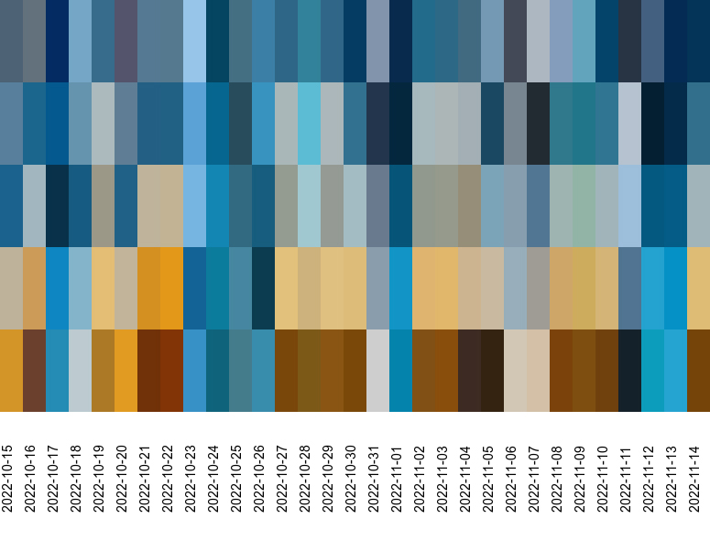
Figure 2. Jesse Overton, Fall 2022 Sky Journal photo colour palette visualization, 2022, Digital Image, Manhattan, NY
After discovering this connection through Andy Warhol’s work, I sought out other examples of art that played on similar themes. In entry twenty-four, I recount a visit to the top of the One Vanderbilt building in east Midtown Manhattan to see Yayoi Kusama Clouds installation. While Kusama’s clouds have a similar industrial chrome appearance, they contrast by being devoid of loftiness, and exist as flattened, gravity-bound objects on the floor of the exhibit space more akin to pools of mercury than clouds. The exhibit space offered an expansive view of the city from its floor-to-ceiling windows, which evidently played an important role in the experience of the piece—I note in the journal that when the clouds themselves could not become airborne by their own substance, they require support to elevate them.
The interpretation of Kusama’s work captured in the sky journal is a revealing comparison with the concept of thinking being akin to walking among clouds, as Harris remarked. Walking among Kusama’s clouds would seem to represent a fundamentally different psychological state than what Harris’ quotation appears to mean if judged on its own merits. These clouds serve to weigh one down or ground a person in a fashion like Keats’ view that the cloudiness of mind was a sullen experience. This feeling of weight and oppressiveness is reflected on in multiple sky journal entries, where an overcast day can feel like being at the bottom of a deep well with a lid put on top.
In the Timaeus, Plato lays out a theory of perception and its relationship to external phenomena. To Plato, colours consist of “a flame which issues from the several bodies” which are distinct types of particles with differing properties like size and speed which produce different effects on the observer. These differences are used to account for phenomena like lightness and darkness which interact to create different colours and hues. These “fire particles” are also conceived of as being emitted as a constant stream, whether observed or not. When analyzing the palettes of sunrise in my sky journal, this seems a fitting metaphor for the impressions made on mood and energy created by a dazzling sunrise gradient on a crisp morning.
McCready-Flora observes that Plato’s theory of colour explicitly avoids delving too deeply in understanding the proportions required for each particle to create specific parts of the colour spectrum, as that road leads toward hubris and the confusion between humanity and the divine. Similarly, Harris’ observations that lead up to her comments in Weatherland also speak to a kind of boldness bordering on hubris that the imagination of the artist can generate superior results compared to observing the natural world.
For the sky journal as a whole, the colours of sunrise involve a sense of exploration and possibility to one’s experience of the day. Just as a sunrise brings a new day full of potential and opportunity, the conception of thought as charting a path through innumerable clouds also allows one to venture into new ideas and possibilities. Both can be seen as a process of discovery and growth, as one looks to the horizon or explores new ideas. In both cases, there may be a sense of uncertainty or unpredictability, as one does not know what the future holds or what new ideas may be discovered. As a primary document for exploring the relationship between the morning sky in Manhattan and Harris' statement that `to think is to walk among clouds`, my sky journal observations and use of time-lapse photography support the idea that the sky can influence one's experience of living in the city, and the incorporation of Harris' statement adds a layer of depth to the relationship between the natural world and the act of thinking.

Bibliography

Bury, R. G., Plato. 9: Timaeus, The Loeb Classical Library, 234, [Repr. der Ausg.] 1929 (Cambridge, Mass.: Harvard Univ. Press, 2007)
Harris, Alexandra, ‘About’, Alexandra Harris <https://www.alexandraharris.co.uk/about> [accessed 20 November 2022]
———, Weatherland: Writers & Artists under English Skies (London: Thames & Hudson, 2015)
Ierodiakonou, Katerina, ‘Plato’s Theory of Colours in the Timaeus’, Rhizai. A Journal for Ancient Philosophy and Science, 2 (2005), 219–33
King, Kenneth, ‘Orbiting Andy Warhol’s Silver Factory’, PAJ: A Journal of Performance and Art, 36.3 (2014), 41–52
Loughran, Tim, and Paul Schultz, ‘Weather, Stock Returns, and the Impact of Localized Trading Behavior’, The Journal of Financial and Quantitative Analysis, 39.2 (2004), 343–64
Marsh, Allison, ‘When a Giant Mylar Balloon Was the Coolest Thing in Space’, IEEE Spectrum, 2020 <https://spectrum.ieee.org/when-a-giant-mylar-balloon-was-the-coolest-thing-in-space> [accessed 20 November 2022]
McCready-Flora, Ian, ‘Affect and Sensation’, Phronesis, 63.2 (2018), 117–47
Overton, Jesse, ‘Fall 2022 Sky Journal’, Jesse Overton <https://ovrtn.com/logs/fall-2022-sky-journal/> [accessed 21 November 2022]
———, ‘Jesse Overton’, LinkedIn <https://www.linkedin.com/in/jovrtn/> [accessed 21 November 2022]
———, ‘Sky Journal Entry #1’, Jesse Overton, 2022 <https://ovrtn.com/logs/fall-2022-sky-journal/entry-1> [accessed 20 November 2022]
———, ‘Sky Journal Entry #3’, Jesse Overton <https://ovrtn.com/logs/fall-2022-sky-journal/entry-3> [accessed 20 November 2022]
———, ‘Sky Journal Entry #8’, Jesse Overton <https://ovrtn.com/logs/fall-2022-sky-journal/entry-8> [accessed 20 November 2022]
———, ‘Sky Journal Entry #12’, Jesse Overton <https://ovrtn.com/logs/fall-2022-sky-journal/entry-12> [accessed 20 November 2022]
———, ‘Sky Journal Entry #24’, Jesse Overton <https://ovrtn.com/logs/fall-2022-sky-journal/entry-24> [accessed 20 November 2022]
———, ‘Sky Journal Entry #30’, Jesse Overton, 2022 <https://ovrtn.com/logs/fall-2022-sky-journal/entry-30> [accessed 20 November 2022]
Saunders, Edward M., ‘Stock Prices and Wall Street Weather’, The American Economic Review, 83.5 (1993), 1337–45
‘YAYOI KUSAMA: RECENT PAINTINGS’, Singapore Art Week 2023 <https://www.artweek.sg/events/yayoi-kusama-recent-paintings> [accessed 24 November 2022]

Alexandra Harris, ‘About’, Alexandra Harris <https://www.alexandraharris.co.uk/about> [accessed 20 November 2022].
Alexandra Harris, Weatherland: Writers & Artists under English Skies (London: Thames & Hudson, 2015), p. 12.
Harris, Weatherland, p. 244.
Harris, Weatherland, p. 245.
Jesse Overton, ‘Jesse Overton’, LinkedIn <https://www.linkedin.com/in/jovrtn/> [accessed 21 November 2022].
Jesse Overton, ‘Fall 2022 Sky Journal’, Jesse Overton <https://ovrtn.com/logs/fall-2022-sky-journal/> [accessed 21 November 2022].
Jesse Overton, ‘Sky Journal Entry #1’, Jesse Overton, 2022 <https://ovrtn.com/logs/fall-2022-sky-journal/entry-1> [accessed 20 November 2022].
Harris, Weatherland, p. 237.
Harris, Weatherland, p. 245.
Harris, Weatherland, p. 237.
Jesse Overton, ‘Sky Journal Entry #30’, Jesse Overton, 2022 <https://ovrtn.com/logs/fall-2022-sky-journal/entry-30> [accessed 20 November 2022].
Jesse Overton, ‘Sky Journal Entry #8’, Jesse Overton <https://ovrtn.com/logs/fall-2022-sky-journal/entry-8> [accessed 20 November 2022].
Harris, Weatherland, p. 245.
Overton, ‘Sky Journal Entry #30’.
Edward M. Saunders, ‘Stock Prices and Wall Street Weather’, The American Economic Review, 83.5 (1993), 1337–45 (p. 1337).
Tim Loughran and Paul Schultz, ‘Weather, Stock Returns, and the Impact of Localized Trading Behavior’, The Journal of Financial and Quantitative Analysis, 39.2 (2004), 343–64 (p. 343).
Kenneth King, ‘Orbiting Andy Warhol’s Silver Factory’, PAJ: A Journal of Performance and Art, 36.3 (2014), 41–52 (p. 49).
Jesse Overton, ‘Sky Journal Entry #12’, Jesse Overton <https://ovrtn.com/logs/fall-2022-sky-journal/entry-12> [accessed 20 November 2022].
Allison Marsh, ‘When a Giant Mylar Balloon Was the Coolest Thing in Space’, IEEE Spectrum, 2020 <https://spectrum.ieee.org/when-a-giant-mylar-balloon-was-the-coolest-thing-in-space> [accessed 20 November 2022].
‘Yayoi Kusama: Recent Paintings’, Singapore Art Week 2023 <https://www.artweek.sg/events/yayoi-kusama-recent-paintings> [accessed 24 November 2022].
Jesse Overton, ‘Sky Journal Entry #24’, Jesse Overton <https://ovrtn.com/logs/fall-2022-sky-journal/entry-24> [accessed 20 November 2022].
Harris, Weatherland, p. 244.
Jesse Overton, ‘Sky Journal Entry #3’, Jesse Overton <https://ovrtn.com/logs/fall-2022-sky-journal/entry-3> [accessed 20 November 2022].
Overton, ‘Sky Journal Entry #12’.
Overton, ‘Sky Journal Entry #30’.
R. G. Bury, Plato. 9: Timaeus, The Loeb Classical Library, 234, [Repr. der Ausg.] 1929 (Cambridge, Mass.: Harvard Univ. Press, 2007), p. 173.
Katerina Ierodiakonou, ‘Plato’s Theory of Colours in the Timaeus’, Rhizai. A Journal for Ancient Philosophy and Science, 2 (2005), 219–33 (p. 229).
Overton, ‘Sky Journal Entry #8’.
Ian McCready-Flora, ‘Affect and Sensation’, Phronesis, 63.2 (2018), 117–47 (p. 133).
Harris, Weatherland, p. 245.

