SOCIAL AND DIGITAL MEDIA CAN BE USED TO REACH A WIDER CUSTOMER BASE.

Executive summary
This report is about finding the effectiveness of social media in digital media marketing to people across the world. Hence, in the project, there is a discussion about the tools, advantages, disadvantages and looking for the future of digital marketing.

Table of Contents
Introduction 4
Concept of Social Media or Digital Media 4
Significance of Digital Media to Reach Wider Customer Base 4
Process of using digital media to Attract customer 5
Conclusion 7
Reference 8

Introduction
Social media is starting to build social networks and share information with users, also known as digital marketing. Companies find every day new ways to engage with existing customers and reach new ones, and marketers track and identify even more ways to better themselves and rectify their faults. In this report, there is a discussion about how social media plays a great role in reaching customers. Also plays a vital role for the companies to track new customers.

Concept of Social Media or Digital Media
With social media, people can share a variety of ideas, creations and talents in writing, arts, and others (Wahyuni, 2024). Through pictures and videos, they get the interest of other audiences around the world and also get updates about their friends and family. Nowadays via social media, people get every detail of breaking news before broadcasting or publishing in traditional media like television and newspapers. Through Social media, people break the traditional barriers of time and distance between them (Wahyuni, 2024). With technologies like Facebook, WhatsApp, Instagram, and Twitter. However, this digital media even creates an interaction between public figures, celebrities and their followers. Another social media advantage is being used for marketing purposes. Companies use social media to promote themselves and their products, get knowledge about their customer preference, and customer feedback. Many organisations collect funds for charity events.

Significance of Digital Media to reach a wider customer base
Digital Media Marketing: Digital media marketing added a new feather in businesses which expanded their reach far beyond traditional marketing. With the popularity of social media platforms and an increasing number of internet users, every business can now tie with a global audience in a second of action (Mahoney, 2024). Through content writing, and advertising, businesses are now growing their interests, and behaviours, updating customer preferences, and knowledge about their feedback, and ensuring their products are reaching people at all times.
Flawless Communication: The advantage of digital marketing is its ability to engage and interact between businesses and their customers through Social media platforms, different websites and email. In the digital world, companies communicate to their audience valuable concerns about the development of their products and gather their feedback which builds a long-lasting relationship between them.
Experiment with consumer requirements: Digital marketing has become a vital part of modern business theory. Another advantage of Digital marketing is its experiment, flexible strategies that are based on market trends and customer requirements. With the ability to quickly modify customer needs and demands, rapidly develop opportunities, reach a wider audience, change market dynamics, and stay differentiated from the rivals in the highly competitive market.
Easy to use: Cellphones, the internet, mobile apps, social media, and other digital technologies have become integral parts of the everyday lives of people around the world. The use of the internet and social media have changed the behaviour of consumers and the ways companies maintain their business. Social and digital marketing has a significant role in different types of opportunities for organisations (Dzilská et al., 2024). Through improved productions, lower costs, and increased sales. On the other hand, digital content management, artificial intelligence, mobile marketing and advertising also are the most important parts of digital marketing nowadays. On the other hand, social media and its related marketing is faster than traditional communication, but it also has some dark sides. According to current affairs, there were many fraud cases.

Process of using digital media to attract customer
In today's fast-forwarded and interconnected social world, digital marketing has become an essential tool for all types of businesses. With the advantages of the internet and social media platforms, companies have found different innovative ways to reach and engage with their target audience. Like Creating unique productivity, promotions, contests and winning digital coupons.
Content Marketing: This type of digital marketing focuses on producing, disseminating, and publishing information via Internet channels for a specific audience. It is mostly utilised by businesses to draw in more clients, grab their interest, and boost online sales. End users and commercial parties make up the majority of the online marketing supply chain. In this method, wholesalers oversee the interactions between businesses and customers. Based on this information, they can better target their marketing campaigns and determine what content customers need.
SEO Marketing: Search engine optimization (SEO) is a tool or process that is used by digital marketers to improve the quality and quantity and mostly targets unpaid website traffic. On one hand, it can make the products, brands or services visible online (Thapliyal et al., 2024). However, on the other hand, it is not an appropriate strategy for every website and is industry-specific, such as paid advertising. For example, since Google accounts for more than 90% of all organic search engine traffic worldwide, as a result, SEO optimization is essential for visibility.
PPC Advertising: Pay-per-click ads are generally a type or strategy of digital marketing where people pay every time someone clicks on business ads. This type of advertising is basically pay-as-you-go. Companies will be able to change or pause their advertisement campaigns that are underperforming and further do not have to spend any money for that (Kumar et al., 2024). With a PPC platform like Google Ads, YouTube ads companies are able to track how many people view and click on their ads. For example, as per Statista the most prominent PPC platform, Google Ads, brought in approximately 147 billion dollars in revenue in the year 2021. However, this demonstrates the acceptance and expansion of PPC Advertising (Shewale, 2024).
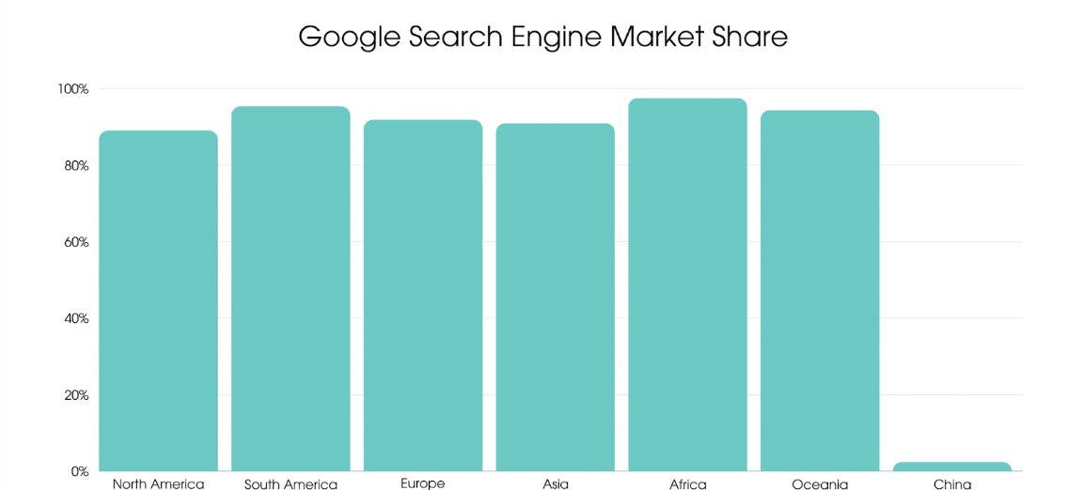
Figure details: Market share of Google search engine across the countries
(Source: Shewale, 2024)
Marketing Communications: It alludes to combining several marketing channels and instruments. Market trends for products are the primary focus of marketing communication platforms. Various kinds of instruments are used in this procedure to get insight into the market. such as advertising campaigns, social media, sponsorship, and personal selling. Although it makes up a minor portion of marketing, advertising has a significant impact on reaching target groups with a straightforward and consistent message.
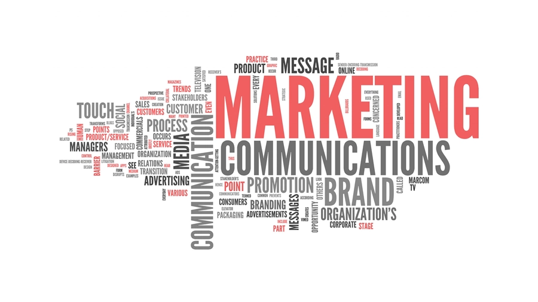
Figure 2: Marketing communications
Source: (MMC Learning, 2023)

Conclusion
In conclusion, social media marketing is a tool for businesses to expand their customer base. With billions of people actively using social media platforms, it provides a supreme opportunity to reach a larger audience and connect with them through just a click. As social media turns into a connection vary from one person to another the future of social media marketing looks promising for every business.

Reference
Dzilská, Z., Kalamen, K., Pollák, F. and Ruschak, M., (2024). Effective Management of Marketing Communication in Social Media.
Kumar, H., Rauschnabel, P.A., Agarwal, M.N., Singh, R.K. and Srivastava, R., (2024). Towards a theoretical framework for augmented reality marketing: A means-end chain perspective on retailing. Information & Management, 61(2), p.103910.
Mahoney, L.M. and Tang, T., (2024). Strategic social media: From marketing to social change. John Wiley & Sons.
MMC Learning, (2023). What is marketing communications (2023) MMC Learning? Available at: https://mmclearning.com/knowledge/what-is-marketing-communications/ (Accessed: 20 April 2024).
Shewale, R., (2024). Google Ads & PPC Statistics 2024 (Revenue & ROI). Available at: https://www.demandsage.com/google-ads-statistics/ [Accessed on 20.04.2024]
Thapliyal, K., Thapliyal, M. and Thapliyal, D., (2024). Social Media and Health Communication: A Review of Advantages, Challenges, and Best Practices. Emerging Technologies for Health Literacy and Medical Practice, pp.364-384.
Wahyuni, L.T., (2024), April. The Role of Digital Marketing Strategies in Increasing Hamed Kebab Sales Turnover. In Kilisuci International Conference on Economic & Business (Vol. 2, pp. 460-467).

