Management Ethics Report

Naseem Uddin
P150596
Contents
Table of Figures 3
Introduction 4
Main Findings 5
Stakeholder Mapping 6
Conclusion 7
Critical Reflection 8
References 9
Appendices 10

Table of Figures

Fig 1: Carroll’s CSR Pyramid Page 5

Fig 2: Stakeholder Map Page 6

Fig 3: Gibbs’ Reflective Cycle Page 8

Introduction
In this report the ethical issues of organisations will be uncovered and will expand the knowledge and understanding of the poster created for The European Environment and Sustainable Development Advisory Councils as well as the defence of the poster. Both the poster and the defence of the poster will be included in the appendices. The EEAC offers independent advice to their respective national or regional governments and parliaments relevant to the environment and sustainable development. It consists of fourteen advisory bodies from eleven European countries and regions, the EEAC brings together experts with many years of experience bringing forth independent advice. The EEAC has annual conferences hosted by an EEAC member where they have discussions on a topic related to environment and sustainable development. Their objective is to provide an operational framework for joint activities, knowledge sharing, dialogue, informed debate and deliberation among different stakeholders and disciplines. The topic for the argument is should businesses be more responsible for sustainability, such as the Corporate Social Responsibility and what the consequence should be for being unethical like some large companies. The debate of the for and the against of implementing models or the policy of sustainability.
The American economist and statistician widely known for his strong belief in free-market capitalism Milton Friedman (1970) says “There is one and only one social responsibility of business – to use its resources and engage in activities designed to increase its profits so long as it stays within the rules of the game, which is to say, engages in open and free competition without deception or fraud.” What he is saying here is that business should use their resources make profit and be run legally without being deceiving or fraudulent. This can be acceptable if they are being morally ethical, large organisations like Apple tend to get away with being unethical which is not fair on the morally ethical organisations.

Main Findings
What is Corporate Social Responsibility? (CSR)
Corporate Social Responsibility is explained by Baker (2004) as “Companies need to answer to two aspects of their operations. 1. The quality of their management – both in terms of people and processes (the inner circle). 2. The nature of, and quantity of their impact on society in the various areas.” This means that the organisation should focus on the management of the people but be wary of the impact it has on society. Every organisation has the responsibility to act in a manner that is beneficial to society and not solely on the organisation, it is also probably accurate to say that all societies at all points in time have had some degree of expectation that organisations would act responsibly.
Pedersen and Huniche (2014) say that according to Carroll (1983), “corporate social responsibility involves the conduct of a business so that it is economically profitable, law abiding, ethical and socially supportive. To be socially responsible then means that profitability and obedience to the law are foremost conditions when discussing the firm’s ethics and the extent to which it supports the society in which it exists with contributions of money, time and talent”. This theory is similar to Friedman’s theory as it commands to follow the rules and be profitable.

Fig 1: Carroll’s CSR Pyramid
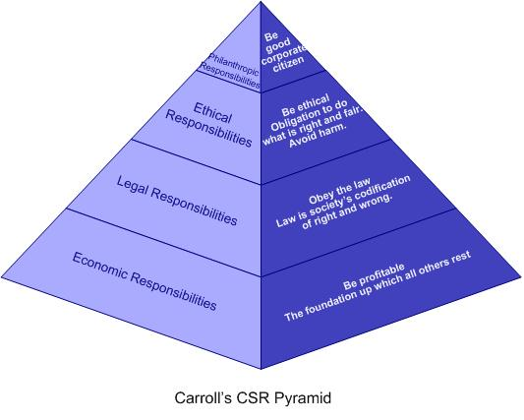
Source: (Carroll, 2016)

What is Sustainable Development in Business?
As explained by John Gardner (2014) “Sustainable development is about making sure that people throughout the world can satisfy their basic needs now, while making sure that future generations can also look forward to the same quality of life.” The defence of the poster (see appendix B) shows that it is morally unethical for a large organisation such as Apple to be using children as employees, whereas Samsung have programme where they support children in low income countries to education, leadership skills, mentorship and life-saving medical treatment. Reisinger (2017) explains how “All of the workers – children or otherwise – suffer harsh working conditions with no protective equipment.” Not only do they have children mining for cobalt but they did not even supply them with safety gear. Most large organisations are looking to make as much profit as they can, they are not going to waste their time and find sustainable ways to keep society happy.

Stakeholder Mapping
Fig 2: Stakeholder Map
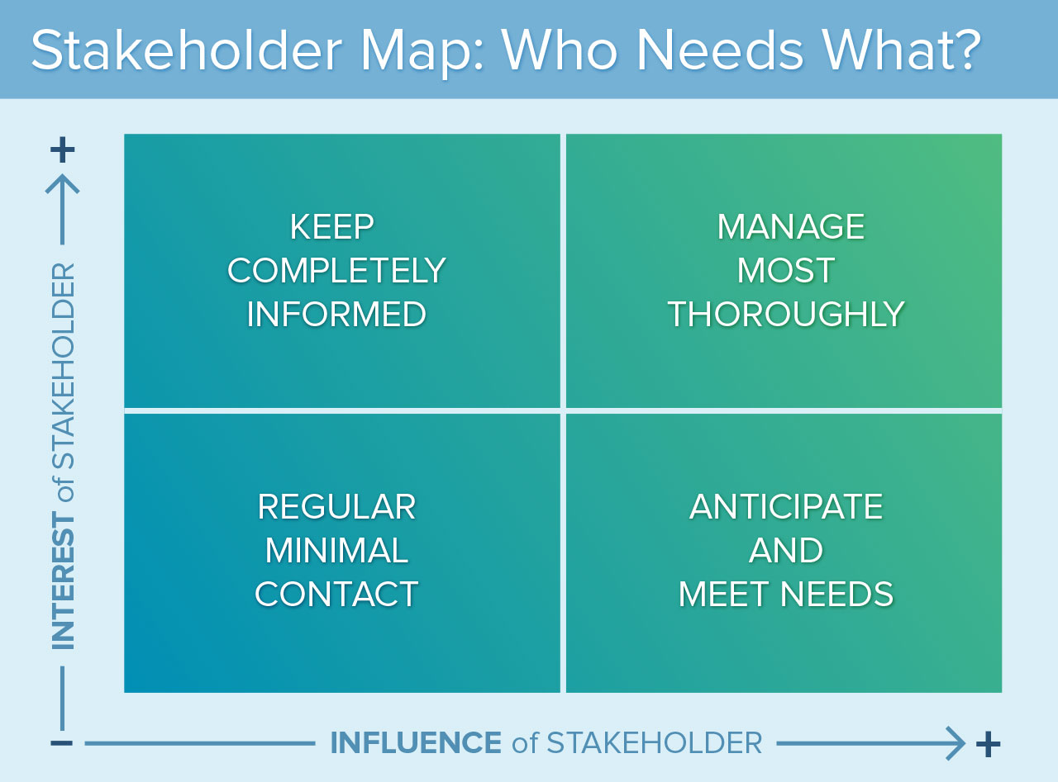

The map will show the organisation which stakeholders will have the most influence as well as interest and how their engagement will be managed by the organisation. With Apple they would keep regular minimal contact with the media, Apple do not want to be in the media for some of their unethical practices. They would want to anticipate and meet the needs of the consumers, as they are the ones that are buying the products. The consumers’ needs are quite crucial to making a good product as if they don’t have the newest or necessary technology the consumers would not buy it. With the stockholders they would want to keep them completely informed with every decision that will be made within the organisation but they would have no influence on the organisation. Employees would be managed most thoroughly as they would be the ones making the products, there would be employees creating the product as well as employees selling the product.
Freeman (2010) explains “The task of executives is to create as much value as possible for stakeholders without resorting to trade-offs. Great companies endure because they manage to get stakeholder interests aligned in the same direction.” Whereas Friedman (1970) has the view that the only important influencer on a business decision is the shareholder as they are the ones directly affected by any major business decisions which can then in turn make them pull out their financial assets and can immediately affect the business.

Conclusion
In conclusion the CSR and the sustainability models are going to become more of a certainty for organisations as consumers are going to want to buy the more ethical or sustainable products. This would not affect much of large organisations profits as it would only take a little to change to more sustainable ways but will they be willing to change their ways. The growth of CSR policies are an indication that consumers that have are ethical buyers are pressuring the government to make these organisations give in or have their profits affected. Many organisations will look at their competitors and see that they have not carried out CSR or sustainability models, which would lead them to not also implement these policies. There can be real change in consumer buying by boycotting unethical companies however it is very hard for a consumer to leave a brand after buying from them for so long.

Critical Reflection
Fig 3: Gibbs Reflective Cycle

Source: (Gibbs, Learning by Doing, 1998)
In this report I have understood what is ethically right and wrong for an organisation, I have also learned new theories and models. The report was tough at first but once I got the relevant theories and information it helped with working through easier. I knew this report was going to be tough as there was a lot of reading to do for it, which meant that the earlier you start the report the better. I did leave the report quite late but I feel as if I have done enough. For next time I think that I will start a lot earlier and take my time through the report. I have used Gibbs’ Model of Reflection to reflect on the task. I created a poster on ethical issues, I then had to defend the poster I created. I chose to make a poster on Apple and how they are not sustainable and are unethical in many ways such as child labour.

References
Baker, M. (2004). Definitions of corporate social responsibility - What is CSR?. [online] Mallen Baker's Respectful Business Blog. Available at: http://mallenbaker.net/article/clear-reflection/definitions-of-corporate-social-responsibility-what-is-csr [Accessed 18 Nov. 2017].
Carroll, A. B. (2016) Carroll’s Pyramid of CSR. Available at: http://www.csrquest.net/imagefiles/CSR%20Pyramid.jpg. Retrieved November 20, 2017.
Freeman, E. (2010). Stakeholder Management » R. Edward Freeman. [online] Redwardfreeman.com. Available at: http://redwardfreeman.com/stakeholder-management/ [Accessed 20 Nov. 2017].
Freidman, M. (1970). Strategic Management: A Stakeholder Approach. Cambridge: Cambridge University Press. Retrieved November 20, 2017
Gardner, J. (2014). Sustainability – a local issue for us all | Open Access Government. [online] Open Access Government. Available at: https://www.openaccessgovernment.org/sustainability-a-local-issue-for-us-all/3316/ [Accessed 18 Nov. 2017].
Gibbs G (1988) Learning by Doing: A guide to teaching and learning methods. Further Education Unit. Oxford Polytechnic: Oxford.
Pedersen, E. and Huniche, M. (2014). Corporate Citizenship in Developing Countries. 1st ed. Frederiksberg: Copenhagen Business School Press, p.32.
Reisinger, D. (2017). Apple Halts Cobalt Buy Over Supply Chain Child Labor Concerns. [online] Fortune. Available at: http://fortune.com/2017/03/03/apple-cobalt-child-labor/ [Accessed 18 Nov. 2017].


Appendices
Appendix A

Appendix B
Management Ethics Naseem Uddin P150596
Poster Defence

- Whose corporation / organisation are you representing

I am representing the European Environment and Sustainable Development Advisory Councils, a network of advisory bodies established by national or regional governments.

- What is the key message you are trying to communicate?

The message I am trying to convey through the poster is the unethical issue of Apple employing children, I will be looking at whether Apple will continue with their unethical ways. Samsung on the other hand have a Hope for Children programme where they provide financial support and are able to give thousands of children in communities around the world access to education, leadership skills, mentorship and life-saving medical treatment.

- What is the main target audience that you hope will read and understand your message?

I am hoping that Apple customers can take this in but it will be hard as when you are a fan of something it is very hard to get out of. My main target audience could be anyone who is against unethical companies, this poster could light a spark in their eye and they would understand how bad what they are doing is.

- What would someone who disagrees with you say in response to your argument?

If I can’t see child labour, is it really happening?
Sustainability should be the government’s problem.
The government should be making sure these big companies are paying the right tax.

- Why have you used the images and words you have selected?

I have not used any words, only images as I think the poster does not need to be explained and the image itself shows what is need to be said. The poster shows a child crying tears with the Apple logo fused with some tears, the child is also wearing a shirt with the Apple logo on it to show that he is an employee.

- What research have you done to underpin your argument?

The research I have done to underpin my argument is to discover the unethical ways of how this organisation is manufacturing its electronics. They are guilty of many unethical activities such as avoiding to pay their fair share of tax, between 2009 and 2012 they avoided paying tax in America by at least 74 billion dollars by making subsidiaries in Ireland. Apple were buying cobalt mined by hand in Congo and it was reported that there was child labour and dangerous working conditions there. Reisinger (2017) explains how “All of the workers – children or otherwise – suffer harsh working conditions with no protective equipment.” This conveys that not only do they have child labour but they have them working in dangerous conditions that is not safe for anyone.

- How strong do you think the evidence is to back up your argument?

I think the evidence is strong as Apple have been called out by various different organisations for their unethical ways, they were also scheduled to appear in front of the Senate’s Permanent Subcommittee on their investigations.

- What would you hope to happen after the audience has understood your message?

I would want the audience to understand and acknowledge the unethical ways of this organisation, I also hope that this might change their mind when making future purchases. This should affect the sales of the organisation and I would hope they would then make changes to be more sustainable and ethical.

- What models and theories will you be referring to in your reflective report?

The main theory I will be using is CSR as well as Carroll’s CSR Pyramid and Stakeholder mapping. I will also be using Freeman and Friedman for differing opinions on their theories.

