
  - Marketing Management
(LCMB 7001)
STUDENT NAME/ ID: ELSA ALMEIDA/ 1906940  LECTURER: TUSHARA BALENDRAN   |  | Innovative Marketing Strategies – Louis Vuitton

1.Introduction ……………………3  2. Company Background ………5  3. Communication Model ………6  4.Definition of IMC ………………7  5. New Promotional Strategy …. 7  6. Definition of Branding ………8  7. Brand Equity- Keller’s brand Equity Model ………………. 8-9  8. Advantages and Disadvantages of Equity model ………………… 10  9. Stages of the Customer journey ……………………………………. 10  10. Touchpoints …………………11-12  11. Customer Journey map ……12-13  12. Strengths and Weaknesses of the Customer journey map ……………………………………..13  13. Customer Satisfaction ……. 14  14. Conclusion ……………………. 15  15. Recommendations ………….. 16  16. References ……………………. 17  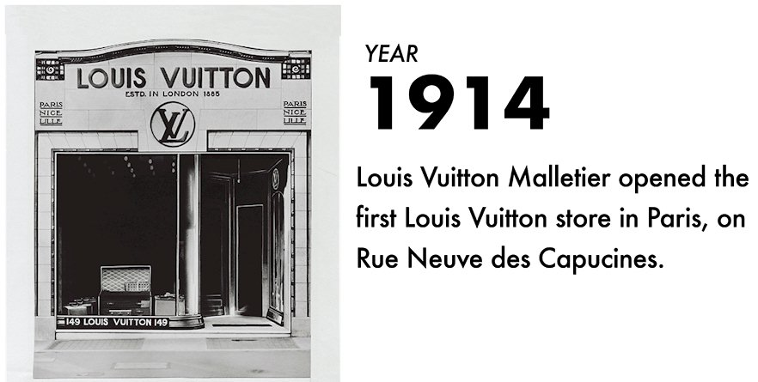  - Introduction  This report is about the brand Louis Vuitton, a French designer and artisan that started to create travel trunks and became globally famous for their unique logo handbags. The report will cover the company background, the Shannon and Weaver communication model, explain the definition of IMC – Integrated Marketing Communications, decribe branding and brand equity describe new marketing strategies, explain the value of the brand, include Keller’s brand equity Model, the disadvantages and disadvantages of the model, as well as the stages in the customer journey. The report will explain the customer touchpoints, give the definition of the customer journey map, critically analyse the customer journey map. Include a Total Engagement Model and finalise with recommendation for the brand regarding the new touchpoints. |  | TABLE OF CONTENTS

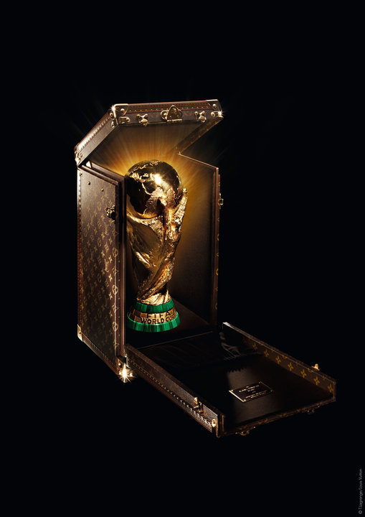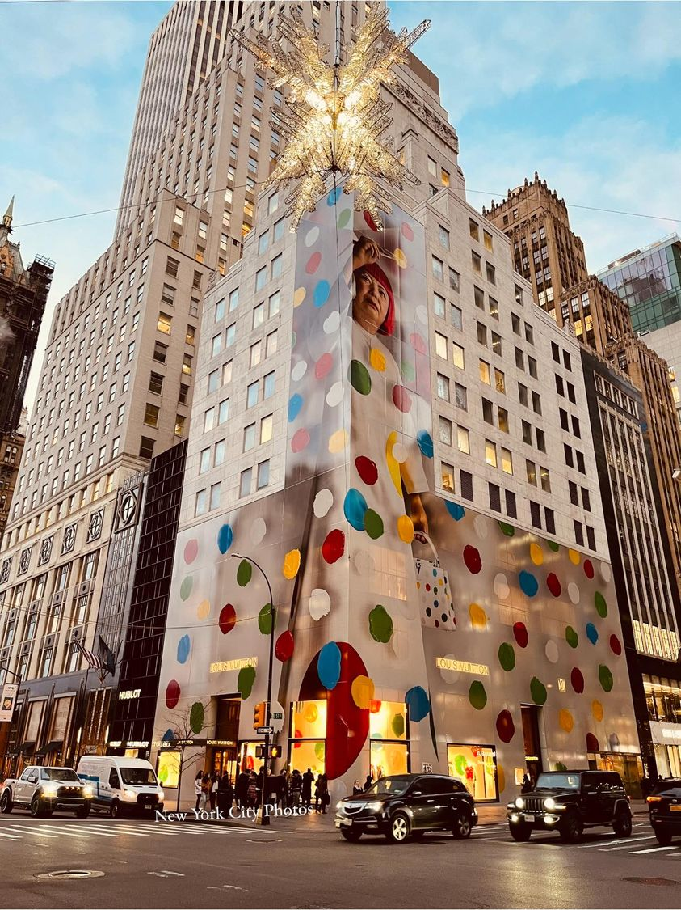

Louis Vuitton x Yayoi Kusama collection

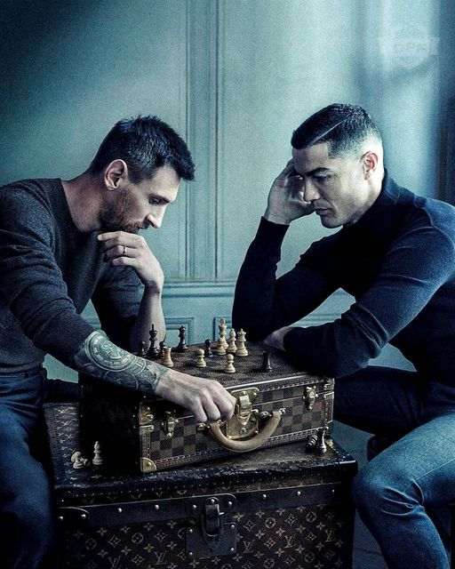
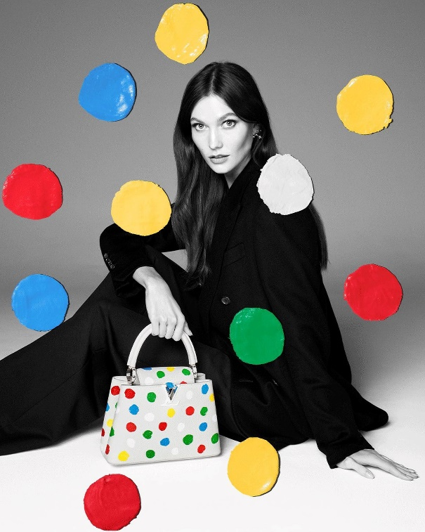
Victory is a State of Mind. A long tradition of crafting trunks photographed by Annie Leibovitz for Louis Vuitton.

2. Company Background – Louis Vuitton

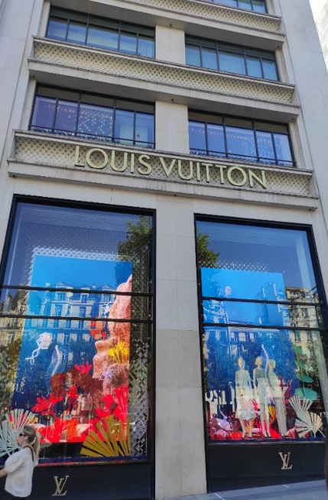
French fashion designer and accomplished artisan Louis Vuitton established his own business in Paris in 1854. Empress Eugénie de Montijo, the wife of Napoleon III, commissioned trunks from Vuitton at the start of his career. At the age of 33, he opened his own handicraft workshop at 4Rue Neuve-des-Capucines. Ingenious closing mechanisms created by Georges Vuitton in 1886 transformed travel trunks into true treasure chests and revolutionised baggage locks. Due to his outstanding craftsmanship in making trunks, Vuitton invented flat-topped stackable containers that were impermeable and as light as a feather. Even now, Louis Vuitton trunks are highly sought and collectible due to their monogram emblems, innovative single lock mechanisms, and unbreakable spring buckles. When his father Louis Vuitton died in 1892, Georges took over the business. Four years later, he unveiled the first canvas bearing the 'LV' monogram, quatrefoil, and flower design. On Louis Vuitton clothing, jewellery, and purses, the recognizable monogram pattern is still visible and continues to stand for opulent travel, elegance, and flair. Gabrielle Coco Chanel, who ordered a custom handbag in 1925, saw Louis Vuitton, which was quickly becoming an iconic company known for superb craftsmanship and great designs. She permitted the bag's mass production in the 1930s, which marked the start of Louis Vuitton's venture into more affordable luxury leather products. The Alma is the name given to that bag today. Other timeless handbag designs include the 1930s storied Keepall, the Speedy 25 that Audrey Hepburn ordered, the 1932 Noé bucket bag, as its 1966 cylindrical Papillon.
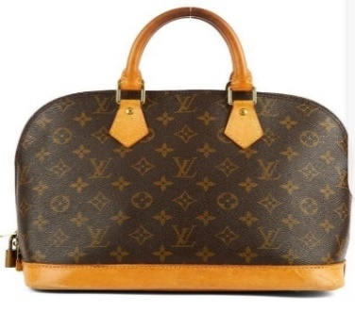
Moet et Chandon and Hennessy amalgamated with Louis Vuitton in 1987, along with the trademarks of cognac and champagne. They joined together to become the main conglomerate, LVMH. The conglomeration greatly expanded the Maison's influence. From iconic handbags to avant-garde ready-to-wear and collaborations with Takeshi Murakami to Marc Jacobs taking over as Creative Director in 1997, Louis Vuitton established itself as a top fashion label from the 1990s onward. In addition to apparel, bags, and luggage, Louis Vuitton also introduced jewellery, sunglasses, shoes, and fragrances in the 2000s. These products all pay homage to the brand's exceptional history and passion for travel and design. A gradual transition into fine jewellery began in 2004, and a further transition into high jewellery began in 2009. The brand's current artistic director for jewellery and watches is Francesca Amfitheatrof. The two petal diamond cuts, which are exclusive to Louis Vuitton and symbolize the brand's trademark monogram, were copyrighted by the company in 2009. On October 24, 2014, the Louis Vuitton Foundation officially opened its doors as the outcome of almost 25 years of dedication to the arts, culture, and history. (Anon, n.d.) ‌(Vuitton, 2022).

Mission Statement for LVMH
The mission of the LVMH company is to present Western "Art de Vivre" in its greatest elegant manifestations. LVMH has to maintain its reputation for creativity and style. Our products combine innovation and history, spark fantasy and the imagination, and respect the cultural ideals they stand for. (Comparably, n.d)
Vision Statement for LVMH
Long-term objectives are given priority in LVMH's family-oriented culture, which has been successfully maintained. The Group's goal is to provide the resources necessary for each of its Houses to develop, produce, and market their products and service through carefully selected distribution channels, while maintaining each House's distinctiveness and autonomy. The three guiding principles that Bernard Arnault outlined are followed by every employee at LVMH. These three criteria promote quality, act as the cornerstone of any output, and ensure long-term success. (Comparably, n.d)
3. Communication

Communication is how people communicate information, ideas, thoughts, sentiments, and the manner they express their emotions. This can be done verbally, nonverbally. Communication can be perceived as an information transmitter, or the way a meaning is shared.

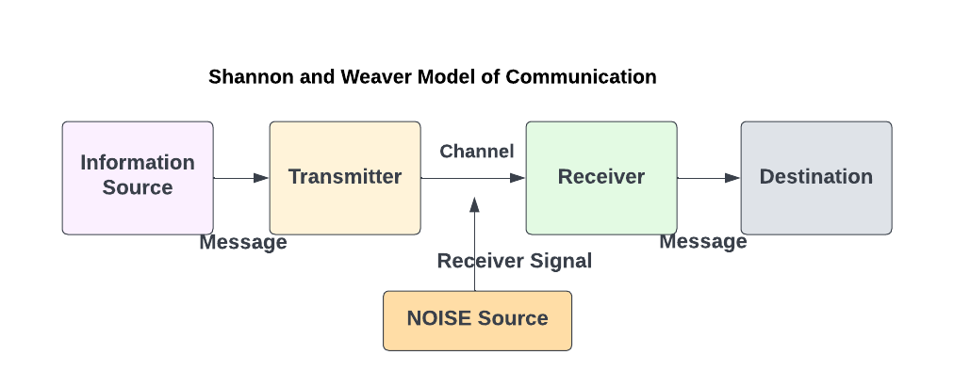

The Shannon weaver model involves of fundamental components like a source, an encoder, a medium decoder, a receiver, and noise. It explains how information travels from a sender to a receiver. A transaction, on the other hand, is a model that represents the sender and the recipient interacting at the same time. In marketing communication is usually used to transmit the various promotions strategies, it can be online or offline. There are two types of communication interpersonal with direct feedback, or impersonal with indirect feedback. (Shannon and Weaver, 1998)

4. Definition of IMC (Integrated Marketing Communications)

Integrated marketing communications (IMC), often known as marketing communications, is a strategy used to ensure that a brand's messaging is constant across all of the media it employs to reach its target audience. It is an approach that acts as a foundation for all marketing interaction platforms. (Pecánek,2022).

Stages in the Integrated Marketing Campaign
- Segmentation, targeting and position
- What are the objectives, and what is to be achieved by the campaign
- How much is it going to cost the company
- What is the combination and strategy that will be implemented to promote
- Evaluating the results of the campaign

5.New Promotional Strategies
Online
Social media marketing: Louis Vuitton can start using their customers, real people, to promote their brand instead of using famous people to be their brand ambassadors, because it is the real people that mostly buy their products, people that most of the time are not rich, but because Louis Vuitton is such a famous brand, they want to purchase their products. On social media you only see them using models, actors, singers promoting their products or being invited to their store openings.
Influencer marketing: By using their customers to promote their new products, people would feel like it is possible for them to acquire the products, instead of thinking that it is just for the rich and famous.
Offline
Spa and gym – Louis Vuitton could in future invest in opening spa and gym, and that way treat their loyal customers with vouchers to use the facilities. Since Louis Vuitton does not do any kind of promotions or discounts on their products, that would be a positive way of showing their appreciation to their customers.
Soft drinks – Louis Vuitton could create a line of water, to give to customers that visit their stores, and also to sell in their restaurants, cafes and hotels.

6.Definition of Branding and Brand equity
Brand marketing is the process of building and sustaining a relationship with customers. Brand marketing uses the products and services as proof of the brand's promise from the company's and the customers' perspectives, promoting the complete brand rather than just a certain product or service.
Brand equity, a marketing term, refers to a brand's value. Consumer behavior and perception have an impact on how valuable a brand is. If customers like a brand, it has strong brand equity. The logo of the company is very important to Louis Vuitton. This is what determines the brand's market value.
7. Brand Equity- Keller’s Brand Equity Model
Keller's brand equity framework is also known as the Customer-Based Brand Equity (CBBE) concept. The tool helps companies learn how to shape what their target market thinks and feels about them to build a strong brand. With the help of the model, you can identify the phase to whom your brand belongs and whatever you need to do to move up. The business never reduces its prices. Never has sales of it. Additionally, discounts and price reductions are not permitted at Louis Vuitton-carrying boutiques. Despite the high cost of Louis Vuitton handbags, consumers are prepared to pay for the prestige symbol. The height of brand equity is seen here. (Hawker, 2019)

Keller’s Equity Model explained
1. Relations = This stage is where the brand already has a relationship with the customer and must maintain the customers loyalty, this is where the brand has created a brand community within their customers. Customers at this point are more than simply aware of your brand and more than just purchasing your products; they also act as brand ambassadors. How frequently a customer purchases from your brand is known as behavioral loyalty. Attitudinal attachment is the adoration and kinship individuals have for your brand. The connection that customers have with other users of your brand is known as "sense of community." Active engagement is the level of commitment consumers have to your brand even if they don't buy anything from you. The feedback on social media plays a big role in this area, nowadays. People posting photos on social media like Facebook, Instagram, Tik Tok with their new Louis Vuitton bags, clothes, opening the parcels that they receive with their new products. Comments thanking the brand for invitations to their events. (Hawker, 2019)
2. Response = The reaction that the customers have after buying In this section is judgment and emotions. Both relate to how consumers perceive your brand and the impact it has, whether favourably or adversely. It’s crucial that your business responds to any complaints or difficulties that clients could raise. Four categories make up the evaluation of a brand: Actual or perceived quality of the brand, Credibility is the reputation of the brand. Consideration: The relevance of the brand. Superiority, the brand’s standing in comparison to rival brands, encompasses, unsurprisingly, how consumers feel about your brand. To develop customer-based brand equity, it is essential to associate your brand with favourable thoughts and opinions. This increases trust and fosters the development of a solid, long-lasting connection between your business and its clients. (Hawker, 2019)
3. Meaning = This stage is where the brand starts to create loyalty with the customers, it will be more than just the quality of the products or the price. The performance includes the functionality of the product, the reliability, the style, the design, pricing and durability, the assistance given to the consumer, are all important factors to consider. When it comes to building customer-based brand equity, satisfaction of the consumer, the authenticity of the product, is more crucial since it is essential to fostering loyalty and developing lasting connections. The imagery focuses more on how your brand satisfies the social and psychological demands of your target market and what consumers perceive about your brand. It concerns their level of satisfaction in being connected with your items due to your brand’s reputation. By helping to increase young people’s access to education and employment possibilities, Louis Vuitton teams all over the world help to assist their local communities. It employs a large percentage of environmentally friendly components, including deadstock and recycled materials, to produce durable, high-quality goods. Because it uses eco-friendly components, it has a less impact on the environment and uses less water and chemicals during manufacture. By 2030, eco-design will influence each new LVMH product. (Hawker, 2019)
4. Identity = This is what defines the brand, the benefits and the message the brand is trying to transmit. The company logo – the canvas with the ‘LV’ monogram, quatrefoil, and floral design that was introduced in 1896, by Louis Vuitton’s son, is globally recognized. This stage shows the broad level of public awareness of your brand. This is a crucial initial step in developing consumer brand equity since it is difficult for people to generate opinions about your brand if they do not know about it. The bulk of the pyramid’s weight is supported by this portion. (Hawker, 2019)
- Advantages and Disadvantages of Equity model

Advantages | Disadvantages
- Can help with the growth of the company long term, by adding new products or concepts and the customers will remain loyal  - Customers stay loyal to the brand and regardless of the price keep buying the products, even when they might have a bad experience  - Can help to negotiate with manufactures, vendors, distributors  - Gives the company competitive advantage over their competitors, because of the brand reputation | - It involves high costs for the company in publicity and advertisements  - Brand perception is more difficult  - If the brand fails to deliver what the customers expect of them, when they launch a new concept that the customers do not like, for example the new Louis Vuitton, Yayoi Kusama collection is not being well accepted by some customers, because it is different from their previous concepts of the brand
Conclusion of Brand Equity
Creating brand equity is a challenge that any brand face within any company, however this is the opportunity that a brand has to build up their high value.

9. Stages of the Customer journey

- Awareness: This is the first stage of the customer journey; this is where the customer feels the need to buy a product, and then start searching for information about the product they want to buy.
- Consideration: During this stage the customer starts to evaluate and to consider which product they are going to buy and start to research about the product they want to buy, trying to get more information on the product.
- Purchase: During this stage the customer has made the decision, the customer has by now considered all the options, and is trying to decide where and how they are going to buy the product, whether they will buy it online, or whether they will go the store to buy it, to go to a Louis Vuitton store, you need to book an appointment.
- Retention: This stage of the journey, is where the company will retain the customers loyalty to the brand, during a long period of time, the customers loyalty is retained trough the experience that they had with the brand.
- Advocacy: During this stage is where the customer becomes the advocate for the brand, recommending the brand to their friends and family, spreading the positive things about the brand, becoming the brands best referrals. (Debutify, 2022
10. Customer Touchpoints
All instances where a customer engages with a brand are considered customer touchpoints. Customers may stumble across a business online or in an advertisement, look up reviews and ratings, visit the website, and make a purchase in person., or contact the customer support. These are all the interactions that take place between a brand and the customers. (Brandification, n.d)
Pre-purchase: Before the customer purchase
- Social media – Louis Vuitton has a Facebook page and Instagram page, where they update all the new products that are being released, the new store openings, to show their customers what is happening within the brand.
- Advertising online – Louis Vuitton has online advertised their products, new launches of products.
- Digital marketing content – Products of Louis Vuitton can be found in all types of digital marketing, while you are going through any online content, an advertisement can just pop up.
- Company events or Exhibitions – Louis Vuitton will invite people to their company events, when there is a new store opening or when they have a runway show for the brand.
- Referral of people – Louis Vuitton uses celebrities, to promote their products, especially always using celebrities as their brand ambassadors, that are more famous at the specific point of their new product launches. (Brandification, n.d)
Purchase: During the customer purchase
- Conversation with company salespeople – To purchase at a Louis Vuitton store, you need to book an appointment.
- Catalogues of the products – Called the LOUIS 200 Catalogue
- Websites of the company – Louis Vuitton has its website where customers can browse through their products and purchase them online.
- Reviews of the products – Customers reviews will help other customers when they want to purchase a product.
- Points of sale – In department stores like Harrods for example, there is a Louis Vuitton point of sale. (Brandification, n.d)
Post-purchase:
- Thank you, letters – Louis Vuitton sends each of their customers together with their product purchase, when bought online, a personalized thank you letter.
- Surveys of products feedback – The surveys regarding their products, company will send their regular customers feedback surveys, as well as through their Facebook and Instagram page, the can read the customers feedback about their products.
- Cross-selling or upselling emails – The company will send emails to their customers to remind them to buy the new products that are being launched.
- Renewals – Whereas Louis Vuitton never has sales or promotions for their products, they will remind their customers that they are launching a new line, to prick their interest. (Brandification, n.d)
11. Customer Journey map
A customer journey map is an illustrated record of each encounter a customer makes with a service, brand, or product. By making a trip map, a business may quickly enter the client's headspace and observe and understand their procedures, demands, and viewpoints. (Angrave,2020)

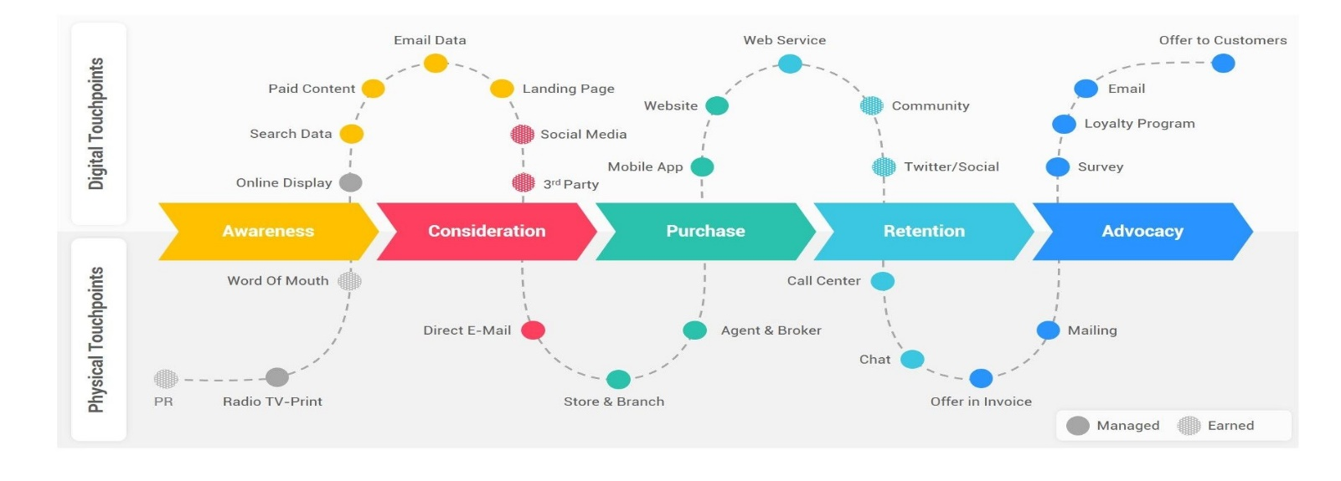
(Angrave,2020)

Digital Touchpoints | You see online display about a new Louis Vuitton bag | See publications on social media about the bag | You buy the new bag online through the Louis Vuitton website | Show off your new bag on social media with photos and comments | You receive an e-mail from Louis Vuitton and new offers for new products
 | Awareness | Consideration | Purchase | Retention | Advocacy
Physical Touchpoints | See the bag in a magazine or on TV | You get a direct e-mail about the new launch of a bag | Make an appointment to go to the store to buy it | Get a thank you letter from Louis Vuitton about your purchase | Get letter about new arrivals in store

12. Strengths and Weaknesses of the Customer journey map
Strengths | Weaknesses
- To improve the customer retention with their loyalty  - Increase in the customer value  - It has lower costs for the brand by providing a better customer experience  - It can result in faster growth for the brand  - Better communication of customer experience within the company  - Helps to identify the customer pain points  - Identifies the cost that the company can reduce | - Need to be monitored regularly to apply and create opportunities for improvement  - Needs support from all areas of the company  - Not be used regularly by the company and not being updated  - The company might need to create different maps for different personas

(Angrave,2020)

13. Customer Satisfaction

An engagement model by Roberts and Alpert (2010) is a set of rules outlining how the client and development team will interact, and how they will build a relationship. It covers the duties, commitment, obligations, guidelines, deadlines, and length of the engagement. This will help with the customer satisfaction, the conversations with the customers, retaining customers and increasing the brands revenue.

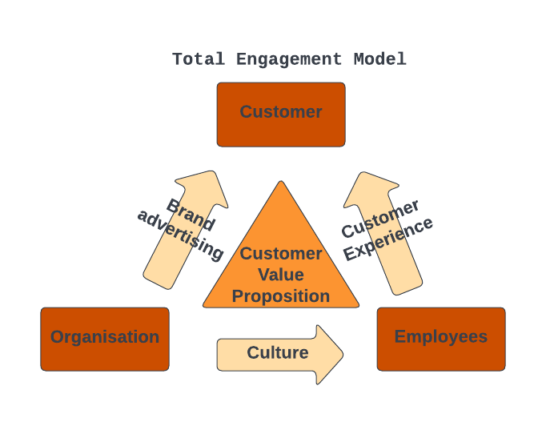

The total engagement model focus mainly on the 4 key elements:
Customer value proposition – It is important for the brand to have a strong customer value proposition because a brand is more than just the logo and brand name. This is the reason customers will want to return to buy from your brand and not from the competitors.
Culture of the brand – How committed the staff is to the brand and the company the goals, the values and the staff should be committed to deliver to the customers an excellent customer experience, both emotional and physical experience.
Brand advertising – What the brand promises. The strong insight the customer has of the brand and how well the brand delivers its customer value proposition.
Customer experience – What the brand delivers. To deliver a well-planned and unique customer experience by the brand and the staff.
(Roberts, Alpert 2010)

14. Conclusion

To conclude this report that is about the brand Louis Vuitton, a French designer and artisan that started to create travel trunks and became globally famous for their unique logo handbags. The report covered the company background, the Shannon and Weaver communication model, explained the definition of IMC – Integrated Marketing Communications, described new promotional strategies, explained branding and brand equity, explained the value of the brand, included a Keller’s brand equity Model, as well as the disadvantages and disadvantages of the model, as well as the stages in the customer journey. The report also explained the customer touchpoints, gave a definition of the customer journey map, critically analysed the customer journey map. Included a Total Engagement Model and finalise with recommendations for the brand regarding the new touchpoints.

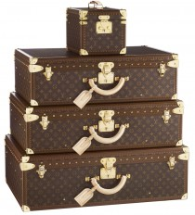

15. Recommendations
My recommendation to Louis Vuitton is for the aftersales, during my research I found that many customers that have had problem with their Louis Vuitton handbags, whenever they have some kind of fault, for example if the strap comes off, then they need to sent it to France, for them to be able to get a new one, or for them to repair the handbag, I would recommend that Louis Vuitton should solve the problem within the store where the customer bought the handbag, and not having to sent it all the way to France to have a replacement or it being repaired.
I would also recommend that Louis Vuitton should give their customers some kind of aftersales rewards, having in account the high cost of the products that they sell, since they do not do ever any kind of discounts.

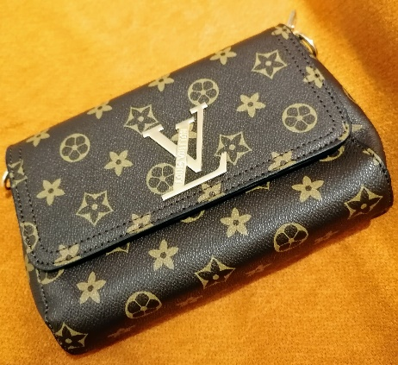



16. References
Angrave, J. (2020). The Journey Mapping Playbook: A Practical Guide to Preparing, Facilitating and unlocking the Value of Customer Journey Mapping, De Gruyter Business Playbooks
Anon, (n.d.). The History Of Louis Vuitton. [online] Available at: https://www.richdiamonds.com/inspiration/the-history-of-louis-vuitton.
Admin, J.L. (n.d.). The Louis Vuitton Logo and its History | LogoMyWay. [online] Available at: https://blog.logomyway.com/louis-vuitton-logo-history/.
Brandification. (n.d.). Brand Touchpoints from Louis Vuitton. [online] Available at: https://brandification.com/en/brand-touchpoints-from-louis-vuitton/ [Accessed 1 Jan. 2023].

Comparably. (n.d.). LVMH Mission, Vision & Values. [online] Available at: https://www.comparably.com/companies/lvmh/mission.

Design, branding and business – Turbologo’s blog. (2020). Louis Vuitton Logo Design – History and Meaning | Turbologo Logo Maker. [online] Available at: https://turbologo.com/articles/louis-vuitton-logo/.

Debutify (2022). eCommerce Customer Journey Mapping. [online] Debutify. Available at: https://debutify.com/blog/7-ways-to-create-an-ecommerce-customer-journey-map/ [Accessed 17 Dec. 2022].

Hooley, G. (2020). Marketing strategy and competitive positioning. Seventh edition. Harlow, England: Pearson.
Hawker, K. (2019). Keller’s Brand Equity Model — What It Is & How to Use It. [online] Medium. Available at: https://medium.com/@keatonhawker/kellers-brand-equity-model-what-it-is-how-to-use-it-84e42d562299.
L’invitation au voyage. Louis Vuitton. (n.d.). L’invitation au voyage. Louis Vuitton. [online] Available at: https://louisvuittonbrand.wordpress.com/.
Roberts, Alpert, (2010). Total Customer Engagement: Designing and Aligning Key Strategic Elements to Achieve Growth. (pp. 171-192). New York: Routledge.
Pecánek, M. (2022). What Is IMC? Integrated Marketing Communications Explained. [online] SEO Blog by Ahrefs. Available at: https://ahrefs.com/blog/imc/.

Shannon, C., Weaver, W. (1998). The mathematical theory of communication. Urbana: University of Illinois Press.
‌Vuitton, L. (2022). LOUIS VUITTON - Official Website United Kingdom. [online] Louisvuitton.com. Available at: https://uk.louisvuitton.com/eng-gb/homepage.

www.unicef.org. (n.d.). Louis Vuitton. [online] Available at: https://www.unicef.org/partnerships/louis-vuitton.

