DS 1 Template

My Screenshots/Photos
- Please add 4–6 screenshots or photos of your digital life.
- You can use your phone or laptop.
- For each screenshot, write one or two sentences explaining what it shows.

Screenshot/Photo 1
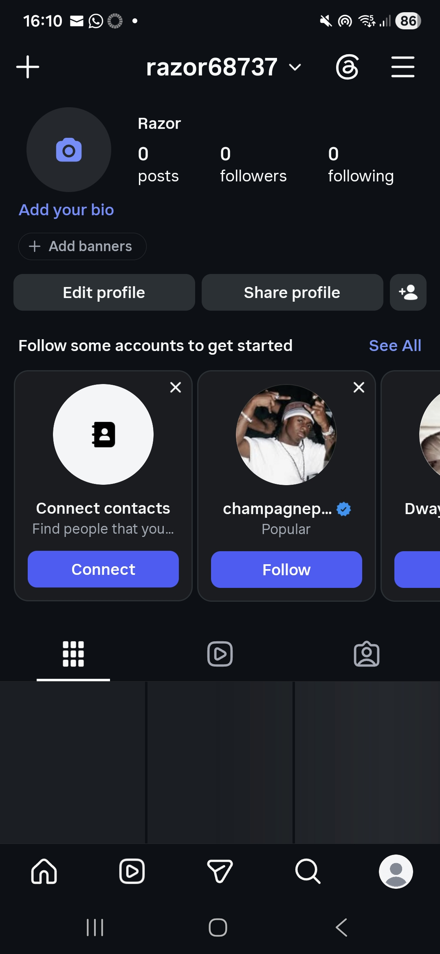]
I use Instagram for social use

Screenshot/Photo 2
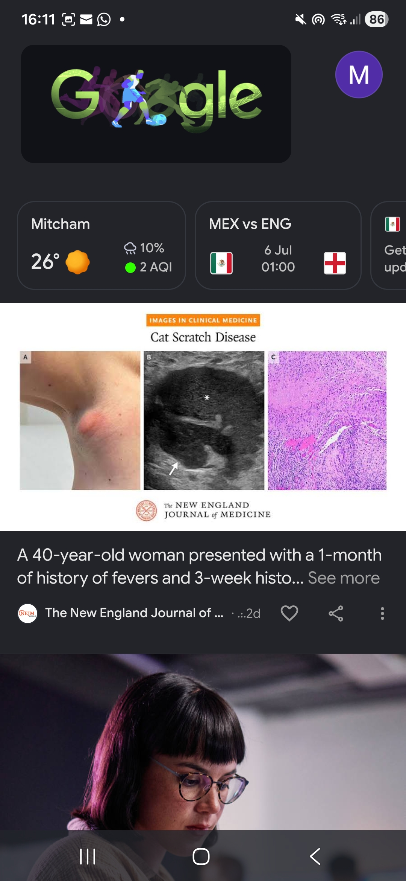
I use google for research

Screenshot/Photo 3
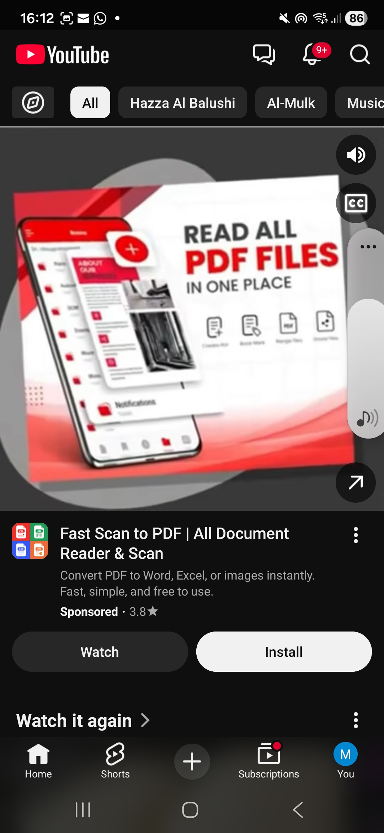 i
I use youtube for listening to Quran

Screenshot/Photo 4
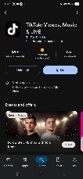
I use to post about my business

Screenshot/Photo 5My Short Reflection
- Write 5–8 simple sentences about your digital life.
- You can use the sentence starters below if helpful.
I use digital tools to communicate with others, complete coursework, and also manage every day activities
- I feel confident when I use email, also search for information online, create documents and for online meetings.
- I want to improve my confidence with new software, online collaboration tools, and keeping my information secure.
- I often use these tools: Microsoft Word, Excel, PowerPoint, Google Docs, email, Zoom, Microsoft Teams, and web browsers.
- I sometimes feel nervous about learning unfamiliar technology, or dealing with online security and privacy.
- I hope this module will help me develop better digital skills, learn new tools, and become more confident using technology.
- Digital skills are important for me because they help me work more efficiently, communicate effectively, also learning my career opportunities

Sentence starters
- I use digital tools to …
- I feel confident when I …
- I want to improve …
- I often use these tools: …
- I sometimes feel nervous about …
- I hope this module will help me …
- Digital skills are important for me because …
You can write more if you want.

Submission Checklist
Before you submit, please check:
​​​ ☒ I added 4–6 screenshots
☒ I wrote short sentences for each screenshot
☒ I wrote my short reflection
☒ My work is my own
☒ My file opens correctly
​​☒ My file opens correctly

