Creating our own database layers

First download some data from OS mastermap. Notice when using master map – topography you can only download a small amount of data at any time. Add your order to the basket and choose GopPackage as you file type.

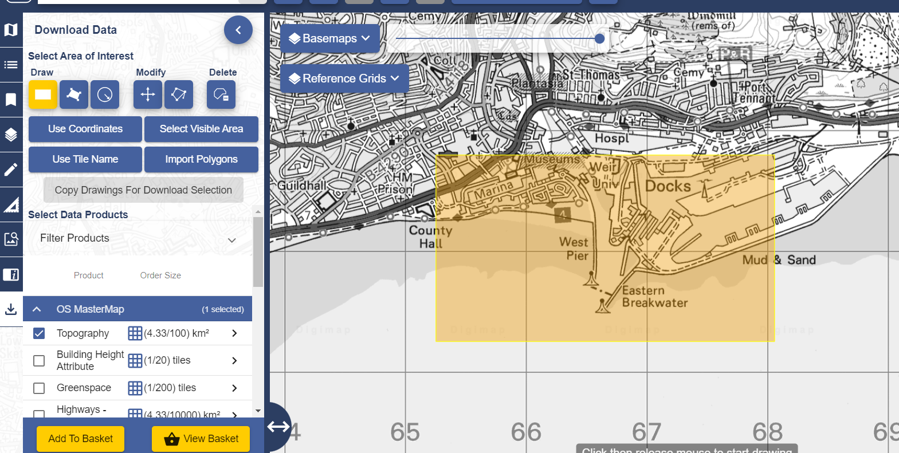

Add some colour to your topography layer and then make the layer the transparent by say 60%. Turn on the Bing aerial layer which should display underneath you are top a graphic layer and this will give you some indication of the location of the union buildings.
Notice I have selected the buildings from the top of Kings Road the technium buildings right down to the IQ building where we are no.
The next thing we need to do is create our own database out of the buildings we have selected to do this we need to save our selection as we have done before and give it a name this is a similar process to saving off the map polygons however here we're using buildings and we're going to create some additional attribute data to the database. Line
Save your database as you need uni buildings.
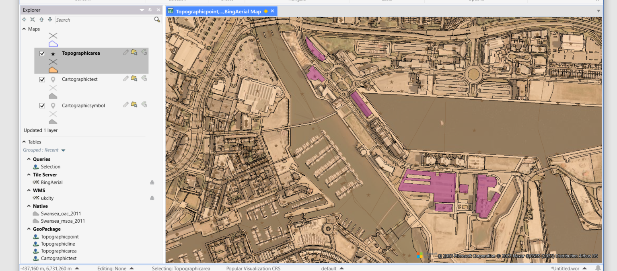

Open your newly created layer and investigate the data behind this layer which we can now edit.

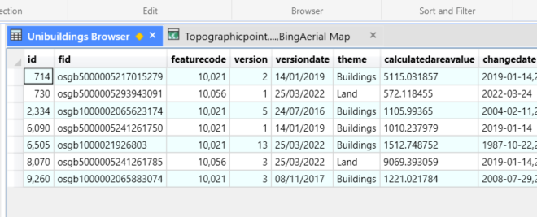

Alternatively if we have some post code data we could make the database in a slightly different way and add points to our map using the post code but converting this post code into the longitude and latitude equivalent. To do this we need to use a little application that we can Google : This FreeMapTools works well. You can transfer a batch of postcodes onto the site and ask for the lon lat and a batch will be sent back to you. Make sure you copy out of excel and paste back into excel using the appropriate locations with a new heading. It can be a little bit tricky as you have to split the longitude and latitude into two cell.

Name | Address | Postcode
UWTSD Alex building | 7 Pleasant St | SA1 5DS
UWTSD College of Art | Dynevor Pl, De-La Beche St | SA1 3EU
Swasnea Busness school | Business Campus (UWTSD, High St | SA1 1NE
IQ building | Kings Rd, Swansea SA1, UK | SA1 8EW
UWTSD technium 2 | 1 Kings Rd | SA1 8PH
UwTSD Marketing | J Shed Arcade,Kings Rd | SA1 8PL

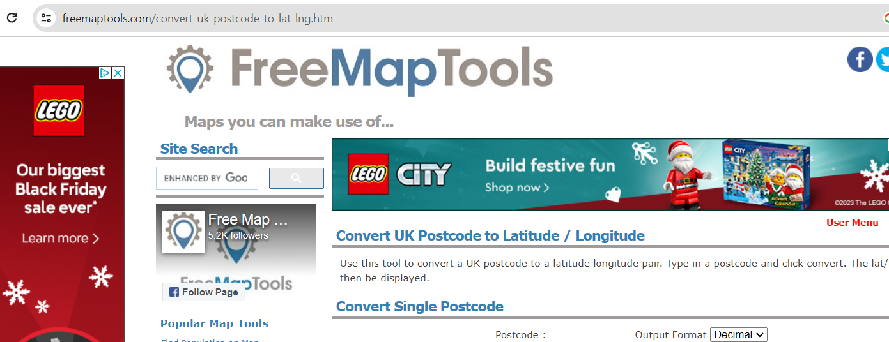

Create a simple excel spreadsheet using the above data. Copy and paste the post codes into the appropriate column on the free map tools and then press convert. Once you see that all the longitude latitudes have appeared copy and paste these back into the spreadsheet. What you will notice is that there is only one column of data you therefore have to split the data as you can see it is, separated. Underneath the data tab use the text to option and you will see the following pop up.

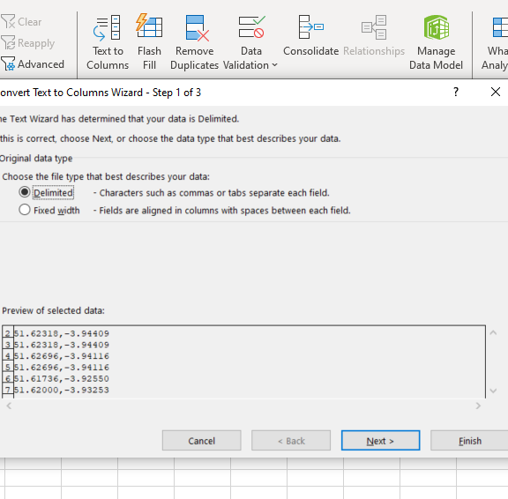

You should then see the two numerical data sets in their own columns. The higher number the 50s are the latitude and the negative number the longitude. Label the fields accordingly. Take this simple spreadsheet back into map info and this time use the create points tool and you should see points are in a similar area to your newly created database.

You should now see something like this.


