Module Title: Enhancing Health and Wellbeing using Digital Skills
Module Code: BMDS7001
Student Number: 0251817
Assignment Title: Reflective account: Multi-stakeholder working
Lecturer: Philip Scott
Word Count: 1626
Submission Date: 08.06.22

Introduction
For this assignment I will critically reflect upon methods of multi- and inter-disciplinary working involved in successful design of the digital solution for Identification Document Verification. The reflective model for this assignment I decided to use was ‘What?, so What?, now What?’ which also considers the importance to reflect during the event and not only after the event to allow for improvements can be considered in the now (Rolfe et al, 2001). Other models predominately reflected after the event.
To support delivery of a policy or strategic aim through successful design of digital technology it is crucial to involve and engage with relevant stakeholders effectively using different methods of communication and also to take time to reflect and evaluate on what went well or areas of improvement in order for lessons to be learnt for similar future projects or programmes. For this digital solution multi-disciplinary working took the form of structured individual interviews, group meetings and personal experience.
In this example the required digital solution is driven from NHS Wales Shared Services Partnership’s (NWSSP) strategic objective to “Focus on continuous service improvement, automation and the use of technology”.
The digital solution utilises Identification Document Verification Technology (IDVT) through a service provider carrying out digital identity checks on behalf of potential employees, which enables them to share their information using digital technology and enables the employer to check they are who they say they are.
Main Body
The stakeholders that I identified for this digital solution to utilise IDV technology were the members of the recruitment team, new employees who had gone through the process most recently and potential service providers. For the initial options appraisal and gap analysis I felt these stakeholders were the most vital as these covered the customer which in this situation would be the potential employee and the supplier at this discovery phase.
However, in moving to the delivery stages of the digital solution, in to the next phase of the project it will be of vital importance to expand this stakeholder group to include a mix of representation from different stakeholders groups including various experts in their fields such as procurement, finance and Information Governance. It may also be necessary to involve the Home Office and Disclosure and Barring Service (DBS) where there are specific concerns or areas of uncertainty in the guidelines.
The members of the group would be:
- Members of the recruitment team.
- Applicants who have recently been employed.
- Information Governance.
- Finance.
- Business Systems representation.
- Procurement.
- Project Team.
- Service provider of the IDV technology.
- Home Office and DBS.
- Senior Responsible Owner (SRO) for the project.
- People and Organisational Development representation.
I feel that the importance of engagement with the right stakeholders cannot be underestimated and in particular to involve the employees who will be using the IDV technology as these are the experts in the process of pre-employment checks and is vital to have these staff onboard when implementing any changes. Based on previous experience I have also found that using a bottom-up approach empowers these employees to be open and transparent when discussing the processes that they go through on a daily basis.
Even though I adopted a bottom-up approach I understood that gaining the Senior Leadership Group buy-in was also crucial and this was achieved through constant engagement and provision of monthly update reports summarising the stakeholder groups priorities and next steps.
To keep the stakeholder groups engaged in the process I also recognised that some individuals require more time and support to deliver what is being asked of them so whilst a collective meeting makes good use of time it was sometimes necessary to pick up certain requirements separately with individuals. This is particularly important when asking specific interview questions as to avoid people’s answers influencing others where groupthink can occur where there is an overarching goal is to minimise conflict and strive for consensus, this also allows for a more open and honest discussion (Janis, 1983).
It is also important to involve the majority of the stakeholders collectively but then to involve some groups as and when their professionalism or expertise is needed. From my experience of transitioning new services from one organisation into another I considered that specific discussions require subgroup representation such as a finance subgroup so that the necessary detail can be discussed and then fed in summary back to the overall group. This allows a more targeted specific discussion where individuals time is finite. It may also be necessary to have separate meetings with internal and external stakeholder’s dependent on the topic. An example of this would be that the IDV technology service provider may not be required where closed dialogue procurement discussions are being held.
I worked with the initial stakeholders to develop a terms of reference for the group which clearly defined the purpose, roles and responsibilities of the group members. Whilst the terms of reference I considered to be relevant for the initial stakeholders were appropriate and adopted, as the project matures these terms of reference will need to be reviewed for relevancy and to consider the roles and responsibilities of the wider stakeholders. To maintain consistency I also found that the same stakeholders from the stakeholders groups were to attend the meetings as if deputies were sent they may not be up to speed with the project but more importantly may not be the decision makers.
Following on from the initial meeting with the stakeholders I realised that having only verbal communication would not work as there was a need to follow up with questions and queries outside of the meeting which could have been resolved during the meeting. I t was apparent that different stakeholders and individuals absorb information more easily through different methods such as visual or written communication. In addition, different information is communicated better using different methods. An example of this would be presenting figures in a table or trend data using charts and not just words.
In addition, from my own experience, being able to identify your own personality type and others helps gain an understanding of behaviours and why individuals can act a certain way in different situations. My experience of engaging with various stakeholders on the IDV technology exploration and also other projects which has highlighted to me that understanding individual personality types and understanding behaviours is important and crucially it is also important to be aware of your own behaviours.
I have attending numerous leadership courses run by the NHS that have explored different models including Disc Personality types designed by Walter Clark seen in figure 1 below which looks at individual behaviours (Walter, 1956).
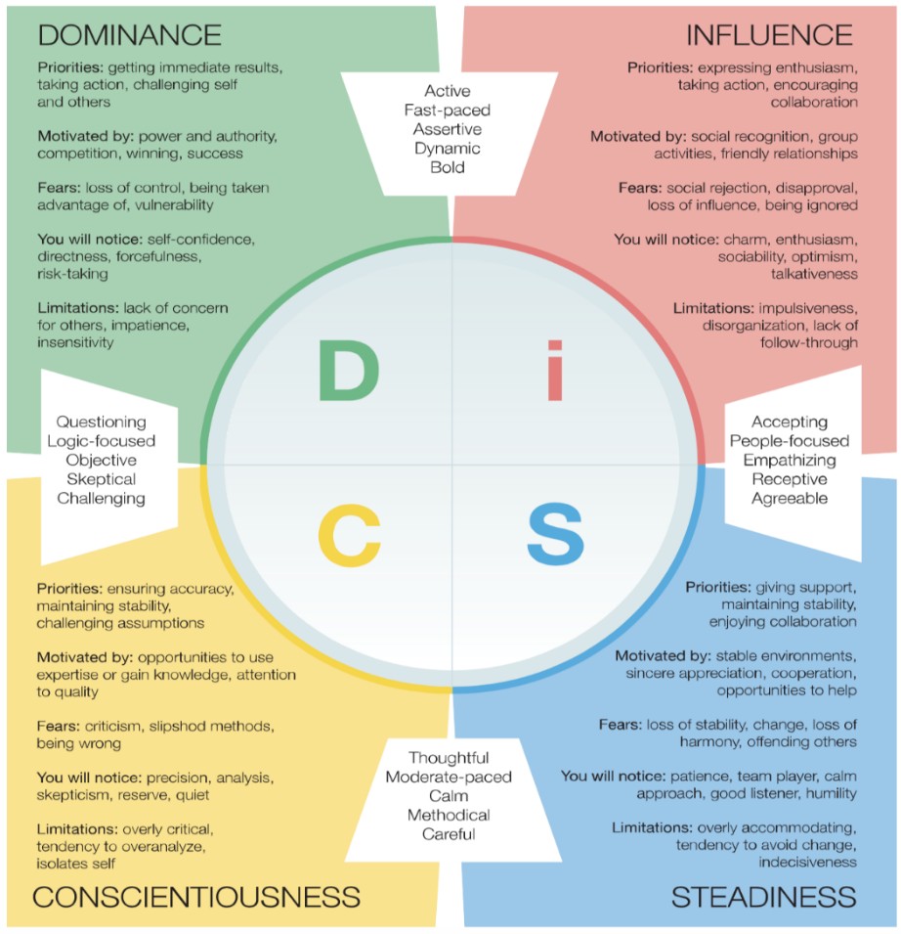
Figure 1 Disc Personality Types
Myers-Briggs Type Indicator (MBTI) in figure 2 below which looks at how people interact and personality preferences (MBTI, 2022) or Insights self-awareness to gain an understanding of individuals including ourselves in figure 3 can be applied to support gaining an understanding (Insights, 2021).
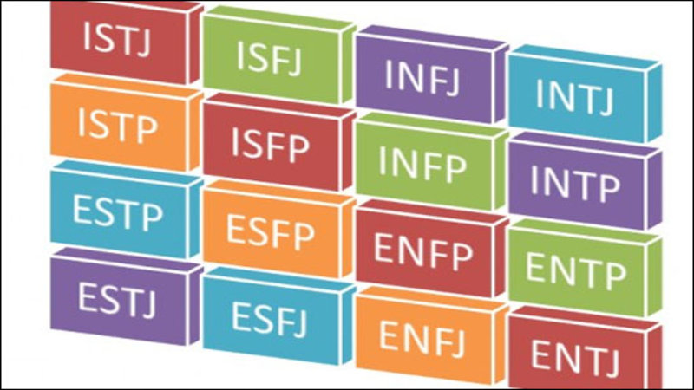
Figure 2 Myers-Briggs Type Indicator (MBTI)

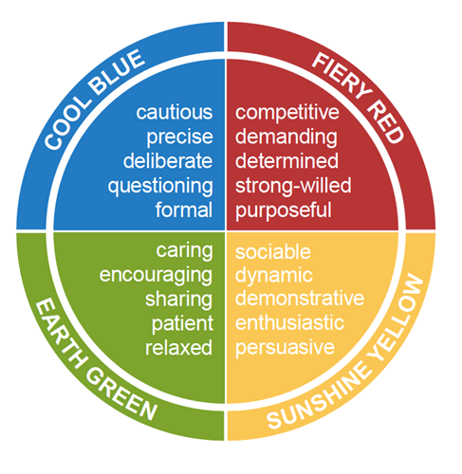
Figure 3 Insights Self Awareness
These applied models ultimately enable a team to work more effectively and communicate better to overcome conflict as there is a mutual understanding of personalities. I felt it would be a good idea to apply one of these tools so the group can understand why other individuals act in a certain way in different scenarios and develop better, more productive working relationships.
When holding the initial stakeholder group meetings, I did observe that some individuals appeared more confident in that environment and were more vocal in communicating their needs which prevented others contributing to the discussion. After that initial meeting I felt that some ground rules/ meeting guidelines or code of conduct was needed to be set to ensure that one person’s views where not being ignored. These guidelines required all individuals to listen to others and everybody to have the opportunity to speak, the aim of this was to avoid any one individual from dominating the group. In retrospect the guidelines should have been clear from the start to avoid any uncomfortableness in the stakeholder group.
As time went on, I observed that the stakeholder group became more comfortable with each other as individuals started to understand each other and were better able to get the best from each other by listening and working together.
This demonstrates the importance of understanding the stages a newly created group go through once setup. As it has been identified the group will need to be expanded it may take some time again for individuals to feel content again going through the stages of team development (Tuckman, 1965). The stages of team development are recognised as.
- Forming – Group is reliant on the leader for guidance.
- Storming – Individual in the group concentrate more on the impression they are making.
- Norming – Decisions are made and implemented.
- Performing – Group is performing at the highest level.

Conclusion
Engagement with relevant stakeholders is vital and to help support this there are many frameworks, methodologies and models that exist to help inform and steer successful projects by understanding of individual personality traits and how teams work together in the best way with differing learning styles and the use of different forms of communication. Also having different types of meetings whether one to one or a group meeting as required to suit both the situation and individual.
To build up a tool kit of these frameworks, methodologies and models so that I can tailor them for application in future developments will help me drive improvement and successfully achieve the common goal or outcome.
To get a group or team working well strong leadership skills are required by the chair not only to enforce the meeting code of conduct but to keep the group focused on the task and to perform at the highest level.

References
Guttenberg, J.L. (2020) ‘Group development model and Lean Six Sigma project team outcomes’, International journal of lean six sigma, 11(4), pp. 635–661. doi:10.1108/IJLSS-09-2018-0101.
HM Government (n.d.) The Digital, Data and Technology Playbook. Available at: https://www.gov.uk/government/publications/the-digital-data-and-technology-playbook/the-digital-data-and-technology-playbook (Accessed 24 May 2022)
Insights (2021) What we do. Available at: https://www.insights.com/ (Accessed 30 May 2022)
Janis, I.L. (1983) ‘Groupthink’ (pp. 2-13). Boston: Houghton Mifflin.
Jessup, C.M. (2002) ‘Applying psychological type and “gifts differing” to organizational change’, Journal of organizational change management, 15(5), pp. 502–511. doi:10.1108/09534810210440405
Myers-Briggs Type Indicator (MBTI) (2022) The Myers & Briggs Foundation. Available at: https://www.myersbriggs.org/ (Accessed 30 May 2022)
Myers, I.B. (1962) ‘The Myers-Briggs Type Indicator: Manual’
Rolfe, G., Freshwater, D., Jasper, M. (2001) ‘Critical reflection in nursing and the helping professions: a user’s guide’. Basingstoke: Palgrave Macmillan.
Tanguay, E. (2020) ‘Reflective writing for nursing, health and social work’. Red Globe Press an imprint of Macmillan Education Limited, London
Tuckman, B. (1965) ‘Forming, Storming, Norming & Performing Team Development Model’
Walter, C. (1956) ‘DISC Assessment Measurement Instrument’

