University Of Wales Trinity Saint David’s
School of Engineering



Vehicle / Motorsport Technology ACHA4012

James Evans
2104143
12/13/2021

Introduction

Laboratory Sessions

2.1 Equipment
Wheel position tests
Formula Ford suspension rig– the front suspension system of a formula ford car with a damper replaced by a turn rod to simulate changing damper length.
A Vernier calliper uses the vernier Scale to measure distances accurately, it was used to measure the damper length, this was a suitable choice due to its high level of accuracy. An alternative would be a Digital calliper as they are more accurate however excessive force when adjusting the distance measured can cause readings to be inaccurate.
A Height gauge with a digital display was used to measure the height of the centre of the wheel, this was a good choice as the digital display is easy to read,
Camber gauge to measure the inward or outward tilt of the wheel as it rotates around the longitudinal axis of the car(camber) values of camber are negative however as gauge couldn’t be attached to the outside of the brake disc this caused it to give positive results that needed to be changed to negative.
Bump plate A bump plate was used as it provides a flat surface to take accurate measurements wheel height and toe angle
DTI (Dial Indicator Test) DTIs are used to measure tiny distances accurately and make small distance changes more obvious this was a suitable instrument to use to make a toe gauge however a digital gauge would have been easier to read
toe gauge a toe gauge rig made up of two DTIs in parallel to each other was set up values of toe were calculated using the results from the two DTI’s
Unsprang mass test
Formula ford rig – the suspension system of a formula 4 car without any springs attached to it, springs were taken off so the force they exerted couldn’t affect the value of the systems weight
A Wireless corner weight scale connected to a laptop was used as it produces much more accurate results than a commercial scale
tyre vertical stiffness test
Hydraulic press used as it produces maximum force with minimum effort
Wheel and tyre a wheel pumped to 10psi was used in testing
DTI – A DTI with millimetre units was used to indicate each time deflection was increased by 2mm
Wireless Corner Weight Scale
spring stiffness test
Hydraulic press
Coil spring
Spring compression tester
DTI(Inches)

2.2 Methodology

Wheel Position Tests
equipment was setup as shown around the formula ford chassis, 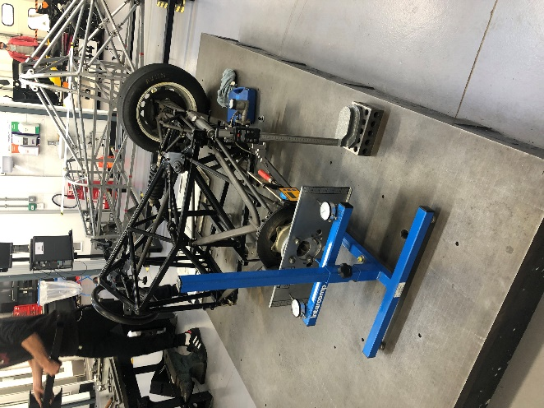
the bump plate was fastened to the brake disc in place of a wheel, the toe gauge was slid under the system
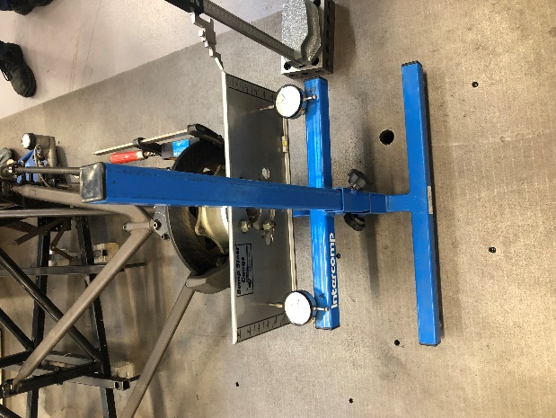
When the DTI’s plungers were halfway compressed with room to move in our outwards,
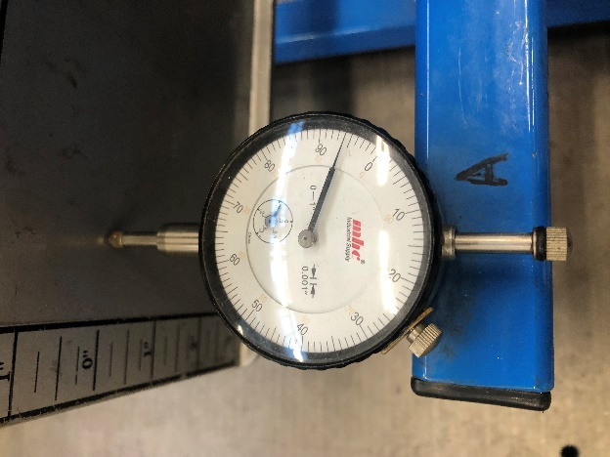
the DTIs were then zeroed. the height gauge was setup in contact with the top edge of the bump plate and zeroed it was then moved out of the way. the camber gauge was fixed to the inside of the brake disc and its original value was recorded. Finally, the original length of the damper was recorded using a vernier calliper. Once setup the damper length was decreased by turning the turn buckle two rotations (PICTURE OF TURN BUCKLE)
the new damper length was recorded along with new values from each piece of equipment and then the process was repeated. After repeating this process 8 times the experiment was complete

task 2 unsprung mass test
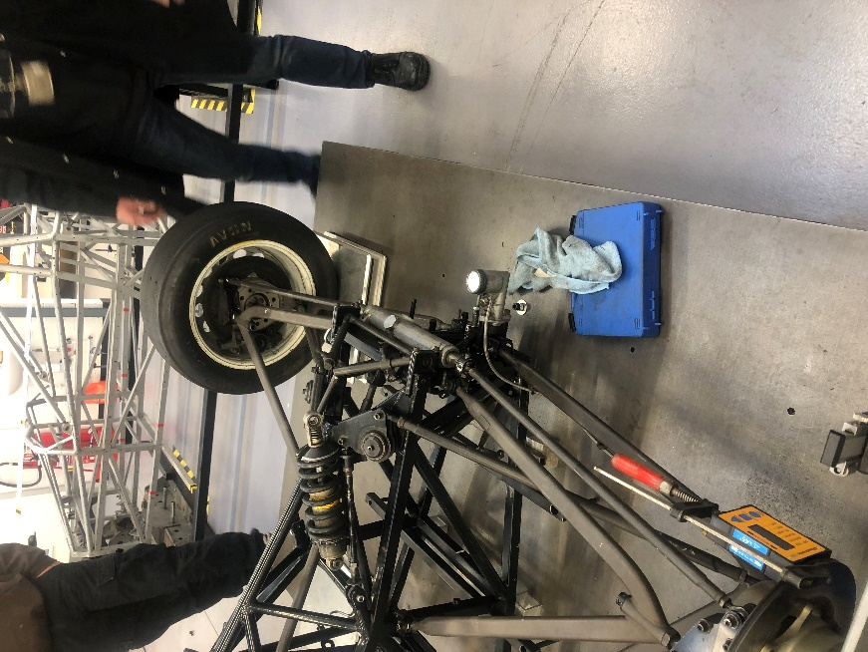
A wireless corner mass scale was zeroed then slid under the wheel as shown and the data shown by the scale was recorded as 30.5kg

the wight was recorded as unsprung mass as there are no springs to alter the measurement, the wishbones were then disconnected from the body of the car and the off car unprung weight was recorded. As 34

Tyre Verticle stiffness test
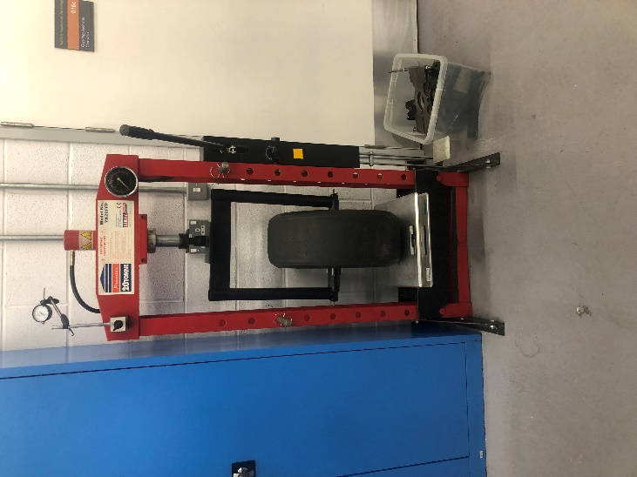
A tyre was set up in a hydraulic press as shown the tyre was placed in the press on top of a corner weight scale. A DTI was then attached to the press to indicate when measurements should be taken and zeroed. the hydraulic presses ram was then locked using its valve and the handle was pulled a tiny amount before the DTI and corner scale were zeroed. The press handle was then pulled down until two revolutions had been made by the DTI meaning the tyres deflection had increased by 2 mm, the value shown by the scale was then recorded, this process was repeated 7 times

Task 4 spring stiffness test
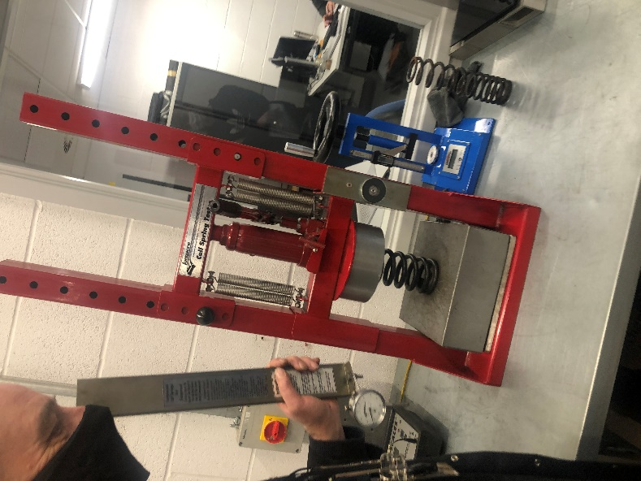
A hydraulic ram was setup above a spring compression tester as shown A DTI was added attached to the ram and zeroed. The handle of the press was pulled until a change in spring compression of 0.1 inches was measured by the DTI, The value measured by the compression tester was then recorded and this process was repeated until one inch of compression had been experienced by the spring.

2.3 Results

Raw Data

Graphs
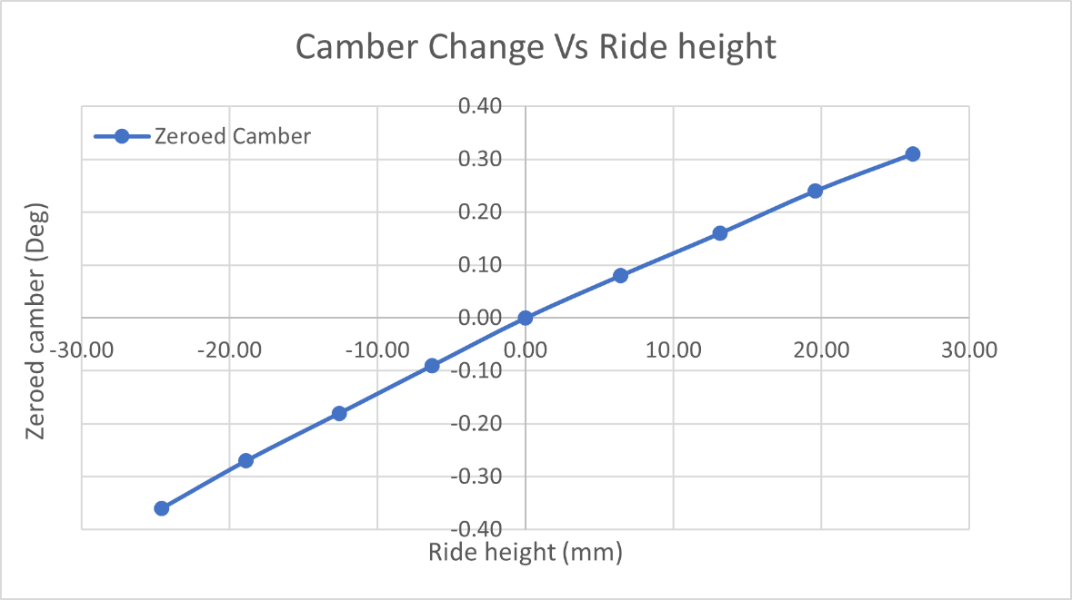
In this Graph the Camber gain of the vehicle is shown this is the difference in how much the camber will change per mm of wheel displacement, camber gain affects the grip of the car during cornering and breaking in this graph we observe the camber gain being greater.
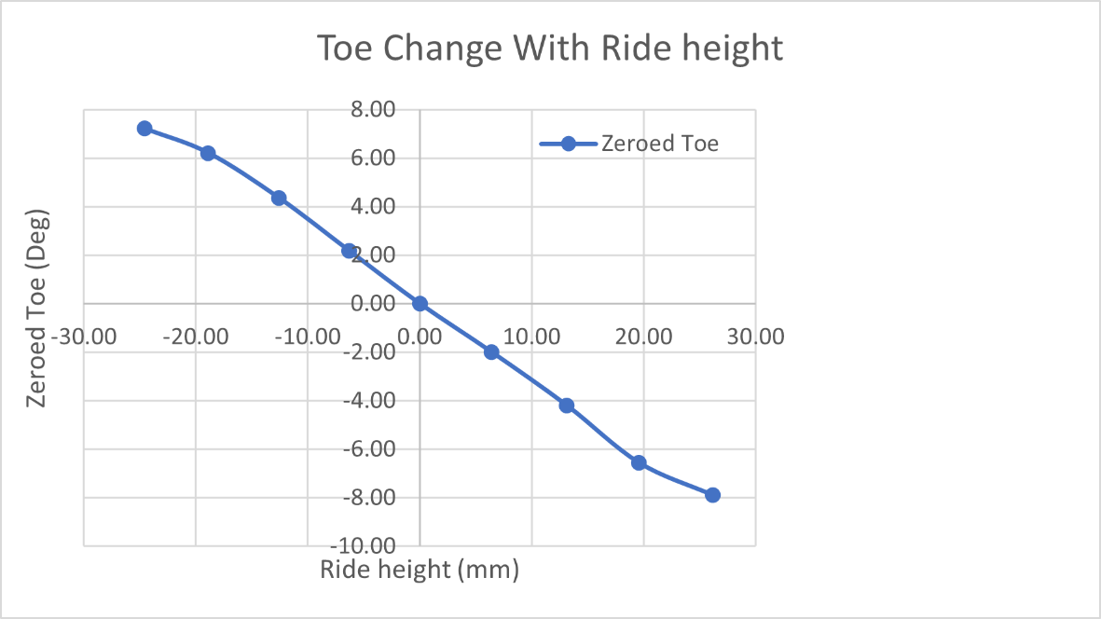
In this graph the bump we can see the geometry of the cars bump steer when at full droop the wheel has a negative toe angle the toe angle becomes more positive as the wheel approaches full bump
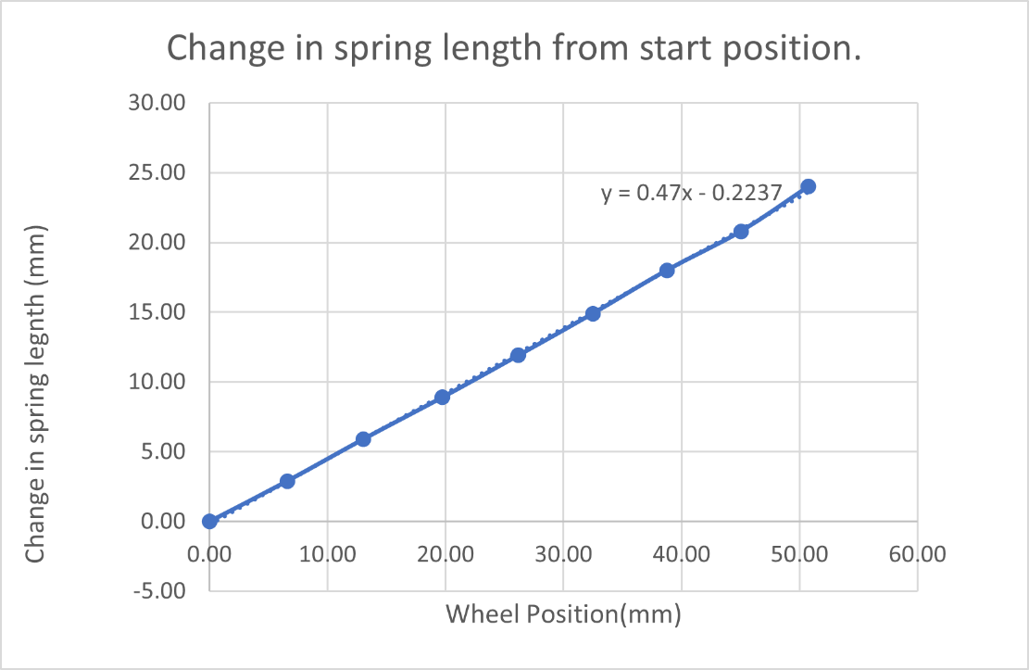
This shows the relationship between wheel position in relation to full droop vs spring length. As the value for wheel position increases the change in spring length increases at a constant rate this means that the higher the wheel in relation to full droop the more compressed meaning spring compression and wheel position are directly proportional. The motion ratio of the car can be calculated by using the gradient of this graph, It is 0.47.
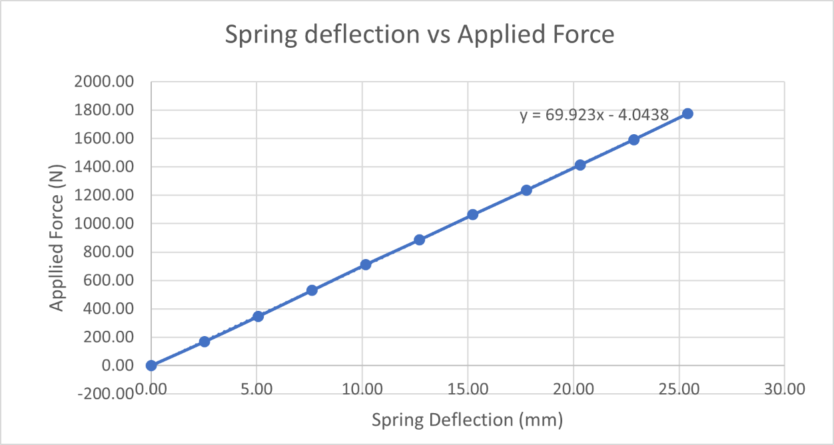
As spring deflection increases on the x axis applied force increases proportionally the value for spring stiffness was calculated by finding the gradient of this graph and multiplying the value by 1000 to convert it from N/mm to N/m
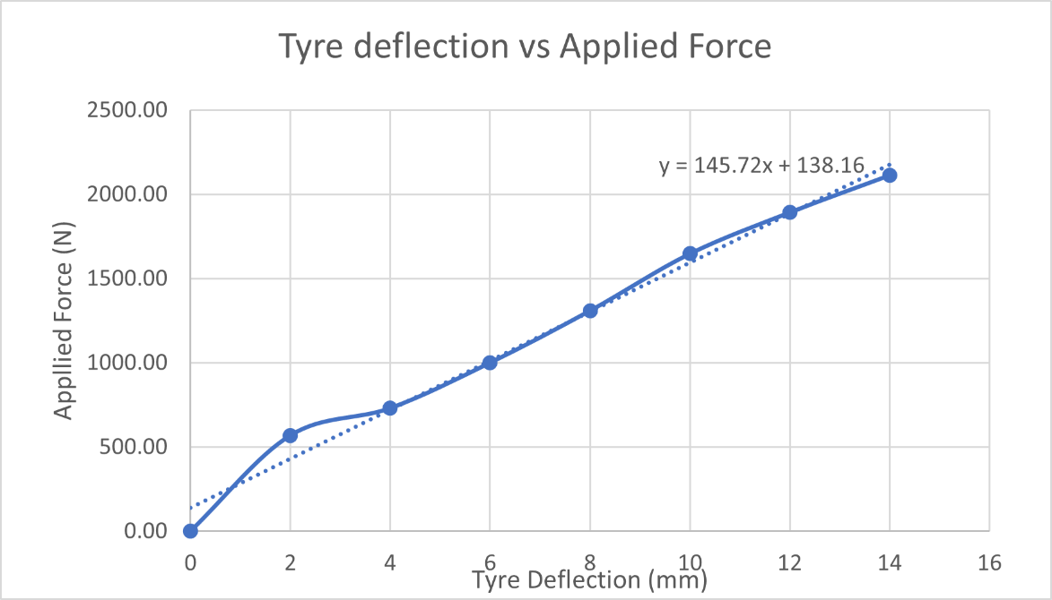
In this graph there is a clear trend line showing the proportional relationship between applied force and tyre deflection the gradient of this graph was used to measure tyre stiffness in N/mm it was then multiplied by 1000 to convert to the proper unit, tyre stiffness was calculated with a value of 145700.

Win geo

3.1 Methodology

Wheel position test simulation
The simulation of tests was completed in Wingeo which is a geometrical analysis software.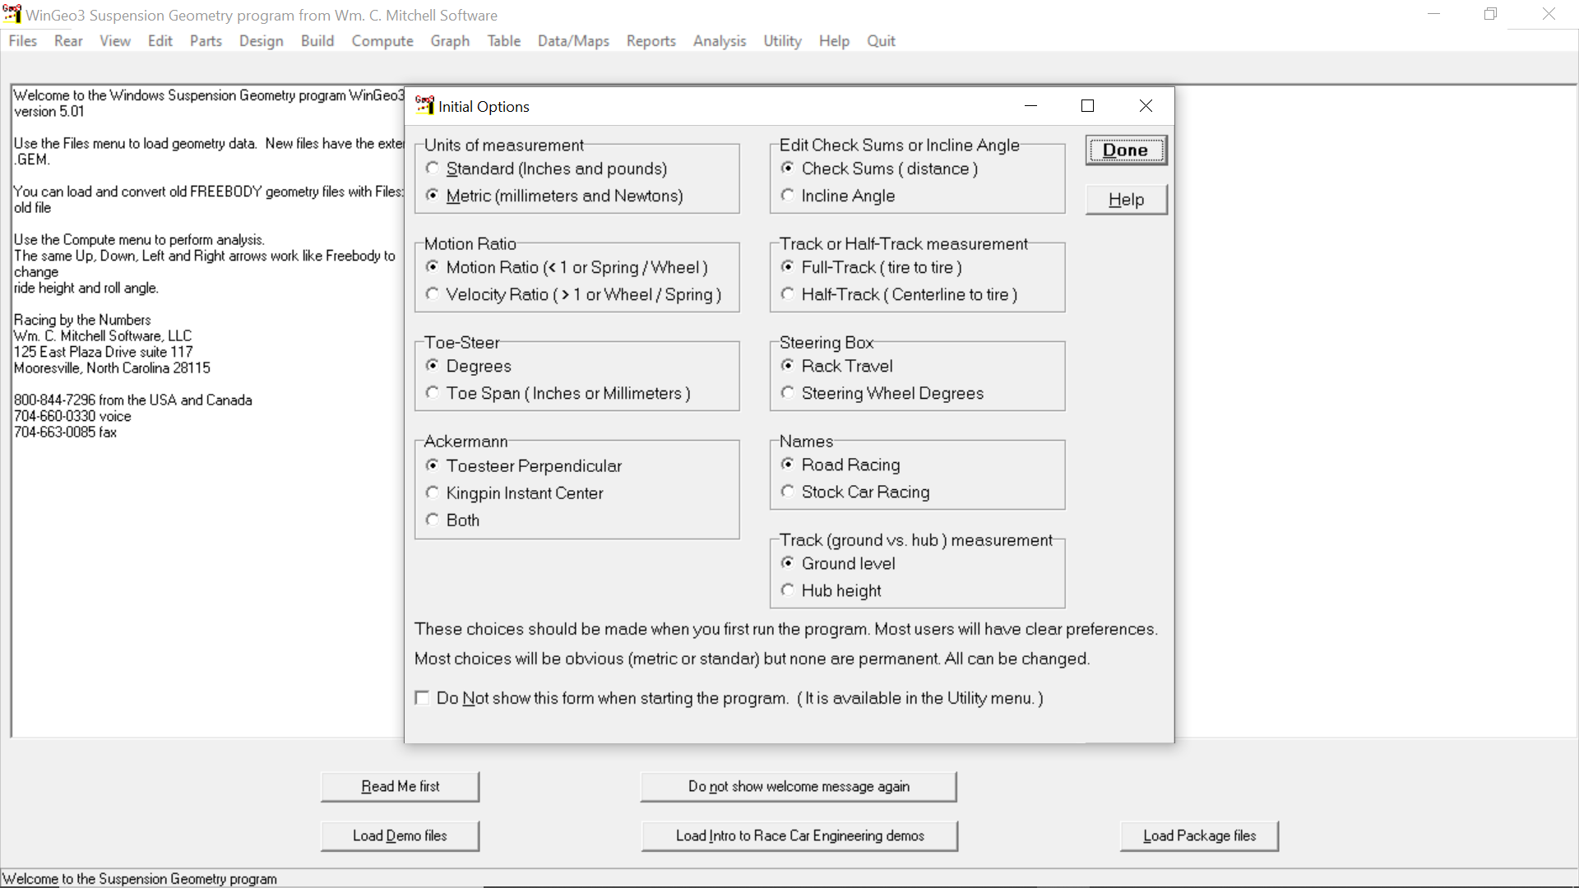
Upon opening WinGeo initial options had to be checked and setup as shown in figure()
After selecting Done to close the options menu the formula ford front suspension model was loaded into WinGeo as shown in figure() A table was then made by clicking Table→ Quick user table →New user Table the columns shown in figure() where then added to the table. The Ride height was then set to -25 to start the simulation at full droop as that is how measurements were made in the workshop results were then recorded to table by clicking compute. Ride height was then increased in increments of 5mm and results were recorded until ride height 20 was reached.

Roll Test Simulation
In this simulation WinGeo was setup the same as previously mentioned up until the point of changing the ride height and with the exception of setting the ride height to full droop, Ride height is instead zeroed roll simulation setup is shown in figure()
Roll was increased in increments of 0.1 degrees at each increment results were recorded by clicking compute.

3.2 Kinematics
Data values at 0 bump and roll

Wheel position test results

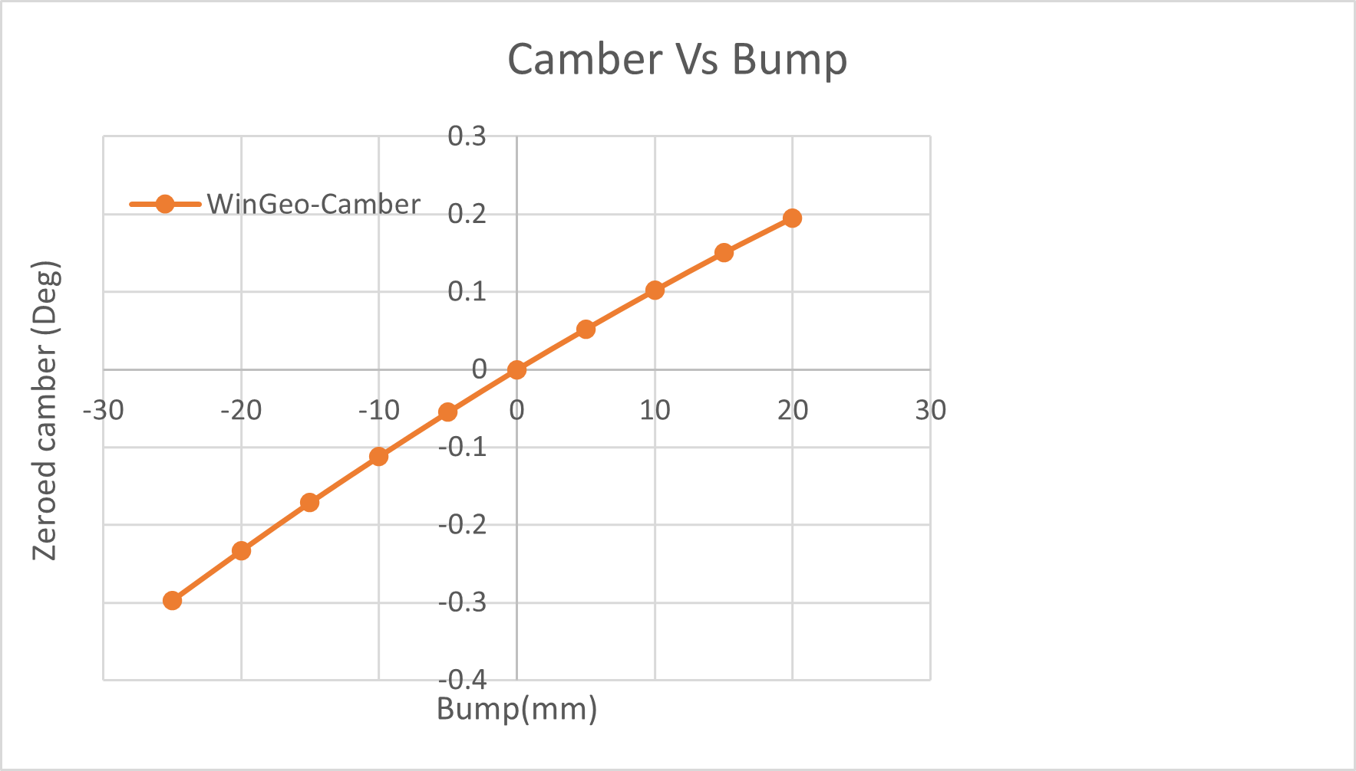#
The Graph in Figure () shows the proportional relationship between camber and bump
The Graph in Figure () shows the inversely proportional relationship between Motion Ratio and Bump as bump increases motion ratio decreases.

Roll Test Results
The graph in figure() shows the camber change throughout a corner in which the maximum roll experienced was 2 degrees as the Roll Angle increased the camber of both wheel changed by the same amount this means that both wheels tilted the same amount during cornering.
In figure() the alignment of the left and right tyres stayed constant as toe values changed by the same amount.

3.3 RC Migration
A simulation was run in which a model of a formula ford cars front suspension system was placed under the Conditions In Figure()
Roll Centre is the point at which cornering forces in the suspension act upon the cars body. migration is the path the roll centre takes through the Frontal Plane
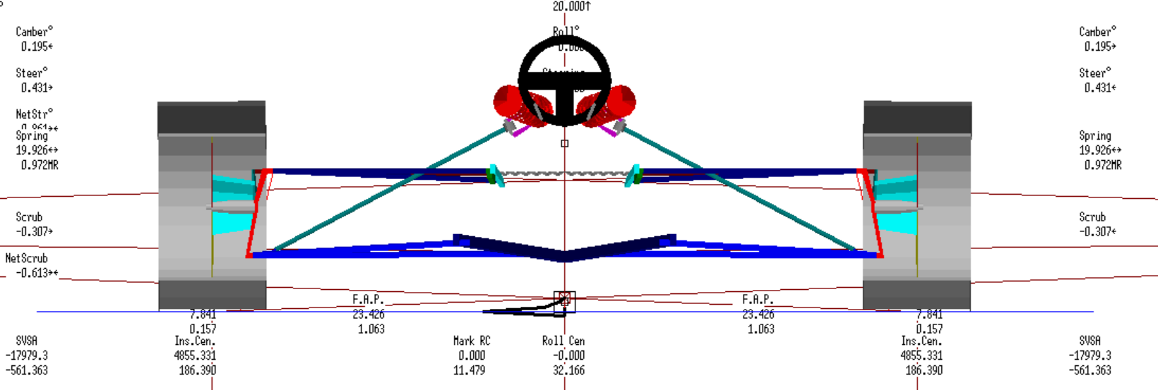
The Black Path above the marked static roll centre in figure() represents the roll centre migration

Roll centre migration is important in understanding how a car corners In motorsport the least amount of RC migration possible is desired as a high roll centre displacement can result in a shift in the direction of weight transfer which would cause the cars direction of travel and contact with the track unpredictable when turning corners.

Suspension calculations

Calculations

Wheel rate (Kw) is how stiff the suspension system is measured at the centre of the wheel, it is found using the relationship between Wheel rate, Spring Rate (Ks) and motion ratio (MR). the formula used was Kw = Ks × ${MR}^{2}$ making use of this equation and the calculated values of Ks (69900 N/m) and MR (0.47) a value of 15440.91 N/m was accepted as wheel rate.
Ride frequency(f) is the harmonic motion of the vehicle on the vertical plane. it’s measured in how many oscillations the spring makes per second and so has a unit of Hz The equation for natural frequency is a combination of two formulas the first is to find circular frequency of the system using the relationship between wheel rate and sprung mass (Ms) it is f(circular) =$\sqrt{\frac{Kw}{Ms}}$ in order to find the linear frequency this value must be divided by 2π to keep the format of the formula simple this is done by multiplying the circular frequency by $\frac{1}{2π}$ combined the formula f =$\frac{1}{2π}$ $\sqrt{\frac{Kw}{Ms}}$ is created. inputting the data calculated for Ms(115Kg) and Kw (15440.91N/m) a value of 1.8 Hz was calculated as Ride frequency

The natural frequency of the unsprung mass(fus) is how many times the vehicle oscillates on the vertical plane per second without damping from springs and dampers. In order to obtain a value for the natural frequency of the unsprung mas the relationship between wheel rate, tyre stiffness (Kt) and unsprang mass(mus) is used for the formula fus=$\frac{1}{2π}\sqrt{\frac{Kw+Kt}{mus}}$ this was used with the values for Kw(15440.91 N/m), Kt(145700 N/m) and Mus(30.5) to calculate a value of 11.57 Hz

Discussion

Validation
To validify collected results they needed to be plotted against simulated results and correlation was observed.
In figure() the lines are similar and results changed in consistent increments this validified collected results for Camber change the values may be slightly different due to human error when testing or uncertainties in measuring instruments
The WinGeo Results in figure () gave a flat line with little gradient variation this would mean that the toe angle experienced little to no change. Whereas measured results produce a line with a much steeper gradient that changes near maximum and minimum ride height this indicates WinGeo is incapable of measuring bump steer accurately.

Conclusion

Significant characteristics

6.2 Methods

