BA (Hons) Leadership and Management Skills for the Workplace
LCLM 5006 Developing Emotional Intelligence Skills
Poster Presentation
—-------------------------------
Student Name: Moazzem hossain
Student id: 2416062
Moudle :LCLM 5006
Lecturer: Dr Kazzem Oseni
.

Poster
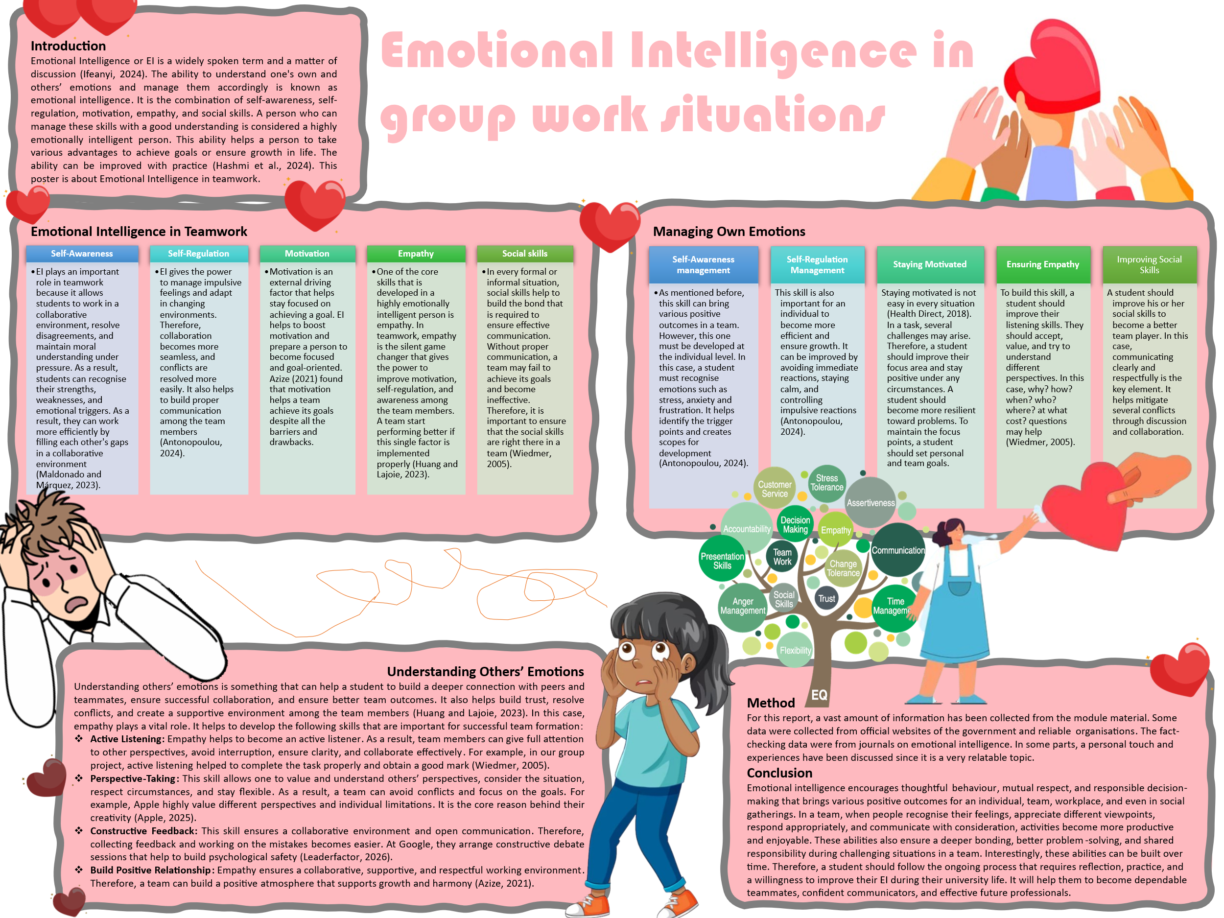

Writing

Introduction
Emotional Intelligence or EI is a widely spoken term and a matter of discussion (Ifeanyi, 2024). The ability to understand one's own and others’ emotions and manage them accordingly is known as emotional intelligence. It is the combination of self-awareness, self-regulation, motivation, empathy, and social skills. A person who can manage these skills with a good understanding is considered a highly emotionally intelligent person. This ability helps a person to take various advantages to achieve goals or ensure growth in life. The ability can be improved with practice (Hashmi et al., 2024). This poster is about Emotional Intelligence in teamwork.

EI in Teamwork
Self-Awareness: EI plays an important role in teamwork because it allows students to work in a collaborative environment, resolve disagreements, and maintain moral understanding under pressure. As a result, students can recognise their strengths, weaknesses, and emotional triggers. As a result, they can work more efficiently by filling each other's gaps in a collaborative environment (Maldonado and Márquez, 2023).
Self-Regulation: EI gives the power to manage impulsive feelings and adapt in changing environments. Therefore, collaboration becomes more seamless, and conflicts are resolved more easily. It also helps to build proper communication among the team members (Antonopoulou, 2024).
Motivation: Motivation is an external driving factor that helps stay focused on achieving a goal. EI helps to boost motivation and prepare a person to become focused and goal-oriented. Azize (2021) found that motivation helps a team achieve its goals despite all the barriers and drawbacks.
Empathy: One of the core skills that is developed in a highly emotionally intelligent person is empathy. In teamwork, empathy is the silent game changer that gives the power to improve motivation, self-regulation, and awareness among the team members. A team start performing better if this single factor is implemented properly (Huang and Lajoie, 2023).
Social skills: In every formal or informal situation, social skills help to build the bond that is required to ensure effective communication. Without proper communication, a team may fail to achieve its goals and become ineffective. Therefore, it is important to ensure that the social skills are right there in a team (Wiedmer, 2005).

Managing Own Emotions
Self-Awareness management: As mentioned before, this skill can bring various positive outcomes in a team. However, this one must be developed at the individual level. In this case, a student must recognise emotions such as stress, anxiety and frustration. It helps identify the trigger points and creates scopes for development (Antonopoulou, 2024).
Self-Regulation Management: This skill is also important for an individual to become more efficient and ensure growth. It can be improved by avoiding immediate reactions, staying calm, and controlling impulsive reactions (Antonopoulou, 2024).
Staying Motivated: Staying motivated is not easy in every situation (Health Direct, 2018). In a task, several challenges may arise. Therefore, a student should improve their focus area and stay positive under any circumstances. A student should become more resilient toward problems. To maintain the focus points, a student should set personal and team goals.
Ensuring Empathy: To build this skill, a student should improve their listening skills. They should accept, value, and try to understand different perspectives. In this case, why? how? when? who? where? at what cost? questions may help (Wiedmer, 2005).
Improving Social Skills: A student should improve his or her social skills to become a better team player. In this case, communicating clearly and respectfully is the key element. It helps mitigate several conflicts through discussion and collaboration.

Understanding Others’ Emotions
Understanding others’ emotions is something that can help a student to build a deeper connection with peers and teammates, ensure successful collaboration, and ensure better team outcomes. It also helps build trust, resolve conflicts, and create a supportive environment among the team members (Huang and Lajoie, 2023). In this case, empathy plays a vital role. It helps to develop the following skills that are important for successful team formation:
Active Listening: Empathy helps to become an active listener. As a result, team members can give full attention to other perspectives, avoid interruption, ensure clarity, and collaborate effectively. For example, in our group project, active listening helped to complete the task properly and obtain a good mark (Wiedmer, 2005).
Perspective-Taking: This skill allows one to value and understand others’ perspectives, consider the situation, respect circumstances, and stay flexible. As a result, a team can avoid conflicts and focus on the goals. For example, Apple highly value different perspectives and individual limitations. It is the core reason behind their creativity (Apple, 2025).
Constructive Feedback: This skill ensures a collaborative environment and open communication. Therefore, collecting feedback and working on the mistakes becomes easier. At Google, they arrange constructive debate sessions that help to build psychological safety (Leaderfactor, 2026).
Build Positive Relationship: Empathy ensures a collaborative, supportive, and respectful working environment. Therefore, a team can build a positive atmosphere that supports growth and harmony (Azize, 2021).

Method
For this report, a vast amount of information has been collected from the module material. Some data were collected from official websites of the government and reliable organisations. The fact-checking data were from journals on emotional intelligence. In some parts, a personal touch and experiences have been discussed since it is a very relatable topic.

Conclusion
Emotional intelligence encourages thoughtful behaviour, mutual respect, and responsible decision-making that brings various positive outcomes for an individual, team, workplace, and even in social gatherings. In a team, when people recognise their feelings, appreciate different viewpoints, respond appropriately, and communicate with consideration, activities become more productive and enjoyable. These abilities also ensure a deeper bonding, better problem-solving, and shared responsibility during challenging situations in a team. Interestingly, these abilities can be built over time. Therefore, a student should follow the ongoing process that requires reflection, practice, and a willingness to improve their EI during their university life. It will help them to become dependable teammates, confident communicators, and effective future professionals.

References
Antonopoulou, H. (2024). The Value of Emotional Intelligence: Self-Awareness, Self-Regulation, Motivation, and Empathy as Key... [online] ResearchGate. Available at: https://www.researchgate.net/publication/379764627_The_Value_of_Emotional_Intelligence_Self-Awareness_Self-Regulation_Motivation_and_Empathy_as_Key_Components.
Apple (2025). Careers at Apple: Explore benefits that make a difference. [online] Apple. Available at: https://www.apple.com/careers/uk/life-at-apple/benefits.html.
Azize, N.M. (2021). The motivation of employees and its impact on projects success. [online] ResearchGate. Available at: https://www.researchgate.net/publication/355711682_the_motivation_of_employees_and_its_impact_on_projects_success.
Hashmi, S., Tahir, O., Nasir, Z., Hasnain, H., Ullah Riaz, R.S., Ali Khan, H.M., Ramza, R., Alghzawi, H.M., Mukherjee, J. and Palav, A. (2024). Impact of emotional intelligence on professional performance and stress resilience among healthcare practitioners. Cureus, [online] 6(11). https://doi.org/10.7759/cureus.74113.
Health Direct (2018). Motivation: How to get started and staying motivated. [online] Healthdirect.gov.au. Available at: https://www.healthdirect.gov.au/motivation-how-to-get-started-and-staying-motivated.
Huang, X. and Lajoie, S.P. (2023). Social emotional interaction in collaborative learning: Why it matters and how can we measure it? Social Sciences & Humanities Open, [online] 7(1), p.100447. https://doi.org/10.1016/j.ssaho.2023.100447.

Ifeanyi, N. (2024). The Role of Emotional Intelligence in Conflict Resolution within Organizations. ResearchGate, [online] 3(2), pp.59–63. Available at: https://www.researchgate.net/publication/383084204_The_Role_of_Emotional_Intelligence_in_Conflict_Resolution_within_Organizations.
Leaderfactor (2026). Google and Psychological Safety | LeaderFactor. [online] Leaderfactor.com. Available at: https://www.leaderfactor.com/learn/google-and-psychological-safety/.
Maldonado, I.C. and Márquez, M.-D.B. (2023). Emotional intelligence, leadership, and work teams: a hybrid literature review. Heliyon, [online] 9(10), pp.1–19. https://doi.org/10.1016/j.heliyon.2023.e20356.
Wiedmer, T.L., 2005. Emotional intelligence: The link to success. Quest, [online] Available at: https://files.eric.ed.gov/fulltext/ED490389.pdf [Accessed 21 Jun. 2025].

