Component 2: Written Report
Changemakers: Building your Personal Brand for Sustainable Employment (BMHP5015_BIRM)

Tutor Name: Nouh Elmitwally
Syed Mudassar Hussain (2407258)
18th July 2026

Contents
Building A Personal Brand for Sustainable Employment 2
1- Introduction 3
2- Job Advertisement 4
3- Job Role Employability Skills 6
4- Evaluating My Own Skills 7
5- Action Plan and Timeline 9
6- Building My Personal Brand 11
7- Promoting My Professional Identity 12
8- Building a Network for Successful Employment 13
9- Conclusion 14
10- References 15
11- Appendix 17
Appendix A: Curriculum Vitae 17
Appendix B: Cover Letter 18

Building A Personal Brand for Sustainable Employment
A Report on Pursuing the Role of Graduate AI & Systems Analyst at iBC Healthcare

1- Introduction
This report evaluates the Graduate AI & Systems Analyst position at iBC Healthcare in Leicester and assesses my readiness to apply. The role connects an organisation-wide artificial intelligence (AI) adoption initiative with frontline staff at a social care provider for adults with learning disabilities, autism, and complex needs (iBC Healthcare, 2026). Digital change is reshaping care, and providers need graduates who can turn technology into safe practice (Topol, 2019). My goal is to support the NHS and social care sector in utilising AI responsibly and effectively, while enhancing my own abilities in data analysis, programming, and change management within a healthcare setting. The report asserts I am a credible candidate if I address a few gaps.

2- Job Advertisement
The position examined in this report is the Graduate AI & Systems Analyst role at iBC Healthcare, located in Leicester, with a salary of £28,000 per year for a full-time, hybrid schedule (iBC Healthcare, 2026). This reflects an authentic and expanding difference within the sector: healthcare organisations increasingly need specialised analysts with both clinical and technical skills, rather than just general IT support, and existing workforce frameworks have struggled to adapt to this change (NHS England, 2023). The full advertisement, including the job description and person specification, is reproduced below and is cited in the reference list.
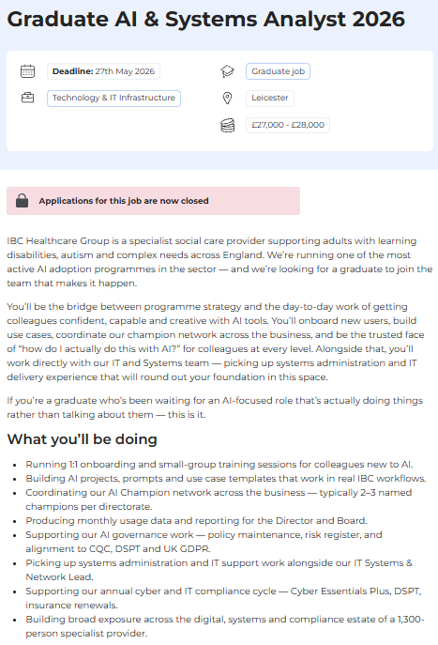

Figure 1: Graduate AI and Systems Analyst Introduction and Responsibilities (iBC Healthcare, 2026)

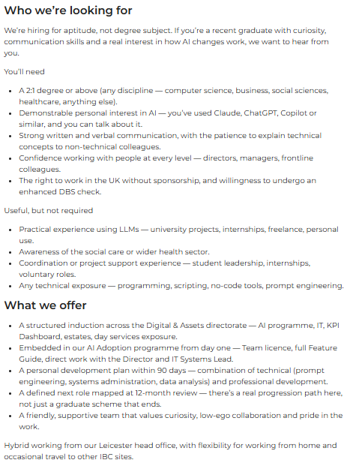

Figure 2: Graduate AI and Systems Analyst Person Specification and Benefits (iBC Healthcare, 2026)

3- Job Role Employability Skills
Employability encompasses a set of accomplishments, including skills, knowledge, and personal traits that enhance graduates' job prospects and career success, benefiting them, the workforce, and the economy (Yorke, 2006). Examining the iBC advertisement from this perspective, the candidate requirements stand out for clearly stating a preference 'for aptitude, not degree subject', which indicates that personal, transferable skills are valued just as much as technical expertise (iBC Healthcare, 2026).
The advert emphasises key skills for the role, particularly effective communication. The individual must facilitate onboarding, conduct small-group training, explain technical concepts to non-technical staff, and engage with everyone from executives to entry-level personnel. In a provider organisation with 1,300 employees, an analyst’s success depends on colleagues adapting their work practices, making clear communication essential for achieving results. Secondly, there is an expectation of technical and digital literacy, including familiarity with AI tools and data. Candidates should have a “demonstrable personal interest in AI” (iBC Healthcare, 2026) (such as using ChatGPT, Claude, or Copilot), and experience with programming or scripting is a plus. This highlights the need for the health and care workforce to improve digital skills to ensure technology enhances care (Topol, 2019). Third, the advertisement emphasises the need for organisational and analytical skills, including managing an AI Champion network, generating monthly reports for the Board, and ensuring compliance with the Care Quality Commission (CQC), the Data Security and Protection Toolkit (DSPT), and UK data protection law under the UK General Data Protection Regulation (UK GDPR). These tasks require problem-solving, time management, and ethical consideration due to the sensitivity of AI in social care. Additionally, curiosity and 'low-ego collaboration' are highlighted, aligning with the adaptability and proactivity that Fugate, Kinicki, and Ashforth (2004) define as vital for employability. Collectively, these skills will serve as my self-assessment standard in the next section.

4- Evaluating My Own Skills
To evaluate myself accurately, I employed three methods: a SWOT (Strengths, Weaknesses, Opportunities, Threats) analysis; structured reflection using Gibbs' (1988) reflective cycle based on feedback from university projects; and a comparison of my CV with the person specification. This approach was necessary because graduates often overestimate their employability skills, necessitating external feedback to correct misperceptions (Jackson, 2014). My SWOT analysis was reviewed by tutors and the careers service, while coursemates, my wider personal network and alumni provided informal feedback that challenged my initial self-assessments.
Regarding my relevant experience and qualifications, I am completing a BSc in Health and Social Care (HSC), which I expect to finish by August 2027. Several of my assessed projects align closely with the responsibilities of this role, including an analysis of Limbic Access as an AI-driven initiative in NHS mental health services; a study focused on data fragmentation and incomplete AI training datasets within HSC; and a project aimed at reducing GP appointment disparities by ethically integrating AI into the NHS App. Additionally, I had a paid programming job over a decade ago, which has given me an authentic, albeit somewhat outdated, technical background. This combination fulfils the desirable criteria outlined in the advertisement, including Large Language Model (LLM) project experience, sector knowledge, and technical experience (iBC Healthcare, 2026).
My strengths align with the job requirements. I possess ethical awareness, a mindset of continuous learning, adaptability, prior programming experience, and strong communication skills. My distinctive advantage, and the contribution I would make in practice, lies in this unique blend: I comprehend care values, safeguarding, and health disparities from my academic background, as well as how AI systems operate and malfunction from my projects. Very few candidates can effectively translate between these two areas, and Fugate, Kinicki, and Ashforth (2004) contend that it is precisely this blend of career identity and accumulated human capital that enhances a candidate's employability beyond mere qualifications.
The skills assessment highlights key areas for improvement: I need to enhance my SQL, Python, or R skills and gain practical experience with machine learning (ML) models. My limited recent experience in a care environment is also a challenge.
To address these, I plan to utilise my university's resources:
- To direct my academic research toward practical digital health challenges.
- Careers Services to find internships in technology and healthcare.
- Alumni and personal networks to connect with professionals and learn about industry tools.

5- Action Plan and Timeline
A successful strategy requires clear, quantifiable, attainable, pertinent, and time-sensitive objectives, rather than ambiguous dreams, as poorly articulated goals hinder both organisations and individuals from effectively monitoring their progress (Ogbeiwi, 2017). Bridgstock (2009) also cautions that graduates need to proactively steer their careers; thus, my strategy combines skill development with strategic industry positioning. My five-year plan consists of three distinct phases, as illustrated below.

Short Term (July 2026 – August 2027, completing my degree)
I plan to enhance my technical skills in my final year by completing a free online SQL course and a Python/R for Data Analysis course via FutureLearn or Coursera by January 2027, along with an introductory ML course by June 2027. I aim to earn certificates for each course. I will also create a professional LinkedIn profile aligned with my CV, and engage in weekly prompt engineering by documenting AI applications related to my coursework and building a small portfolio. Additionally, I intend to seek a volunteer or part-time role in a local care setting to gain at least 6 months of relevant experience before graduation. Lastly, I will attend two workshops on applications and interviews from the university's careers service.
Medium term (September 2027 – 2028)
I plan to pursue graduate positions in digital and AI within the HSC sector, including applying for this iBC pathway, with applications customised and assessed by the careers service. If I do not achieve immediate success, I will look for a role in systems, data, or project support at a care organisation to gain professional experience and complete a recognised data qualification, such as a Level 4 data analyst apprenticeship module or a Microsoft Data Fundamentals certification.
Long term (2029 – 2031)
When I secure a position, I will utilise the employer's personal development planning and any available training funding to enhance my knowledge in ML and governance. I aim to obtain a recognised qualification in information governance or cybersecurity and pursue a role in AI governance or digital transformation in social care. Consequently, the resources I need are specific: subscriptions to online courses, support from university career services and tutors, opportunities for volunteering, mentoring from alumni, and eventually, professional development funded by my employer. I will assess this plan every six months using Gibbs' (1988) cycle, ensuring that my reflections consistently inform my actions.

6- Building My Personal Brand
Personal branding has become an important concept in career and management research, as changing job markets demand that individuals take control of their career trajectories (Gorbatov, Khapova and Lysova, 2018). I will focus my personal brand on a unified message: a health and social care graduate committed to ensuring AI is safe, ethical, and practical.
LinkedIn will serve as my main platform, featuring a profile that aligns perfectly with my CV and a headline that communicates this branding. I plan to share brief posts summarising my three university projects, Limbic Access, AI training set fragmentation, and ethical AI integration in the NHS App, as case studies that showcase both my industry expertise and technical knowledge, along with concise articles about trends in digital health. This approach will be supported by a straightforward personal website that will showcase a collection of my AI use cases, project summaries, and certificates as I earn them, providing potential employers with a more comprehensive perspective than a CV alone can offer.
Maintaining consistency across these channels is more important than sheer volume: each post, article, and portfolio entry will reinforce the same personal brand, ensuring that by the time I seek positions like the iBC analyst role, an employer searching my name will find cohesive evidence of precisely the skills and qualities outlined in the job listing.

7- Promoting My Professional Identity
Effectively communicating my abilities, experience, and academic projects to prospective employers requires a clear, professional approach. My main tools are a tailored CV and cover letter (see Appendix A and Appendix B). For the iBC analyst position, my CV will highlight my health and social care degree with a focus on AI, hands-on LLM experience, a previous programming job, volunteer work in the care sector, and qualifications in SQL, Python/R, and ML as I earn them. The cover letter (Appendix B) will directly correspond with the person specification, offering concrete examples for each essential criterion, as employers typically assess fit based on the specification rather than a generic profile (refer to Figure 2; iBC Healthcare, 2026). LinkedIn will support and mirror this positioning, sharing overviews of my academic projects and brief articles on digital health advancements. Finally, I will develop a two-minute verbal 'elevator pitch' that conveys my unique selling proposition for careers fairs and interviews.

8- Building a Network for Successful Employment
Networking is essential for a sustainable career in health and social care. It provides access to mentorship, career-relevant information, and hidden job opportunities, and has been shown to support both visibility and career advancement (Forret and Dougherty, 2004). In a qualitative study involving 18 alumni, English et al. (2021) discovered that professional networks were established through four primary mechanisms: work-integrated learning, social media, engagement with university staff, and volunteering. This evidence was gathered directly from the graduates, rather than relying on institutional assumptions. In a values-driven sector where trust is essential, I have built my plan around these same mechanisms.
Staff and Alumni Involvement
I will connect with university tutors and, through the alumni network, professionals working in digital health or social care technology, aiming for two mentoring conversations each term.
Social Media Connectedness
I will actively engage with organisations such as Skills for Care and the Digital Care Hub on LinkedIn, contributing to discussions rather than only consuming content.
Work-Integrated Learning, Volunteering and Professional Events
I will treat my planned volunteering placement as a networking opportunity in its own right, and will attend digital health conferences, AI workshops, and events run by bodies such as the British Computer Society (BCS), the Faculty of Clinical Informatics, and NHS digital transformation programmes, aiming for at least two sector events per year and to make and follow up two new contacts at each one.
Together, these strategies will help me create a visible, endorsed professional identity.

9- Conclusion
This report has examined the Graduate AI & Systems Analyst position at iBC Healthcare and consistently argued that my hybrid profile positions me as a credible candidate for the future. The position requires effective communication, proficiency in AI and digital tools, organisational skills, awareness of ethical governance, and adaptability (iBC Healthcare, 2026), all of which mirror the broader digital transformation occurring within the care workforce (Topol, 2019). My self-assessment includes honest evaluations with tutor and peer feedback to avoid common overconfidence seen in graduates (Jackson, 2014), demonstrating a strong alignment in ethics, communication, resilience, and AI knowledge specific to the sector, while also highlighting areas where I lack current programming skills, ML understanding, and recent professional experience. My organised action plan (Ogbeiwi, 2017) addresses these shortcomings through clearly defined phases before and after my graduation in August 2027, leveraging specific resources such as online courses, volunteering opportunities, career services, and mentoring. Lastly, my strategy for personal branding and networking ensures that these skills are evident to employers through a well-curated LinkedIn profile, a customised CV, and proactive engagement within the industry (Gorbatov, Khapova and Lysova, 2018; English et al., 2021). I remain highly motivated to pursue this position, as it aligns with my values, education, and technical curiosity, and this plan provides a realistic, evidence-based pathway to attain it.

10- References
Bridgstock, R. (2009) 'The graduate attributes we’ve overlooked: Enhancing graduate employability through career management skills', Higher Education Research & Development, 28(1), pp.31-44. Available at: https://doi.org/10.1080/07294360802444347.
Dacre Pool, L. and Sewell, P. (2007) 'The key to employability: developing a practical model of graduate employability', Education + Training, 49(4), pp.277-289. Available at: https://doi.org/10.1108/00400910710754435.
English, P., de Villiers Scheepers, M.J., Fleischman, D., Burgess, J. and Crimmins, G. (2021) 'Developing professional networks: the missing link to graduate employability', Education + Training, 63(4), pp.647-661. Available at: https://doi.org/10.1108/ET-10-2020-0309.
Forret, M.L. and Dougherty, T.W. (2004) 'Networking behaviours and career outcomes: Differences for men and women?', Journal of Organizational Behavior, 25(3), pp. 419–437. Available at: https://doi.org/10.1002/job.253.
Fugate, M., Kinicki, A.J. and Ashforth, B.E. (2004) 'Employability: A psycho-social construct, its dimensions, and applications', Journal of Vocational Behavior, 65(1), pp.14-38. Available at: https://doi.org/10.1016/j.jvb.2003.10.005.
Gibbs, G. (1988) Learning by doing: a guide to teaching and learning methods. Oxford: Further Education Unit, Oxford Polytechnic.
Gorbatov, S., Khapova, S.N. and Lysova, E.I. (2018) 'Personal branding: Interdisciplinary systematic review and research agenda', Frontiers in Psychology, 9, p.2238. Available at: https://doi.org/10.3389/fpsyg.2018.02238.
iBC Healthcare (2026) Graduate AI & Systems Analyst 2026. Available at: https://www.brightnetwork.co.uk/graduate-jobs/ibc-healthcare/graduate-ai-systems-analyst-leicester-2026-ah48 (Accessed: 05 July 2026).
Jackson, D. (2014) 'Testing a model of undergraduate competence in employability skills and its implications for stakeholders', Journal of Education and Work, 27(2), pp. 220–242. Available at: https://doi.org/10.1080/13639080.2012.718750.
NHS England (2023) 4.2 Specialist artificial intelligence (AI) skills within the NHS. Available at: https://digital-transformation.hee.nhs.uk/support-for-organisations/research-and-publications/dart-ed/horizon-scanning/developing-healthcare-workers-confidence-in-ai/chapter-4-workforce-transformation/specialist-ai-skills-within-the-nhs (Accessed: 07 July 2026).
Ogbeiwi, O. (2017) 'Why written objectives need to be really SMART', British Journal of Healthcare Management, 23(7), pp.324-336. Available at: https://doi.org/10.12968/bjhc.2017.23.7.324.
Topol, E. (2019) The Topol Review: preparing the healthcare workforce to deliver the digital future. Health Education England. Available at: https://topol.hee.nhs.uk/ (Accessed: 05 July 2026).
Yorke, M. (2006) Employability in higher education: what it is – what it is not. York: The Higher Education Academy.

11- Appendix

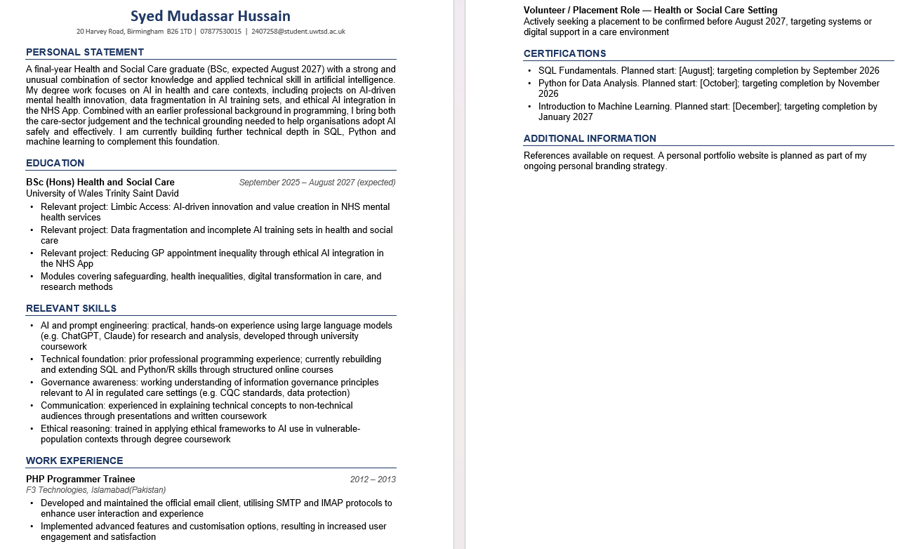
Appendix A: Curriculum Vitae

Appendix B: Cover Letter


