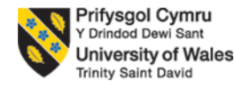

Student name: Yetunde Onasanya
Student ID: 1905364
Module Name: Living with Care: The Older Person
Module code: BMHP6009
Lecturer name: Edward Goka
Assessment 2: Supporting Paper

Table of Contents

Introduction………………………………………………………..3
Evaluation on Points ………….…………….…….….………….3
Standpoints ………………………………….…………….……...4
Support and Services …………...……………………….……...4
Covid-19 and the Elderly ………………….…………….………4
Recommendations…………………..……………………………4
References……………………………...………………………….5
Appendix..………………………...…………………………..……6

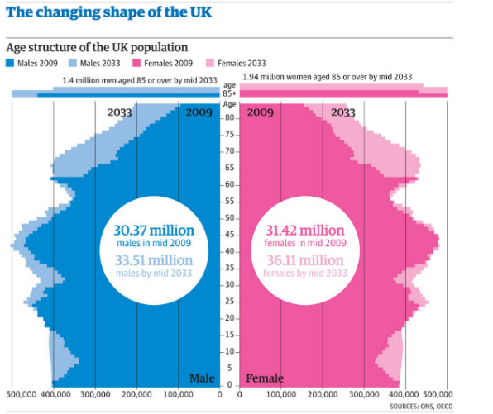
Introduction
This report discusses the magnitude of how the ageing population pose challenges for the health and social care system. This demographic image showing the continuously growing UK population shows that with 19% of the population over the age of 65 according to the UK demographic, if nothing is done to ease the pressure off health and social care systems particularly economically wise, such system may no longer be able to withstand the burden of the ever-growing need for elderly support.
Evaluation on Points
The first main point discussed in the group is the heavy demands that the ageing population place on the healthcare system which leads to rising health costs. As people are living longer with 8.5% of the population aged 65 and over, (NIH, 2015) demands for health care services to support the elderly are continuously growing as more and more members of the elderly need attentive care. According to Guardian, healthcare costs rise 2% each year as a result of people staying alive and growing older. This is due to the fact that the ageing population increases as people are living longer and therefore more support is required through services such as ambulatory care, hospital services, nursing home services and home healthcare is consumed a lot more by older adults’ than they are by younger adults. The elderly also often need help at home with activities of daily living for example taking baths and buying groceries and this puts more pressure on health and social care systems that offer such resources like domiciliary care.
Another point against ageing population putting pressure on the healthcare system is staff shortages. Staff shortages mean that there is not enough staff to cater to service needs and this applies particularly upon the coronavirus pandemic where 60,000 workers face being sacked for refusing the Covid vaccine, (Siddle, 2021). The rapid aging of populations presents the challenge of labour-force shortages due to the increase in need for staff, (E. Bloom, Canning and Lubet, 2015). Staff shortages in care homes has also become a regular occurrence since the pandemic and care homes are facing the most acute short staffing across the healthcare systems with there being 170,000 vacancies for care home roles last month alone according to the National Care Association, (Guardian, 2021).
A third main point is the loneliness in the ageing population. Loneliness is a crucial issue among the elderly and accompanied by isolation affects millions of older people daily. According to Age UK over 2 million people over the age of 75 are experiencing loneliness as a result of the loss of loved ones, financial issues, status, illness or their children moving on or away, (Age UK, 2018). Studies show that 50% of people aged over 60 are at risk of social isolation and 33% of older people will experience some degree of loneliness later in life, (Fakoya, McCorry and Donnelly, 2020). Despite the services available to fight against this, as more and more older people require support to combat their experiences of isolation health and social care workers can become pressured due to the overwhelming need for such services.

Standpoints
My standpoint in this debate is that the ageing population is putting pressure on and affecting healthcare systems and healthcare workers. Other views surrounding this topic contradict this and suggest that the ageing population is not the sole cause for the increase in demand and pressure for healthcare services and that healthcare workers have such jobs for a reason and are therefore aware of the hardships that may be faced when working with the elderly. My colleagues also argue there are sufficient number of volunteers that offer support for the elderly to lessen the burden on healthcare services. Despite this, according to statistics volunteering fails to appeal to men and younger people and charities continue to reach out and desperately recruit members that are willing to support the elderly without pay, (Corry, 2014). The other group also argued over the fact that paying tax already goes towards the necessary support needed to look after the elderly, however income tax is not paid on pensions and therefore the elderly themselves are not paying this tax, but this comes out of younger workers. Research shows that a higher percentage of working population of supporting the growing needs of the ageing population in social care, healthcare and pensions.
Support and Services
An example of current government support that is available in place to support the UK elderly population is befriending services. These services are offered by charities supporting the elderly such as The Silver Line and are readily made available to the public via helplines and webchats every day of the year. This is to offer daily support for older people that have been negatively affected by loneliness and merely having someone to conversate with on a regular basis is a form of support used to improve their mental health and overall wellbeing leading to a better quality of life. Such charities also offer community outings, clubs and trips dedicated to the elderly and bringing these members together to help reduce the time they spend isolated. Phone call services are also offered by the NHS to help tackle the issue of loneliness. Independent Age is another organisation that offers befriending services which matches older people and organises regular coffee and chat drop ins. Another organisation is the Royal Voluntary Service that allows volunteers to help older people with small daily tasks such as going grocery shopping and helping to deliver meals. Age UK is a well-known organisation that has local branches across the country that offers a range of services to support the elderly such as an ‘active buddy’ who’s job is to help an older person become more physically active and also befriending services, (NHS, 2021).
COVID-19 and the Elderly
Covid-19 has had its impact on the elderly and of course services. An example of this is what has been stated previously which was the shortage of staff that came as a result of the pandemic and the many jobs and lives that were lost as a result of the disease. The Covid-19 jab has become mandate for those working in residential care homes which has also caused a number of care workers to reside and therefore adding to the shortage of staff, (Hunt, 2021). Covid-19 has had an impact on the elderly as older people face significant risk of developing severe illness upon contracting coronavirus due to physiological changes that accompany ageing and potential underlying health conditions such as high blood pressure and Alzheimer’s. Because of such problems, older people are very susceptible to contracting the disease and labelled as vulnerable alongside infants. During these times of isolation as a result of having to quarantine and shield, older people need safe access to nutritious food, basic supplies, money, medicine to support their physical health, and social care. At this time older people are most at threat and therefore require even closer attention and care than previously which increases the strain placed on the healthcare system, (WHO, 2020).
Recommendations
In conclusion, recommendations to release the pressure of healthcare workers supporting the elderly is by improving befriending services by creating more community areas for the elderly to gather and enjoy each other’s company. This is because loneliness is one of the biggest issues amongst the elderly in today’s ageing population. Another recommendation would be to provide healthcare workers with the support for the pressure they receive for example and healthcare worker grant or loan from the government.

References
Age UK (2018). Loneliness research and impact. [online] Ageuk.org.uk. Available at: https://www.ageuk.org.uk/our-impact/policy-research/loneliness-research-and-resources/.
Corry, D. (2014). Vintage volunteers: can charities keep attracting an ageing population? [online] the Guardian. Available at: https://www.theguardian.com/voluntary-sector-network/2014/aug/15/can-charities-keep-attracting-ageing-population [Accessed 10 Dec. 2021].
E. Bloom, D., Canning, D. and Lubet, A. (2015). Global Population Aging: Facts, Challenges, Solutions & Perspectives. [online] American Academy of Arts & Sciences. Available at: https://www.amacad.org/publication/global-population-aging-facts-challenges-solutions-perspectives.
Fakoya, O.A., McCorry, N.K. and Donnelly, M. (2020). Loneliness and social isolation interventions for older adults: a scoping review of reviews. BMC Public Health, [online] 20(1). Available at: https://bmcpublichealth.biomedcentral.com/articles/10.1186/s12889-020-8251-6.
Hunt, T. (2021). Care homes: why mandatory vaccination could make staff shortages worse. [online] The Conversation. Available at: https://theconversation.com/care-homes-why-mandatory-vaccination-could-make-staff-shortages-worse-170988 [Accessed 9 Dec. 2021].
NHS (2021). Loneliness in the elderly: how to help. [online] nhs.uk. Available at: https://www.nhs.uk/mental-health/advice-for-life-situations-and-events/loneliness-in-the-elderly/.
NIH (2015). World’s older population grows dramatically. [online] National Institute on Aging. Available at: https://www.nia.nih.gov/news/worlds-older-population-grows-dramatically#:~:text=The%20world [Accessed 9 Dec. 2021].
Siddle, J. (2021). More than 95% of care workers say homes hit by staff shortages. [online] mirror. Available at: https://www.mirror.co.uk/news/uk-news/over-95-care-homes-hit-25396294.
The Guardian (2021). UK care homes: how are staff shortages affecting you. [online] the Guardian. Available at: https://www.theguardian.com/society/2021/oct/12/uk-care-home-staff-how-are-labour-shortages-affecting-you.
WHO (2020). Supporting older people during the COVID-19 pandemic is everyone’s business. [online] www.euro.who.int. Available at: https://www.euro.who.int/en/health-topics/health-emergencies/coronavirus-covid-19/news/news/2020/4/supporting-older-people-during-the-covid-19-pandemic-is-everyones-business#:~:text=Support%20for%20older%20people%2C.

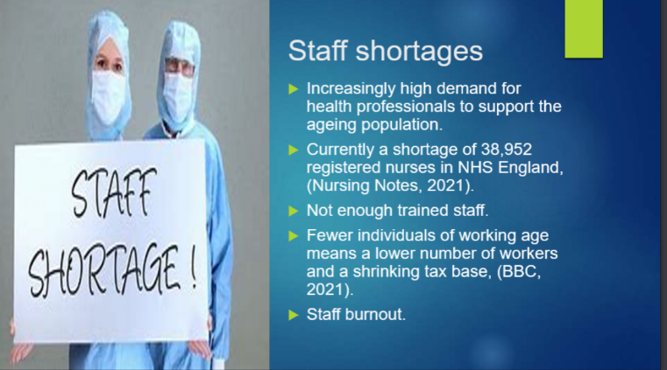
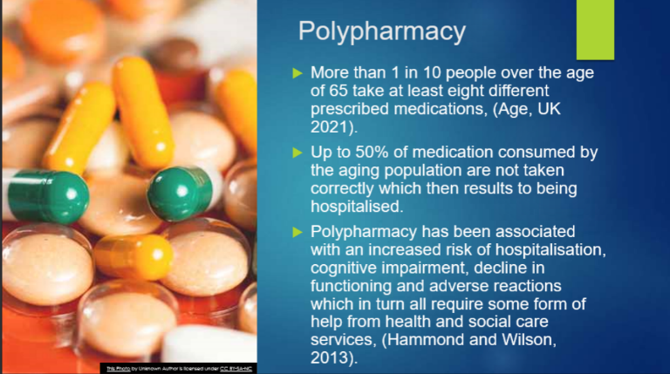
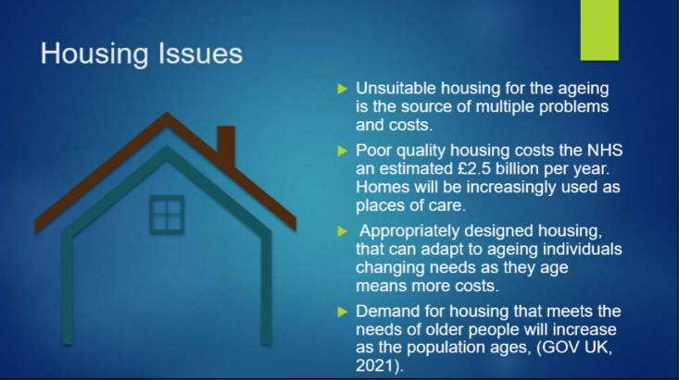
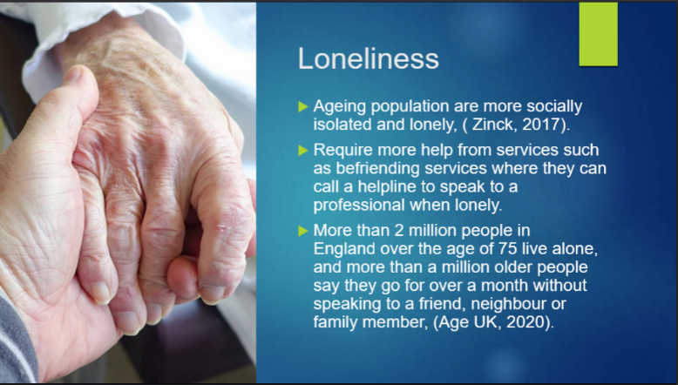
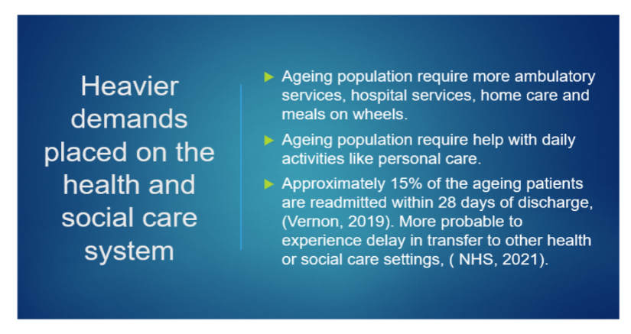
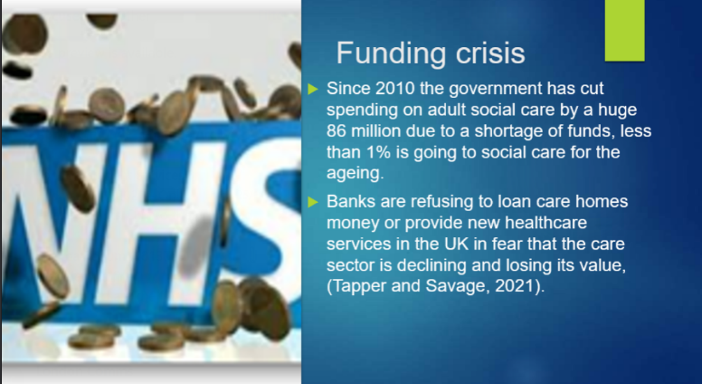
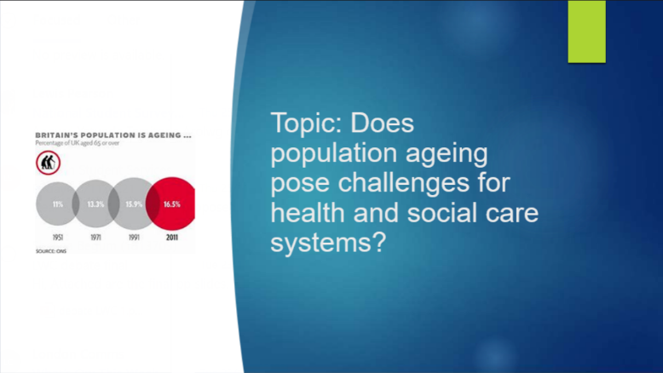

Appendix



