

Early years Practitioners Handbook
Transitions in Children from Early Years


Content Page
- Transition
- The Needs of the Child
- The role of the Adult
- Partnership
- Interventions
- Proposed Outcomes
- Reference list

Transition
When a child’s goes through life from Nursery to college there are many transitions they will have to overcome, from leaving their parents to changing classes - these will be milestone events for the children which will have definite effect on their development’, Early Years Matters (2018). The child will experience different emotions and barriers every time they will move through different transitions. Every child that starts a nursery setting, and also their parents, they will be faced with new environments and also new experiences. A child will run through a mixture of emotions – from feeling confident, to shy and intimidated.
According to the Early Years Matters (2020) and Pacey (2016) transition should be a journey that the child, parents and the practitioners process together and when everyone works together then the transition can be smooth as possible for all that is involved.
Children will face different types of transitions in life this could be home and school.
See below for some examples:
Care and Education (Kirkless, 2013)
- Leaving mum and dad and going to Nursery
- Nursery to Reception
- Reception to year one
Environmental Change (PACEY, 2016)
- New baby
- Parents separating
- Moving House
- Bereavement

Parents also should be assured that most children will stop crying after they have settled but most nurseries have an open door policy whereby if they do not settle the parents will be contacted in order to try different resolutions. An open door policy is a good thing in order to be proactive in keeping up to date with the child’s progress, as well as settling the child in.
Communication is very important with the parents and they should have the confidence in the practitioners. Settling in periods can be very flexible and individual needs of the child and parents should be taken in account. Every setting has a settling in procedure and policy, and this can be shared with the parents before the child starts.
As we work as early Years Practitioners we play a big part in the child’s development and also it’s up to us as professionals to provide the best ever transition experiences for the child that is starting the nursery for the first time and also for the parents.
To allow the Transition to be successful the welsh Government (2017) will:
- allow plenty of time – Practitioners should recognize that each child will adjust in their own way.
- Consider the circumstances – of each individual family, support and involvement will be different with every family.
- Be inclusive – Make all families feel welcome and we do not judge anyone.

The Needs of the Child
When a child is about to start Nursery attachment can be very hard as this is the first time the child has left their mother. The baby will recognize how nurture and care provides a loving a supportive environment and this will help them when they will start being a dependent infant.
Every child’s needs must be meet as every child is an individual and so are they needs practitioners will get to know the child and what their needs are. When working with children communication plays a big part and it will be a key in building a successful relationship with the child. There are many barriers where communication may be difficult, for example nonverbal, anxious, scared or just overwhelmed .Practitioners are trained to deal with children and recognize when a child is anxious and recognize signals and techniques to alleviate concerns.
Observations and assessments will be carried out by the practitioner this will enable them to see what stage the child is at. This can be done in a formal capacity and in an informal capacity. These could be visual, recorded or written observations and assessments, and this will help with the processes if the children need further support if needed, the observation and assessment will support any referrals you make to other and outer agencies with childcare.
Development is very important in the early years as children’s brains are very much like sponges. A holistic view of a child and their development is good practice. When you are working with children everyone needs to consider all the children, all their different needs in their development, all practitioners should and need to be aware of an array of different theories and theorists and their research to help them with supporting the children in their development, and that they have informed modern society and practice (Lindon, 2010).

Maslow’s theory (TES, 2019) suggests that to achieve full potential or self-actualization, a human must have their basic needs met as this will help them move on and achieve the requirements they need to move on.
This is shown on the pyramid below
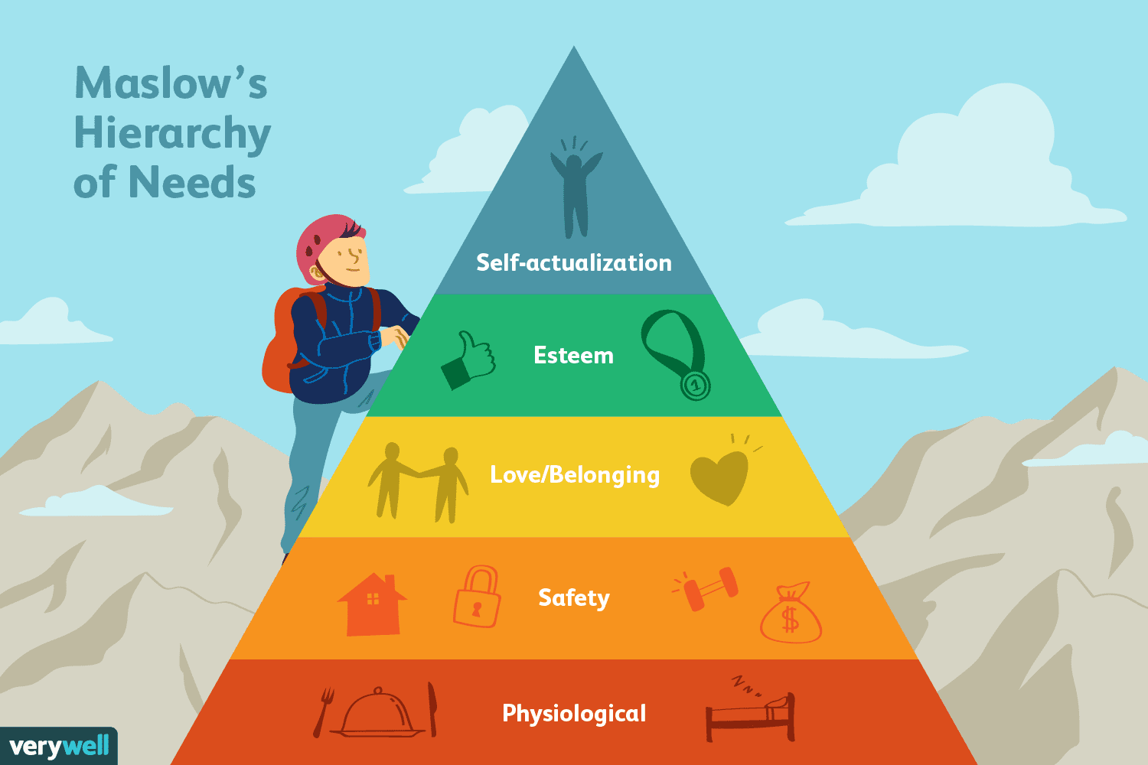

In wales the New Curriculum was implemented by the welsh Government (2020) and in the document it states schools should support children for them to develop into confident and capable learners. Also Welsh Government reiterate that practitioners role is to identify if any has individual needs and that these are responded on a daily basis.
Practitioners will create a process when transiting takes place and this will build on their familiarity, consistency and routine. While the child then will be observed this will help us plan for and incorporate their interests. Article 12 of the UNCRC Regarding the voice of the child states that the child’s views and feelings must be considered (UNCIEF, 2019).
When working with children we must remember that ‘we are all unique’ and in all part of the transition process needs of the child and family members must be taken in to consideration, and they are dealt in a flexible and sensitive way (welsh government, 2017).

Play
It is very important that we promote and encourage that children begin their active lives through play, giving the children the opportunity to play outdoors as much as they can will give them the easiest and natural way for the child to engage in the necessary levels of physical activity.
Children will use play and this will help them develop a methodical, systematic and logical collection information through their senses and movement.
The (EYFS) states that as practitioners we support children’s schematic play patterns we can build on the individual interests.
When a child shows patterns of repeated behavior and this will allow them to explore and express developing ideas and all this through their play and exploration this is known as the (Schemas).
Guidelines in Start Active, Stay active for children under 5 years old are:
- Physical activity should be encouraged from birth
- Children of pre -school age should be active daily for 180 min throughout the day.
- All under-five’s should minimize the amount of time spent being sedentary.
The welsh governments policy on play states below
• Play is so critically important to all children in the development of their physical, social, mental, emotional and creative skills that society should seek every opportunity to support it and create an environment that fosters it. Decision making at all levels of government should include a consideration of the impact of those decisions, on children’s opportunities to play (Welsh Government).

The Role of the Adult
When a child is born they will form a bond with their mother this is known as attachment. It is very important that the practitioners and parents develop a trusting and good relationship and effective communication is key as it is highlighted in the common Core Skills and Knowledge for children’s workforce (Children’s Workforce Development Council – CWDC, 2010).
When the child starts Nursery they will have to build a bond and trust with unfamiliar people, Early Years Practitioners must be fully aware of all the skills and of course Knowledge for them to be successful in their role.
Practitioners must take the below in to consideration when working with children.
Taking time to get to know the child that will help them to understand what the child likes and dislikes then the child will trust the practitioner and a attachment will be formed as mentioned in Bowlby’s attachment theory (Van Rosmalen, L. Van der, horst, F. and van der veer,R. 2016)
At Nursery Clear information is important between the practitioners and families, in settings Newsletters, noticeboards and also a app on the parents phone and verbal conversation is important and keeps everyone up to date.
All childcare practitioner should be fully aware how and why their role is important and ensuring the transition will go as smooth as possible for everyone involved. When a child is happy and feels welcome with you they will go home with a positive approach.
The management has responsibility to ensure that the policies and procedures are in place and that the National Minimum standards are met and that all staff are kept up to date with the regulations. All settings are required by the CIW to follow the National Minimum Standards. This is a comprehensive set of mandatory guidelines which must be followed and applied (Care Inspectorate Wales 2016).
It is the practitioners responsibility that to ensure that the transition to nursery and leaving the parent and everything is put in place to make it as trouble free as possible. All children will be at the top of any decision making that is made on their behalf. All children need to be valued and they need to feel safe and secure this will develop if communication is maintained. When you are working with children it is important that you are a good role model you can demonstrate by showing respect, showing kindness using the appropriate language and showing kindness.
Bruner believed that, according to Lindon (2010), a child’s learning and development could be directly affected by an adult’s positive intervention.

Partnership
When working in childcare you may find in some occasion that you will be working in partnership with variety of other agencies, including the parents, this will allow interventions that can make a difference to the child’s development. During transitions the child will be at the Centre of the process you will have to understand that their world and routines will be changing and that they will be spending a lot of time with you and your setting. It is very important that you establish a strong links with all parties that are involved and this will result in appositive transition.
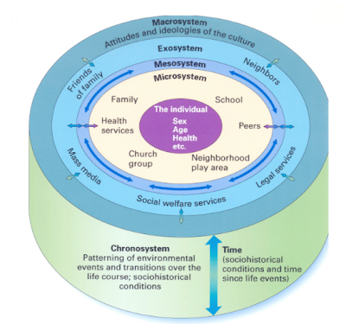

It is important that the parents and nursery have a strong link as this will have appositive effect on the child’s well – being, according to Bronfenbrenner’s model (Ashiabi and O’neal, 2015) which positively influences their cognitive development .
Its important that you gain as much information from the parents about the child before they start the setting as this will make the transition easier for everyone involved in. Practitioners should give as much information about the setting and how the process in an email as the family will have time to feel prepared Further more on the settling in day More information will be given and explained about the Daily routines.
Within a nursery setting formal and informal observations are carried out any additional support or provision needed for the children is put in place. All settings work with Multi agencies so that effected practice and support can be carried out in a practical way jones et al,(2008).
Interventions
In our setting we work closely with the parents and our aim is to maintain close links with the Families, Interventions have been implemented these are all aimed at building and liaising with the Families.
Nursery Visit
When a parent shows an interest in the Nursery we recommend that they come and visit the Nursery as they can view the setting and meet the staff.

Welcome pack
All our Families will be given a welcome pack, the pack will have all the necessary forms that need to be completed before the child starts. In the forms this will a opportunity for the parents to give all details about the child.
- Any Allergies
- Daily Routine / Sleep pattern
- Health issues
- Any comforters
- All about me form
All this information that we will be given will give us a insight of the child and their routine.

Settling in sessions
Before the child is due to start the nursery we will advice that they have to sessions which we call settling in, We encourage the parents to leave the child at the nursery. The parents are welcome to stay in the office or outside the building for their reassurance that the child has settled. Parents will be provided with Photographs of the child in their settling in session. Settling in sessions are time for information sharing about the child and the most important people in that child’s life(Collins, 2010, p23)
Handovers
In the Nursery the parents can access a app on their phone called the Eylog which pictures is shared with parents throughout the day, and the end of the day all information will be sent out to parents in regard of what the child has ate, slept and done. Also the parents can discuss with the practitioner face to face on how the child has been throughout the day.
Proposed Outcomes
As everything has been put in place for transition and everyone worked in Partnership you have created a safe, secure and a nurturing environment. Then the children are settled and happy they will be able to build relationship and be more curious and confident and also understand their daily routine. They will begin to develop relationships, with other children and other staff they will also to show in understanding of the environment and they be able to explore the surroundings independently.

Reference Lists

