Student Name: Daniel Newman
Student Number: 1702330
Module: Application Development
Module Code: ACCA5012
Lecturer: Kemi Ademoye

Table of Contents:

Introduction …………………………………………………………………….. Page 3
Website Design Principles: ……………………………………………….. Page 3
Usability and User Experience: …………………………………………. Page 4
Requirements: ………………………………………………………………….. Page 4
Design: ……………………………………………………………………………… Page 5
Implementation: ………………………………………………………………. Page 6
Evaluation: ……………………………………………………………………….. Page 20
References: ………………………………………………………………………. Page 21

Introduction
In this assignment the author will show a variety of applied skills in HTML, CSS and JavaScript. The author has researched website design principles as well as the concepts of usability and user experience. The author has also implemented these design principles in the creation of a website and report detailing how these design principles have helped develop the website.

Website Design Principles
To make a successfully designed website it must be designed with the core design principles in mind. ShortieDesigns [1] narrows these design principles down to 10 major points. These design principles are Purpose, Communication, Typefaces, Colours, Images, Navigation, Grid Based Layouts, “F” pattern design, Load Time and Mobile Friendly.
Purpose refers to the use of the website. The website’s pages should have a reason for existing rather than existing for no real reason. For example, if the users are coming to a website that sells items, the website should have a page where purchasing those items is possible.
Communication refers to how the message of the website is displayed. This point basically refers to the layout of the website as it means that the information should be easy to find. Using bold headings that summarise what that section of content is about helps the user find exactly what they are looking for sooner. It helps make the website concise and less frustrating to use.
Typefaces refers to which fonts are most common and easier to read online. Arial and Verdana are the most common fonts used online as they’re very basic and not complicated whereas some other fonts might be harder to read for some users.
The colours used in a website should complement each other and the branding of the business or persons that run the website. As an extension of colours complementing each other they should also have contrast between them, this is because darker colours stand forward in frame whilst lighter colours exist in the background [2].
Images should be used effectively. The use of graphics in a website helps engage the audience with what they are being presented with. But when using images online they should always be relevant and to help display the writer’s point or to set a scene within the website. When using images online a few things to consider is firstly the use of alternative text that helps to summarise your image, if an image is not loading then it will display that text instead, alternate text will help convey an images message if it did not appear. Images should also resize depending on the size of the screen it is being displayed on, if this was not done correctly then a user would not see the full image when on a mobile device. [3]
The navigation of a website is essential to ensuring that the website is easy to use for the user. It’s a common assumption that users will give up on a website if they have to click on any links on the website any more than three times in order to find what they are looking for. An easy way to prevent this is to have a navigation bar on the top of the screen which would link to pages where more navigation links are available.
Using a grid based layout on a website is a good way to structure a website with more and better looking content. It also helps make a website more responsive on more devices. If a website uses a grid based system it makes the website seem more trustworthy because it looks more professional, whereas a simpler looking website looks less professional and poorly strung together. [4]
An “F” pattern design is how the user reads the website. Most users would first begin by looking at the options on the navigation bar then returning to the starting location, then they would look left to right at the first part of content. The user would repeat the process of looking down then left to right to navigate a single page. [5] The reason this design principle is important is because it is based off mapping the important content within the areas that the user is likely to pay more attention to.
Load Times refers to how quickly the webpage takes to load. Some ways to improve load time would be to place content within a CSS or JavaScript file so that some code can be shared between pages. As well as this images can be combined, for example a large image of social media icons which can be mapped to show only one specific section of the image, this would mean that the website would only have to load the one image to display many images. [6]
Arguably, one of the most important design principles is that a website should be mobile friendly. According to Business Insider [7], in 2017 75% of the world’s population uses mobile phones, this means that the potential of a user accessing a website by mobile browser is incredibly likely. Typically modern websites should be designed with a mobile-first approach, the website should be simplified to fit the screen and be responsive enough to fit everything on the page and still look as good as the website would look on browser. [8]

Usability and User Experience
Usability refers to how easy the website is to use and learn to the user. Typically, a website should not require much learning and should be fairly intuitive in its design so that the user can just jump in and use the website with no confusion. User experience on the other hand is the value and feeling the website gives the user. User Experience is altered by the user’s interaction with the website and how the user’s needs are met within the website. [9] Though Usability and User Experience are two different things, they both complement each other, as if the website is easy to use and intuitive then the user experience will be heightened because the user will have enjoyed using the website more as they had less issues with it. [10]

Requirements
The website produced is about a campaign of Dungeons and Dragons that the author experienced with his friends as a hobby. The website serves as a wiki styled experience where a user can find out information on the story that took place in the game as well as the main eight characters that were created for the game. The website will have a home page, a page with details of the story, a character selection screen, separate pages dedicated to each of the eight characters as well as an about the author page. Its target audience is mainly for people who play Dungeons and Dragons and want inspiration for story and characters that they can include in their own games, any fan of the board game can find something to take inspiration from in this site.
A requirement of the website is to be responsive and one of the means of creating a responsive website is the use of breakpoints. Certain aspects of the website will be dictated by a media query to change the size of an image or banner once the screen is altered to a certain size. Other sections of the website will be using a grid system with bootstrap to change the amount of space each element takes up of the screen depending on the device viewing it. Additionally the viewport setting will be set to “device-width” which will change the width of the website based on the screen size viewing it.
The website must be responsive on mobile devices. The website must be tested at many screen sizes so that it is functional on many different screens. The website’s colours should contrast well to have a good aesthetic feel to it. The website should be easy to navigate and also should use the bootstrap grid layout to format elements correctly. Finally the website must provide a good user experience by using the core design and usability conventions.

Design
The author has made efforts to ensure that the website follows the Design Principles from Task 1. The website has a main purpose, it gives information to the reader and does that well. There are not any web pages that don’t have a main purpose in the website.
The website follows the previously mentioned communication aspect of design principles as every section of text has a title to clearly define what is going to be there. As well as this, the website’s links are easy to understand and the user would likely know what each link would do.
In terms of typefaces, the most common ones are used in the website. Styles have also been used to set some titles to uppercase text. This helped indicate important choices within the website.
The colours chosen for the website are dark red and white. Additional colour is added to the website through the use of images rather than having a third main colour on the website. The dark red is the darker colour so that it stands out and feels closer than the rest of the content. The white is the lighter colour and so it acts as the main background. The colours contrast and complement each other well.
The navigation of the website is simple. Every section of the website is accessible from every page as every link is accessible on the footer. This follows the 3 step rule as every page takes a minimum of one click to get to.
The website uses grid based layouts to place some of its content together and to help make the website responsive.
Load Times are not a big issue on the website. The characters of the website have individual pages dedicated to them and as a result a page didn’t need to be made with all of that information on it which would result in a long load time for that page.
The website is mobile friendly, images and text scale to fit the website and also the navigation bar turns into a button to display that information.

Implementation
In this section of the report the author has included screenshots of some classes, script and functions the website has and has explained what each does. As well as screenshots of the full website.
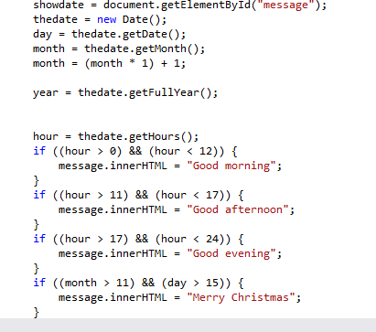
This JavaScript function uses the devices built in clock to determine the time of day to display either “Good Morning”, “Good Afternoon” or “Good Evening” and also checks if the day is December 25th to determine whether to display “Merry Christmas”.
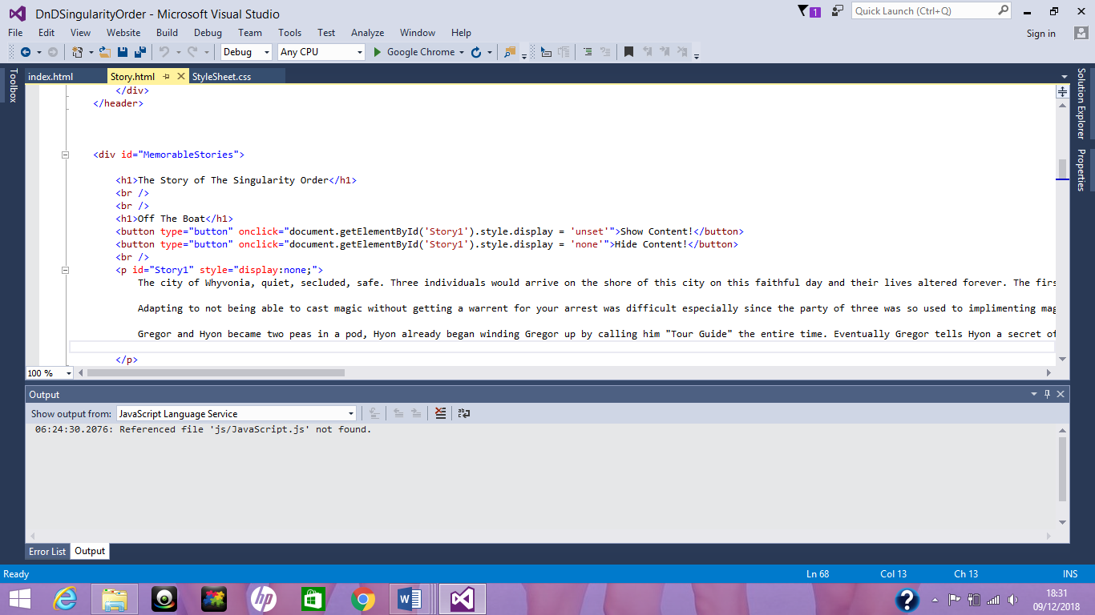
This line of JavaScript activates when a button gets clicked. When the “Show Content” button is pressed it changes the CSS so that it displays the content. When “Hide Content” is pressed it sets the display of the content to none.

See example

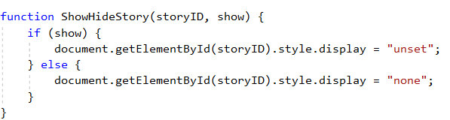

Screenshots
Page 1 - Home Page
This page is the home page of the website. Its purpose is to introduce the website’s contents.
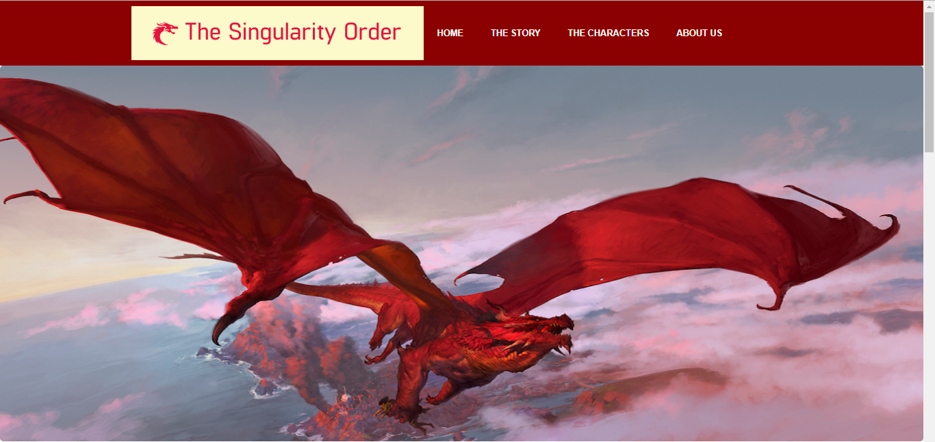
The time of day JavaScript can be seen in the text below. “Good Evening”.
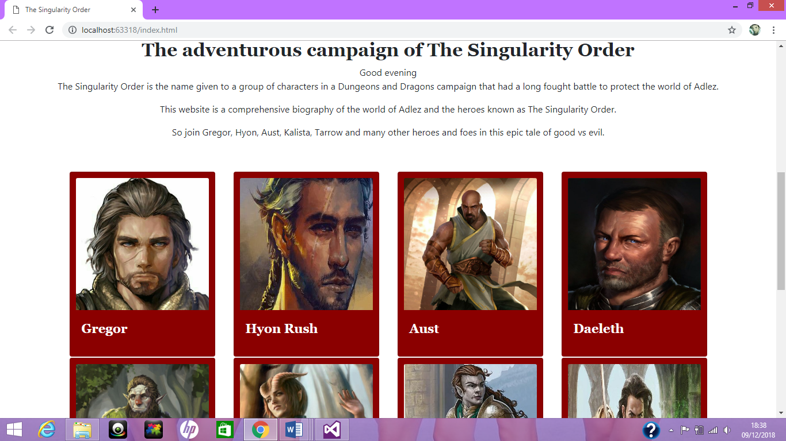
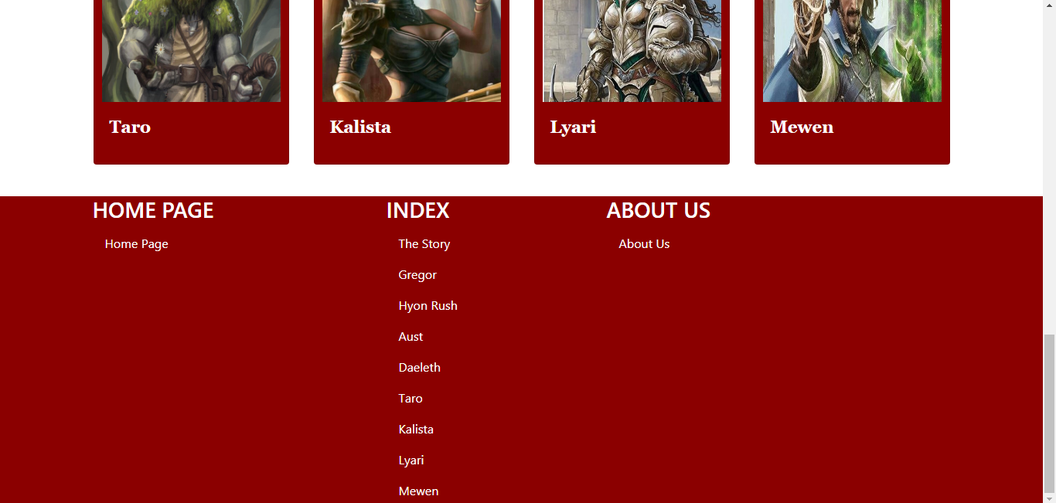

Page 2 – The Story
This page is to tell memorable events of the story of the board game. Following two screenshots display the Hide/Show content JavaScript working.
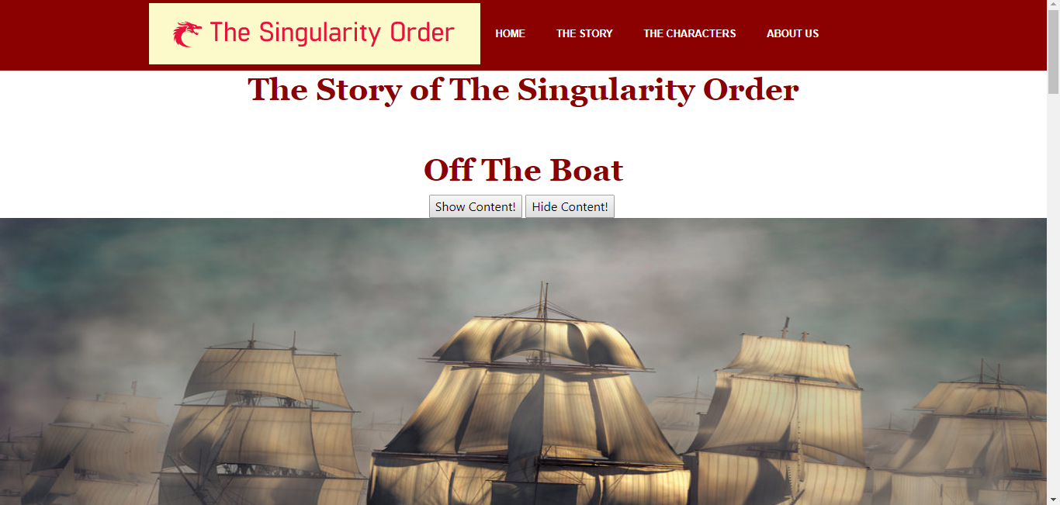
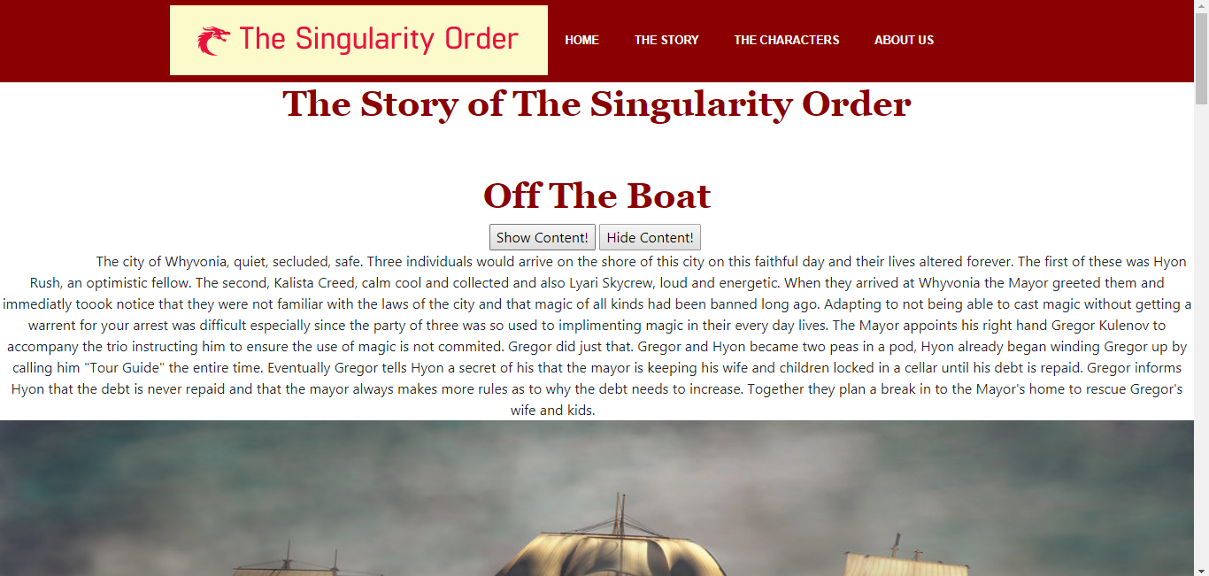
Another example of the stories section. The page is long but follows a consistent style.
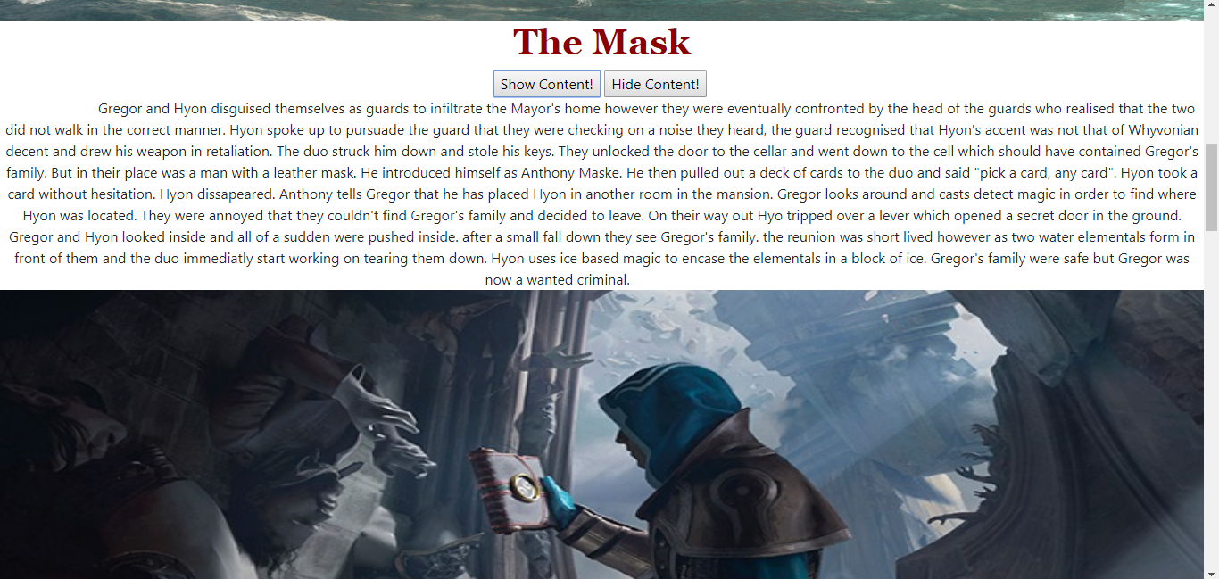

Page 3 – Character Selection
This page displays an image of the chracters and the names on their character cards act as a link to each characters bio.
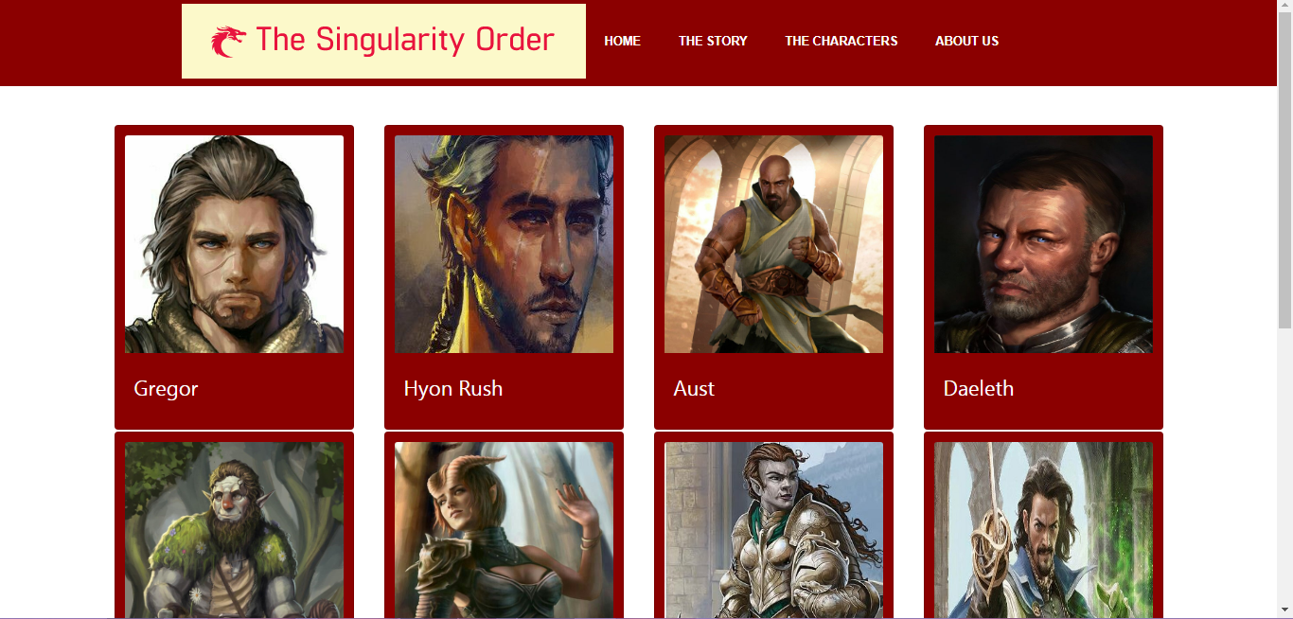
Page 4 – Character 1
Each characters page follows the same style to keep it consistent throughout. At the top, a character card with basic information. And below, a more in-depth desription. The following screenshots until webpage 12 will have this layout.
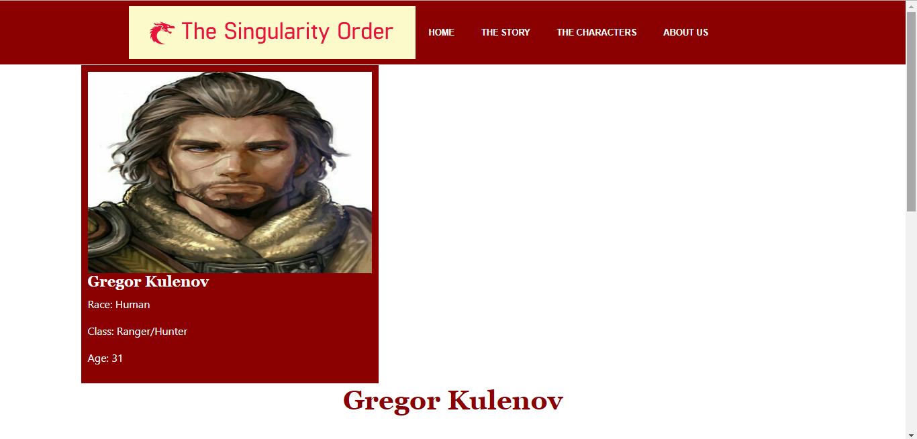

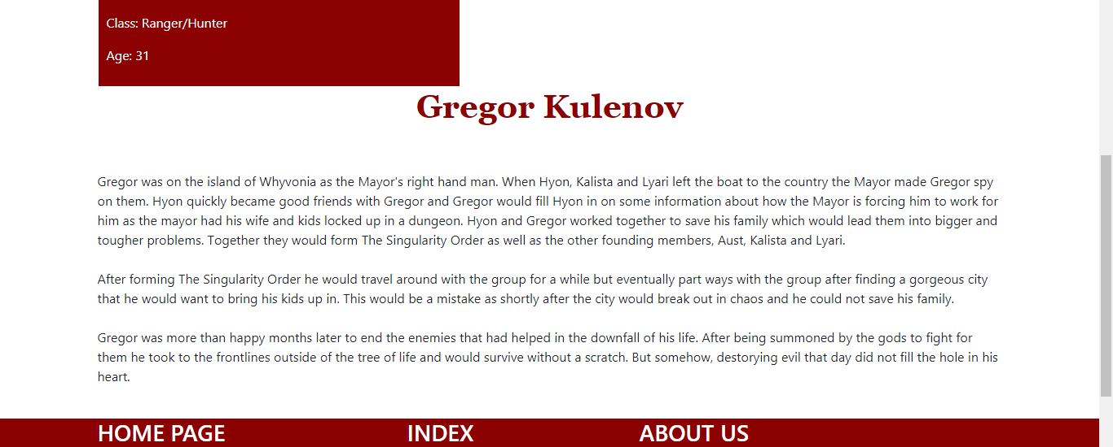

Page 5 – Character 2
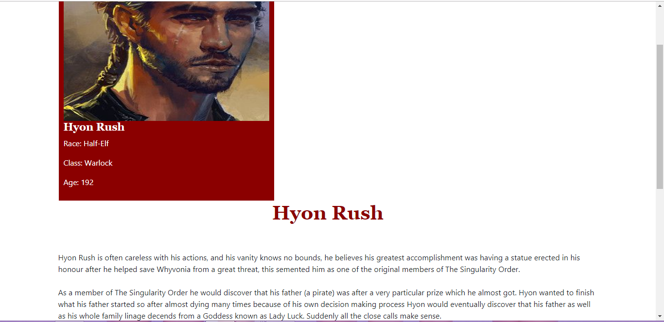

Page 6 – Character 3
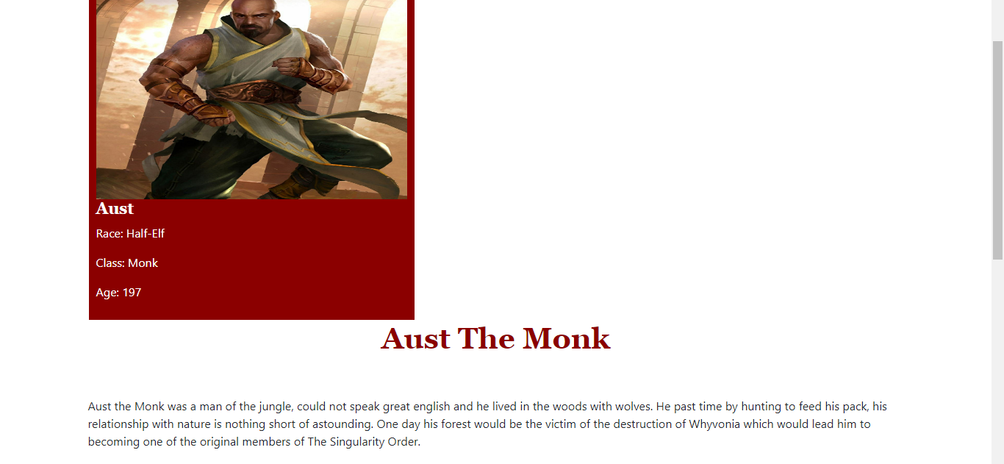
Page 7 – Character 4
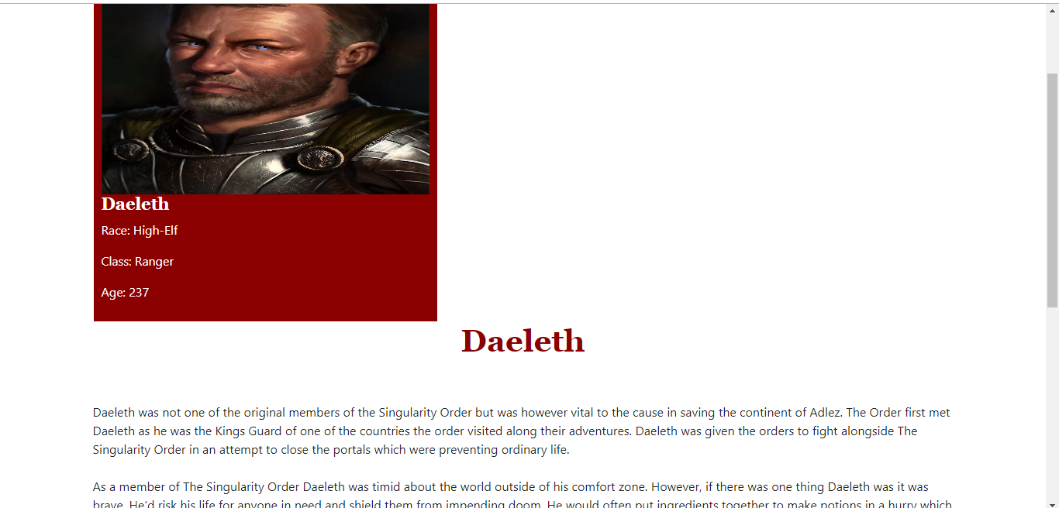

Page 8 – Character 5

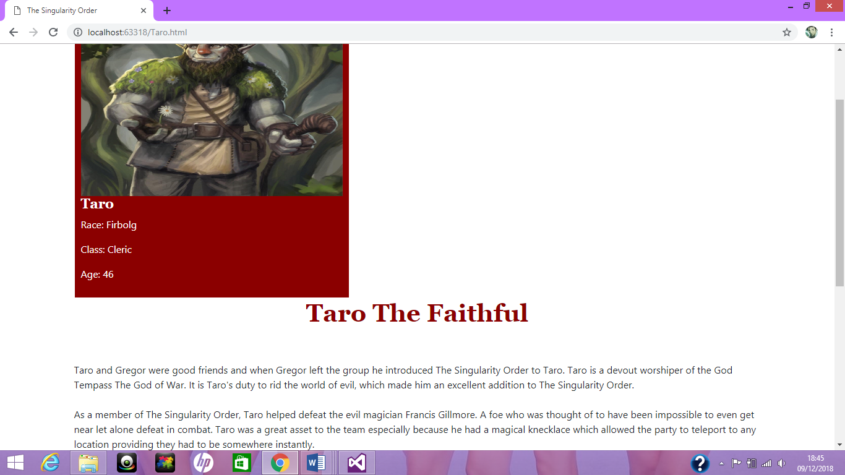
Page 9 – Character 6
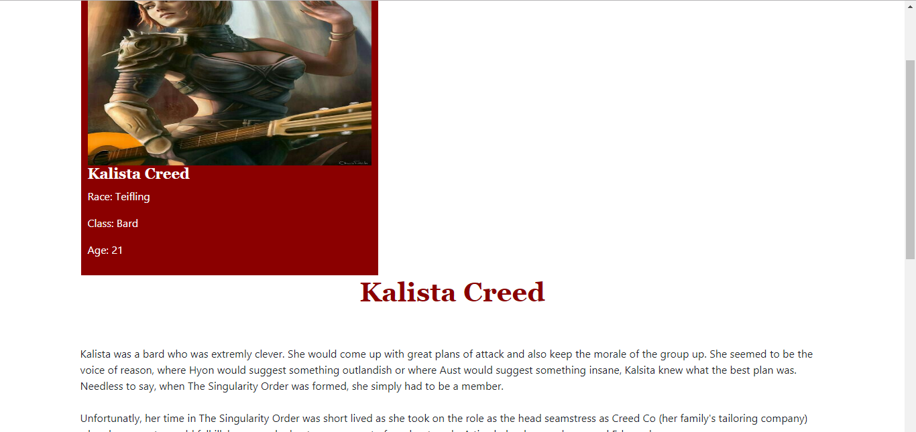

Page 10 – Character 7
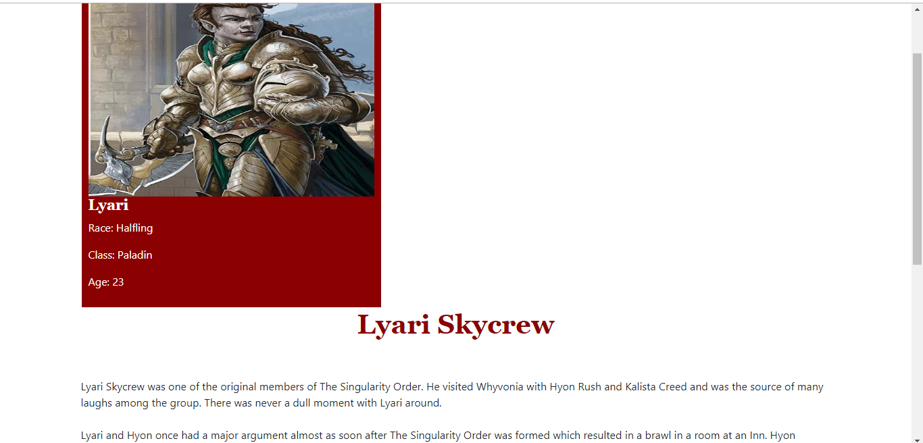

Page 11 – Character 8
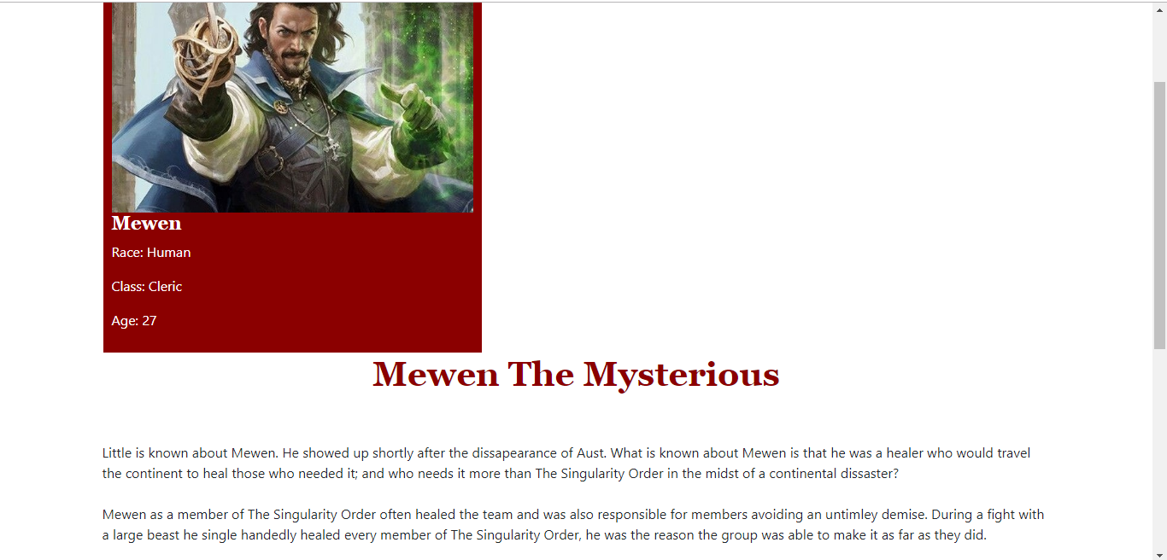

Page 12 – About Us
The purpose of this page is to inform the user about the campaign of Dungeons and Dragons.
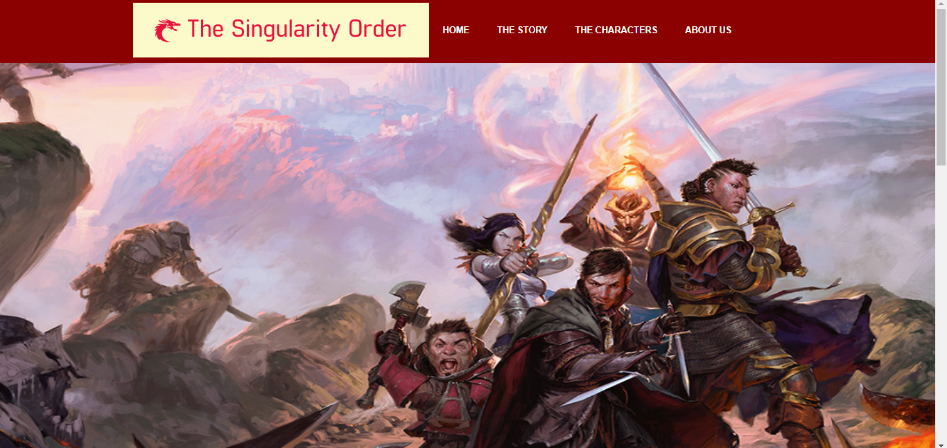

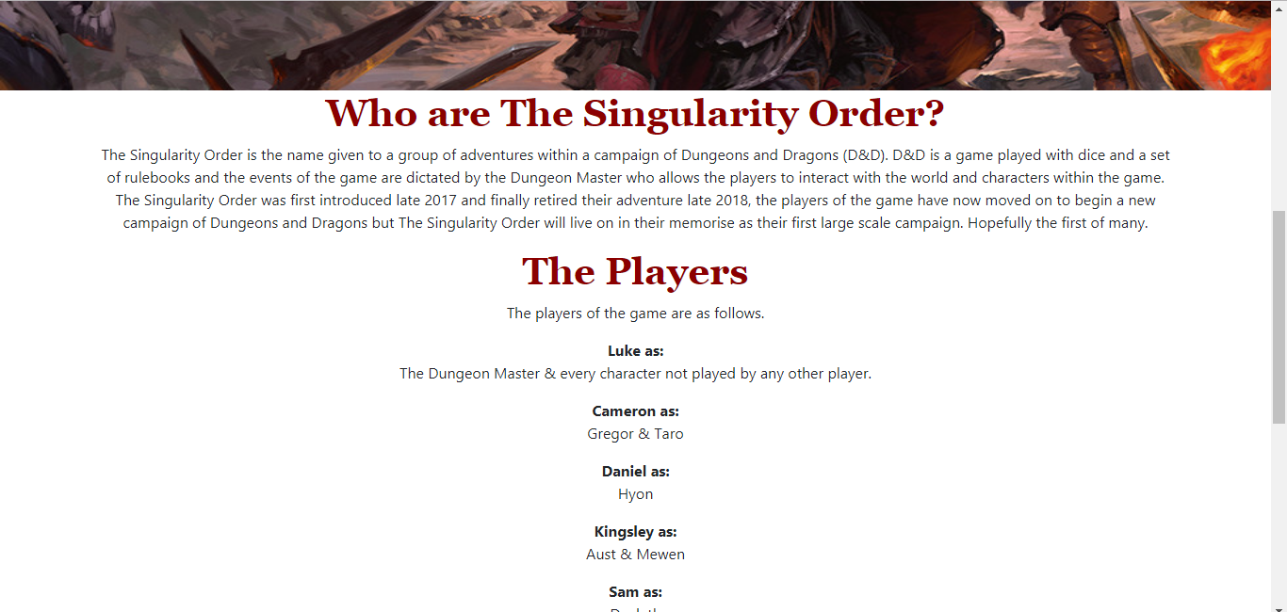

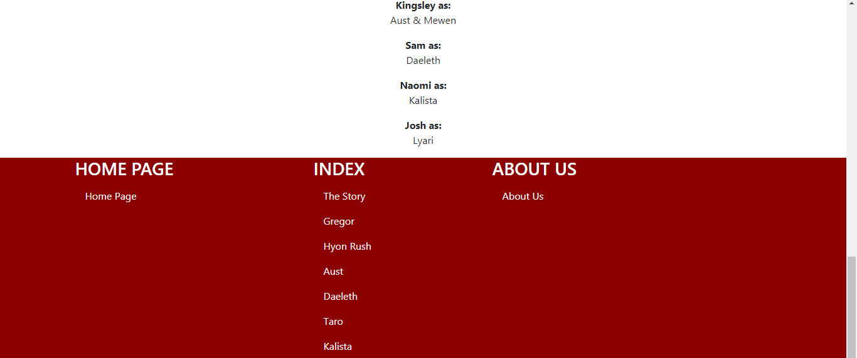
Screenshots on mobile device
Home page
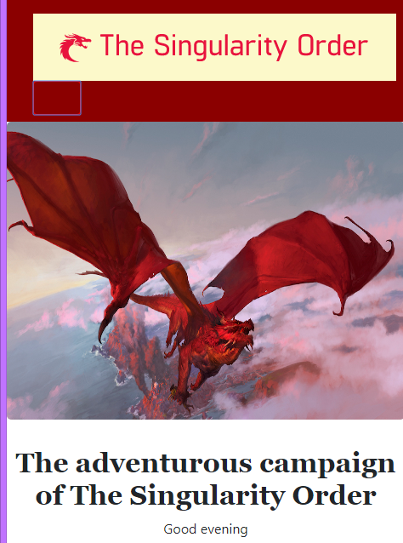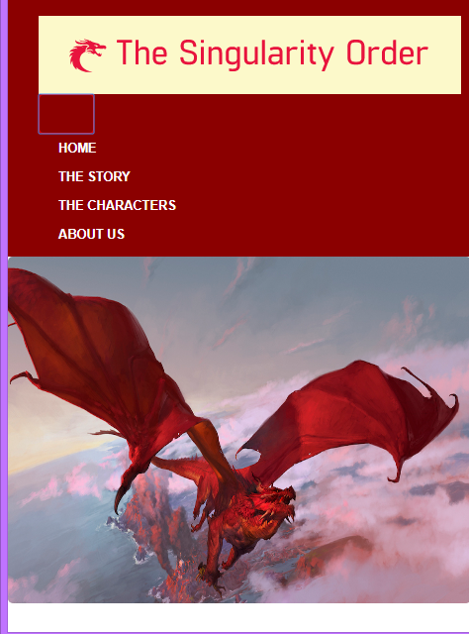
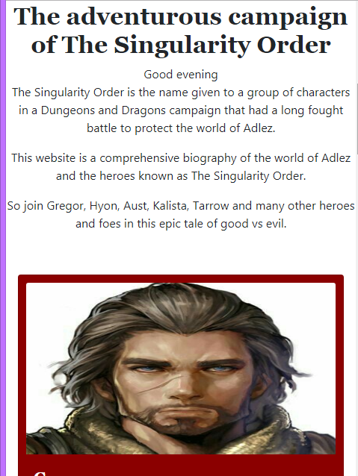
Characters page
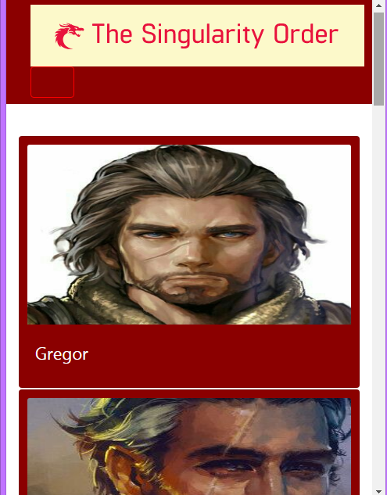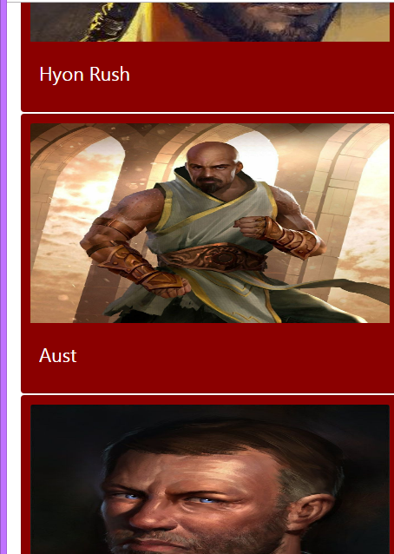
Story Page
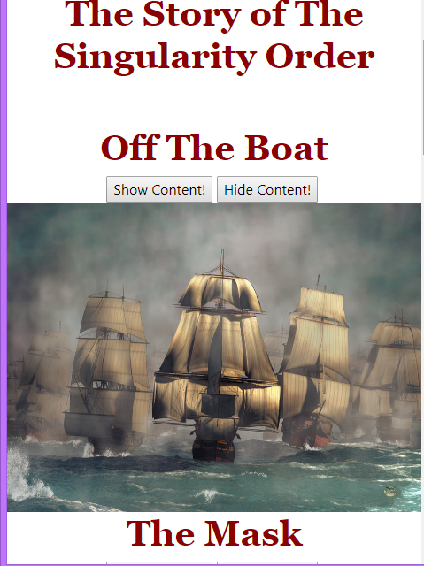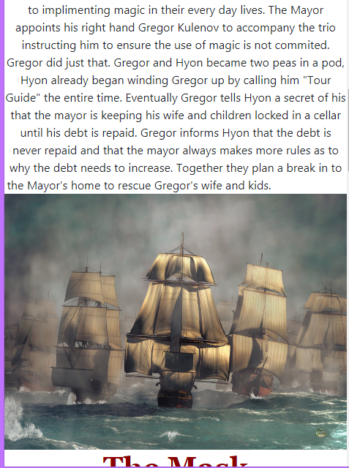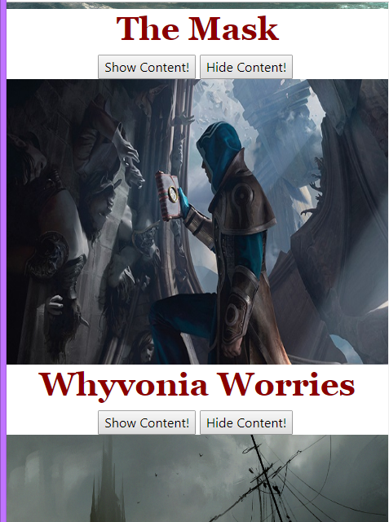
Each character page

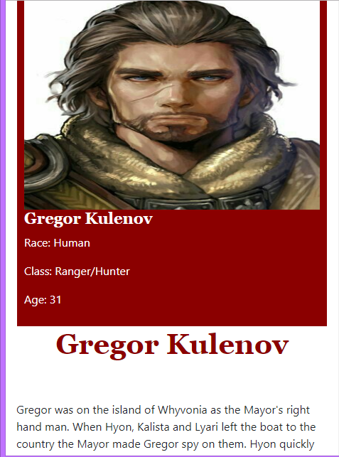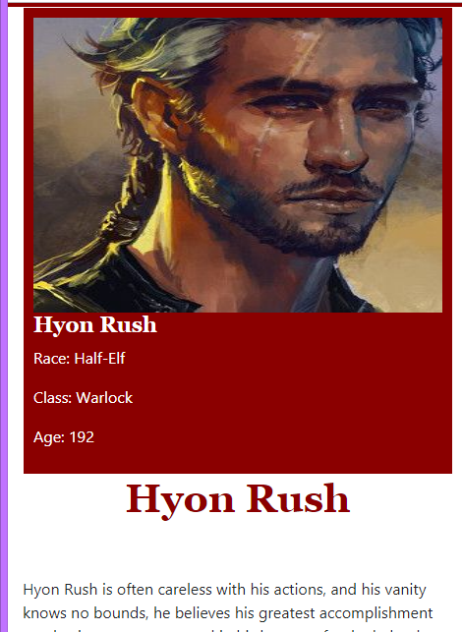
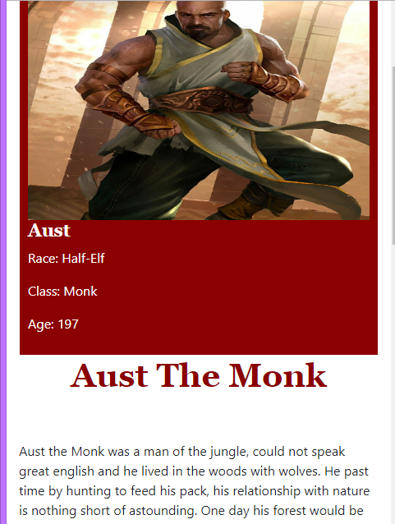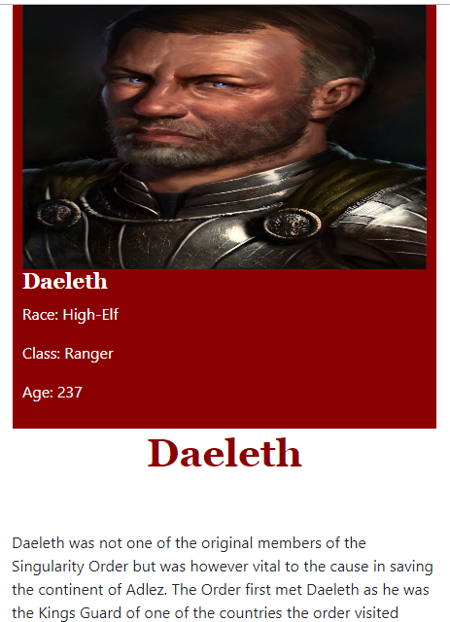

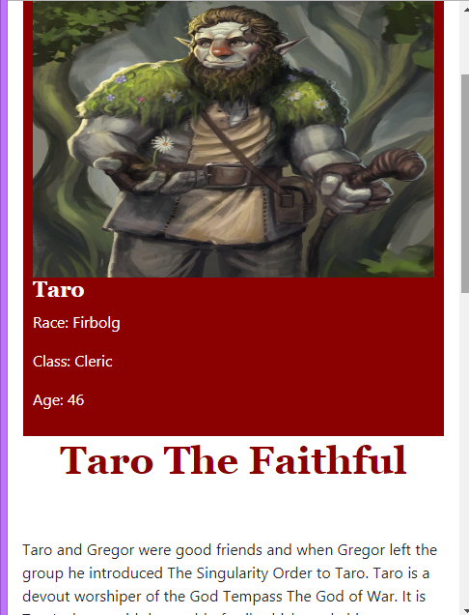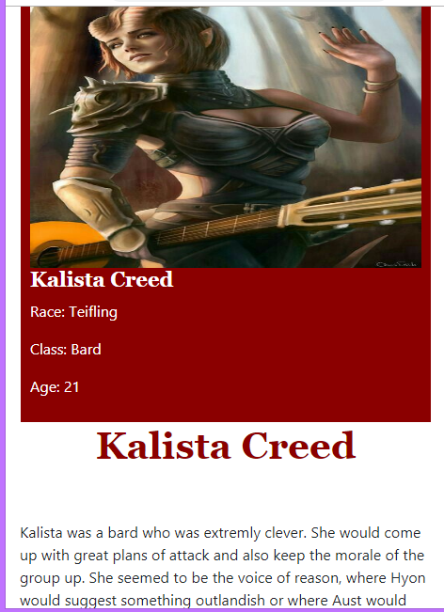
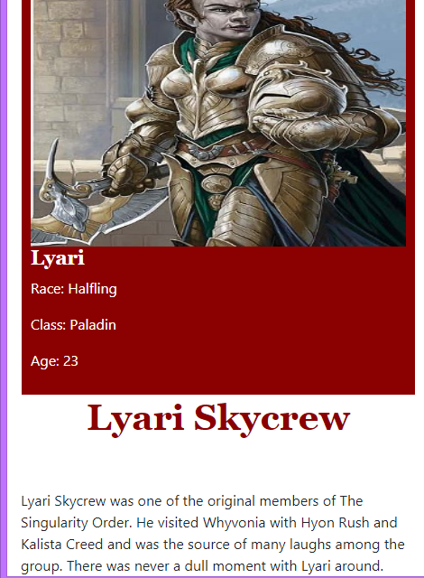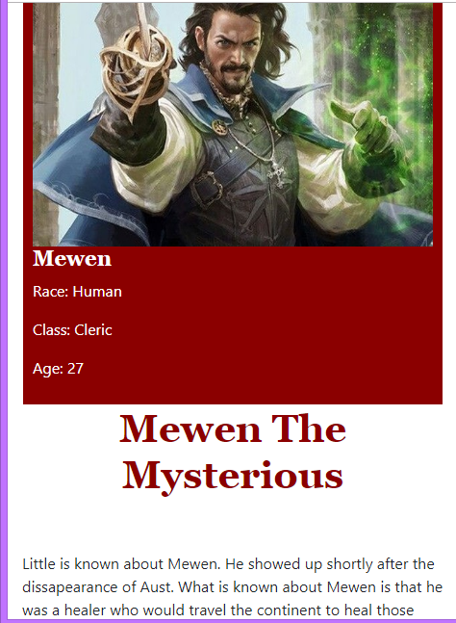

About Us Page
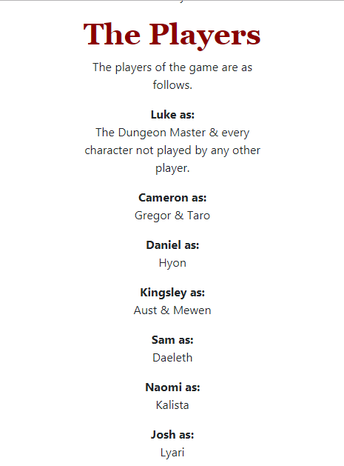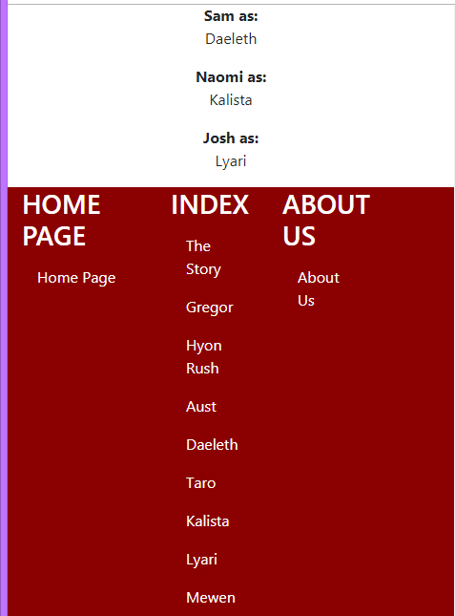

Evaluation
Software verification and validation are important to the development process of websites. Verification refers to the lifecycle of the website when compared to the requirements specification and design. Validation refers to making sure the website does what it’s meant to and serves the right purpose. [11] In the requirements it was said that the website must be responsive, it’s shown in the screenshots that the website does accommodate for smaller screens. It was said that the website’s house style should contrast and have a good aesthetic, it is believed that this is the case. Navigation had to be easy, this was achieved by links being in the footer and titles explaining what the content would be. As a result of these requirements being met the usability of the website is greatened which helps better the user experience.
Overall the website was a success and meets the goals initially set by the author. The purpose and design principles mentioned in Task 1 have been met in the implementation. In the future the author would like to add more interactive features to the website, such as a like button to like story content or characters.

References

[1] | S. Woods, "10 Top Principles of Effective Web Design," SHORTIEDESIGNS, 4 March 2014. [Online]. Available: https://shortiedesigns.com/2014/03/10-top-principles-effective-web-design/. [Accessed 1 December 2018].
[2] | K. Aaberg, "Color Contrast – all about the difference," Love of Graphics, 1 June 2011. [Online]. Available: https://www.loveofgraphics.com/color/colorcontrast/. [Accessed 1 December 2018].
[3] | A. W. Warner, "4 Rules for Using Images on Your Website," Fooplugins, [Online]. Available: https://fooplugins.com/4-rules-using-images-website/. [Accessed 1 December 2018].
[4] | N. Babich, "Building Better UI Designs With Layout Grids," SmashingMagazines, 20 December 2017. [Online]. Available: https://www.smashingmagazine.com/2017/12/building-better-ui-designs-layout-grids/. [Accessed 1 December 2018].
[5] | B. Jones, "Understanding the F-Layout in Web Design," tutsplus, 7 March 2012. [Online]. Available: https://webdesign.tutsplus.com/articles/understanding-the-f-layout-in-web-design--webdesign-687. [Accessed 1 December 2018].
[6] | C. C. (. b. F. Stewart), "CSS Sprites: What They Are, Why They’re Cool, and How To Use Them," CSS-Tricks, October 2015. [Online]. Available: https://css-tricks.com/css-sprites/. [Accessed 1 December 2018].
[7] | R. Hollander, "Two-thirds of the world's population are now connected by mobile devices," Business Insider, 19 September 2017. [Online]. Available: https://www.businessinsider.com/world-population-mobile-devices-2017-9?r=US&IR=T. [Accessed 1 December 2018].
[8] | T. Griffin, "Five Tips For Designing A Mobile-First Website," Forbes, 19 March 2018. [Online]. Available: https://www.forbes.com/sites/forbestechcouncil/2018/03/19/five-tips-for-designing-a-mobile-first-website/. [Accessed 19 December 2018].
[9] | "Usability Vs. User Experience," VisualHierarchy, [Online]. Available: https://visualhierarchy.co/blog/usability-vs-user-experience/. [Accessed 1 December 2018].
[10] | MockPlus, "The Ultimate Guide—Difference Between Usability and User Experience," Mockplus, [Online]. Available: https://www.mockplus.com/blog/post/difference-between-usability-and-user-experience. [Accessed 1 December 2018].
[11] | "What is Verification and Validation," Software Testing Help, 5 October 2018. [Online]. Available: https://www.softwaretestinghelp.com/what-is-verification-and-validation/. [Accessed 2 December 2018].

marking criteria and Student FEEDBACK

This section details the extent to which the assessment criteria are demonstrated by you, which in turn determines your mark. The marks available for each category of skill are shown. Lecturers will use the space provided to comment on the achievement of the task(s), including those areas in which you have performed well and areas that would benefit from development/improvement.

Common Assessment Criteria Applied (Assignment 1) | Marks available | Marks  awarded
1. Engagement with Literature Skills

Very good evidence of a range of reference sources consulted. For additional improvements, expand the range of reference sources consulted to include more academic reference sources and not just websites. Please see comment below about citing reference sources in your write-up. (Grade mark: 70.00%) | 5 | 3.5
2. Knowledge and Understanding Skills

A very good discussion of a variety of web design principles, with a good overview of usability and user experience that also identifies their differences. (Grade mark: 68.00%) | 25 | 17
3. Cognitive and Intellectual Skills

A good evaluation of the implemented website has been provided. The documentary evidence of testing could be improved beyond screenshots to further demonstrate test cases for the interactive functionality. (Grade mark: 47.50%) | 20 | 9.5
4. Practical Application Skills

A good attempt featuring a simple website. There is, however, room for improvement. The implemented solution demonstrates basic understanding of RWD and a mobile-first strategy as for your RWD you have mostly just edited one of the class tutorial exercises. Aim to enhance tutorial exercises to further demonstrate your understanding of the concepts including reusing the Costa website background image. For example, you needed to adjust the media queries to suit your website content as the images are skewed on smaller screens, which indicates that a mobile-first approach has not been followed. Some good, basic attempts of including some JS interactive behaviour but please note the following. There was a missing closing curly brace in your JavaScript file and also make the greeting message on the home page more obvious (see report for suggestions). The repetitive inline button click event on the Story page could also be simplified via the use of a JavaScript function with a parameter to accept the ID of the element to show/hide or use jQuery. See additional comments in your report and particularly note the comments about the logo. Overall, a good attempt. (Grade mark: 60.00%) | 45 | 27
5. Transferable Skills for Life and Professional Practice

The report is of a good standard but use formatting (e.g. bold fonts, bullets, sub-sections) to highlight important content and break up the content and avoid using contractions in formal, academic work. (Grade mark: 60.00%) | 5 | 3

Assignment Mark (Assessment marks are subject to ratification at the Exam Board. These comments and marks are to give feedback on module work and are for guidance only until they are confirmed. ) | Late Submission Penalties (tick if appropriate) |  | 60%
 | Up to 1 week late (40% Max) |  | 60%
 | Over 1 week late (0%) |  | 60%

