Assignment Title: Cultural Awareness (BMIH5003)
Student: Khalida Miah (2017369)
Lecturer: Mike Davies
Executive Summary
Failing to understand cultural differences may create a great mess by making customers dissatisfied. In a hotel, there come guests from different cultural backgrounds. Based on the cultural background differences, guests demand and expectation differs. To satisfy the guests, hotel staff need to have adequate knowledge of different cultures.
The report is prepared to get some knowledge about the cultures of the United States and India. Based on the scores on Hofstede’s model’s cultural dimensions, the report analyses two countries’ cultures. The Ritz-Carlton Charlotte, US is used here in this report as a reference. Some do’s and don’ts are also provided at the end of the report.
From the comparison of the two countries’ cultures, the report has found that there remain differences in the dimensions such as power distance, individualism, long-term orientation, and indulgence between the US and India. To treat the Indian guests in the US, the hotel staff in the US should concentrate on these areas. So, employees who serve international guests should concentrate on improving their cultural knowledge to improve their performances.

Contents
Introduction 1
Country A 2
Country B 3
Country Analysis 5
Hotel Handbook (Do’s and don’ts) 5
Conclusion 7
References 8

Introduction
In a hotel operation, employees’ cultural awareness is needed to understand the perspectives and expectations of the guests who come from different cultural backgrounds (Levy, 2010). Cultural awareness is the knowledge of the likeness and divergence among different cultures. The report will use Hofstede’s Cultural Dimension Model to analyse the cultural similarities and differences between the United States and India. A guideline of “Do’s and Don’ts” will be provided for the hotel staff in serving the international guests.

Country A
The Ritz-Carlton Charlotte is a luxury hotel situated at 201 East Trade Street, Charlotte, NC of United States (The Ritz-Carlton, n.d.). It is the subsidiary of the international hotel chain Marriot International (Marriott, 2019).
The Hofstede model is illustrated in this report to analyse the different perspectives of cultural awareness.
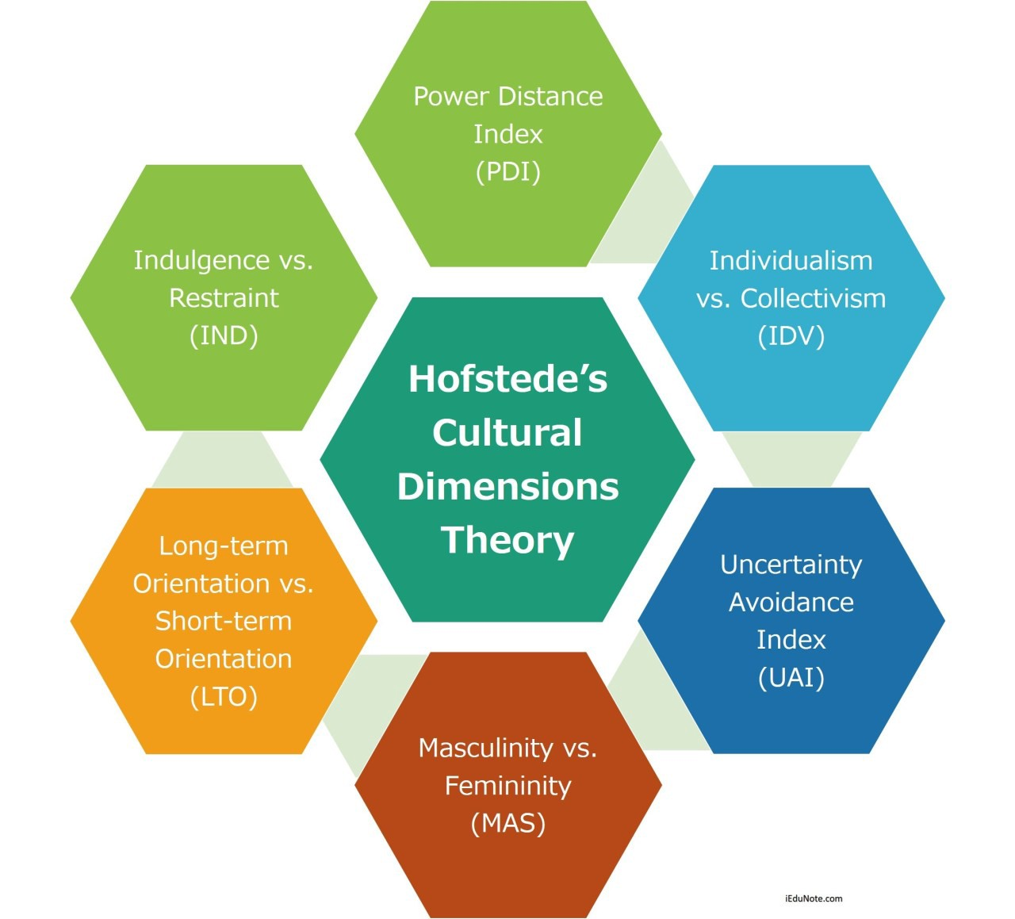
Figure 1: Hofstede Cultural Dimension Model. Source: (Hofstede Insights, 2021).
The following figure entails the scores of the United States on the six cultural dimensions proposed by Hofstede model.
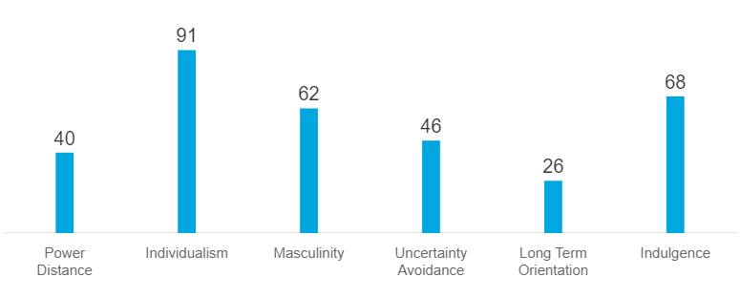
Figure 2: The scores of the US on Hofstede model' dimensions. Source: (Hofstede Insights, 2019)
Power Distance
The US holds below 50 in the power distance dimension which means in the US the inequalities and unfairness is not justified. Hierarchical status doesn’t mean a lot to the people of the US. So, the hotel staff of the US try to serve guests regardless of their social status.
Individualism
The US with a score of 91 in the individualism dimension belongs to the individualistic society. The people of individualistic societies try to build their own identity and career development (Inaba, 2014). The hotel staff of the US may try to serve guests efficiently for their promotion and high career growth.
Masculinity
The society with a high score in the masculinity dimension indicates that the people of the society are competition and goal-driven. The characteristic of masculine society may drive the hotel staff to try to be the best in their work field.
Uncertainty Avoidance
The below-average score of the US in uncertainty avoidance indicates that hotel staff may be tended to accept new ideas, innovation and be ready to try something new while serving their guests (Lee and Jang, 2012).
Long-term Orientation
The US holds a very low score in the long-term orientation dimension which accounts for 26. That means Americans are more practical and they are not pragmatic. So, the hotel staff of the US will be flexible to other cultures of international guests.
Indulgence
The high score in the indulgence dimension means that the Americans are adventure seekers. The hotel staff of the US will love their work in serving guests coming for enjoying a vacation or other purposes.

Country B
India is chosen for country B. The scores of India in the 6 dimensions of Hofstede’s model are illustrated in the following figure.
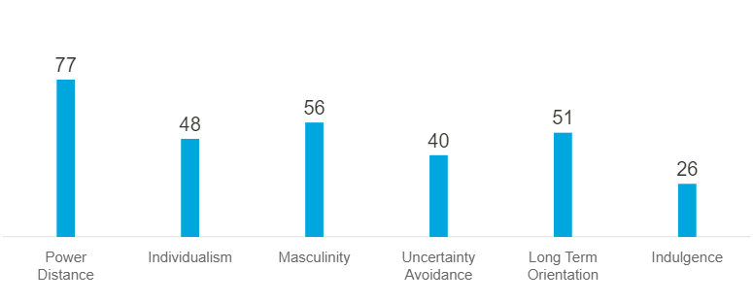
Figure 3: India's scores on Hofstede's dimensions. Source: (Hofstede Insights, 2021b)
Power Distance
India scores high in the power distance dimension which indicates that the guests of India are likely to expect a high level of services at the time of taking hotel services.
Individualism
The score of India in the individualism dimension is below-average which indicates that Indians somewhat belongs to a collectivist society. So, the guest from India may like to create a bond with the hotel staff.
Masculinity
With 56 scores in the masculinity dimension, the people of India are motivated by success. Women in the masculine society enjoy less freedom than men (Freeman, 2001). Guests from India may tend to observe the hotel staff as the goal driver.
Uncertainty Avoidance
With a low score in the uncertainty avoidance dimension, the guest from India may not prefer perfection in everything. In an unexpected situation, guests from India may tend to be tolerant.
Long-term Orientation
With a more than average score in long-term orientation, the people of India are long-term oriented. They respect their culture and expect hotel staff will respect their values and norms.
Indulgence
The score of 26 in the indulgence dimension indicates that Indian society belongs to a restrained culture. The people of restrained cultures may not usually seek leisure (Byram, 2012). So, the guests from India are likely to visit the United States for business or other work-related purposes while it is not unusual that the guest may come for vacation.

Country Analysis
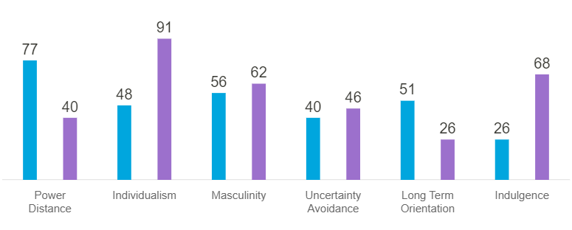
Figure 4: Cultural dimension comparison between US and India. Source: (Hofstede Insights, 2021a)
From the above comparison chart, it can be concluded that there are similarities and dissimilarities in the cultural dimensions between India and the US. The two countries scores are close in the masculinity and uncertainty avoidance dimension whereas the two countries’ cultures differ in the rest four dimensions e.g., power distance, individualism, long-term orientation, and indulgence. As Hofstede’s model analysis reveals that two countries’ cultures differ in many cases, the hotel staff of the Ritz-Carlton should need to have gathered the knowledge of Indian culture to better serve them.
The guest from India belongs to a collectivist society whereas the hotel staff of the US belong to an individualistic society. Although the hotel staff of the Ritz-Carlton belongs to an individualistic society, they should focus on building rapport with guests from India. Guests from India are from a restrained society.
Many Indian doesn’t eat beef for their religious purposes (Framarin, 2010). Without knowing their preferences, if beef is served to Indian guests, there would happen a big mess and create big customer dissatisfaction.

Hotel Handbook (Do’s and don’ts)
The handbook will provide certain guidelines for the two countries’ hotel staff.
Etiquettes | Do’s and don’ts
Serving Food | US | - Offer cutlery  - Never touch your face or any other parts of the body while serving.
Serving Food | India | - Arrange the facilities of handwashing as Indian love to eat with their hands.  - Try to serve food by the right hand.  - Don’t force guests to use cutlery.
Greetings | US | - Use hello, welcome, good morning, etc.  - Ensure communication professionally.  - Don’t assume you know everything.
Greetings | India | - Use Namaste  - Express honour, gratitude in conversation.
Handshakes | US | - Maintain eye contact  - Do firm handshakes
Handshakes | India | - Use namaste by placing two hands together with a slight bow.  - Don’t expect guest knows English.
Surprising | US | - Do surprise guests with gifts.
Surprising | India | - Do provide free meals.
Punctuality | US | - Do give more focus on punctuality.
Punctuality | India | - Do show punctuality.
Others | US | - Address guests by name.
Others | India | - Don’t point with fingers.  - Do take things by the right hand.

Conclusion
By using Hofstede’s model, the cultural similarities and dissimilarities between US and India are demonstrated in the report. Different service failures because of the misunderstanding of international guest expectations are also demonstrated. From the analysis, a guideline for the hotel staff of the US and India are provided.

References
Byram, M. (2012). Language awareness and (critical) cultural awareness – relationships, comparisons and contrasts. Language Awareness, 21(1-2), pp.5–13.
FRAMARIN, C.G. (2010). The value of nature in Indian (Hindu) traditions. Religious Studies, 47(3), pp.285–300.
Freeman, C. (2001). Is Local: Global as Feminine: Masculine? Rethinking the Gender of Globalization. Signs: Journal of Women in Culture and Society, 26(4), pp.1007–1037.
Hofstede Insights (2019). The United States - Hofstede Insights. [online] Hofstede Insights. Available at: https://www.hofstede-insights.com/country/the-usa/.
Hofstede Insights (2021a). Country Comparison - Hofstede Insights. [online] Hofstede Insights. Available at: https://www.hofstede-insights.com/country-comparison/india.
Hofstede Insights (2021b). India. [online] Hofstede Insights. Available at: https://www.hofstede-insights.com/country/india/.
Hofstede Insights (2021c). National Culture. [online] Hofstede insights. Available at: https://hi.hofstede-insights.com/national-culture.
Inaba, M. (2014). Individualistic attitudes toward attractive rewards in older people: An experimental study using ultimatum games. Japanese Psychological Research, 57(2), pp.91–102.
Lee, S.K. and Jang, S. (Shawn) (2012). Re-examining the overcapacity of the US lodging industry. International Journal of Hospitality Management, 31(4), pp.1050–1058.
Levy, S.E. (2010). The hospitality of the host: A cross-cultural examination of managerially facilitated consumer-to-consumer interactions. International Journal of Hospitality Management, 29(2), pp.319–327.
Marriott (2019). About Marriott International | Corporate Information. [online] Marriott.com. Available at: https://www.marriott.com/marriott/aboutmarriott.mi.
The Ritz-Carlton (n.d.). Charlotte. [online] The Ritz-Carlton. Available at: https://www.ritzcarlton.com/en/hotels/charlotte [Accessed 15 Feb. 2022].

