

Windows 10 Ransomware Memory Forensics: An Experimental Analysis of Acquisition Timing Using WinPmem, SIFT Workstation and Volatility 3

By
Gopika Virakan Valappil
Student ID: 2436585

Supervisor: Dr. Alireza Esfahani

Project submitted as part of the requirements for the award of
MSc. Cybersecurity and Digital Forensics
Module: ACFA7003

September 2026

DECLARATION

I, Gopika Virakan Valappil, declare that I am the sole author of this Project; that all references cited have been consulted; that I have conducted all work of which this is a record, and that the finished work lies within the prescribed word limits.

This work has not previously been accepted as part of any other degree submission.

Signature: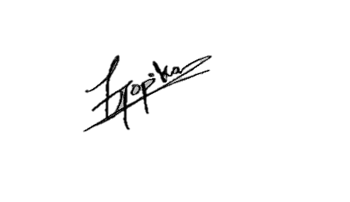

Date: 24/09/2026

FORM OF CONSENT
I, Gopika Virakan Valappil, hereby consent that my Project, submitted in candidature for the MSc. Cybersecurity and Digital Forensics, if successful, may be made available for inter-library loan or photocopying (subject to the law of copyright), and that the title and abstract may be made available to outside organisations.
Signature: 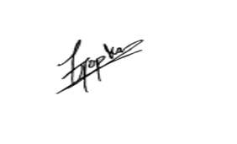

Date: 24/09/2026
Abstract
Ransomware investigations frequently depend on volatile evidence that may disappear or change as a system continues to operate. This research investigates how the timing of volatile-memory acquisition influences the recovery and interpretation of ransomware-related artefacts within a Windows 10 environment. The study focuses specifically on whether different acquisition points provide different levels of investigator-readable evidence and evaluates the effectiveness of Volatility 3 and supporting forensic techniques for analysing these artefacts.
A controlled experimental methodology was implemented within an isolated virtualised environment consisting of a Windows 10 victim system, SIFT Workstation and a supporting Kali Linux virtual machine. Rather than deploying live ransomware, a benign PowerShell-based ransomware-behaviour simulation was used to generate controlled file-renaming and related artefacts without introducing malicious software. Memory images were acquired using WinPmem at different experimental stages, including a structured PRE, MID and POST sequence during T2. SHA-256 hashing supported post-acquisition evidence integrity, while Volatility 3 plugins and string examination were used to identify and correlate process, command-line, memory-region and textual artefacts.
The results demonstrated that acquisition timing influenced artefact visibility under the tested conditions. The T2 MID acquisition produced the richest combination of simulation-related evidence, including PowerShell activity and references to Rename-Item and .locked, while some of these artefacts were not identified in the corresponding PRE and POST examinations. T3 additionally demonstrated the presence of the WinPmem acquisition footprint within captured memory. The findings also showed that no individual forensic technique provided sufficient context independently.

TABLE OF CONTENTS

List of Figures vii
List of Tables vii
Chapter 1: Introduction 1
1.1 Background and Context 1
1.2 Problem Statement 2
1.3 Research Aim 2
1.4 Research Objectives 2
1.5 Research Questions 3
1.6 Significance of the Research 3
1.7 Scope and Limitations 4
1.8 Dissertation Structure 4
Chapter 2: Critical Literature Review 6
2.1 Introduction 6
2.2 Ransomware Behaviour and the Need for Memory Forensics 6
2.3 Windows Volatile Memory as a Source of Forensic Evidence 7
2.4 Memory Acquisition Techniques and Forensic Integrity 8
2.5 Acquisition Timing and Artefact Persistence 9
2.6 Memory Analysis Using Volatility 3 10
2.7 Ransomware Artefact Identification in Volatile Memory 11
2.8 Critical Comparison of Existing Experimental Approaches 12
2.9 Research Limitations, Gaps and Positioning of This Study 14
2.10 Chapter Summary 15
Chapter 3: Research Methodology 16
3.1 Introduction 16
3.2 Research Philosophy 16
3.3 Research Approach 17
3.4 Research Strategy 17
3.5 Data Collection 18
3.6 Data Analysis 18
3.7 Validity, Reliability and Reproducibility 19
3.8 Ethical and Safety Considerations 20
3.9 Methodological Limitations 20
Chapter 4: Experimental Design 22
4.1 Experimental Architecture 22
4.2 VirtualBox and Network Isolation 23
4.3 Windows 10 Victim Environment 23
4.4 SIFT Workstation 24
4.5 Kali Linux Supporting Environment 24
4.6 Forensic Tools: WinPmem and Volatility 3 24
4.7 Controlled Ransomware-Behaviour Simulation 25
4.8 Experimental Stages: T0, T1, T2 and T3 26
4.9 Experimental Variables and Controls 28
4.10 Evidence Integrity and Snapshot Strategy 28
Chapter 5: Experimental Implementation 30
5.1 Environment Preparation 30
5.2 T0 Clean Baseline 31
5.3 T1 Experiment 32
5.4 T2 PRE/MID/POST Experiment 34
5.5 T3 Supporting Experiment 35
5.6 Memory Acquisition Using WinPmem 37
5.7 SHA-256 Integrity Verification 37
5.8 Volatility 3 and Strings Analysis 38
5.9 Practical Challenges and Resolutions 40
Chapter 6: Results, Evaluation and Discussion 41
6.1 Introduction 41
6.2 T1 Results 41
6.3 T2 PRE Results 43
6.4 T2 MID Results 43
6.5 T2 POST Results 45
6.6 T2 PRE/MID/POST Comparative Analysis 45
6.7 T3 Supporting Results 47
6.8 Cross-Trial T1/T2/T3 Comparison 48
6.9 Evaluation of Forensic Techniques 49
6.10 Effect of Memory Acquisition Timing 50
6.11 Comparison of Experimental Findings with Existing Literature 51
6.12 Answers to the Research Questions 52
Chapter 7: Conclusions and Recommendations 54
7.1 Research Overview 54
7.2 Achievement of the Research Aim 54
7.3 Achievement of the Research Objectives 55
7.4 Key Findings 55
7.5 Research Limitations 56
7.6 Recommendations 57
7.7 Future Research 58
Chapter 8: Reflection 59
8.1 Project Planning and Management 59
8.2 Technical and Research Challenges 59
8.3 Adaptation of the Original Methodology 60
8.4 Skills and Professional Development 60
8.5 What Would Be Done Differently 61
References 63
Appendix A — Approved Ethics Documentation 69
Appendix B — Laboratory and Virtual Machine Configuration 69
Appendix C — Controlled Ransomware-Behaviour Simulator 71
Appendix D — T0 Baseline Evidence 72
Appendix E — T1 Experimental Evidence and Screenshots 73
Appendix F — T2 PRE/MID/POST Evidence and Screenshots 75
Appendix G — T3 Supporting Experimental Evidence and Screenshots 76
Appendix H — SHA-256 Integrity Verification Records 78
Appendix I — Volatility 3 Analysis Outputs 82
Appendix J — T1/T2/T3 Comparative Evidence 83
Appendix K — VirtualBox Snapshot Records 85
Appendix L — Commands and Additional Technical Evidence 87

List of Figures
Figure 1 Experimental Architecture……………………………………………………28
Figure 2 T2 Controlled ransomware-behaviour simulation…………………………….34

List of Tables
Table 1 Comparative analysis of selected approaches 19
Table 2 Forensic tools and techniques used 31
Table 3 Summary of experimental stages and purpose 33
Table 4 Comparison of T2 acquisition stages 52
Table 5 Comparison of experimental observations 54

Chapter 1: Introduction

1.1 Background and Context
Ransomware has become a significant cybersecurity challenge because of its ability to encrypt valuable data, disrupt normal operations and restrict access to critical systems. Consequently, ransomware is increasingly examined not only as a prevention and detection problem but also from a digital forensic perspective. Following an incident, investigators may need to reconstruct the processes, commands and system activities associated with suspicious behaviour rather than relying solely on persistent artefacts such as encrypted files.
Within this context, Hamid and Rahman [1] highlight the importance of volatile-memory forensics for examining temporary information held within a running system. Their review demonstrates that memory analysis can reveal transient evidence that may not remain available through storage-based investigation alone, including active processes, process relationships and execution-related information. Ransomware-focused research has similarly shown that memory-derived characteristics can support the identification of ransomware activity, reinforcing the value of RAM as an investigative evidence source [2].
However, the forensic value of volatile memory is accompanied by an important limitation: memory continues to change while a system is operating. Rzepka et al. [3] demonstrated through Windows 10 experiments using WinPmem that inconsistencies can occur during live memory acquisition, challenging the assumption that a captured image represents a perfectly static system state. Acquisition timing introduces a related problem. Hirano and Kobayashi [4], through their FIMAR approach, demonstrated the value of acquiring memory across multiple temporal points when reconstructing ransomware-related activity. Considered together, these studies suggest that the evidence recovered from volatile memory can be influenced both by the acquisition process and by when acquisition takes place.
Building on this issue, the present study investigates ransomware-related artefacts in Windows 10 volatile memory using a controlled benign ransomware-behaviour simulation. Memory is acquired at different experimental stages using WinPmem and subsequently analysed within SIFT Workstation using Volatility 3 and supporting forensic techniques. By comparing the resulting process, command-line and string-based evidence across acquisition stages, the study examines how acquisition timing influences the availability and interpretation of ransomware-related forensic artefacts.

1.2 Problem Statement
Although volatile memory can provide valuable evidence during ransomware investigations, its transient nature creates an important forensic problem. Artefacts visible during execution may change or disappear as processes terminate and memory is reused [1]. This problem is complicated further by the acquisition process itself, as live memory capture occurs while the target system continues to operate and may therefore contain inconsistencies [3]. Temporal approaches such as FIMAR further indicate that evidence availability can differ across acquisition points [4].
A practical question therefore remains concerning how acquisition timing affects the recovery and interpretation of ransomware-related artefacts in a controlled Windows environment. This study addresses that question experimentally by comparing Windows 10 volatile-memory evidence acquired at different stages of a benign ransomware-behaviour simulation using WinPmem, SIFT Workstation and Volatility 3.

1.3 Research Aim
The primary aim of this research is to investigate how the timing of volatile-memory acquisition influences the recovery and interpretation of ransomware-related artefacts within a Windows 10 environment. Through a controlled ransomware-behaviour simulation, memory is acquired at different experimental stages using WinPmem and subsequently examined within SIFT Workstation using Volatility 3 and supporting forensic techniques.

1.4 Research Objectives
To achieve the research aim, the study is guided by three objectives:
RO1: To critically examine contemporary literature concerning ransomware behaviour, volatile-memory forensics, memory acquisition and forensic analysis techniques, with particular attention to the challenges associated with recovering transient evidence.
RO2: To design and conduct a controlled ransomware-behaviour simulation within a Windows 10 virtual environment, acquiring volatile-memory evidence using WinPmem at different experimental stages to represent changes in system activity over time.
RO3: To analyse and compare the acquired memory evidence within SIFT Workstation using Volatility 3 and supporting forensic techniques, including process, command-line, memory-region and string analysis, to evaluate how acquisition timing influences the identification and interpretation of ransomware-related artefacts.
Together, these objectives establish a progression from reviewing existing research, through controlled experimentation, to the comparative evaluation of the resulting forensic evidence.

1.5 Research Questions
Based on the research aim and objectives outlined above, the study addresses the following research questions:
RQ1: What ransomware-related artefacts can be identified within Windows 10 volatile memory following a controlled ransomware-behaviour simulation?
RQ2: How does the timing of volatile-memory acquisition affect the ransomware-related artefacts recoverable from Windows 10 memory?
RQ3: How effectively can Volatility 3 and supporting forensic techniques identify and correlate ransomware-related activity across different memory-acquisition stages?
These questions provide a clear direction for the experimental investigation. RQ1 focuses on identifying the forensic artefacts present within the acquired memory, while RQ2 examines whether those artefacts differ according to the point of acquisition. RQ3 evaluates the usefulness of the forensic analysis techniques employed in identifying and correlating evidence across the different experimental stages. Together, the questions connect the existing literature, experimental design and subsequent evaluation of the findings.

1.6 Significance of the Research
Rather than proposing a new ransomware-detection method or memory-acquisition tool, this study contributes a controlled experimental examination of how investigator-readable volatile-memory artefacts vary across different acquisition stages when conventional software-based live acquisition is used. By combining WinPmem acquisition with Volatility 3 process, relationship, command-line and memory-region analysis alongside string examination, the research connects three issues that are often considered separately in existing work: ransomware-related memory evidence, acquisition timing and the limitations of live memory capture. The contribution therefore lies not only in demonstrating that ransomware-related artefacts can be recovered from memory, but in examining how their visibility and interpretative value change across a known experimental timeline. This provides practical insight into why the timing and context of acquisition should be considered when reconstructing ransomware-related activity. The principal project deliverable is therefore an experimental evaluation of acquisition timing in Windows 10 memory forensics, supported by a documented and reproducible workflow for memory acquisition, integrity verification, artefact analysis and cross-stage comparison.

1.7 Scope and Limitations
This research is limited to the forensic examination of volatile memory within a controlled, virtualised Windows 10 environment. A benign ransomware-behaviour simulation is used rather than live ransomware, allowing relevant activity to be reproduced without introducing unnecessary security risks. Memory acquisition is performed using WinPmem, while SIFT Workstation, Volatility 3 and selected supporting techniques are used for forensic analysis. Although this approach provides a controlled environment for comparing evidence across different acquisition stages, it does not reproduce every aspect of a real-world ransomware incident. Consequently, the findings should not be generalised to all ransomware families, Windows versions, acquisition tools or operational environments.

1.8 Dissertation Structure
The remainder of this dissertation is organised into seven chapters, progressing from the theoretical basis of the research through the experimental investigation, analysis of findings, conclusions and reflection.
Chapter 2: Critical Literature Review
This chapter critically reviews existing research relating to ransomware, volatile-memory forensics, memory acquisition and temporal analysis. It compares relevant approaches and limitations in previous studies before identifying the research gap addressed by the present investigation.
Chapter 3: Research Methodology
This chapter explains the methodological approach adopted for the study and justifies the use of controlled experimental research. It describes the research approach, data collection and analysis methods, validity and reliability considerations, ethical and safety measures, and methodological limitations.
Chapter 4: Experimental Design
This chapter presents the design of the controlled virtualised environment used to investigate Windows 10 volatile memory. It describes the experimental architecture, forensic tools, benign ransomware-behaviour simulation and the T0–T3 experimental stages, with particular emphasis on the T2 PRE, MID and POST acquisition sequence.
Chapter 5: Experimental Implementation
This chapter describes how the experimental design was implemented in practice. It documents the preparation of the environment, execution of the controlled experimental stages, memory acquisition using WinPmem, integrity verification and subsequent forensic analysis using Volatility 3 and supporting techniques.
Chapter 6: Results, Evaluation and Discussion
This chapter presents, compares and critically discusses the forensic evidence recovered from the experimental memory images. Particular attention is given to differences between the T2 PRE, MID and POST acquisitions, with T1 and T3 providing supporting observations, before the findings are interpreted against the research questions and existing literature.
Chapter 7: Conclusions and Recommendations
This chapter summarises the principal findings and evaluates the extent to which the research aim and objectives were achieved. It also identifies the limitations of the study, provides recommendations for forensic practice and proposes areas for future research.
Chapter 8: Reflection
This chapter reflects on the planning, practical implementation and challenges encountered during the research project. It considers the technical and research skills developed during the study and identifies improvements that could be made if the investigation were repeated.

Chapter 2: Critical Literature Review

2.1 Introduction
This chapter critically reviews research relevant to ransomware investigation and volatile-memory forensics, establishing the theoretical and technical basis for the experimental study. The review focuses on ransomware behaviour, the evidential value of volatile memory, live-memory acquisition, acquisition timing and the interpretation of memory-resident artefacts. Particular attention is given to the tension between the value of RAM as a source of transient evidence and the difficulty of obtaining a stable representation of a system that remains active during acquisition.
Rather than treating previous studies independently, the literature is compared according to its purpose, experimental approach and limitations. This is important because existing work ranges from investigator-led memory analysis to automated ransomware detection and specialised acquisition architectures. The chapter therefore distinguishes findings that directly inform the present experiment from broader research that demonstrates the developing capabilities of memory forensics. The final sections identify the research gap addressed by the controlled Windows 10 experiment.

2.2 Ransomware Behaviour and the Need for Memory Forensics
Volatile-memory forensics has developed into an important component of digital investigation because RAM can preserve information associated with a system's current or recent activity. Hamid and Rahman's review [1] identifies processes and other transient information among the evidence that memory analysis can expose. This complements persistent-storage examination because some execution-related information may change or disappear once processes terminate or memory is reused.
Ransomware provides a particularly relevant context for this problem. Aljabri et al. [2] demonstrated that memory-derived features can distinguish ransomware activity using machine-learning techniques. Their results support the evidential value of RAM, although automated classification differs from the investigator-led interpretation undertaken in this research. The distinction is important: demonstrating that a classifier can recognise ransomware-related patterns does not necessarily explain which individual artefacts remain visible to an investigator at different points in time.
The reliability of the captured memory also requires consideration. In experiments involving more than 180 Windows 10 memory dumps, Rzepka et al. [3] found inconsistencies during WinPmem-based live acquisition. Their findings challenge the convenient assumption that a software-acquired memory image represents one perfectly static instant. Hirano and Kobayashi [4] approach the temporal problem differently through FIMAR, which enables memory to be considered across multiple acquisition points. Together, these studies establish two closely related issues for forensic interpretation: memory changes over time, while the acquisition process itself may also affect the state being captured.
Ransomware-specific memory research reinforces the need for contextual interpretation. Oh et al. [5] investigated ransomware-process triage across memory dumps from five ransomware families and highlighted process masquerading as a difficulty when separating ransomware from legitimate activity. Consequently, process names alone provide weak evidence. Jakobsen [6] similarly presents running processes and transient system information as important memory-forensic sources, supporting the use of multiple artefact categories rather than a single indicator.
Memory may also retain material with direct investigative significance. Fernandez de Loaysa Babiano et al. [7] examined live forensic techniques against Salsa20-based cryptographic ransomware and recovered encryption-related material from volatile memory, with high recovery rates under some tested conditions. Their work illustrates the potential value of acquisition during execution, although cryptographic-material recovery is a narrower objective than reconstructing process and command activity. Block [8] further demonstrates that modifications within Windows memory-mapped executable images can be examined forensically, while also showing why suspicious memory behaviour requires cautious interpretation. These studies collectively support memory analysis, but they also show that the meaning of an artefact depends heavily on context.

2.3 Windows Volatile Memory as a Source of Forensic Evidence
The method used to acquire RAM is inseparable from the evidence subsequently analysed. Rzepka et al. [9] extend their earlier work through a scenario-based assessment of acquisition tools, showing that weaknesses in acquisition can have different investigative consequences depending on the analysis being performed. This is significant because acquisition quality should not be evaluated only by whether a dump is successfully produced; its suitability also depends on what investigators intend to recover from it.
Ransomware-oriented work demonstrates the practical interest in this evidence source. Thaseen et al. [10] examine memory forensics specifically in relation to ransomware analysis, while Hirano and Kobayashi's RanSMAP dataset [11] approaches ransomware through storage- and memory-access patterns intended to support deep-learning detection. These studies operate at different analytical levels, but both reinforce the importance of runtime behaviour. RanSMAP is particularly useful in demonstrating that ransomware can leave measurable memory-access patterns, although such datasets do not directly answer how investigator-readable artefacts vary between individual live acquisitions.
The broader ransomware literature also places memory evidence within a larger behavioural problem. Begovic et al. [12] survey cryptographic ransomware encryption detection, while Zhao et al. [13] examine evasive ransomware and defensive approaches. Both demonstrate that ransomware investigation cannot be reduced to identifying encrypted files after the event. However, their broad detection and defence focus leaves a more specific forensic question concerning what transient evidence remains observable during different stages of execution.
This question reflects wider challenges within digital forensics. Breitinger et al. [14], in their review of a decade of DFRWS EU research, illustrate the continuing development and diversification of digital-forensic methods. Within memory forensics specifically, Fernández-Álvarez and Rodríguez [15] show that evidence distributed across single or multiple memory dumps can assist module extraction and DLL-hijacking detection. Although their research is not ransomware-focused, it supports the principle underlying temporal comparison: separate captures may preserve different information.
Interpretation also matters as much as extraction. Khalid et al. [16] propose an explainable-AI direction for digital-forensic investigations, reflecting a broader concern that analytical outputs need to be understandable and defensible. This is relevant to the present research even though it does not employ XAI. Process listings, command lines, memory regions and strings are useful only when investigators can relate them to activity and explain the basis for their conclusions.

2.4 Memory Acquisition Techniques and Forensic Integrity
Research outside ransomware demonstrates how varied the evidential contents of memory can be. Baier et al. [17] examine the identification and extraction of TLS key material, while Hilgert et al. [18] investigate the applicability of memory forensics to Apache2 web servers. These studies address different systems and artefacts, yet both illustrate that volatile memory can expose information that is difficult to obtain from persistent evidence alone.
Database research provides another example. Nissan et al. [19] use machine learning to reverse-engineer query activity from database memory, whereas Wagner et al. [20] investigate cache patterns for log verification. The significance of these studies to ransomware forensics is indirect but useful: they demonstrate that residual runtime structures can support reconstruction even when the investigator's target activity has already interacted with a complex application environment.
The same principle extends to programming runtimes and malware analysis. Ali, Case and Ahmed [21] investigate the Python runtime environment from a memory-forensic perspective and subsequently examine automated detection and analysis of Go malware [22]. Their work illustrates both the increasing complexity of memory evidence and the movement towards specialised analytical methods. However, such specialisation also limits direct transferability; techniques designed for runtime reconstruction or Go malware do not necessarily explain the visibility of PowerShell-based ransomware-related activity in Windows 10.
Acquisition technology is likewise evolving. Turicu and Oniga [23] investigate FPGA-assisted volatile-memory forensics for bare-metal malware analysis, representing a substantially different approach from conventional software acquisition. Mystakidis et al. [24] instead use explainable AI and ensemble classification for malware detection from memory artefacts. These approaches demonstrate the breadth of contemporary research but also reveal a practical divide: advanced hardware or AI-based techniques may improve acquisition or classification, while many investigations still depend on accessible software tools and investigator interpretation.

2.5 Acquisition Timing and Artefact Persistence
Memory evidence should not be treated as a replacement for persistent forensic sources. Nayak et al. [25] consider ransomware investigation and recovery using the Autopsy digital-forensics platform, while Dafoe et al. [26] explore per-file recovery through file-system forensics and flash-translation-layer data extraction. These approaches demonstrate that ransomware can be investigated at multiple layers. Memory contributes runtime context; disk and lower-level storage examination may preserve evidence or recovery opportunities after volatile artefacts have disappeared.
Machine-learning research adds another perspective. Alraizza and Algarni [27] survey ransomware detection using machine learning, illustrating the growing emphasis on automated behavioural classification. When considered alongside memory-feature approaches [2], [11], this work shows considerable progress in ransomware detection. However, detection accuracy and forensic reconstruction are different objectives. An automated model may indicate ransomware-like behaviour without showing an investigator how process relationships, commands or readable strings changed between acquisition stages.

2.6 Memory Analysis Using Volatility 3
The present research adopts conventional, accessible forensic tooling rather than developing a new detector. The Volatility Foundation's parity release [28] reflects the maturation of Volatility 3, while the framework documentation [29] establishes its role in extracting forensic information from memory images. The Windows documentation [30] provides the basis for the plugins used in this study, including windows.pslist, windows.pstree, windows.cmdline and windows.malfind.
These plugins provide complementary perspectives. Process enumeration can identify activity present in a memory image; process-tree examination adds parent-child context; command-line recovery may reveal how a process was invoked; and malfind can identify memory regions warranting further investigation [30]. None should independently be treated as proof of ransomware. Block's findings [8] are particularly relevant here because executable-memory behaviour can have legitimate as well as suspicious explanations. Correlation is therefore preferable to interpreting isolated plugin output.
SIFT Workstation provides the forensic environment used for this analysis [31], while WinPmem provides the Windows memory-acquisition capability [32]. Their roles should be distinguished: WinPmem collects the live memory image, whereas SIFT hosts the subsequent analysis workflow. This separation does not remove acquisition effects, because WinPmem must execute on the target system. The acquisition process can therefore become part of the captured activity, an issue directly consistent with the acquisition-reliability concerns raised by Rzepka et al. [3], [9].
Operational ransomware guidance provides additional context. The joint StopRansomware guidance [33] presents ransomware as an incident requiring coordinated detection, response and evidence preservation. MITRE ATT&CK characterises data encryption for impact as technique T1486 [34], while PowerShell is represented under Command and Scripting Interpreter as T1059.001 [35]. These sources provide useful behavioural terminology for the experiment, but they do not establish that the presence of PowerShell or a file-renaming action independently proves ransomware. In this research, those behaviours are known components of a controlled benign simulation and are interpreted alongside the experimental timeline.

2.7 Ransomware Artefact Identification in Volatile Memory
The reviewed literature reveals three related but only partly connected research directions. First, ransomware studies demonstrate that volatile memory can support process triage, feature-based detection and recovery of encryption-related material [2], [5], [7], [10], [11]. Their strength lies in demonstrating that RAM contains useful ransomware-related evidence, but their principal objectives are generally detection, triage or recovery rather than comparison of investigator-readable artefacts across conventional live-acquisition stages.
Second, temporal and acquisition-quality studies expose limitations in treating memory as a stable evidence source. FIMAR demonstrates the value of examining memory over time [4], while Rzepka et al. show that software-based Windows memory acquisition may itself contain inconsistencies [3], [9]. FIMAR's specialised thin-hypervisor architecture, however, differs substantially from a practical WinPmem workflow. The results therefore establish the importance of temporal analysis without directly resolving what an investigator should expect when using conventional live acquisition.
Third, broader memory-forensics research demonstrates increasingly sophisticated extraction, reconstruction and automated analysis across executable images, encryption material, databases, programming runtimes and malware [8], [17]–[24]. This breadth confirms the forensic potential of memory but also highlights growing methodological specialisation. Much of this work answers questions different from those encountered when an investigator compares straightforward process, command-line, memory-region and string evidence across a known ransomware-related timeline.
A narrower gap therefore remains at the intersection of acquisition timing, conventional live-memory capture and investigator-led interpretation of ransomware-related artefacts. Existing work establishes that memory is valuable, temporal change matters and acquisition can introduce inconsistencies but these issues are less often examined together using an accessible Windows forensic workflow.
The present study addresses this gap through a controlled benign ransomware-behaviour simulation in Windows 10. WinPmem is used to acquire memory at different experimental stages, with the structured PRE, MID and POST sequence providing the principal temporal comparison. Volatility 3 and string examination are then used to correlate process, parent-child, command-line, memory-region and textual evidence. The design does not claim to reproduce the complexity of genuine ransomware, nor does it assume that every difference between captures is caused solely by timing. Instead, it examines artefact visibility against a known experimental sequence while retaining live-acquisition inconsistency as an alternative explanation.

2.8 Critical Comparison of Existing Experimental Approaches
The literature demonstrates that volatile memory can preserve valuable evidence of ransomware and other runtime activity, but its forensic interpretation is complicated by continuous system change and the effects of live acquisition. Ransomware research establishes the value of memory-derived evidence, while temporal and acquisition-quality studies show why the point and method of capture matter. Broader memory-forensic research further demonstrates the importance of contextual and increasingly specialised analysis.
The principal gap concerns how investigator-readable ransomware-related artefacts vary across acquisition stages when conventional software-based live acquisition is used. The experimental methodology developed in the following chapter addresses this gap by combining controlled ransomware-like activity, staged WinPmem acquisition and correlated Volatility 3 and string analysis.
Table 2.1: Comparative analysis of selected approaches relevant to ransomware memory forensics and acquisition timing
Table 1Comparative analysis of selected approaches
Study | Main Focus | Approach / tools | Key contribution | Limitation relevant to this study
Rzepka et al. [3] | Reliability of Windows memory acquisition | Windows 10 memory dumps; WinPmem | Demonstrated inconsistencies during live memory acquisition | Focuses on acquisition consistency rather than ransomware-related temporal artefact comparison
Hirano and Kobayashi [4] | Temporal memory forensics | FIMAR; incremental memory acquisition | Demonstrated value of examining memory across multiple temporal points | Uses a specialised thin-hypervisor architecture rather than conventional software-based live acquisition
Oh et al. [5] | Ransomware process triage | Memory dumps; LLM-based analysis | Demonstrated usefulness of memory evidence for identifying ransomware processes | Focuses on process triage rather than changes in investigator-readable artefacts across acquisition stages
Fernandez de Loaysa Babiano et al. [7] | Ransomware cryptographic evidence | Live forensic techniques; Salsa20 ransomware | Demonstrated that volatile memory can preserve encryption-related evidence | Focuses primarily on cryptographic-material recovery rather than broader temporal artefact comparison
Rzepka et al. [9] | Quality of memory-acquisition tools | Scenario-based acquisition assessment | Showed that acquisition quality can affect subsequent forensic investigation | Primary focus is acquisition reliability rather than temporal ransomware reconstruction
Aljabri et al. [2] | Ransomware detection | Machine learning using memory features | Demonstrated that memory-derived features can support ransomware classification | Automated classification does not directly explain how investigator-readable evidence changes over time
Present study | Acquisition timing and ransomware-related artefact visibility | WinPmem, SIFT Workstation, Volatility 3, strings | Compares investigator-readable artefacts across controlled acquisition stages, particularly T2 PRE/MID/POST | Controlled benign simulation, virtualised Windows 10 environment and limited non-identical experimental trials

Table 2.1 demonstrates that existing studies address several important aspects of volatile-memory forensics, including acquisition reliability, temporal analysis, ransomware detection and artefact recovery. However, these approaches generally examine these issues separately or employ specialised acquisition and automated analytical techniques. Comparatively limited attention has been given to how investigator-readable ransomware-related artefacts vary across defined acquisition stages when conventional software-based live-memory acquisition is used. The present study addresses this narrower gap through controlled WinPmem acquisition and correlated Volatility 3 and string analysis within a Windows 10 environment.

2.9 Research Limitations, Gaps and Positioning of This Study
A specific gap emerges at the intersection of acquisition timing, practical live-memory capture and investigator-led artefact interpretation. FIMAR [4] demonstrates the value of temporal memory acquisition but relies on a specialised thin-hypervisor architecture. Ransomware-focused studies such as Oh et al. [5] and Aljabri et al. [2] establish the value of memory-derived evidence but primarily address process triage or automated classification. Conversely, Rzepka et al. [3], [9] demonstrate that software-based live acquisition can introduce inconsistencies, although their principal concern is acquisition reliability rather than temporal changes in ransomware-related artefacts. These studies therefore address related aspects of the problem but leave comparatively limited experimental investigation of how investigator-readable ransomware-related artefacts vary across acquisition stages when conventional live-memory acquisition is used.
The present study addresses this narrower gap through a controlled benign ransomware-behaviour simulation in Windows 10. Memory acquired with WinPmem at different experimental stages is examined using Volatility 3 and string analysis to compare process, parent-child, command-line, memory-region and textual evidence. The study does not attempt to reproduce the full behavioural complexity of genuine ransomware or assume that differences between memory images result exclusively from acquisition timing. Instead, artefact visibility is examined against a known experimental timeline while live-acquisition inconsistency is retained as an alternative explanation for observed variations. This positions the study between temporal memory analysis and practical live-memory forensics and provides a focused basis for examining how acquisition timing affects forensic interpretation.

2.10 Chapter Summary
This chapter critically reviewed research concerning ransomware behaviour, volatile-memory forensics, memory acquisition and artefact analysis. Existing studies demonstrate that RAM can preserve valuable runtime evidence while also showing that its forensic value is affected by temporal change and the limitations of live acquisition [3], [4], [9]. Ransomware-focused research further demonstrates the usefulness of memory-derived evidence for process identification, behavioural analysis and automated detection [2], [5], [11].
The review identified comparatively limited research combining practical software-based live-memory acquisition with temporal comparison of investigator-readable ransomware-related artefacts. This gap provides the basis for the experimental approach adopted in this study. The following chapter therefore presents the methodology used to investigate how acquisition timing influences the recovery and interpretation of ransomware-related volatile-memory evidence.

Chapter 3: Research Methodology

3.1 Introduction
This chapter explains the methodology used to investigate how the timing of volatile-memory acquisition influences the recovery and interpretation of ransomware-related artefacts. A controlled experimental approach was adopted in which Windows 10 memory was acquired at different stages of a benign ransomware-behaviour simulation and subsequently analysed and compared.
The chapter describes the research philosophy, approach and experimental strategy, followed by the methods used for data collection and analysis. Measures supporting validity, reliability and reproducibility are also considered, together with the ethical, safety and methodological limitations of the research.

3.2 Research Philosophy
The study adopts a pragmatic and empirical research philosophy because it investigates an observable forensic problem through practical experimentation. The research questions require evidence obtained from Windows 10 volatile memory to be examined across different acquisition stages rather than addressed through theoretical analysis alone.
A pragmatic position allows methods to be selected according to their usefulness in answering these questions. Process information, parent-child relationships, command-line activity, memory regions and recoverable strings are therefore examined as complementary evidence. Interpretation is grounded in the experimental results while recognising the limitations associated with live-memory acquisition.
Alternative philosophical positions were considered but were less suitable for the present investigation. A strictly positivist position could support objective measurement of observable artefacts, but the interpretation of volatile-memory evidence also requires contextual judgement because an identified process, string or memory region does not independently establish its forensic significance. Conversely, an interpretivist philosophy would be more appropriate for research concerned primarily with human experiences, perceptions or meanings and was therefore less applicable to the technical evidence examined in this study. Pragmatism was consequently adopted because it allowed empirical evidence to be examined systematically while retaining the contextual interpretation required in digital-forensic analysis.

3.3 Research Approach
An empirical, experimental and comparative approach was adopted. Technical evidence was generated directly within a controlled Windows 10 environment, with the acquired memory images and extracted artefacts forming the primary research data.
The experimental component involved a controlled benign ransomware-behaviour simulation followed by volatile-memory acquisition at defined stages. Comparative analysis was then used to establish whether relevant artefacts appeared, persisted, changed or were no longer identified between acquisition points. The analysis focused on process information, parent-child relationships, command-line activity, potentially suspicious memory regions and readable strings.
Statistical significance testing was not applied because the experiment was not designed to estimate a population-level effect from a large sample. Instead, it provided an artefact-level comparison within defined experimental conditions. Individual indicators were therefore interpreted alongside other recovered evidence and the known experimental timeline rather than being treated as independent confirmation of ransomware-related activity.
Similarly, qualitative methods such as interviews, questionnaires and case-study accounts would not directly answer the research questions, which concern artefacts recovered from volatile memory. The investigation therefore used an experimental and comparative approach in which observable technical artefacts were identified and compared across defined acquisition stages. This allowed the analysis to focus on whether evidence appeared, persisted, changed or was no longer identified, while forensic significance was established through correlation with other artefacts and the known experimental timeline.

3.4 Research Strategy
A controlled laboratory experiment was selected because it enabled ransomware-related behaviour and memory acquisition to be examined under predefined conditions. The virtualised laboratory consisted primarily of a Windows 10 victim system, SIFT Workstation and a supporting Kali Linux virtual machine. Rather than deploying live ransomware, a benign PowerShell-based ransomware-behaviour simulation reproduced selected activities, including modification and renaming of researcher-created test files. This provided control over the experimental activity without introducing functional ransomware.
A clean baseline acquisition, T0, established a reference state. Subsequent trials T1, T2 and T3 examined memory around the controlled activity, with T2 providing the principal PRE, MID and POST temporal comparison. This design was informed by temporal memory-forensics research demonstrating that different acquisition points can preserve different investigative information [4].
VirtualBox snapshots were created at key experimental checkpoints to preserve known states and support controlled restoration where required. Recovered evidence was interpreted against the documented experimental timeline rather than assuming that every difference between memory images resulted from the simulation.

3.5 Data Collection
WinPmem was used consistently to acquire Windows volatile memory throughout the experiment. Software-based live acquisition occurs while the operating system remains active, meaning that the resulting image cannot automatically be regarded as a perfectly static representation of one instant. Previous Windows memory-acquisition research has demonstrated the possibility of inconsistencies during this process [3], [9].
Collection began with the T0 clean baseline. Further memory images were obtained during T1, T2 and T3. T2 generated the principal temporal dataset through PRE, MID and POST acquisition stages, while T1 and T3 provided supporting experimental observations rather than identical replications.
Following acquisition, SHA-256 hashes were calculated and recorded for the memory images. Hashing was used to verify post-acquisition integrity and was not interpreted as evidence that the system had remained static during live capture. The memory images, Volatility 3 outputs and relevant string-analysis results were retained as the experimental dataset.

3.6 Data Analysis
Memory images were analysed within SIFT Workstation using Volatility 3 and supporting string examination. Multiple artefact categories were used because an isolated process or memory indicator may have legitimate explanations and should not independently be interpreted as evidence of ransomware-related activity [5], [8].
windows.pslist was used to examine process information, while windows.pstree provided parent-child relationships. windows.cmdline was used to recover available command-line context, and windows.malfind was used to identify memory regions warranting further examination. malfind output was treated as an investigative indicator rather than proof of malicious activity. String examination was used to search for relevant textual artefacts, including command references, file paths, the .locked extension and the predefined simulation marker.
Cross-stage comparison formed the principal analytical method. Artefacts from the acquired images were compared to determine whether relevant evidence appeared, persisted, changed or was no longer identified. Particular emphasis was placed on T2 PRE, MID and POST because these stages formed the most structured temporal comparison.
Finally, recovered evidence was interpreted against the known experimental timeline. This enabled simulation-related evidence to be distinguished cautiously from normal Windows activity and investigator-generated artefacts, including the WinPmem acquisition footprint.

3.7 Validity, Reliability and Reproducibility
Validity was supported through a controlled simulation with predefined actions and a documented experimental timeline. This allowed recovered evidence to be compared with known activity and reduced the likelihood of unrelated Windows behaviour being attributed incorrectly to the simulation.
Reliability was supported by maintaining a controlled virtualised environment and consistently using WinPmem for acquisition. Nevertheless, exact replication of volatile-memory contents cannot be expected because the target system continues to operate during live capture. The acquisition-related inconsistencies identified in previous research [3], [9] were therefore considered when interpreting differences between images.
Reproducibility was supported by documenting experimental stages, acquisition commands and analytical procedures. VirtualBox snapshots preserved key system states, while acquired images and analytical outputs were retained. SHA-256 hashes provided additional verification that memory images remained unchanged after acquisition. These measures provide an auditable experimental record, although exact memory contents may differ if the experiment is repeated.

3.8 Ethical and Safety Considerations
The ransomware-related nature of the research required appropriate safety controls. Live ransomware was not executed. Instead, a controlled benign PowerShell-based simulation reproduced selected ransomware-like behaviour on designated researcher-created test files. This generated relevant forensic artefacts without introducing functional ransomware into the laboratory environment.
The experiment was conducted within a controlled VirtualBox environment. Researcher-created test data were used, and the study involved no human participants, personal information or unauthorised access to third-party systems. These measures provided a proportionate approach to research risk while allowing the required forensic activity to be examined.
Ethical approval was obtained prior to the experimental study, and the approved ethics documentation is provided in Appendix A.

3.9 Methodological Limitations
Several limitations affect the interpretation of the findings. First, the benign ransomware-behaviour simulation does not reproduce the full technical and behavioural complexity of genuine ransomware. The results therefore concern the forensic artefacts generated by the controlled activity rather than every artefact that could be expected during a real ransomware incident.
Second, experimentation was conducted within a virtualised Windows 10 environment. Behaviour and artefact availability may differ on physical systems, other Windows versions or alternative configurations. Software-based live acquisition also introduces uncertainty because memory continues to change while it is being captured [3], [9]. Differences between acquired images therefore cannot automatically be attributed solely to the simulation timeline.
Finally, T1, T2 and T3 were not identical experimental repetitions. T2 provided the principal structured PRE, MID and POST comparison, while T1 and T3 supplied supporting observations. Cross-trial differences are therefore interpreted cautiously, and the findings should not be generalised to all ransomware families, acquisition tools or operational forensic environments.

Chapter 4: Experimental Design
The experimental design was selected to provide controlled temporal comparison rather than to reproduce a complete real-world ransomware incident. A virtualised architecture was therefore used to support repeatable system states and isolation, while a benign PowerShell-based simulation provided known activity against which recovered memory artefacts could be interpreted. The staged acquisition design was intended to examine changes in artefact visibility across time, with T2 PRE, MID and POST forming the principal controlled comparison.

4.1 Experimental Architecture
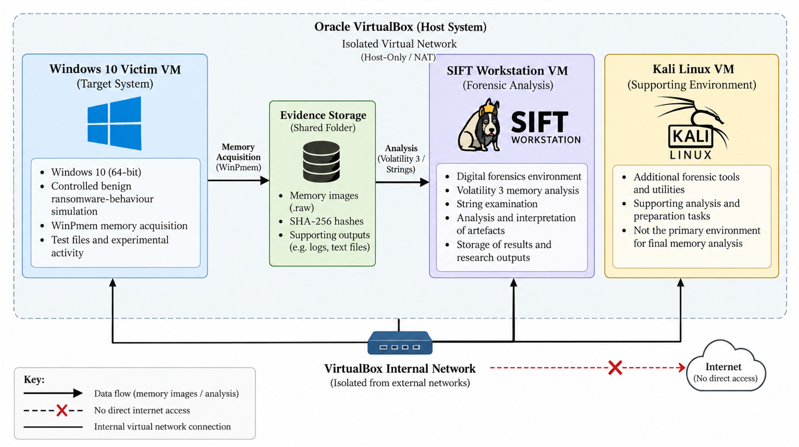
Figure 1 Experimental Architecture
Figure 4.1: Virtualised experimental architecture used for Windows 10 memory acquisition and forensic analysis.
The experimental architecture was designed to provide a controlled environment in which Windows volatile-memory evidence could be generated, acquired and analysed. Oracle VirtualBox hosted three principal virtual machines: a Windows 10 victim system, SIFT Workstation and a supporting Kali Linux environment. Each system was assigned a distinct role to separate experimental activity from subsequent forensic examination.
The Windows 10 virtual machine hosted the controlled benign ransomware-behaviour simulation and was the source of the volatile-memory evidence. WinPmem was used to acquire memory at predefined experimental stages. The resulting images were analysed primarily within SIFT Workstation using Volatility 3 and supporting string examination. Kali Linux provided supporting laboratory functions but was not used as the primary source of the final memory-analysis results.
This architecture established a workflow from controlled activity generation through memory acquisition to forensic analysis while maintaining logical separation between the victim and analysis environments.

4.2 VirtualBox and Network Isolation
Oracle VirtualBox provided the virtualised laboratory and enabled system states to be preserved through snapshots. This was important because known states could be retained or restored at key experimental checkpoints without unnecessarily repeating earlier stages.
Network configuration balanced experimental isolation with the connectivity required for laboratory preparation. The Windows 10 victim primarily used Host-only networking, while SIFT used NAT and Host-only adapters. Kali Linux also used Host-only connectivity for laboratory communication and NAT when external access was required for supporting tasks.
These arrangements limited unnecessary external exposure of the victim environment while allowing communication between relevant laboratory systems. Network connectivity and adapter configuration were verified before formal evidence acquisition.

4.3 Windows 10 Victim Environment
The Windows 10 virtual machine acted as the experimental target and primary source of volatile-memory evidence. Windows 10 was also relevant to previous research examining the reliability and investigative implications of software-based memory acquisition [3], [9].
Researcher-created test files were placed within a designated directory. The controlled PowerShell simulation operated only on these files, performing predefined file operations, including renaming selected files with the .locked extension and introducing the marker T1_SIMULATED_ENCRYPTED_DATA. These known actions provided reference points against which subsequently recovered memory artefacts could be interpreted.
WinPmem was executed on the victim system to acquire physical memory at the required experimental stages. Named VirtualBox snapshots were created at key checkpoints to preserve relevant system states.

4.4 SIFT Workstation
SIFT Workstation served as the primary forensic-analysis environment. SIFT is a dedicated digital-forensics and incident-response environment maintained by the SANS Institute [31]. Its use separated the analysis process from activity occurring on the Windows victim.
Acquired .raw memory images were made available within SIFT for analysis. Volatility 3 provided structured memory examination, while string-searching techniques were used to identify relevant readable artefacts. This environment supported consistent analysis of process information, process relationships, command-line activity, memory regions and textual evidence across the acquired images.

4.5 Kali Linux Supporting Environment
Kali Linux had a supporting rather than primary analytical role. It assisted with laboratory preparation, connectivity testing and supporting forensic activities during development of the experimental environment.
The final structured examination of the Windows memory images was performed primarily within SIFT Workstation. Kali was therefore not treated as a competing forensic platform or an independent source of experimental results. This distinction is important because the study evaluates memory artefacts rather than comparing the performance of SIFT and Kali.

4.6 Forensic Tools: WinPmem and Volatility 3
WinPmem and Volatility 3 performed the principal acquisition and analytical functions respectively. WinPmem was selected as a software-based method for acquiring physical memory from the running Windows victim [32]. Previous studies using live Windows acquisition demonstrate that this process is not completely passive because the operating system continues to execute while memory is captured [3], [9]. The WinPmem acquisition footprint was therefore considered when interpreting the resulting evidence.
Volatility 3 was used as the principal memory-analysis framework [29], [30]. windows.pslist examined process information, windows.pstree provided parent-child relationships and windows.cmdline supplied available command-line context. windows.malfind was used to identify memory regions warranting further examination, but its output was treated as an investigative indicator rather than proof of malicious activity. String examination complemented these plugins by identifying relevant textual artefacts.
The role of each acquisition, analysis and integrity-verification technique within the experimental workflow is summarised in Table 4.1.
Table 4.1: Forensic tools and techniques used within the experimental workflow
Table 2 Forensic tools and techniques used
Tool or technique | Purpose in this study | Evidence examined
WinPmem | Live volatile-memory acquisition | Windows physical-memory images
windows.pslist | Process examination | Process information within acquired memory
windows.pstree | Process relationship analysis | Parent-child process relationships
windows.cmdline | Command-line examination | Process execution context and commands
windows.malfind | Memory-region examination | Potentially suspicious executable memory regions
Strings analysis | Textual artefact examination | Rename-Item, .locked, simulator references and marker strings
SHA-256 | Post-acquisition integrity verification | Cryptographic hash values of acquired memory images

Using a consistent acquisition tool and analytical framework across the main experimental stages supported systematic comparison between memory images.

4.7 Controlled Ransomware-Behaviour Simulation
A controlled benign ransomware-behaviour simulation was developed in PowerShell to generate selected ransomware-like artefacts without executing genuine malicious software. The purpose was not to reproduce a specific ransomware family but to create known activity suitable for investigating the temporal visibility of volatile-memory evidence.
The script operated exclusively on researcher-created test files within a designated directory. It performed controlled file operations, including renaming selected files with the .locked extension, and introduced the predefined T1_SIMULATED_ENCRYPTED_DATA marker. These actions generated known process, command and textual reference points that could subsequently be searched for within acquired memory.
The known sequence of the simulation strengthened forensic interpretation because recovered artefacts could be compared with documented experimental activity. However, the simulation did not reproduce the full behaviour of genuine ransomware, which may include encryption routines, persistence, privilege manipulation, network communication and defensive evasion. The design therefore prioritised experimental control and safety over complete real-world realism.

4.8 Experimental Stages: T0, T1, T2 and T3
The practical investigation was organised into T0, T1, T2 and T3. The staged design was informed by temporal memory-forensics research demonstrating that evidence availability can vary according to the point of acquisition [4].
T0 established the clean baseline before the ransomware-behaviour experiments. It provided a reference memory state against which later activity could be considered.
T1 introduced the controlled simulation and included EARLY and POST acquisitions. It established the practical workflow and provided initial observations of simulation-related process, command-line and textual evidence.
T2 formed the principal temporal experiment and consisted of PRE, MID and POST acquisitions. PRE represented the state before the relevant simulated activity, MID captured memory during experimental activity, and POST represented the later state following execution. This sequence enabled direct comparison of whether relevant artefacts appeared, persisted or were no longer identified across acquisition stages.
T3 provided an additional POST acquisition as supporting experimental evidence. It also provided evidence relevant to identifying acquisition-generated activity, including the observable WinPmem footprint.
T1, T2 and T3 were not treated as identical experimental repetitions. Their sequences and purposes differed, with T2 providing the principal controlled PRE/MID/POST comparison. Cross-trial observations were therefore used as supporting evidence rather than assuming direct experimental equivalence.
The purpose and evidential role of each experimental stage are summarised in Table 4.2.
Table 4.2: Summary of experimental stages and their purpose
Table 3 Summary of experimental stages and purpose
Stage | System state | Memory acquisition | Main purpose
T0 | Clean Windows 10 baseline | Baseline | Establish a reference state before experimental activity
T1 EARLY | Early experimental activity | EARLY | Examine initial recoverability of simulation-related artefacts
T1 POST | Following simulated activity | POST | Examine artefact visibility after the T1 simulation
T2 PRE | Before controlled activity | PRE | Establish the reference state for the principal temporal comparison
T2 MID | During controlled activity | MID | Examine artefacts while simulation-related activity was occurring
T2 POST | Following controlled activity | POST | Examine artefact visibility after the activity had completed
T3 POST | Supporting experimental run | POST | Examine recurring artefact categories and the observable acquisition footprint

Within this structure, T2 provided the principal temporal comparison because memory was acquired at defined PRE, MID and POST stages surrounding the controlled simulation. The relationship between these acquisition points and the simulated activity is illustrated in Figure 4.2.
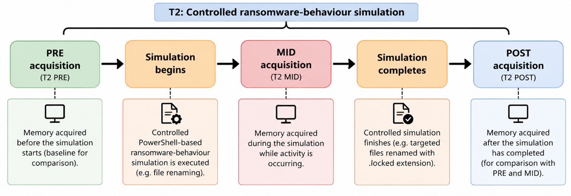
Figure 2 T2 Controlled ransomware-behaviour simulation
Figure 4.2: Temporal relationship between the T2 PRE, MID and POST memory-acquisition stages and the controlled ransomware-behaviour simulation.

4.9 Experimental Variables and Controls
The principal independent variable was the stage of volatile-memory acquisition, particularly the PRE, MID and POST conditions used in T2. The dependent variables were the observable forensic artefacts recovered from each image, including process information, parent-child relationships, command-line information, relevant memory regions and readable strings.
Several elements were kept consistent to support comparison, including the Windows 10 victim environment, controlled PowerShell simulation, WinPmem acquisition method and Volatility 3 analytical framework. VirtualBox snapshots were also used at key checkpoints to preserve known system states.
Complete experimental equivalence was not assumed. Normal Windows activity and the acquisition process itself could modify volatile memory, while T1, T2 and T3 followed different acquisition sequences. Previous research demonstrates that software-based live acquisition can contain inconsistencies [3], [9]. Observed differences were therefore interpreted against the known experimental timeline rather than automatically attributed to the simulation.

4.10 Evidence Integrity and Snapshot Strategy
Evidence preservation was incorporated throughout the experimental workflow. Following WinPmem acquisition, SHA-256 hashes were calculated and recorded for the memory images. These hashes provided post-acquisition integrity verification by allowing subsequent copies or analyses to be checked against the recorded values. They were not treated as proof that the original live acquisition represented a perfectly static memory state.
A structured VirtualBox snapshot strategy was also maintained throughout T0–T3. Named snapshots were created at important checkpoints before and after simulation, acquisition and analytical activities. This supported restoration to known states where required and documented progression through the practical workflow.
Memory images, hash records and analytical outputs were retained as experimental evidence. Together, the documented acquisition stages, SHA-256 records and named snapshots created an auditable connection between experimental activity, memory acquisition and subsequent analysis.

Chapter 5: Experimental Implementation
This chapter describes the practical implementation of the experimental design presented in Chapter 4. It documents how the virtual forensic environment was prepared, how the controlled benign ransomware-behaviour simulation was executed across the T0–T3 experimental stages, and how volatile memory was acquired and preserved for analysis. The chapter also explains the practical use of WinPmem, SHA-256 verification, Volatility 3 and supporting string examination, together with the technical challenges encountered and the adjustments made during implementation. Detailed evaluation and interpretation of the resulting forensic evidence is reserved for Chapter 6.

5.1 Environment Preparation
Before beginning memory acquisition, the virtual laboratory was prepared and tested to ensure that the experimental systems could communicate as required while keeping the victim environment controlled. Three virtual machines were configured in Oracle VirtualBox: Windows 10 as the victim system, SIFT Workstation as the primary forensic workstation, and Kali Linux as a supporting environment. Network adapters were configured using Host-only and NAT connections according to the role of each system. Connectivity between the required laboratory machines was verified before experimental activity began.
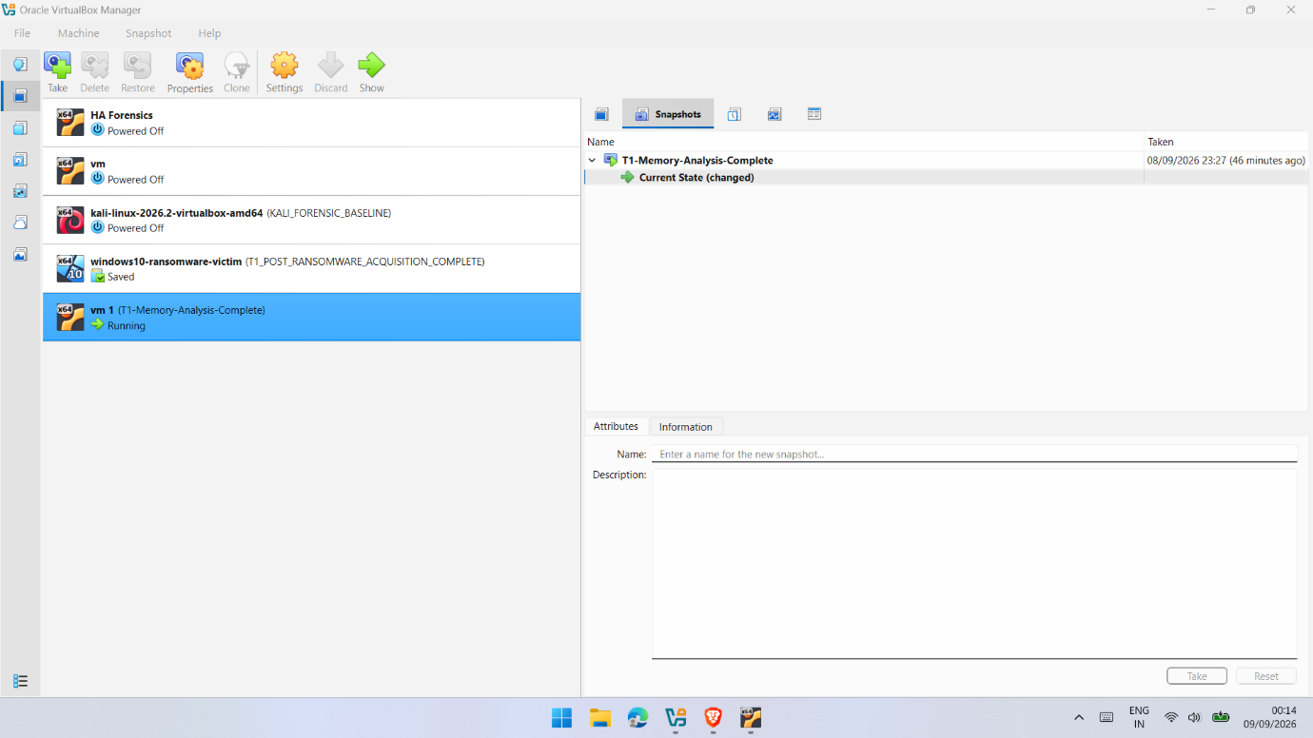
Figure 5.1: Oracle VirtualBox environment used to manage the virtual machines and experimental snapshots during the practical investigation.
The forensic tools were then prepared. WinPmem was made available to the Windows 10 victim for live memory acquisition, while Volatility 3 was configured within SIFT for analysis of the resulting memory images. Supporting Linux utilities, including strings and hashing tools, were also verified before the main experiments.
Dedicated evidence locations were established for transferring and storing the .raw memory images and analytical outputs. Test directories and files were prepared on Windows for the controlled ransomware-behaviour simulation. Clean VirtualBox snapshots were then created before experimental activity, providing recoverable checkpoints and helping to maintain separation between the different stages of the practical investigation.

5.2 T0 Clean Baseline
The practical investigation began with T0, which established a clean memory baseline before any controlled ransomware-related activity was introduced. The Windows 10 victim was prepared in its normal operating state and checked to confirm that the ransomware-behaviour simulation had not been executed. This baseline provided a reference point for distinguishing ordinary Windows activity from artefacts observed during later experimental stages.
A complete volatile-memory image was acquired from the running Windows 10 system using WinPmem. The resulting .raw image was transferred to the designated evidence location, and a SHA-256 hash was calculated to provide a post-acquisition integrity reference. The successful acquisition and hash verification are shown in Figure 5.2.
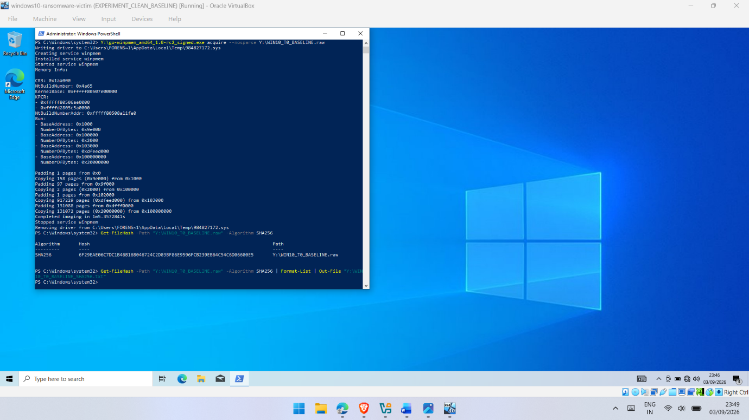
Figure 5.2: WinPmem acquisition and SHA-256 integrity verification of the T0 clean-baseline Windows 10 memory image.
Once the baseline evidence had been preserved, a VirtualBox snapshot named T0_CLEAN_BASELINE_COMPLETE was created. A corresponding Kali forensic baseline was preserved as KALI_FORENSIC_BASELINE. These checkpoints established the initial experimental state before proceeding to T1 and provided a controlled reference for later comparison.

5.3 T1 Experiment
Following completion of the clean baseline, T1 introduced the controlled ransomware-behaviour simulation and the first timing-based comparison. Before beginning the experiment, the Windows 10 victim was preserved using the snapshot T1_PRE_EXPERIMENT, providing a recoverable state before the main T1 activity. An early memory acquisition was then performed using WinPmem and preserved as WIN10_T1_EARLY.raw, producing an approximately 4.5 GB memory image. Its SHA-256 hash was recorded before analysis.
The benign PowerShell simulation, stored as C:\T1_Simulator.ps1, was subsequently executed against the designated test directory. The script performed controlled file operations and produced .locked test files containing the predefined marker T1_SIMULATED_ENCRYPTED_DATA. These known actions created reference artefacts that could later be compared with evidence recovered from memory.
Following execution, the predefined files within C:\T1_Test were successfully renamed with the .locked extension. Figure 5.3 provides implementation evidence of the resulting controlled file artefacts and confirms that the intended observable behaviour was generated without deploying genuine ransomware.
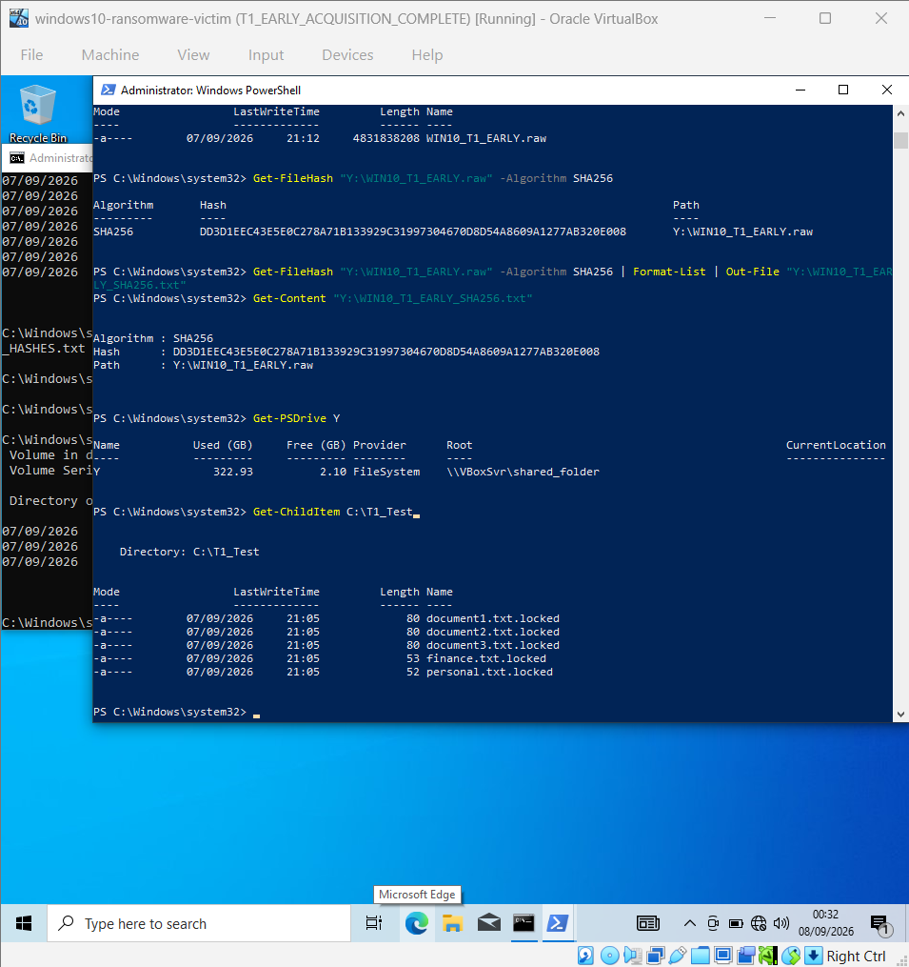
Figure 5.3: Controlled .locked file artefacts generated within C:\T1_Test following execution of the benign ransomware-behaviour simulation during T1.
A further memory image, WIN10_T1_POST.raw, was acquired after the simulated activity and was similarly preserved and hashed.
Initial examination was conducted within SIFT Workstation using Volatility 3 and supporting techniques. Process and command-history information was examined alongside malfind output and strings. The practical evidence preserved the PowerShell execution context, including an observed PowerShell process with PID 6468 and parent PID 4984. The simulator script and .locked test files were subsequently verified within the restored Windows environment.
Snapshots were maintained throughout the experiment, including T1_EARLY_ACQUISITION_COMPLETE and T1_POST_RANSOMWARE_ACQUISITION_COMPLETE, while the SIFT analysis state was preserved as T1-Memory-Analysis-Complete. T1 therefore established the initial timing-based workflow and provided the foundation for the more structured PRE/MID/POST comparison undertaken in T2.

5.4 T2 PRE/MID/POST Experiment
T2 extended the initial T1 investigation by introducing a structured temporal design based on PRE, MID and POST memory acquisitions. This provided the principal direct comparison of acquisition timing within the practical investigation. Before simulated activity began, the Windows 10 environment was returned to the required experimental state and preserved using the T2_PRE_MID_EXECUTION snapshot.
The PRE memory image was acquired using WinPmem and preserved for subsequent analysis. Its recorded SHA-256 value was:
a3fca4e12b3672b90fff1943c4d78ee7e3a7aabc25530ee25f732a6df35d47d8
The controlled PowerShell ransomware-behaviour simulation was then executed, and the MID acquisition was performed while relevant experimental activity was present. This stage was intended to capture transient evidence closer to active execution rather than relying exclusively on a later memory image. The MID image was approximately 4.5 GB and produced the SHA-256 value:
3648f54ca6d7eb534dfed5bb7e8da02743931686d61ae6e2191d3dd318e105f0
During analysis, a PowerShell process with PID 5208 was identified in the MID acquisition. String examination also recovered simulation-related material, including references to Rename-Item and the .locked extension.
String-based examination was then used to compare simulation-related artefacts across the experimental stages. References to Rename-Item and .locked were identified within the MID acquisition, while corresponding filtered results were not identified in the PRE and POST outputs, as illustrated in Figure 5.4.
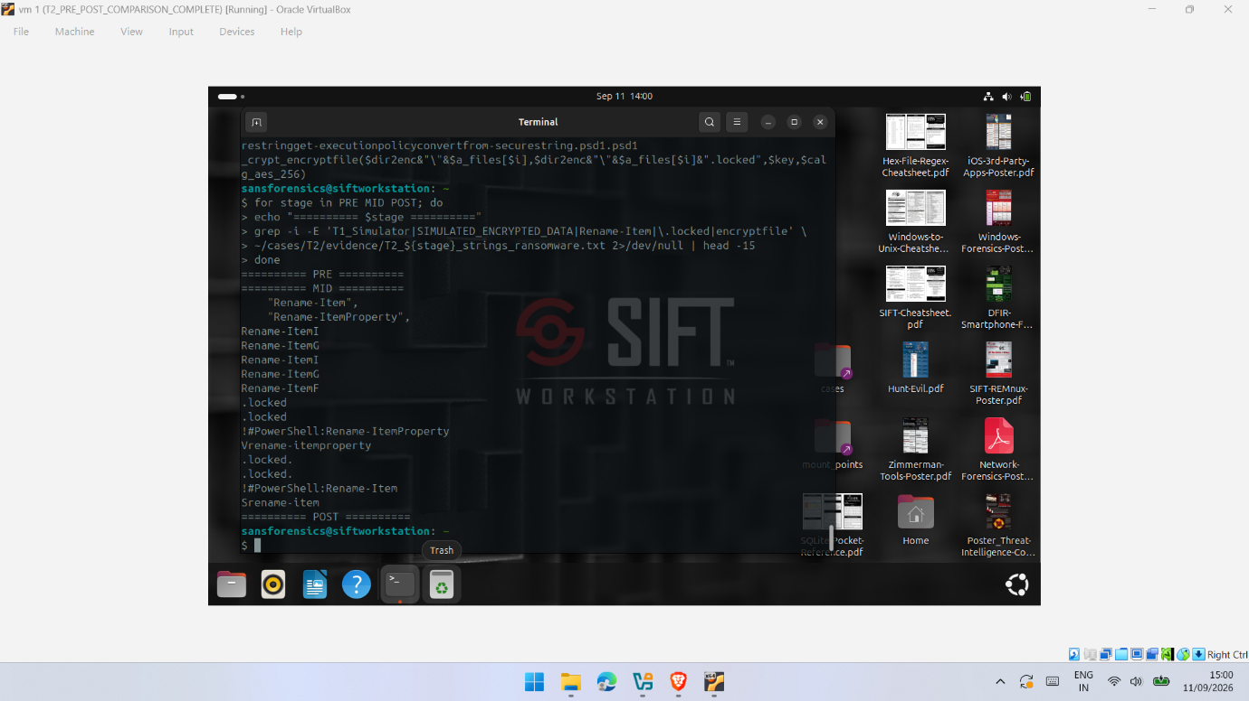
Figure 5.4: T2 PRE/MID/POST string comparison showing Rename-Item and .locked references identified within the MID acquisition.
A third acquisition was completed at the POST stage after the relevant simulated activity had progressed. The PRE, MID and POST images were transferred to SIFT Workstation and examined using a consistent combination of windows.pslist, windows.pstree, windows.cmdline, windows.malfind and string analysis. Separate analytical outputs were retained to support comparison between the three stages.
VirtualBox snapshots were created throughout T2, including T2_POST_SIMULATION_EXECUTION, T2_POST_ACQUISITION_COMPLETE and T2_MID_ARTEFACT_VERIFICATION_COMPLETE. Corresponding SIFT checkpoints, including T2_POST_MEMORY_ANALYSIS_COMPLETE and T2_PRE_POST_COMPARISON_COMPLETE, preserved the analysis workflow. T2 therefore produced a documented sequence of memory evidence suitable for examining how observable forensic artefacts varied across PRE, MID and POST acquisition points. Detailed interpretation of these differences is presented in Chapter 6.

5.5 T3 Supporting Experiment
The T3 experiment provided an additional post-simulation acquisition to support the observations obtained during the earlier experimental stages and to examine the acquisition workflow in a further controlled run. Before execution, the Windows 10 victim was prepared and preserved using the snapshots T3_PRE_EXPERIMENT and T3_PRE_SIMULATION_READY. The same benign PowerShell ransomware-behaviour simulation was then executed against the designated test data, after which the system state was preserved as T3_POST_SIMULATION_EXECUTION.
A post-simulation memory image, WIN10_T3_POST.raw, was acquired using WinPmem and transferred to the forensic environment. The image produced the SHA-256 value:
b8a509c02a181974f1e6bd67eda1708f87b3a765c948165cc37a2d43e567e9e4
This value was recorded for integrity verification, after which the Windows state was preserved as T3_POST_ACQUISITION_COMPLETE.
Analysis was conducted within SIFT Workstation using the same core techniques applied during the previous experiments. windows.pslist, windows.pstree, windows.cmdline, windows.malfind and string examination were used to generate the T3 analytical outputs. The recovered evidence included a PowerShell process with PID 6752, WinPmem with PID 1688, and command-line evidence showing WinPmem acquiring the T3 memory image. String analysis also recovered references associated with the controlled simulator and its predefined marker.
Figure 5.5 documents the WinPmem acquisition of the T3 POST memory image following the controlled simulation.
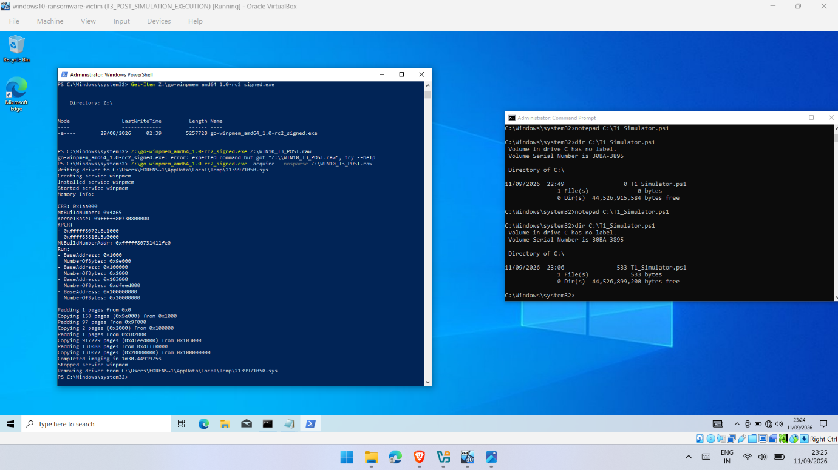
Figure 5.5: WinPmem acquisition of the WIN10_T3_POST.raw memory image following the controlled ransomware-behaviour simulation.
The completed analysis was preserved using T3_POST_MEMORY_ANALYSIS_COMPLETE and T3_FINAL_PRACTICAL_COMPLETE. T3 was treated as supporting experimental evidence rather than an identical repetition of T2, allowing recurring artefacts and acquisition-related activity to be considered during the cross-trial analysis presented in Chapter 6.

5.6 Memory Acquisition Using WinPmem
WinPmem was used consistently to acquire volatile memory from the running Windows 10 victim. Each acquisition was performed while the virtual machine remained active, allowing memory to be collected at the intended experimental stage. This was particularly important during T2, where PRE, MID and POST represented different points surrounding the controlled simulation.
The resulting .raw images were approximately 4.5 GB, corresponding to the memory allocated to the victim virtual machine. Descriptive filenames, including WIN10_T1_EARLY.raw, WIN10_T1_POST.raw and WIN10_T3_POST.raw, maintained an association between each memory image and its acquisition stage.
WinPmem-related processes and command-line artefacts were visible within some acquired images, particularly T3. These were retained as part of the evidence because they represented the acquisition-tool footprint rather than activity generated by the ransomware-behaviour simulation. This distinction is important because software-based live acquisition interacts with the target system and can influence the memory state being captured [3], [9].

5.7 SHA-256 Integrity Verification
SHA-256 hashing was used following acquisition to support evidence integrity. Hash values were calculated for the acquired .raw images and recorded against their corresponding experimental stages. These values provided reference points for verifying that the acquired evidence remained unchanged during subsequent transfer, storage and analysis.
For example, the T2 MID image produced:
3648f54ca6d7eb534dfed5bb7e8da02743931686d61ae6e2191d3dd318e105f0
while the T3 POST image produced:
b8a509c02a181974f1e6bd67eda1708f87b3a765c948165cc37a2d43e567e9e4
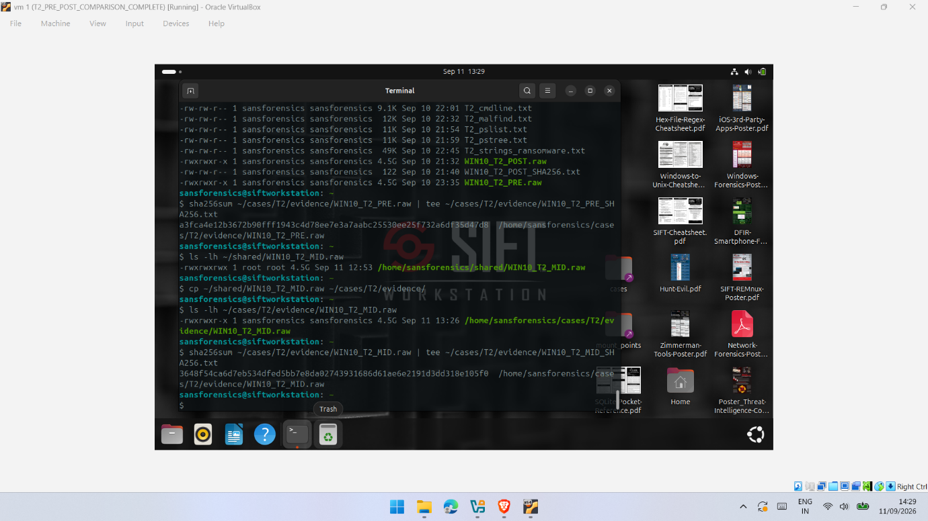 Figure 5.6: SHA-256 integrity verification of the WIN10_T2_MID.raw memory image within the SIFT forensic environment.
Importantly, hash verification demonstrates post-acquisition integrity rather than proving that the original live capture represented a perfectly static memory state. Inconsistencies arising during live acquisition remain a separate consideration [3], [9]. SHA-256 hashing therefore supported preservation of the evidence after collection, while acquisition reliability was considered independently.

5.8 Volatility 3 and Strings Analysis
Following acquisition and integrity verification, the memory images were analysed within SIFT Workstation using Volatility 3 and supporting string examination. A consistent set of plugins was applied where appropriate to generate comparable outputs. Volatility 3 provides structured plugins for examining Windows memory artefacts, including processes, process relationships and command-line information [29], [30].
The windows.pslist plugin was used to enumerate processes, while windows.pstree provided parent-child relationships and additional execution context. windows.cmdline was used to recover available command-line information associated with processes of interest. During T3, these techniques identified PowerShell activity together with the WinPmem acquisition process and the command associated with WIN10_T3_POST.raw, as illustrated in Figure 5.7.
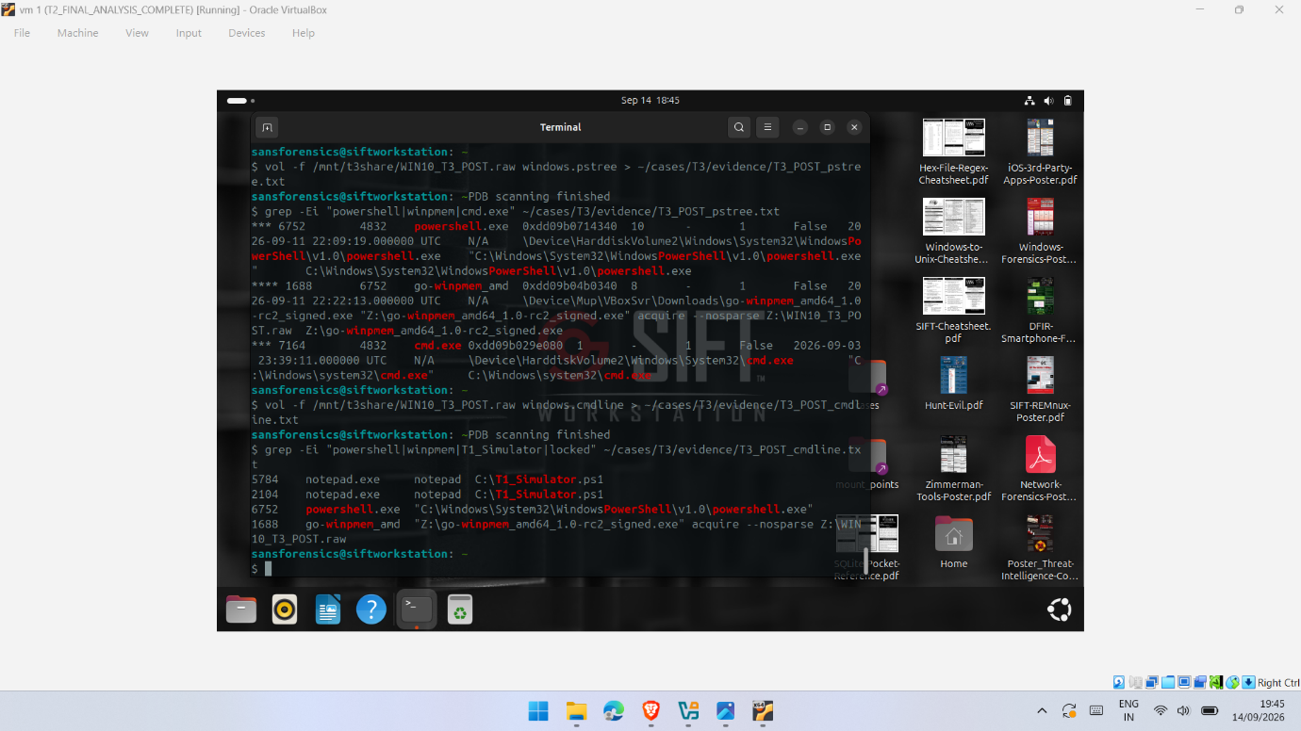
Figure 5.7: Volatility 3 windows.pstree and windows.cmdline analysis showing PowerShell activity, the WinPmem acquisition process and the command used to acquire WIN10_T3_POST.raw.
The windows.malfind plugin was also applied to identify potentially suspicious executable memory regions [30]. Its output was treated as an investigative indicator rather than independent evidence of ransomware-related activity because executable-memory findings require correlation with additional forensic context [8].
Structured analysis was complemented by string searches for known experimental artefacts, including T1_Simulator.ps1, Rename-Item, .locked and T1_SIMULATED_ENCRYPTED_DATA. During T2, simulation-related strings were recovered from the MID acquisition, while their visibility differed across the PRE and POST images. These observations were retained for detailed temporal interpretation in Chapter 6.
Analytical outputs were organised according to trial and acquisition stage so that process, command-line, memory-region and string evidence could be correlated before the cross-stage and cross-trial comparisons.

5.9 Practical Challenges and Resolutions
Several practical challenges were encountered during implementation and required adjustment before a stable experimental workflow was established. One initial issue concerned the virtual network configuration. The required Host-only interface was not immediately available within the forensic environment, preventing communication between the relevant virtual machines. The adapter configuration was reviewed and corrected, after which connectivity was successfully verified.
Tool availability presented a further challenge. Volatility was not initially available within the intended analysis environment, with commands such as vol.py returning errors. Volatility 3 was subsequently installed and configured, enabling the required plugins, including windows.pslist, windows.pstree, windows.cmdline and windows.malfind, to be executed successfully. SIFT Workstation was then used as the primary forensic environment because it provided a stable platform for the completed memory-analysis workflow.
The experimental procedure also developed during the practical investigation. T1 established an initial EARLY/POST comparison, while T2 introduced the more structured PRE/MID/POST acquisition sequence. T3 provided an additional POST acquisition as supporting experimental evidence. The trials were therefore documented according to the procedures actually performed rather than presented as identical experimental repetitions.
Regular VirtualBox snapshots were maintained throughout configuration, troubleshooting and experimental activity. These checkpoints allowed stable system states to be restored following configuration changes and reduced the risk of technical problems affecting subsequent stages. Overall, these adjustments enabled the practical investigation to proceed while maintaining a documented and controlled experimental workflow.

Chapter 6: Results, Evaluation and Discussion

6.1 Introduction
This chapter presents and critically evaluates the findings obtained from the T1, T2 and T3 memory-forensics experiments. The analysis focuses on evidence recovered through Volatility 3 and string examination, including process activity, parent-child relationships, command-line information, potentially suspicious memory regions and simulation-related textual artefacts. Particular attention is given to the T2 PRE, MID and POST acquisitions because these provide the clearest basis for evaluating changes in artefact visibility across acquisition stages.
The findings are first considered individually before being compared across acquisition points and experimental trials. The effectiveness and limitations of the forensic techniques are then evaluated, followed by discussion of acquisition timing in relation to existing research. Finally, the combined evidence is used to answer the three research questions established in Chapter 1.
The evaluation focuses on the evidential significance of the recovered artefacts rather than simply whether individual tools produced output. Each result is therefore considered in relation to the acquisition stage, the known experimental timeline and other corroborating artefacts. Particular attention is given to whether evidence was identified, persisted, changed or no longer identified between acquisition points. Where an expected artefact was not identified, this is treated as a meaningful experimental observation rather than automatically interpreted as complete absence from physical memory. This approach allows both positive and negative findings to contribute to the evaluation while recognising the temporal and acquisition-related limitations of volatile-memory evidence.

6.2 T1 Results
T1 provided an initial indication that the visibility of simulation-related evidence could differ according to the stage at which memory was acquired. Comparison of the EARLY and POST acquisitions showed that relevant activity could be reconstructed from several complementary artefact types rather than from a single forensic indicator.
Within the T1 evidence, PowerShell activity associated with the experimental environment was identified, including a PowerShell process with PID 6468 and parent PID 4984. Supporting examination recovered references to the controlled simulation script, C:\T1_Simulator.ps1. Following execution, the designated test directory contained files renamed with the .locked extension, while examination of the test data confirmed the predefined T1_SIMULATED_ENCRYPTED_DATA marker. String examination additionally recovered Rename-Item, .locked, simulator script and marker references, providing investigator-readable context that could be correlated with the known experimental activity.
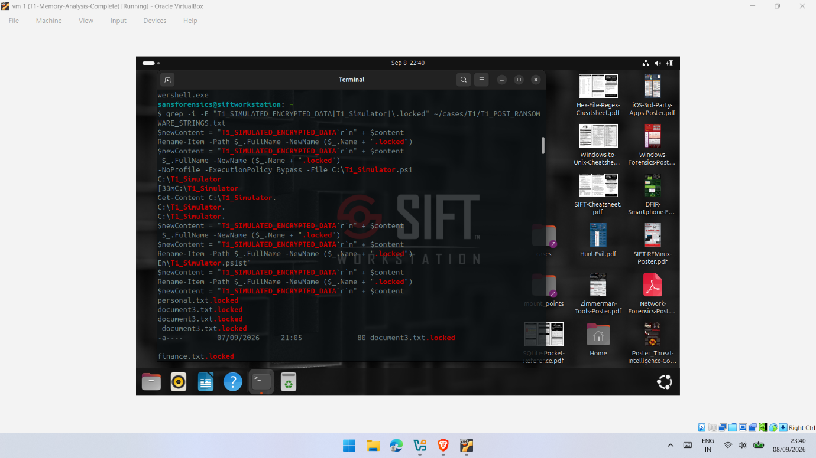
Figure 6.1: T1 string-analysis evidence showing the controlled simulation marker, Rename-Item, .locked references and T1_Simulator.ps1 recovered from the T1 memory evidence.
These findings were not interpreted as demonstrating that an individual PowerShell process, recovered string or windows.malfind result independently represented ransomware-related activity. PowerShell is a legitimate Windows component, while executable or otherwise unusual memory regions require additional forensic context before their significance can be established. The evidential value instead arose from correlation between process information, recovered strings, the known simulation timeline and the controlled file-system changes.
T1 therefore demonstrated the practical value of combining process and string-based evidence when reconstructing the controlled activity. However, because T1 used an EARLY/POST structure rather than the more controlled PRE/MID/POST sequence, it was treated as supporting evidence rather than the principal basis for evaluating acquisition timing.

6.3 T2 PRE Results
The T2 PRE acquisition established the reference state immediately before the controlled ransomware-behaviour simulation. Its purpose was to identify processes and memory characteristics that were already present before the MID and POST stages. This distinction was important because artefacts observed across multiple acquisition stages could not automatically be attributed to the controlled simulation.
Analysis of the PRE image using windows.pslist showed that PowerShell activity was already observable before the relevant MID-stage activity. Consequently, the presence of PowerShell alone could not be considered evidence of ransomware-related behaviour. Interpretation required correlation with additional forensic context, including process relationships, command-line information, recovered strings and the known experimental timeline.
The string comparison provided a clearer distinction between PRE and MID. Simulation-related textual indicators subsequently identified during MID, including Rename-Item and .locked, were not identified in the corresponding filtered PRE output. This does not establish that the strings were completely absent from physical memory; rather, they were not recovered through the analysis applied to the PRE image.
Overall, PRE provided an essential reference point by distinguishing general process activity from artefacts more directly associated with the controlled simulation. It therefore provided the basis against which the richer MID evidence and subsequent POST results were interpreted.

6.4 T2 MID Results
The T2 MID acquisition produced the richest set of simulation-related artefacts within the PRE/MID/POST comparison. Because the image was acquired during the relevant stage of controlled activity, it captured evidence closer to active execution than the later POST acquisition. This observation is consistent with temporal memory-forensics research showing that volatile evidence availability can vary according to acquisition timing [4].
Process analysis identified PowerShell PID 5208 within the MID image. PowerShell presence alone was not treated as evidence of simulated ransomware behaviour because PowerShell activity was also observable during PRE. Stronger contextual evidence was provided by string analysis, which recovered Rename-Item and .locked references corresponding with known file-renaming behaviour performed by the controlled simulation.

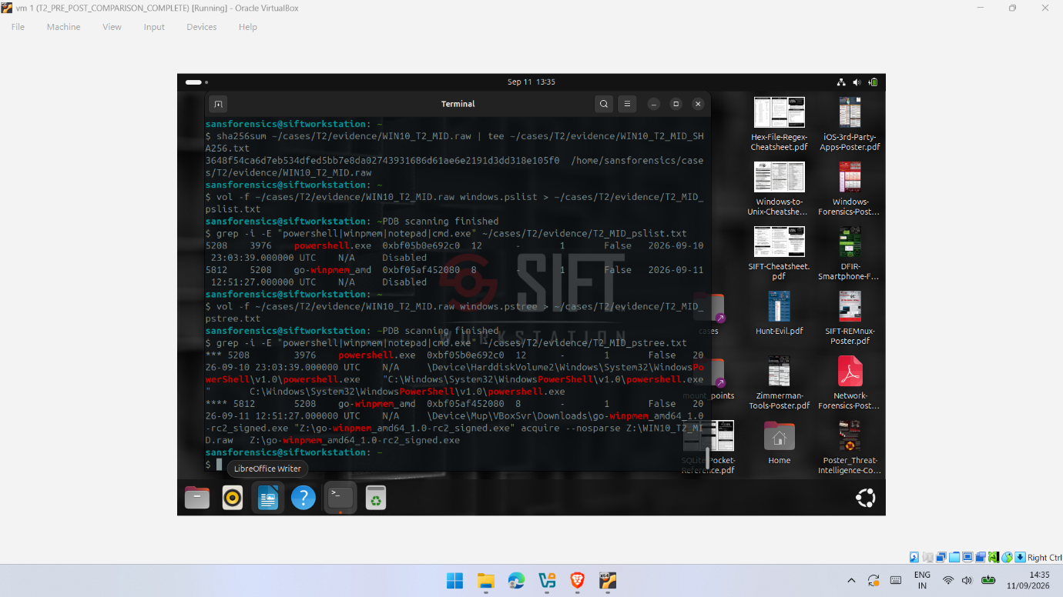

Figure 6.2: Volatility 3 process analysis of the T2 MID memory acquisition showing PowerShell PID 5208 and the WinPmem acquisition process.
The MID findings demonstrate the importance of correlating multiple artefact types. Process analysis established PowerShell activity, while string evidence provided additional context linking recovered memory contents to known experimental actions. Outputs from windows.pstree, windows.cmdline and windows.malfind were also examined for supporting execution and memory-region context. Any regions identified by windows.malfind were treated as investigative indicators rather than proof of malicious activity because executable-memory behaviour requires interpretation alongside additional forensic evidence [8], [30].
Importantly, the simulation-related strings identified during MID were not identified in the same way in the corresponding filtered PRE and POST comparisons. Under the T2 experimental conditions, MID therefore provided richer investigator-readable evidence associated with the controlled activity. This does not establish MID as universally superior; it demonstrates that artefact visibility differed between acquisition stages within T2.

6.5 T2 POST Results
The T2 POST acquisition represented the later system state following the relevant controlled simulation activity. Comparison with MID showed that some previously observable artefacts were no longer identified using the same analytical techniques. In particular, the PowerShell process identified during MID was not present in the compared POST windows.pslist output.
A similar difference occurred during string examination. References to Rename-Item and .locked, which provided contextual evidence during MID, were not identified in the corresponding filtered POST comparison. This does not demonstrate that the information had been completely removed from physical memory. It establishes only that these artefacts were not recovered using the applied techniques from that POST image. Volatile-memory contents change over time, and evidence availability can depend on the point of acquisition [4].
Under the tested conditions, POST therefore contained less directly interpretable simulation-related evidence than MID. This does not mean that post-event acquisition lacks forensic value. Rather, the results demonstrate that different acquisition points can preserve different views of system activity. Comparison with earlier acquisitions and the known experimental timeline provided greater interpretative context than consideration of the POST image alone.

6.6 T2 PRE/MID/POST Comparative Analysis
Comparison of the T2 PRE, MID and POST acquisitions provides the clearest temporal evidence produced by this study. Rather than demonstrating a simple accumulation of evidence over time, the three acquisitions provided different views of the experimental sequence. This is consistent with Hirano and Kobayashi [4], who demonstrate the forensic value of examining volatile memory across multiple temporal points.
PRE established the reference state. PowerShell activity was already observable, demonstrating that process presence alone could not be attributed to the controlled simulation. During MID, PowerShell PID 5208 was observed alongside simulation-related strings including Rename-Item and .locked. As these strings corresponded with known actions performed by the benign simulation, their correlation with process evidence provided stronger contextual information. By POST, the MID PowerShell process was no longer present in the compared windows.pslist output, while the corresponding filtered string examination did not identify the same simulation-related references.
Table 6.1: Comparison of key artefacts across the T2 acquisition stages
Table 4 Comparison of T2 acquisition stages
Evidence examined | PRE | MID | POST
PowerShell activity | Observed | Observed, PID 5208 | MID process not observed
Rename-Item reference | Not identified in comparison | Identified | Not identified in comparison
.locked reference | Not identified in comparison | Identified | Not identified in comparison
Simulation context | Limited | Stronger correlation | Reduced direct visibility
Evidential role | Reference state | Richest simulation-related evidence | More limited than MID

The string-based differences summarised in Table 6.1 are also visible in the PRE/MID/POST comparison presented previously in Figure 5.4.
The comparison demonstrates that the relationship between acquisition timing and evidential value was not simply cumulative. A later acquisition did not necessarily provide a richer representation of earlier activity. Under the T2 experimental conditions, MID produced the richest combination of investigator-readable process and textual evidence, whereas the corresponding POST examination did not identify several of the same indicators.
Importantly, failure to identify an artefact using the applied techniques does not demonstrate that it was completely absent from physical memory. Volatile memory changes continuously, and software-based live acquisition may itself introduce inconsistencies [3], [9]. The observed differences must therefore be interpreted as differences in recoverable and observable evidence rather than proof of complete artefact disappearance.
The findings do not establish MID as a universally superior acquisition point, nor do they demonstrate that POST acquisition is inherently less valuable. Instead, T2 provides experimental evidence that the forensic picture available to an investigator can vary according to when memory is acquired. Where operationally feasible, timely acquisition and comparison of multiple temporal acquisitions may provide complementary evidence that would not necessarily be available through reliance on a single image [4].

6.7 T3 Supporting Results
T3 provided a supporting observation for findings obtained during the earlier trials. It was not designed as an identical PRE/MID/POST repetition of T2 and is therefore not treated as a direct replication.
Analysis of WIN10_T3_POST.raw identified PowerShell PID 6752 with parent PID 4832. WinPmem PID 1688 was also identified, while windows.pstree and windows.cmdline provided additional execution context. The recovered evidence included the WinPmem acquisition command associated with WIN10_T3_POST.raw, while string examination identified references associated with the controlled simulation and its predefined marker. Together, these findings demonstrated that process, command-line and textual evidence could again be correlated within the controlled environment.
T3 also provided direct evidence of the acquisition-tool footprint. The presence of WinPmem PID 1688 and its associated acquisition command represented activity generated by evidence collection rather than by the ransomware-behaviour simulation. This observation is consistent with research demonstrating that software-based live acquisition interacts with the system being examined and may influence the captured state [3], [9]. Distinguishing acquisition-related artefacts from the activity under investigation is therefore important when interpreting live-memory evidence.
Overall, T3 provided supporting evidence that comparable categories of process, command-line and textual artefacts were recoverable during another controlled execution. Because its acquisition sequence differed from T2, however, these findings are treated as supporting observations rather than evidence of direct experimental replication.

6.8 Cross-Trial T1/T2/T3 Comparison
Comparison across T1, T2 and T3 identified recurring categories of forensic evidence, although the trials were not identical in design. PowerShell activity, command-related information and simulation-associated textual artefacts were recoverable at different points across the experimental workflow. These findings demonstrate the value of correlating multiple evidence types rather than relying on a single process or memory artefact when reconstructing activity.
T1 demonstrated that PowerShell activity and simulator-related references could be recovered alongside the known .locked file changes. T2 provided the principal temporal comparison through its structured PRE, MID and POST acquisitions. MID contained the richest combination of simulation-related evidence, including PowerShell PID 5208 and references to Rename-Item and .locked, while several of these indicators were not identified in the corresponding filtered POST examination. T3 provided supporting observations through PowerShell PID 6752, simulation-related strings and evidence of the WinPmem acquisition process. The latter also demonstrated that investigator-generated acquisition activity can become part of the captured memory state.
Table 6.2: Cross-trial comparison of principal experimental observations
Table 5 Comparison of experimental observations
Trial | Main evidence recovered | Main contribution
T1 | PowerShell activity, simulator references and controlled .locked artefacts | Established initial recoverability of simulation-related evidence
T2 | PRE/MID/POST process and string evidence | Provided the principal comparison of acquisition timing
T3 | PowerShell, simulator strings and WinPmem process/command evidence | Supported recurring artefact categories and demonstrated the acquisition footprint

The results demonstrate consistency in the categories of evidence recovered rather than identical artefacts across every acquisition. This distinction is important because volatile memory changes continuously and software-based live acquisition may itself influence the captured state [3], [9]. Furthermore, differences between T1, T2 and T3 cannot be attributed solely to acquisition timing because their acquisition sequences were not experimentally equivalent.
T2 therefore provides the strongest experimental basis within this study for addressing the acquisition-timing question. T1 and T3 provide supporting observations that strengthen interpretation of the T2 findings without being treated as independent replications.

6.9 Evaluation of Forensic Techniques
The experiments demonstrated that no single forensic technique provided sufficient context to reconstruct the controlled activity independently. The most informative results were obtained by correlating Volatility 3 outputs with string examination and the known experimental timeline. This reduced the risk of assigning excessive significance to an isolated process, memory region or textual artefact.
windows.pslist provided an effective starting point by identifying processes, including PowerShell instances observed during the experiments. Its principal limitation was that process presence alone provided limited information about the purpose of that activity. This was particularly evident in T2, where PowerShell was observable in both PRE and MID. windows.pstree added contextual value by exposing parent-child relationships, while windows.cmdline provided available command-line information. In T3, this included the WinPmem acquisition command, which helped distinguish acquisition-generated activity from the controlled simulation.
windows.malfind provided an additional investigative perspective by identifying memory regions warranting further examination [30]. Such findings were not interpreted independently as evidence of ransomware-related activity because executable-memory observations require correlation with process, execution and experimental context [8].
String examination was particularly useful for recovering human-readable experimental context. References including Rename-Item, .locked and the predefined simulation marker provided links between otherwise generic process activity and known actions performed during the controlled simulation. Its limitations were demonstrated by T2, where relevant strings identified during MID were not identified in the corresponding filtered PRE and POST examinations.
Overall, the techniques provided complementary forms of evidence. windows.pslist established process presence, windows.pstree provided relationship context, windows.cmdline supplied execution information where available, and windows.malfind supported examination of potentially relevant memory regions. String analysis provided some of the clearest investigator-readable links to the simulation, although its effectiveness varied between acquisition stages.
The principal analytical strength therefore came from correlation rather than any individual technique. Within this experiment, the effectiveness of Volatility 3 depended not only on extracting artefacts but also on combining complementary outputs with string evidence, acquisition timing and the known experimental sequence.

6.10 Effect of Memory Acquisition Timing
The experimental findings indicate that acquisition timing influenced the visibility and interpretability of ransomware-related artefacts within the tested Windows 10 environment. This was most clearly demonstrated during T2, where structured PRE, MID and POST acquisitions enabled evidence from different stages of the controlled simulation to be compared directly.
Among the three T2 acquisition stages, MID produced the richest combination of simulation-related evidence. PowerShell activity was identified alongside references to Rename-Item and .locked, providing stronger contextual links to the controlled ransomware-behaviour simulation. In comparison, these simulation-related strings were not identified in the corresponding filtered PRE and POST examinations. The results therefore demonstrate that artefacts observable through the applied techniques at one acquisition point may not be equally observable at another.
However, these findings do not demonstrate that MID acquisition is universally superior or represents an optimal acquisition point for ransomware investigations. Volatile memory changes continuously as processes execute, terminate and memory regions are reused. Furthermore, software-based live acquisition can introduce inconsistencies because the target continues operating during capture [3], [9]. Differences between acquisition stages may therefore reflect both genuine temporal changes and characteristics of the live-acquisition process.
The findings instead support a more cautious conclusion: acquisition timing can influence the forensic evidence available for interpretation, but no single acquisition point can be assumed to preserve every relevant artefact. Where operationally feasible, timely acquisition and comparison of evidence from multiple temporal points may provide a more complete representation of changing system activity than reliance on a single later memory image. This interpretation is consistent with temporal memory-forensics research demonstrating the investigative value of examining volatile memory across different points in time [4].

6.11 Comparison of Experimental Findings with Existing Literature
The experimental findings broadly support existing research concerning the temporal and dynamic nature of volatile-memory evidence while also highlighting important methodological differences. Hirano and Kobayashi [4] demonstrated through FIMAR that examining memory across multiple temporal points can provide evidence that may not be available from a single acquisition. A comparable pattern was observed in T2, where Rename-Item and .locked references identified during MID were not identified in the corresponding filtered PRE and POST examinations. The present findings therefore support the broader value of temporal comparison. However, FIMAR employs a specialised acquisition architecture, whereas this experiment used conventional software-based live acquisition with WinPmem. The findings should therefore be considered complementary rather than directly equivalent.
This distinction becomes particularly important when considered alongside Rzepka et al. [3], [9]. Their research demonstrates that live Windows memory acquisition can introduce inconsistencies because system execution continues during capture and because acquisition quality can affect subsequent forensic analysis. The PRE/MID/POST differences observed here are compatible with a temporal explanation, but acquisition timing cannot be treated as the only possible cause. Some variation may also have resulted from characteristics of the live-acquisition process. Recognising this alternative explanation prevents the findings from being interpreted more strongly than the methodology supports.
The findings also complement ransomware-memory research focused on identification and detection. Oh et al. [5] demonstrate the usefulness of memory-derived information for ransomware-process triage, while Aljabri et al. [2] show that memory-derived features can support automated ransomware classification. Their objectives differ from those of the present study. Rather than determining whether ransomware can be classified or detected from memory, this investigation examines how investigator-readable evidence varies across acquisition stages and how multiple artefact types contribute to forensic interpretation.
Taken together, the literature and experimental findings identify the specific contribution of this study. Existing research demonstrates the value of temporal memory examination [4], identifies limitations associated with live-memory acquisition [3], [9], and demonstrates the analytical usefulness of memory-derived ransomware evidence [2], [5]. This study brings these concerns together within a controlled Windows 10 experiment using WinPmem and Volatility 3. Its contribution is not the identification of a universally optimal acquisition point, but experimental evidence that acquisition timing can influence the forensic picture available to an investigator while uncertainty introduced by live acquisition remains part of the interpretation.

6.12 Answers to the Research Questions
The combined findings from T1, T2 and T3 provide evidence addressing the three research questions established in Chapter 1.
RQ1: What ransomware-related artefacts can be identified within Windows 10 volatile memory following a controlled ransomware-behaviour simulation?
The experiments identified several relevant artefact categories, including process information, parent-child relationships, command-line information, memory-region indicators and simulation-related strings. PowerShell processes were identified across the trials, while references including Rename-Item, .locked and the predefined simulation marker provided contextual links to known experimental activity.
The findings demonstrate that Windows 10 volatile memory can preserve multiple categories of investigator-readable evidence associated with the controlled ransomware-behaviour simulation. Importantly, these artefacts became more informative when interpreted collectively and in relation to the known experimental timeline rather than as isolated indicators.
RQ2: How does the timing of volatile-memory acquisition affect the ransomware-related artefacts recoverable from Windows 10 memory?
T2 provided the clearest evidence that acquisition timing influenced the visibility and interpretability of ransomware-related artefacts. Under the tested conditions, MID contained the richest combination of process and simulation-related textual evidence, including PowerShell activity and references to Rename-Item and .locked, while some of these indicators were not identified in the corresponding filtered PRE and POST examinations.
The findings therefore demonstrate that different acquisition stages can provide different forensic views of developing system activity rather than evidence simply accumulating over time. This supports the temporal importance of memory acquisition identified in previous research [4].
However, because Windows memory continues to change during live capture and software-based acquisition can introduce inconsistencies [3], [9], the observed differences cannot be attributed exclusively to timing. The evidence supports acquisition timing as an influential factor under the tested conditions rather than establishing a universally optimal acquisition stage.
RQ3: How effectively can Volatility 3 and supporting forensic techniques identify and correlate ransomware-related activity across different memory-acquisition stages?
Volatility 3 was effective for extracting complementary process, relationship and command-line evidence when its plugins were used alongside supporting string examination. windows.pslist, windows.pstree and windows.cmdline provided different forms of execution context, while windows.malfind supplied investigative indicators requiring cautious interpretation. String examination further connected recovered memory contents with known simulation actions.
The strongest interpretations resulted from correlation across these evidence types rather than reliance on any single artefact or analytical technique. Within the scope of the experiment, Volatility 3 therefore provided an effective framework for identifying and correlating relevant memory artefacts, but its evidential value depended on contextual interpretation, supporting techniques and consideration of acquisition timing.

Chapter 7: Conclusions and Recommendations

7.1 Research Overview
This research investigated how the timing of volatile-memory acquisition influences the recovery and interpretation of ransomware-related artefacts within Windows 10 memory. A controlled virtual laboratory was developed using Windows 10, SIFT Workstation and Kali Linux, with WinPmem used for memory acquisition and Volatility 3 and string analysis applied for forensic examination. Rather than executing live ransomware, a controlled benign PowerShell-based ransomware-behaviour simulation generated selected ransomware-like file activity within an isolated environment.
Across T1, T2 and T3, memory was examined at different stages of experimental activity, with particular emphasis on the structured T2 PRE, MID and POST acquisitions. This design enabled artefact recoverability and temporal variation to be examined while maintaining a controlled and safe experimental environment.

7.2 Achievement of the Research Aim
The research aim was addressed through the controlled acquisition, analysis and comparison of Windows 10 volatile-memory evidence at different experimental stages. The T1, T2 and T3 trials demonstrated that simulation-related artefacts could be recovered using WinPmem, Volatility 3 and supporting string analysis.
More importantly, the structured T2 PRE/MID/POST comparison demonstrated that the visibility and interpretability of recovered artefacts varied between acquisition points. Under the tested conditions, MID produced the richest combination of simulation-related process and textual evidence, while some of these indicators were not identified in the corresponding filtered PRE and POST examinations.
The study therefore demonstrated that acquisition timing can influence the forensic evidence available for interpretation within the experimental conditions. However, because volatile memory continues to change during live acquisition and software-based capture can introduce inconsistencies [3], [9], the observed differences cannot be attributed exclusively to acquisition timing. This distinction is important because the study identifies a temporal influence without claiming that MID represents a universally optimal acquisition point.

7.3 Achievement of the Research Objectives
The research objectives established at the beginning of the study were addressed through the literature review and experimental investigation.
RO1 was addressed through a critical review of existing research concerning ransomware behaviour, volatile-memory forensics, acquisition reliability, forensic tools and the temporal availability of memory artefacts. The review established the theoretical basis for the experimental investigation and identified comparatively limited research combining practical live-memory acquisition with temporal comparison of investigator-readable ransomware-related artefacts.
RO2 was achieved through the development of an isolated Windows 10 laboratory and implementation of a controlled benign ransomware-behaviour simulation. Memory images were acquired using WinPmem across T1, T2 and T3, with the structured T2 PRE/MID/POST sequence providing the principal temporal comparison.
RO3 was achieved through analysis and comparison of the acquired images using Volatility 3 and supporting string examination. Process information, parent-child relationships, command-line information, memory-region indicators and simulation-related textual evidence were examined across the acquired images. Together, these objectives provided the experimental evidence required to address the overall research aim.

7.4 Key Findings
Several findings emerged from the experimental investigation. First, Windows 10 volatile memory preserved useful evidence associated with the controlled ransomware-behaviour simulation. This included PowerShell processes, parent-child relationships, command-line information and simulation-related strings such as Rename-Item, .locked and the predefined simulation marker. However, individual artefacts were most informative when correlated with other evidence and the known experimental timeline rather than interpreted independently.
Second, acquisition timing influenced artefact visibility within the experimental conditions. This was most clearly demonstrated by T2, where MID produced the richest combination of simulation-related process and textual evidence. Some indicators identified during MID were not identified in the corresponding filtered PRE and POST examinations. A later acquisition therefore did not necessarily provide a richer representation of earlier activity. This finding does not establish MID as universally optimal; rather, it demonstrates that the availability and interpretability of volatile artefacts can vary according to the point at which memory is captured.
A further finding was that the acquisition process itself could become part of the captured evidence. T3 contained identifiable WinPmem process and command-line activity generated by memory acquisition rather than by the controlled simulation. This demonstrates the importance of distinguishing investigator-generated acquisition artefacts from the activity under investigation.
Overall, effective interpretation depended on three related factors: the timing of acquisition, correlation between complementary artefact types, and awareness of the forensic footprint introduced by live acquisition.
The principal benefit of this research is the practical insight it provides into the interpretation of temporally sensitive volatile-memory evidence. By combining controlled acquisition timing with investigator-readable process, command-line, memory-region and textual artefacts, the study demonstrates why ransomware-related memory evidence should be interpreted through correlation and against the acquisition timeline rather than from isolated indicators. The work also highlights the importance of recognising acquisition-tool activity as part of the captured memory state. These findings provide a practical basis for more cautious and context-aware interpretation of volatile-memory evidence in ransomware-related forensic investigations.

7.5 Research Limitations
Several limitations should be considered when interpreting the findings. First, the study used a controlled benign ransomware-behaviour simulation rather than live ransomware. This provided a safe and controlled method for generating known artefacts but did not reproduce the behavioural complexity, persistence mechanisms, encryption routines or variability associated with genuine ransomware families.
Second, the experiments were conducted within a virtualised Windows 10 environment. The findings may therefore differ on physical systems, newer Windows versions, alternative hardware configurations or systems operating under different workloads.
A further limitation concerns software-based live-memory acquisition. WinPmem captures memory while the operating system continues to execute, meaning that an acquired image cannot be assumed to represent a perfectly static system state. Previous research demonstrates that live Windows memory acquisition can contain inconsistencies capable of affecting subsequent forensic interpretation [3], [9]. Differences between closely timed acquisitions may therefore reflect both genuine temporal changes and characteristics of the live-acquisition process.
Finally, T1, T2 and T3 were not identical experimental repetitions. T2 provided the principal structured PRE/MID/POST comparison, while T1 and T3 supplied supporting observations. Cross-trial differences were therefore not treated as direct evidence of timing effects. The conclusions concerning acquisition timing rely principally on the within-T2 comparison, and the finding that MID produced the richest simulation-related evidence should be interpreted only within the conditions tested.

7.6 Recommendations
The findings indicate that volatile-memory acquisition should be treated as a time-sensitive forensic activity rather than on the assumption that a single later image will preserve all relevant runtime evidence. Where volatile memory is relevant to a ransomware investigation, timely acquisition may preserve artefacts that could become less observable as system activity changes.
Where operationally feasible and proportionate, multiple memory acquisitions at relevant temporal points may provide complementary evidence for reconstructing changing activity. Differences between captures should nevertheless be interpreted cautiously because they may reflect both genuine temporal change and characteristics of the live-acquisition process.
Memory analysis should also rely on correlated evidence rather than a single process, plugin or indicator. Process information, parent-child relationships, command-line evidence, memory-region findings and readable strings should be interpreted collectively and against the known incident or experimental timeline. Acquisition-tool activity should be documented so that investigator-generated artefacts, such as WinPmem processes and commands, can be distinguished from activity under investigation.
Finally, acquired memory images should be hashed and accompanied by clear records of acquisition stages, commands and analytical procedures. Hashing should be understood as supporting post-acquisition integrity rather than demonstrating that the original live-memory capture represented a perfectly static system state.

7.7 Future Research
Future research should extend the present study through a larger number of controlled repetitions using an identical PRE/MID/POST acquisition structure and fixed acquisition intervals. Repeating the same temporal sequence would enable the consistency of the patterns observed during T2 to be evaluated and provide a stronger basis for distinguishing recurring temporal effects from run-specific variation.
The experimental scope could also be extended to newer Windows versions, different memory configurations and alternative acquisition tools to determine whether comparable artefact-visibility patterns occur across different technical environments. Further research could employ more realistic but safely contained ransomware workloads to examine whether the patterns identified through the benign simulation remain observable when additional behaviours such as encryption, persistence, process manipulation or defensive evasion are present.
Finally, future experiments could compare conventional software-based live acquisition with approaches designed to reduce interference with the target system. Such a comparison would help distinguish genuine temporal changes in volatile evidence from inconsistencies introduced during acquisition and would directly address one of the principal limitations identified in this study.

Chapter 8: Reflection

8.1 Project Planning and Management
Managing the project required careful organisation because each experimental stage generated multiple memory images, forensic outputs, screenshots and snapshot states. I divided the practical investigation into T0, T1, T2 and T3 stages, which made it easier to monitor progress and maintain a clear sequence of evidence. VirtualBox snapshots were created at important checkpoints so that I could return to known system states when required without unnecessarily repeating earlier work.
I also adopted consistent filenames for memory images, analytical outputs and supporting evidence. As the practical work progressed, I became more systematic in documenting acquisition stages and preserving results. This improved the organisation of the project and gave me a stronger understanding of the importance of maintaining an auditable record throughout a digital-forensics investigation.
From a time-management perspective, I learned that practical forensic work requires more contingency time than I had initially expected. Configuration problems, large memory acquisitions and repeated analysis could delay later stages even when the overall experimental plan was clear. As the project progressed, I became more effective at dividing the work into smaller stages and completing the associated evidence organisation and documentation alongside each experiment rather than leaving these tasks until the end. If undertaking a similar project again, I would allocate additional time for environment testing and troubleshooting before formal experimentation and establish clearer milestones for acquisition, analysis and writing from the beginning.

8.2 Technical and Research Challenges
Several technical challenges arose during the practical work and required troubleshooting before the experiments could continue. One of the main difficulties involved VirtualBox network configuration, particularly establishing reliable Host-only communication between the virtual machines. I had to review and adjust the adapter configuration before connectivity between the required systems could be confirmed.
Another challenge occurred when Volatility was not initially available in the required analysis environment, resulting in command and module errors. I resolved this by installing and configuring Volatility 3 and verifying that the required plugins operated correctly before continuing the analysis.
Although these difficulties initially slowed the practical work, resolving them became an important part of the learning process. They improved my confidence in troubleshooting virtualised forensic environments and reinforced the importance of validating tools, network configuration and system communication before formal evidence collection begins.

8.3 Adaptation of the Original Methodology
The experimental methodology developed as I gained a clearer understanding of how acquisition timing could be investigated in practice. T1 helped establish the initial workflow for executing the controlled benign ransomware-behaviour simulation, acquiring memory and examining the resulting evidence. From this experience, I recognised that a more structured temporal comparison was required.
T2 was therefore organised around PRE, MID and POST acquisition stages, allowing memory evidence to be compared at defined points surrounding the simulated activity. T3 subsequently provided an additional supporting experimental stage rather than an identical replication of T2.
This refinement taught me that an experimental methodology may require adjustment during practical implementation. More importantly, I learned that such changes must be documented transparently and considered when interpreting the findings. In this project, recognising that T1, T2 and T3 were not experimentally equivalent was important in preventing the cross-trial results from being interpreted more strongly than the design supported.

8.4 Skills and Professional Development
Completing this project strengthened both my technical and research skills. From a technical perspective, I developed practical experience in acquiring Windows volatile memory using WinPmem and analysing memory images with Volatility 3. I gained experience using windows.pslist, windows.pstree, windows.cmdline and windows.malfind, together with string examination and SHA-256 integrity verification.
More importantly, I developed a better understanding of forensic interpretation. Identifying an artefact is only one part of the investigative process; its significance must be established by correlating it with other evidence and the wider experimental and incident timeline. For example, the presence of PowerShell alone could not be treated as evidence of ransomware-related activity, while WinPmem artefacts had to be recognised as activity introduced by the acquisition process itself.
From a research perspective, the project strengthened my ability to organise experimental evidence, critically compare findings, recognise alternative explanations and acknowledge methodological limitations. It also reinforced the importance of avoiding conclusions that extend beyond what the experimental evidence can support.
The project also changed the way I approached independent study. Earlier in the work, I tended to focus on resolving the immediate technical task before fully documenting why a particular decision or result was important. As the investigation progressed, I became more systematic in connecting practical observations with the literature, research questions and limitations of the experimental design. I also learned that obtaining a technical output is not the same as understanding its research significance. This encouraged me to question results more critically, consider alternative explanations and maintain clearer records while the work was being completed. In future research, I would adopt this structured approach from the beginning rather than developing it gradually during the project.

8.5 What Would Be Done Differently
If I were to repeat the project, I would introduce greater consistency between the experimental trials. T1, T2 and T3 produced useful evidence, but their structures were not identical, limiting the strength of direct cross-trial comparison. I would therefore apply the same PRE, MID and POST structure to every trial, use fixed acquisition intervals and conduct a larger number of repetitions. This would provide a stronger basis for determining whether observed temporal patterns were reproducible rather than specific to an individual experimental run.
I would also prepare and test the complete forensic environment before beginning formal evidence collection. In particular, VirtualBox networking, Volatility 3 installation, evidence-transfer locations and analytical commands would be verified in advance. This would reduce troubleshooting during formal experimentation and improve consistency between acquisitions.
Overall, the project demonstrated that successful digital-forensics research involves more than operating forensic tools. It requires controlled experimentation, careful evidence management, critical interpretation and recognition of uncertainty. The challenges encountered throughout the project ultimately improved my ability to approach technical forensic problems systematically and evaluate results with greater caution.

References

[1] I. Hamid and M. M. H. Rahman, “A comprehensive literature review on volatile memory forensics,” Electronics, vol. 13, no. 15, Art. no. 3026, 2024, doi: 10.3390/electronics13153026.

[2] M. Aljabri, F. Alhaidari, A. Albuainain, S. Alrashidi, J. Alansari, W. Alqahtani, and J. Alshaya, “Ransomware detection based on machine learning using memory features,” Egyptian Informatics Journal, vol. 25, Art. no. 100445, 2024, doi: 10.1016/j.eij.2024.100445.

[3] L. Rzepka, J. Ottmann, F. C. Freiling, and H. Baier, “Causal inconsistencies are normal in Windows memory dumps (too),” Digital Threats: Research and Practice, vol. 5, no. 3, Art. no. 31, pp. 1–20, 2024, doi: 10.1145/3680293.

[4] M. Hirano and R. Kobayashi, “FIMAR: Fast incremental memory acquisition and restoration system for temporal-dimension forensic analysis,” Forensic Science International: Digital Investigation, vol. 46, Art. no. 301603, 2023, doi: 10.1016/j.fsidi.2023.301603.

[5] D. B. Oh, D. Kim, and H. K. Kim, “volGPT: Evaluation on triaging ransomware process in memory forensics with Large Language Model,” Forensic Science International: Digital Investigation, vol. 49, Supplement, Art. no. 301756, 2024, doi: 10.1016/j.fsidi.2024.301756.

[6] A. T. Jakobsen, “Memory forensics,” in Practical Cyber Intelligence: A Hands-on Guide to Digital Forensics. Hoboken, NJ, USA: Wiley, 2024, ch. 4, pp. 33–38, doi: 10.1002/9781394256129.ch4.

[7] L. Fernandez de Loaysa Babiano, R. Macfarlane, and S. R. Davies, “Evaluation of live forensic techniques, towards Salsa20-based cryptographic ransomware mitigation,” Forensic Science International: Digital Investigation, vol. 46, Art. no. 301572, 2023, doi: 10.1016/j.fsidi.2023.301572.

[8] F. Block, “Windows memory forensics: Identification of (malicious) modifications in memory-mapped image files,” Forensic Science International: Digital Investigation, vol. 45, Supplement, Art. no. 301561, 2023, doi: 10.1016/j.fsidi.2023.301561.

[9] L. Rzepka, J. Ottmann, R. Stoykova, F. C. Freiling, and H. Baier, “A scenario-based quality assessment of memory acquisition tools and its investigative implications,” Forensic Science International: Digital Investigation, vol. 52, Supplement, Art. no. 301868, 2025, doi: 10.1016/j.fsidi.2025.301868.

[10] S. Thaseen, B. Veronica, S. Islam, and F. Antony, “Memory forensics for ransomware analysis,” in 2025 16th Student Research Conference on Applied Computing (SRC), Dubai, United Arab Emirates, 2025, pp. 1–6, doi: 10.1109/SRC65875.2025.11263561.

[11] M. Hirano and R. Kobayashi, “RanSMAP: Open dataset of Ransomware Storage and Memory Access Patterns for creating deep learning based ransomware detectors,” Computers & Security, vol. 150, Art. no. 104202, 2025, doi: 10.1016/j.cose.2024.104202.

[12] K. Begovic, A. Al-Ali, and Q. Malluhi, “Cryptographic ransomware encryption detection: Survey,” Computers & Security, vol. 132, Art. no. 103349, 2023, doi: 10.1016/j.cose.2023.103349.

[13] L. Zhao et al., “Unveiling evasive ransomware and breaking through the predicament: A comprehensive review of evasion techniques and defense mechanisms,” Cybersecurity, vol. 9, Art. no. 129, 2026, doi: 10.1186/s42400-025-00428-8.

[14] F. Breitinger, J.-N. Hilgert, C. Hargreaves, J. Sheppard, R. Overdorf, and M. Scanlon, “DFRWS EU 10-year review and future directions in Digital Forensic Research,” Forensic Science International: Digital Investigation, vol. 48, Supplement, Art. no. 301685, 2024, doi: 10.1016/j.fsidi.2023.301685.

[15] P. Fernández-Álvarez and R. J. Rodríguez, “Module extraction and DLL hijacking detection via single or multiple memory dumps,” Forensic Science International: Digital Investigation, vol. 44, Supplement, Art. no. 301505, 2023, doi: 10.1016/j.fsidi.2023.301505.

[16] Z. Khalid, F. Iqbal, and B. C. M. Fung, “Towards a unified XAI-based framework for digital forensic investigations,” Forensic Science International: Digital Investigation, vol. 50, Supplement, Art. no. 301806, 2024, doi: 10.1016/j.fsidi.2024.301806.

[17] D. Baier, A. Basse, J.-N. Hilgert, and M. Lambertz, “TLS key material identification and extraction in memory: Current state and future challenges,” Forensic Science International: Digital Investigation, vol. 49, Supplement, Art. no. 301766, 2024, doi: 10.1016/j.fsidi.2024.301766.

[18] J.-N. Hilgert, R. Schell, C. Jakobs, and M. Lambertz, “About the applicability of Apache2 web server memory forensics,” Forensic Science International: Digital Investigation, vol. 46, Supplement, Art. no. 301610, 2023, doi: 10.1016/j.fsidi.2023.301610.

[19] M. I. Nissan, J. Wagner, and S. Aktar, “Database memory forensics: A machine learning approach to reverse-engineer query activity,” Forensic Science International: Digital Investigation, vol. 44, Supplement, Art. no. 301503, 2023, doi: 10.1016/j.fsidi.2023.301503.

[20] J. Wagner, M. I. Nissan, and A. Rasin, “Database memory forensics: Identifying cache patterns for log verification,” Forensic Science International: Digital Investigation, vol. 45, Supplement, Art. no. 301567, 2023, doi: 10.1016/j.fsidi.2023.301567.

[21] H. Ali, A. Case, and I. Ahmed, “Memory analysis of the Python runtime environment,” Forensic Science International: Digital Investigation, vol. 53, Supplement, Art. no. 301920, 2025, doi: 10.1016/j.fsidi.2025.301920.

[22] H. Ali, A. Case, and I. Ahmed, “Memory forensics techniques for automated detection and analysis of Go malware,” Forensic Science International: Digital Investigation, vol. 57, Supplement, Art. no. 302118, 2026, doi: 10.1016/j.fsidi.2026.302118.

[23] D. C. Turicu and F. Oniga, “Accelerating volatile memory forensics for bare-metal malware analysis with FPGA devices,” Journal of Information Security and Applications, vol. 98, Art. no. 104393, 2026, doi: 10.1016/j.jisa.2026.104393.

[24] A. Mystakidis et al., “XAI-driven malware detection from memory artifacts: An alert-driven AI framework with TabNet and ensemble classification,” AI, vol. 7, no. 2, Art. no. 66, 2026, doi: 10.3390/ai7020066.

[25] S. C. Nayak, V. Tiwari, and B. K. Samanthula, “Review of ransomware attacks and a data recovery framework using Autopsy digital forensics platform,” in 2023 IEEE 13th Annual Computing and Communication Workshop and Conference (CCWC), 2023, pp. 605–611, doi: 10.1109/CCWC57344.2023.10099169.

[26] J. Dafoe, N. Chen, B. Chen, and Z. Wang, “Enabling per-file data recovery from ransomware attacks via file system forensics and flash translation layer data extraction,” Cybersecurity, vol. 7, Art. no. 75, 2024, doi: 10.1186/s42400-024-00287-9.

[27] A. Alraizza and A. Algarni, “Ransomware detection using machine learning: A survey,” Big Data and Cognitive Computing, vol. 7, no. 3, Art. no. 143, 2023, doi: 10.3390/bdcc7030143.

[28] Volatility Foundation, “Announcing the official parity release of Volatility 3!,” May 16, 2025. [Online]. Available: https://volatilityfoundation.org/announcing-the-official-parity-release-of-volatility-3/. [Accessed: Sep. 18, 2026].

[29] Volatility Foundation, “The Volatility Framework.” [Online]. Available: https://volatilityfoundation.org/. [Accessed: Sep. 18, 2026].

[30] Volatility Foundation, “Windows Tutorial,” Volatility 3 Documentation. [Online]. Available: https://volatility3.readthedocs.io/en/latest/getting-started-windows-tutorial.html. [Accessed: Sep. 18, 2026].

[31] SANS Institute, “SIFT Workstation.” [Online]. Available: https://www.sans.org/tools/sift-workstation. [Accessed: Sep. 18, 2026].

[32] Velocidex, “WinPmem: The multi-platform memory acquisition tool.” [Online]. Available: https://github.com/Velocidex/WinPmem. [Accessed: Sep. 18, 2026].

[33] Cybersecurity and Infrastructure Security Agency, Federal Bureau of Investigation, National Security Agency, and Multi-State Information Sharing and Analysis Center, “#StopRansomware Guide,” 2023. [Online]. Available: https://www.cisa.gov/stopransomware/ransomware-guide. [Accessed: Sep. 18, 2026].

[34] MITRE, “Data Encrypted for Impact (T1486),” MITRE ATT&CK. [Online]. Available: https://attack.mitre.org/techniques/T1486/. [Accessed: Sep. 18, 2026].

[35] MITRE, “Command and Scripting Interpreter: PowerShell (T1059.001),” MITRE ATT&CK. [Online]. Available: https://attack.mitre.org/techniques/T1059/001/.[Accessed: Sep. 18, 2026].

Appendix A — Approved Ethics Documentation
Ethical approval was obtained using the University’s Ethical Approval Form – Computing Students Only. The approved application reflects the proposed methodology at the time of submission. During implementation, the technical configuration was refined, including the use of WinPmem for volatile-memory acquisition and SIFT Workstation as the primary forensic-analysis environment. The final experimental activity used a controlled benign ransomware-behaviour simulation. The approved ethics form is reproduced below in its original form without retrospective amendment.

Appendix B — Laboratory and Virtual Machine Configuration
This appendix provides supporting evidence of the virtualised laboratory environment used during the experimental investigation. Oracle VirtualBox was used to host the Windows 10 victim system and the supporting forensic virtual machines. Host-only networking was used where communication between experimental systems was required, while network access was controlled according to the role of each virtual machine. The screenshots below document key elements of the laboratory and network configuration used during the practical work.
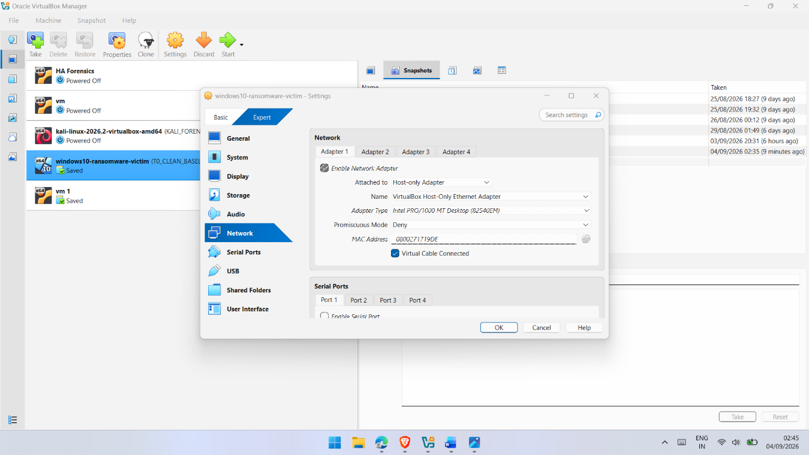
Figure B.1: Oracle VirtualBox network configuration for the Windows 10 ransomware-behaviour victim VM, showing Adapter 1 configured as a Host-only Adapter.
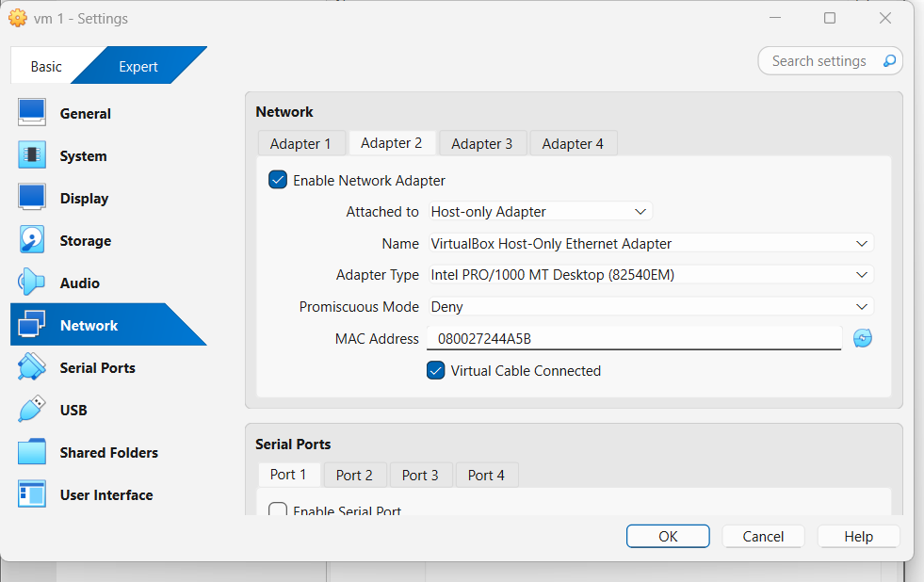
Figure B.2: Oracle VirtualBox network configuration for the SIFT forensic workstation, showing Adapter 1 configured using the VirtualBox Host-only Ethernet Adapter.
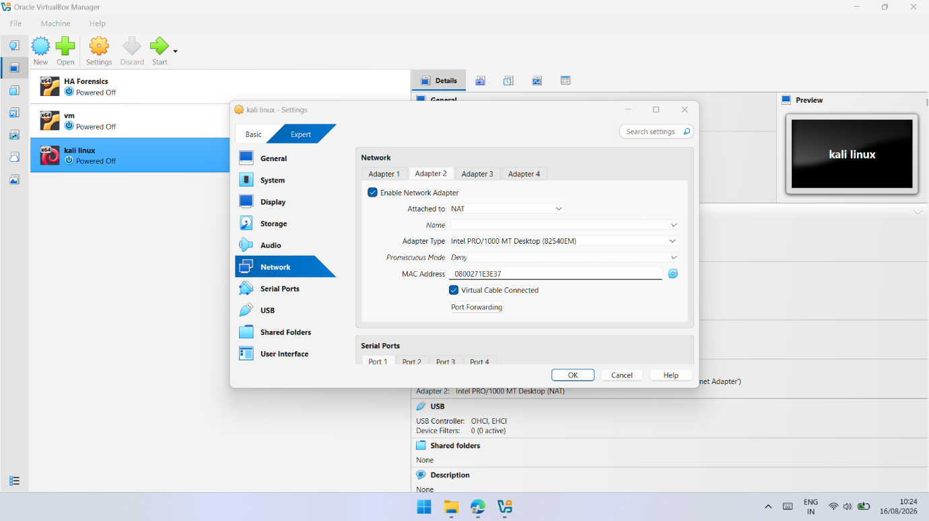
Figure B.3: Oracle VirtualBox network configuration for the Kali Linux supporting VM, showing Adapter 1 configured for NAT connectivity.
Appendix C — Controlled Ransomware-Behaviour Simulator
This appendix provides supporting evidence of the benign PowerShell ransomware-behaviour simulator used during the controlled experiment. The script was designed to reproduce selected observable behaviours associated with ransomware activity without deploying genuine ransomware. It operated on designated .txt test files within C:\T1_Test, inserted the predefined T1_SIMULATED_ENCRYPTED_DATA marker and renamed the test files using the .locked extension. These controlled and identifiable actions provided known reference artefacts for subsequent volatile-memory examination.
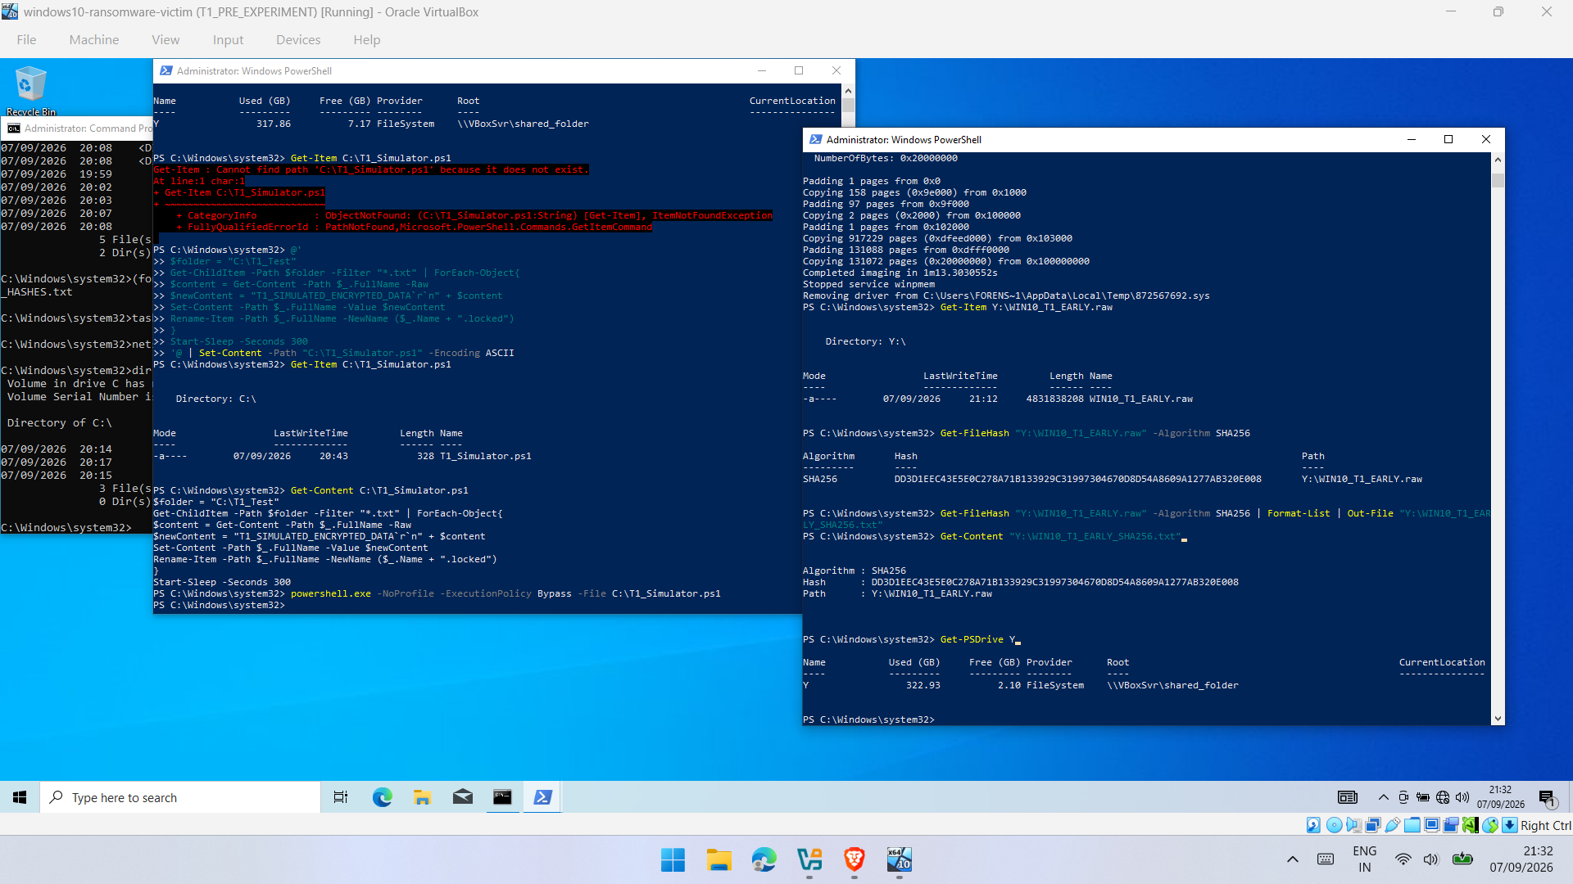
Figure C.1: PowerShell source and execution evidence for the controlled ransomware-behaviour simulator, showing T1_Simulator.ps1, the predefined T1_SIMULATED_ENCRYPTED_DATA marker, controlled file modification and the Rename-Item operation used to append the .locked extension.
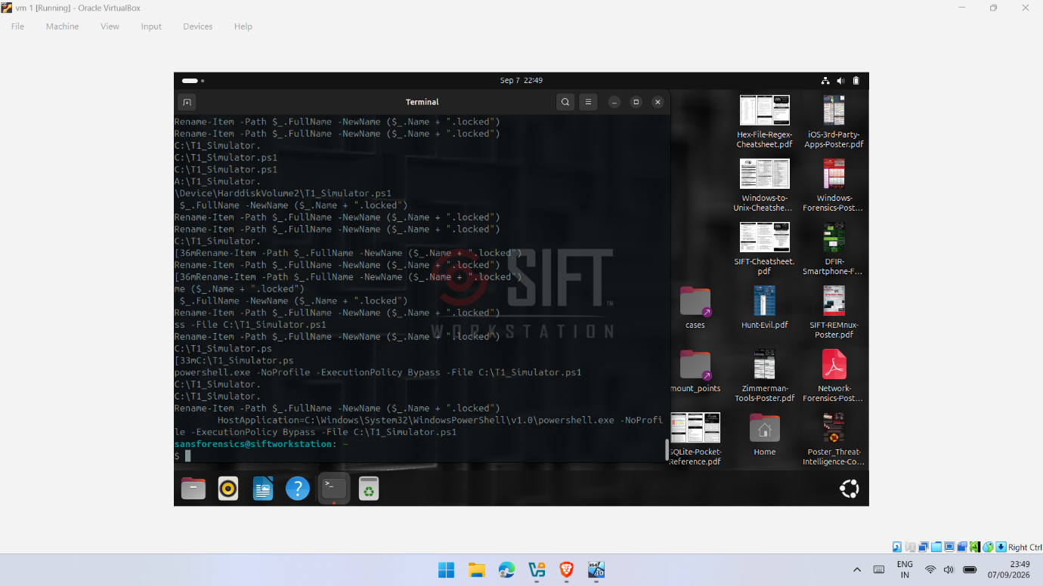
Figure C.2: String examination of the T1 memory evidence showing recovered references to C:\T1_Simulator.ps1, Rename-Item, .locked and related simulator activity.
Appendix D — T0 Baseline Evidence
This appendix provides supporting evidence for the T0 clean-baseline stage used as the reference state for the experimental workflow. The baseline was established before the controlled ransomware-behaviour activity, and the corresponding memory image was retained as WIN10_T0_BASELINE.raw.
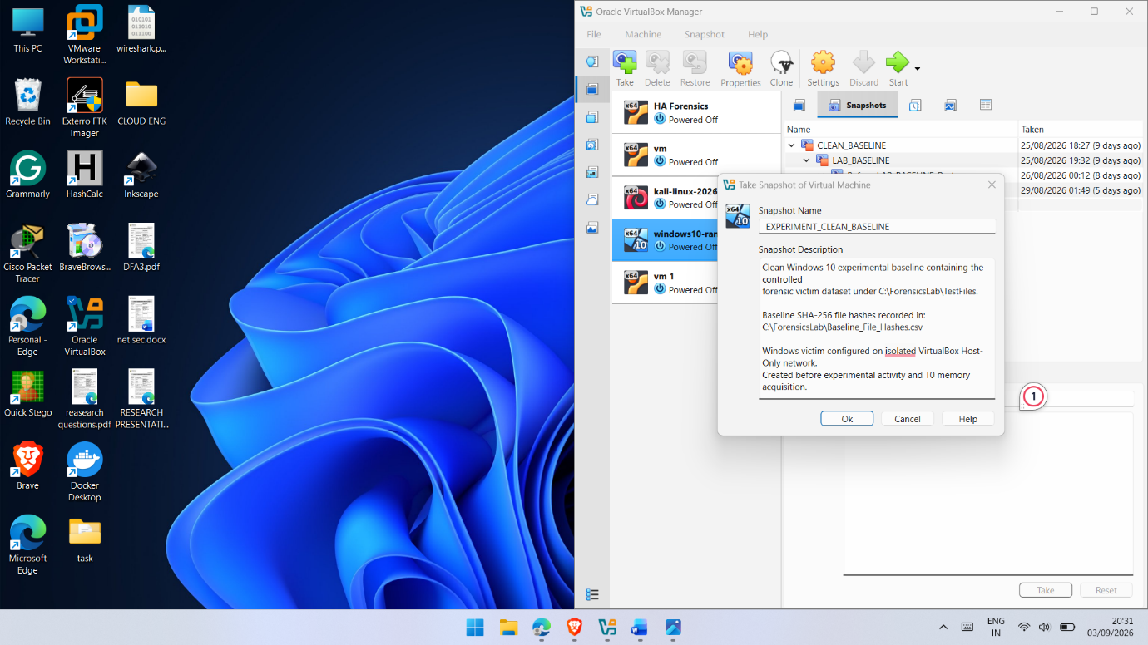
Figure D.1: VirtualBox EXPERIMENT_CLEAN_BASELINE snapshot documenting the clean Windows 10 experimental state prior to T0 memory acquisition and subsequent controlled experimental activity.
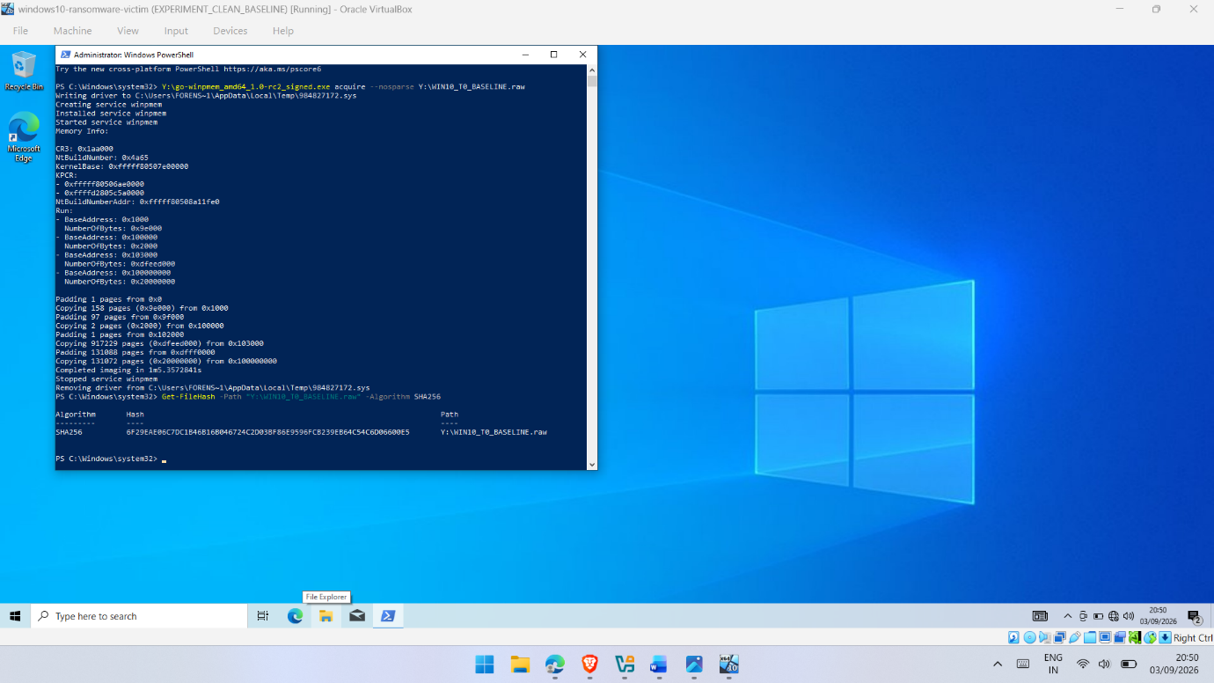
Figure D.2: WinPmem acquisition of the T0 clean-baseline memory image (WIN10_T0_BASELINE.raw) and subsequent SHA-256 integrity verification.
Appendix E — T1 Experimental Evidence and Screenshots
This appendix provides supporting evidence from the T1 controlled experimental execution. The retained evidence demonstrates the benign PowerShell simulator, acquisition of the EARLY and POST memory images, and subsequent recovery of simulator-related artefacts during forensic analysis.
Figure E.1: T1 EARLY experimental evidence showing the controlled PowerShell simulator, WinPmem acquisition of WIN10_T1_EARLY.raw, and SHA-256 verification of the acquired memory image.
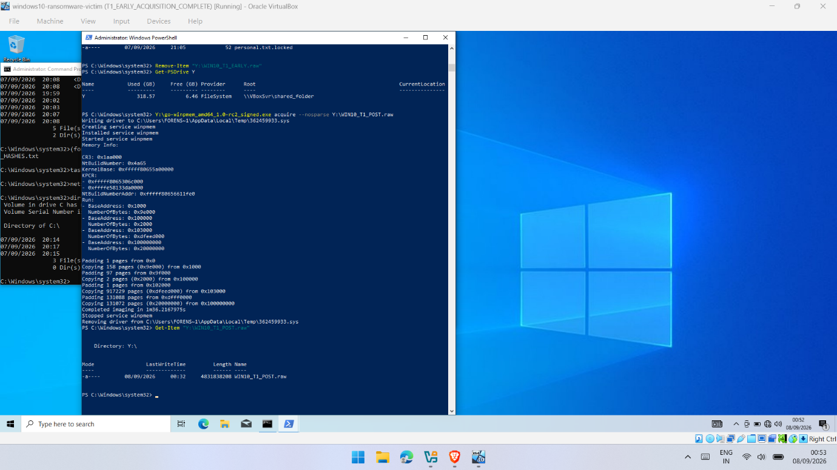
Figure E.2: T1 POST memory acquisition evidence showing WinPmem acquisition of WIN10_T1_POST.raw following the controlled simulation, with the completed memory image retained on the shared evidence drive.
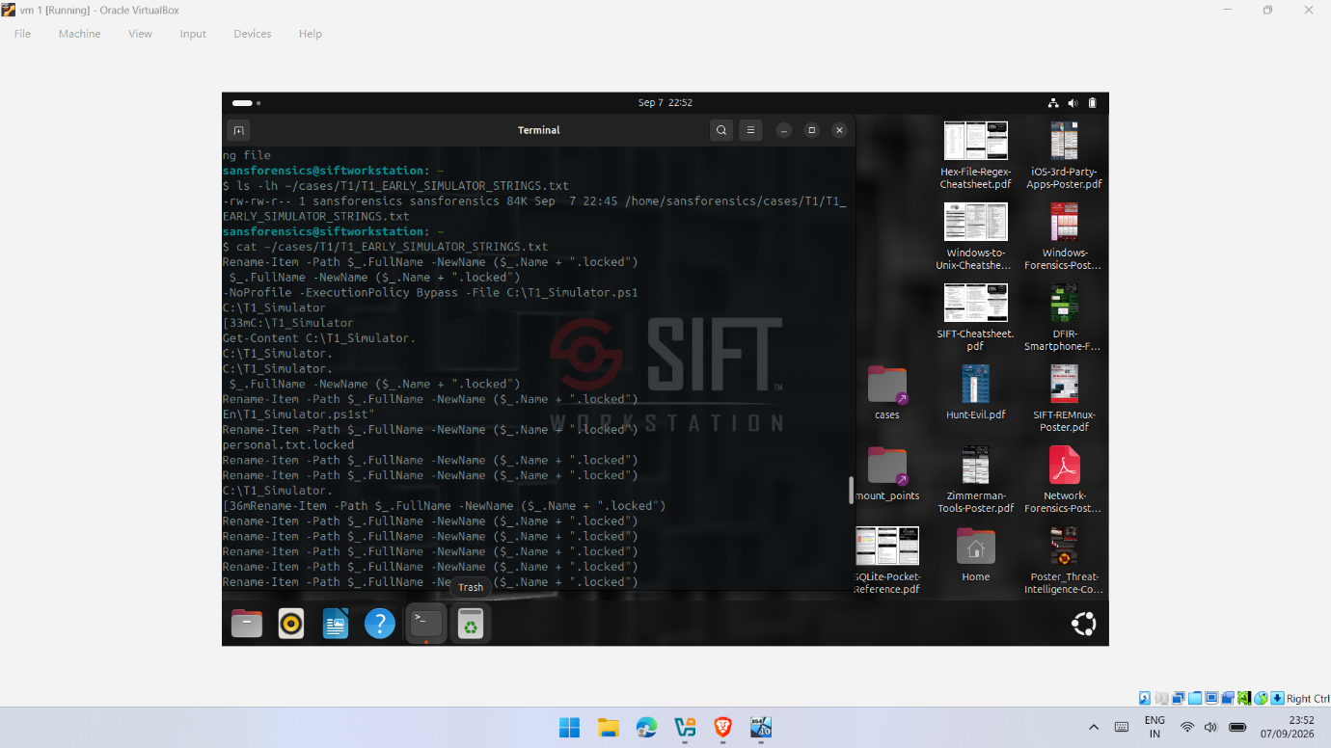
Figure E.3: T1 EARLY string-analysis evidence on SIFT Workstation showing recovered references to Rename-Item, .locked, T1_Simulator.ps1 and the associated PowerShell execution command.

Appendix F — T2 PRE/MID/POST Evidence and Screenshots
This appendix provides supporting evidence from the T2 PRE/MID/POST experiment, which formed the principal temporal comparison in the study. The retained evidence supports comparison of process, memory-region and simulation-related artefacts across the three acquisition stages. Additional PRE/MID/POST comparative evidence is presented in Appendix J.
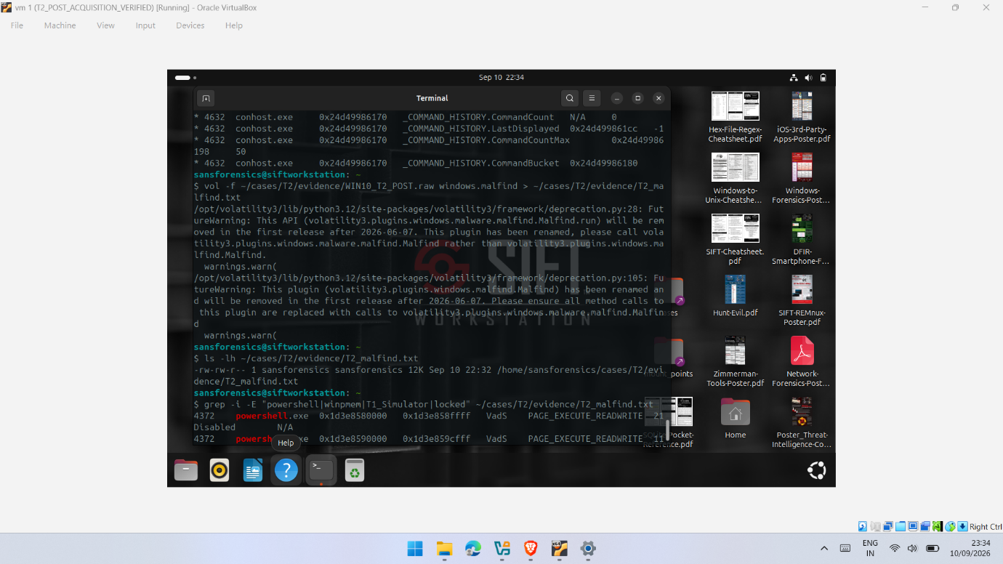
Figure F.1: Volatility 3 windows.malfind analysis of the T2 POST memory image showing executable memory regions associated with PowerShell. The output was treated as an investigative indicator and not as independent evidence of ransomware-related activity.

Appendix G — T3 Supporting Experimental Evidence and Screenshots
This appendix provides supporting evidence from the T3 experimental trial. The retained outputs document the T3 POST memory acquisition and subsequent forensic analysis using Volatility 3. The evidence provides supporting observations of PowerShell activity, process relationships, command-line artefacts and the observable WinPmem acquisition footprint within the captured memory. T3 is treated as supporting experimental evidence rather than an identical replication of the T2 PRE/MID/POST experiment.
Figure G.1: T3 POST memory acquisition showing successful WinPmem acquisition of WIN10_T3_POST.raw following the controlled simulation on 11 September 2026.
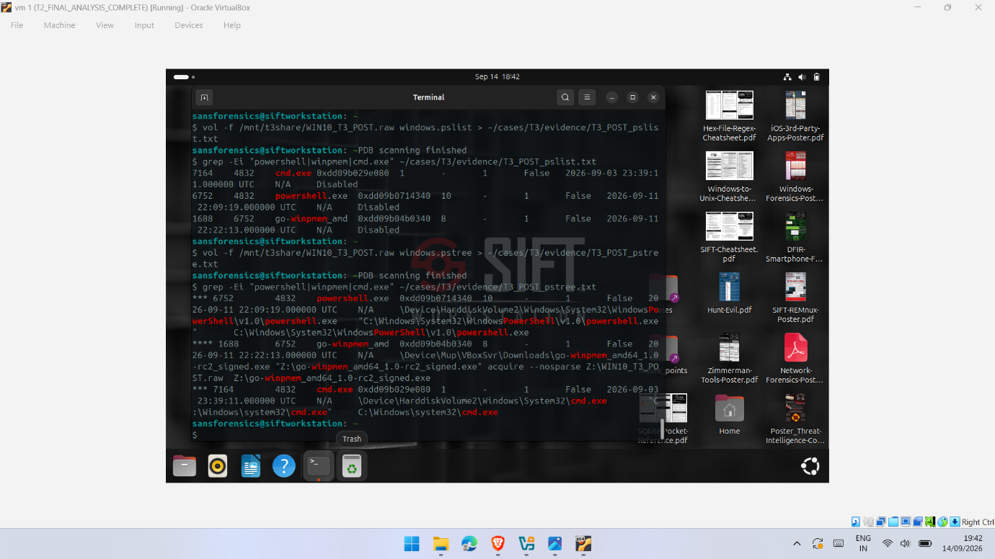
Figure G.2: T3 Volatility 3 process analysis of WIN10_T3_POST.raw showing PowerShell PID 6752 and the WinPmem acquisition process PID 1688 as its child, together with the retained WinPmem acquisition command.
Figure G.3: T3 Volatility 3 windows.cmdline analysis of WIN10_T3_POST.raw, showing retained references to T1_Simulator.ps1, PowerShell PID 6752 and WinPmem PID 1688, together with the command used to acquire the T3 POST memory image.

Appendix H — SHA-256 Integrity Verification Records
This appendix presents the SHA-256 integrity verification records retained for the memory images used throughout the experimental investigation. Hash values were generated following acquisition and recorded as part of the forensic evidence-handling process. The selected evidence covers the T0 baseline and the principal experimental acquisitions from T1, T2 and T3.
Figure H.1: SHA-256 verification of the T0 baseline memory image, WIN10_T0_BASELINE.raw, following acquisition with WinPmem on the Windows 10 victim system.
The T0 baseline image produced the SHA-256 value:
6F29EAE06C7DC1B46B16B046724C2D03BF86E9596FCB239EB64C54C6D06600E5
This record provides the integrity reference for the clean baseline acquisition obtained before the controlled experimental activity.

Figure H.2: SHA-256 integrity verification of the T1 EARLY memory image, WIN10_T1_EARLY.raw, following WinPmem acquisition on the Windows 10 victim system.
The T1 EARLY image produced the SHA-256 value:
DD3D1EEC435EE0C278A71B133929C31997304670D8D54A8609A1277AB320E008
This verification record confirms that an integrity value was retained for the T1 EARLY acquisition used during subsequent forensic analysis.

Figure H.3: SHA-256 integrity verification of the T2 PRE and MID memory images on the SIFT Workstation, providing integrity records for the principal temporal comparison.
The recorded SHA-256 values were:
T2 PRE — WIN10_T2_PRE.raw
a3fca4e12b3672b90fff1943c4d78ee7e3a7aabc25530ee25f732a6df35d47d8
T2 MID — WIN10_T2_MID.raw
3648f54ca6d7eb534dfed5bb7e8da02743931686d61ae6e2191d3dd318e105f0
These records support the integrity of the PRE and MID memory images used in the T2 acquisition-timing comparison.

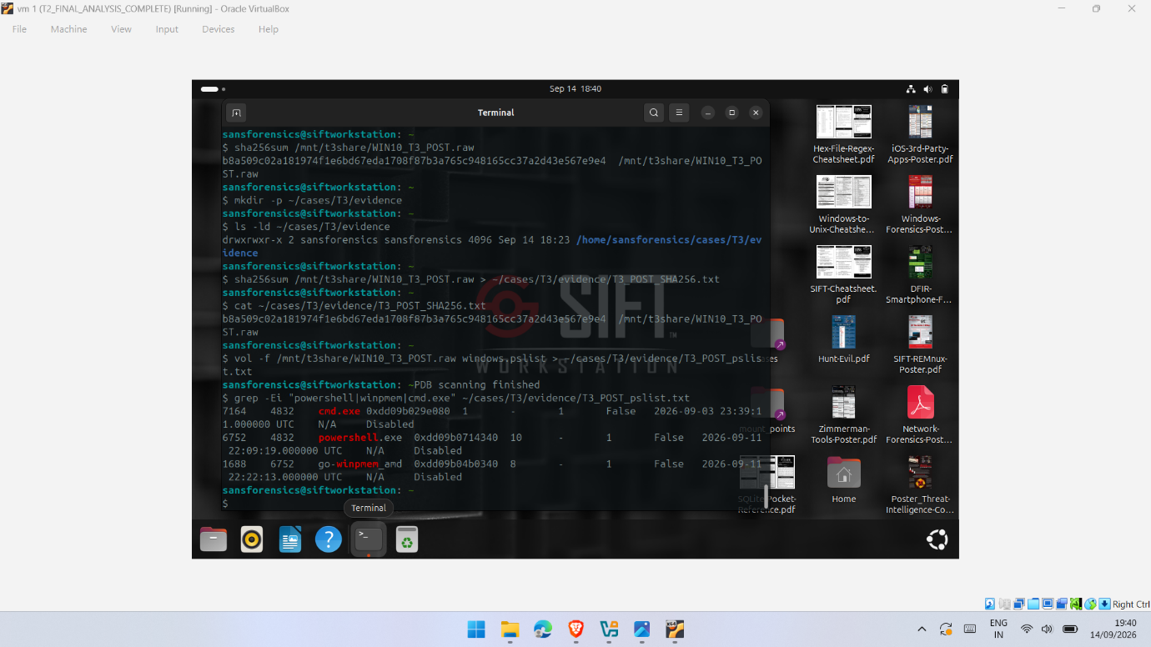
Figure H.4: SHA-256 integrity verification of the T3 POST memory image, WIN10_T3_POST.raw, on the SIFT Workstation.
The T3 POST image produced the SHA-256 value:
b8a509c02a181974f1e6bd67eda1708f87b3a765c948165cc37a2d43e567e9e4
The verified T3 POST image was subsequently used for the final Volatility 3 process and command-line analysis.
Collectively, these SHA-256 records demonstrate that cryptographic integrity values were generated and retained for the principal memory images used in the investigation. The hashes provide post-acquisition integrity references for the forensic images; they do not imply that the volatile memory remained static during live acquisition.
Appendix I — Volatility 3 Analysis Outputs
This appendix provides supplementary Volatility 3 outputs generated during forensic analysis of the acquired memory images. The evidence supports the process, process-tree, command-line and memory-region analysis discussed in Chapters 5 and 6. Only selected outputs are included to avoid duplicating evidence already presented in the main report and other appendices.
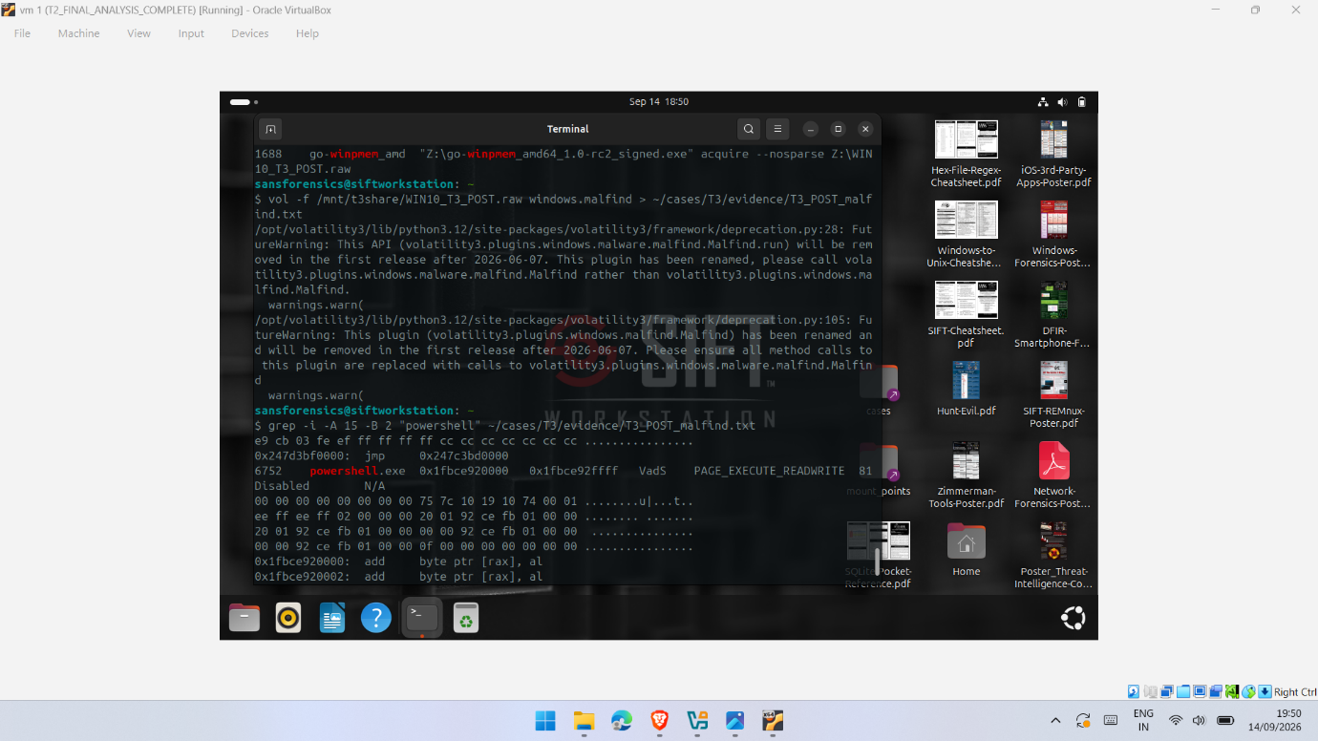
Figure I.1: Volatility 3 windows.malfind output for WIN10_T3_POST.raw, identifying executable writable memory regions associated with PowerShell PID 6752. The output was treated as supplementary memory-region evidence and not, by itself, as proof of malicious or ransomware activity.
The supplementary windows.malfind output complements the process, process-tree and command-line evidence presented elsewhere in the report. The identified executable writable memory regions associated with PowerShell were treated as investigative indicators requiring correlation with other artefacts and the experimental timeline, rather than as independent evidence of malicious or ransomware-related activity.

Appendix J — T1/T2/T3 Comparative Evidence
This appendix provides supporting evidence for the cross-trial comparison presented in Chapter 6. The retained outputs demonstrate the different categories of evidence generated across T1, T2 and T3. T2 provided the principal temporal comparison, while T1 and T3 supplied supporting observations from separate controlled executions.
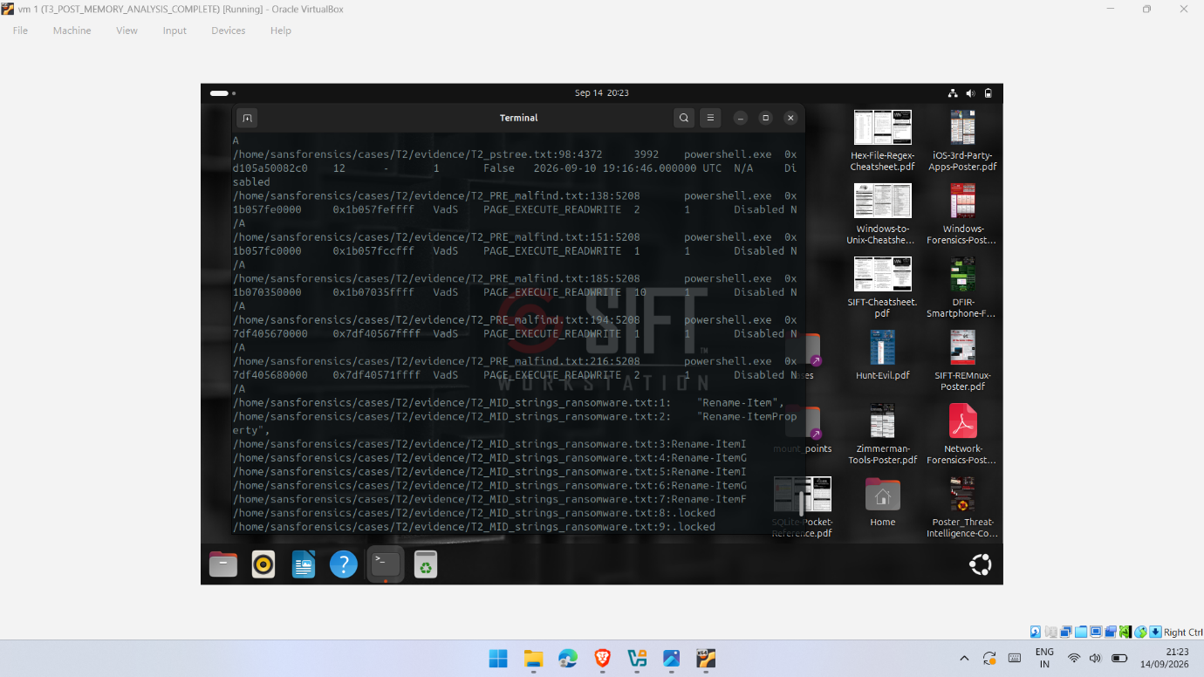
Figure J.1: Comparative T2 forensic evidence showing PowerShell-related memory observations in the PRE acquisition and simulation-related Rename-Item and .locked strings recovered from the MID acquisition.
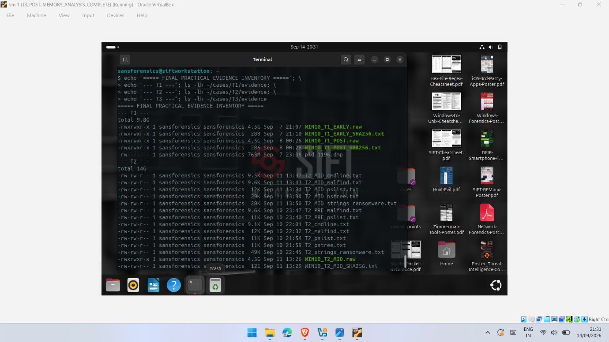
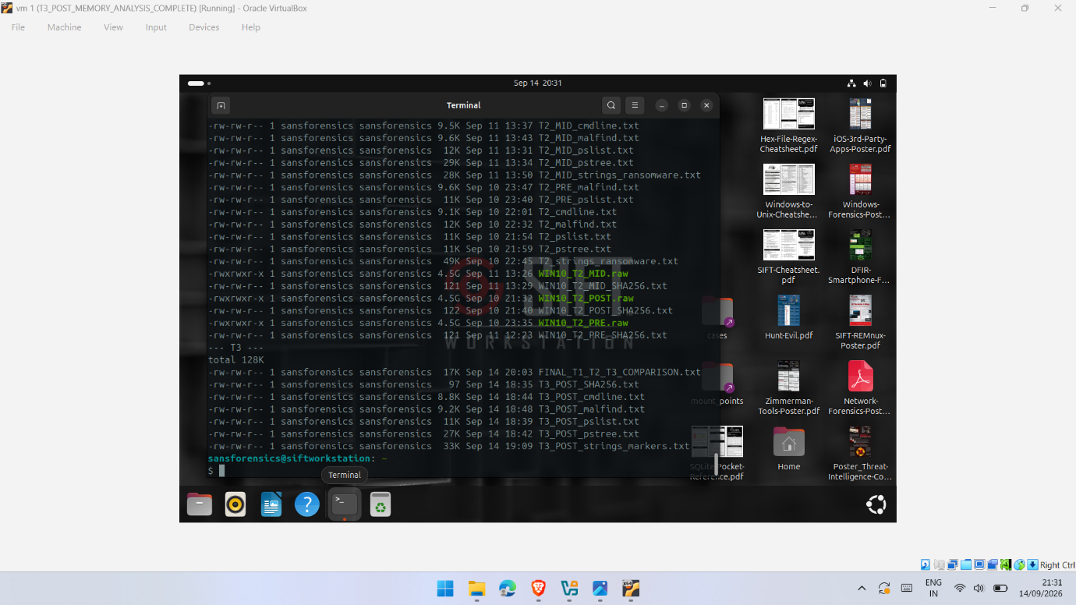
Figure J.2(a–b): Final practical evidence inventory showing retained T1, T2 and T3 memory images, integrity records and forensic-analysis outputs.

Appendix K — VirtualBox Snapshot Records
VirtualBox snapshots were created throughout the experimental workflow to preserve key system states and support controlled progression between acquisition and analysis stages. The snapshot records below document the experimental sequence across the Windows 10 victim system, SIFT forensic workstation and Kali Linux supporting VM. These records provide supporting evidence of the baseline, T1, T2 and T3 experimental stages.

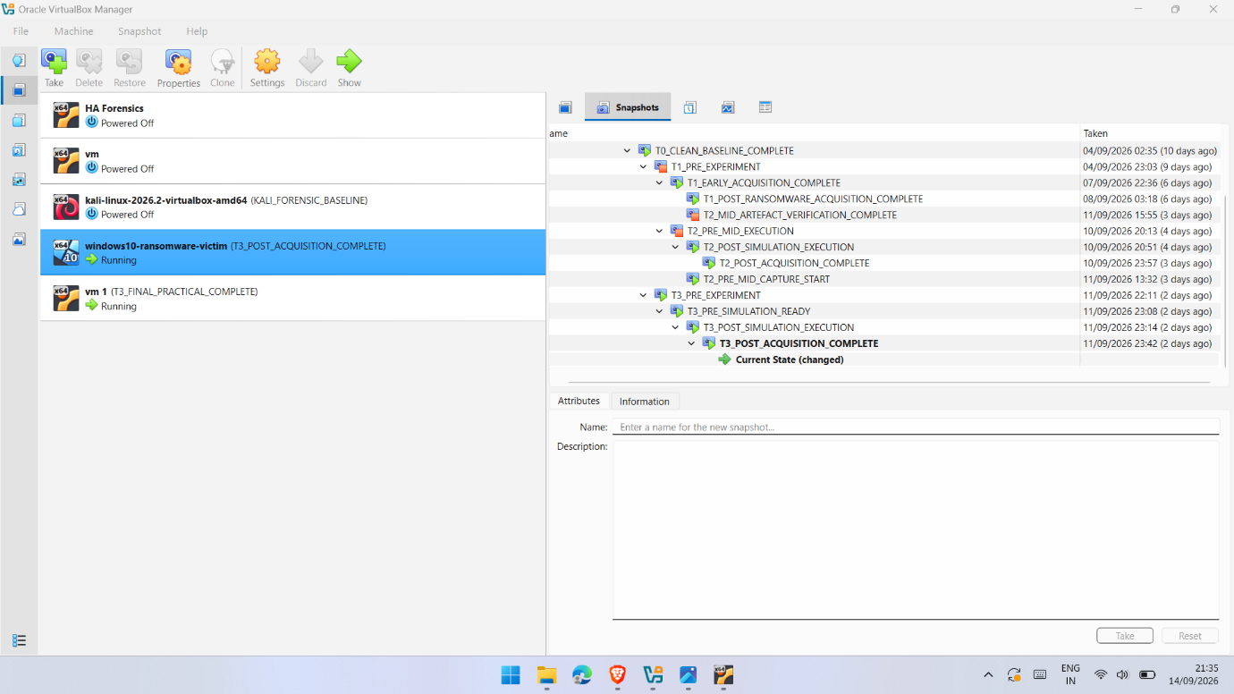
Figure K.1: VirtualBox snapshot history of the Windows 10 victim VM documenting the progression of the T1, T2 and T3 experimental stages, including pre-experiment, simulation and post-acquisition states.
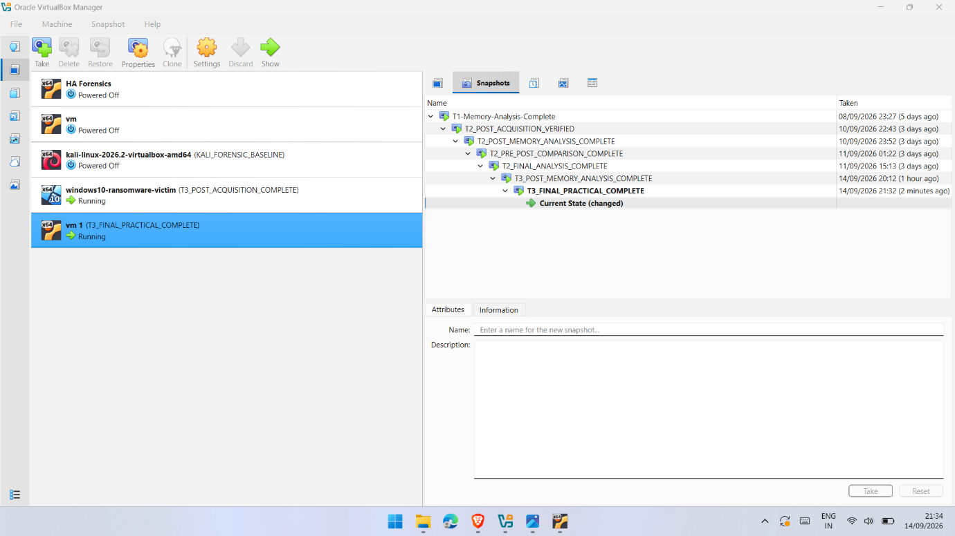
Figure K.2: VirtualBox snapshot history of the SIFT forensic workstation documenting completed analysis and verification stages across T1, T2 and T3.
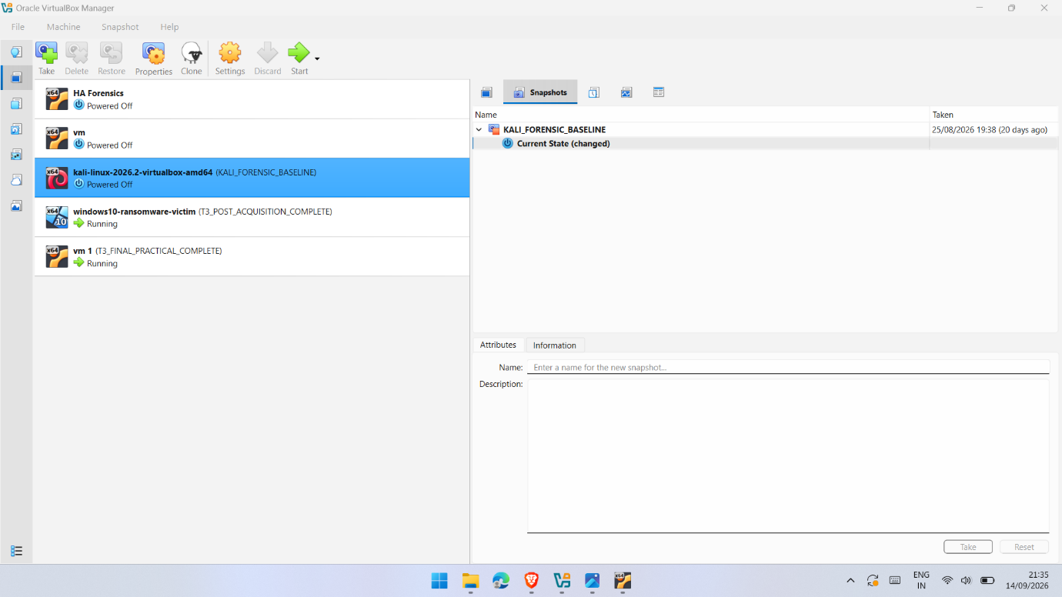
Figure K.3: VirtualBox snapshot record of the Kali Linux supporting VM showing the preserved KALI_FORENSIC_BASELINE state.

Appendix L — Commands and Additional Technical Evidence
This appendix records the principal commands used during memory acquisition, integrity verification and forensic analysis. The commands are included to support reproducibility of the experimental procedure while avoiding unnecessary technical detail in the main methodology and results chapters.
L.1 WinPmem Memory Acquisition
WinPmem was executed from the Windows 10 victim environment to acquire volatile-memory images. The following command structure was used during the experimental acquisitions:
Y:\go-winpmem_amd64_1.0-rc2_signed.exe acquire --nosparse Y:\WIN10_T0_BASELINE.raw
The same acquisition procedure was applied to the relevant T1 and T2 memory images. During T3, the acquisition was performed using:
Z:\go-winpmem_amd64_1.0-rc2_signed.exe acquire --nosparse Z:\WIN10_T3_POST.raw
L.2 SHA-256 Integrity Verification
SHA-256 hashing was used after acquisition to record the integrity value associated with the acquired memory images. On Windows, PowerShell Get-FileHash was used:
Get-FileHash -Path "Y:\WIN10_T0_BASELINE.raw" -Algorithm SHA256
Get-FileHash "Y:\WIN10_T1_EARLY.raw" -Algorithm SHA256
Within SIFT Workstation, SHA-256 verification was performed using sha256sum, for example:
sha256sum ~/cases/T2/evidence/WIN10_T2_PRE.raw
sha256sum ~/cases/T2/evidence/WIN10_T2_MID.raw
sha256sum /mnt/t3share/WIN10_T3_POST.raw
The resulting integrity records are presented separately in Appendix H.
L.3 Volatility 3 Process Analysis
Volatility 3 was used to examine processes present within the acquired memory images. The principal plugins used were windows.pslist, windows.pstree, windows.cmdline and windows.malfind.
Representative commands included:
vol -f /mnt/t3share/WIN10_T3_POST.raw windows.pslist
vol -f /mnt/t3share/WIN10_T3_POST.raw windows.pstree
vol -f /mnt/t3share/WIN10_T3_POST.raw windows.cmdline
vol -f /mnt/t3share/WIN10_T3_POST.raw windows.malfind
Outputs were redirected to case-specific evidence files where required, for example:
vol -f /mnt/t3share/WIN10_T3_POST.raw windows.pslist > ~/cases/T3/evidence/T3_POST_pslist.txt
vol -f /mnt/t3share/WIN10_T3_POST.raw windows.pstree > ~/cases/T3/evidence/T3_POST_pstree.txt
vol -f /mnt/t3share/WIN10_T3_POST.raw windows.cmdline > ~/cases/T3/evidence/T3_POST_cmdline.txt
vol -f /mnt/t3share/WIN10_T3_POST.raw windows.malfind > ~/cases/T3/evidence/T3_POST_malfind.txt
L.4 Targeted Evidence Filtering
Targeted filtering was used to identify relevant processes and experimental indicators within the retained Volatility outputs. Examples included:
grep -Ei "powershell|winpmem|cmd.exe" ~/cases/T3/evidence/T3_POST_pslist.txt
grep -Ei "powershell|winpmem|cmd.exe" ~/cases/T3/evidence/T3_POST_pstree.txt
grep -Ei "powershell|winpmem|T1_Simulator|locked" ~/cases/T3/evidence/T3_POST_cmdline.txt
For malfind, filtering was used to locate output associated with PowerShell while retaining the surrounding context:
grep -i -A 15 -B 2 "powershell" ~/cases/T3/evidence/T3_POST_malfind.txt
L.5 String Analysis
String extraction and targeted searches were used alongside Volatility 3 to identify textual artefacts associated with the controlled simulation. Searches focused on indicators such as the simulator path, Rename-Item, .locked, and the experimental marker.
Representative searches included:
grep -Ei "T1_Simulator|Rename-Item|locked" <strings-output-file>
These searches supported comparison of simulation-related textual evidence between acquisition stages, particularly the T2 PRE, MID and POST images.
L.6 Reproducibility Note
The commands above represent the principal acquisition, hashing and analysis procedures used during the practical investigation. File paths and image names varied according to the experimental trial and acquisition stage. Commands were applied to genuine experimental memory images retained within the relevant case directories. Supporting screenshots, integrity records and analytical outputs are provided throughout Appendices D–K.

