HNCHND Computing Level 4
Academic and Employability Skills

Academic and Employability Skills Report

By Rhys Davies
Student Number: 181019

(/04/2025)

Section 1 - Presentation 2
Section 2 – Skill Evaluation 4
Critical Thinking 5
Time management 5
Communication 5
Teamwork 6
Creativity 6
Adaptability 6
Self Evaluation 6
Section 3 – Action Plan 7
Short Term Goals 7
Long Term Goals 7
Action Plan 7
Section 4 – Application, Time Management and Sel-organization 8
Enhance productivity 8
Section 5 – Conclusion and Evaluation 11
Assessment Component 2 12
Section 1 – Looking after your data 13
Assessment Action Plan 14
Section 2 – Disaster Recovery 15
Disaster Scenarios 15
Section 3 – Evaluation 18
Section 4 - Ransomware 19
References 20

Section 1 - Presentation
My name is Rhys Davies, and I am currently studying at Pembrokeshire College. I am studying Computing at Level 4 and would like to continue working in the Computing field further in my life.
From presenting a presentation I have learnt that:
You need to be confident and speak with a clear voice.
You should use powerful actions such as strong verbs and hand movements.
You should engage the audience by asking questions and including quizzes in your presentation.
You should use strong body language such as facial expressions and eye contact in order to effectively convey your ideas and persuade others.

From presenting the PowerPoint presentation I have found that I can improve on:
I speak clearly and loudly to ensure that others can hear me, however I tend to speak quickly which can cause issues when presenting. I need to improve my speed when presenting as it will significantly improve my presentation skills and show that I am confident as well as knowledgeable and in control of the presentation.
I need to use more hand gestures in order to gather the audiences attention more. It is important I improve my hand gestures as it can greatly attract the audiences attention and cause them to be more focused on the presentation.
I struggle with eye contact which can cause the audience to be less focused and less motivated to listen to the presentation. It is important for me to improve on this in order to be more interactive and engaging with the audience.
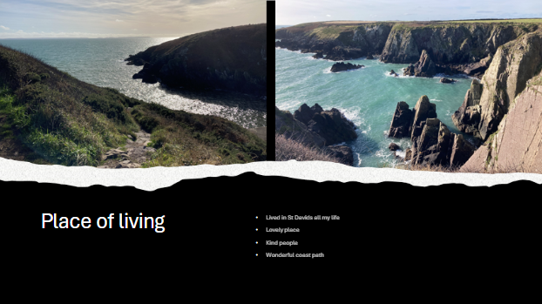
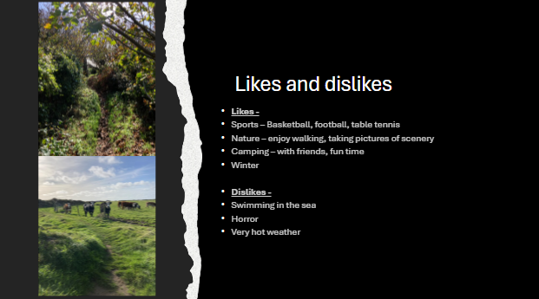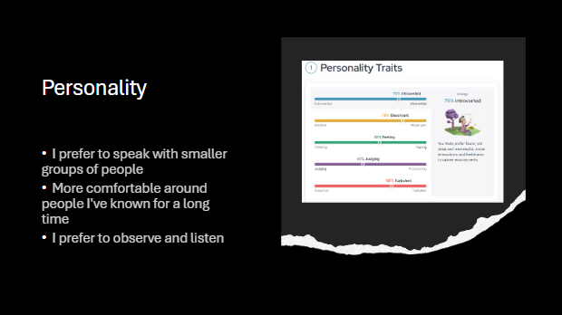
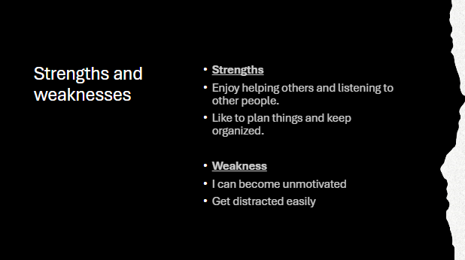

Section 2 – Skill Evaluation
There are many important skills which are required for successful learning in a higher education environment. Some of these are Critical Thinking, Time management and Communication.
Critical Thinking is a very important skill for higher education learning as (Needleman, 2025)“You should be able to think logically and deduce information without being told everything directly.” Critical thinking is a key skill needed for higher education as it will allow students to make well informed decisions as well as understand other perspectives. Students with critical thinking skills will be able to analyze problems thoroughly and create multiple solutions which will be effective for the task. This is very important for higher education as you will need to often analyze texts, create logical arguments and understand complex concepts.
Time management is an extremely important skill for all levels of learning, especially higher education. (Team, 2025)“Time-management skills are the skills that help you organize your time effectively to be more productive “Having good time management skills will allow you to improve your overall work rate and can help you produce better work. Time management can be improved in many ways, for example using a daily planner to help manage all of your deadlines and tasks for the day. Another example is simply establishing a routine. Having a well-put together routine will allow you to have more time to relax as well as give you more time to do your work and study without having to stress about time.
Communication is a skill which is important for all levels of learning and working. There are many sections to communication which will all affect how well you communicate with others. For example, you need to be clear and concise, it is important to choose the correct words and how they are said or written. It is very important to (Emerson, 2024)“Avoid unnecessary words and overly flowery language”. This can easily distract the reader/listener from your message and cause a misunderstanding. Another skill for communication is to understand body language also known as nonverbal signs, it is very important that you can understand body language and nonverbal signs as it allows you to communicate your feelings and intentions to the audience. This can include your facial expressions, posture and hand gestures.

Similarly, there are also transferrable skills which employers will look for when you are applying for a job. These skills are similar to the previous ones and are necessary for all jobs.
Teamwork is a transferable skill which is useful for every level of working and school. Teamwork is a very important skill which can allow for much more efficient and productive learning and working. Being able to collaborate with others in an effective way will allow your work to be done quicker and in an elevated level. Another major benefit of teamwork is, (Wooll, 2024)“It boosts employee engagement and morale, fosters faster learning, and improves communication” This is very important in the workplace as if employee morale is low, work will be less efficient, and productivity will be slowed down.
Creativity is a transferable skill which is used in many different workplaces. Creativity is a skill which gives employees the ability to think unconventionally as well as to approach problems in an innovative way which can make problem solving significantly easier. Employees who have good creativity are able to adapt to the world in a much quicker rate than others, which can benefit them in a large way. A major benefit to creativity skills is (Alba, 2017)“Creativity skills can be developed across all subject and sectors at any stage.” meaning everyone is capable of improving their creativity.
Adaptability is a transferable skill and one of the most important skills to have. Being able to adapt within the workplace is a very useful skill and can allow for more flexibility and improvement in learning and development. Adaptability means to be able to adjust and thrive in a variety of environments. These environments can be personal, professional or social and all have their own situations which you must learn and evolve to overcome (Kaplan, 2023)“An adaptable person in the workplace can keep up with moving priorities, projects, clients and technology”.

Self Evaluation
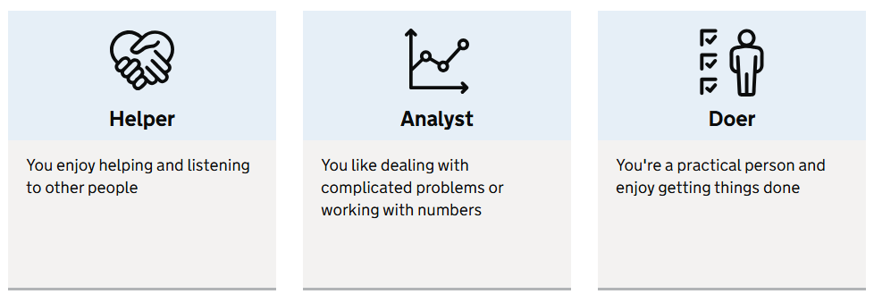I did a self-evaluation test on the national career's website, and these are my 3 main skills given after answering all questions. My first skill is” Helper” meaning I enjoy helping and listening to other people. This is the same as my personal evaluation I completed on my PowerPoint. When comparing these to my initial skill evaluation I can see they are similar and allow me to find areas where I need to improve. The main point I need to improve on is my communication and working with others. I usually prefer to work on my own more and not with others. However, it is very important to be able to communicate with others in order to improve efficiency and learn more.

Section 3 – Action Plan

Short Term Goals – My main short-term goals are to improve my overall skills and to improve my knowledge about Information Technology. My goals are also to stay on top of all my tasks and assignments and manage my time well in order to complete these tasks without any stress.

Long Term Goals - My main long-term goal is to improve my time management and learn how to priorities my tasks. Another long-term goal is to complete my academic life with high grades. This will help with job searching once I have completed my college course. I want to improve time management the most as it (college, 2024)“gives you a greater sense of control over your workday”.

Action Plan – I have created an action plan to allow me to efficiently use my time in order to improve my skills and grow academically. By using this action plan, I was able to improve in a much more organized way.
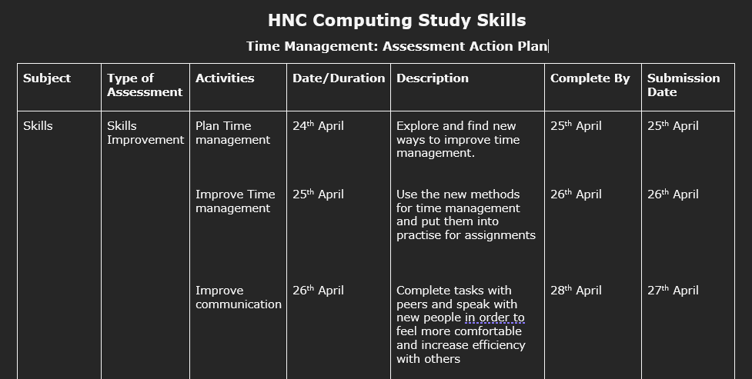
This action plan involves improving both my time management skills and communication skills by completing various tasks and studying methods of improving. This helped me become more efficient with my time and to plan out tasks before I started working on them.

Section 4 – Application, Time Management and Sel-organization

Enhance productivity
There are many different ways in which you can improve and enhance your productivity for example, one method I used is to manage my time in a more efficient way. Being able to good time management will allow you to be way more productive and allow for tasks to be completed in a much more efficient way. The main way to improve your productivity with time management is to create plans which will briefly guide you throughout your tasks in order to complete the work without wasting time not knowing and understanding what to do next. Having good time management will allow you to cut down on time and stop having excess wasted time where you are unsure what to do in the assignment.
Not only will time management allow you to complete your work in a much more efficient manner, but it will also lower your stress levels as you have already planned out how and when you will do your tasks. Having a plan can reduce stress levels by great amounts as you no longer have the chaotic worrying of if you are able to complete the assignment in time last minute. The plan will allow you to efficiently complete the assignment before the deadline date, giving you time to review your work and make sure it is to its best quality.
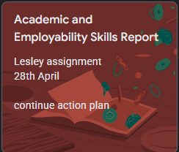
For example, I use Google keep in order to track my progress through tasks and set dates for when the assignment is so I know how long I have to complete each task.

I created a E-portfolio with a variety of different subjects we have worked on over the last 2 years of college. I have used this portfolio in order to display my work and my accomplishments over the years. Here are screenshots of my completed portfolio. The reason I created my portfolio like this is to grab the viewers attention in order to make them want to keep reading and find out more information about my accomplishments.
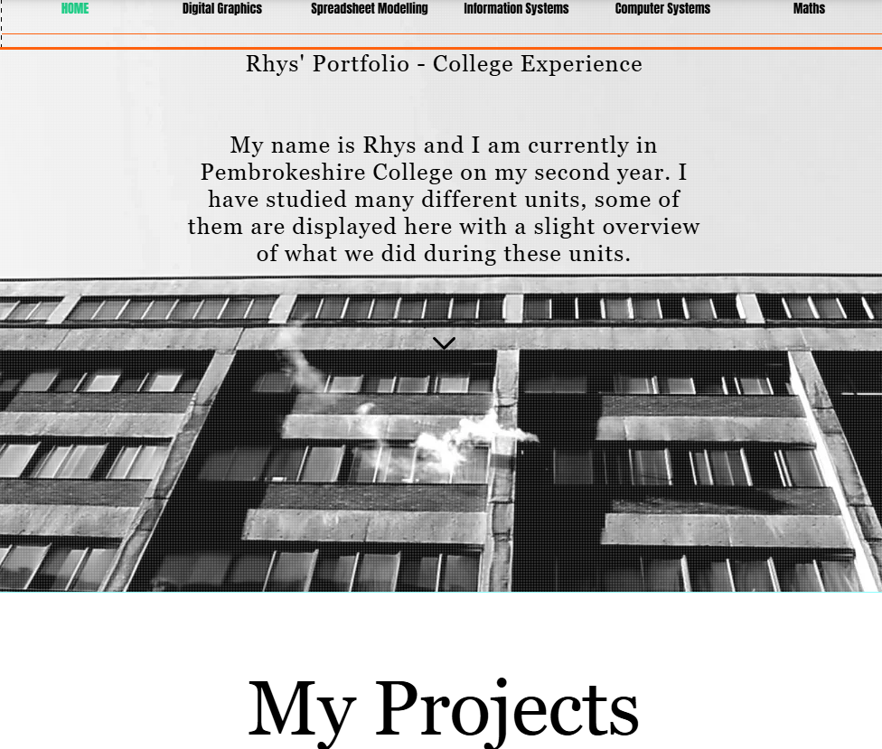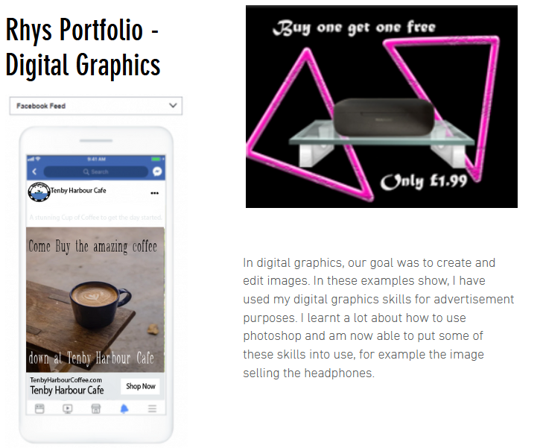
I chose this layout for my portfolio in order to display the most important images/examples of my work first in order to grab the viewers' attention. This is followed by a few sentences explaining the project/ course and what I learnt from completing it.
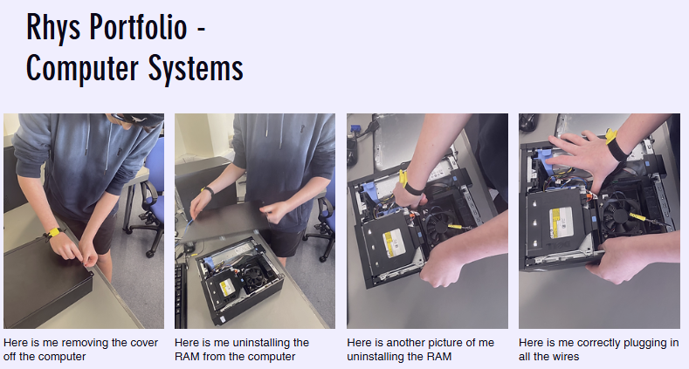
Here is another project we completed with step by step descriptions and images of what we did during this project. I have used smaller images and less text in order to keep it well organized and easy to follow.

Section 5 – Conclusion and Evaluation

This document contains a lot of very important and useful information which has allowed me to grow academically and to improve on many of my skills in order to become much more effective within my college life. After doing lots of research about different academic skills I have learnt a lot of interesting facts which I have put into use in order to improve. I have studied many various topics and all of them were very beneficial for my growth.
One topic I found very interesting and allowed for me to improve the most was Time management. Time management was a very important area for me as I always used to leave my tasks till the last minute, and it was very chaotic and left me very stressed. However, after learning to plan and how to efficiently manage my team I was able to complete assignments much quicker, and without much stress as I was doing them way before the deadline, this also meant I had time to go over my work and to double check.
For those considering further studying I would recommend I would recommend adaptability. This skill is very important for not only education and academically but also in jobs further in your life. You will always need to be able to adapt to the whole world as it is constantly changing. (Thompson, 2024)“When you’re adaptable, you can handle changes with grace, determination and rationality”

Assessment Component 2

Section 1 – Looking after your data

There are many different ways you can back up your data. The main rule for backing up your data is the 3-2-1 back up rule. (Gillis, 2024)“The 3-2-1 backup strategy is recognized as a best practice for information security and data protection professionals”. This is where you keep 2 copies of your data saved on different storage types and 1 kept offside (not the same physical location as the other 2 copies). This will allow you to be extra secure in case of any disasters which happen.
This backup method will allow for a robust level of data protection which can be used throughout your life whether it's in college, university or work. The 3 places where you could place your work would be, on your hard drive and a cloud storage device and for your one copy offsite you can place it onto a remote cloud server where it is unable to be affected by a disaster at the primary location.

Assessment Action Plan

Subject | Type of Assessment | Activities | Date/Duration | Description
Backup Plan | Plan | Creating backups | 5 minutes | Create 3 backups of your work you are wanting to protect
 |  | Relocate the first Copy to your hard drive | 1 minute | Relocate the first of the copies onto your hard drive which will be your first backup
 |  | Relocate your second Copy to Cloud storage device | 1 minute | Relocate the second copy to your cloud storage device which will be useful in case a corruption occurs on the hard drive with the other copy
 |  | Relocate your last Copy to the remote cloud server | 1 minute | Relocate the last copy to your remote cloud storage. This will protect you from disasters which may have occurred at the physical location.

Section 2 – Disaster Recovery

Disaster Scenarios

- Your local area gets flooded, and you are unable to save your computer, causing it to get broken and you lose all the data stored on it.
My backup strategy will cope with a flood as you may lose you 2 copies saved onto your physical computer however you will still have the backup created onto the cloud on a offsite device. This will allow you to keep your data safe. To get back your data you will simply need a new device and to login to the offsite kept cloud to redownload the file to your computer to continue working.
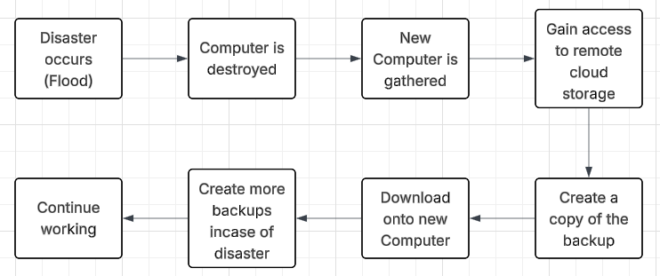
- Your place of work is on fire and all of your equipment and computers are set alight causing all the hardware to melt and become unusable.
My backup strategy will cope with a fire similar to the flood as all the data stored on the hard drive and local cloud will be lost. However, the offsite backup will be safe and untouched. To get back your data you will simply need a new device and to login to the offsite kept cloud to redownload the file to your computer to continue working.
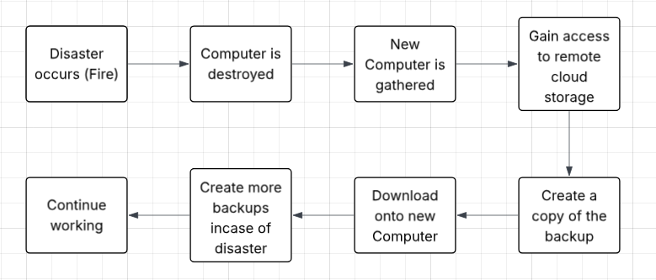
- Your computer is filled with malware which causes all of your files and data to be deleted.
My backup strategy will be capable of coping with a malware attack as the offsite backup will not be touched, however the files located on the computer will all be lost. The offsite backup will be able to let you stay safe from any physical computer attacks or disasters. To get back your data you will need to first remove the malware and then to gather the spare backup saved in the remote location.
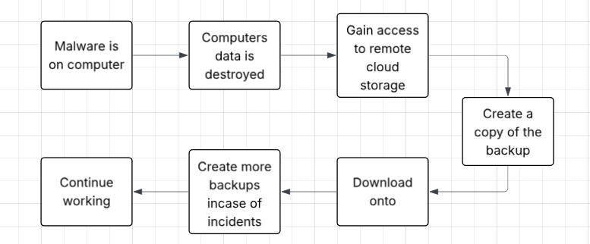
- Your computer's hard drive fails which causes you to lose all data saved onto that hard drive.
My backup strategy will work against hardware failure as you have saved your data onto a separate hardware storage device such as the cloud so if your hard drive does fail you will still have both your local cloud and remote cloud to keep backups on. Simply create a copy of one of the backups you have in order to continue working on your work.
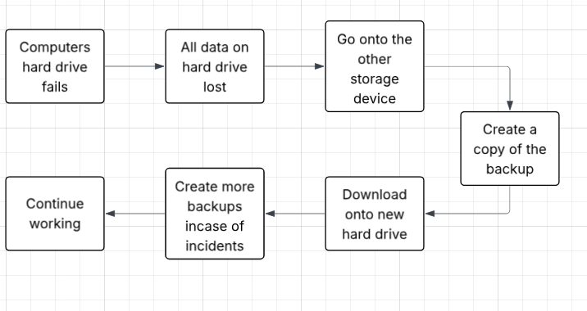
- Your computer is attacked by an insider of your company causing your computer to be breached by malicious attacks.
My backup strategy will work against an insider attack as you will have your offsite saved backup which the insider will not be able to attack, however your 2 copies on the computer will be attacked. You will need to remove the attacker from the computer, then create a copy of your backup file in order to continue working.
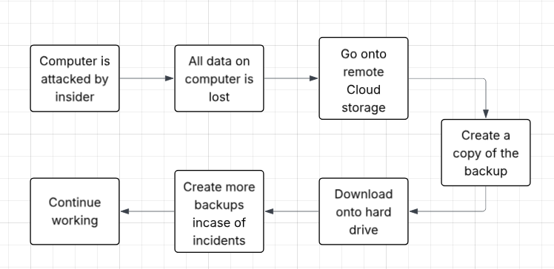
- Your colleague accidentally deletes the incorrect folder on your computer, and you lose all your important data.
My backup strategy will work against an accidental incident as we have saved 2 other copies at separate locations in case of an issue such as this. Simply create a copy of one of the backups saved in a separate location in order to continue working.

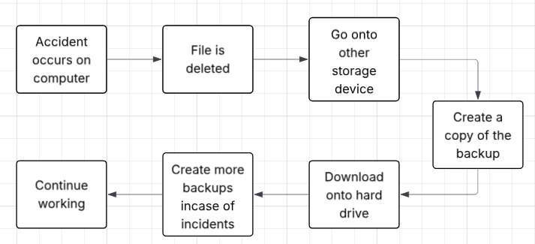

Section 3 – Evaluation

The strategies used for the disaster recovery are effective, however can be improved. Here are some of technologies used for each of the disaster recovery strategies.
- The effectiveness of my backup plan for this scenario was good and allowed the data to be saved even after losing the hardware/computer. The hardware and software that is used within this scenario is the remote cloud storage which was used to save a backup of the work and was not affected by the flood.

- The effectiveness of my backup plan for this scenario was great and allowed the data to be saved even after losing the hardware/computer. The hardware and software that is used within this scenario is the remote cloud storage which was used to save a backup of the work and was not affected by the fire.

- The effectiveness of this backup plan under this scenario was good and was able to keep the backups safe and allowing for a quick fix. The hardware and software that is used within this scenario is the remote cloud storage which was used to save a backup of the work and was not affected by the malware as it is not at the same physical location.

- The effectiveness of this backup plan under this scenario was excellent and only 1 of the 3 backup copies were affected by the incident. The hardware that was affected was the hard drive however the backup copies on the other storage device and remote location were safe.

- The effectiveness of my backup plan for this scenario is good but can be improved and saved with better security within the company. The hardware that was used for this scenario was the remote cloud storage which was untouched by the insider and was safe.

- The effectiveness of my backup plan for this scenario is amazing. The accident caused by the colleague is easily fixable. The hardware used was the seperate storage device and the remote back up which allowed the user to continue with work and have no issues.

Section 4 - Ransomware

“Your computer is attacked by an insider of your company causing your computer to be breached by malicious attacks.”
Ransomware could be added to this scenario as the insider of the company could put the data that has been stolen up for ransom meaning the company would need to pay a specific amount of money otherwise the attackers would leak the information. One way to help prevent this from occurring is to, make computers inside of work more protected with passwords and logins. This will help prevent other workers from accessing your computer and touching your information. A real-world example of ransomware is, Ryuk 2019 and 2020, this was spread mainly through emails and through dangerous links and attachments. The ransom amount to be paid was over $300 thousand dollars. (Gatefy, 2021)“According to the FBI, Ryuk’s attacks have already caused more than USD 60 million in damage worldwide”

References
Alba, F. (2017). Learning Resource 5: Introduction to Creativity Skills. Education Scotland.
Emerson, M. S. (2024, January 8). Professional & Executive Development. Retrieved from 8 Ways You Can Improve Your Communication Skills: https://professional.dce.harvard.edu/blog/8-ways-you-can-improve-your-communication-skills/
Gatefy. (2021, March 19). Gatefy. Retrieved from 7 real and famous cases of ransomeware attacks: https://gatefy.com/blog/real-and-famous-cases-ransomware-attacks/
Gillis, A. S. (2024, November). TechTarget. Retrieved from 3-2-1 backup strategy explained: Is it effective?: https://www.techtarget.com/searchdatabackup/definition/3-2-1-Backup-Strategy#:~:text=The%20basic%20concept%20of%20the,the%20data%20is%20sent%20offsite.
Kaplan, Z. (2023, March 3). Forage. Retrieved from What Are Adaptability Skills? Definition and Examples: https://www.theforage.com/blog/skills/adaptability
Needleman, R. (2025, April 2). UNIADMISSIONS. Retrieved from What Are The 6 Essential Skills For University Students?: https://www.uniadmissions.co.uk/application-guides/6-essential-skills-for-university-students/#:~:text=Critical%20Thinking%3A%20You%20should%20be,are%20all%20completed%20on%20time.
Team, I. E. (2025, March 4). Indeed. Retrieved from Time-management skills: definition, examples and tips for improvement: https://uk.indeed.com/career-advice/career-development/time-management-skills
Thompson, J. (2024, August 29). business.com. Retrieved from How Well Do You Handle Change? The Benefits of Being Adaptable: https://www.business.com/articles/how-well-do-you-handle-change-the-benefits-of-being-adaptable/
Wooll, M. (2024, July 15). BetterUp. Retrieved from The importance of teamwork in the workplace with tips to improve: https://www.betterup.com/blog/importance-of-teamwork#:~:text=Teamwork%20is%20vital%20in%20the,faster%20learning%2C%20and%20improves%20communication.

