Tialanthia lynch
Birmingham, UK Telephone: 07481184114 Email: tialanthialynch@gmail.com

personal statement
I am a motivated, friendly and hardworking individual with experience across hospitality, customer service, healthcare and education. I am currently studying at the University of Wales Trinity Saint David alongside my professional experience, developing strong communication, organisation, teamwork and time-management skills.
My previous roles have taught me to work effectively in fast-paced environments, provide excellent customer service and adapt to different situations. I have also taken on leadership responsibilities within a café, supporting colleagues and helping to ensure the smooth running of the workplace. My experience in a dental practice further developed my professionalism, attention to detail and ability to work responsibly. I am reliable, adaptable and eager to continue developing my skills in a professional environment.

Experience
Starbucks: Barista
January 2025 – July 2026
• Delivered friendly, efficient customer service in a busy environment.
• Prepared food and beverages while maintaining quality and hygiene standards.
• Processed orders and payments accurately and worked effectively as part of a team.
• Managed competing demands while balancing employment with university studies.

Longfellow Road Dental Practice: Trainee Dental Nurse
December 2023 – April 2024
• Assisted with patient care and chairside support during dental procedures.
• Followed infection-control and safety procedures.
• Maintained equipment and accurate patient records.
• Developed professional communication and attention to detail.
Café Roj — Barista / Waitress
October 2019 – August 2023
• Provided high-quality customer service in a busy café environment.
• Managed orders, payments and telephone bookings.
• Assisted with stock checks and supplier orders.
• Regularly took on additional leadership responsibilities and supported the management of the café.

Education
University of Wales Trinity Saint David, Birmingham
Business Skills for the Workplace December 2025 – Present

Ashlawn School Sixth Form
A Levels: English Literature (C), Psychology (C), Media Studies (C) | 2019–2021

Ashlawn School
GCSEs including Maths (4), English Language (5), English Literature (5), Art & Design (6) | 2014–2019

ADDITIONAL EXPERIENCE
Teaching Assistant — Saint Marie’s Primary School | 2020
Supported children with classroom activities, reading and supervised break/lunchtime activities.

Volunteer Sports Coach — Rugby & Northampton Athletics Club | 2019
Coached young athletes, planned activities and promoted teamwork and safe participation.
KEY SKILLS
Communication • Customer Service • Teamwork • Leadership • Organisation • Time Management • Problem Solving • Attention to Detail • Adaptability • Working Under Pressure

INTERESTS
Competitive athletics and fitness, with over 11 years of involvement in Rugby & Northampton Athletics Club. I enjoy strength training and maintaining an active lifestyle, which has developed my discipline, consistency and goal-oriented approach.

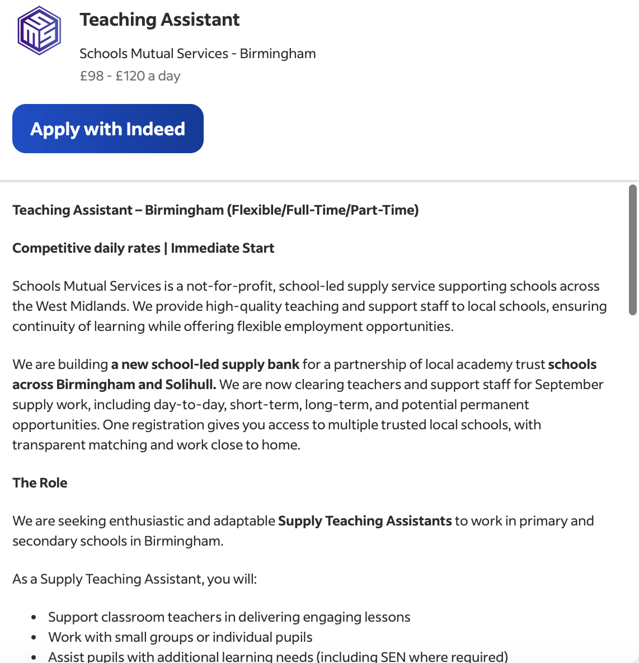

t

Cover Letter: Primary School Teaching Assistant Tialanthia Lynch
Birmingham, UK
07481184114
tialanthialynch@gmail.com

19th October 2026

Hiring Manager
Schools Mutual Services

Dear Hiring Manager,

Re: Application for the position of Primary School Teaching Assistant

I am writing to express my interest in the Primary School Teaching Assistant position at your school. I am a motivated, patient and hardworking individual with previous experience supporting children in a primary school environment. I am keen to contribute to a positive learning environment where children feel supported, encouraged and able to reach their full potential.

During my previous experience as a Teaching Assistant at Saint Marie’s Primary School, I supported children with classroom activities, assisted with reading and helped supervise pupils during break and lunchtime. This experience strengthened my communication and organisational skills and gave me an understanding of the importance of creating a safe, supportive and engaging environment for children. I particularly enjoyed helping pupils with their learning and encouraging them to participate in classroom activities.

Alongside this experience, my employment in hospitality, including my roles at Starbucks and Café Rojo, has helped me develop strong interpersonal skills, patience and the ability to remain calm in busy situations. I have also taken on additional leadership responsibilities in my previous café role, demonstrating initiative, reliability and the ability to work effectively as part of a team. I believe these transferable skills would allow me to build positive relationships with pupils and work collaboratively with teachers and other school staff.

I am currently studying at the University of Wales Trinity Saint David, where I continue to develop my organisation, time management and independent learning skills. I am enthusiastic about opportunities to develop professionally, gain further experience in education and contribute positively to children’s academic and personal development.

I would welcome the opportunity to discuss my suitability for this position further. Thank you for considering my application. I look forward to hearing from you.

Yours sincerely,
Tialanthia Lynch

