

Assessment 1 – Reading Task Template
PART 1: Upload your photo of your A3 in-class notes here:
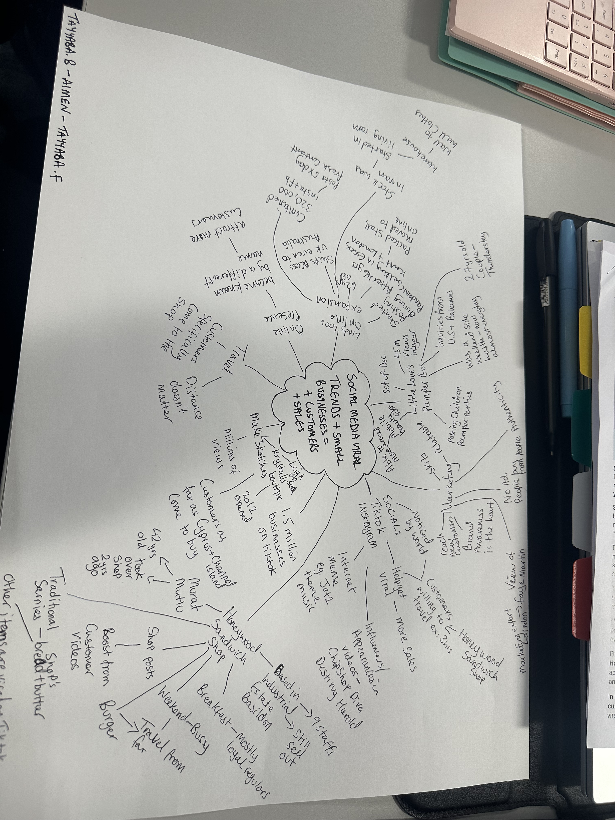

PART 2:
- Answer every question below in 1-3 full sentences.
- Use your own words. Do not use generative AI to answer these questions.
- Include a specific detail from the text when asked.
REMINDER
- The main idea is the overall message of the whole text.
- A key point helps to explain the main idea.
- A specific detail or example from the text shows that the key point is true.

- What is the main idea of the whole text?
Social media turns online attention into a real income and success for small businesses.

- What is one key point that supports the main idea, and which specific example from the text shows this?
Content shared by customers not just the business itself, is what most effectively boots and draws new people. Specific example from the text
The sandwich shop does not post its own videos on TikTok .but it is content posted by its customers that has boosted its bottom line.
Plus, customers travel three hours just for the shop’s chicken burger all because of those customers shared content.

- What is a different key point that supports the main idea, and which specific example from the text shows this?
Viral attention can draw customers from extremely far distance not just people who live nearby.
Specific example: customers travelled three hours for our chicken burger, people come Honeywood sandwich shop from far and wide. Not just the local regular because of the viral social media attention.

- Which part of the text do you think is most important, and why?
it is important because it reveals the real secret its not just the business advertising its real customers sharing their love. That’s makes the biggest differences. this feels more trusted and reaches far more people. Customers travelled three hours for our chicken burger. Because how powerful social media really is people travel huge distance not just from down the road.

Reflection:
- What did you find difficult in this task (including in-class components), and why was it difficult?
The difficult part was picking one single most important point or example because the text has several strong equally relevant ideas that all support the main message.
Why it was difficult; the text gives multiple good examples (Honeywood’s chicken burger, Bingley mega chippy, spud man chip shop David) and different key point customers content works best, customer travel far trade grows. tenfold memes help small businesses.

- What helped you with this difficulty, and how did it help you?
Focusing back on the main idea of the text first.
Social media turns online attention into a real income and success for small businesses.
Made decision clear
Customers shared content boots sales directly proves the main idea.
Customers travel three hours also prove it.

