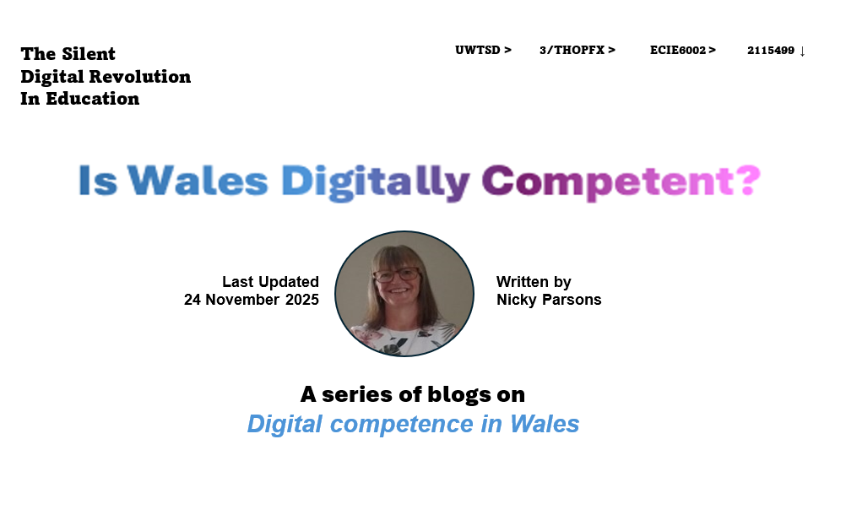

(Senedd Research, 2024)


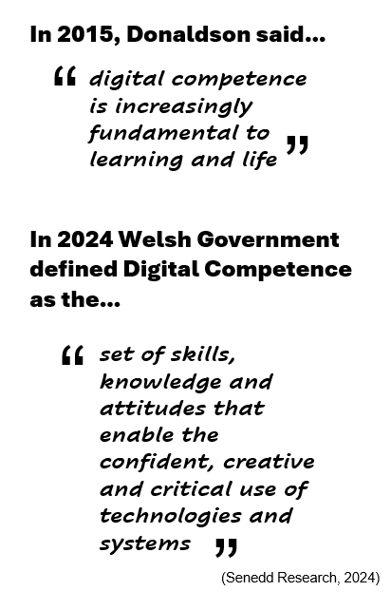
In 2016, following Donaldson’s 2015 review of the Welsh Educational Curriculum, the Digital Competency Framework (DCF) was introduced in schools in Wales
3 November 2025: Blog 1 = 8 Minute Read
(i-stock, 2025)
Its key aspects are:
- Along with literacy and numeracy, digital competency, is one of the three mandatory, core-skill, cross-curricular responsibilities, which must be embedded into all six areas of learning (AOL’s), of the Welsh Educational Curriculum.
- It does not replace information and communication technology (ICT) lessons. As these teach about the tools and infrastructure used in the digital world. Whereas, digital competence, teaches the skills, knowledge and attributes to use ICT tools, confidently and safely.
What IS the Digital Competence Framework?
It is a crucial component of the School Educational Curriculum in Wales.
Its aim is to ensure learners develop competent skills, knowledge and attitudes to be able to use digital technologies and systems, confidently, creatively, and critically in an increasingly digital and fast changing world.
What is the STRUCTURE of the Digital Competence Framework?
The Digital Competence Framework is divided into Four Strands
Strand One

Citizenship
Strand Two

Interacting & Collaborating
Strand Three

Producing
Strand Four

Data & Computational Thinking
Divided into the Elements of

- Identity, Image & Reputation
- Health & Wellbeing
- Digital Rights, Licensing & Ownership
- Online Behaviour & Online Bullying
Divided into the Elements of

- Communication
- Collaboration
- Storing & Sharing

Divided into the Elements of

- Sourcing, Searching & Planning
- Creating Digital Content
- Evaluating & Improving Digital Content
Divided into the Elements of

- Problem Solving & Modelling
- Data & Information Literacy

Five Progression Steps
Each strand’s individual elements are further sub-divided into five progression steps.
Each progression step details an age-appropriate, digital literacy skill-level, to be attained by the student, from age 3 to 16+.
You can access the Digital Competence Framework through this web link:
Digital Competence Framework (Wales) - HWB

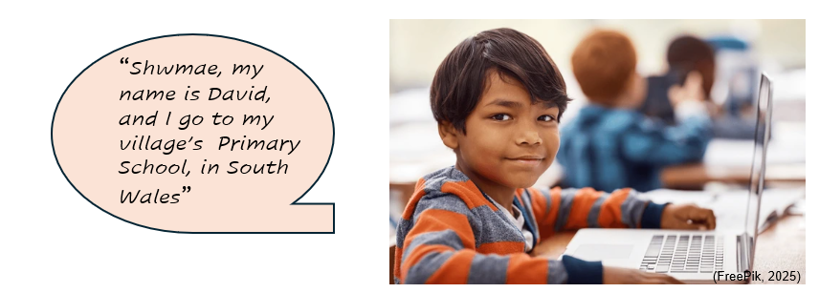

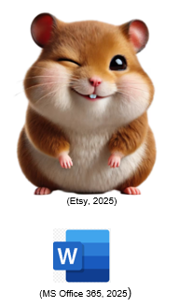
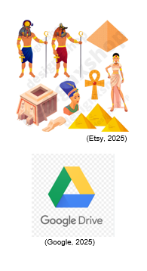
Progression Step 1 – Foundation Phase
(Age 3 to 6) Nursery and Reception – AOL Language, Literacy & Communication

“I can work with others to produce digital work”

A shared story is collaboratively created in MS Word™. The story features the class pet and their adventures during the half-term holiday. Firstly, verbally sharing with the class the pet’s adventures, each child is assisted, to construct and input a relevant sentence into the MS Word™ document. Additionally, each group selects a picture, to copy and paste into the document. The finished document is shared on the Whiteboard, with each child invited to identify their own sections. Assessment evidence is provided by screenshots, photos and the document itself.
Progression Step 2 – End of Key Stage 1/Start of Key Stage 2
(Age 6-8) Years 1, 2, 3 – AOL Science & Technology

“I can use online collaborative platforms to create and edit a file”

Following the teaching of the life cycle of the butterfly, an already created MS PowerPoint™ presentation is shared to a group of children, which has individual slides pre-headed for each stage of the life-cycle. The headings have deliberate spelling errors. Each child completes a slide and corrects the heading, being supported to create, edit and save their slide. Finally, the presentation is shown on the white-board. Assessment evidence is created by screen shots and photos.
We are going to track David’s school journey, from age 3 through to age 16+, and detail how he could attain all of the Five Progression Steps, for the Individual Element “Collaboration”, from Strand Two “Interacting & Collaborating”, of the Digital Competence Framework.

The DCF in action…
Progression Step 3 – Key Stage 2
(Age 8-11) Years 4, 5, 6 – AOL Humanities & Health & Wellbeing

“I can work with others to create an online collaborative project for a specific purpose. Sharing and appropriately setting permissions”

Create a ‘virtual museum’ on a historical topic, using a Google Drive™ shared folder. Firstly, the group selects a ‘project-lead’ person, then collaboratively creates a project-plan document, detailing each person’s resource gathering task and their profile permissions necessary to upload it to the shared folder. Whilst the lead sets the individual’s profile permissions, plus a ‘view only’ profile for the teacher, the others search and gather their allocated digital resource. Assessment evidence is provided by the plan document, screen shots and photos.
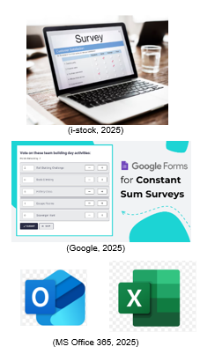
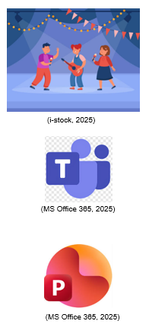
Progression Step 5 – Key Stage 4
(Age 14-16) Years 10, 11 – AOL Mathematics & Numeracy

“I can reflect on choice of collaboration solutions, use them appropriately and comment on how this could be improved to meet the aims of tasks”

Design and undertake an online digital survey, on a relevant current affair or school related topic, asking for opinions on several specific questions. Using a group email to other class members alongside creating a survey on Google Forms™. Following which a digital document is created, using a table, spreadsheet, and/or graphs, to collate, and present the results gathered. Alongside an evaluation of the results gathered with a conclusion, which gives two or more evidence-based, actionable recommendations. Assessment evidence is provided by the digital document.

Progression Step 4 – Key Stage 3
(Age 11-14) Years 7, 8, 9 – AOL Expressive Arts & Language, Literature & Communication

“I can independently select and use a range of online collaboration tools to create a project, with others, in one of more languages”

Organise a digital meeting, to showcase a recent school event, using the MS Office™ suite . Welsh and English must be used throughout using Google™ Translate. The task includes creating an ‘event planning document’, which details the structure of the event, plus a justification log detailing each individual’s role and why, plus the digital tools selected from MS Office™ and why. Following the digital event, a reflective summary is added to the planning document. Assessment evidence is provided by the event document and a recording of the actual digital event.


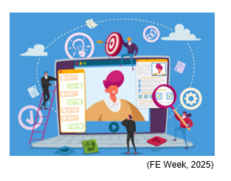
What digital life-skills has David developed, by completing all of the progression steps for the DCF’s element ‘Collaboration’?...

Workplace Readiness > Experience of using and selecting appropriate work-based digital platforms and infrastructure. Competence regarding collaborative digital communications, project planning, data gathering, evaluation and opinion, virtual meetings and presentations. Competence in cyber-security and data protection.

Civic Engagement > Experience of online communities and digital citizenship to engage collaboratively and responsibly with the global digital society.

Personal Life > Evaluating digital data. Competence around privacy protection and digital safety and responsibility. Ability to select media sources appropriately. Competencies in knowing the value of creating and protecting their digital footprint.

Home Life > Create and use shared digital domestic budget, chore, schedule, shopping, planners. Online domestic admin, banking and bill-payment. Using shared digital leisure.

Positives >

- Competences gained relating to the DCF’s four strands of: digital citizenship; interacting & collaboration; producing; and data and computational thinking
- Relevant employment digital skills
- Digital confidence and engagement
- Improved digital footprint, online responsibility, safer digital behaviours.

What are the positives and negatives of the DCF? …


What are the DCF’s negatives in some schools >

- Unclear direction given to the digital leader.
- The digital leader given full responsibility, for embedding the DCF across the curriculum, with staff dependent on them instead of delivering the DCF independently, under the guidance of the digital leader.
- Inadequate digital resources and infrastructure to effectively deliver the DCF.
- Inadequate staff knowledge and CPD to effectively deliver the DCF.
- Weak and insufficient cross-curricular mapping of the DCF.
- Weak and insufficient assessment of student attainment of the DCF’s progression steps.

Reference List – Blog 1 (3 November 2025)
Brittanica (2025) Lime Butterfly. Available at: Butterfly | Description, Insect, Life Cycle, Classification, & Facts | Britannica (Accessed: 20 November 2025).
Estyn (2019) Digital competence. Available at: Digital competence: Improving pupils’ digital skills - Estyn (Accessed: 20 November 2025).
Etsy (2025) Egyptians Clip Art. Available at: Egyptians clip art - Etsy UK (Accessed: 21 November 2025).
Etsy (2025) Hamster Watercolour Clipart. Available at: 24 Hamster Watercolor PNG Clipart, Cute Hamster PNG, Cute Hamster Clipart, Greedy Hamster Sublimation, Nursery Art, Digital PNG, Bundle - Etsy UK (Accessed: 20 November 2025).
F E Week (20250 Young people aren’t the digital natives employers need. Available at: Young people aren’t the digital natives employers need (Accessed: 21 November 2025).
FreePik (2025) Boy in classroom with laptop. Available at: Boy in classroom with laptop (Accessed: 20 November 2025).
Google Drive (2025) Organise your files in Google Drive. Available at: Organise your files in Google Drive - Computer - Google Drive Help (Accessed: 21 November 2025).
Gov.Wales (2015) Well-being of Future Generations (Wales) Act 2015. Available at: Well-being of Future Generations (Wales) Act 2015: the essentials | GOV.WALES (Accessed: 20 November 2025).
HWB (2025) Empowering learning through technology. Available at: Empowering learning through technology - Hwb (Accessed: 21 November 2025).
HWB (2025) The Digital Competence Framework (Wales). Available at: Digital Competence Framework (DCF) - Hwb (Accessed: 18 November 2025).
i-stock (2025) Survey on a Laptop Screen. Available at: 220,630 Survey On A Laptop Screen Stock Photos, Pictures & Royalty-Free Images - iStock (Accessed: 21 November 2025).
i-stock (2025) Digital Skills Stock Photos. Available at: 539,860 Digital Skills Stock Photos, Pictures & Royalty-Free Images - iStock (Accessed: 18 November 2025).
i-stock (2025) School Concert Illustrations. Available at: 8,609 School Concert Illustrations & Clip Art - iStock (Accessed: 21 November 2025).
MS Office 365 (2025) Microsoft Office is part of Microsoft 365. Available at: Microsoft Office is part of Microsoft 365 (Accessed: 21 November 2025).
Senedd Research (2024) Curriculum Reform: The Digital Competence Framework. Available at: Curriculum reform: The Digital Competence Framework (Accessed: 18 November 2025).
Shutterstock (2025) Child Studying on a Laptop at School. Available at: 82+ Thousand Child Studying On A Laptop In School Royalty-Free Images, Stock Photos & Pictures | Shutterstock (Accessed: 20 November 2025).
Twinkl (2025) DCF Resources – Curriculum for Wales. Available at: DCF Resources - Curriculum for Wales - Twinkl (Accessed: 21 November 2025).
10 November 2025: Blog 2 = 7 Minute Read

What are the positive and negative effects of the digital world on today’s children and young people ? ...
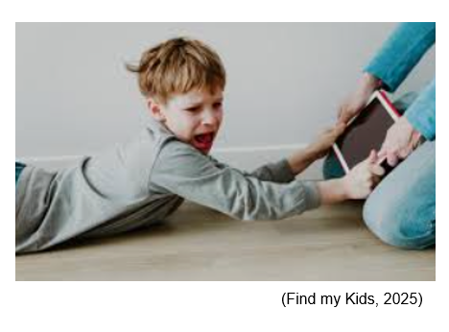

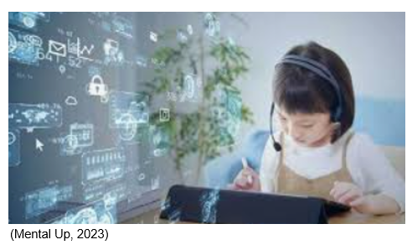

Firstly, some background data…

Public Health Wales (2023) stated…

- 43% NCY3 learners own a smart-phone and regularly use social-media, increasing to 83% NCY6 children.
- 46% NCY3-6 learners report being cyber-bullied.
- <50% NCY3-6 report they exercise <= 4x/week.
- 62% NCY3-6 report sleep difficulties.

Ofcom (2025) report…

- Rising statistics of 3-5 year olds using social-media.
- All age children increasingly engaging with ‘Brain Rot’ social-media platforms.
- Steeply growing use of AI, particularly teenagers, 50% report mistrusting it.
- Children’s engagement with current affairs is highly reliant on social-media.
- 30% of NCY7+ recall social-media safety lessons.
- 25% of social interactions in the 8-11 age-group are digital, rising to 40-50% in the 12-16 age-group.
- 92.6% of children aged 10-15 use social media daily.
- 58.1% spend over 3 hours, on social media, on school days.
- Teenage friendships are now hybrid social relationships of digital and face to face interactions.
- Younger children remain grounded in the physical world, their exposure to digital media is growing year on year.

OECD (2025) conclude from their 2022 PISA assessment…

- OECD countries average, 96% of 15-year-olds with access a desktop computer, laptop, or tablet at home.
- 98% own a smartphone with internet connection.
- 50% of 15-year-olds, spend 30+ hours a week on digital devices.



Positive >

- Greater learning opportunities
- Higher development of analytical skills
- Social connection and belonging
- Identity and voice
- Links for emotional support
- Relevant digital life-skills
- Sought after digital employment skills, leading to greater future opportunity
- Versatile learning platforms
- Speed of information
- Global access
- Parental controls to set child protection limits
- Ability to track children and children to call for help in emergency situations

Negative >

- Mental health and emotional impacts, including body-image, life-style and retail pressures
- Exposure to cyber-bullying
- Cognitive difficulties in the physical world
- Social and behavioural communication deficits in the physical world.
- Sedentary behaviour health risks
- Sleep disturbances risk
- Privacy violations, unauthorised shared personal images
- Grooming and exploitation risk
- Age-related risks such as by-passing purchasing & betting, age regulations
- Misinformation and bias reinforcement risk
- Addiction risk
- Impaired self-regulation
- Theft of digital personal data
- Exposure to online scams
- Excessive online gaming leading to increased impulsive behaviours and aggression
- Erosion of physical workforce, as AI increasingly replaces traditional roles

Positive and negative effects of the digital world on today’s children and young people…

Which theoretical frameworks, support the DCF in developing digital ‘consumer & producer’ competence?…

Several of the cognitivism based theories have relevance to the delivery of the DCF. Such as, Piaget’s (1936) personal constructivism theory, which believes children construct their own knowledge through, multiple individual learning experiences, which are relevant to their mental, biological and emotional stage of development. This aligns well with the five progression steps for the individual elements of the DCF (Bates, 2019). The same could be said for Kolb’s (1984) experiential learning theory, in which the learner’s knowledge is built through repeated exposure to cycles of learning, which include, experimentation, conceptualisation, experience and reflection, (Bates, 2019). Alongside, Bruner’s (1961) notion of discovery theory, where the learner is shown the tools they could use to complete a set task, but facilitate their own learning by independently exploring them, to meet the task’s aims (Bates, 2019)

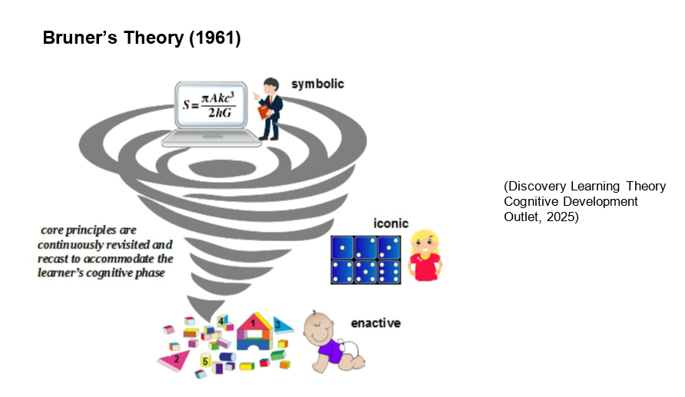

These theories can be seen in action, in the progression steps described in the previous blog. Step four, particularly illustrates Kolb’s (1984) and Bruner’s (1961) theories. Where the learner is tasked to explore and analyse different digital tools, then create a justification log for the tools they select to meet the needs of the set task. Plus, following the digital event, to produce a reflection document on the reality of their suitability. This progression step enables the learner to understand their role both as a producer of digital information and a consumer of digital platforms (eLearning industry, 2025).

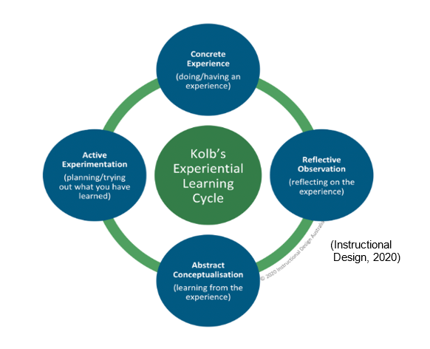

Siemens’ (2005) and Downes’ (2010) linked theory on connectivism, aligns with learner’s becoming competent and safe digital consumers and producers. The theory believes that in e-learning there are ‘nodes’, which are any source that generates digital information, plus ‘links’, which are the digital routes across which the information travels from the ‘nodes’ to digital consumers. Siemen and Downes believed that there are eight principles of digital connectivism: 1) learning facilitated through e-connection’s nodes and links; 2) accessibility to collect diverse opinions; 3) ability to additionally include knowledge gained from non-human sources; 4) access to evolving knowledge; 5) connections being nurtured to facilitate continual learning; 6) synthesis and analysis of information gathered from multiple sources; 7) continual analysis of the most recent knowledge; 8) continual assessment, of the validity and credibility of the nodes and links used in digital information consumerism.
These principles all underpin safe and competent use of the digital world and can be directly linked to the individual elements in the ‘collaboration’ strand of the DCF (eLearning Industry, 2025).



Digital Propaganda

McLuhan (1966) discussed the emerging ‘global village’ driven by worldwide digital media-platforms, suggesting media-platforms themselves, generated the final opinion reinforced to digital consumers. By facilitating, a massive digital collection of individual opinions, the sum of which formed the ultimate ‘global village’s’ opinion. Recent USA elections have demonstrated the theory, where digital influencer battles were fought online, to secure the final global opinion (NCSC.Gov.UK, 2023). Current bias reinforcement algorithms being used in personal news feeds reinforce this theory further (Gov.UK, 2025).

Prensky (2001) described all citizens of the world as either, digital natives (born into digital world), digital immigrants (not born into a digital world, but adapted) or digital refugees (not born into it and not adapted). Those attempting to sway collective digital opinion, often concentrate on issues relevant to digital natives and immigrants, and not digital refugees (Gov.UK, 2025).

Legislation…

- Online Safety Act (2023) (Gov.UK, 2025) - Duties which social media and search engine platforms must follow in the UK. Online Safety Act: explainer - GOV.UK
- Ofcom (2025) - 40+ measures which UK digital organisations must follow New rules for a safer generation of children online
- Wales Safeguarding Procedures (2020) (Social Care Wales, 2025) - Procedures which must be followed when an individual’s wellbeing is doubted. Safeguarding Wales

Policy…

- HWB (2025) - Web-page detailing responsibilities school’s must encompass in their digital access policy. Keeping safe online policy and practice

Practice…

- HWB (2025) - Web-page with links to information about all things digital for practitioners, parents and learners. Keeping safe online - Hwb
- HWB (2025) - Digital competence framework’s for teaching digital competency skills:
Mainstream. Digital Competence Framework
Early years & ALN Digital Competence Framework ABC Steps RfL ALN

Professional Training…

- The National Crime Agency’s Child Exploitation and Online Protection Centre (NCA-CEOP, 2025) - Age-related teaching resources, practitioner training and guidance for all, regarding using the digital world safely CSA CEOP Resources, Training and Guidance

Parental Guidance…

- HWB (2025) – Web-page with links to information about all things digital for parents to use. Keeping safe online - Hwb
- The National Crime Agency’s Child Exploitation and Online Protection Centre (NCA-CEOP, 2025) - Provides age-related digital guidance for parents CSA CEOP Resources, Training and Guidance
How does current legislation, policy and practices keep learner’s safe from the negative effects of the digital world ? …

These measures combine to protect children from digital harms both at school and home. However, still too many children are effected by online harms. (NCA-CEOP, 2025).

Ofcom published their reviewed ‘Children’s Register of Digital Risks’ on 24/04/2025. Following which, all UK social media and search engine platforms, were given until 24/07/2025, to update their own organisation’s polices and practices accordingly, and submit their risk assessments and mitigation plans. Their updated practices to be operational by 25/07/2025. (Ofcom, 2025).

Ofcom has powers to fine any digital platform which fails to comply, with fines of up to £18m or 10% of their global annual revenue and/or ban the platform from the UK (ICLG, 2025).

Reference List – Blog 2 (10 November 2025)
Bates, B. (2019) Learning theories simplified. 2nd edn. London: Sage Publications.
Bruner, J. S. (1961) ‘The act of discovery’. Harvard Educational Review, 31(1), pp. 21–32. Available at: The Act of Discovery Bruner1 PDF | PDF (Accessed: 24 November 2025).
Canadian Paediatric Society (CPS) (2017) ‘Screen time and young children: Promoting health and development in a digital world’, Paediatrics & child health, 22(8), pp. 461–477. Available at: https://doi.org/10.1093/pch/pxx123 (Accessed: 22 November 2025).
Discovery Learning Theory Cognitive Development Outlet (2025) Bruner’s Theory. Available at: Discovery Learning Theory Cognitive Development Outlet - Online Store (Accessed: 24 November 2025).
Downes, S. (2010) ‘New technology supporting informal learning’. Journal of Emerging Technologies in Web Intelligence, 2 (1), pp. 27-33. Available at: 20141226041314947.pdf (Accessed: 24 November 2025).
e-Learning Industry (2025) Connectivism Learning Theory: Everything You Need To Know. Available at: Connectivism Learning Theory: Everything You Need To Know (Accessed: 24 November 2025).
Find My Kids (2025) The positive and negative effects of technology on child development. Available at: Positive & Negative Effects of Technology on Child Development, Health and Education (Accessed: 22 November 2025).
Gov.UK (2025) Online disinformation and AI threat guidance for electoral candidates and officials. Available at: Online disinformation and AI threat guidance for electoral candidates and officials - GOV.UK (Accessed: 24 November 2025).
Gov.UK (2025) What does the Online Safety Act do? Available at Online Safety Act: explainer - GOV.UK (Accessed: 24 November 2025).
Haddock, A., Ward, N., Yu, R., and O'Dea, N. (2022) ‘Positive Effects of Digital Technology Use by Adolescents: A Scoping Review of the Literature’. International journal of environmental research and public health, 19(21), Document Ref: 14009. Available at: https://doi.org/10.3390/ijerph192114009 (Accessed: 22 November 2025).
HWB (2025) Keeping safe online policy and practice. Available at: Keeping safe online policy and practice (Accessed: 24 November 2025).
HWB (2025) Keeping safe online. Available at: Keeping safe online - Hwb (Accessed: 24 November 2025).
HWB (2025) The Digital Competence Framework (Wales) Mainstream. Available at: Digital Competence Framework (DCF) - Hwb (Accessed: 18 November 2025).
HWB (2025) The Digital Competence Framework (Wales). RfL ABC Steps ALN. Available at: Digital Competence Framework ABC Steps RfL ALN (Accessed: 24 November 2025).
ICLG (2025) Ofcom confirms new child safety regulations for online platforms. Available at: Ofcom confirms new child safety regulations for online platforms | ICLG (Accessed: 24 November 2025).
Instructional Design (2020) Kolb1984 Theory. Available at: kolb 1984 theory - Search Images (Accessed: 24 November 2025).
Kolb, D. A. (1984). Experiential learning: Experience as the source of learning and development. Englewood Cliffs, NJ: Prentice-Hall.
McLuhan, M. (1966) Understanding Media; the Extensions of Man. New York: Signet Books.
Mental Up (2023) Positive and negative effects of technology on children. Available at: Positive and Negative Effects of Technology on Children - MentalUP (Accessed: 22 November 2025).
National Cyber Security Centre (NCSC) (2023) Defending Democracy. Available at: Defending democracy - NCSC.GOV.UK (Accessed: 24 November 2025).
NCA-CEOP (2025) National Crime Agency - Child Exploitation and Online Protection Centre. Available at: CSA CEOP Resources, Training and Guidance (Accessed: 24 November 2025).
OECD (2025) How's life for children in the digital age? Available at: How's Life for Children in the Digital Age? | OECD (Accessed: 22 November 2025).
Ofcom (2025) Children’s Register of Risks. Available at: Children's Register of Risks (Accessed: 24 November 2025).
Ofcom (2025) New rules for a safer generation of children online. Available at: New rules for a safer generation of children online (Accessed: 24 November 2025).
Ofcom (2025) Children’s Media Literacy Report 2025. Available at: Children's Media Literacy Report 2025 (Accessed: 22 November 2025).
PHW (2023) Social media regularly used by 48% of primary age children in Wales, report shows… Available at: Social media regularly used by 48% of primary age children in Wales, report shows - Public Health Wales (Accessed: 22 November 2025).
Piaget, J. (1936) Origins of intelligence in the child. London: Routledge & Kegan Paul.
Prensky, M. (2001) ‘On the Horizon: Digital Natives, Digital Immigrants’, MCB University Press, 9 (5), pp. 1-6. Available at: Digital Natives, Digital Immigrants (Accessed: 24 November 2025).
Shutterstock (2025) Big arm manipulating brains through digital devices. Available at: Creative Composite Illustration Photo Collage Big Stock Photo 2329582983 | Shutterstock (Accessed: 24 November 2025).
Siemens, G. (2005) ‘Connectivism: A learning theory for the digital age’. International Journal of Instructional Technology and Distance Learning, 2 (1), pp. 3-10. Available at: Connectivism: A learning theory for the digital age. (Accessed: 24 November 2025).
Social Care Wales (2025) Wales Safeguarding Procedures. Available at: Safeguarding Wales (Accessed: 24 November 2025).
UNICEF (2025) Childhood in a Digital World. Available at: Childhood in a Digital World | Innocenti Global Office of Research and Foresight (Accessed: 22 November 2025).

17 November 2025: Blog 3 = 6 Minute Read

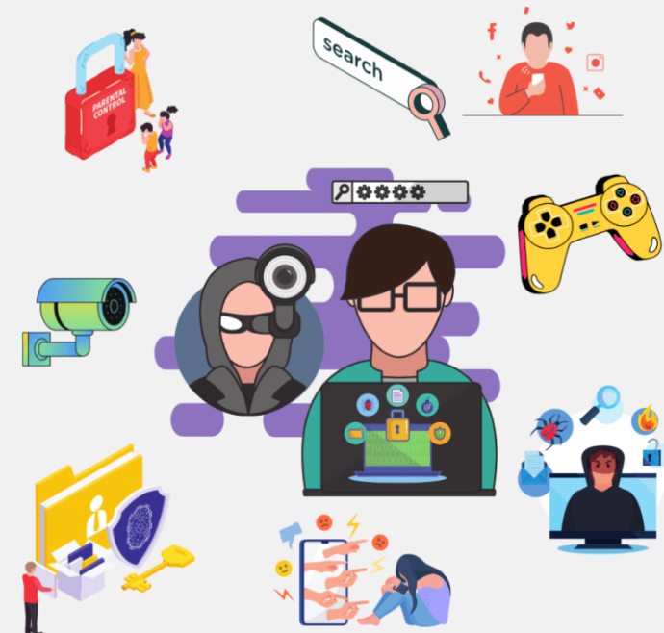
What are the benefits of digital technology to teaching and learning ? ...

&

What are the barriers to digital inclusion ? ...

(Skool of Code, 2025)

Hi, I’m Nicky,
I work in F2F Adult Learning. Where I support the teaching of literacy, numeracy & life-skills to ALN/SEN adults. I have also had experience of working in a SEN unit for adolescent boys with profound & multiple learning needs and complex behavioural issues.

What are the digital technology benefits and impacts for teaching and learning I have experienced? …

- Classroom practice - It positively impacts our learner’s engagement and learning experience. We are able to use more multi-media teaching resources delivered through the Smart-Board to achieve the lesson’s aims. These resources are more engaging for our ALN learners than pen and paper. Particularly as many of them cannot write, but can touch a Smart-Board to indicate their choices or use an electronic pointer. It promotes Welsh/English bilingualism with access to on-line translation services.

- Time management - for lesson planning and making resources. We can use AI to assist us in lesson-planning and finding a range of appropriate and engaging resources. This method is faster and finds us resources which better meet all of our learner’s diverse needs. Online staff meetings increases convenience and flexibility.

- Assessment - We are able to use video clips and photo’s to upload for assessment purposes. These methods are more suitable for our learners than written test papers etc.

- Record-keeping and data collection efficiency and convenience - We can sit with our learners to complete forms on line with them, the register is online and we keep each student’s record of learning online too. This benefits our learners greatly, as the majority of them are unable to complete paper-forms by hand. We benefit, as we are able to access our record-keeping and work e-mails at home, when it is convenient to us. The organisation benefits through faster collection of statistical data.

- CPD easier and more convenient - By training being online, including mandatory training, we are able to be flexible about where and when we chose to do it. This benefits learners as we keep our skills relevant and do not have to cancel lessons to undertake training.

- Knowledge being kept up-to-date - Being members of relevant digital platforms we keep up-to-date, which delivers a better learner’s experience. The organisation can quickly disseminate new information to us digitally.

- Communication faster and easier - We can group text our learners with relevant information. For example when class is re-starting after a holiday. Send reminders we are meeting at a different venue etc. This benefits our learners so they don’t miss out on things and is quick and efficient for us.

- Blended learning offers greater flexibility - During Covid we did all of our lessons online. Some of our learners still access our classes through face-time calls.

- Work-life-learning balance - All of these things combined, mutually benefit staff and learners through improved time management, flexibility and learning experience..

(OECD, 2025, HWB, 2025, Gov.Wales, 2025, SFE, 2022, Wales247, 2025)




(Shutterstock, 2025)
(Shutterstock, 2025)

Theory & Opinion

The benefits discussed above can be linked to Siemens’ (2005) and Downes’ (2010) integrated theories on connectivism, as described in Blog 2. Our learners and us being the ‘consumers and producers’, the digital programmes, apps, search engines and organisational interfaces used, the ‘nodes’ and the internet and interactive smart-boards the ‘links’.

“Digital media positively impacts children’s opinion of learning, providing engagement opportunities not always seen with print materials”
(Shapiro, 2019, p.56)



(Shutterstock, 2025)

The barriers to digital inclusion include…

- Access to the digital world - Through lack of access to digital devices or access to power or the internet.

- Poor digital literacy and competency - Driven by fear of the digital world or lack of access to digital education.

- Poor infrastructure design which exacerbates exclusion - Particularly effects those with disabilities, as mainstream digital infrastructure design pre-dominantly has a lack of inclusive design and fails to support assistive technologies. This leads to a poor range of choice and prohibitively expensive ‘speciality inclusive’ digital products.

- Cultural norms and home dynamics – Developing areas were digital infrastructure is still growing or is heavily controlled. Familial hierarchy systems, regarding which family members can have access to limited digital devices and internet access. Language difficulties can also impair access in a different culture.

- Safety related digital risks - Where digital competency is low, fear of internet risks can fuel restrictions being imposed on digital use, both for social and academic use. This is particularly true for ASD digital users who are disproportionally at risk from bias algorithms in social media feeds.

- Socio-economic and geographical difficulties - The cost of digital devices and access to the internet can be prohibitive to some educational settings and families at home. There may be limited access to the internet in remote areas.

- Digital eco-impact concerns - The carbon footprint of the digital world is forecast to reach up to 8.8% of global emissions in 2025. These come from the initial manufacturing processes and the constant renewal of outdated devices, along with high e-waste levels. Alongside, power consumption, particularly for AI servers. Additionally, AI servers consume enormous amounts of water for onsite server cooling, forecast to reach up to 6.6 billion m3 by 2027.

(Gov.UK, 2025, ITU, 2025, OECD, 2023)

Theories which link to digital inclusion barriers:

Bourdieu’s 1986 Theory of Cultural Capital - which believed societal and cultural privileges assist an individual’s success. This can be linked to the socio-economic and geographical disparities which can be a barrier to digital inclusion.

Baron-Cohen et al’s 1985 Theory of the Mind – which concluded that those with ASD are at a higher risk of ‘influence’ and ‘exploitation’ due to ASD’s neurological differences. This links to the digital barrier regarding safety related risk.

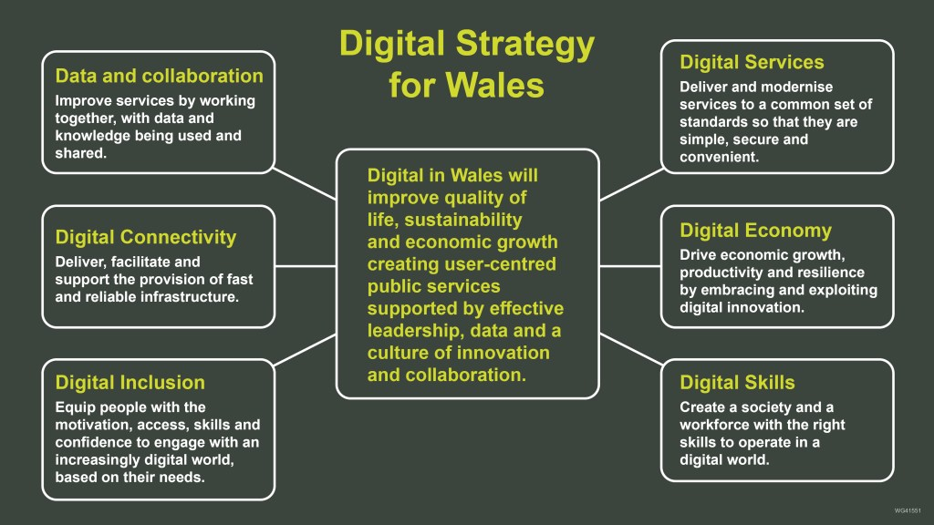
In order to mitigate as many of the barriers to digital inclusion as possible, in 2020 Welsh Government launched its ‘Digital Strategy for Wales’ with its ‘Six Mission Statements’, aimed to positively impact the achievement of the Welsh Seven Wellbeing Goals by 2050…

Welsh Government published its AI Plan for Wales in 2025, which states it aims to…

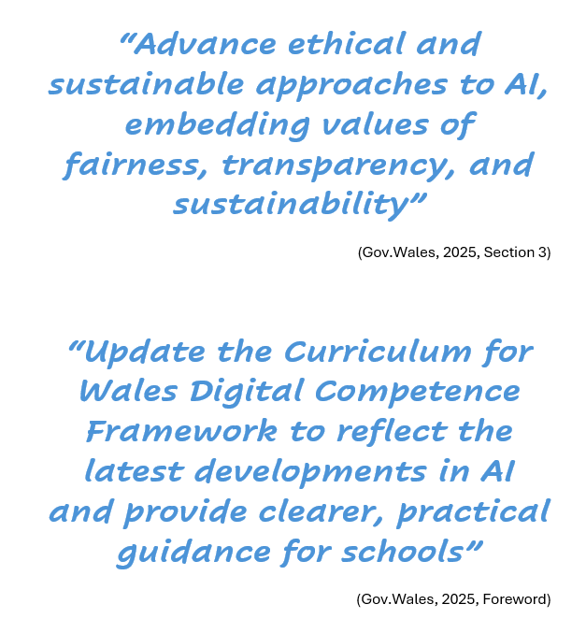

Audit Wales (2023) concluded the overall statistics for digital inclusion are improving but there remains particular groups in society which will require more targeted intervention…

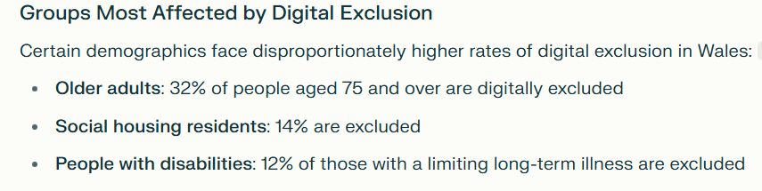
(Audit Wales, 2023)

Reference List – Blog 3 (17 November 2025)
Audit Wales (2023) Digital inclusion in Wales: Report of the Auditor General for Wales. Available at: Digital inclusion in Wales (Accessed: 26 November 2025).
Baron-Cohen, S., Leslie, A. M., and Frith, U. (1985) ‘Does the autistic child have a "theory of mind”?’, Cognition, 21(1), pp. 37-46. Available at: https://doi.org/10.1016/0010-0277(85)90022-8 (Accessed: 26 November 2025).
Bourdieu, P. (1986) ‘The Forms of Capital’, in Richardson, J. (ed.) Handbook of Theory and Research for the Sociology of Education, pp. 241-258. New York: Greenwood.
Downes, S. (2010) ‘New technology supporting informal learning’. Journal of Emerging Technologies in Web Intelligence, 2 (1), pp. 27-33. Available at: 20141226041314947.pdf (Accessed: 24 November 2025).
Gov.UK (2025) Digital Inclusion Action Plan: First Steps. Available at: Digital Inclusion Action Plan: First Steps - GOV.UK (Accessed: 26 November 2025).
Gov.Wales (2020) Digital Strategy for Wales. Available at: Digital Strategy for Wales – setting the context | Digital and Data Blog (Accessed: 18 November 2025).
Gov.Wales (2025) Wellbeing of Wales in 2025. Available at: Wellbeing of Wales: 2025 | GOV.WALES (Accessed: 26 November 2025).
Gov.Wales (2025) AI Cymru: Shaping a Smarter, Fairer, More Prosperous Wales. Available at: AI Cymru: Shaping a Smarter, Fairer, More Prosperous Wales [HTML] | GOV.WALES (Accessed: 26 November 2025).
Gov.Wales (2025) Investing in digital skills at school and at home. Available at: Investing in digital skills at school and at home | GOV.WALES (Accessed: 26 November 2025).
HWB (2025) Empowering learning through technology. Available at: Empowering learning through technology - Hwb (Accessed: 27 November 2025).
ITU (2025) Tech sector emissions, energy use grow with rise of AI. Available at: Press Release (Accessed: 26 November 2025).
OECD (2023) How much water does AI consume? The public deserves to know. How much water does AI consume? The public deserves to know - OECD.AI (Accessed: 26 November 2025).
OECD (2025) The impact of digital activities on children’s lives: How’s life for children in the digital age? Available at: The impact of digital activities on children's lives: How's Life for Children in the Digital Age? | OECD (Accessed: 26 November 2025).
Services for Education (SFW) (2022) 5 Benefits of Digital Learning for Teachers. Available at: 5 Benefits of Digital Learning for Teachers - Services For Education (Accessed: 26 November 2025).
Shapiro, J. (2019) The New Childhood. London: Yellow Kite.
Shutterstock (2025) Royalty-free images. Available at: 5+ Million Digital Connection Royalty-Free Images, Stock Photos & Pictures | Shutterstock (Accessed: 26 November 2025).
Siemens, G. (2005) ‘Connectivism: A learning theory for the digital age’. International Journal of Instructional Technology and Distance Learning, 2 (1), pp. 3-10. Available at: Connectivism: A learning theory for the digital age. (Accessed: 24 November 2025).
Skool of Code (2025) Why are digital literacy skills important for your kids? Available at: Why Are Digital Literacy Skills Important For Your Kids? (Accessed: 26 November 2025).
Wales247 (2025) Redefining Education: How Digital Learning Is Changing the Game. Available at: Redefining Education: How Digital Learning Is Changing the Game (Accessed: 26 November 2025).

24 November 2025: Blog 4 = 5 Minute Read
How effective, is the use of interactive smart-boards, in meeting the needs of our learners?…

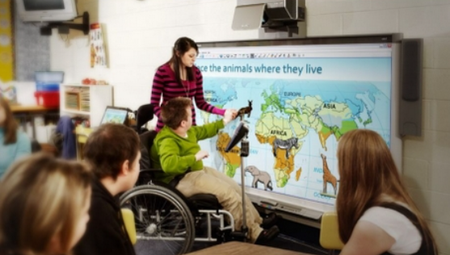

(SmartTech, 2025)
Adult Learning has replaced its white-boards with interactive smart-boards…
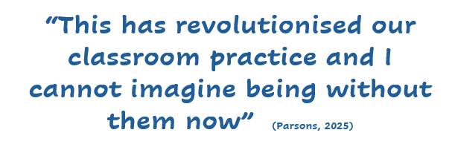
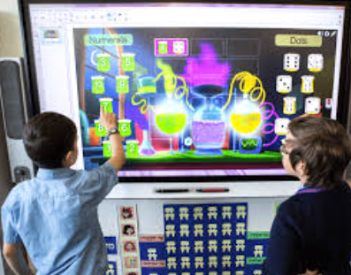
(EdTech, 2024)

Background

Our learners are all ages, of ALN/SEN adults, with multiple different needs, life experiences, confidence levels and expectations. Many have had past adverse experiences, particularly educational and care related. Developing a trust based relationship with them is our first priority, alongside constantly reassuring them of their value, abilities and safety. Seeing them thrive in the environment we create for them, is a privilege and the interactive smart-boards are a big part of that process.
(PCC, 2025)

Please click on the web-links below for videos on the smart- boards and tools which go with them, showing how they empower inclusivity and equitable education:

Empowering All Students | SMART's inclusive technology supports equitable education

Communication and Special Education

(SmartTech, 2025)

Benefits

- Relationships - Smart-boards allow us to react quickly when building and reinforcing our trust relationships with the learners, as we can pick up quickly on things that they saying and immediately go to the smart-board and find relatable video-clips etc, this works well to enhance their engagement, build relationships and their sense of worth. For example when teaching RNLI life-skills regarding beach & water safety. One learner remembered the old Joe & Petunia TV adverts on the topic and we were instantly able to find video-clips of them, this enabled the learner concerned to feel of great value to the class. Also, when a learner wishes to share their negative or positive feelings regarding something, with their fellow learners, we have been able to show relatable digital content to support their discussion. This fosters their sense of belonging to a trusted group of people. Some of our groups of learners have become well established social groups beyond our classes, sharing multiple activities together.
- Topic resources - are so much easier to find to use for our learners through the smart-board medium. As the internet has a vast array of differing ability level, interactive topic-related apps and printable resources to use. This has permitted us to increase our inclusivity for each of our learner’s needs and lesson their barriers to education.
- Learner engagement - has been positively impacted by the use of the smart-boards too. As many of the topic apps have interactive learning opportunities, which our learners are able to use, such as touching the board to indicate their choices, or touch and dragging images to the right places.
- Visual controls – We are able to adjust sizes, use different digital overlays and change the colour and size of the free writing lined digital paper on the board and the colours of the digital pens, to meet the individual learner’s preferences. The tool box also uses the national recognised symbol language of Widget which is used in schools and SEN.

These benefits can be linked to theories such as:

- Siemens’ (2005) and Downes’ (2010) integrated theories on connectivism (as described in Blog 2).
- Bergin and Bergin’s (2009) theory on attachment, which emphasised the positive benefits of secondary attachments formed in the classroom.
- Maslow’s (1943) hierarchy of needs and Rogers (1969) freedom to learn theories, which both support for optimal engagement with education, individuals need their physiological and safety needs met first.
- Dewey (1938) who believed that learning is achieved through an individual’s interaction with the world around them.
- Vygotsky (1978) who believed that learning is a social process facilitated through individuals interacting together.

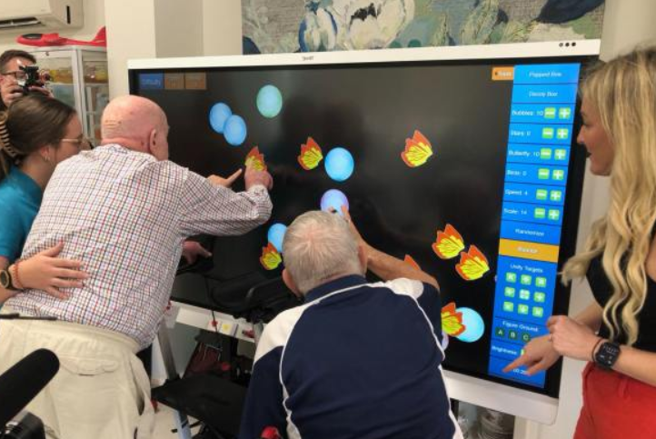

Barriers

- The smart-board being permanently fixed to the wall in one position instead of on an adjustable height and tilt bracket is a barrier for our wheelchair users in several of our venues. We have requested for them to be changed, repeatedly!
- The digital ‘tools’ missing from the tool tray beneath the smart-board, impacts some of our learner’s engagement. We improvise until they are returned!
- Some sites we wish to access such as YouTube are barred under the digital safety policy. We always find something else we can access, it just takes longer to find!

Development of Digital Competency

- The learners’ supported use of smart-boards enables them to access the digital world whilst in class.
- We voluntarily utilise the DCF ABC Framework were it is feasible to do so with an individual learner.
- We assist our learners to update their individual learning plan aims each term. Digital literacy is always considered and we support the learners to achieve their individual goals throughout the term. Some learner’s are able to follow the progression steps of the DCF ABC Framework (HWB, 2025), some we aim to maintain and widen their current digital skills.
(Garden Village, 2025)

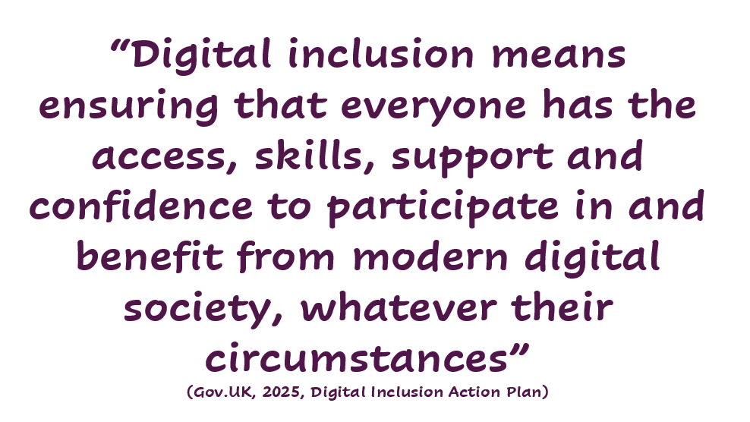
Reference List – Blog 4 (24 November 2025)
Bergin, C. and Bergin, D. (2009) ‘Attachment in the classroom’, Educational Psychology Review, 21(2), pp. 141-170. DOI: https://doi.org/10.1007/s10648-009-9104-0 (Accessed: 27 November 2025).
Dewey, J. (1938) Experience and Education. New York: Macmillan Company.
Downes, S. (2010) ‘New technology supporting informal learning’. Journal of Emerging Technologies in Web Intelligence, 2 (1), pp. 27-33. Available at: 20141226041314947.pdf (Accessed: 24 November 2025).
EdTech (2024) EdTech for inclusion. EdTech for inclusion | SEN Magazine (Accessed: 27 November 2025).
Garden Village (2025) Available at: Smart Board Launch to uplift resident experience - Garden Village (Accessed: 27 November 2025).
Gov.UK (2025) Digital Inclusion Action Plan: First Steps. Available at: Digital Inclusion Action Plan: First Steps - GOV.UK (Accessed: 26 November 2025).
HWB (2025) Digital Competency Framework ABC Steps RfL ALN. Available at: Digital Competence Framework ABC Steps RfL ALN (Accessed: 27 November 2025).
Maslow, A. H. (1943) ‘A theory of human motivation’, Psychological Review, 50(4), pp. 370–396. Available at: https://doi.org/10.1037/h0054346 (Accessed: 27 November 2025).
Parsons, N. (2025) ‘A series of blogs on digital competence in Wales‘. University of Wales Trinity St David’s. Course No: 3/TH09FX. Student No: 2115499. Module No. ECIE6002, Unpublished Blog.
PCC (2025) Essential Skills. Available at: Essential Skills (English, maths, digital) - Pembrokeshire County Council (Accessed: 27 November 2025).
Siemens, G. (2005) ‘Connectivism: A learning theory for the digital age’. International Journal of Instructional Technology and Distance Learning, 2 (1), pp. 3-10. Available at: Connectivism: A learning theory for the digital age. (Accessed: 24 November 2025).
SmartTech (2025) Inclusive Education with Smart. Available at: Inclusive Education With SMART | Give Every Student A Voice (Accessed: 27 November 2025).
Vygotsky, L. S. (1978). Mind in society: The development of higher psychological processes. Cambridge, Mass.: Harvard University Press.

Assessment Word Count = 4000 +/- 10% (Range Min 3600 to Max 4400)
Actual Word Count = 4388
Blog 1 - 1225
Blog 2 - 1313
Blog 3 - 1062
Blog 4 - 788
Total = 4388

