Digital Skills and Research Method BMSW4003
Website Assignment
Iulian C Tampau
SN 1904938

Weebly.com login details:

Email 1904938uwtsd@gmail.com

Password UniFun123

Gmail login details:

Username 1904938uwtsd

Password UniFun123

Website rationale

The design of the website for the purposed business has taken into consideration several visual aspects such as: blue colour being associated with trust, confidence, wisdom and truth; a clean layout has been selected in order to maintain a simple on point style and be easy to read to the visitors. Our unique selling point, the fact that we are able to speak the same language as our customers has been highlighted from the beginning of our website.

The business logo has been integrated on the website header and throughout the website as per image nr 1, a photo of healthcare personnel has been placed under the company name with the purpose of adding a visual representation of our services.

I integrated our story page in the main menu to be able to give our customers the chance to learn more about our team and instructions on how to get in touch with us, also touching on our staffing solutions business experience and know how.

On the Services Page I separated clearly the three types of services the nursing agency is offering. As it can be seen on picture 5, I integrated Contact Form for clients/ Enquire now Option in order to offer to the clients the quick option of enquiring more very easily. Upon clients providing their business email, later on an email will be sent out to them with our brochure/business poster. I also incorporated a contact form on the next page, in the candidate’s section, in order to make it easy for candidates to register their interest.

When designing the website strong consideration has been given to having the website ready for Search Engine Optimisation. SEO is described by (Thomas, 2013)as the number one way to get free traffic to your website from search engines. According to (Ebner & Granitza, 2019) through SEO marketing campaigns we can create awareness and promote our business, the benefits of being discoverable through SEO can be described as raised traffic on the website, increased website ranking and higher conversion rates. For our business website as per picture 4 and 7, I have updated the SEO settings on the website editor platform in order to reflect our services description and I included the most related Meta Keywords as when either a client or a candidate is looking for healthcare candidates/jobs, our website will be brought up on the search engines.
On our contact page I integrated Social Media links to our pages on the popular platforms such as Facebook, LinkedIn, Instagram and Twitter. I also incorporated the “Call Now” option making it easy for everyone to reach us immediately and added a subscribe form to our newsletter allowing us to keep interested parties up to date with our services. Finally, I integrated a Google map, ensuring that we are discoverable on Google Maps, with the ai to make it easier for us to be discovered and for our visitors allowing them to obtain easy directions, and plan around their visit over at us.

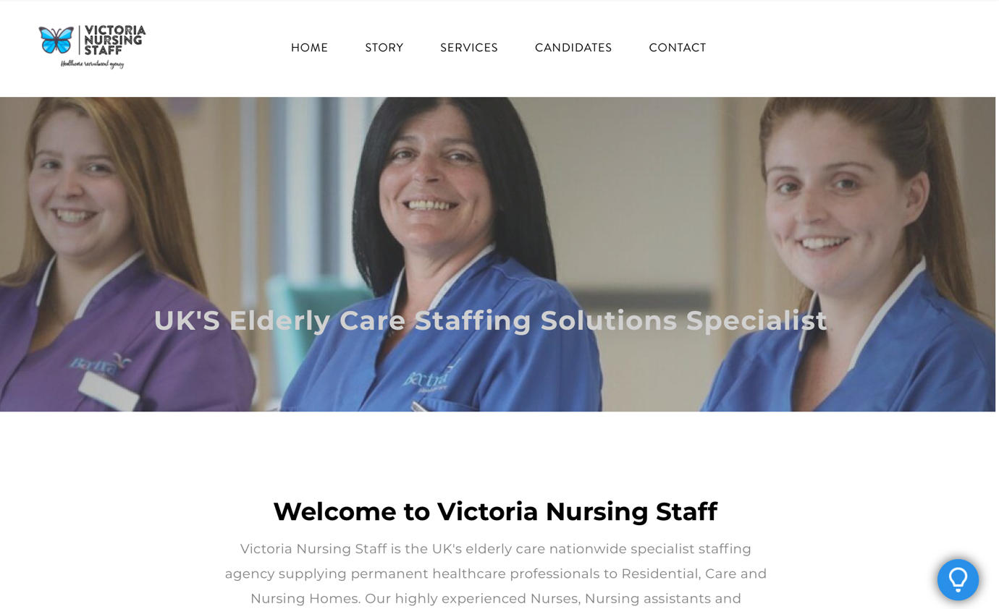
Figure 1 Home Screen Top

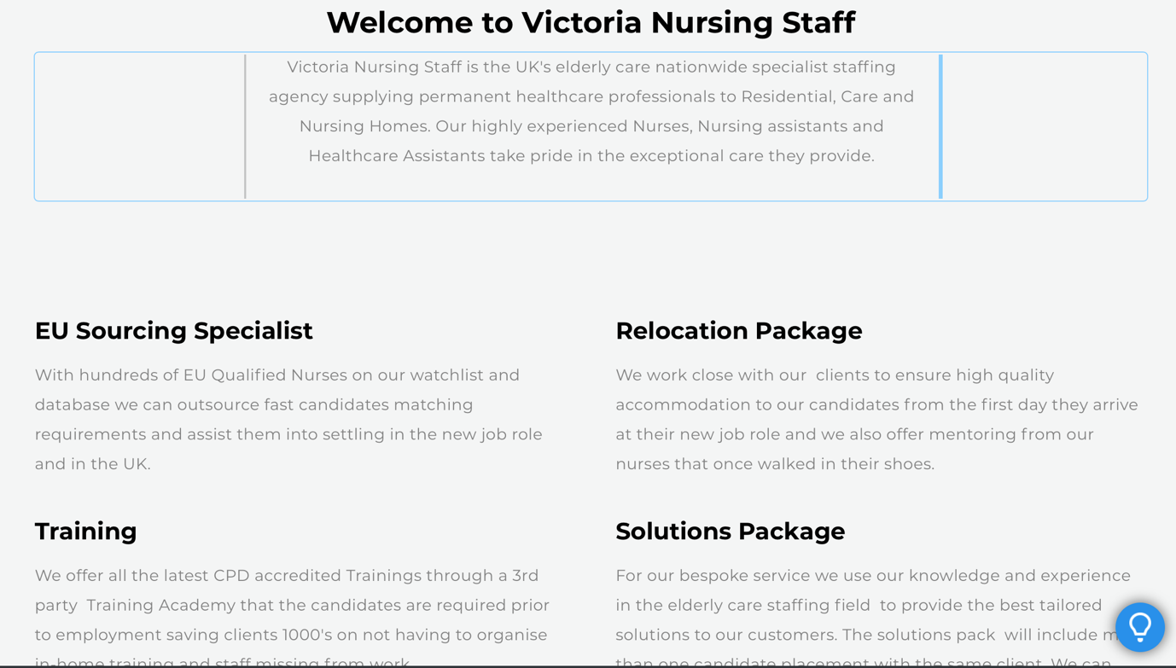
Figure 2 Home Screen Bottom

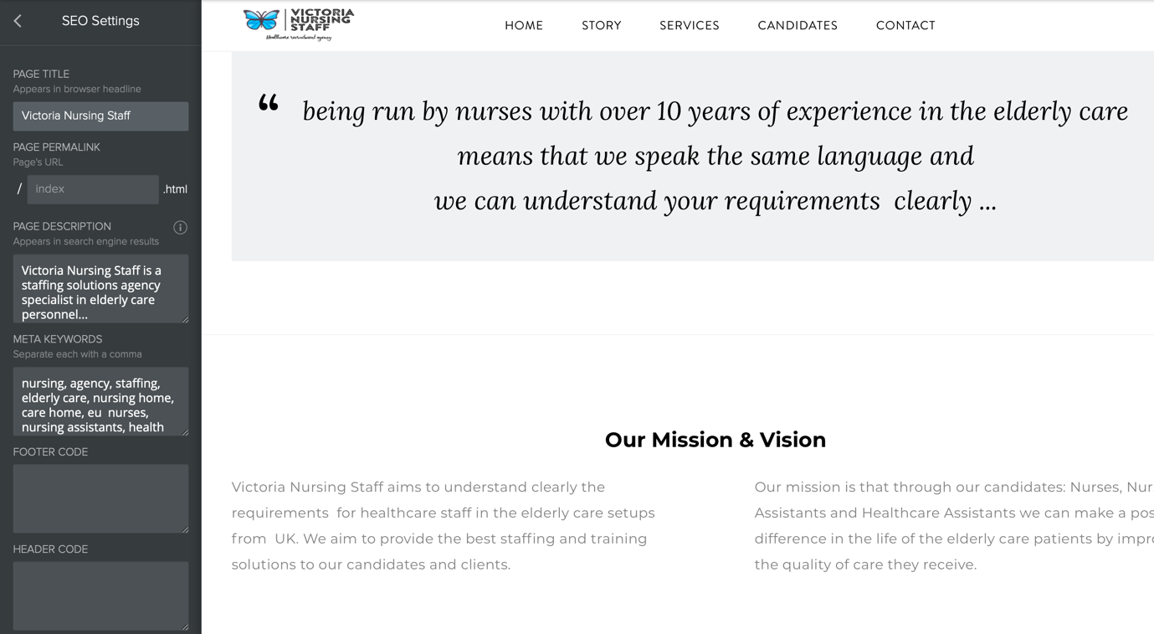
Figure 3 Home Page SEO Keywords

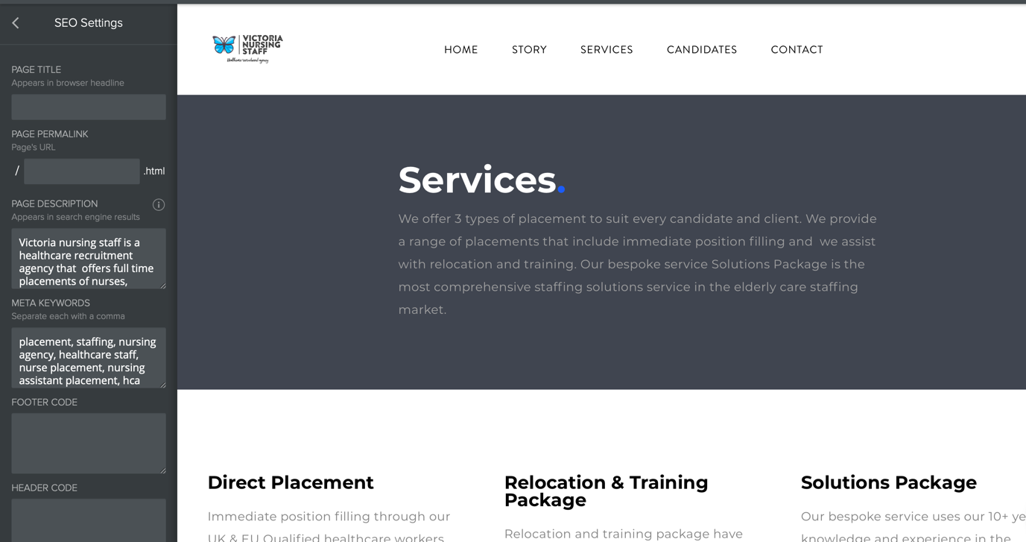
Figure 4 Services Page & SEO Keywords

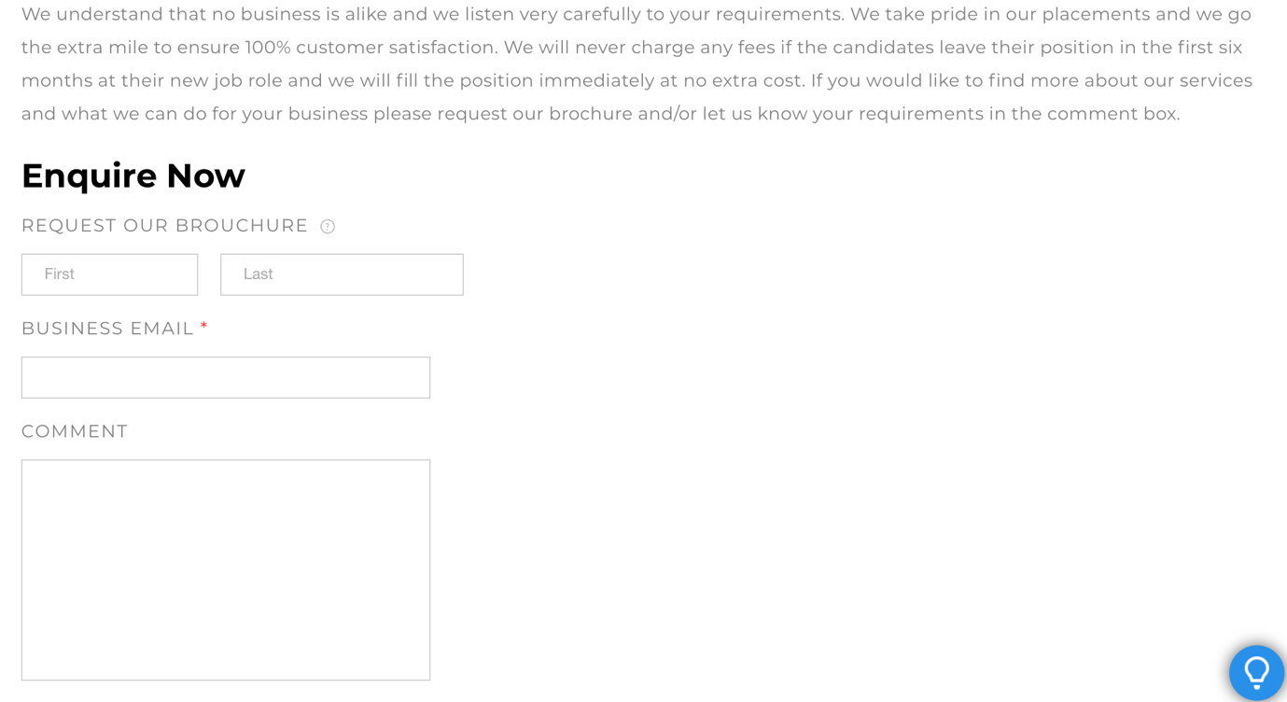
Figure 5 Contact form for Clients

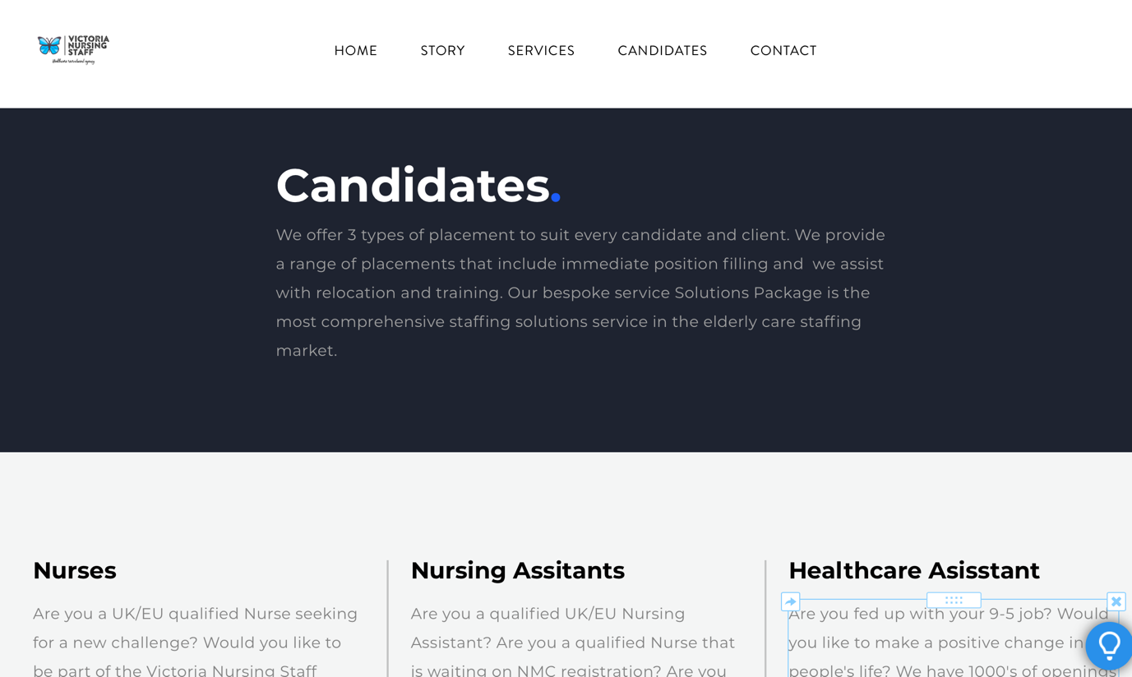
Figure 6 Candidates Options

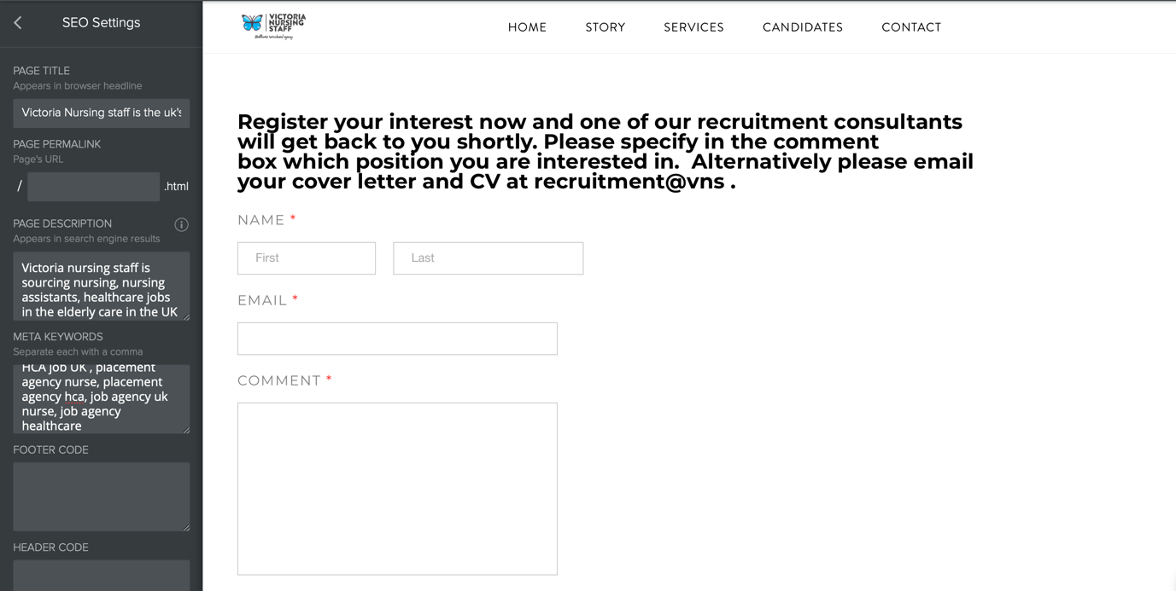
Figure 7 Contact form for candidates & SEO Keywords

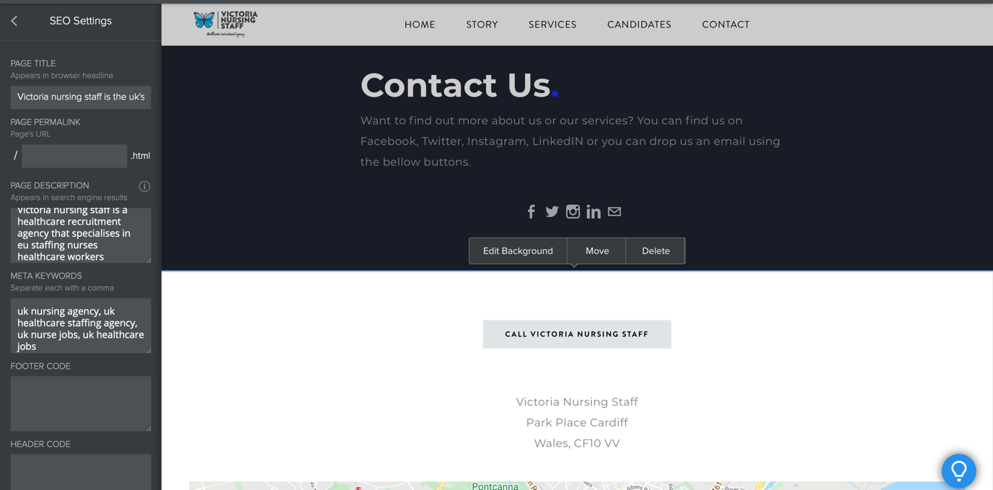
Figure 8 Contact page Seo Keywords Social Media Links and Call button

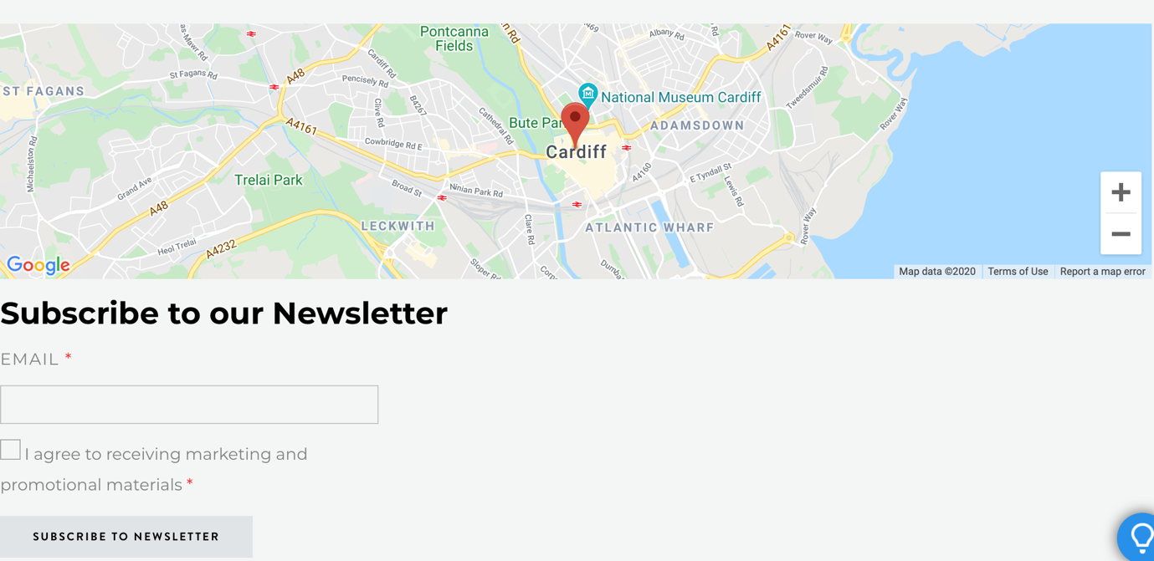
Figure 9 Google Maps incorporation and Newsletter function

Bibliography
Ebner, T. & Granitza, L., 2019. The SEO Book: Search Engine Optimization 2020. 1 ed. Washington: Amazon Digital Services LLC - KDP Print US.
Thomas, C., 2013. ECommerce Marketing: How to Drive Traffic That Buys to Your Website. 1 ed. Cornwall: Kernu Publishing.

