

Innovating New Working Practices and Breeding an Environment Where Talent May Grow
Assignment Title: Assessment component 1: Individual report
Programme: Master of Business Administration (MBA)
Module: Human Capital Management
Lecturer: Eno Maycock (Birmingham)
Module Code: LCMB7023
Student Name: Khushi Jayeshkumar Pat el
Student ID: 2604434
Word Count: 2673
Submission date: 15 October 2026

Table of Contents
1. Introduction 5
2. Task A: Designing Innovative Working Practices 5
2.1 NHSX Work Design Challenges and Context 5
2.2 Evaluating Traditional and Contemporary Working Practices 6
2.3 Cross-Functional Collaboration and Agile Project Teams 6
2.4 Hybrid Flexibility and Digital Collaboration Technologies 7
2.5 Employee Autonomy and Responsible Management Accountability 8
2.6 Integrated Innovative Work Design and Performance Evaluation 8
3. Task B: Breeding an Environment Where Talent May Grow 8
3.1 NHSX Talent Challenges and Future Skills 8
3.2 Critical Evaluation of Talent Development Theories 9
3.3 Continuous Learning and Inclusive Capability Development 10
3.4 Career Progression, Mentoring and Internal Mobility 11
3.5 Psychological Safety, Inclusion and Talent Accountability 12
3.6 Integrated Talent Ecosystem and Strategic Evaluation 13
4. Task C: Reflective Report 13
4.1 AI as Strategic HR Decision Support 13
4.2 Three Personal Experiences Using AI 14
4.3 Personal HR Capability Development Action Plan 15
5. Conclusion 15
References 17
Appendices 20
Appendix 1: Employee Engagement by Work Location 20
Appendix 2: AI Implementation and Change Management Practices 20

List of Abbreviations
Abbreviation | Full Form
NHSX | NexSpace Health Systems
HPWS | High-Performance Work Systems
HR | Human Resources
HRM | Human Resource Management
CIPD | Chartered Institute of Personnel and Development
OECD | Organisation for Economic Co-operation and Development
SHRM | Society for Human Resource Management
WEF | World Economic Forum

1. Introduction
NexSpace Health Systems (NHSX) is a healthcare technology provider that creates AI-based solutions and has roughly 600 workers around the world. The delays are caused by hierarchical decision-making operations in the United Kingdom, India, and the United Arab Emirates. Lack of creativity, lack of international collaboration, and limited career development pose risks for innovation and the retention of top-performing employees. The report assesses innovative working practices, a talent growth ecosystem, and ethical AI-informed HR decision-making.

2. Task A: Designing Innovative Working Practices

2.1 NHSX Work Design Challenges and Context
Decision-making is slow because the hierarchies of approvals remain a challenge when it comes to responsiveness across NexSpace Health Systems international, healthcare-sensitive operations. Hybrid coordination challenges hinder knowledge exchange across geographically distributed teams, and limited employee discretion limits experimentation. According to Deloitte, 33% were working on it, and 6% had done a lot to balance agility and stability (Poynton et al., 2025). Decentralised decisions might foster innovation but could challenge clinical accountability and patient information protection. Thus, NHSX requires more rapid negotiated decisions with defined responsibility, escalation and review processes, and clinical oversight.
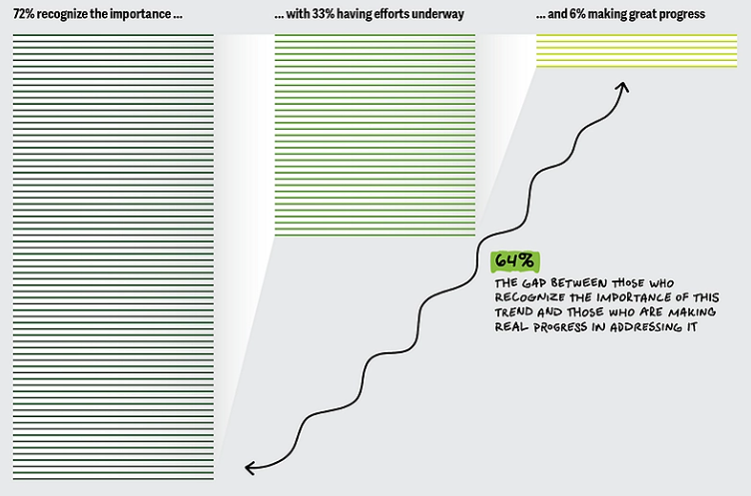
Figure 1: Organisational Agility and Stability Progress
(Source: Poynton et al., 2025)

2.2 Evaluating Traditional and Contemporary Working Practices
Traditional hierarchical structures are helpful for consistent control but limit experimentation and responsiveness between specialist teams in the organisation during the process of reaching approvals. Today, modern work design focuses on cooperation and flexibility, which, however, must be accompanied by coordinated roles and firm security protection. Lynn et al. (2023) focus on technological change, work arrangements and organisational capabilities. High-Performance Work Systems (HPWS) integrate selective recruitment, training, assessment, incentives and employee involvement to enhance capabilities. Mehralian et al. (2023) link HPWS with innovation through organisational learning, integration and resource reconfiguration. These benefits remain conditional because performance demands can compete with employee wellbeing and sustainable workloads. Hanu and Khumalo (2024) examine resilience during crises, limiting direct generalisation of their findings to NHSX.
Sociotechnical Systems Theory emphasises co-optimisation of social roles, organisational processes and technological systems in workplace design. Interdependence and distributed responsibilities are themes of interest in digital healthcare technology systems (Adams, 2024). More multidisciplinary autonomy may help boost software innovation for NHSX while allowing clinicians to maintain control in safety-critical decisions. As a result, NHSX should bring together selective delegation, secure and effective workflows, and wellbeing monitoring to safeguard service quality.

2.3 Cross-Functional Collaboration and Agile Project Teams
NHSX can introduce cross-functional agile teams of software developers, clinical specialists and operational managers. A common project goal and short delivery time may minimise delays within the department and stimulate problem detection. Elashry, Kortam and Ali (2024) associate knowledge management systems with organisational ambidexterity in telecommunications. However, their sector differs from healthcare, limiting direct assumptions about clinical effectiveness and patient safety. Bellis, Cunial and Trabucchi (2024) relate digital leadership to the agile innovation of both physical and digital settings. These practices could be applied to NHSX by routine project reviews, open dissemination of knowledge, and clear governance. Freedom with agile could accelerate product development, but unchecked modifications could put patients at unnecessary risk. Technical teams provide routine improvements within decision limits agreed by clinical specialists, who provide approval on releases for safety-critical purposes. This will allow for more rapid collaboration with responsible governance in NHSX's three countries of operation.

2.4 Hybrid Flexibility and Digital Collaboration Technologies
NHSX requires the ability for hybrid and flexible working practices to bring people together in the UK, India and UAE. Cooperative collaboration platforms could be used for project updates, clinical discussion, document control, and for asynchronous knowledge exchange. Gallup (2026) reports 25% engagement among hybrid workers, compared with 24% among on-site remote-capable workers, highlighting mixed workplace experiences [Refer to Appendix 1]. This association gives some evidence of improvement in engagement and/or innovation in hybrid set-up arrangements alone. According to Microsoft (2024), 75% of the knowledge workers they surveyed integrate AI in their work. Their graph shows large numbers, but their usage is not the best evidence of successful collaboration. Clear expectations for a response, combined with secure messaging and shared project dashboards and meetings across the country with NHSX. Time differences may result in delayed critical clinical decisions and technical support, while flexible hours may affect wellbeing. The use of approved AI tools, combined with the implementation of access controls and staff training, would minimise information risks and promote responsible coordination. Managers should measure how well people are collaborating by measuring response time, knowledge reuse, and employee feedback rather than connectivity.
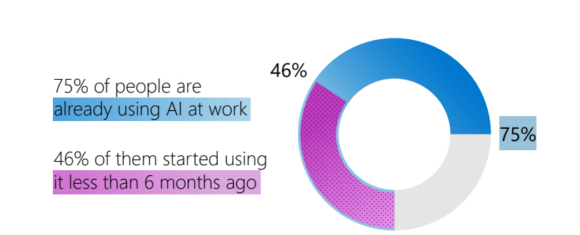
Figure 2: AI Adoption Among Knowledge Workers
(Source: Microsoft, 2024)

2.5 Employee Autonomy and Responsible Management Accountability
Autonomy may enable the members of NHSX to suggest practical changes before applying for approval from multiple management layers. Decisions on system usability, workflow, and reliability of services should involve developers and clinical specialists. Small experiments may be conducted to test ideas before they can be implemented on a larger scale, if teams adopt approved quality and data protection procedures. However, wide discretion might lead to inequitable practices and unnecessary access to patients private data. Furthermore, there should be decision boundaries for NHSX to deal with routine change, clinical approval, incident escalation, and management accountability. Managers could coach, explain expectations for performance, and check in on workloads to help engagement with the job.

2.6 Integrated Innovative Work Design and Performance Evaluation
Agile delivery, employee autonomy, flexible working, and secure digital collaboration should go hand in hand, operating under the same coordinated health system through NHSX. Human resources may be able to help with capability building, whereas clinical leaders have the responsibility to set the safety standards, and technology management would oversee it. New teams could experiment between different functions prior to implementing on a broader scale across the three national operating sections. Managers should regularly monitor decision turnaround, project delivery, knowledge sharing, staff wellbeing, and clinical incidents. Faster delivery would offer limited strategic value if errors increased or employees faced unsustainable workloads. Evaluation should thus be a comparison between the innovation gains and compliance results, employee experiences, and measures for patient safety indicators. Differences exist between local regulations and working cultures, so these should be maintained while maintaining common organisational standards. Employee feedback could lead to changes in responsibilities and the identification of successful practices in quarterly reviews for addressing emerging risks. A balanced implementation approach would provide NHSX with innovation goals along with health care services reliability and professional accountability.

3. Task B: Breeding an Environment Where Talent May Grow

3.1 NHSX Talent Challenges and Future Skills
NHSX faces rising talent losses as experienced high-performing employees see limited career progression and insufficient learning opportunities. These changes pose a risk to significant product expertise, clinical collaboration and the organisation's ability to build future digital skills. By 2030, 39% of core skills for workers are expected to change across all employers globally (WEF, 2025). This global prediction describes general uncertainty but has no qualified ability to mention NHSX's technical or scientific skill deficits. Specific capability audits and fair progression routes can help to ensure retention of staff through relevant learning and credible career progression.
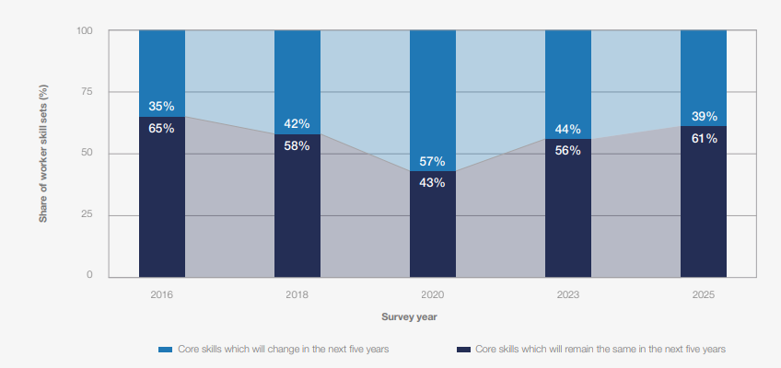
Figure 3: Expected Changes in Workers' Core Skills by 2030
(Source: WEF, 2025)

3.2 Critical Evaluation of Talent Development Theories
Talent development requires more than recruitment incentives because lasting growth depends on learning, trust, and employee motivation. Senge's Learning Organisation connects with the elements of systems thinking, personal mastery, mental models, shared vision, and collaborative team learning. These disciplines drive NHSX knowledge exchange but require knowledge exchange sessions and sustained, leadership-enabled time for shared learning. Edmondson's Psychological Safety empowers staff to admit errors, express concerns, and challenge inappropriate clinical design choices (Edmondson, 2023). Such openness may strengthen improvement, yet safety remains ineffective without clear feedback processes and professional accountability.
Self-Determination Theory is an explanation of motivation that links meaningful participation and continued development opportunities to autonomy, competence, and relatedness. Laguerre and Barnes-Farrell (2025) identify need satisfaction as a mechanism linking HR practices with employee outcomes. Sanseverino et al. (2026) show supportive leadership helps engagement, although Italian findings require careful NHSX adaptation. Tiffin et al. (2024) validate measures of basic needs, supporting evaluation beyond informal employee assumptions. Overall, these theories are ones that support inclusive development, but NHSX must invest in learning and make progression visible.

3.3 Continuous Learning and Inclusive Capability Development
NHSX should create structured pathways to take specialist training in clinical software tools and to develop leadership and good practice around AI. Technical and interpersonal competencies could be developed through access to mentoring, peer reviews and applied projects. Billett, Troth and Yan (2024) link the concepts of continuous learning while working to innovation and wellbeing of employees through changing practices. However, scheduled training alone may deliver limited gains without protected time and opportunities to apply new skills. Among non-formal training participants, 87% of men and 80% of women reported job-related reasons (OECD, 2025). These percentages describe participants' reasons for training rather than unequal learning outcomes or experiences among NHSX employees. Protected learning hours and structured project assessment may link the development of capability to quantifiable product enhancements, while fair course access may be available.
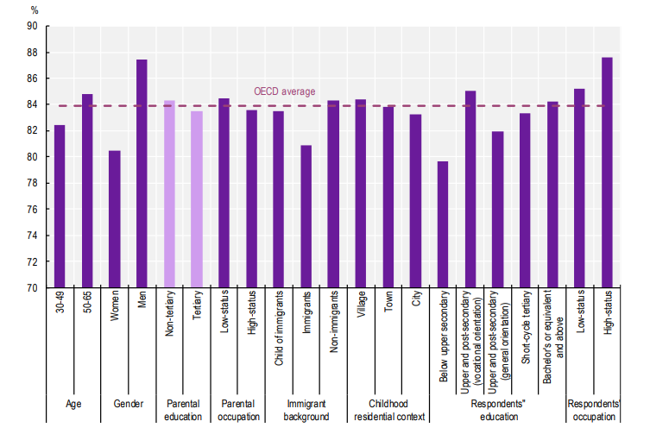
Figure 4: Gender Differences in Job-Related Training
(Source: OECD, 2025)

3.4 Career Progression, Mentoring and Internal Mobility
NHSX should develop clear pathways for career progression, including clinical software knowledge, leadership skills, and progression criteria for all international departments. The staff could work with experienced subject specialists in structured mentoring sessions to help develop coaching that is more supportive in agreed-upon areas of development. Greif (2025) evaluates the evidence regarding coaching effectiveness, which is dependent on implementation quality and employee participation. According to LinkedIn Learning (2025), 55% of career-development champions said that they prioritised internal mobility higher. There may be internal vacancies and skills profiles that link existing suitable employees with emerging opportunities before dropping to outside employees. However, internal recruitment cannot address issues with limited vacancies or where access to specialist development is unequal. Future leaders should be identified as part of succession planning through published criteria and capability assessments through regular feedback and documentation. Managers would require protected mentoring time and HR support at a time of great growth, which could result in costs. Fair selection processes and genuine advancement opportunities could aid in retention and minimise the perception of favouritism.
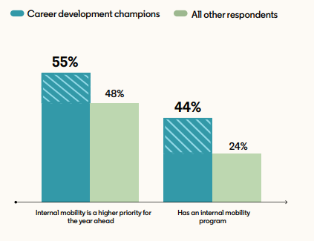
Figure 5: Internal Mobility Priorities
(Source: LinkedIn Learning, 2025)

3.5 Psychological Safety, Inclusion and Talent Accountability
Psychological safety empowers NHSX staff to report software bugs and ask questions about decisions and openly make suggestions for improvements in services. Alami, Zahedi and Krancher (2024) link positive team cultures with software quality behaviours in agile teams. However, software team findings cannot prove equal results for safety-critical clinical systems in different countries. Consequently, confidential reporting channels, opportunities for constructive feedback, and regular management reactions to issues of concern are needed for employee voice. According to Young and Tong (2025), 54% of employees are positive about their managers' willingness to offer them support in terms of career planning in the long term, compared to 49% in 2023. This five-point rise suggests enhancing career support, although UK survey findings cannot represent NHSX employees.
Therefore, leadership training programs must include ample access to inclusive development opportunities, periodic workload reviews, and clear expectations of performance. The risk to experimentation and clinical responsibility must be balanced with timely identification of recurring unsafe practice by managers. Differences in employee feedback and promotion may indicate whether the increased psychological safety provides equal learning opportunities and measurable improvements.
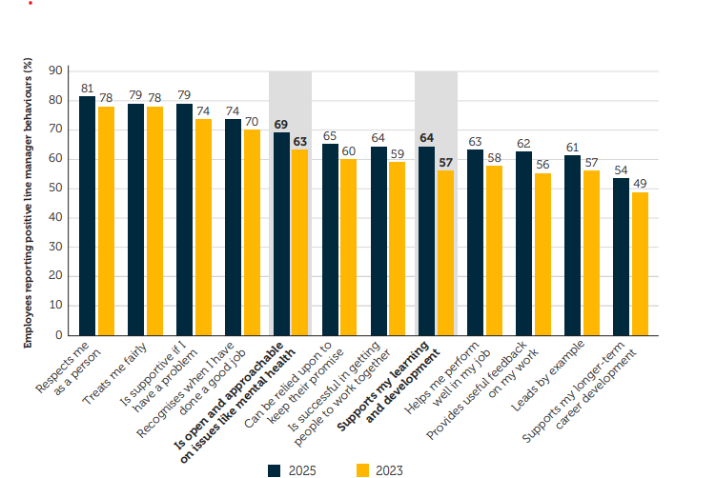
Figure 6: Managerial Behaviours and Support
(Source: Young and Tong, 2025)

3.6 Integrated Talent Ecosystem and Strategic Evaluation
Continuous learning, mentoring, internal mobility, and psychological safety should be connected through shared goals in the talent ecosystem. HR leaders could create a skills assessment module for UK, Indian, and UAE teams and perform role mapping. Department managers need to establish protected learning time, designate mentors, and make criteria for promotion available based on evidence. Clinical leaders need to ensure development programmes remain safe, compliant, and responsible in the use of AI. Barriers to participation in the workforce, inclusion, wellbeing, and fair promotion may emerge through regular feedback by employees. Performance metrics should encompass turnover, completed learning, specialist internal promotions, specialist engagement and retention. However, completion rates do not give a clear proof of capability gains or real improvements in clinical innovation. Training may be customised to address local labour requirements and rules, which can make training more expensive and complex to manage. Resources, staff pressure and employee experiences should be compared with outcomes, and the results should be reported quarterly.

4. Task C: Reflective Report

4.1 AI as Strategic HR Decision Support
Data from Artificial intelligence can be utilised in HR recruitment screening, workforce planning, talent development and performance assessment. However, historical bias in automated rankings may result from a lack of records or circumstances important to each individual employee. Bujold et al. (2024) point to fairness, privacy, transparency and human oversight as concerns to be raised in relation to responsible AI. SHRM (2025) reported that 43% of all HR professionals surveyed agreed their organisations followed change management practices [Refer to appendix 2]. This finding points to implementation behaviour as reported, not towards improvements in fairness or towards improvements in decision quality. HR managers should verify AI-generated content, protect employee information, and document the rationale for choices, all consistent with NHSX's guidelines. Each situation for recruitment shortlists and performance concerns should be treated on a case-by-case basis before management decides. A combination of ethical protections and professional empathy can enhance efficiency and ensure employee trust and accountability.

4.2 Three Personal Experiences Using AI
I leveraged AI to find research in academic journals that explored psychological safety, learning systems, and employee motivation. This accelerated my initial research and helped to relate much of the relevant theories to NHSX's workforce challenges. However, suggested publication details needed to be checked against journal pages, because there might be mistakes in confident responses. I realised that while the speed of searching can add value, without reliable sources, this information cannot be used to make a final analysis.
Next, I asked AI to find evidence of numbers in published surveys of workplaces or data presented in graphs. It facilitated the separation of information on skills disruption, career development, and AI implementation into distinct themes. However, national survey percentages might be taken for indicators of NHSX staff. I learned to distinguish external findings and company facts, and to doubt the significance of comparisons.
Finally, AI feedback was used to check coverage of assessment requirements, sentence length, and references. It explained unclear expressions and gaps, making it easier to determine the quality of written arguments. However, automatic revisions could be very impersonal and failed to accurately capture the experiences to reflect on. Therefore, I saw the need to have my judgement and correct experiences along with my moral professional duty.

4.3 Personal HR Capability Development Action Plan
My strengths are organising research and evaluating evidence, but there are areas to develop my practical HR analytics skills. My objective is to make responsible decisions related to HR, based on technical skills, human sensitivity, and a fair evaluation of the workforce.
Development Area | Action | Timeline | Success Indicator
HR Analytics | I will take an introductory course and study two real employee datasets. | Three months | Certificate and two checked exercises
Ethical AI | I will cover formal guidance on four cases of bias and privacy in recruitment. | Two months | Four documented assessments
Communication | I will engage in three formal Staff discussion interviews with appropriate mentor support. | Three months | Three records of feedback and written comments for improvement
Table 1: Personal HR Capability Development Action Plan
(Source: Self-Developed)

5. Conclusion
NHSX needs cross-functional agile teams and federated autonomy to enhance innovation while maintaining critical clinical safety and quality standards. The combination of learning, mentoring, and clear career paths can be achieved within a talent ecosystem to enhance employee growth and retention. Validations, privacy measures, expert judgment, and authentic human care are essential for responsible AI-supported HR decisions. These are all measures that contribute to the organisation's agility, sustainable workforce capabilities, and reliable healthcare technology performance.

References
Adams, J. (2024) ‘Examining ethical and social implications of digital mental health technologies through expert interviews and sociotechnical systems theory’, Digital Society, 3, article 24. Available at: https://doi.org/10.1007/s44206-024-00110-5 (Accessed: 11 October 2026).
Alami, A., Zahedi, M. and Krancher, O. (2024) ‘The role of psychological safety in promoting software quality in agile teams’, Empirical Software Engineering, 29(5), article 119. Available at: https://doi.org/10.1007/s10664-024-10512-1 (Accessed: 11 October 2026).
Bellis, P., Cunial, M. and Trabucchi, D. (2024) ‘Mastering hybrid worlds through digital leadership: The role of agility in fostering innovation’, Business Horizons, 67(4), pp. 369–380. Available at: https://doi.org/10.1016/j.bushor.2024.04.002 (Accessed: 11 October 2026).
Billett, S., Troth, A. and Yan, H. (2024) ‘Elaborating the relations amongst workers’ learning, innovations and well-being’, Vocations and Learning, 17(1), pp. 123–142. Available at: https://doi.org/10.1007/s12186-023-09336-9 (Accessed: 11 October 2026).
Bujold, A., Roberge-Maltais, I., Parent-Rocheleau, X., Boasen, J., Sénécal, S. and Léger, P.-M. (2024) ‘Responsible artificial intelligence in human resources management: a review of the empirical literature’, AI and Ethics, 4, pp. 1185–1200. Available at: https://doi.org/10.1007/s43681-023-00325-1 (Accessed: 11 October 2026).
Edmondson, A.C. (2023) Right Kind of Wrong: The Science of Failing Well. New York: Simon Element/Simon Acumen.
Elashry, M.M., Kortam, W.A.E. and Ali, T.M. (2024) ‘High-performance work systems and organisationalHCM ambidexterity: The mediating role of knowledge management systems—evidence from the Egyptian public-telecommunication sector’, Future Business Journal, 10, article 45. Available at: https://doi.org/10.1186/s43093-024-00331-7 (Accessed: 11 October 2026).
Gallup (2026) State of the Global Workplace: 2026 Report Available at: https://www.gallup.com/workplace/697904/state-of-the-global-workplace-global-data.aspx (Accessed: 11 October 2026).
Greif, S. (2025) The Future of Coaching: Building Bridges Between Science and Practice. Cham: Springer.
Hanu, C. and Khumalo, N. (2024) ‘From high-performance work systems and resilience to employee well-being during crises: Exploring the moderating role of employee ambidexterity’, Current Psychology, 43, pp. 9955–9968. Available at: https://doi.org/10.1007/s12144-023-05138-3 (Accessed: 11 October 2026).
Laguerre, R.A. and Barnes-Farrell, J.L. (2025) ‘Bringing self-determination theory to the forefront: Examining how human resource practices motivate employees of all ages to succeed’, Journal of Business and Psychology, 40, pp. 1–37. Available at: https://doi.org/10.1007/s10869-024-09951-w (Accessed: 11 October 2026).
LinkedIn Learning (2025) Workplace Learning Report 2025: The Rise of Career Champions. Available at: https://business.linkedin.com/learn/resources/workplace-learning-report (Accessed: 11 October 2026).
Lynn, T., Rosati, P., Conway, E. and van der Werff, L. (eds.) (2023) The Future of Work: Challenges and Prospects for Organisations, Jobs and Workers. Cham: Palgrave Macmillan.
Mehralian, G., Sheikhi, S., Zatzick, C. and Babapour, J. (2023) ‘The dynamic capability view in exploring the relationship between high-performance work systems and innovation performance’, The International Journal of Human Resource Management, 34(18), pp. 3555–3584. Available at: https://doi.org/10.1080/09585192.2022.2138494 (Accessed: 11 October 2026).
Microsoft (2024) AI at Work Is Here. Now Comes the Hard Part: 2024 Work Trend Index Annual Report. Available at: https://www.microsoft.com/en-us/worklab/work-trend-index/ai-at-work-is-here-now-comes-the-hard-part (Accessed: 11 October 2026).
OECD (2025) OECD Skills Outlook 2025: Building the Skills of the 21st Century for All. Paris: OECD Publishing. Available at: https://www.oecd.org/content/dam/oecd/en/publications/reports/2025/12/oecd-skills-outlook-2025_ac37c7d4/26163cd3-en.pdf (Accessed: 11 October 2026).
Poynton, S., Cantrell, S., Scoble-Williams, N., Mallon, D. and Lahiri, G. (2025) ‘Stagility: Creating stability for workers for organizations to move at speed’, Deloitte Insights, 24 March. Available at: https://www.deloitte.com/us/en/insights/focus/human-capital-trends/2025/organizational-agility-and-creating-stability-at-work.html (Accessed: 11 October 2026).
Sanseverino, D., Sacchi, A., Molino, M. and Ghislieri, C. (2026) ‘Be engaged at work in a digital scenario: A multigroup study using self-determination theory’, Current Psychology, 45, article 832. Available at: https://doi.org/10.1007/s12144-026-09365-2 (Accessed: 11 October 2026).
SHRM (2025) From Adoption to Empowerment: Shaping the AI-Driven Workforce of Tomorrow. Alexandria, VA: Society for Human Resource Management. Available at: https://www.shrm.org/content/dam/en/shrm/topics-tools/research/from-adoption-to-empowerment-shaping-the-ai-driven-workforce-of-tomorrow.pdf (Accessed: 11 October 2026).
Tiffin, P.A., Cabrera, R., Dexter-Smith, S. and Van den Broeck, A. (2024) ‘Capturing autonomy, competence, and relatedness at work: Further examining and validating an English language version of the work-related basic need satisfaction scale’, Frontiers in Psychology, 15, article 1304309. Available at: https://doi.org/10.3389/fpsyg.2024.1304309 (Accessed: 11 October 2026).
WEF (2025) The Future of Jobs Report 2025. Geneva: World Economic Forum. Available at: https://www3.weforum.org/docs/WEF_Future_of_Jobs_Report_2025.pdf (Accessed: 11 October 2026).
Young, J. and Tong, D. (2025) CIPD Good Work Index 2025. London: Chartered Institute of Personnel and Development. Available at: https://www.cipd.org/globalassets/media/knowledge/knowledge-hub/reports/2025-pdfs/8868-good-work-index-2025-report-web1.pdf (Accessed: 11 October 2026).

Appendices

Appendix 1: Employee Engagement by Work Location
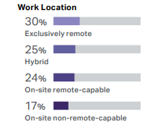
Figure 7: Employee Engagement by Work Location
(Source: Gallup, 2026)

Appendix 2: AI Implementation and Change Management Practices
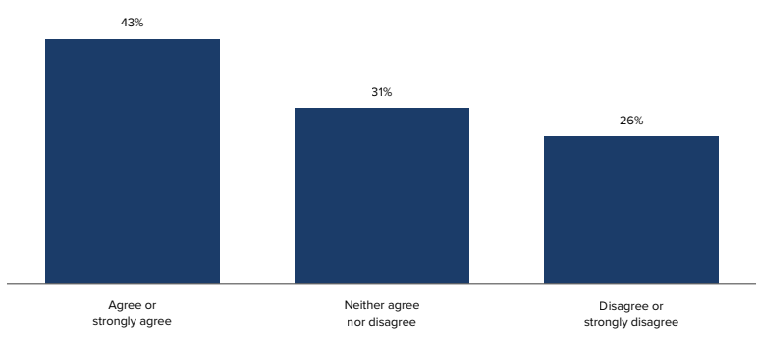
Figure 8: AI Implementation and Change Management Practices
(Source: SHRM, 2025)

