Wedding Planning
Business Plan


Executive Summary

We plan on opening our own Wedding Planning Company under the name of Pimp my Wedding, based on what market research we’ve done we believe there is a market for what we will be offering, we have got our personnel and financing organized all we must do is start off by creating booklets outlining what different packages we will have on offer and for what price. Because we will be requiring a deposit, this will cover all our fees, if we were to have a cancellation, we believe that we will be able to be financially stable whilst working on the customer’s requirements.
Markets and Competition

Target Markets

For our company the target market is pretty obvious such as; being engaged couples soon to be married, however we do believe we will be able to offer different wedding packages to those with a small and high budget.

Our advertising goal is to reach our Target Market being women between the ages of 20 and 40 to make it more likely to reach more people who are getting married with the UK average now being 35 to get married according to the Office of national Statistics

The market trend for weddings in 2018 according to the Independent is spending £30,350 on your wedding.

Competition

The biggest competitor in wales we could find is “Weddings by Zoe” we have researched into the company and browsed through her Gallery on her website looking at pictures from the different weddings she’s planned, based off how many different weddings, she has pictures from planning and I’m sure there is a market for it in our area.

According to her website she only offers weddings at three different venues, which we will be offering many more than that to our customers, we have already picked five venues we could possibly recommend to our clients.

Product Positioning
Comparing our fees compared to other companies is very difficult because every wedding will have a different quote; this is because most people have different choices on location, venue, themes etc.

I however we believe that the wedding we can provide for £20,000 is a competitive priced based off the venue and abilities of our personnel.

According to the Independent the average wedding in 2018 costs £30,350, we believe a wedding we could organize for £30,350 would be more than average in our opinion.

Marketing

We will use social media to advertise our business, we will pay Facebook to advertise our page for as little as £12 a day. For 10 days we can have our business ad be reached to 11,000 people, we can even refine what people we want to reach based of our target market, we will be reaching women between the ages of 20 and 40 to make it more likely to reach more people who are getting married within the UK average now being 35 to get married according to the Office of national Statistics

We will also do the same on twitter as on Facebook, however their pricing is different.

We will have an advertisement video created to have on our social media pages and even pay for them to be run on YouTube, in this advert we will show the best pictures of our weddings taken by our photographer.

We will go to local wedding fairs and set up and show potential clients what wedding packages we have to offer.

Sales

Once actually starting the business we will do mock runs with our phone staff to see if we believe they are doing the job the way we want It, It is not so likely that being a wedding planner that we would get repeat sales from the same client but we would think that everyone that went to the wedding would be able to see what our company can offer and they could ask the married couple later who planned the wedding if they have one of their own weddings coming up perhaps.

Being a wedding planner the phone staff will only have to receive calls, the customers would have got our contact number from an online ad or a referral from a past client.

Employees /Key Personnel

We will employ a variety of different personnel that are essential. We will be hiring a professional florist who we know, when we speak to the client on what flowers they want if they have it planned we will be able to meet their needs or if they aren’t sure what they want we can put them in contact with our florist who will talk them through the different variety of flowers we can offer.

One of the most important personnel would be the photographer because that’s the only thing the customer will have to remind them of us after the wedding as photos of the day will be viewed for years, the photographer will we using has worked in the industry for over 10 years so we will be relying on their skills on the day.

A DJ is another essential personnel, we have a friend who has worked as a DJ at many weddings in the past which is essential to me to ensure the customers will be happy with him. His fees are more than we have found quotes for online but I would feel more confident using him as we know he has done it many times before.

My hair and makeup staff are one of my most important personnel, we have four friends who we will use for our weddings, their roles will be to do the styling of the bridesmaids hair and makeup, we are using friends because between them they have degrees in Hair and Beauty and I believe they are the best people we know for the job, plus two of them have done their job for weddings in the past, so we will also be relying on their experiences at the job before.

We will hire in a security firm for weddings if the clients say they want them, some people don’t think there is a need but when you have bigger weddings they can be valuable in controlling problems such as fights which can happen when there are hundreds of guests. The company we will use for this is Churchill Security Limited a company based all over the UK which helps if the client wants their wedding to be anywhere in the UK.

Advisors and support services

We will be contacting financial advisors such as Financial Solutions Wales to have a meet to get their opinion on our business plan to see if they have found any flaws in our plan, using their expertise hopefully it could save me thousands for the cost of a few hundred for consultation we believe it is definitely worth seeking advice because if a customer was dissatisfied they might try and take legal action against us , If that was to happen we will be using David and Snape solicitors in Bridgend because they have come highly recommended to us from a friend who has had legal trouble with their business in the past, we believe they will be a able to protect us from legal action if a customer was to be so dissatisfied with a wedding we’ve planned for them that they would want money back.

Premises and Equipment

The customer usually has recommendations for where they want to get married, if they did not we would show them the different locations we offer comparing prices and distance for convenience.

Most equipment such as lighting and music speaker equipment is usually already built into the venue, Some of our personnel will be required to bring their own equipment such as the DJ and Photographer. Depending on the venue the caterers may be bringing their own equipment. We will not be responsible for operating, transporting or maintaining any of the equipment because our staff are outsourced freelancers.

Suppliers

One of the most important suppliers are the clothing suppliers, for the women we will be using Wed2b, they are a quality wedding supplier company based in Cardiff, we would send our customers to there for the bridesmaids dresses and when they purchase we will earn 10% commission from Wed2b.

We will do the same thing for the grooms, we would recommend Dyfed men’s wear which is located in Cardiff and Ystrad Mynach, they offer 10% commission as well which is one of the main reasons why we would use them suppliers.

For the wedding cakes we will be using Cup & Cake Bakery based in Cardiff, they offer high quality wedding cakes at all different price ranges we will show the customers what cakes are available in a booklet without giving away the name of our suppliers, we will be adding a 25% on top of the cost of the cakes

If any of our suppliers were to suddenly go out of business we believe we will be able to find new suppliers for all the clothing and cake needs from other suppliers however the rates will be different and may cost us more which is the reason we have picked these suppliers first.

Financial Forecast

Cashflow/Profitability/Financing

We will be relying on a £10,000 loan from family and £5,000 in savings between us to start up this company, one benefit is we do not have to put our own money into supplying the wedding dresses and grooms suits as the customer will have to purchase them through our suppliers directly.

We also require a deposit before we start organising anything and the photographers and DJ are sub contracted by us and will not be booked until nearer the day as they have flexible schedules the reason we do this is to save us as much up front cost as possible because customers may cancel their wedding and we would only be left with the deposit.

With wedding planning the profit we receive may be drastically different based of what the customer requires we will make between 10 and 25% on the cost of most of our suppliers, for personnel the only prices that don’t change would be Photographers and DJ which we will be putting 25% on top of their fees, we will add up the fees it costs us to organise and personnel and create a quote which we think is reasonable and competitive.

Because all weddings cost differently based off the customers personal requests it is hard to do an example cost but below is a mock up price of a basic wedding with general prices based off what our suppliers quote us:

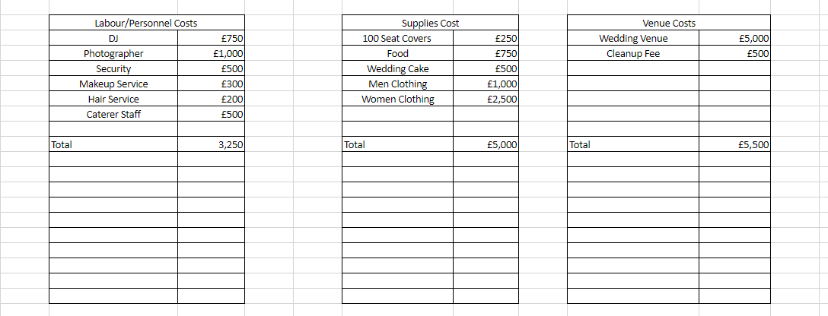

The wedding shown above would cost around £15,000 give or take, our business model is to add 25% on top so we would give a quote closer to £20,000, this in my opinion is a more cheaper wedding with the UK average being £30,355 according to the Independent.

Hypothetically speaking if we were to only offer this particular wedding with these fees, we would be able to fund the operations of the first wedding with our money and the deposit of £5,000 which would cover booking cancelations if a wedding was cancelled.

We expect that the business would be guaranteed profitable if we could consistently find clients even if we could get 4 weddings in a year this would cover our living costs with the almost 25% profit we would be making per wedding. We do believe that because we have managed to get personnel costs so low and the fact that they will be all booked for the day and they aren’t full time employees we will not have to pay their wages whilst we are in between weddings, this is the main advantage of hiring 3rd party staff however we may struggle to book this complete set of personnel on the same days if they are fully booked for a certain time period, this could be an inconvenience for customers plans and mean we may need to hire different staff depending on which personnel is unavailable.

Bibliography

https://www.weddingsbyzoe.co.uk/
https://www.wed2b.co.uk/
http://www.dyfedmenswear.co.uk/
http://www.cupandcakebakery.co.uk/
http://www.fswales.co.uk/
https://www.qualitysolicitors.com/davidandsnape
https://www.churchillsecurity.co.uk/

References
Hosie, R. (2018). “AVERAGE UK WEDDING COST REACHES ALL-TIME HIGH”. Independent. Available at: https://www.independent.co.uk/life-style/love-sex/wedding-cost-uk-average-how-much-marriage-ceremony-bridebook-a8460451.html [Accessed at 12 September. 2018]

ONS “Marriages in England and Wales: 2015” Available at: https://www.ons.gov.uk/peoplepopulationandcommunity/birthsdeathsandmarriages/marriagecohabitationandcivilpartnerships/bulletins/marriagesinenglandandwalesprovisional/2015 [Accessed at 13 September. 2018]

