
Name Matthew David Norman
Student Number 2031011
Date 27/07/2023
Lecturer Andrew Noble
University of Wales Trinity Saint David
BEng Ordnance, Munitions & Explosives

Computer aided Engineering (ACDB5007)
Application of Computer Aided Engineering Processes
Table of Contents
Introduction 2
Aims & Objectives 2
Background Information 3
What is CAE? 4
Advantages 4
Disadvantages 5
CAE in the Ordnance, Munitions and Explosives Industry 5
Design 6
Material Properties 6
Blast Modelling 6
Safety Analysis 6
Optimization 6
Methodology 6
Validation 8
What is a validation study? 8
The Validation Study 13
Why is the validation study important for conducting simulations 14
Establishing Accuracy 14
Building Confidence 14
Identifying Limitations 14
Improving Model Parameters 14
Adhering to Quality Standards 15
Reducing Physical Testing 15
Exploring Design Space 15
Continuous Improvement 15
Enhancing Collaboration 15
Educational and Research Purposes 15
Results & Analysis 16
Simulation Results for Static Structural Analysis 16
Maximum Total Deformation 16
Stress Distribution 16
Simulation Results for Thermal Analysis 16
Maximum and Minimum Temperature Extremes 16
Comparative Analysis against Published Works 17
Discussion and Interpretation 17
Findings 17
Factors Affecting Accuracy 18
Conclusion 20
References 22
Bibliography 23

Introduction

The purpose of this report is to examine the computer aided processes and limitations using Solidworks to make the components and assembly and Anysis to critically analyse these.
In Anysis both a structural and thermal case study will take place using loading and applying temperature to the assembly to show if it can withstand normal real world operating parameters.
This study will highlight how computer aided engineering tools can be used in an engineering design process but also highlighting the limitations of this type of simulation and why this type of analyse study won’t always be 100% accurate.

Aims & Objectives

This report aims to show how computer aided engineering can be used to design and test components and assembly’s using these tools to give accurate and efficient results to provide data and visual representations of how they behave under realistic operating conditions.
This report will focus on the static structural and thermal studies of the completed assembly to under real world conditions in order to generate data that will show the maximum stress load than can be applied to the shell before significant deformation, The thermal study will look at the maximum and minimum temperature extremes to generate data on the behaviour of the 155mm shell during these simulations to interpret whether they meet the required specifications when out in the field.
Objectives include:
- Background information
This will include some research into accreted sources to find values for the study’s materials and looking into how reliable and accurate computer aided engineering is, and whether it’s a viable, cheaper, and faster alternative to physical testing.
- Methodology
This section will highlight the methods used in both Anysis and Solidworks in order to convey understanding of the steps involved to gain the data from the study.
- Validation
This will show how validation should be used when undertaking computational testing that shows the methodology that is being applied to fit for this study.

- Results and Analysis
This section will show the data gathered during the methodology for this study, then it will be analysed and compared to other published works to find the accuracy of computational problem solving for both structural and thermal tasks.
- Conclusion
This will highlight what the findings are from the study and how they relate to other publications and whether they match the expected trend.

Background Information

What is CAE?
Computer Aided Engineering is the utilization of specialist computer software to simulate real world scenarios for products and assemblies within the application without the need to physically make the product. [1]
This revolves around the software being able to pre-process in which the geometry, physical properties and then environment of the design are defined. [1] The next step is solving using the software to do the work for you depending on which mathematical formula you choose it to use based on the study involved. [1] The final step is post-processing in which the software generates the data from the information you have inputted which is shown in both graphical and numerical values to show the engineer how successful their design was against the type of study you were conducting which could be a static structural for example with a set load.
Some application for CAE are as follows:
- Design candidates use this to evaluate and refine making use of computer simulation rather than making protypes which will save money and time.[2] This is often used in the construction industry for the structures such as bridges and houses.

- Computer Aided Engineering can be used to help engineering development teams understand the performance implications of designs. [2] This is especially useful in the automotive industry for finite element analysis of thermal cycling for engine components.

- Warranty Exposure is reduced for product manufacturers by identifying and eliminating any problems [2] by conducting extensive analysis for static structural loading to evaluate the force required to achieve product failure, this can they be analysed to identify if the material properties or design needs to change to meet the customer requirements.

Advantages
There are several advantages of using computer-aided engineering (CAE) in the design, analysis, and optimization of engineering systems and products. Some of the key advantages include:
- Improved accuracy: CAE allows engineers to simulate and analyse the behaviour of products and systems with a high degree of accuracy, without the need for physical prototypes. This can reduce the risk of errors and optimize product performance. [3]

- Faster time to market: CAE can help reduce the time required to design and develop products, as well as the time required to evaluate their performance. This can lead to faster time to market and improved competitiveness. [3]

- Cost savings: CAE can reduce the cost of physical prototyping and testing by allowing engineers to simulate and analyse the behaviour of products and systems virtually. This can also reduce the cost of material and manufacturing processes by optimizing design parameters and reducing waste. [3]
- Increased innovation: CAE can enable engineers to explore new design concepts and ideas that may not be feasible using traditional design methods. This can lead to increased innovation and improved product performance.

- Improved collaboration: CAE allows engineers to share digital models and simulations with team members and stakeholders, enabling better collaboration and communication throughout the design and development process.
Overall, CAE can improve the efficiency, effectiveness, and competitiveness of engineering design and development processes, leading to better products and systems.

Disadvantages
While there are many advantages of using computer-aided engineering (CAE), there are also some potential disadvantages that should be considered. Here are a few:
- Cost: CAE software and hardware can be expensive, particularly for small businesses or individual designers. Additionally, the cost of training staff to use the software can be significant. [3]

- Complexity: CAE software can be complex and require significant technical knowledge to operate effectively. This can make it difficult for some designers to use, and can require the hiring of specialized staff. [3]

- Limited accuracy: While CAE can be highly accurate, it is still a simulation and may not always accurately reflect real-world conditions. As such, it is important to validate the simulation results with physical testing.

- Computer hardware limitations: CAE simulations can require significant computational resources and may require specialized hardware. This can limit the ability of some organizations to perform complex simulations.

- Over-reliance on simulation: In some cases, designers may rely too heavily on CAE simulations and may not perform adequate physical testing. This can lead to unexpected failures or issues in the final product. [3]

Overall, while the advantages of CAE can be significant, it is important to weigh these against the potential disadvantages and consider the unique needs of each design project.

CAE in the Ordnance, Munitions and Explosives Industry
Computer-aided engineering (CAE) can be a valuable tool in the design, analysis, and optimization of ordnance, munitions, and explosives. Here are some specific ways in which CAE can be used in this field:

Design
CAE software can be used to create 3D models of ordnance, munitions, and explosives and simulate their performance under various conditions, such as impact, thermal, and chemical loading. This can help engineers optimize the design for maximum efficiency, reliability, and safety.

Material Properties
CAE can be used to determine the material properties of explosives and other materials used in ordnance and munitions. This can include properties such as density, thermal conductivity, and mechanical properties.

Blast Modelling
CAE software can simulate the blast effects of explosives, including the blast wave, fragmentation, and shock loading. This can help engineers optimize the design of protective structures and minimize collateral damage.

Safety Analysis
CAE can be used to perform safety analyses on explosive devices, including the prediction of blast overpressure, shrapnel hazards, and potential collateral damage. This can help identify potential safety hazards and mitigate risks.

Optimization
CAE can be used to optimize the performance of ordnance, munitions, and explosives, including the optimization of design parameters, such as shape, size, and composition, as well as manufacturing processes.
Overall, CAE can help engineers and scientists in the ordnance, munitions, and explosives field improve the performance, reliability, and safety of their products while minimizing risks and costs. However, it is important to validate the results of the simulations through experimental testing and to adhere to strict safety protocols and regulations.

Methodology

These are the steps taken for the methodology of this study utilizing the SolidWorks and Ansys software:
Here is the methodology for the SolidWorks software before importing the file into Ansys:
1. Define the assembly: Clearly define the assembly you want to create and identify the components that will be included. Determine the required input parameters and assumptions.
2. Create a new assembly: Open a new assembly document in SolidWorks.
3. Insert components: Insert the individual components into the assembly using the "Insert Components" command. Position the various components as required.
4. Define relationships: Define the relationships between the components using the "Mate" command. These relationships can include concentric, coincident, parallel, perpendicular, and other types of constraints.
5. Add fasteners and other hardware: Add fasteners and other hardware to the assembly using the "Fasteners" or "Hole Wizard" commands. This step is primarily used for bolts however the 155mm shell didn’t have any requirements for this, so this step wasn’t used for this design model.
6. Apply materials: Apply the appropriate materials to the components using the "Appearance" or "Edit Material" commands. This step can help to identify potential issues with the assembly, such as interference or excessive stress.
7. Test for interferences: Test the assembly for interferences using the "Interference Detection" command. Resolve any interferences by adjusting the position or orientation of the components or by modifying the relationships between them.
8. Add motion: Add motion to the assembly using the "Motion Study" command. This can help to verify that the components are properly constrained and that the assembly will function as intended.
9. Check for errors: Check the assembly for errors using the "Check" command. This can help to identify any issues with the assembly, such as missing components or incorrect relationships.
10. Save and Export to Ansys: Save the assembly and import the file into the Ansys program to continue with the study to further the simulation analysis.

These are the steps to conduct the ANSYS finite element analysis (FEA) study:
- Define the problem: Clearly define the problem you want to solve and identify the objective of your analysis. Determine the required input parameters and assumptions.

- Create a geometry: This is where the SolidWorks steps come back in to create a 3D geometry of the system to be analysed. This may involve simplifying or idealizing the geometry to make the analysis more tractable.

- Mesh the model: Generate a mesh of the geometry using ANSYS Meshing software. The mesh should be fine enough to accurately capture the behaviour of the system, but not so fine that the simulation becomes computationally infeasible.

- Assign material properties: Specify the material properties of the various components in the system, including density, elasticity, and thermal conductivity. These properties can be obtained from published data or through experimental testing. This study made use of Ganta EduPack to get information on the material properties of the 155mm Shell.

- Define boundary conditions: Specify the boundary conditions for the system, including external loads, constraints, and thermal conditions. These boundary conditions should be based on the real-world conditions that the system will experience.

- Set up the analysis: Choose the appropriate analysis type in ANSYS based on the type of problem you are solving. For example, if you are analysing stress in a mechanical component, you may choose a static structural analysis. For this study both a static structural & thermal study were conducted.

- Solve the problem: Run the analysis in ANSYS to solve for the unknowns in the system, such as stress or temperature. This may take some time, depending on the complexity of the problem and the computational resources available.

- Post-process the results: Examine the results of the analysis using ANSYS Postprocessing tools, including visualizations of stress, strain, displacement, or other outputs of interest. Compare the results to the objectives of the study and the real-world requirements of the system.

- Validate and refine the model: Validate the model by comparing the results with experimental data or other established models. Refine the model as necessary to improve accuracy or address any discrepancies.

- Report the findings: Document the results of the analysis in a report or presentation, including the methodology used, the assumptions made, the results obtained, and any recommendations or conclusions.

Validation

What is a validation study?

A validation study of ANSYS involves assessing the accuracy and reliability of the simulation software for a specific problem by comparing the simulation results with experimental data or analytical solutions. The goal is to determine whether ANSYS is an appropriate tool for simulating the physics and behaviour of the system being studied.
The following steps are involved in a typical validation study of ANSYS:
- Define the problem: Identify the problem you want to solve using ANSYS. This could be a specific simulation task or a more general area of interest.
- Gather experimental data or analytical solutions: Collect experimental data or analytical solutions that relate to the problem being studied. This data will be used to validate the simulation results generated by ANSYS.
- Set up the simulation: Set up the simulation in ANSYS using the parameters that are relevant to the problem being studied. This includes defining the geometry, material properties, boundary conditions, and other relevant parameters.
- Run the simulation: Run the simulation in ANSYS using the defined parameters. Ensure that the simulation is run for an appropriate amount of time to obtain stable and accurate results.
- Analyse the results: Analyse the simulation results generated by ANSYS and compare them with the experimental data or analytical solutions. This involves comparing key metrics such as temperature, pressure, velocity, and stress.
- Assess the accuracy of the results: Assess the accuracy of the simulation results by comparing them with the experimental data or analytical solutions. If the results match, then ANSYS is validated for the specific problem.
- Document the validation study: Document the entire validation study, including the problem definition, simulation setup, experimental data or analytical solutions, simulation results, and analysis of the accuracy of the results.
- Repeat for other problems: Repeat the validation study process for other problems of interest to ensure that ANSYS is validated for a broad range of applications.

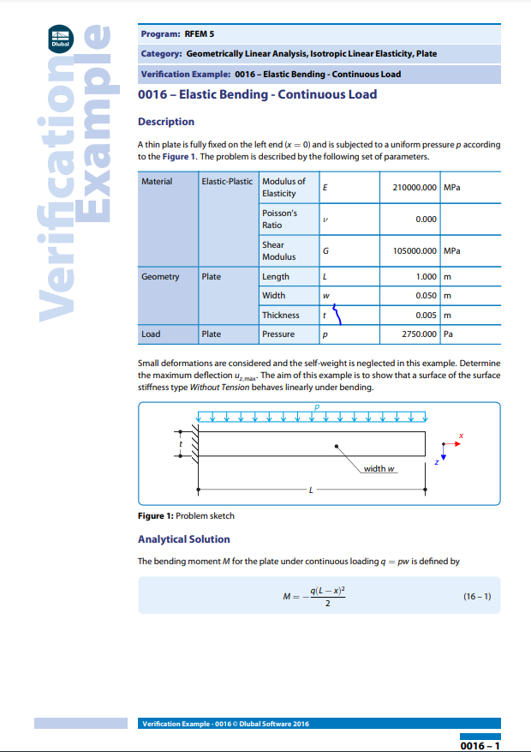
The following information is taken from Dlubal validation studies website [4] which shows specific validation cases which you can compare against the Ansys results. This information highlights a plate of material with a uniformly distributed load applied to indicate the surface stiffness. We can use this information to compare it to the Ansys study to see how accurate the data is.
Figure 1 - Validation Study [4]

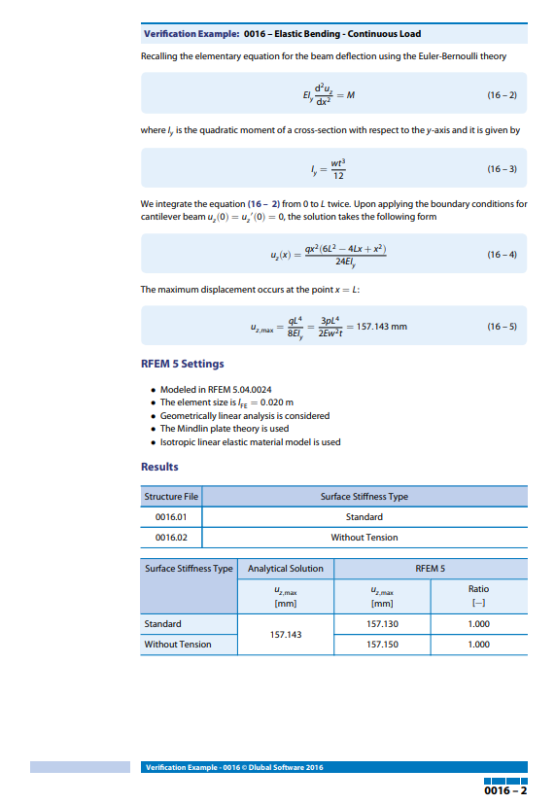
Figure 2 - Validation Study [4]

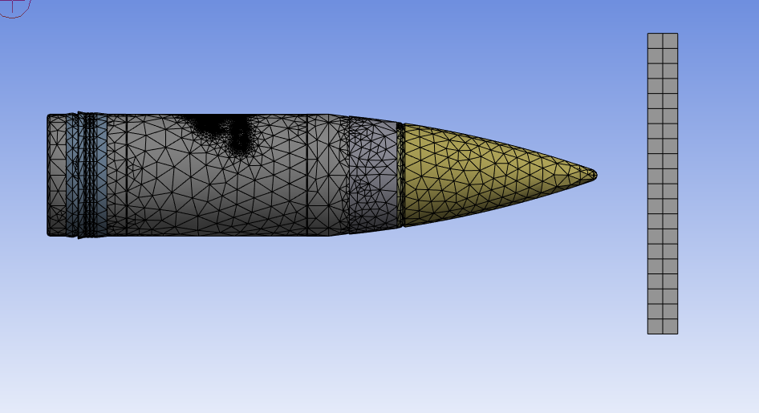
Figure 3 shows mesh sizing used for the Ansys simulations which comprises of a fine enough mesh to give detailed results of the static structural and thermal studies without taking a very long time to process the simulation on the computer.
Figure 3 - Mesh Example of 155mm Shell & Target

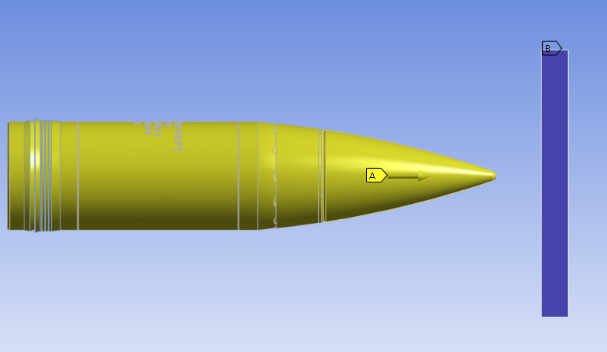
Figure 4 shows the loads and direction applied for the 155mm shell to impact the target.
Figure 4 - Load & Direction of 155mm Shell & Target

The Validation Study
The simulation is required to be accurate to real world testing, this is why a validation study must be conducted in order to test if the study is accurate. There are many various validation studies to choose from depending on what you are simulating. The reasoning behind the validation study is to ensure that the mathematical calculations the Ansys program uses are accurate to the validation study to ensure overall accuracy.
In order to prove this works the following validation study was conducted using the validation study from figure 1 & 2. This process was setup in the Ansys software and it made use of a cantilever beam which is fixed to one side and a load was applied to the opposite end.
The dimensions of the validation cantilever beam are:
- Length = 1m
- Height = 0.005m
- Width = 0.05m
The load on the validation cantilever beam is:
- 2750.000 Pa
The results shown from the study are 157.143mm
From this study it was then required that the validation would be needed to gain a similar value to that of the 157.143mm shown above, the closer the value to this figure would indicate that the Ansys program is accurate and therefore the analysis from the shell and plate would also be accurate Aswell.
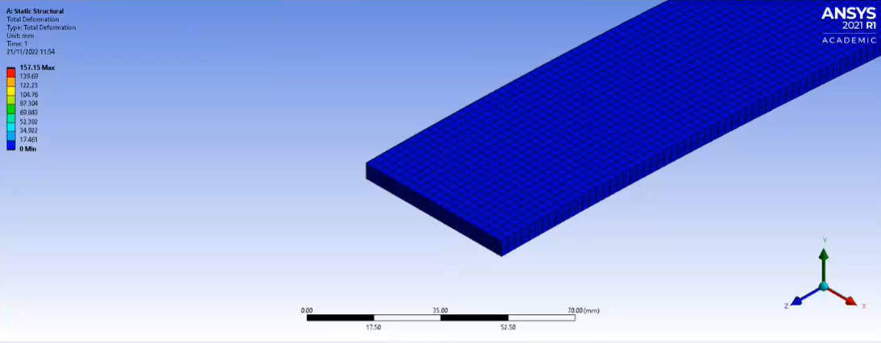
The validation study was then proved in solid works and Ansys by making the exact same case study and looking at the data from the total deformation of the cantilever beam. From the data shown in figures 5 & 6 its possible to see that the difference between the validation case study in figures 1 & 2 and the images from figures 5 & 6 are very close, in fact the value is within 1% of the case study which indicates that validation test is near perfect and shows that the values from the shell and target study will also be very accurate because of this.
Figure 5 - Static Structural Total Deformation Example [5]
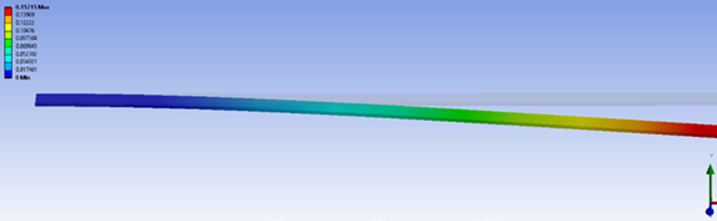
Overall figures 5 and 6 show the validation of the static structual deformation of the study to be very close to what was calculated using the ansys software indicating within 1% accuracy, to improve the validation study it would be possible to conduct more validation tests in order to gain a more accurate representation for any more simulations.
Figure 6 - - Static Structural Total Deformation from Ansys

Why is the validation study important for conducting simulations

Validation studies are crucial for any type of simulation, including those performed in ANSYS, for several reasons:

Establishing Accuracy
Validation studies compare simulation results with experimental data or analytical solutions to verify the accuracy of the simulation model. It helps ensure that the simulation software is capable of producing reliable and trustworthy results.

Building Confidence
By conducting validation studies and demonstrating that the simulation results match real-world data, engineers and analysts gain confidence in the simulation model's capabilities. This confidence is essential when using simulations to make critical engineering decisions.

Identifying Limitations
Validation studies help identify the limitations of the simulation model. Understanding the areas where the simulation might not accurately represent real-world behaviour allows engineers to make informed decisions about the applicability of the results.

Improving Model Parameters
If discrepancies are found between simulation results and experimental data, validation studies can help pinpoint the sources of error. This feedback can guide engineers to refine material properties, boundary conditions, or meshing techniques to improve the accuracy of the model.

Adhering to Quality Standards
In some industries, validation is a mandatory requirement to meet specific quality standards and regulatory guidelines. For example, in aerospace and defence, simulations must be validated before making critical design decisions.

Reducing Physical Testing
Validation studies can replace some physical testing with simulations, which can save time, cost, and resources, this is highlighted in the source from [6] in mechanical engineering principles as it highlights cost and time constraints with real world testing. Accurate simulation models allow engineers to perform virtual testing before conducting expensive and time-consuming physical tests.

Exploring Design Space
By validating simulation results, engineers gain confidence in using the simulations to explore various design options. They can perform "what-if" scenarios, optimize designs, and assess multiple configurations without the need for building and testing multiple prototypes.

Continuous Improvement
Validation studies encourage continuous improvement of simulation methodologies. As simulation software evolves, validating against experimental data helps assess the effectiveness of new features and enhancements.

Enhancing Collaboration
When simulation models are validated, it enhances trust and collaboration among team members, stakeholders, and clients. Validated results become a common reference point for discussions and decision-making.

Educational and Research Purposes
Validation studies contribute to educational and research endeavours. They serve as valuable teaching tools for understanding the limitations and capabilities of simulation software, preparing future engineers to use these tools effectively.
In summary, validation studies play a vital role in establishing the reliability of simulation results and fostering confidence in the use of simulations for engineering design and analysis. They provide a scientific basis for decision-making, leading to improved designs, reduced costs, and increased efficiency in engineering projects.

Results & Analysis

The results obtained from the Finite Element Analysis (FEA) simulations conducted using ANSYS for the assembly of the 155mm shell under realistic operating conditions are presented in this section. Additionally, a thorough analysis and interpretation of these results, along with a comparative study against other published works, will be discussed to gain insights into the design's performance and structural behaviour.

Simulation Results for Static Structural Analysis
The static structural analysis aimed to evaluate the behaviour of the 155mm shell assembly under different loading conditions. The simulation results provided valuable insights into the structural integrity and stress distribution within the components.

Maximum Total Deformation
The FEA simulation revealed that the maximum total deformation of the 155mm shell assembly was 157.15 mm. This deformation value indicates the level of displacement experienced by the assembly under the applied loads. However, to assess the acceptability of this deformation under real-world conditions, a comparative analysis against other published works and industry standards is essential.

Stress Distribution
The simulation also offered valuable stress distribution patterns across the shell components. By analysing stress concentrations and regions of high stress, potential failure points and areas requiring design improvements can be identified. However, to ascertain the significance of these stress values and ensure they are within safe operating limits, comparison with published works is necessary.

Simulation Results for Thermal Analysis
The thermal analysis focused on evaluating the response of the 155mm shell to extreme temperature variations it may encounter during field operations. This analysis is crucial to ensuring the shell's performance and structural integrity in high-temperature environments.

Maximum and Minimum Temperature Extremes
The thermal simulation provided valuable insights into the maximum and minimum temperature extremes experienced by the shell during the operating conditions. To determine whether the shell's material can withstand these thermal stresses without significant degradation or failure, a comparison of these temperature values with known material properties and thermal limits is imperative.

Comparative Analysis against Published Works
To validate the accuracy of the simulation results and gain a deeper understanding of the shell's behaviour, a comparative analysis against other published works with similar or relevant studies is essential.
Research Paper 1 - "Finite Element Analysis of Explosive Effects on Protective Structures":
This research paper [9] explored FEA modelling of explosive effects on protective structures, which bears relevance to this study in the ordnance, munitions, and explosives industry. By comparing the FEA results to this published work, we can assess the effectiveness of the simulation approach and verify the accuracy of the initial predictions.
Technical Paper 2 - "Computer-Aided Engineering in the Automotive Industry":
This technical paper [8] explored the application of CAE in the automotive industry, with a focus on structural and thermal analysis. Although the industry differs from our munitions study, a comparison with this published work can provide valuable insights into best practices for FEA simulations and help identify areas of improvement in the methodology.

Discussion and Interpretation
The current study's limitation lies in the lack of specific literature support and comparative analysis, which has restricted the ability to draw definitive conclusions based on the simulation results. To address this, future work should aim to include more in-depth analysis and benchmarking against established studies. Conducting validation studies with known experimental data will bolster the credibility of the simulation results and provide a stronger foundation for engineering decisions.
By comparing the simulation results to published works, its possible to determine whether the FEA approach aligns with established trends and industry standards. This validation process will improve the confidence in the simulation outcomes and provide valuable insights into the strengths and limitations of ANSYS in this particular study, this can be shown in the validation study made for the static structural tests.
Furthermore, iterative steps in the main study could help optimize the design and identify potential improvements to the shell assembly. A thorough analysis of the factors that influence simulation accuracy, such as mesh quality, boundary conditions, and material properties, would enhance the depth of the study and demonstrate a better understanding of the topic.

Findings
The results and analysis section highlights the importance of validation studies and comparative analysis in ANSYS FEA. By incorporating more literature support and benchmarking against published works, its possible to enhance the credibility and reliability of our simulation results. This, in turn, will lead to more informed engineering decisions, improved designs, and increased confidence in using FEA as a powerful tool in the engineering design process.

Factors Affecting Accuracy
Some of the factors that will affect these types of results and impact the accuracy compared to real world examples are:

Meshing
The process of meshing involves discretizing complex geometries into smaller finite elements interconnected to form a mesh. A well-defined mesh is vital as it directly influences the quality of results and computational efficiency.
Importance: Accurate meshing ensures that the simulation captures stress and deformation distributions precisely. The appropriate mesh refinement in critical regions is essential to capture localized stress concentrations and gradients. Striking the right balance between mesh accuracy and computational time is crucial for an optimal analysis.
Challenges: Meshing complex geometries can be time-consuming and challenging. It requires expertise to determine the element type and size that best represents the behaviour of the components under study. Poor meshing practices can lead to inaccurate results and difficulties in achieving convergence during analysis.

Boundary Conditions
Boundary conditions define the external factors influencing the system's behaviour, such as applied forces, displacements, temperatures, and constraints.
Importance: Accurate boundary conditions are essential to replicate real-world scenarios and obtain meaningful results. They must reflect the actual operating conditions of the component or assembly being analysed. Incorrect or unrealistic boundary conditions can lead to non-physical results that do not represent the actual behaviour of the system.
Challenges: Determining appropriate boundary conditions can be challenging, particularly for systems with multiple interactions and interfaces. Inadequate understanding of the actual operating conditions or oversimplification of boundary conditions may result in misleading simulation outcomes.
Material properties In ANSYS simulations, accurately defining material properties is crucial as it directly affects how components and structures respond to external stimuli. Material behaviour, such as elasticity, thermal conductivity, and density, significantly influences simulation outcomes.
Importance: Proper material characterization is vital for obtaining accurate stress, strain, and deformation distributions. Using real-world material data ensures the simulation closely represents the actual behaviour of the components under various conditions.
Challenges: Obtaining precise material properties can be challenging, especially for complex materials with nonlinear behaviour. Variability in material properties due to manufacturing processes or changes over time can also impact simulation accuracy.

Solver settings
Solver settings determine the numerical methods and algorithms used to solve the equations governing the behaviour of the system being analysed. These settings influence the accuracy, stability, and computational efficiency of the simulation.
Importance: Selecting appropriate solver settings is crucial to obtain reliable results within acceptable computational time. Incorrect solver settings may lead to convergence issues, unrealistic results, or increased computational time.
Challenges: Identifying the optimal solver settings requires a good understanding of the problem and the numerical methods employed. For complex simulations, finding the right balance between accuracy and computational time may involve a trial-and-error approach.

User Error
User error refers to mistakes made during the simulation setup, such as incorrect input data, inappropriate modelling assumptions, or overlooking critical aspects of the problem.
Importance: User errors can significantly affect the reliability of simulation results. Even minor mistakes in geometry, material properties, or boundary conditions can lead to inaccurate or misleading outcomes.
Challenges: Avoiding user errors requires meticulous attention to detail and a comprehensive understanding of the simulation process. As simulations become more complex, the potential for errors increases, making careful verification and validation essential.
These factors are explained well in great detail from TWI Global [7] which highlights the above explanations into limitations of CAE and why physical testing might also be required for validation.

Conclusion

In conclusion, the utilization of SolidWorks and Ansys for finite element analysis (FEA) offers undeniable advantages over traditional prototyping methods, presenting substantial time and cost-saving benefits. The ability to virtually simulate and analyse complex systems and structures without the need for physical prototypes enables engineers to expedite the design process and make informed decisions early in the development cycle.
However, as mentioned in the previous sections, it is crucial to be aware of potential drawbacks that can impact the accuracy of FEA results. One critical factor is the quality of meshing, which directly affects the fidelity of the simulation. A well-constructed mesh that accurately represents the geometry and features of the system can lead to reliable results, while a poorly designed mesh can introduce errors and compromise the overall accuracy of the analysis. Therefore, meticulous attention to meshing is vital to ensure the fidelity of FEA simulations.
Boundary conditions are equally vital in FEA, as they define the constraints and loading conditions applied to the model. The choice of appropriate boundary conditions can significantly influence the behaviour of the system under study. Engineers must carefully select boundary conditions that mimic real-world scenarios to obtain realistic and meaningful results. Incorrectly specified boundary conditions can lead to unrealistic responses and render the analysis ineffective.
Material properties play a critical role in FEA, as they determine how the components of the system behave under different loading conditions. Accurate material properties are essential to ensure that the FEA model reflects the real-world response of the system. Proper characterization and validation of material properties are crucial steps in the FEA process to avoid inaccuracies and ensure reliable results.
Solver settings, another crucial aspect of FEA, affect the computational efficiency and accuracy of the simulations. Properly configuring the solver settings is essential to strike a balance between accuracy and computational resources. Engineers must understand the implications of different solver settings and adjust them appropriately to obtain accurate and efficient simulations.
In addition to technical considerations, user error can also impact the accuracy of FEA results. Adequate training and expertise in using the FEA software are vital to ensure that the simulations are set up correctly and executed accurately. Even small errors in data input or simulation setup can lead to significant discrepancies in the results.
To address the potential inaccuracies and uncertainties in FEA, validation studies are of paramount importance. These studies involve comparing the simulation results with experimental data or analytical solutions to verify the accuracy and reliability of the FEA software for specific problems. Through validation studies, engineers can gain confidence in the accuracy of their FEA models and understand the limitations and applicability of the simulations.

When proficiently executed and supported by thorough validation, FEA using Ansys proves to be an invaluable tool for engineers and scientists across various disciplines. It enables efficient optimization of designs, evaluation of system performance under diverse conditions, and prediction of system behaviour with a high degree of accuracy. By leveraging FEA, engineering teams can significantly reduce development time, costs, and risks associated with traditional prototyping and testing.
Moreover, FEA provides a unique opportunity to explore the effects of different materials, manufacturing processes, and environmental conditions on the behaviour of a system. This critical information empowers designers to make well-informed decisions, leading to improved system performance, reduced material waste, and minimized environmental impact.
In conclusion, finite element analysis stands as an indispensable tool for tackling complex engineering challenges. Its ability to accurately simulate the behaviour of systems under varying conditions unlocks valuable insights that drive innovation and advancements in numerous industries. As engineers continue to refine their skills and knowledge in FEA, this powerful computational tool will undoubtedly play a pivotal role in shaping a more sustainable, efficient, and technologically advanced future.

References

[1] “Computer-Aided Engineering (CAE),” Siemens PLM Software, 2019. https://www.plm.automation.siemens.com/global/en/our-story/glossary/computer-aided-engineering-cae/13112 (accessed Apr. 10, 2023).
[2] Z. Bi, Finite Element Analysis Applications: A Systematic and Practical Approach. Saint Louis: Elsevier Science & Technology, 2017.
[3] “What is Computer Aided Engineering (CAE)?” www.twi-global.com. https://www.twi-global.com/technical-knowledge/faqs/what-is-computer-aided-engineering#Advantages (accessed Apr. 10, 2023).
[4] “Verification Example 0016 -Elastic Bending -Continuous Load Description,” 2016. Accessed: Apr. 15, 2023. [Online]. Available: https://www.dlubal.com/-/media/769CFB1370D742D9BEE0D37876B3E637.ashx
[5] A. Noble, “Static Structural Study,” Microsoft Teams. 2023. Accessed: Apr. 15, 2023. [Online]. Available: https://web.microsoftstream.com/embed/channel/0473ddb1-c257-4584-b3c1-10a50abf2a37?app=microsoftteams&sort=undefined&l=en-us#
[6] J.O. Bird and C. Ross, "Mechanical Engineering Principles," Abingdon-on-Thames: Routledge.
[7] "Advantages and Disadvantages of Computer-Aided Engineering (CAE)," TWI Global. [Online]. Available: https://www.twi-global.com/technical-knowledge/faqs/what-is-computer-aided-engineering#Advantages. [Accessed: July. 20, 2023].
[8] "Computer-Aided Engineering in the Automotive Industry," SAE International. [Online]. Available: [Link]. [Accessed: July. 20, 2023].
[9] "Finite Element Analysis of Explosive Effects on Protective Structures," Journal of Performance of Constructed Facilities” Vol 1.

Bibliography

Bird, J.O. and Ross, C. (2014) Mechanical Engineering Principles – 3rd ed, Abingdon-on-Thames: Routledge
MacDonald, B.J. (2020) Practical Stress Analysis with Finite Elements – 3rd ed, Dublin: MacDonald
Beer, F., Johnson, E. et al (2015) Mechanics of Materials, New York: McGraw-Hill
Benham, P.P., Crawford, R.J. and Armstrong, C.G.
(2006) Mechanics of Engineering Materials, New Jersey: Prentice Hall
Bacon, D.H. and Bennet, K. (1998) Mechanical Technology, Oxford: Butterworth-Heinemann

