TITLE PAGE
PAGE 1

NAME: Sefia Bibi
STUDENT NUMBER: 2014087
MODULE NAME: Professional career development
MODULE NUMBER: BMSW 4005
LECTURER NAME: Tayo
TITLE: Reflective Portfolio Task 3

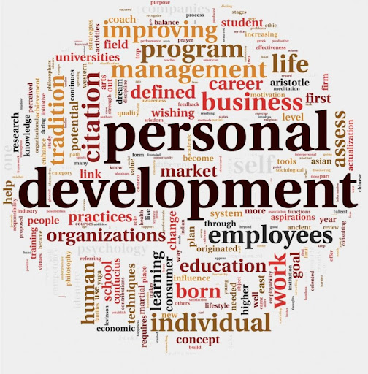
Google.com

Contents Page
Page 2

TITLE PAGE……………………………………………………………………PAGE 1
CONTENTS PAGE…………………………………………………………….PAGE 2
INTRODCUCTION……………………………………………………………..PAGE 3
DEFINITION OF SWOT ANALYSIS…………………………………………PAGE 4
MY SWOT ANALYSIS…………………………………………………………PAGE 5
DEFINITION OF PERSONAL DEVELOPMENT PLAN (PDP)……………PAGE 6
MY PERSONAL DEVELOPMENT PLAN (PDP)…………………………...PAGE 7
SKILLS REGUIRED TO BE AN EFFECTIVE MANAGER………………..PAGE 8/9
CONCEPTS I HAVE LEARNED FROM THIS MODULE………………….PAGE 10/11
CONCLUSION………………………………………………………………….PAGE 12
REFERENCES………………………………………………………………….PAGE 13

INTRODUCTION
PAGE 3
In this report I am going to talk about and reflect on professional career development. I will also be looking at different tools, theories and the models that we use to achieve our goals. In this report I am also going to explain about on what SWOT analysis is and the PDP is. In this report I am going to talk about how important it is to be able to obtain studies and why we need to carry on with our progress in the career we chose to be in. I have also looked at what is needed to be a good manager in the health care sector and to analysed these skills, what makes these skills important and how they are used or required at work/placement.


Google.com

PAGE 4
DEFINITION OF SWOT ANALYSIS
What is Swot Analysis?
Swot analysis is a tool that is used to help a person or organization to identify the Strengths, Weaknesses, opportunities and threats about the business competition or a project planning, it is also a technique that is used to assess these four aspects of business, swot analysis is a simple tool that can be used to help you analyse what your company does best right now and to devise a successful strategy for the future. Sarsby. (2016).

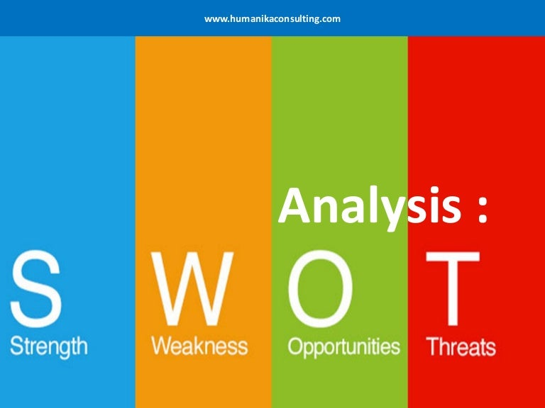

Google.com

PAGE 5
MY SWOT ANALYSIS

Strengths
- Good communication skills
- Motivation skills
- Ability to work under pressure
- Time Management
- Problem solving
- Organizing skills
- IT skills
Weaknesses
- Impatient
- Emotional

Opportunities
- Do level 5 in health social care
- Do more training
- Better job in the future

Threats
- Rejections
- New advance Technology
- Covid 19
- Finances
- Competitions

PAGE 6
DEFINITION OF PERSONAL DEVELOPMENT PLAN (PDP)
What is personal development plan?
Personal Development plan is an action plan that you can use to identify your goas and what you want to achieve as an individual. You can also identify your Strengths, weaknesses and the areas that you need to improve and develop to meet your goals. Also to do what you need to do to achieve your goals. PDP is a form that is self-reflection and self-evaluation used in higher education and workplaces. ( 1st June 2021 by Michelle Putter)

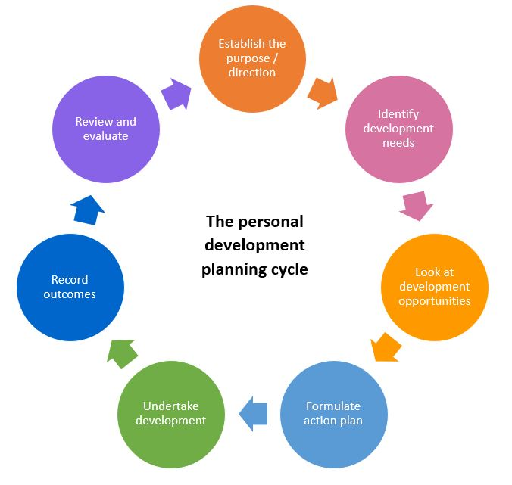

Google.com

PAGE 7
MY PERSONAL DEVELOPMENT PLAN
My plan is do level 5 in health and social care and to get higher qualification or a degree at the university.
To carry on with my studies and not give this up.
To maintain my work and have regular meetings and to record and monitor my work.
To review my goals and future plans.

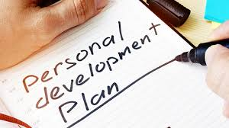

Google.com

PAGE 8
SKILLS REQUIRED TO BE AN EFFECTIVE MANAGER
To be an effective manager in health care settings you need to have good communication skills and are willing to support the team in different situations. They should be able to deliver a good service and be reliable to the team. A manager must understand the policy’s and producers of the company. They must be able to facilitate the staff members with the right guidance and support.
BUDGET
Healthcare manager needs to find out what kind of resources that they need to work with or operate with e.g. employees’ salaries, IV bags, new equipment, and bed sheets. The manager must communicate with staff to control each department’s financial needs. They should know what needs are absolute and where to cutback and can be made if needed.
STAFF MANAGEMENT
Specific training is critical in health care sector as a manager they need to understand what’s important to the providers to work with even if you don’t have the experience in clinical background, the health care management courses integrate with a secure sense of communication would be to put together to advocate well for your staff.
PROJECT MANAGEMENT
Same as any other business healthcare has their own objectives .healthcare management professionals know how to deal with situations and to look at a bigger picture of proactivity work by avoiding the bottlenecks and the problems that they can be hold progress back to. They also know how to put goals in place and how to implement them and to gather information if there is any adjusted along the way.
Soft skills is another skill that helps health care managers excel. Although technical skills are also important employers like to see candidates that are strong all well rounded of transferable. Skills and abilities so, I have identified some of the most transferable skills for being an effective manager.
COMMUNICATION
Communication are most important as being a manager to be not all about just sitting in the office you have to communicate with other clinical staff members, different departments, patients and other administers and clinicians. Communication is one of the most relied on skills.
TEAM WORK
Team work is an important factor for health care providers. The manager should promote good team work among staff members with seeing their strengths and setting their gaols. Team work help and reduce stress on everyone, by sharing the duties out.in healthcare it is very important for staff to work with the team for patients safety as it minimizes adverse events and helps to be able to deliver exceptional care to the patients. More than 70 percent of the errors occur due to dysfunctional team dynamics. As a manager you would need to build a strong team bond within your own area across the organization.

PAGE 9

RELATIONSHIP BUILDING SKILL
Relationship building is another hand in hand team work when working with the team and collaborating when you’ve done a good job of developing strong professional relationship with your peers. Relationship building skill is a good skill depending on the job role that you are doing. To be a manager it is good practice to have relationship building skills at your workplace and this could facilitate an appropriate bond between managers and the staff members.
RESEARCH
Research is another skill which is used and applied to a variety of scenarios in the health care management, for example if one of the patient is frustrated and believes that they have been billed incorrectly, you should be comfortable in following up with the right people to resolve the issue. As a manager you need to be comfortable with researching and collecting information from internal stakeholders to get a good plan.
PROBLEM SOLVING
Problem solving is an important skill to be used for the manager as this helps the company and employees to be able to prosper and succeed and this also helps with creativity in the department and overcome obstacles. Problem solving helps us to identify opportunities that come available within the workplace.



Google.com
PAGE 10

CONCEPTS I HAVE LEARNED FROM THIS MODULE
SETTING GOALS AND OBJECTIVES (SMART)
When setting a goal it gives you long time vision and short time motivation. By setting a goal it helps you organize your time and resources so you can make the most of your life. Setting a goal also gives you short time motivation and you can focus on your knowledge. Goal also helps you choose where you want to be in life and helps you to raise your self-confidence as you recognize your own ability and competence in achieving the gaols that have set out. To help me learn how to set my goals I used the SMART tool smart stands for Specific, Measurable, Attainable, Relevant and time base. (mindtool.com)
UK EMPLOYMENT LAW
In this module I have learned the U.K employments law and legislations, about the rights at work. An U.K employment law regulates the relationship between the employers and employees. The law regulates the expected from an employee and an employer, what there right are at work, this includes, recruitment which comes under Equality Act 2010 and makes it unlawful for employers to discriminate against job applicants e.g. race, age, disability, sex. It also talks about pay and holiday entitlement.
Employment Rights Act 1996, which covers the right to be given employments particular, dismissal notice and reason, unfair dismissal, redundancy payments, employer insolvency, disclosure and detriment.
Data Protection act 2018 which was implements the general Data Protection regulation (GDPR) it came into force may 2018. It safeguarding important information and to make sure that it is used properly and legally. Working time Regulation act 1998 says that limit the working hours which is 48 hours a week and average of 8 hour a day with a lunch break. There is also the Health and Safety work act 1974 which states that the working environment should be safe for employees, in the U.K and also requires the employers to meet the health and safety obligations. Discipline and grievance is the employment act 2008 the importance of code of practice on disciplinary and grievance procedures. (Connolly 2006)
In this module I have learnt about self-awareness it has helped me to understand about me my traits and feelings, this is about how I feel and my actions also about my emotions I have learnt what I can do to control my feelings and how to manage my thoughts. Self- awareness also helps with recognising our strengths and weaknesses. Self- awareness has different tools that help you to improve you self- awareness. Self-awareness is about the person thinks about themselves and their actions, being able to self –aware makes your life better and can live happy, also you can focus on the important things that you would like to do or succeed. There are

PAGE 11

Lots of benefits to have self-awareness that you can have better listening skills and to good thinking skills and have extra self-restraint and have more inspiration. (Oxford Dictionary, 2018)
In this module have I have also learned about learning theories we did a personality test in class and everyone’s results came back different which showed that everyone is different. My test results show that I am very peoples- oriented 55% that means by socializing with people, outgoing and very confident in my personality. The test that we did was very reliable and valid tool to use.

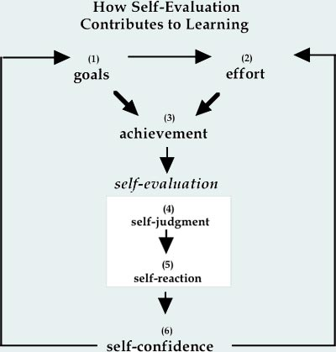
Google.com

PAGE 12

CONCLUSION
In my opinion and from what I have researched and learnt from this module to be an effective manager in the healthcare sector is a very big responsibility to have and to be able to do this effectively it is important and crucial that all training is done and up to date. Managers have a lot of important tasks to do a good manager keeps the workplace running successfully, having a good manager means that employees can also be successful in their job. Swot analysis, PDP, and smart have really helped me understand how to look at what I want to achieve and how I can do this. Learning about self -awareness has helped to understand myself better my traits and feelings I have found tis very helpful.



Google.com

PAGE 13
REFERENCES

- Connolly. (2006). Discrimination law. Sweet & Maxwell.
- Sarsby. (2016). Swot analysis : a guide to SWOT for students of business studies. Leadership Library, an imprint of Spectaris Limited.
- https://cpdonline.co.uk/knowledge-base/business/what-are-personal-development-plans/
- https://www.brightonsbm.com/news/importance-management-skills-healthcare/
- https://www.mindtools.com/page6.html
- https://www.verywellmind.com/what-is-self-awareness-2795023
- Kidner. (2008). Blackstone’s statutes on employment law 2008-2009 (18th ed.). Oxford University Press.
- Munna, & Shaikh, S. I. (2021). Impact of Shared Ethnicity in Building Effective Relationship: A complete Literature Review on Higher Education Context.
- Simpson. (1994). Mangement for Doctors: Doctors and management—why bother? BMJ, 309(6967), 1505–1544. https://doi.org/10.1136/bmj.309.6967.1505
- Torrington, D. and Hall, L. (1998). Human Resource Management. 4th ed. London: Prentice Hall Europe

