222222222222222222222222222222222222222222222222222222222
UWTSD

Computer Networks and Cybersecurity student number- 1901140

Internet Technology and Security (ACCA4018)
Ibrahim Balogun

Contents
Abstract 1
Introduction to Website 2
Implementation 2
Page 1 2
Page 2 3
Page 3 4
Page 4 5
Page 5 6
Validation 6
Evaluation 7
Usability 7
Accessibility 7
Search Engine Optimisation 7
Self-Evaluation 8
Usefulness 8
Search Engine Optimisation (SEO) 8
Accessibility 8
References 8

Abstract
This report will contain a description of the website that I created. I will be talking about the purpose and what is my target audience for the site. This will allow me to create my site for a specific audience, I will then be talking about the relevance, so how does my site fit the current times and events. I will then be showcasing the pages from my website and evaluating if the usability, accessibility and if its search engine optimised, I will also be validating my code to make use that I don’t have any errors, making sure that the website is functional as possible, then I will try and list out the positives and negatives and how I would improve my website in the future.

Introduction to Website
I have created this website for educational purpose, the site provides the user with a deep understanding about Nigeria and what the country has to offer and what it’s about. The website should act like BBC bitesize, providing lots of information while being easy to read. The subject matter is about the country Nigeria. I expect to have an audience ranging from young people, who just want to expand their knowledge about Africa, all the way up to the elderly who might be planning their next holiday. Due to current events having above-average knowledge about a nation is necessary, in any conversation in case you somehow offend another person, know what you are talking about has never been so important.

Implementation

Page 1
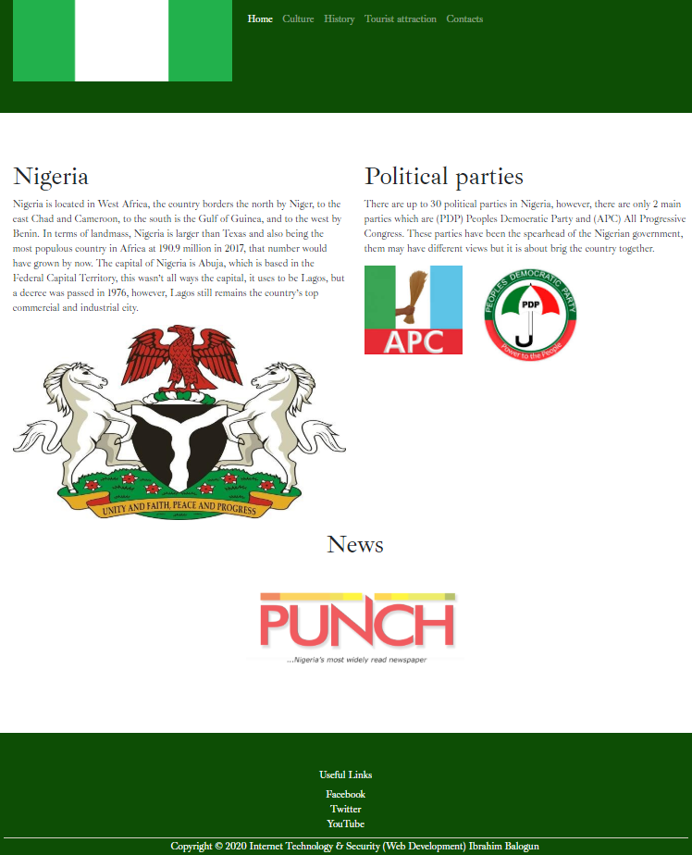
This is the home page, it allows the user to look up basic knowledge about Nigeria, I have added links to the other pages, this makes it easier for the user to navigate around the different pages and the other pages have more in-depth details on different subjects on the country, a link to a popular Nigerian newspaper has been put below to give users the chance to lookup current affairs of the country.

Page 2
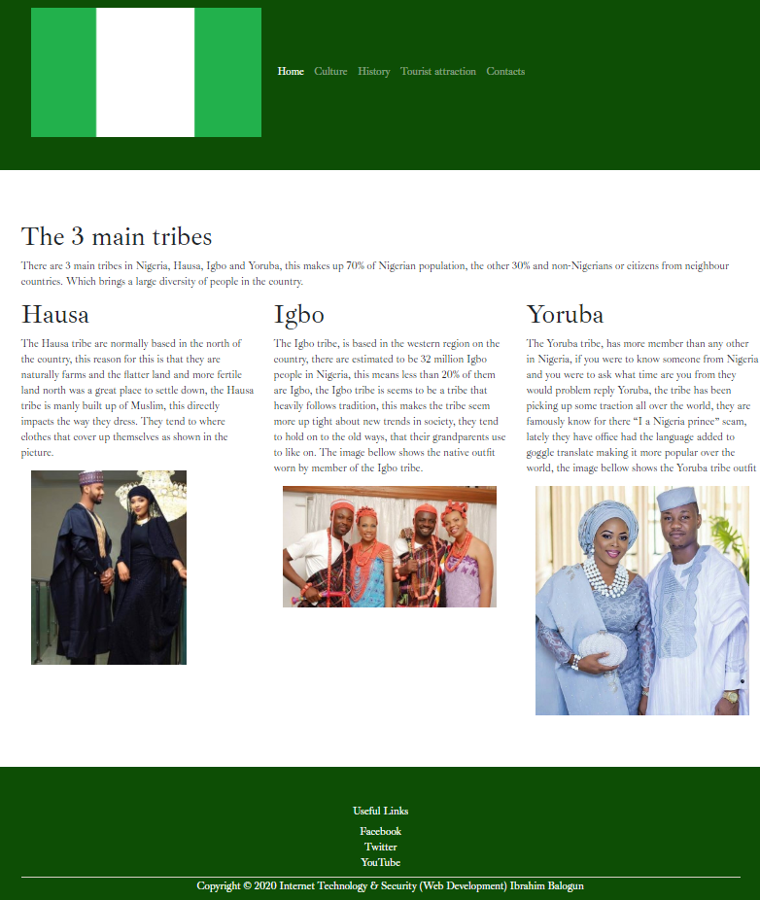
Page 2 shows the 3 main cultures/tribes in the country, which is important information if you are wanting to move into the country, it also add where each tends to say in the region and how they dress, this way you can easily identify them.

Page 3
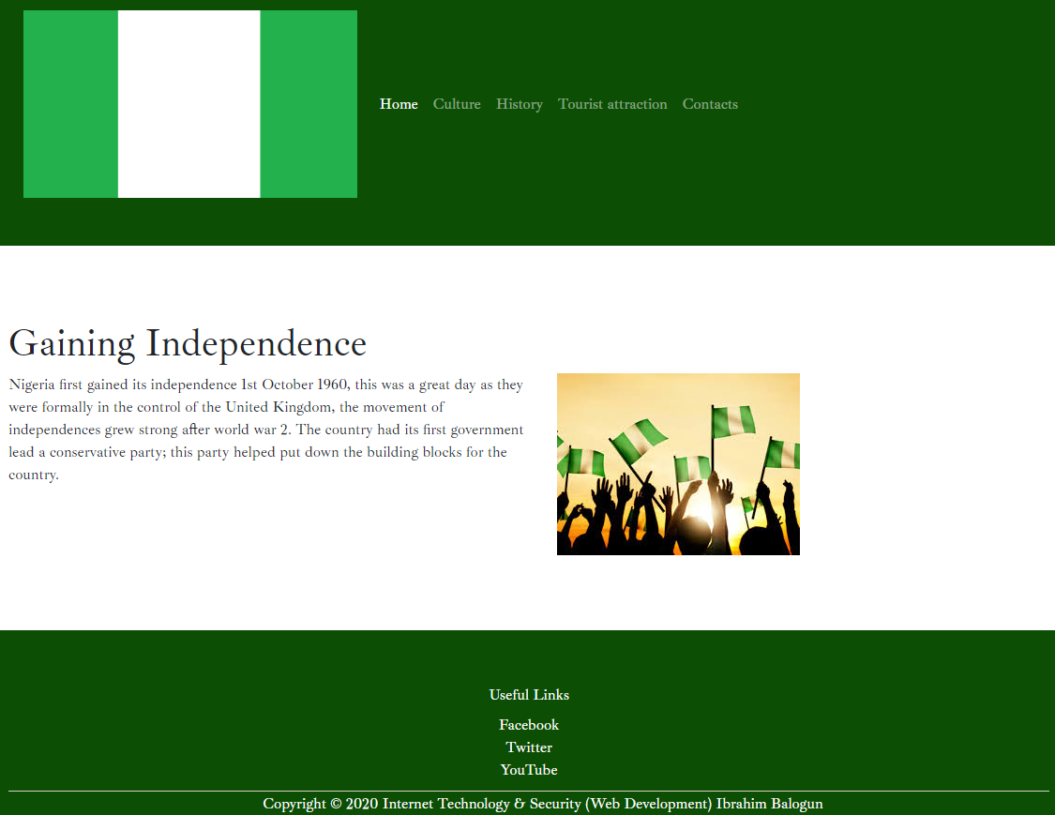
Page 3 shows the way the country gained its independence and which way the government swung either left or right, this gives the users a quick history lesson about the country.

Page 4
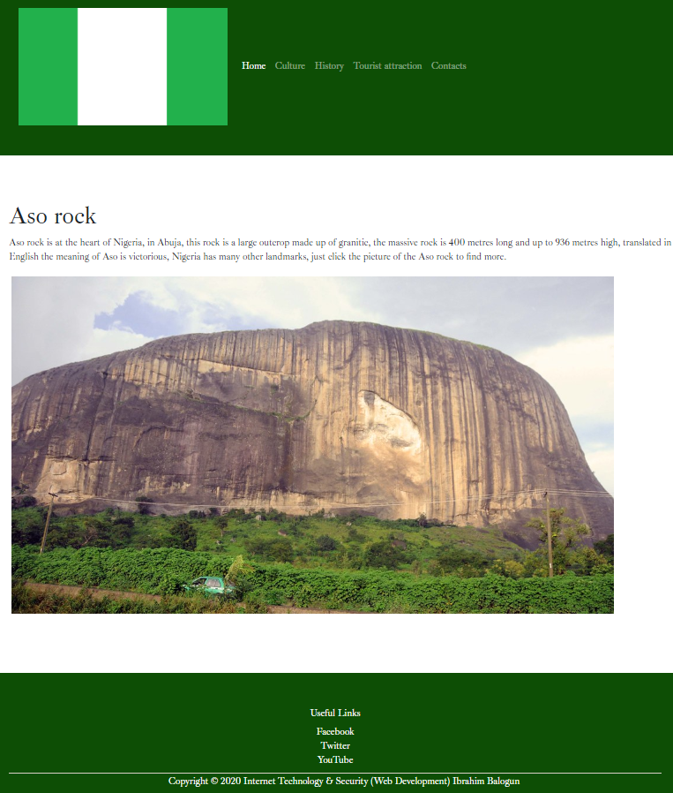
This page is all about the different types of tourist attraction in the country, the most common attraction is Aso rock, the image is a link to a list of different attraction in Nigeria.

Page 5
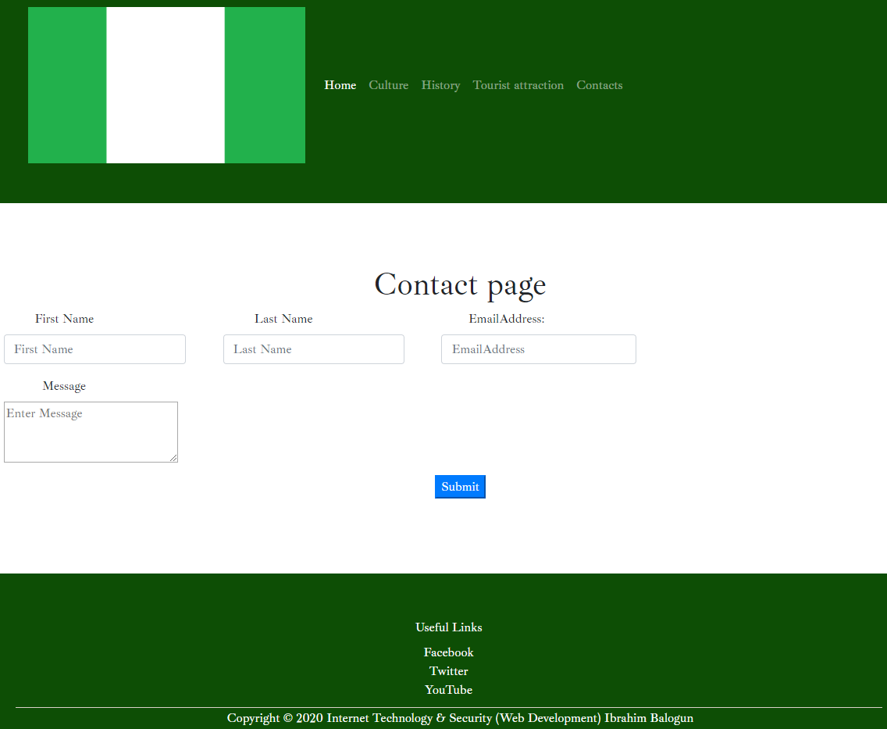
This page is for feedback, the user can send me feedback of what I can change about the website

Validation
When you have finished creating the website the next thing to do is to make sure the site doesn’t have any errors, so I validated my HTML code and it seems that I had made a few mistakes. The error codes I had where mainly due to typing or I miss spelt a word, for example in my index page I didn’t fully delete a line of code so the error was “No p element in scope but a p end tag seen”, this can be easily fixed by deleting the end p tag, this type of error was commonly seen on all the pages and they will be fixed in the final version. Validating my CSS code came out a lot cleaner I had only 1 error, which was given a position to an image that I couldn’t, the only way to fix this error is to delete the line of code.
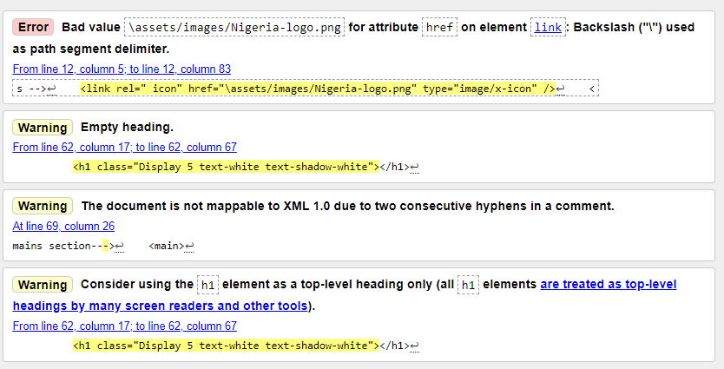 | 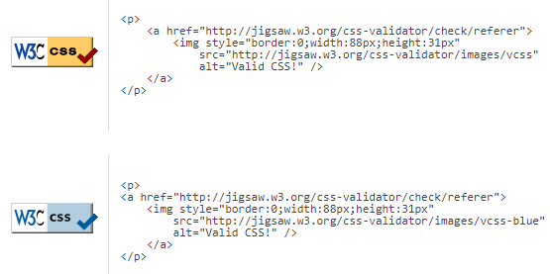
Validation for my index.html page | Validation for my CSS

Evaluation

Usability
When a person clicks a link to open a website and it doesn’t open can get frustrating for the end-user, have the site work properly has a lot of factors, making the website easy on the eye, don’t fill the page with text making anyone look at it fall to sleep. If the website isn’t responsive and it lags all the time when a user is on it makes it harder and harder for the users to keep using your website making sure that responsive and flows well with handheld devices. [1]

Accessibility
This is an important point that any website user will have to look into, there are many ways to make your site more usable for the end-user, this can be broken done into its availability and accessibility, making sure the server uptime is high so users wouldn’t have to wait for the server to get back online, making sure there aren’t any dead links on the site and making sure the site us mobile responsive because more than 70% of the world population has access to a mobile phone these make the site more available and accessible to a wide range of people all the time. [2]

Search Engine Optimisation
This is how many websites end up on the front page of Google, the website has keywords that whenever someone is searching for something and they type something related, for example, if the website is about Nigeria in the search engine optimisation I would add the keyword, Africa because these are related words and your most likely to use it in a sentence [3]

Self-Evaluation

Usefulness
My website provides a lot of useful features, the layout of the website make sure that any person with visually might find it easier to read, I used a white and green background because these type of colours are a lot easier on the easier even for a person who don’t have any problems. I coded the website so it has the ability to resize or in a better term be responsive so when on a handheld phone the pages on my website will resize allowing anyone to view it better, I have also tested that all the links on my pages work, they do, to make sure the site is always on par, I added a report section here so users can give me feedback on what they feel could be improved and I can make changes and pushout put date. My website is full of knowledge content that isn’t overly complicated but at the same time it could be used as a reference in an assignment

Search Engine Optimisation (SEO)
My website has been searched engine optimisation, I made sure to add some on every page this way all my pages will be more likely to show up on the front page of Google or Firefox.

Accessibility
My website offers some accessibility to users who find it difficult to see, for example, I have the classic black text on a white background this makes it easy to read, it would have been hard if it was yellow text on a red background, the reason for this is that those colours are too similar and putting them that close together makes it virtually impossible to distinguish one from the other. My website also has a responsive body so if the screen needed to be made bigger it would be possible, without messing up the format of the page. However, the website isn’t perfect I want able to add a text to speech or speech to text into my website but there might be a plugin done by google.

References

[1] | B. Witten, “What Is Website Usability Why Is It Important,” 13 March 2018. [Online]. Available: https://health.usf.edu/is/blog/2018/03/13/what-is-website-usability--why-is-it-important. [Accessed 1 January 2020].
[2] | 10 July 2019. [Online]. Available: https://www.crazyegg.com/blog/principles-website-usability/. [Accessed 1 January 2020].
[3] | 26 July 2018. [Online]. Available: https://hackernoon.com/seo-web-development-tutorial-for-beginners-7273308b6448. [Accessed 1 January 2020].

Links used to create my website
https://www.flickr.com/photos/24283686@N06/6404276021
https://www.britannica.com/place/Nigeria
https://www.britannica.com/topic/Hausa
https://study.com/academy/lesson/nigerian-ethnic-groups.html
https://www.sahistory.org.za/dated-event/nigeria-gained-independence-united-kingdom
https://infoguidenigeria.com/nigerian-coat-of-arms/
https://www.legit.ng/1197958-full-list-political-parties-nigeria-2018-leaders.html
https://www.edarabia.com/nigeria/independence-day/
http://www.travelstart.com.ng/blog/30-top-attractions-in-nigeria/
https://www.legit.ng/1179502-best-yoruba-native-dress-styles.html
https://www.pinterest.com/pin/448600812864418049/
https://idonsabi.com/stunning-hausa-wedding-styles/

marking criteria and Student FEEDBACK

This section details the extent to which the assessment criteria are demonstrated by you, which in turn determines your mark. The marks available for each category of skill are shown. Lecturers will use the space provided to comment on the achievement of the task(s), including those areas in which you have performed well and areas that would benefit from development/improvement.

Common Assessment Criteria Applied (Assignment 1) | Marks available | Marks  awarded
1. Engagement with Literature Skills

Demonstrates basic engagement with relevant literature and the discussion of concepts is basic with the supporting related research missing. Expand the scope of reference sources consulted to further improve your research work. (Grade mark: 40.00%) | 25 | 10
2. Knowledge and Understanding Skills

Demonstrates a good understanding of the standards used to design and implement a website with a generally good understanding of the validation results. As you have not completed the research exercise properly, this has had an impact on your ability to properly evaluate the website against the requirements of the assignment brief. (Grade mark: 50.00%) | 20 | 10
3. Cognitive and Intellectual Skills

4. Practical Application Skills

A very good attempt featuring a simple website with well-thought-out content. There are, however, some things to note. Using "jpg" for the alt attribute for all your images is NOT acceptable and does not meet basic accessibility requirements. You should use alternative text descriptions that are meaningful and help users who are unable to view the images to have some understanding of what they are displaying. Ensure all tags are properly nested and closed. Make your logo link to the home page as users expect this behaviour and remember to highlight the main menu link of the currently active page. You need to introduce a column size change for medium/small screens on the "culture" page - see your report. The layout for the contact page also requires some improvement and a vertical layout would have been much better. There was some content from the tutorial exercise that was not relevant for your website and this should have been removed, i.e. the social media links. Also, use better file names for your pages to improve SEO. Generally, I would have liked to see some more variation of the content and concepts used. (Grade mark: 68.00%) | 50 | 34
5. Transferable Skills for Life and Professional Practice

The report is of a good standard. Generally, aim to improve your writing style. See your report for suggested improvements. (Grade mark: 50.00%) | 5 | 2.5

Assignment Mark (Assessment marks are subject to ratification at the Exam Board. These comments and marks are to give feedback on module work and are for guidance only until they are confirmed. ) | Late Submission Penalties (tick if appropriate) |  | 56.5%
 | Up to 1 week late (40% Max) |  | 56.5%
 | Over 1 week late (0%) |  | 56.5%

