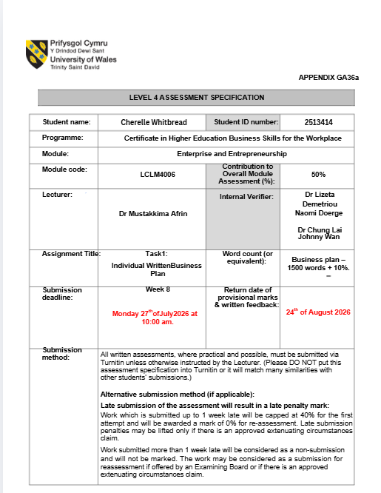



Managing Enterprise in the 21st Century

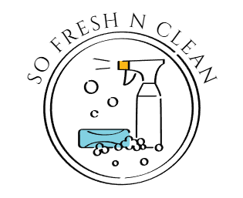
Business Plan

Submission Date: Monday 27th July 2026
Lecturer: Dr Mustakkima Afrin

Table of Contents
Group Information 2
Executive Summary 4
Business Concept 5
Business Description 5
Product Description 5
Business Objectives (SMART Objectives) 5
Short-Term Objectives (less than a year) 5
Long-Term Objectives (less than a year) 5
Market Analysis and Marketing Plan 6
Market Analysis (Competitors, Customers, Target Groups) 6
PESTEL Analysis 6
SWOT Analysis 6
Marketing Mix (4Ps) 6
Management Team 6
Management Team and Their Background 7
Organisational Chart 7
Key Milestones 7
Financial Plan (One Year) 7
Sources of Finance 7
Cash Flow Forecast 7
Sales Forecast 7
Cost of Production Forecast 7
Break Even Analysis 7
Operations and Management Plan 7
Production of Good and Service 7
Technology Plan 7
Human Resource Plan 7
Expansion Plan 8
Reference List 8
Appendices: 9

Executive Summary
So Fresh and Clean is a start-up residential cleaning business that aims to provide reliable, affordable, and high-quality cleaning services to households in the local area. The business has been created to meet the growing demand for professional domestic cleaning, particularly among busy working professionals, families, older adults, and individuals who require extra support to maintain a clean and healthy home.
The mission of So Fresh and Clean is to deliver exceptional cleaning services that improve customers’ quality of life by creating clean, hygienic, and welcoming living environments. The business is committed to providing excellent customer service, maintaining high professional standards, and building long-term relationships based on trust, reliability, and customer satisfaction.
The services offered will include regular weekly and fortnightly cleaning, one-off cleans, deep cleaning, end-of-tenancy cleaning, spring cleaning, and move-in or move-out cleaning. As the business develops, additional specialist services may be introduced to meet customer demand

Business Concept
My vision for So Fresh and Clean is to become a well-recognised and trusted cleaning company within the local community. I aim to build a strong reputation through high-quality services and positive word-of-mouth, with the long-term goal of developing So Fresh and Clean into a recognised brand.
I do not want the business to be known only for professional cleaning. I also want to help improve people’s wellbeing and quality of life by providing a organising services and offer practical advice on how to maintain a clean, healthy and comfortable home.

Business Description
So Fresh and Clean is a start-up domestic cleaning business that will provide cleaning services to local residential customers. The business will operate as a sole trader during its first year and will initially be managed by the owner. Services will include regular weekly and fortnightly cleaning, deep cleaning, kitchen and bathroom cleaning, and end-of-tenancy cleaning. I aim to build a strong local reputation by providing dependable, professional and affordable cleaning services adding a person touch.
My mission is to create clean, safe, and healthy environments while delivering exceptional customer service. I am committed to using effective cleaning products, modern equipment, and pay attention to detail to ensure every property is cleaned to the highest standard. I would also like to offer a decluttering option as this is one of the main reason people find it hard to maintain a clean home and can find their homes overwhelming and that can deteriorate ones mental health.

Product Description
Services Offered
● Regular domestic cleaning – Routine cleaning of kitchens, bathrooms, bedrooms, living areas and other areas of the home.
● Deep cleaning – A more detailed clean for customers who require additional attention to their home.
● One-off cleaning – Cleaning services for customers who need a clean on a single occasion.
● Home organising – Helping customers organise and maintain tidy and functional living spaces.
● Cleaning advice – Providing customers with practical advice on how to maintain a clean, healthy and organised home.
The service will focus on being reliable, affordable and professional, while providing customers with a friendly and personalised experience.
The main benefit of the service is that it will save customers time and effort while helping them maintain a cleaner, more organised and comfortable home. So Fresh and Clean aims to provide more than a cleaning service by helping customers improve their overall home environment and wellbeing.

Business Objectives (SMART Objectives)

Short-Term Objectives (less than a year)
Short Term Objectives (Less than 1 Year)
● Establish a strong customer base within the local area by gaining at least 20–30 regular clients.
● Build brand awareness through social media, flyers, and word-of-mouth recommendations.
● Achieve consistent weekly bookings to ensure steady income and business growth.
● Deliver high-quality services to achieve positive customer reviews and repeat business.
● Break even within the first 6–12 months of trading.
● Develop a simple booking and scheduling system to manage appointments efficiently.
● Purchase all essential cleaning equipment and supplies needed to operate professionally.
● Ensure all services are delivered reliably, safely, and to a high standard to build trust and reputation.

Long-Term Objectives (More than a year)
● Expand the business beyond the local area and build a wider customer base across surrounding towns and communities.
● Employ and train additional staff to support increased demand and improve service capacity.
● Establish So Fresh and Clean as a well-known and trusted cleaning brand with a strong reputation for quality and reliability.
● Increase the number of regular long-term clients to ensure stable and consistent income.
● Introduce a wider range of services, such as specialist deep cleaning, end-of-tenancy cleaning, and eco-friendly cleaning options.
● Invest in professional equipment and improved systems to increase efficiency and service quality.
● Develop partnerships with local businesses, landlords, and letting agencies to secure regular contracts.
● Achieve steady business growth and long-term financial stability.

Market Analysis and Marketing Plan
A market analysis identifies the opportunities and challenges within the cleaning industry and demonstrates the potential demand for the business. The UK cleaning industry continues to grow due to increasing awareness of hygiene, busy lifestyles, and the growing trend of outsourcing domestic and commercial cleaning services (British Cleaning Council, 2024).

Market Analysis (Competitors, Customers, Target Groups)
The target market for the business will include residential homeowner or private tenants, landlords, letting agents, small businesses, offices, and elderly customers who require reliable and professional cleaning services. According to the Office for National Statistics (2024), the UK has experienced growth in the number of households and small businesses, creating greater demand for outsourced cleaning services.
Consumer demand has also shifted towards environmentally friendly cleaning solutions. Many customers now prefer businesses that use eco-friendly, non-toxic cleaning products and sustainable practices, helping cleaning companies gain a competitive advantage (British Business Bank, 2023).
Competition within the industry is high, with national cleaning franchises, independent local cleaning companies, and self-employed cleaners all competing for customers. To remain competitive, the business will differentiate itself by offering flexible appointment times, competitive pricing, high-quality customer service, fully insured cleaners, and personalised cleaning packages (Porter, 1985).

PESTEL Analysis
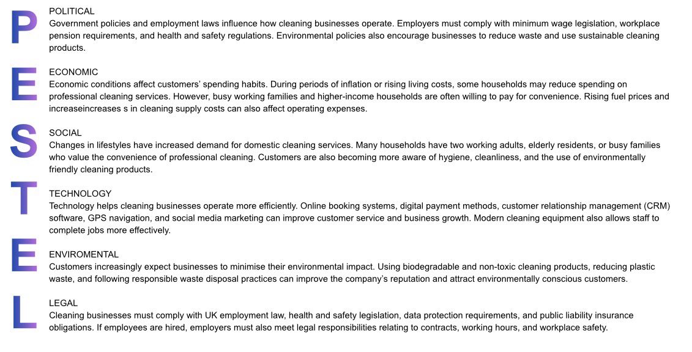

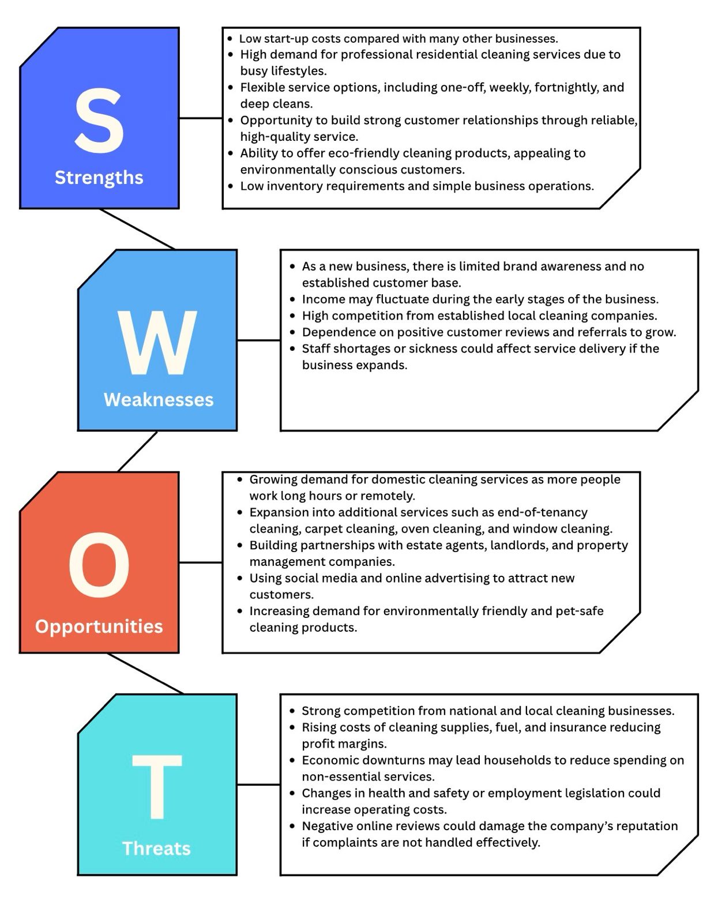
SWOT Analysis

Marketing Mix (4Ps)

The 4 Ps of Marketing (Product, Price, Place, and Promotion)
1. Product
• Domestic house cleaning
• Deep cleaning
• End-of-tenancy cleaning
• Eco-friendly cleaning options
• Flexible cleaning package such as weekly, fortnightly, or one-off cleans.
2. Price
• Hourly rates (e.g. £18–£30 per hour) or fixed price for size of job
• Fixed prices for specific services
• Discounts for regular customers
• Package deals for multiple services
• Free quotations
3. Place
• Our local area, community.
• Bookings via phone, email, website, or social media
• Mobile service/App where cleaners travel to customers
• Online booking system
4. Promotion
• Facebook and Instagram pages
• Local community groups
• Flyers and business cards
• Google Business Profile
• Customer referrals

Management Team
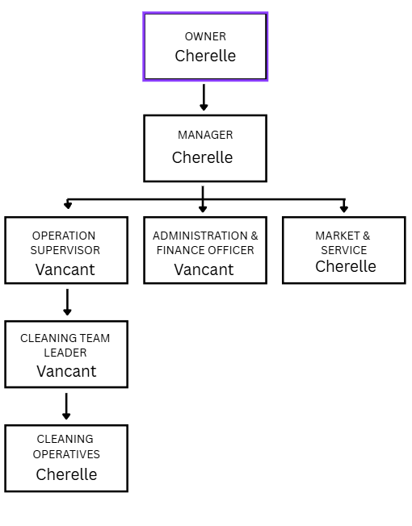

Management Team and Their Background

As I am currently a sole business owner I will start off covering all the roles till I am ready to expand my business and require other bodies to cover other roles, but I will always stay hands on so I can work alongside my team and our job standards and values will continue throughout our work.

One-Year Financial Plan – So Fresh and Clean
The financial plan for So Fresh and Clean aims to ensure that the business has enough money to cover its start-up and running costs while generating a profit during the first year.

Estimated First-Year Financial Plan
Financial item | Estimated amount
Start-up costs | £1,420
Annual fixed costs | £2,150
Annual variable costs | £4,800
Total first-year costs | £8,370
Estimated annual sales revenue | £18,000
Estimated profit before tax | £8,970

Monthly Sales Target
To achieve approximately £18,000 in annual revenue, So Fresh and Clean would need to make an average of:
£18,000 ÷ 12 = £1,500 per month
For example, if the average cleaning job is £60, the business would need approximately 25 cleaning jobs per month to generate £1,500 in monthly sales.

Financial Objectives
- Keep start-up costs within the planned £1,420 budget.
- Generate approximately £18,000 in sales during the first year.
- Cover all fixed and variable costs.
- Reach the break-even point as early as possible.
- Build a regular customer base to provide reliable monthly income.
- Reinvest some of the profit into marketing, equipment and business growth.
- Monitor income and expenses every month to ensure the business remains financially sustainable.

Sources of Finance
So Fresh and Clean will require approximately £1,420 to cover the initial start-up costs. The business will use a combination of personal savings and external finance if required.
Source of finance | Amount | Purpose
Personal savings | £1,000 | Equipment, cleaning products and PPE
Family/friends | £420 | Marketing, insurance and fuel
Total finance | £1,420 | Start-up costs

Personal Savings
The main source of finance will be personal savings. Using personal money means the business will not have to make loan repayments or pay interest. It also gives the owner greater control over the business.

Family and Friends
A small amount of finance could be provided by family or friends. This could help cover any remaining start-up costs, such as marketing and fuel. Any money borrowed should be agreed clearly, including how and when it will be repaid.

Future Finance
As So Fresh and Clean grows, the business could consider other sources of finance, such as a small business loan, government-backed finance or reinvesting profits back into the business. This could help fund additional equipment, employees and expansion.

Cash Flow Forecast
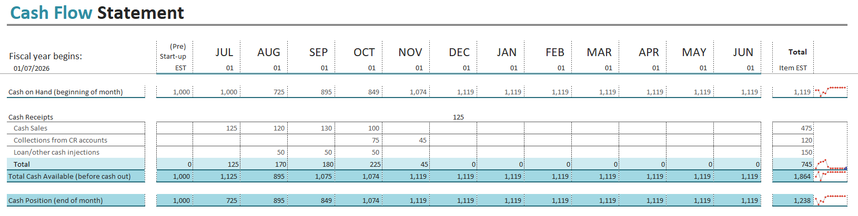

Cost of Production Forecast
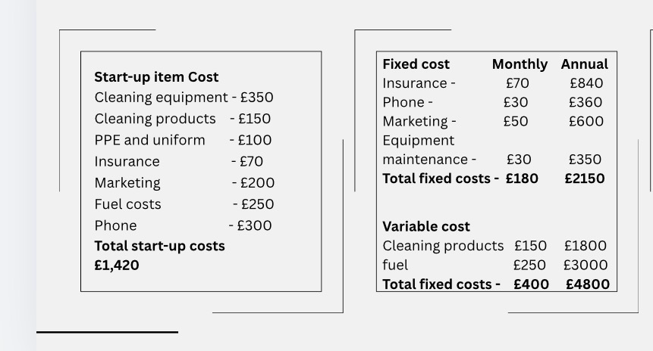

Break Even Analysis

I plan to charge £60 (low side of charge, it will vary depending on job size) per cleaning service. Based on the estimated annual costs, the business has fixed costs of approximately £2,150 and variable costs of £4,800 per year. If the business completes around 20 cleaning jobs per month, the variable cost is approximately £20 per clean.
The contribution made from each clean is therefore:
£60 − £20 = £40
The break-even point is calculated by dividing the fixed costs by the contribution per clean:
£2,150 ÷ £40 = 53.75
Therefore, So Fresh and Clean would need to complete approximately 54 cleaning jobs per year to break even. This is approximately 4–5 cleaning jobs per month.
The sales value at break-even would be approximately:
54 × £60 = £3,240
This means that once the business has generated approximately £3,240 in sales, it will have covered its fixed costs based on these assumptions. Any additional contribution after the break-even point can contribute towards profit

.

Production of Good and Service
So Fresh and Clean does not produce physical goods; instead, it provides a service-based product, which is domestic cleaning and home organisation.
1. Customer Booking – Customers contact the business through social media, phone, or messaging to request a service.
2. Assessment of Needs – The business identifies the type of cleaning required (regular clean, deep clean, or one-off clean).
3. Preparation of Equipment – Cleaning materials and equipment are prepared before visiting the customer’s home.
4. Service Delivery – Cleaning and organising tasks are carried out in the customer’s home, including kitchens, bathrooms, bedrooms, and living areas.
5. Quality Check – The work is reviewed to ensure it meets a high standard and customer expectations.
6. Customer Feedback – Customers are encouraged to provide feedback to help improve the service.
Resources Used
● Cleaning products (eco-friendly and standard options)
● Cleaning equipment (cloths, mops, vacuum cleaner, sprays, etc.)
● Transport to travel to customer homes
● Time and labour provided by the business owner and future staff
The service is delivered directly in the customer’s home, making it convenient and flexible. Appointments will be scheduled based on customer availability, ensuring a personalised and efficient service.

References
British Cleaning Council (2024) The UK Cleaning, Hygiene and Waste Industry. Available at: https://britishcleaningcouncil.org (Accessed: 26 July 2026).
Gov.uk (2025) Employing people. Available at: https://www.gov.uk/browse/employing-people (Accessed: 24 July 2026).
Health and Safety Executive (2025) Health and Safety at Work. Available at: https://www.hse.gov.uk (Accessed: 24 July 2026).
Johnson, G., Scholes, K. and Whittington, R. (2020) Exploring Strategy. 12th edn. Harlow: Pearson.
Kotler, P. and Keller, K.L. (2016) Marketing Management. 15th edn. Harlow: Pearson Education.
Office for National Statistics (2024) Business and Household Statistics. Newport: ONS.
Porter, M.E. (1985) Competitive Advantage: Creating and Sustaining Superior Performance. New York: Free Press.
UK Government (2019) The Control of Substances Hazardous to Health Regulations 2002 (COSHH). Available at: https://www.legislation.gov.uk (Accessed: 24 July 2026).
UK Government (2024) Health and safety for employers. Available at: https://www.gov.uk/topic/business-tax/employing-people (Accessed: 6 August 2026).
UK Government (2024) National Minimum Wage and National Living Wage. Available at: https://www.gov.uk/national-minimum-wage (Accessed: 6 August 2026).

