Shit is Fucked up and Bullshit.

For this brief I wanted to highlight how women don’t feel safe when on their own.
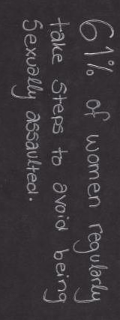
I researched ways women protect themselves when they’re on their own because I wanted to include objects that women use to protect themselves within my poster. I looked at facts and figures surrounding women’s safety, which I wanted to include in my poster. I liked the idea of incorporating handwritten quotes so it felt more real, I wanted the writing to be a bit messy to give a raw atmosphere because it’s a raw and sensitive subject for a lot of people. To make it interactive I added a hyperlink within the quote with a link of a website that has names of websites for people to get help they need.
I’m happy with my poster, I think it works pretty well as the lighting makes it look quite cynical, and I wanted to show the emotions that women feel when on their own. It took a few attempts to get the poster with the link to work because it kept having a white line down the middle of it, so I added the link in Acrobat rather than Photoshop, which worked for me. Next time I’ll make a Gif to relate to my topic of interest to experiment with different techniques.
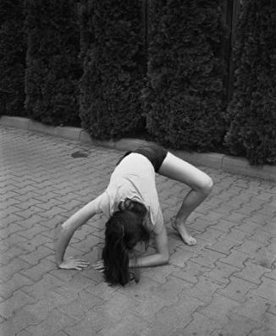
Joanna Piotrowska;
Joanna Piotrowska is a polish photographer who began practising photography professionally in 2004. Piotrowska uses both black and white photographs and 16mm films within her work. Piotrowska looks into history, memory and repetition and is inspired by feminist and psychology texts.
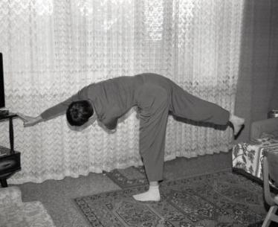
I’m fascinated by Piotrowska’s ‘Self- Defence’ series where she places women in self-defence positions. It has a big impact on showing how women are usually the victims, which I want to show in my work too. Piotrowska did this series to show that it’s usually men who teach and practice self-defence and rarely women when women are the ones who need to defend and protect themselves more. I’ve found this series influential because it showed me of ways I could photograph a woman protecting themselves. This series also showed how often women are seen as vulnerable, which made me want to make people realise by making my own photos where women have to protect themselves.

Rora Blue;
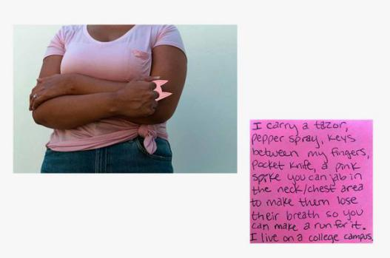
Rora Blue is an American artist who began professional photography in 2015. Blue looks at representations of colour as she feels it shows emotions well and helps her connect emotionally with the viewer. She asks people questions surrounding her topic and uses their answers to think of ideas for her photographs. Blue’s work has been included in media outlets like The New York Times and Teen Vogue and has received awards for her work and has exhibited her work in different countries.
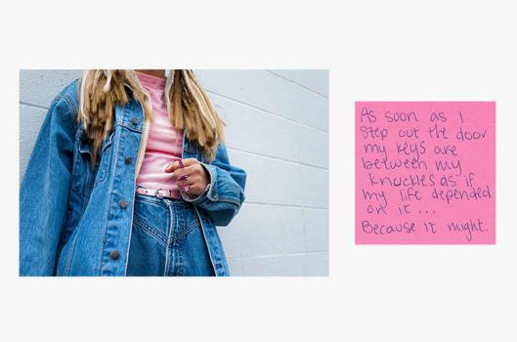
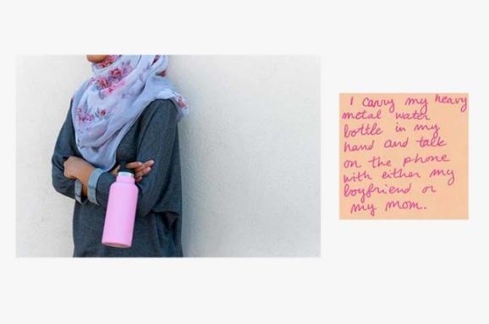
I’m interested in Blue’s “The Walk” series where she asked women how they protect themselves when on their own, she wrote down the responses on sticky notes and took photos of women (neck down so it’s anonymous and easier to relate to) holding an object mentioned in the responses. Blue uses the colour pink within her photos as it’s associated with women and girls, and girls sometimes grow up to dislike it because it’s pushed on them and Blue wanted to reclaim the colour so people don’t have to feel like they have to like it because society tells them to. I’ve found this series influential because I wanted to show how women don’t feel safe and Blue’s images highlight that by using everyday objects. I knew I wanted to show how women don’t feel safe, but I wasn’t sure how to until I saw the sticky notes which helped me decide on using text.

References
A WOMEN’S THING. 2019. The Objects Women Carry For Protection While Walking Alone | A WOMEN’S THING. [online] Available at: <https://awomensthing.org/blog/objects-women-carry-for-protection-rora-blue/> [Accessed 19 October 2020].
Ballard, J., 2019. 61% Of Women Regularly Take Steps To Avoid Being Sexually Assaulted | Yougov. [online] Today.yougov.com. Available at: <https://today.yougov.com/topics/lifestyle/articles-reports/2019/03/28/women-safety-sexual-assault-awareness> [Accessed 13 October 2020].
Dawidradziszewski.com. 2020. JOANNA PIOTROWSKA — Galeria Dawid Radziszewski. [online] Available at: <http://www.dawidradziszewski.com/artists/joanna-piotrowska/> [Accessed 15 October 2020].
Plan International UK. n.d. Street Harassment | Plan International UK. [online] Available at: <https://plan-uk.org/act-for-girls/street-harassment> [Accessed 13 October 2020].
Rora Blue. 2020. About — Rora Blue. [online] Available at: <https://www.rorablue.com/about> [Accessed 16 October 2020].
Tate. 2019. Art Now: Joanna Piotrowska: All Our False Devices – Exhibition At Tate Britain | Tate. [online] Available at: <https://www.tate.org.uk/whats-on/tate-britain/exhibition/joanna-piotrowska> [Accessed 15 October 2020].

