Pathway Project 1
Student name: Saifur Rahman
Student ID: 1605 226
Lecturer Name: Miguel Martins
Module Code: EMPL4013

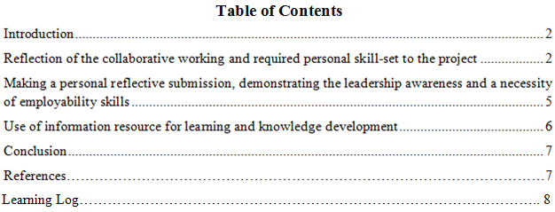

Introduction
Work in the group is a very challenging task for every person. This was the first time I worked in a group to prepare the presentation. To complete my part in the presentation effectively, I had to work upon the collaboration with the group members. This reflection paper will focus the overall activities in the group presentation.
Reflect upon the collaborative working and a personal skill-set to the project
To perform the group presentation, I had required a set of personal skills those are discussed below.
Time management
Time management was one of the most vital issues in the presentation because there was a certain deadline for the presentation and missing the deadline will get a huge penalty in the academic result. Time management refers the technique which is applied by an individual to complete the particular task within the allocate time effectively and efficiently (Forsyth, 2007). Time management is an important skill for an individual because good time management skill helps successfully completion of works and the efficiency of the individual is proved. Prepare a plan of the time management for the presentation at first I had required to gather knowledge about various time management models.
80/20 time management rule is a very helpful time management technique. The main idea of this rule is that 20% efforts of an individual can provide 80% of the result (Marshall, 2013). In other words, 20% the group members are performed 80% of the group work. In addition, 80% noncooperation comes from the 20% group members. This 80/20 time management rules gave me clear possibilities what would be the possible response of each group members, their efforts, and outcome of the group performance. So, I remained very careful about the time management of my given part to conduct successful and did not keep the tasks off for other members.
Pickle jar theory is another time management concept that also helped me a lot in the time management of the presentation. This theory is basically developed on the concept that time is limited like pickle jar where there is some most important task e.g. big rocks in the jar that must be given priority first and there is some least important task e.g. pebbles in the jar that can be done in the free-time (Ilnad, 2013). This theory metaphorically teaches the time management for the prime important task and non-prime tasks. So, by developing the importance of various elements in the daily life, pickle jar theory is effective time management technique. This model helped me to prioritise the most important tasks in my part of the presentation and least essential tasks. In addition, it helped me to develop daily work schedule based on the priority for completing the presentation. As a result, there was no scope of missing or delaying important tasks in the presentation as well as other tasks in the presentation. And, eventually, I completed my part in the presentation efficiently.
Time management is an important skill that is required in every phase of the presentation work. These models of time management helped me to understand the various ways of effective time management for prime tasks and non-complementary tasks involved in the presentation. I prepared a schedule for the presentation works that includes top priority works to least priority works. I had followed the time schedule for each work and marked the milestones. Thus ways time management skill was applied in the formulation of the presentation.
Interpersonal communication
Interpersonal communication is another important skill that is essential in the group work. Interpersonal communication refers to exchange of information between two individual to create and sustain shared meaning (Turner and West, 2008). In this process, individuals are sharing feelings, information, and meaning through nonverbal, written and verbal methods. In the group work, interpersonal communication is mandatory because it is necessary to communicate properly with the group leader and other member complete the presentation in the most effective and efficient manner. To perform interpersonal communication for the group presentation effectively, I had studied some theories of interpersonal communications and then apply my knowledge in the group communication.
Systems perspectives interpersonal communication theory helped me to communicate in the micro level work environment e.g. group presentation. This theory explains various sorts of interrelationships in the group that extended the network and relations in the group communication (Daly and Knapp, 2002). I used the concepts of this theory in the communication with my group members. I had communicated with the group members verbally through face-to-face and over the telephone, non-verbal ways like written form over email. As a result, a synergic result had been achieved in the communication process and the work had been done successfully.
Social exchange theory is another interpersonal communication concept that is also essential to know and apply while working in a group. This theory emphasise on the maintaining the relationships and developing a relationship (Huston and Burgess, 2013). In the group work, building interpersonal relation is very important to continue interpersonal communication because if I have no good relation with my group members, I cannot communicate with them spontaneously, as a result, there will exist communication gap that may hamper in the presentation process. I was concentrated first to develop interpersonal relationships with the group members so that I discussed clearly my parts and I had also helped my other group members to share information about their parts so that all members were done the presentation well. Social communication apps such as Whatsapp played a big role to develop the interpersonal communication.
Networking
Networking is a big issue in working in the group especially in the academic presentation. If group members are not connected each other, the progress of the presentation will greatly hamper. In addition, networking creates a positive environment in the work so that more ideas can be generated that brings favourable outcome (Misner, 2011). In this presentation, we created a group chat on WhatsApp. We gave a message to our group chat and connected all time. When we need any query, I had just written the message and the member who was familiar with that issue replied instantly. Thus ways the networking worked very effectively in the developing the presentation.
Prepare an individual reflective submission, demonstrating awareness of leadership and a range of employment skills
The group presentation is a very challenging task because there has differences perception and ability among group members. So, getting a good outcome from the group work, awareness in leadership is very important because leadership inspires and motivates the group member to complete the given task efficiently and timely (Griffin, 2007). Awareness in leadership helped me a lot in the presentation development. Leadership skill is not only restricted to the leaders only rather any individual should have this skill. Awareness in leadership helped me to apply appropriate leadership style considering the situations. In the distribution the part of the presentation between members, collection and analyse of data, gather information etc. we had used participative leadership style. As a result, my group did not miss any important issues and information to input in the presentation. In other situation, when any group member is shown reluctant in his/her given part, we used autocratic leadership approach so that he/she had completed the part timely. The awareness in leadership helped me in these ways throughout the group presentation.
The topic of our presentation was sustainability and global citizenship in the tourism sector. We had developed this presentation in the context of Travelodge hotel. While I developed the presentation, I experienced that community is a very vital component in the tourism sector. The tourism sector is directly involved with the local, domestic and international community. Community involvement is very necessary to get sustainability in the tourism sector. For example, I observed that when local and national community were involved in the tourism sector, the number of domestic and international visitors were gathered in the Welsh, as a result, the Travelodge hotel can generate more revenue and the economic activities have increased in the community where the hotel has its operations.
Sustainability is another important thing in the tourism sector because sustainability ensures long-term benefits to the tourism sector of a country. In this presentation, I founded tourism sector consumed a huge amount of resources including water, energy and foods and other resources (DCMS, 2009). So, to get sustainability in this sector, Travelodge has taken many initiatives such as renewable energy, recycle rainwater, and stop wastage of water to ensure efficient utilisation of resources.
On the other hand, global citizenship is also playing a big role in the sustainability of the tourism sector. Global citizenship refers all people will aware of various aspects of the wider world (Dower, 2016). In the presentation, I founded global citizenship is essential to proper in the tourism sector as well as Travelodge. For example, the Travelodge hotel practices the value of the hotels in the community and initiates many things such as charity fund raising programme, community awareness about environmental sustainability etc. as part of the global citizenship. So that the tourism sector of Welsh has gained attraction locally, nationally and internationally.
In the current globalized business world, employment skill must have to the individual to prosper not only in the career but also in the academic life. Employment skills refer the transferable skills that an individual required to make capable of any work (Andriotis, 2017). In the presentation, employment skills of mine played very significant roles, for instance, I used my creativity in the slide development, I research deeply through internal, journal article with utmost patience, I used my critical thinking skill to solve problems aroused in the presentation. So, my employment skills were effectively applied in preparing the presentation.

Organise knowledge and learning through use of a range of information resources
This group presentation was a new experience for me. I have learned a lot of things while working in the group presentation. For example, we, the group members together brainstormed about the project, shared ideas and opinions so that synergic output was got in the presentation. The sharing of knowledge between us increases the depth of our knowledge about various aspects of sustainability of tourism in the global context. This presentation enhanced the knowledge of mine and my group members about sustainability in the tourism sector in the Welsh, global citizenship, entrepreneurship and leadership in the tourism sector and many other issues. I had researched a lot while over internet sources, journal and books, as a result, I gathered much related information along with the given tasks and my learning has improved a lot. I learned the relationships between entrepreneurship and leadership in the tourism sector for the sustainability locally and nationally. I had lack of ability to use powerpoint presentation, but this group presentation helped me to learn the process of preparing power point slide from one of my group member. In addition, work in the group gave me many lessons for example, the proper way of using skills, interpersonal communication, effective time management and networking through different online apps. Moreover, each member shared their knowledge and information with other so that the level of knowledge and understanding of the every member definitely increased. I had maintained a learning log while participating in the group presentation activities. This learning log helped me to evaluate my success, challenges and effectiveness of the overcome challenges which I believe will be helpful in the future.
Conclusion
This group presentation has given me a good lesson in my study. I have learned a lot of things while working in the group presentation. The group members together brainstormed about the project, shared ideas and opinions so that synergic output was got in the presentation. I am confident that this learning will help me in career development in future.

References
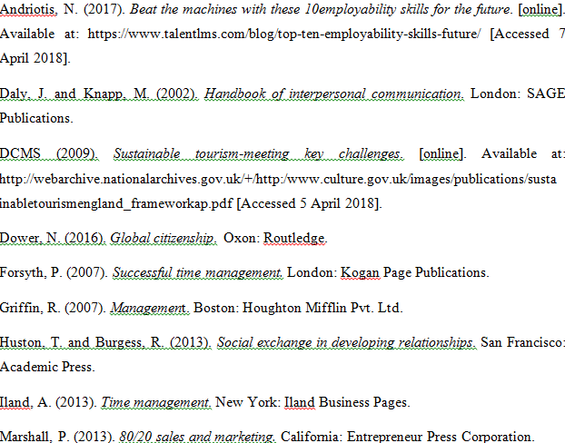

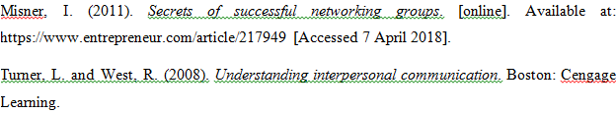
Learning Log
- How did you work together?
Answer: This work was done together. I and my team did research together, analyse relevant data and consult together to prepare the presentation with most valid information.
- Who did what?
In this presentation, I did the introduction, company profile, meaning of global citizen in the part of sustainability and globalisation.
- What went wrong?
In this presentation, the only wrong was lack of understanding of my part but I had overcome that.
- What went well?
The good thing was that I had completed my part successfully in the presentation and my group members were satisfied.
- Did you meet often enough?
Yes, I frequently met with my group members and we together discuss our progress in the presentation.
- Did you use Skype or other online meeting platform?
Yes, I used Whatsapp to communicate with my group members to discuss various issues related to the presentation.
- Did that work well?
The Whatsapp effectively worked well because anywhere and anytime I met with my group members.
- Did you have technical problems in meeting online?
No I had not faced any technical problem in meeting online. I smoothly communicate over online.
- Did some group members refuse to meet online?
No, all members had whatsapp and nobody refused to meet online because it was easier than meeting directly.
- How did you overcome this?
No problem was in meeting online so no issue of overcoming.
- Did someone not pull their weight?
Nobody pull their weight because everybody was serious and committed to the group activities.
- Did you discuss this with them as a group?
Everybody was serious and committed to the group activities so no issue of discussing with them as a group.
- Did you resolve this problem satisfactorily?
There was no problem in the group. So, there was no issue of resolving problem.
- How did you divide the work between you?
First, we had broken down the topics of the presentation and then each member willingly chosen their suitable part in which they were confident enough.
- Was it fairly shared out?
Definitely distribution of work was fair.
- What have you learned by doing this?
I have learnt about the effective participation in the group, interpersonal communication between group members and various aspects of sustainability and globalisation of tourism sector in Welsh.
- Did you enjoy the process?
Yes, I enjoyed each process throughout the presentation.
- Why did you enjoy it?
I enjoyed the work because it was a new experience for me working in a group and brainstorming did properly in this work.
- Did you dislike the process?
No, I did not dislike the process.
- Why did you dislike it?
There was no issue of dislike the process.
- How could it have been improved?
All group members have to be collaborative and provided their best effort for better result.

