
University of Wales Trinity Saint David
School of Engineering

Design for Manufacture and
Assembly: Component
Optimisation
Manufacturing Design & Technology
ACMA5002
Corey Smith
1352007
21 June 2026
Abstract
This project investigated the design and manufacture of a protective phone case for the iPhone 15. The aim was to develop a product that could provide suitable impact protection, securely retain the phone and remain practical for high-volume manufacture at a competitive cost.
A structured design process was used to assess customer requirements, technical performance, material suitability and manufacturing risks. Quality Function Deployment was applied to translate customer needs into engineering requirements, while a design Failure Mode and Effects Analysis was used to identify and evaluate potential product failures. Material selection methods were then used to compare suitable polymers against the mechanical, environmental and manufacturing requirements of the case.
Impact-modified styrene acrylonitrile was selected as the preferred material due to its combination of impact resistance, rigidity, dimensional stability, surface finish and cost. It also provides the required resistance to water, ultraviolet exposure and normal service temperatures without relying on additional protective coatings. Injection moulding was selected as the most suitable manufacturing process because it can produce detailed components with consistent dimensions, short cycle times and low unit costs at high production volumes.
The manufacturing assessment considered the component mass, material usage, production cycle, machine suitability, labour and tooling costs. The results indicated that the machine and tooling would represent the main initial investments, although these costs could be distributed across the proposed production volume to achieve an economically viable cost per case.
Overall, the proposed phone case was considered technically and commercially feasible. Further prototype testing and manufacturing trials would be required to validate the final fit, retention, impact performance and surface quality before production.

Contents
1 Introduction 1
2 Literature Review 3
2.1 Product design requirements 3
2.2 Impact protection and structural analysis 3
2.3 Material selection 3
2.4 Impact-modified SAN 4
2.5 Snap-fit design 4
2.6 Injection moulding and manufacturability 4
2.7 QFD and DFMEA 5
2.8 Cost and sustainability 5
3 Definition of Customer Requirements 6
3.1 QFD 7
3.2 Design Failure Mode and Effects Analysis 9
3.3 Final design and design for manufacture 11
4 Material Selection 12
4.1 Parameters 12
4.2 Toughness 14
4.3 Price 15
4.4 Comparison 17
5 Simulations 17
5.1 Static stress analysis 17
5.1.1 Setup parameters 17
5.1.2 Safety factor 21
5.1.3 Von Mises stress 22
5.2 Injection moulding simulation 23
5.2.1 Material setup 23
5.2.2 Visual defects and warpage 24
5.2.3 Process and time 26
6 Machine selection 26
6.1 Clamping force 26
7 Cost analysis 28
7.1 Machine 28
7.2 Salary 28
7.3 Material 28
7.4 Tooling 29
7.5 Cycle time 29
7.6 Batch time 30
7.7 Time per piece 31
7.7.1 Production rate 31
7.8 Hourly cycle rate 32
7.9 Labour 32
7.10 Equipment cost rate 33
7.11 Work cell 33
7.12 Tooling per piece 34
7.13 Total part cost 35
7.14 Break even 35
8 Conclusion 37
9 References 39
10 Appendices 1
10.1 Appendix A – Quality Function Deployment 1
10.2 Appendix B – Design Failure Mode and Effects Analysis 2

Figures List:
Figure 1 - QFD 7
Figure 2 - DFMEA 9
Figure 3 - Final phone case design 11
Figure 4 - Granta material filters a 12
Figure 5 - Granta material filters b 13
Figure 6 - toughness - remaining polymers 14
Figure 7 - Toughness - all polymers 15
Figure 8 - Price - remaining polymers 16
Figure 9 - Price - all polymers 16
Figure 10 - SAN properties used for stress analysis in Fusion 360 18
Figure 11 - stress simulation - top corner force 19
Figure 12 - stress simulation - side force 20
Figure 13 - stress simulation - bottom inside face force 21
Figure 14 - stress simulation – Safety factor 22
Figure 15 - stress simulation - Von Mises 22
Figure 16 - ABS values used for injection moulding simulation 23
Figure 17 - SAN processing properties from Granta 24
Figure 18 - injection moulding simulation - weld lines 25
Figure 19 - injection moulding simulation – warpage 25
Figure 20 - injection moulding simulation - process and time 26
Figure 21 - phone case - projected area 27
Figure 22 - SAN - material price 29
Figure 23 - Complete Quality Function Deployment matrix for the proposed iPhone 15 phone case 1
Figure 24 - Complete Design Failure Mode and Effects Analysis for the proposed iPhone 15 phone case 2

Tables List:
Table 1 - comparison of SAN, PC and PS 17

Equations List:
Equation 1 - cycle time - from lecture 29
Equation 2 - batch time - from lecture 30
Equation 3 - production time per piece - from lecture 31
Equation 4 - hourly production rate - from lecture 31
Equation 5 - hourly cycle rate - from lecture 32
Equation 6 - labour cost - from lecture 32
Equation 7 - equipment cost - from lecture 33
Equation 8 - cost of work cell - from lecture 34
Equation 9 - tooling cost - from lecture 34
Equation 10 - cost per piece - from lecture 35
Equation 11 – break-even 35
Equation 12 – break-even quantity 36

Introduction
Mobile phones are high-value consumer products that are used frequently and transported through a wide range of environments. Their exposed screens, camera lenses and external surfaces can be vulnerable to scratching, impact damage and deformation during everyday use. Protective cases are therefore commonly used to reduce the likelihood of damage while maintaining access to the functional features of the device. However, an effective phone case must balance protection with usability, appearance, material use, manufacturing cost and suitability for high-volume production.
The purpose of this project is to design and evaluate a protective mobile phone case for the Apple iPhone 15. The case is intended to provide a secure snap-fit around the phone while maintaining access to the charging port, speakers, cameras and control buttons. It must also be capable of being fitted and removed without cracking, permanently deforming or damaging the phone. Particular consideration is therefore required around the corners, openings and retention features, as these areas are likely to experience the greatest stresses during installation and normal use.
Injection moulding has been selected as the proposed manufacturing process because it is suitable for producing polymer components in high volumes with consistent dimensions, repeatable surface quality and relatively low unit costs once production has been established. The phone case must therefore be designed in accordance with Design for Manufacture and Design for Assembly principles. Features including wall thickness, draft angles, radii, undercuts, parting-line position and ejection requirements must be considered to improve manufacturability and simplify production. Potential manufacturing defects, including warpage, air traps, weld lines, incomplete filling, shrinkage and residual stress, must also be considered during the design process.
Impact-modified styrene acrylonitrile (SAN) has been selected as the proposed case material following an assessment using the CES EduPack database. The material provides a combination of rigidity, impact resistance, dimensional stability, surface quality and suitability for injection moulding. Its performance must nevertheless be evaluated against the functional requirements of the design, particularly the deformation required during phone insertion and the stresses generated around the snap-fit features. Material selection must also consider cost, recyclability and environmental impact.
A structured design process will be used to convert customer expectations into measurable engineering requirements. Quality Function Deployment will be applied to establish the relationship between customer needs and technical design characteristics.
The phone case will be developed using three-dimensional computer-aided design. Injection moulding simulation will be used to assess material flow, filling behaviour, cooling and the likelihood of manufacturing defects. Finite element analysis will also be used to evaluate stress and deformation under representative loading conditions. The simulation results will be compared with the identified customer and engineering requirements to determine whether design improvements are necessary.
The project will additionally include material selection, manufacturing process planning, sustainability assessment and detailed cost analysis. Material, machine, labour and tooling costs will be considered to estimate the cost per unit and assess the suitability of the design for high-volume production. The overall objective is to develop a protective phone case that is functional, robust, manufacturable, cost-effective and environmentally responsible.

Literature Review

Product design requirements
When developing a product, customer needs must be converted into measurable engineering requirements while also considering performance, manufacturing and cost. For a phone case, the main requirements are protection, secure retention, access to the controls and openings, acceptable appearance and economical manufacture. Some of these requirements conflict with each other. For example, increasing the wall thickness or retention engagement may improve rigidity and security, but it may also increase the mass, material use and installation force. Product-development literature shows that requirements and design trade-offs should be considered together rather than as separate decisions (Krishnan and Ulrich, 2019).

Impact protection and structural analysis
The protection provided by a phone case depends on the material, the case geometry and the way the phone impacts the ground. Research into mobile-device protection found that impact angle, screen bonding, elastomer grade and protective geometry all affected performance (Hughes et al., 2018). This shows that protection cannot be judged from material strength alone. Features such as the corner shape, raised screen and camera lips, wall thickness and radii are also important. As this research used high-fidelity impact modelling, static stress analysis should only be used to assess stress concentrations during insertion rather than to confirm drop protection (Hughes et al., 2018).

Material selection
Material selection should begin by removing any materials that do not meet the main design requirements. The remaining options can then be compared using objectives such as cost, mass and environmental impact (Ashby, 2017). A thermoplastic used for a phone case must provide suitable toughness, rigidity, dimensional stability, environmental resistance and injection-moulding compatibility. This approach reduces the risk of selecting a material based on only one favourable property and allows candidate materials to be compared using the complete product specification.

Impact-modified SAN
SAN provides good stiffness, dimensional stability, chemical resistance and surface appearance, although standard SAN can be brittle and therefore less suitable for impact applications (Gilbert, 2016; Li and Zhang, 1995). Research has shown that adding dispersed rubber particles can significantly improve the toughness of SAN (Li and Zhang, 1995). The amount of rubber present has also been shown to affect its fracture behaviour (Mazidi, Razavi Aghjeh and Abbasi, 2013). Impact-modified SAN is therefore more suitable than standard SAN for a phone case that will experience snap-fit strain and accidental impacts. Its appearance and chemical resistance also support the use of the material without an additional surface coating.

Snap-fit design
The performance of a snap-fit feature depends on its geometry, bending elasticity and friction. These factors affect assembly, retention and the difference between insertion and removal behaviour (Yoshida and Wada, 2020). Allowable strain, lead-in geometry, radii and interference are also important considerations in polymer snap-fit design (Bonenberger, 2016). Too much interference may cause high installation forces, cracking or permanent deformation, while too little interference may result in poor retention. The retention lip must therefore hold the phone securely without exceeding the strain capability of the material.

Injection moulding and manufacturability
Injection moulding is suitable for producing large numbers of phone cases with integrated retention lips, openings and surface features. Product function, polymer behaviour and mouldability should be considered together during the design process (Malloy, 2010). A relatively uniform wall thickness helps to reduce uneven cooling, shrinkage and warpage. Radii improve material flow and reduce stress concentrations, while draft helps the component to be removed from the mould. Gradual transitions should also be used around openings and retention features. Moulding simulation can then be used to assess filling, pressure, cooling and possible distortion.

QFD and DFMEA
QFD provides a structured method of linking customer requirements to measurable technical characteristics. However, the final priorities depend on the quality of the weightings and relationship judgements used (Chan and Wu, 2002).
DFMEA is then used to identify possible failure modes, their causes, effects and existing controls before manufacture. Conventional risk-priority numbers can produce the same total from different combinations of severity, occurrence and detection (Liu, Liu and Liu, 2013). Engineering judgement must therefore remain important when deciding which improvement actions are required.

Cost and sustainability
The main costs of an injection-moulded component include material, tooling, machine time and labour. Injection-moulding energy use can vary depending on the material, production scale, machine and processing conditions, which makes generic energy values unreliable (Hesser et al., 2016; Nguyen et al., 2024). A durable, single-material case without a secondary coating may reduce material use and additional processing. However, a complete life-cycle assessment would be required before making wider environmental claims.

Definition of Customer Requirements
The phone case will be designed specifically for the iPhone 15 and must provide a secure fit without obstructing the buttons, ports, speakers or camera. Its primary function is to reduce the risk of damage to the phone during accidental drops by absorbing and distributing impact energy, particularly around the corners and raised edges. The selected material must therefore provide a suitable balance of toughness, stiffness and limited flexibility, allowing the case to protect the phone while still being fitted and removed without cracking.
The case must also withstand normal daily use, including repeated handling, minor impacts and contact with other objects when carried in pockets or bags. It should resist scratching, cracking and permanent deformation while maintaining its fit and appearance over time. As the case may be exposed to sunlight and elevated temperatures, the material should have suitable UV resistance and retain its mechanical properties without excessive softening or distortion. It must also resist water and occasional contact with common household liquids or cleaning products. These properties should be provided by the base material itself, without relying on additional protective coatings, as this reduces manufacturing complexity, cost and the risk of coating wear or delamination during use.

QFD
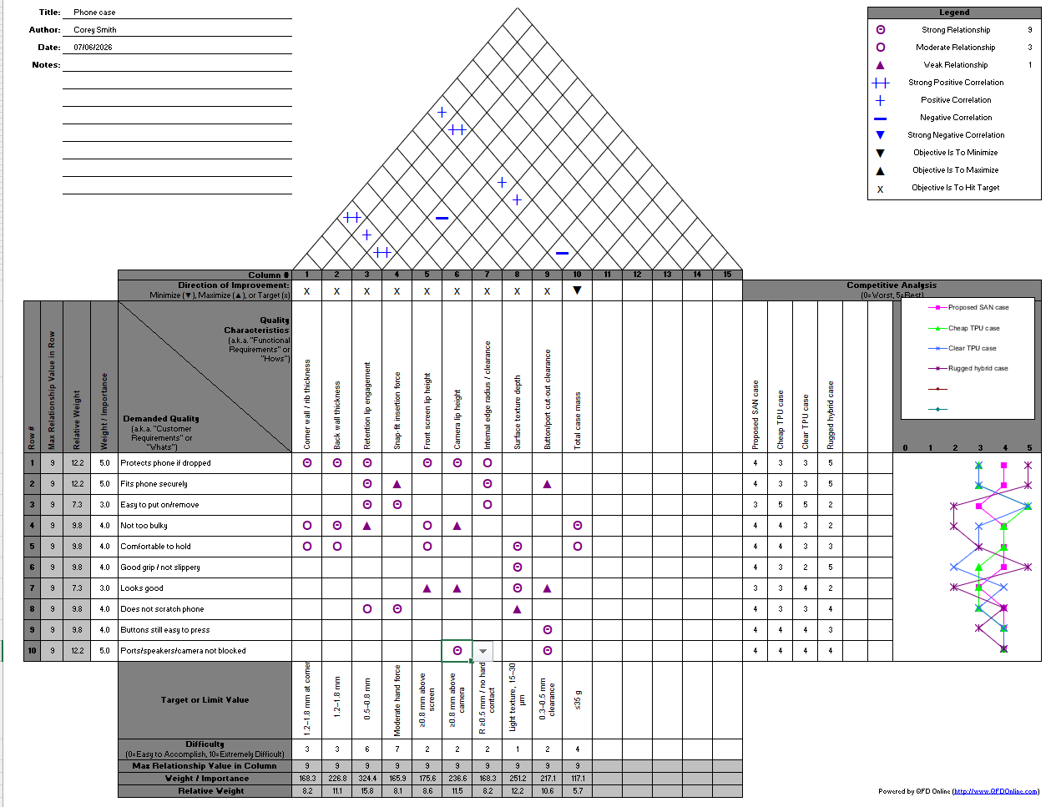
Figure 1 - QFD
The QFD was used to translate customer requirements into measurable technical characteristics for the proposed impact-modified SAN phone case. Customer requirements were weighted according to their importance, with protection when dropped, secure fit and unobstructed ports, speakers and camera receiving the highest ratings. These requirements were prioritised because failure in these areas could either result in damage to the phone or prevent the case from functioning correctly during normal use.
The relationship matrix shows that drop protection is most strongly affected by corner and back-wall thickness, retention-lip engagement and the raised screen and camera lips. Secure fit and ease of installation are mainly influenced by retention-lip engagement, insertion force and internal clearance. Surface texture was identified as the main technical characteristic affecting grip, while button and port cut-out clearance directly affects accessibility. This demonstrates that several technical characteristics influence more than one customer requirement and therefore cannot be considered independently.
The calculated technical priorities show that retention-lip engagement received the highest priority, followed by surface texture depth, camera-lip height and back-wall thickness. Button and port cut-out clearance also received a relatively high priority. Total case mass received the lowest priority because it has fewer strong relationships with the customer requirements. These results indicate that retention, grip, protection and accessibility should receive the greatest attention during design development.
The roof of the House of Quality identifies interactions between technical characteristics. For example, increasing wall thickness can increase both insertion force and total mass, while increasing internal clearance can reduce insertion force. Increasing retention-lip engagement may improve the security of the phone but may also make the case harder to install or remove. These relationships show that improvements to protection and retention must be balanced against ease of assembly, bulk and weight.
The competitive assessment indicates that the proposed SAN case performs consistently across the customer requirements. It offers a more rigid and protective design than the cheaper TPU cases, although the rugged hybrid case performs better in some protection-related areas. The QFD therefore influenced several design decisions, including the use of raised screen and camera lips, increased clearance and radii around the ports, lead-in features to reduce insertion force, a 1.5 mm rear wall and moderate texture on the side surfaces. These features aim to provide suitable protection and retention without making the case excessively heavy, bulky or difficult to use.
The full Quality Function Deployment matrix is provided in Appendix A, Figure 23.

Design Failure Mode and Effects Analysis
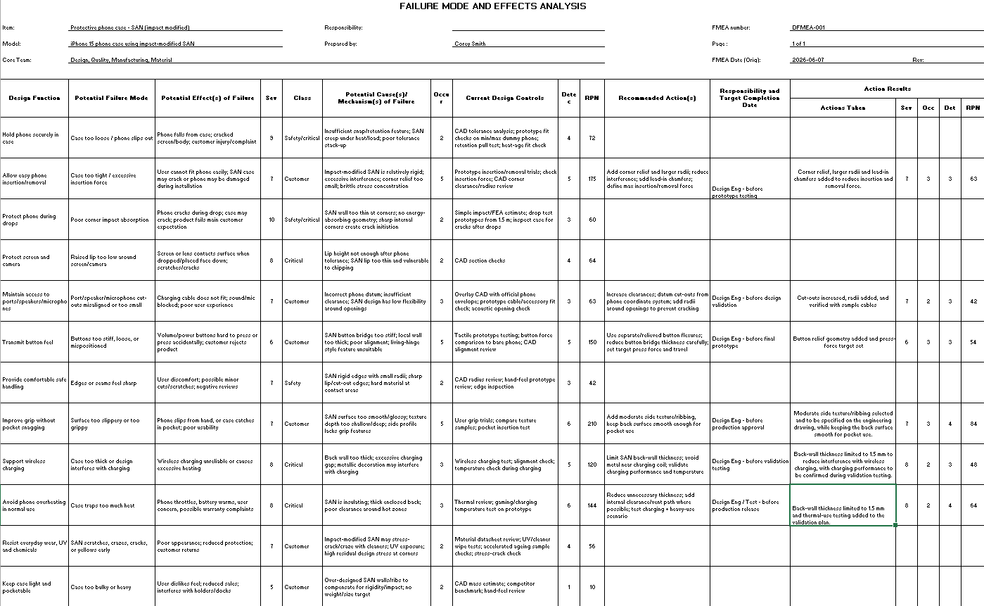
Figure 2 - DFMEA
A Design Failure Mode and Effects Analysis (DFMEA) was completed to identify potential design failures before the phone case progressed towards manufacture. The analysis considered the main functions of the case, including retention of the phone, ease of installation and removal, drop protection, protection of the screen and camera, access to buttons and ports, grip, wireless charging, heat management and resistance to everyday wear.
Each failure mode was assessed using severity, occurrence and detection scores. These were multiplied together to calculate a Risk Priority Number (RPN), allowing the risks to be compared and prioritised. However, severity was also considered separately because a low overall RPN does not necessarily mean that a failure with serious consequences can be ignored.
The highest initial RPN was 210 for the risk of the case being either too slippery or too grippy. A case with insufficient grip could be dropped more easily, while an excessively rough surface could catch inside a pocket and reduce usability. To reduce this risk, moderate texture or ribbing was selected for the side surfaces, while the rear surface would remain smoother for pocket use. This surface requirement would be specified on the engineering drawing. The resulting RPN was reduced to 84.
Excessive insertion and removal force produced the second-highest initial RPN of 175. This was important because impact-modified SAN is more rigid than materials such as TPU, meaning excessive interference could make installation difficult or cause cracking. Corner relief, larger radii and lead-in chamfers were therefore added to reduce the force required while maintaining sufficient retention. These changes reduced the estimated RPN to 63.
Button operation was also identified as a significant risk, with an initial RPN of 150. If the material surrounding the buttons is too thick or stiff, the buttons may become difficult to operate. The button-relief geometry was therefore revised and a target operating force was defined, reducing the RPN to 54. Clearances around the charging port, speakers and microphone were also increased, with radii added around the openings to reduce the risk of interference and cracking.
The DFMEA also influenced the design of the raised lips around the screen and camera, which were included to prevent direct contact with a surface during a drop. Drop protection remains dependent on successful prototype and impact testing.
Wireless charging and overheating produced initial RPNs of 120 and 144 respectively. The rear wall was limited to 1.5 mm to reduce the charging gap and avoid unnecessary insulation. Standard wireless-charging compatibility is intended, rather than full MagSafe compatibility, as no magnetic alignment system is included. Charging-performance and thermal-use testing were added to the validation plan, reducing the estimated residual RPNs to 48 and 64.
Overall, the DFMEA highlighted the balance required between rigidity, retention, insertion force, protection, grip and wall thickness. It directly influenced several design details and identified the validation testing still required before production approval.
The final case remained a single-piece injection-moulded component, avoiding separate fasteners and secondary assembly operations.
The full Design Failure Mode and Effects Analysis is provided in Appendix B, Figure 24.

Final design and design for manufacture
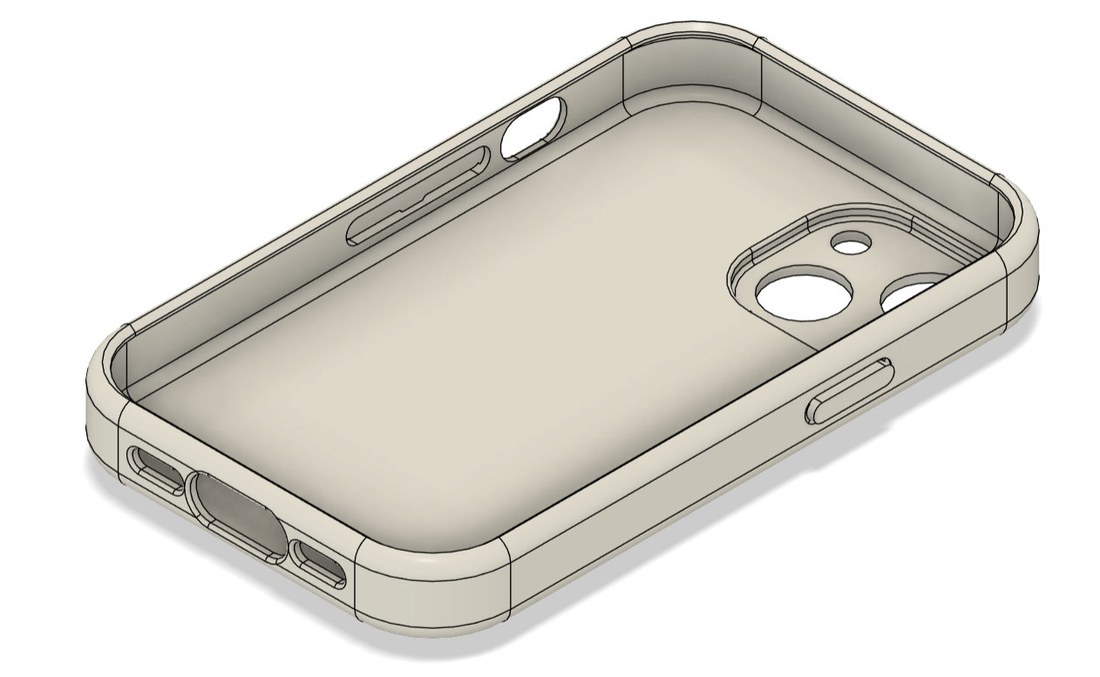
Figure 3 - Final phone case design
Source: Author’s own design using Autodesk Fusion 360.
Figure 3 shows the final single-piece injection-moulded case. It uses a 1.5 mm nominal wall thickness, raised screen and camera lips, radiused openings and integrated retention features. Wall thickness was kept as uniform as practical to reduce shrinkage and warpage. Draft of 1° was applied in the mould-opening direction. The proposed parting line follows the perimeter, with the gate and ejectors positioned on the internal front face. The retention geometry would be checked during tool design to confirm mould release.

Material Selection

Parameters
Granta EduPack (ANSYS, 2022) was used with the selected parameters to narrow down the material choice. Figures 4 and 5 show the filters used to narrow down the material options, from the polymer section. 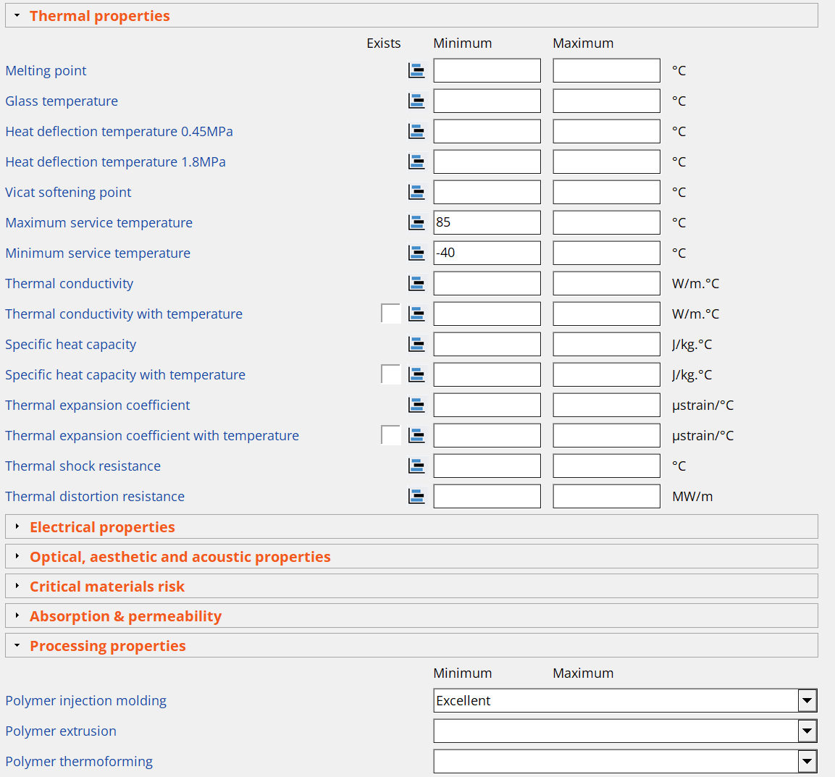
Figure 4 - Granta material filters a
Source: ANSYS Granta EduPack 2022 R2.
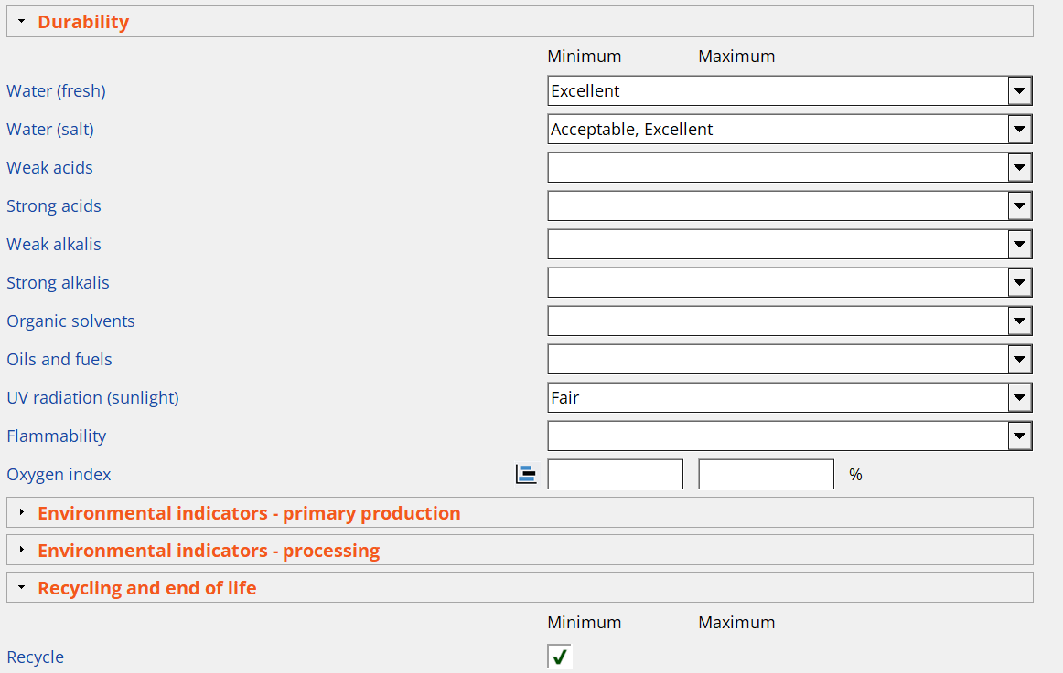
Figure 5 - Granta material filters b
Source: ANSYS Granta EduPack 2022 R2.
The minimum and maximum service temperatures were selected to align with the automotive standard for interior components. Mobile phones are frequently left inside vehicles, so these temperature limits help ensure that the material does not degrade during exposure and continues to perform afterwards, including if the phone is dropped when being removed from the vehicle.
Polymer injection moulding was set to excellent to reduce the risk of deformed parts while also making the mould design slightly easier. This also gives potential to reduce the time per cycle, reduce waste by reducing part defects and reduce complexity.
For durability, fresh water was set to excellent and salt water allowed excellent or acceptable. As most modern phones are either waterproof or water resistant, it would therefore be unacceptable for a protective case to degrade under the same conditions.
Finally, recycling was set to yes. It is important that any material used is recyclable wherever possible. This is even more important when high volumes are produced, to limit the waste going to landfill.

Toughness
The graph below compares toughness for the remaining polymers after the above filters were applied.
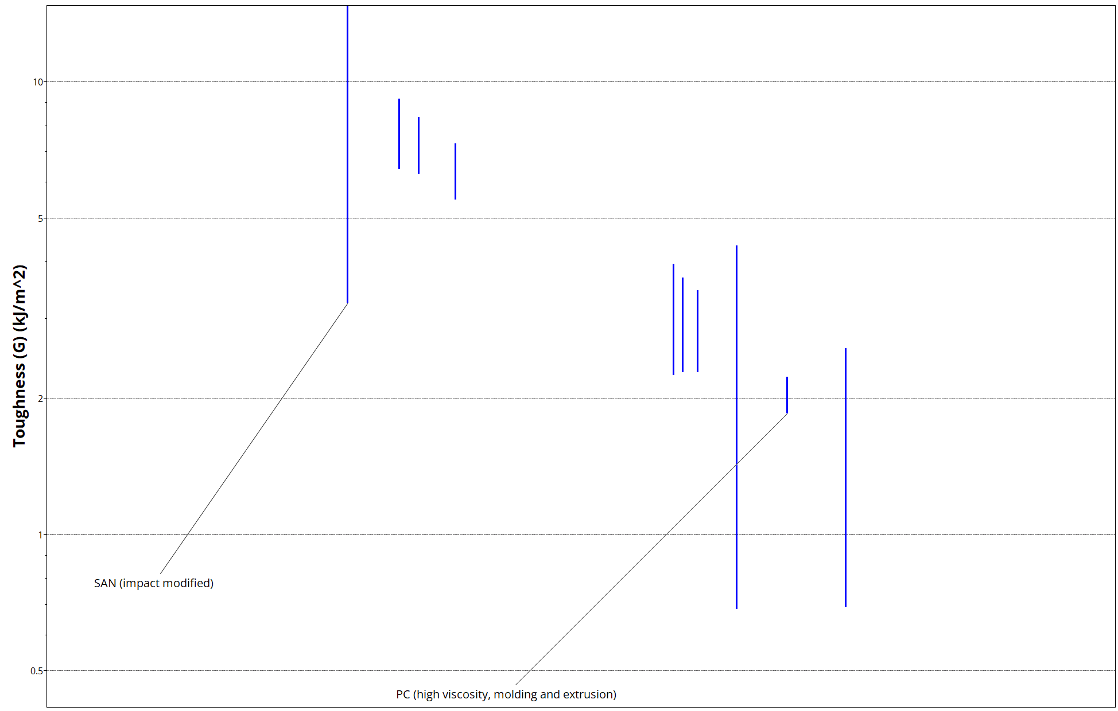
Figure 6 - toughness - remaining polymers
Source: ANSYS Granta EduPack 2022 R2.
SAN (Impact modified) has the highest toughness. Another common material for mobile phone cases that is shown here for comparison is PC, which has a much lower toughness than SAN.
The graph below shows a comparison of toughness for all polymers, with some common ones highlighted. This gives a strong degree of confidence in the toughness of the part as it ranks much higher than other commonly used materials. However, it does not rank as highly as some other plastics or most rubber materials.

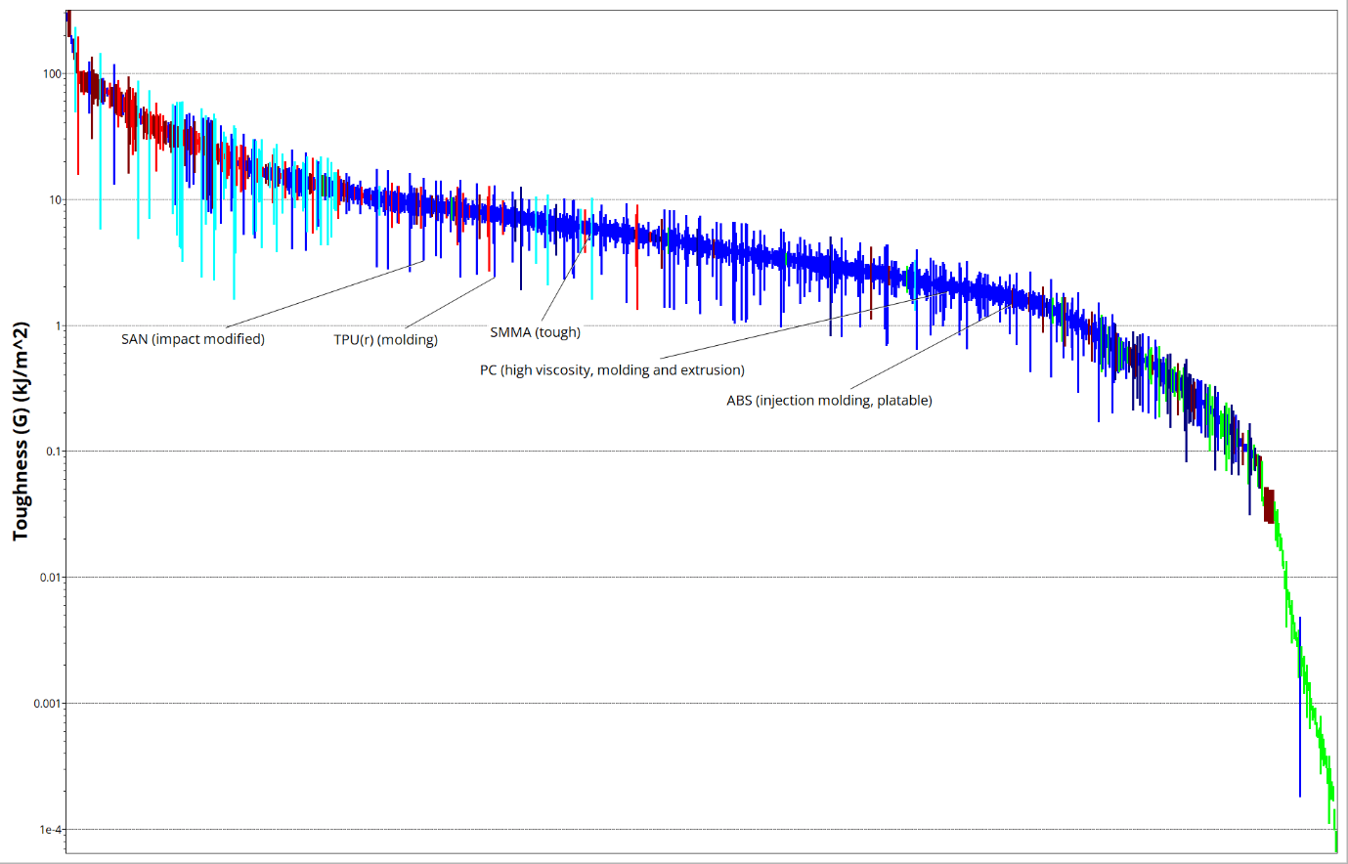
Figure 7 - Toughness - all polymers
Source: ANSYS Granta EduPack 2022 R2.

Price
Price was also considered during material selection. Figure 8 compares the prices of the polymers remaining after the filtering process, while Figure 9 shows the wider comparison across all polymers. Again, there are some common materials highlighted, SAN shows good results, being lower cost per unit volume than the others highlighted, and one of the cheaper plastics or rubbers, but not as cheap as foam.

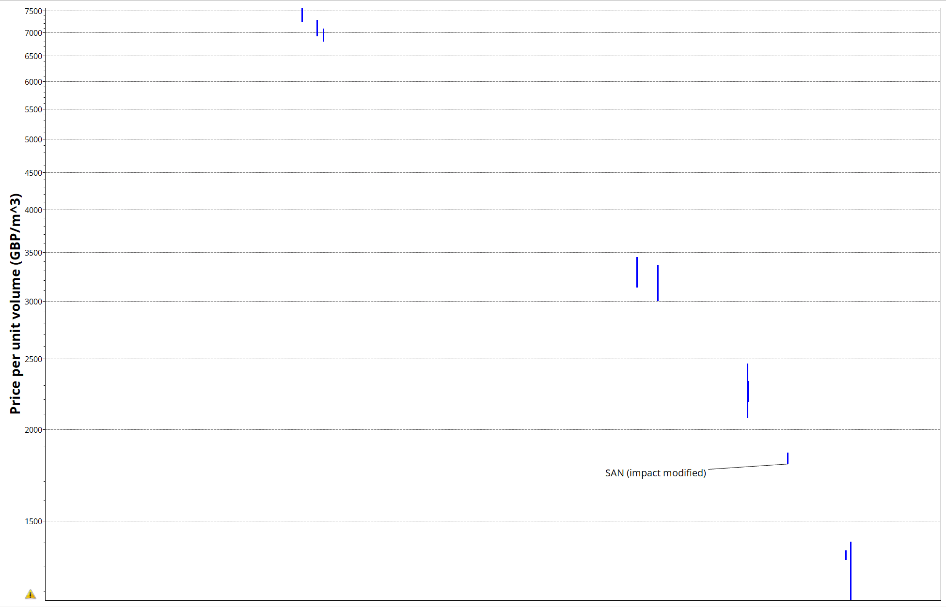
Figure 8 - Price - remaining polymers
Source: ANSYS Granta EduPack 2022 R2.
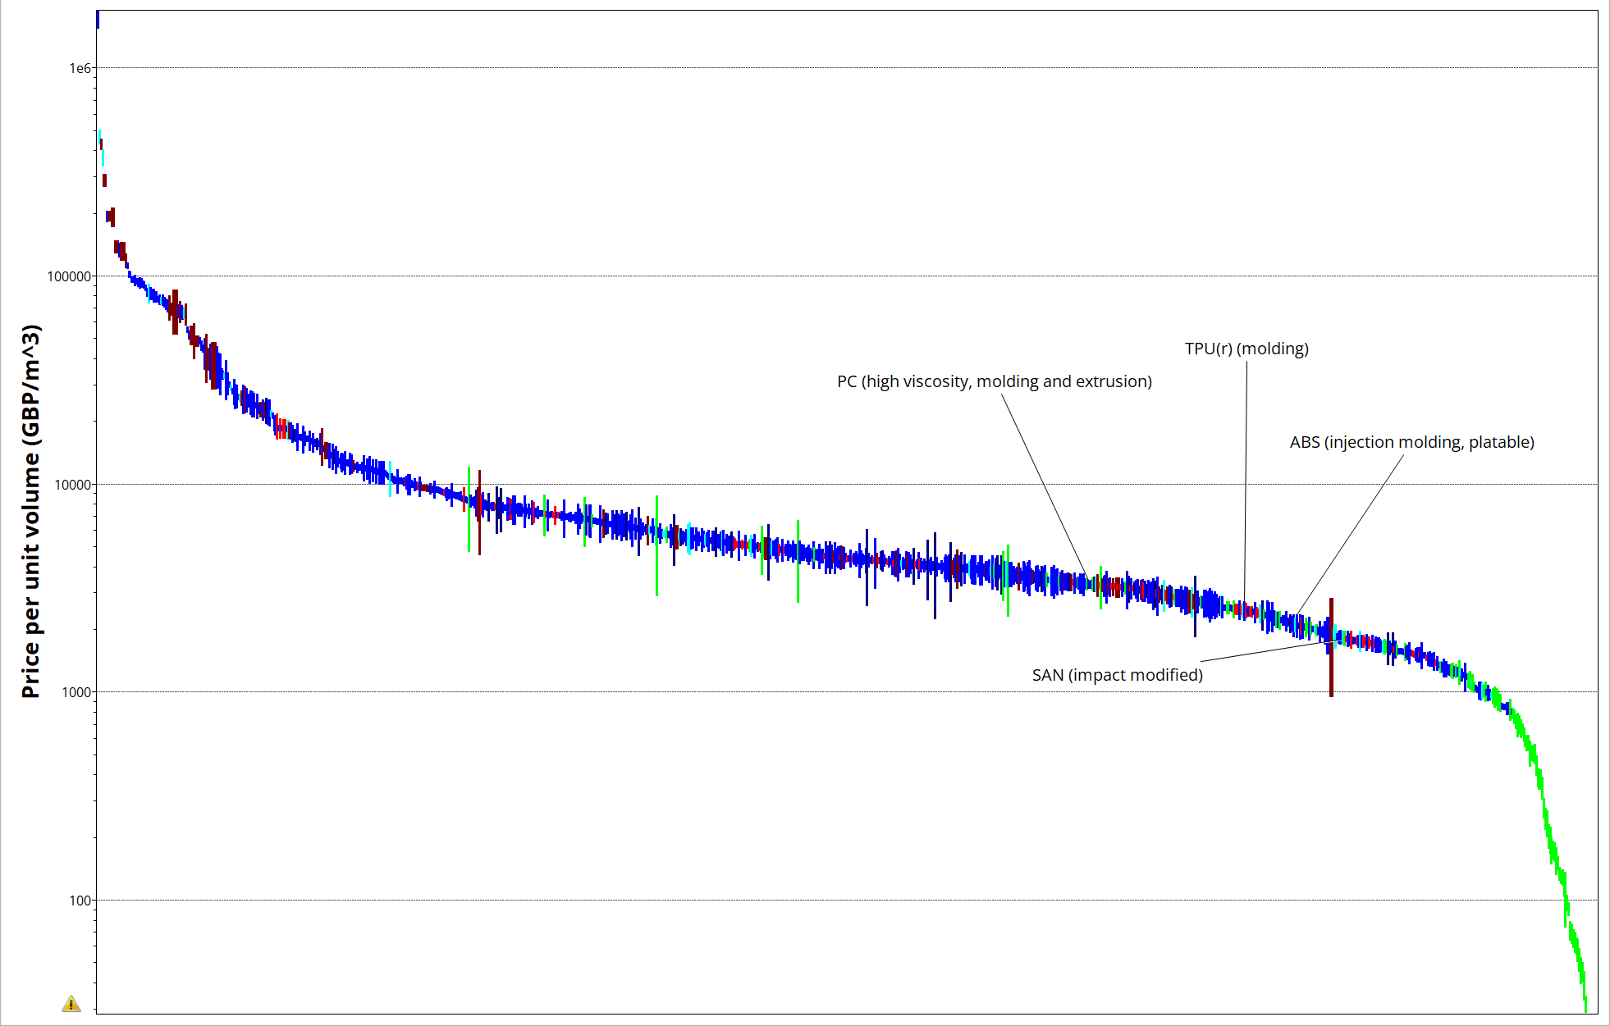
Figure 9 - Price - all polymers
Source: ANSYS Granta EduPack 2022 R2.

Comparison
Table 1 - comparison of SAN, PC and PS
Property | SAN, impact modified | PC, high viscosity | PS, high impact
Price (£/kg) | 1.78–1.80 | 2.63–2.85 | 1.14–1.33
Young’s modulus (GPa) | 2.02–2.12 | 2.32–2.44 | 1.16–2.55
Toughness, G (kJ/m²) | 3.24–14.7 | 1.85–2.23 | 0.683–4.34
Notched impact strength at 23°C (kJ/m²) | 69–79 | 69.7–102 | 7.34–11.6
Source: ANSYS Granta EduPack 2022 R2.
Impact-modified SAN was selected because it provides the highest overall toughness range while remaining less expensive than PC. Although high-impact PS is cheaper, its impact strength is considerably lower. PC provides greater stiffness and potentially higher notched impact strength, but at a significantly higher material cost.

Simulations

Static stress analysis

Setup parameters
The mechanical and physical properties of SAN (Impact modified) from Granta EduPack (ANSYS, 2022). were used to run static stress simulations on the phone case which are shown below.
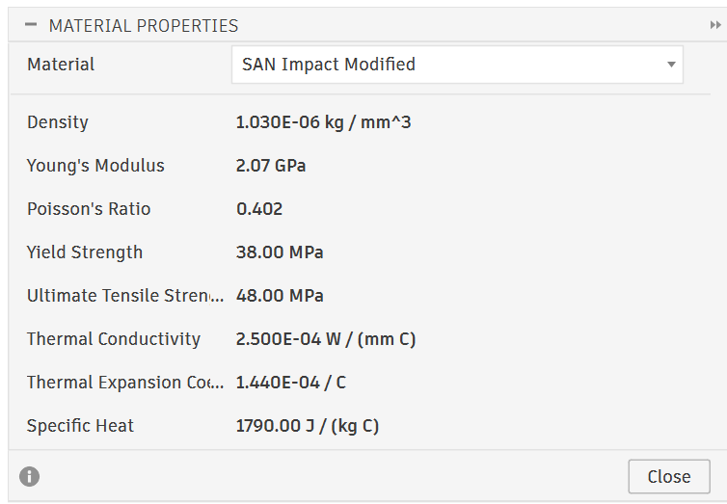
Figure 10 - SAN properties used for stress analysis in Fusion 360
Source: Author’s own simulation using Autodesk Fusion 360.
Figures 11-13 show the setup of the static stress simulation. The bottom face is fixed. Figure 11 shows that there is a force of 20N applied to each top corner, at an angle of 30° in the y axis relative to the normal of the face, this is to represent the phone being pushed in at a slight angle.
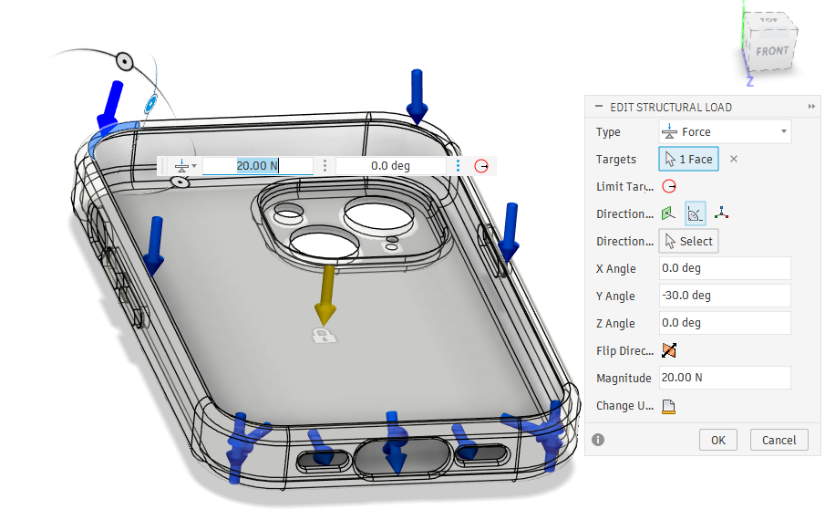
Figure 11 - stress simulation - top corner force
Source: Author’s own simulation using Autodesk Fusion 360.
Figure 12 shows that there is a force of 10N applied to each side at an angle of -40° in the y axis relative to the normal of the face. This is to represent the phone being pushed almost straight down onto the faces.

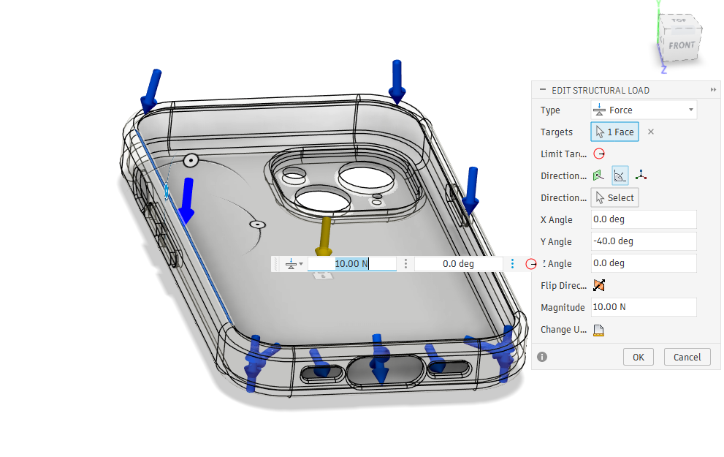
Figure 12 - stress simulation - side force
Source: Author’s own simulation using Autodesk Fusion 360.
Finally, Figure 13 shows that there is a force of 10N applied to the inside bottom faces, this is to represent the bottom of the phone being inserted into the case first, before pushing the rest of the phone to snap into the case.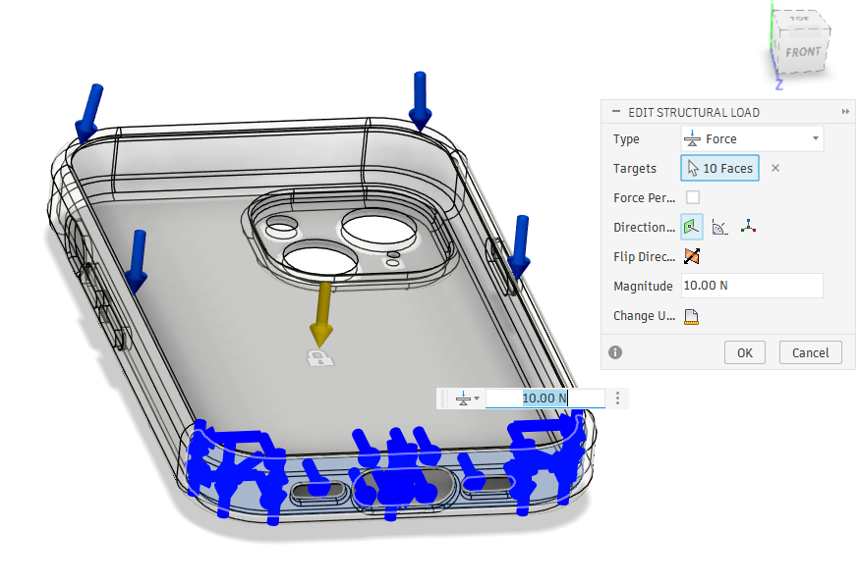
Figure 13 - stress simulation - bottom inside face force
Source: Author’s own simulation using Autodesk Fusion 360.
The applied 20 N and 10 N loads were selected as reasonable preliminary estimates of the forces generated during phone installation. The bottom face was fixed to simplify the analysis, although this may have reduced the predicted displacement compared with actual use as it will cause significant artificial stiffening of the case.

Safety factor
The simulation produced a minimum safety factor of 5.57, indicating that the applied loading remained well below the material yield strength.
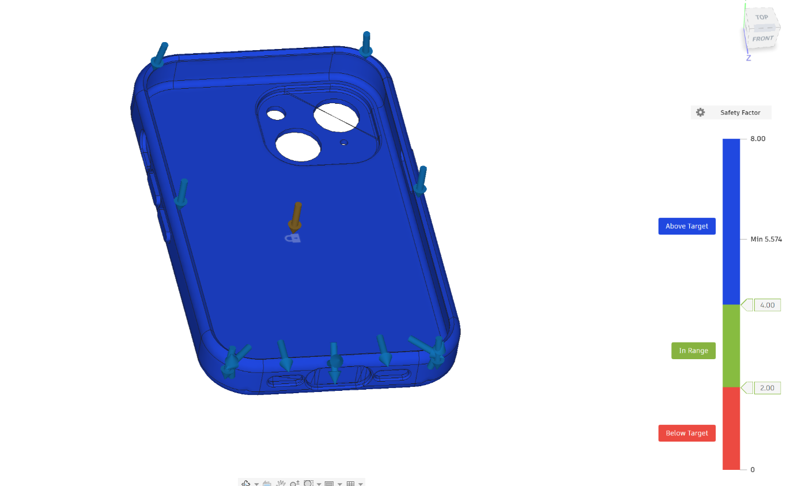
Figure 14 - stress simulation – Safety factor
Source: Author’s own simulation using Autodesk Fusion 360.

Von Mises stress
Figure 15 shows a maximum Von Mises stress of 6.818MPa. Compared wi_{t}h the material yield strength of 38MPa, this confirms the safety factor of 5.57.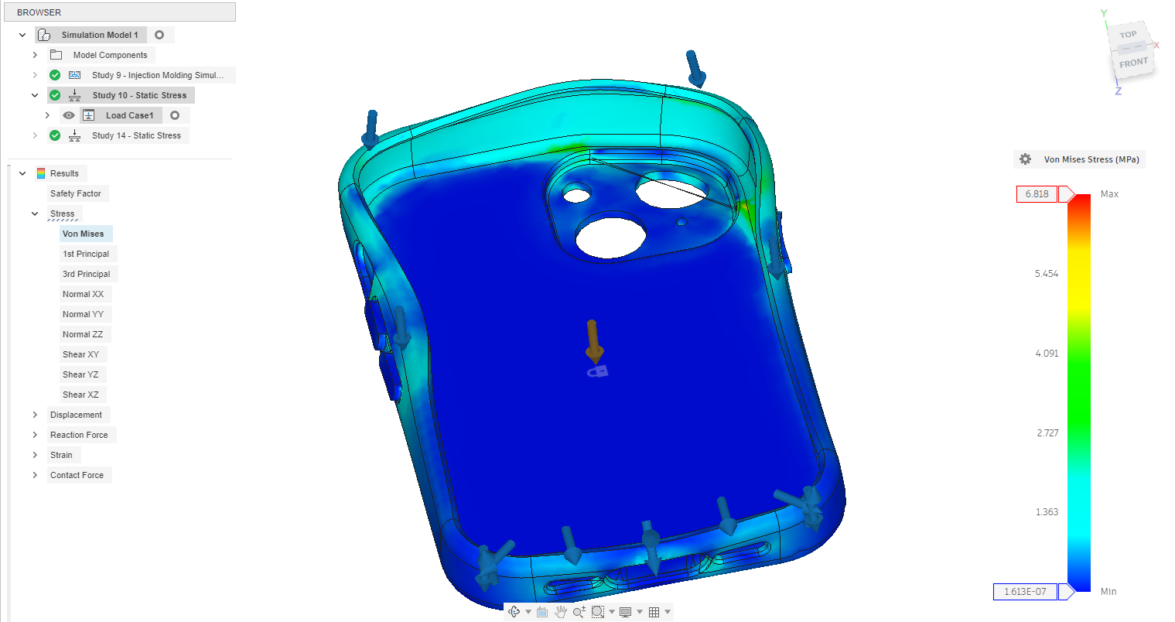
Figure 15 - stress simulation - Von Mises
Source: Author’s own simulation using Autodesk Fusion 360.

Injection moulding simulation

Material setup
Next Fusion 360 was also used to run an injection moulding simulation on the model. Fusion 360 does not permit custom materials to be defined for injection-moulding simulations, although this option is available for static stress analysis. A standard material available within the software was therefore selected. Generic ABS was used as it has similar physical, mechanical and processing properties to the SAN selected.
These are the values of ABS from Fusion, temperatures are given in Kelvin rather than degrees Celsius, to convert to Celsius -273.15.
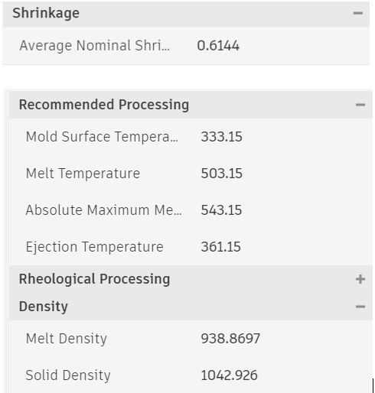
Figure 16 - ABS values used for injection moulding simulation
Source: Autodesk Fusion 360

ABS:
Mold surface temperature: 60°C
Melt Temperature: 230°C
Absolute maximum melt temperature: 270°C
Ejection temperature: 88°C
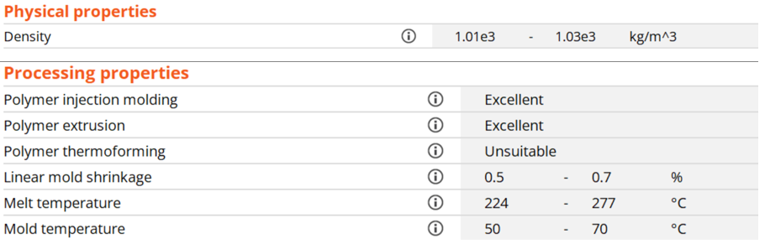
Figure 17 - SAN processing properties from Granta
Source: ANSYS Granta EduPack 2022 R2.
SAN and ABS have similar values of density and mould shrinkage while also being within the range of melt temperature and mould temperature.

Visual defects and warpage
Figure 18 shows the visual defects; there are no sink marks but there are weld lines on 13 of the faces that were marked as aesthetic. They are however, not on large faces such as the back panel, but instead, small weld lines on some radiused edges and around the camera housing. There is potential scope to further reduce these through either minor redesign of the phone case or tweaking of the process settings such as the temperature of the material and the temperature of the mould. 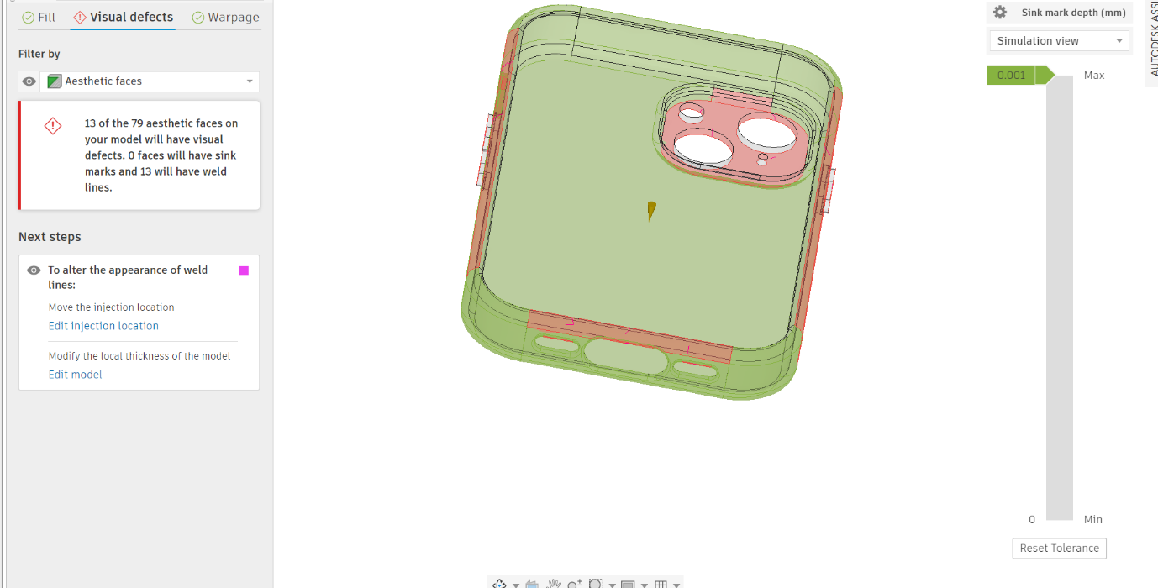
Figure 18 - injection moulding simulation - weld lines
Source: Author’s own simulation using Autodesk Fusion 360.
The maximum predicted warpage was 0.32 mm. This is relatively small compared with the overall dimensions of the case, although physical fit testing would be required to confirm that it does not affect retention.
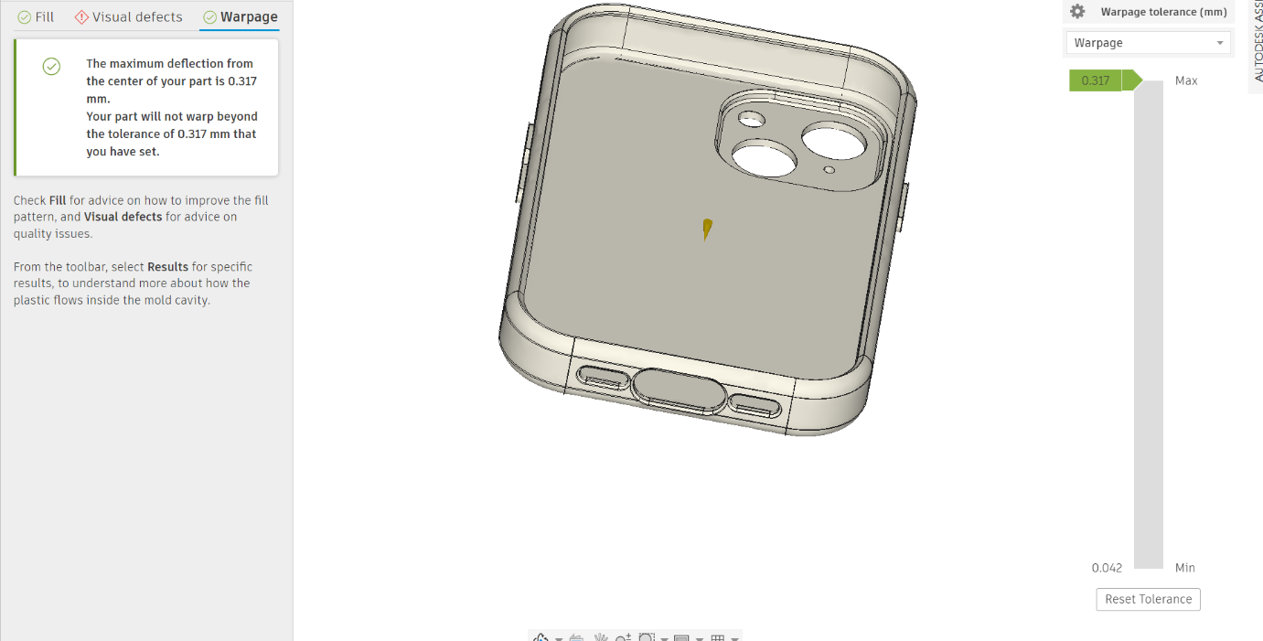
Figure 19 - injection moulding simulation – warpage
Source: Author’s own simulation using Autodesk Fusion 360.

Process and time
Figure 20 shows the injection moulding process, including the time taken for each stage. However, the cooling time of 0.01 s is clearly incorrect, and attempts to resolve this issue were unsuccessful. It was therefore assumed that the total time was correct.
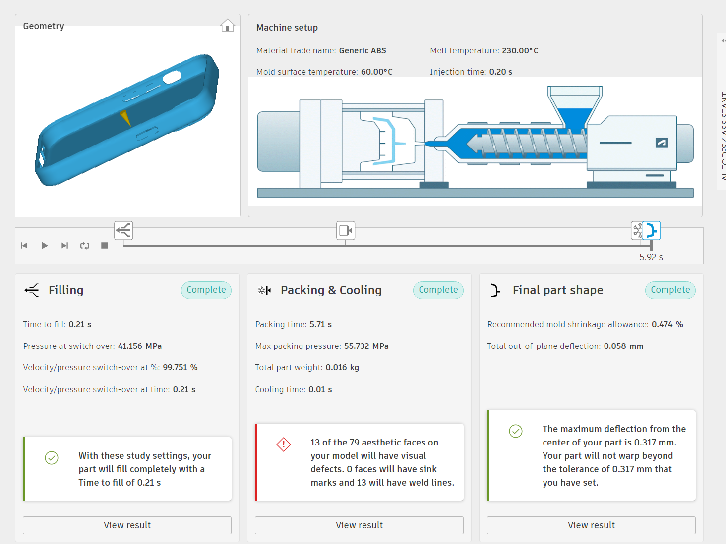
Figure 20 - injection moulding simulation - process and time
Source: Author’s own simulation using Autodesk Fusion 360.

Machine selection

Clamping force
To calculate the required clamping force, the force acting normal to the direction of pull was determined using Force = Pressure × Projected area. The highest pressure value obtained from Fusion was used.
The projected area of the case is 7313.893mm². Assuming a 2-cavity mould, this would bring the area to 14,627.786mm². which is equal to 0.014627786 m².
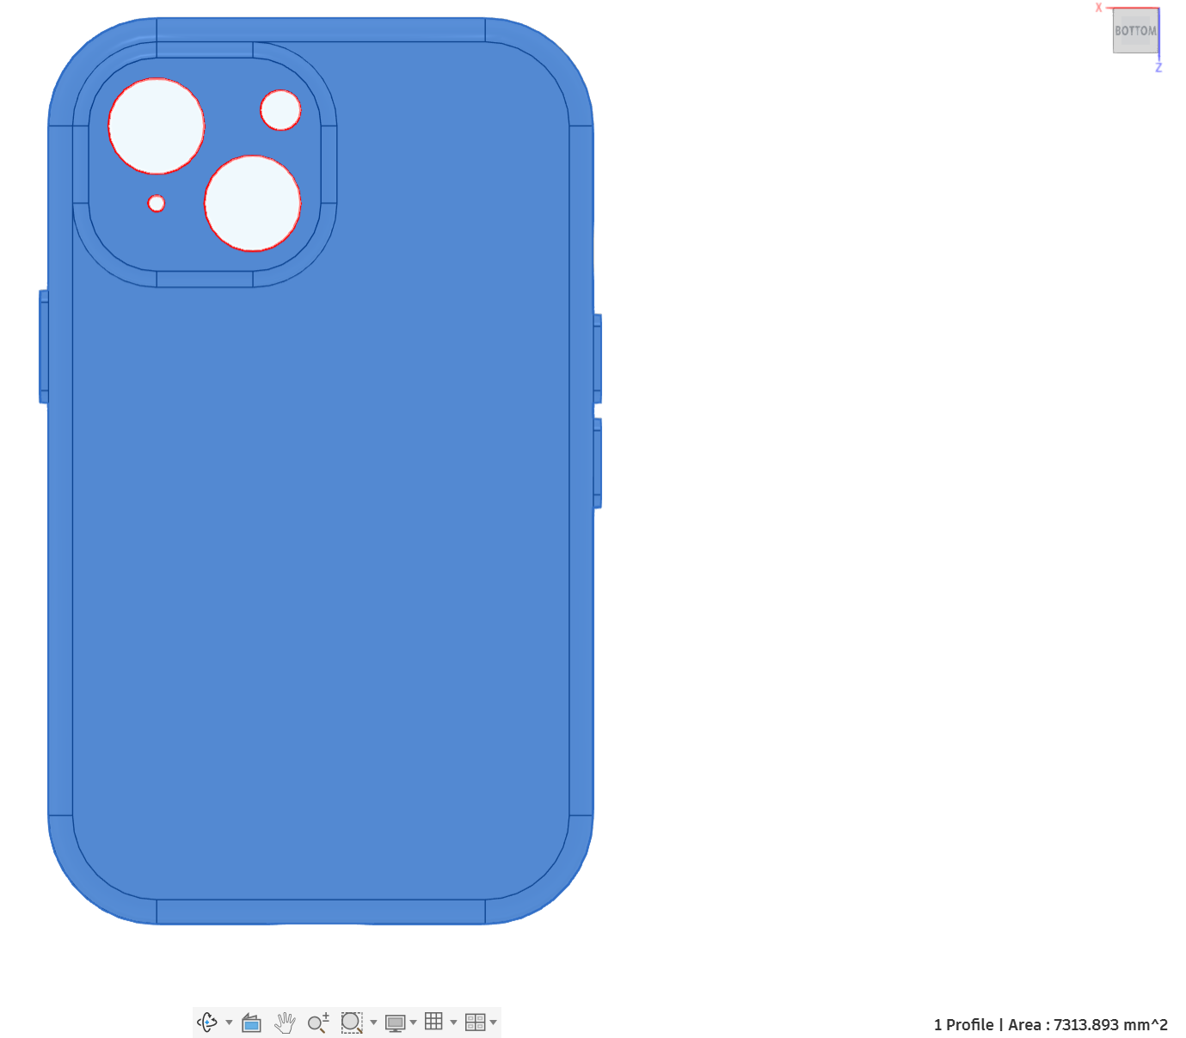
Figure 21 - phone case - projected area
Source: Author’s own simulation using Autodesk Fusion 360.
F = PA
F = 55.732×10⁶×0.014627786
F = 815,169N
F = 815.17kN
Converting kN to tonnes:
815.17/9.81 = 83.1T
A clamping force of 83.1 T is the minimum required. However, it is preferable not to operate the machine consistently at its maximum capacity. Therefore, a 100 T machine was selected to provide additional capacity and potentially extend the machine’s service life by avoiding continuous operation at its limit.

Cost analysis
The production-time and cost equations used in the following calculations were taken from Gabr (2026).

Machine
The price of a 100 T machine can vary significantly, ranging from $15,000 to $40,000 (Daoben Machinery, 2025). For the cost analysis, a total machine purchase and installation cost of £40,000 was assumed with equipment overheads of 20%.
Injection moulding machines typically have a service life of 10–20 years (Topstar, 2024). A service life of 15 years was therefore assumed.

Salary
A typical shift 8-5 with breaks allows for 8 hours of production. Over a year, accounting for weekends and holidays that’s around 253 days (Timetastic, 2024), which gives 2024 hours of production.
Salaries for injection moulding machine operators vary significantly depending on location and experience. Therefore, a representative annual operator salary of £30,000 was assumed based on the advertised salary levels reviewed (Indeed, 2026). This is equivalent to £14.82 per hour based on 2,024 working hours per year with a labour overhead rate of 25%.

Material
Each cycle produces 2 parts as it is a 2 cavity tool, each batch will be 200 cycles to give a total of 400 cases per batch.
The material cost data from Granta EduPack (ANSYS, 2022) puts SAN at £1.80 per kg or 0.0018 per g. The case has a mass of 16g so adding 6g for runner and sprue waste per case gives a total material requirement of 22g per case.
The estimated shot mass is 44g for two cases, including runner and sprue waste. This is below the machine’s rated shot weight of 120g (daobenmachinery, 2025), confirming sufficient capacity. 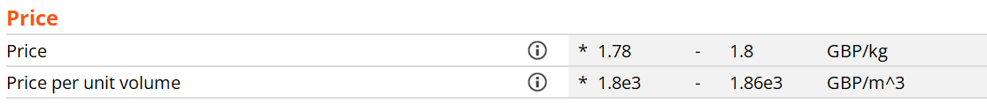
Figure 22 - SAN - material price
Source: ANSYS Granta EduPack 2022 R2.

0.0018 * 22 = £0.0396 or 3.96p per case.

Tooling
Tooling costs can vary significantly depending on the size, number of cavities and complexity. Typical values range from £10,000 for simple single-cavity moulds to £100,000 for larger, more complex multi-cavity tools (Rutland Plastics, 2026). A tooling cost of £20,000 was assumed because the design is relatively simple but uses two cavities. Hardened steel was selected to provide a long service life of approximately 500,000 cycles, which is equivalent to 1,000,000 cases.

Cycle time
The following equation will be used to calculate the total time to produce 1 part.
Equation 1 - cycle time - from lecture
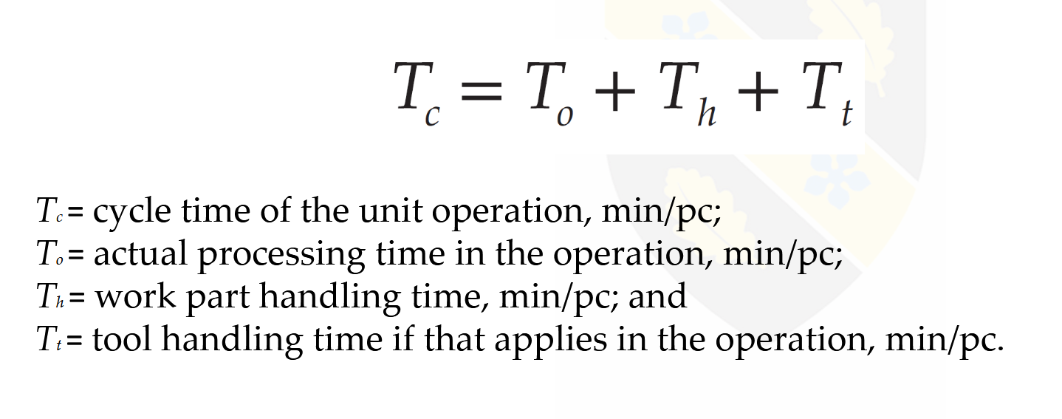
As a rule of thumb, a 100 T machine has a mould operating time of up to 5 s for the mould to open and close, although this is affected by the size of the mould (Custom Plastics, 2024). A mould operating time of 4 s was therefore assumed.

T_{o} = 5.71+0.21 (fill and pack times from Fusion) + 4s (mould operating time) = 9.92s for 2 parts, so 4.96s/pc.
T_{o} = 0.0823min/pc
. Ejection time can range from 0.5 s to 2 s (Custom Plastics, 2024). Therefore, an ejection time of 1 s was assumed. The time required to remove the sprues and carry out a quick visual inspection was assumed to be 5 s for both parts.
T_{h} = 1s(ejection time) + 5s(to remove sprues and visual inspection)
T_{h} = 6s for 2 parts, so 3s/pc
Convert to minutes = 3/60 = 0.05min/pc
No separate tool-handling time was included because no periodic tool adjustment or replacement was required during the production cycle.
T_{t} = 0
T_{c} = 0.0823 + 0.05
T_{c} = 0.1323min/pc

Batch time
Equation 2 - batch time - from lecture
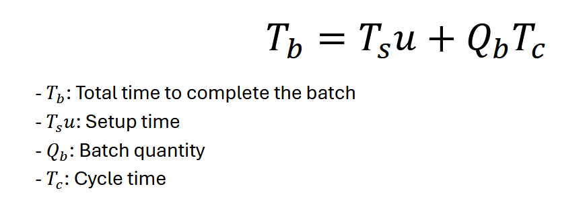
The setup time can consist of screw audit, hot runner audit, mould inspection, water inspection, core review, valve gates and final inspection (MacKenzie, 2023). As it is assumed this will be a dedicated machine for producing phone cases, there will be no changing of the mould for a different product. Different colour material can be used with this same mould to produce different colour phone cases. Given the correct material parameters, a different material could be used with the same mould if desired in the future to either save cost or improve some material parameters such as flexibility or toughness. Setup time is assumed to be 15 minutes, as the mould is already installed in a dedicated machine and only start-up checks, material preparation, purging and first-off inspection are required.
T_{s}u = 15
Q_{b} = 400
T_{c} = 0.1323
T_{b} = 15 + 400 x 0.1323
T_{b} = 15 + 52.92 = 67.92minutes/batch

Time per piece
Equation 3 - production time per piece - from lecture
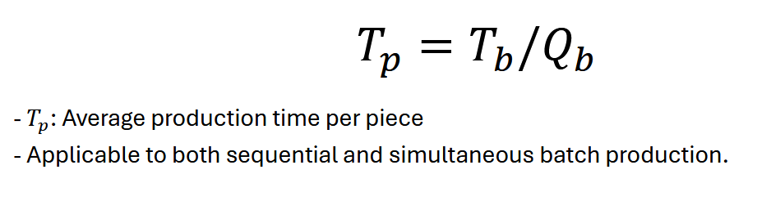
T_{p} = 67.92/400 = 0.1698minutes/pc

Production rate
Equation 4 - hourly production rate - from lecture
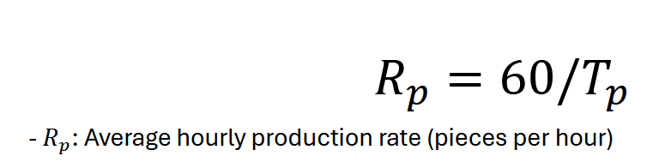
R_{p} = 60/0.1698 = 353.36 pc/hour

Hourly cycle rate
Equation 5 - hourly cycle rate - from lecture
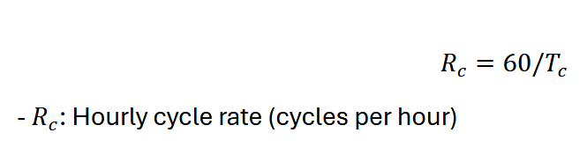
R_{c} = 60/0.1323(T_{c} taken from above is minutes/pc) = 453.51 pc/hour excluding setup time
or
R_{c} = 60/0.2646 = 226.76 cycles/hour

Labour
Equation 6 - labour cost - from lecture
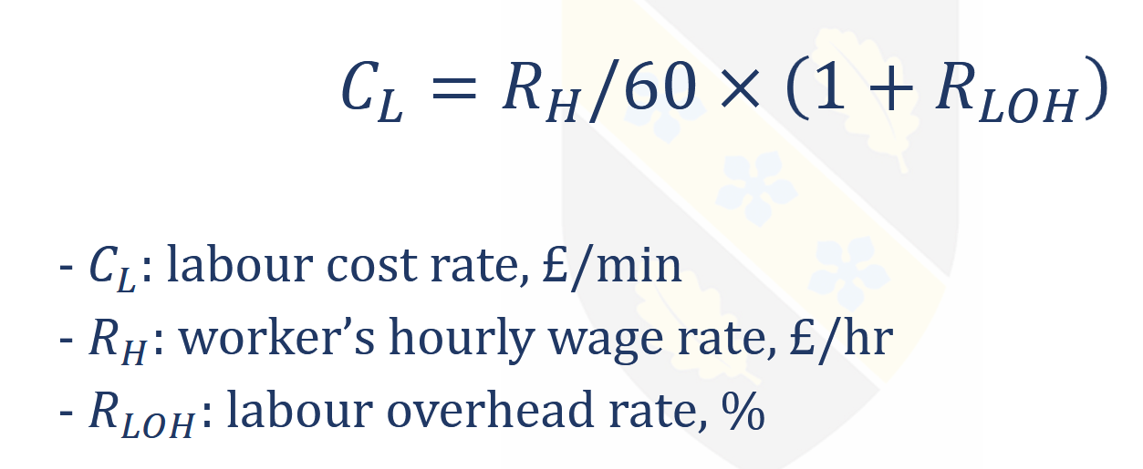
C_{l} = 14.82/60 *(1+0.25)
C_{l} = 0.247 x 1.25
C_{l} = £0.30875/min

Equipment cost rate
Equation 7 - equipment cost - from lecture
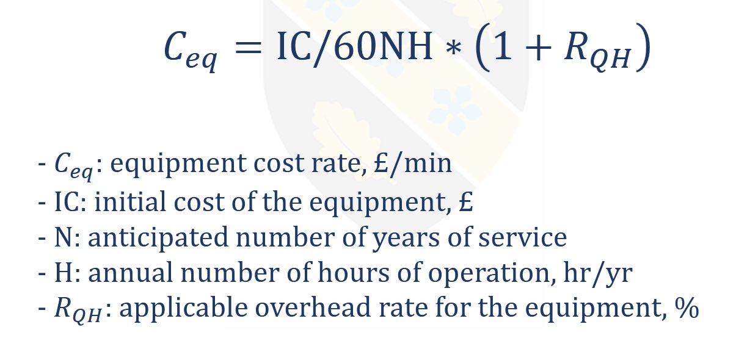
IC = £40,000
N = 15 years
H = 2024 hours/year
R_{QH} = 20% = 0.2
C_{eq} = (40000/(60 x 15 x 2024)) x (1 + 0.2)
C_{eq} = £0.02635/min

Work cell

Equation 8 - cost of work cell - from lecture
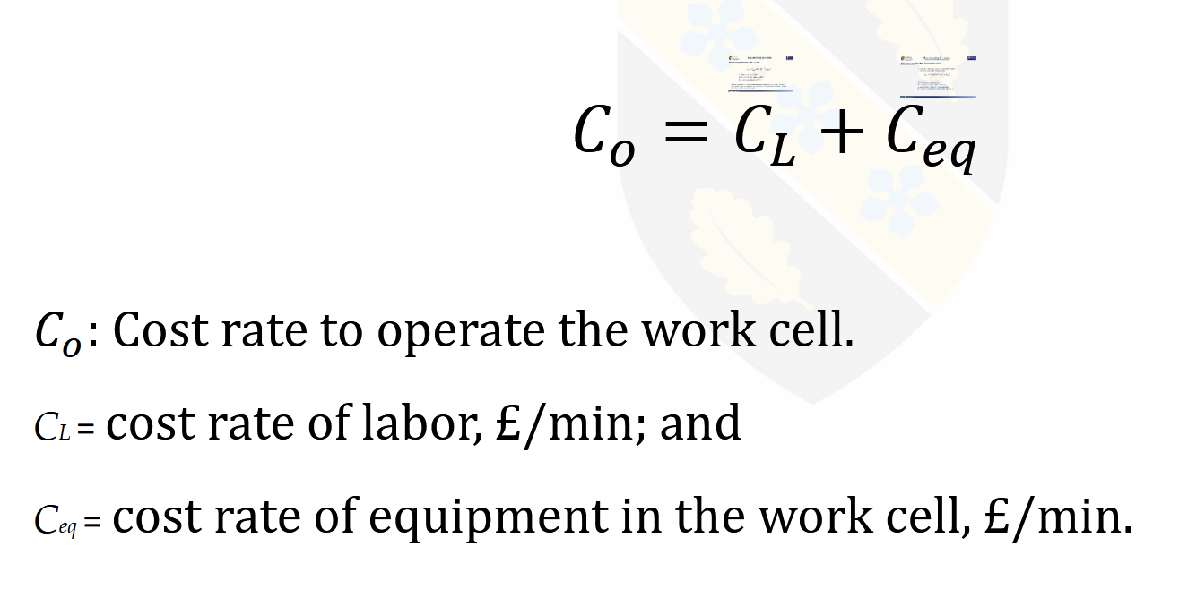

C_{o} = C_{l} + C_{eq}
C_{o} = 0.30875 + 0.02635 = £0.3351/min

Tooling per piece
Equation 9 - tooling cost - from lecture
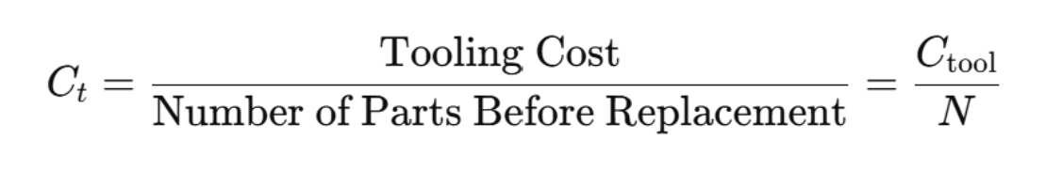
C_{t} = 20000/1000000 = £0.02

Total part cost
Equation 10 - cost per piece - from lecture
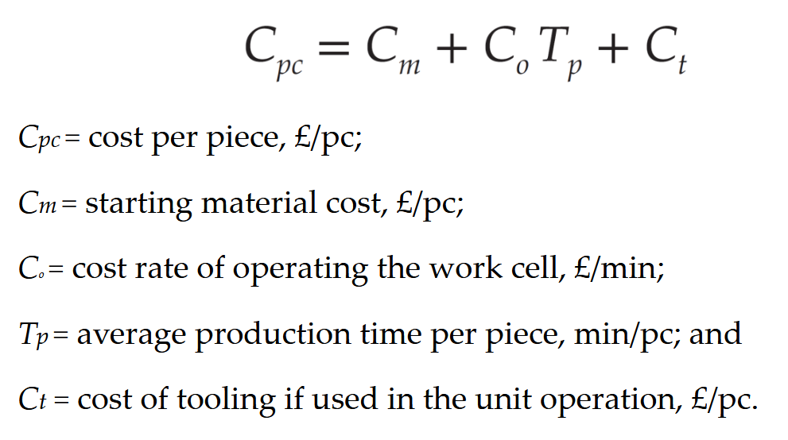
C_{m} = £0.0396/pc
C_{pc} = C_{m} + C_{o}T_{p} + C_{t}
C_{pc} = 0.0396 + (0.3351 x 0.1698) + 0.02
C_{pc} = 0.0396 + 0.0569 + 0.02
C_{pc} = £0.1165/pc

Break even

Equation 11 – break-even
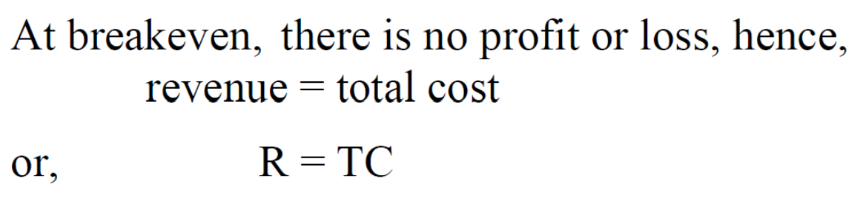
Equation 12 – break-even quantity
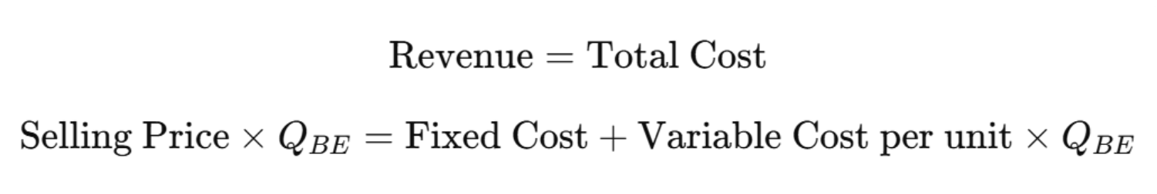
Fixed costs = cost to run the machine + tooling = C_{o} * 60*8*253 + 20,000
Fixed costs = 0.3351*60*8*253 + 20,000
Fixed costs = £60,694.544
Variable cost per unit = material cost = £0.0396
A selling price of £10 was selected following a comparison with other iPhone 15 cases, including a DEFENCE case and screen-protector bundle priced at £14.99 (Currys, 2026) and an Apple silicone MagSafe case priced at £49.00 (Apple, 2024). This positions the product within the lower-cost section of the market while remaining substantially above the estimated manufacturing cost.
Selling price = £10
10 x Q_{BE} = 60694.544+0.0396Q_{BE}
9.9604Q_{BE} = 60694.544
Q_{BE} = 60694.544/9.9604
Q_{BE} = 6093.58 = 6094 cases
It should be noted that this analysis only includes the costs of machinery, tooling, labour and materials. It does not consider costs such as factory and office rent, supporting roles, administration, warehousing, quality control, waste, distribution or marketing. However, it provides guidance for determining the selling price of the product and assessing its viability as a potential new product. In this case, the analysis indicates that the product could be a viable option, particularly for a large company with existing infrastructure and sufficient capital to purchase the machinery and cover labour costs.

Conclusion
This project has demonstrated the systematic development and manufacturing assessment of a protective phone case designed specifically for the iPhone 15. The design process began by identifying the principal customer and product requirements, including protection against impact, secure retention of the phone, unobstructed access to the camera, speakers and charging port, resistance to everyday wear, and suitability for economical mass production. These requirements were then translated into measurable engineering characteristics through the Quality Function Deployment process.
The QFD identified wall and corner thickness, retention-lip engagement, internal clearance, raised screen and camera protection, and surface texture as important characteristics influencing the performance of the case. Particular emphasis was placed on impact protection and secure fit because failure in either area could result in damage to the phone or the case becoming detached during use. The design FMEA provided a further assessment of potential weaknesses, including insufficient impact resistance, cracking, dimensional inaccuracies, poor retention and obstruction of the phone’s features. This allowed the most significant risks to be recognised and reduced through appropriate design controls and verification activities.
Impact-modified styrene acrylonitrile was selected as the proposed material because it provides a suitable balance between rigidity, impact resistance, dimensional stability, surface finish, water resistance and manufacturing cost. The material is also capable of meeting the expected environmental requirements of the product without requiring additional coatings for water, ultraviolet or general surface protection. Its suitability for injection moulding supports the production of a consistent case with the required detail, dimensional accuracy and external appearance.
Injection moulding was selected as the most appropriate manufacturing process because the intended production quantity justifies the initial tooling investment and allows short cycle times, consistent quality and repeatable production. The manufacturing assessment considered material consumption, cycle time, machine requirements, labour, tooling and associated production costs. Although tooling represents a considerable initial expense, this cost is distributed across the production volume, resulting in a relatively low cost per component. The selected machine must provide sufficient clamping force, shot capacity and process control to manufacture the case reliably without unnecessary excess capacity.
Overall, the proposed phone case is considered technically feasible and suitable for high-volume manufacture. The combination of structured design methods, material selection, risk assessment and production-cost analysis provides confidence that the product could meet its intended functional and commercial requirements. Before full production, physical prototypes and injection-moulding trials would be required to confirm fit, insertion force, retention, impact performance, dimensional accuracy and surface quality. The results of these tests could then be used to make final design adjustments and establish the production process parameters.

References
ANSYS, Inc. (2022). Ansys Granta EduPack 2022 R2 [computer software].
Apple (2024). iPhone 15 Silicone Case with MagSafe - Black. [online] Apple (UK). Available at: https://www.apple.com/uk/shop/product/MXPD3ZM/A/iphone-15-silicone-case-with-magsafe-black.
Autodesk, Inc. (2026). Autodesk Fusion 360 [computer software].
Ashby, M. (2017). Materials selection in mechanical design. 5th ed. Amsterdam: Butterworth-Heinemann.
Bonenberger, P.R. (2016). The First Snap-Fit Handbook. Carl Hanser Verlag GmbH & Co. KG eBooks, Hanser Publishers/Hanser Publications, pp.I–XXII. doi:https://doi.org/10.3139/9781569905968.
Chan, L.-K. and Wu, M.-L. (2002). Quality function deployment: A literature review. European Journal of Operational Research, [online] 143(3), pp.463–497. doi:https://doi.org/10.1016/s0377-2217(02)00178-9.
Currys (2026). DEFENCE iPhone 15 Case & Screen Protector Bundle - Clear. [online] Currys.co.uk. Available at: https://www.currys.co.uk/products/defence-iphone-15-case-and-screen-protector-bundle-clear-10255601.html [Accessed 20 Jun. 2026].
Customplastics (2024). Custom Plastics - Understanding Injection Molding Cycle Time. [online] Custom Plastics. Available at: https://customplasticpart.com/2024/12/07/injection-molding-cycle-time/.
daobenmachinery (2025). How Much Does a 100 Ton Injection Moulding Machine Price? [online] Plastic Injection Molding Machine|Plastic Molding Machine|Plastic Injection Machines-DAOBEN. Available at: https://www.daobenmachinery.com/100-ton-injection-moulding-machine-price/ [Accessed 9 Jun. 2026].
Gabr, M. (2026). Cost Calculation and Break-Even Analysis in Manufacturing. ACMA5002 Manufacturing Design and Technology, Lecture 16 [lecture slides]. University of Wales Trinity Saint David.
Gilbert, M. (ed.) (2016). Brydson’s Plastics Materials. 8th ed. Kidlington: Elsevier.
Hesser, F., Mihalic, M., Paichl, B.J. and Wagner, M. (2016). Injection moulding unit process for LCA: Energy intensity of manufacturing different materials at different scales. Journal of Reinforced Plastics and Composites, 36(5), pp.338–346. doi:https://doi.org/10.1177/0731684416674565.
Hughes, K., Vignjevic, R., Corcoran, F., Gulavani, O., De Vuyst, T., Campbell, J. and Djordjevic, N. (2018). Transferring momentum: Novel drop protection concept for mobile devices. International Journal of Impact Engineering, 117, pp.85–101. doi:https://doi.org/10.1016/j.ijimpeng.2018.03.001.
Indeed (2026). Injection Mold Operator salary in United Kingdom. [online] uk.indeed.com. Available at: https://uk.indeed.com/career/injection-mold-operator/salaries.
Krishnan, V. and Ulrich, K.T. (2019). Product Development Decisions: A Review of the Literature. Management Science, [online] 47(1), pp.1–21. doi:https://doi.org/10.1287/mnsc.47.1.1.10668.
Li, S. and Zhang, X.-J. (1995). Toughening mechanism of SAN resin. Journal of Polymer Research, 2(4), pp.239–245. doi:https://doi.org/10.1007/bf01492776.
Liu, H.-C., Liu, L. and Liu, N. (2013). Risk evaluation approaches in failure mode and effects analysis: A literature review. Expert Systems with Applications, 40(2), pp.828–838. doi:https://doi.org/10.1016/j.eswa.2012.08.010.
MacKenzie, G. (2023). Fundamentals of Injection Molding Press Startups. [online] Plastics Today. Available at: https://www.plasticstoday.com/injection-molding/the-troubleshooter-fundamentals-of-injection-molding-press-startups [Accessed 12 Jun. 2026].
Malloy, R.A. (2010). Plastic Part Design for Injection Molding. München: Carl Hanser Verlag GmbH & Co. KG. doi:https://doi.org/10.3139/9783446433748.
Mazidi, M.M., Razavi Aghjeh, M.K. and Abbasi, F. (2013). Unstable Fracture Behavior of Rubber Toughened Poly(Styrene-co-Acrylonitrile). Journal of Macromolecular Science, Part B, 52(8), pp.1158–1182. doi:https://doi.org/10.1080/00222348.2012.756325.
Nguyen, D.T., Yu, E., Barry, C. and Chen, W.-T. (2024). Energy consumption variability in life cycle assessments of injection molding processes: A critical review and future outlooks. Journal of Cleaner Production, [online] 452, p.142229. doi:https://doi.org/10.1016/j.jclepro.2024.142229.
RutlandPlastics (2026). How Much Does Injection Moulding Cost in the UK? [online] Rutland Plastics. Available at: https://www.rutlandplastics.co.uk/how-much-does-injection-moulding-cost-in-the-uk/ [Accessed 9 Jun. 2026].
Timetastic (2024). How many working days are in a year? [online] Timetastic - A blog about taking and managing time off work. Available at: https://timetastic.co.uk/blog/how-many-working-days-are-in-a-year/.
Topstar (2024). How long is the service life of injection molding machines? - TopStar. [online] TopStar. Available at: https://www.topstarmachine.com/how-long-is-the-service-life-of-injection-molding-machines/ [Accessed 9 Jun. 2026].
Yoshida, K. and Wada, H. (2020). Mechanics of a Snap Fit. Physical Review Letters, 125(19). doi:https://doi.org/10.1103/physrevlett.125.194301.

Appendices

Appendix A – Quality Function Deployment
Appendix A presents the complete Quality Function Deployment matrix used to translate customer requirements into measurable technical characteristics.
Figure 23 - Complete Quality Function Deployment matrix for the proposed iPhone 15 phone case

Appendix B – Design Failure Mode and Effects Analysis
Appendix B presents the complete Design Failure Mode and Effects Analysis used to identify and assess potential design failure modes.
Figure 24 - Complete Design Failure Mode and Effects Analysis for the proposed iPhone 15 phone case

