The Effectiveness of CBT for Social Anxiety in Autism Spectrum Disorder: A Systematic Review.

Jonathan Butterworth

Abstract
As many as 50% of adults with autism spectrum disorder also suffer with social anxiety, which leads to more anxiety and a poor quality of life. There is a need to find effective counselling strategies to alleviate this anxiety and therefore enable greater social interaction.
Method. A search of the library as University Of Wales Trinity Saint David was performed to draw together the most recent, available research data on the subject of new counselling methods for social anxiety in autism, in order to assess accessibility and efficacy. The results of that search are contained in this systematic review.
Conclusion. More research is required into this subject, and the best methods, data gathering and strategy implementation for that research need to be agreed upon and followed by all who undertake future studies.

- Introduction
The aim of this systematic review is to discover and compare the results of research that has been conducted with regard to new and/or innovative counselling techniques that can be used for the treatment of social anxiety, particularly as it manifests in adults who have been previously diagnosed with autism spectrum disorder (ASD). There is significant prevalence of the comorbidity of these two conditions (Spain et al. 2018) and that deems it relevant to review what therapies are available (along with their respective rates of success). It is also relevant to look specifically at interventions that are targeted at the adult population. The number of new diagnoses of ASD in UK has increased exponentially since 1998 (Russell et al. 2021) and a recent study by O’Nions et al. (2023) has shown that a significant proportion of the adult population are either diagnosed later in life, or even remain without a clinical diagnosis of the condition, which indicates the necessity to provide counselling interventions that are specifically targeted at adults. The following systematic review will scrutinise and critique the available, recently published literature on the subject, highlight any shortcomings and make recommendations for future research.

- Selection criteria
All articles for the review were selected from and limited to the library of University Of Wales Trinity Saint David. The initial search was an attempt to isolate a particular, contemporary form of counselling, Acceptance Commitment Therapy (ACT), however There was a completely absence of available literature on that specific subject when used as an intervention for adults with comorbid social anxiety and autism spectrum disorder. There was a similar lack of results when other modern forms of therapy such as mindfulness-based therapy or dialectical therapy. Searches for any of those forms of counselling in the title of the work, when combined with search terms for autism returned no results. The search was rephrased several times to no avail. The search criteria were then broadened to a title search of, ‘cognitive behavioural therapy OR CBT for adults with social anxiety and autism spectrum disorder,’ which initially returned 1 result. Wildcards were used wherever possible in this search and for all subsequent searches to maximise results. The exact search is shown in table 1.

Table 1
Search Criteria
 | Title contains | CBT OR Cognitive behaviour* therapy
AND | Title contains | “Social anxiety”
AND | Title contains | Autis*
AND | Title contains | Adult*

It was noted after advice from the librarian, that the system sometimes “gets confused” if too many wildcards are used at one time so experimental searches were performed both with and without wildcards to confirm that their use was not falsely limiting results. The order of the words in the search criteria was also changed several times to discover if that also had an effect on search results.
Further searches broadened the search criteria from ‘Title’ to ‘Any field’ which returned 50 results. These results were then used as a starting point to focus the available literature to more relevant results. Filters were added to limit the date range to literature published between 2017 and 2023, and review articles were excluded. Both of these filters were added from the left column of the library search page. These filters reduced the results returned to 30. The final search, including filters, is shown in screenshot 1 below.
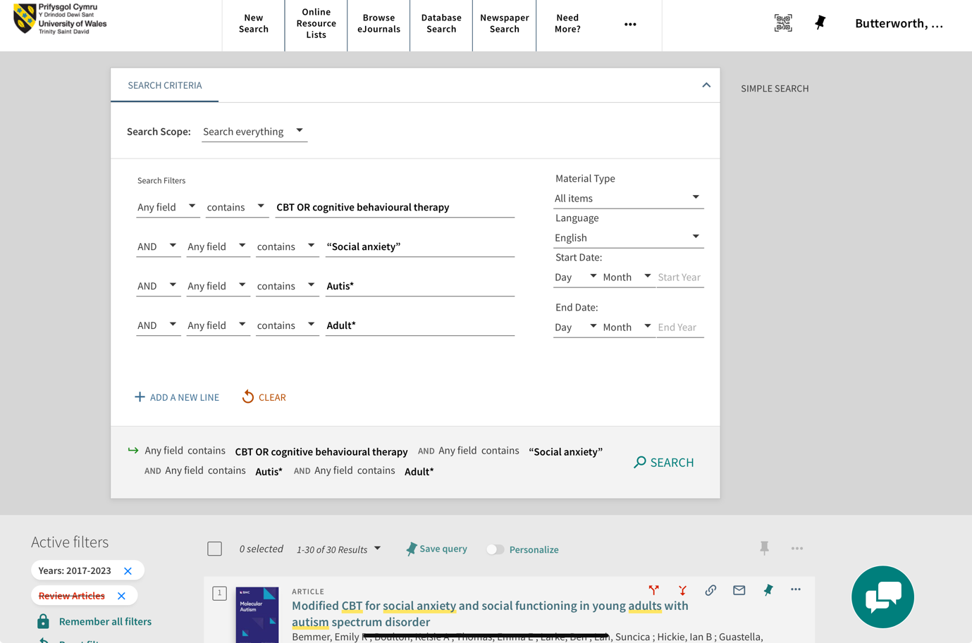
Screenshot 1

Several attempts were made to add further filters in order to exclude irrelevant results, such as only including articles related to psychology and excluding articles that included the word ‘children’ in the title, but on each occasion articles which the author considered would be relevant to the final review were then removed from the search results. At that stage the decision was taken to manually search the 30 results to find only articles which specifically pertained to treatment for adults. It was necessary during this process to broaden the term ‘adult’ to include ‘young adult’ in order to assemble a reasonable number of articles which were relevant to the basic research criteria for this review.
6 articles were then selected for their pertinence, with 1 being subsequently excluded after reading, as it was discovered that the research participants were a group of professionals (counsellors, psychologists and psychiatrists) and the subject of that research was an enquiry into different potential interventions for the demographic previously mentioned but did not contain first person research with the target group. It was therefore deemed unsuitable in terms of this review. It was however retained for reference in the discussion below. The 5 remaining studies were then scrutinised for the robustness of their methods and their results were then synthesised. The studies included in this review are shown in table 2.

Table 2
Group cognitive behaviour therapy (CBT) for social interaction anxiety in adults with autism spectrum disorder (Spain, Blainey & Vaillancourt, 2017).
An Internet Based Intervention for Adults with Autism Spectrum Disorder – A Qualitative study of Participants Experiences (Westerberg et al. 2021).
Modular Cognitive-Behavioral Therapy for a Young Adult With Autism Spectrum Disorder, Comorbid Obsessive Compulsive Disorder, and Social Anxiety Disorder (Ordaz, Lewin & Storch, 2018).
Cognitive Behaviour Therapy Versus a Counselling Intervention for Anxiety in Young People with High-Functioning Autism Spectrum Disorders: A Pilot Randomised Controlled Trial (Murphy et al. 2017)
Modified CBT for social anxiety and social functioning in young adults with autism spectrum disorder (Bemmer et al. 2021).

- Quality assessment
All studies chosen for this review were shown to be methodologically sound. Results were reported against accepted and established clinical scales (although different scales were used for each review, making it difficult to compare results directly. Funding for all the studies was provided either by national or local governments, or state-run health service providers. There was a combination of quantitative and qualitative data analysis provided across the collection of studies. Table 3 below shows a summary of the main elements of the studies.
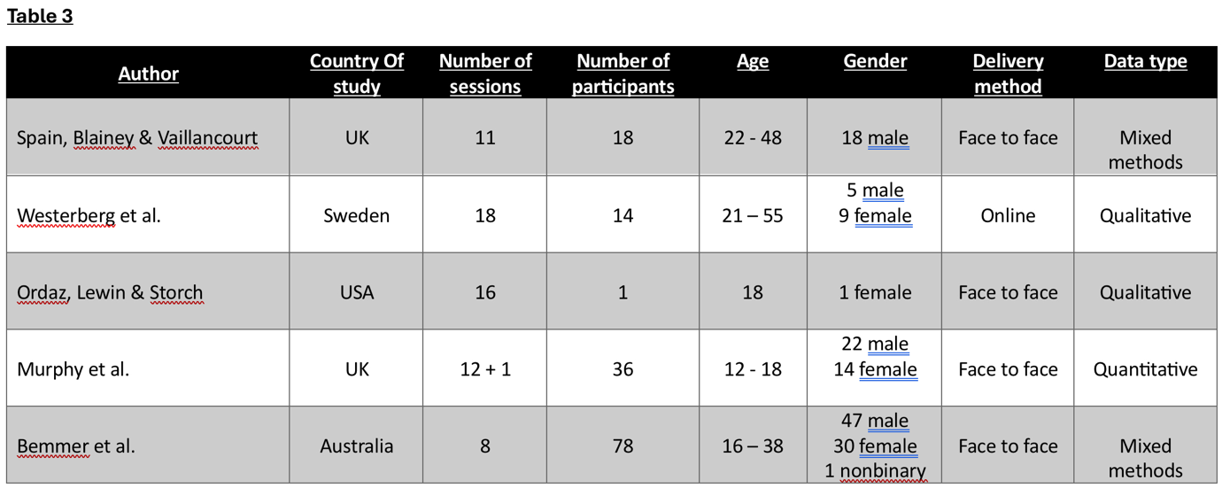

- Overview of studies
4.1 The first study was titled Group cognitive behaviour therapy (CBT) for social interaction anxiety in adults with autism spectrum disorder (ASD) (Spain, Blainey & Vaillancourt, 2017). The study was conducted in England and published in the Journal of Research in Autism Spectrum Disorders. The study initially involved 18 participants aged between 22 and 48 years of age, with 2 people dropping out after the first session. It was a non-randomised, single arm trial of a novel group therapy approach to social anxiety in adults with ASD. All participants had been diagnosed with ASD without cognitive impairment and were recruited from UK Adult Autism Psychological Therapies Service (AAPTS). All participants were male. Results were taken by means of a self-assessment questionnaire completed before commencement and after completion of the course, and results were judged on two scales; the Leibowitz Social Anxiety Scale (LSAS) (Liebowitz, 1987) and the Hospital Anxiety and Depression Scale (Zigmond, 1983; Stern, 2014 ).
The study itself consisted of 11 sessions of CBT informed group therapy, delivered weekly. Each session lasted 2 hours. The study was piloted on three occasions between 2013 and 2016. There were five participants in each of the first two sets of sessions and eight people in the third set. Each session was presented on a specific topic, with the more complex subjects being presented over 2 sessions. The subject areas covered began with an overview of social skills and the concepts of CBT, then moved onto an assessment of communication strengths and difficulties, types of relationships, conversation skills, non-verbal communication, emotional awareness of self and others, social vulnerability and assertiveness. A session on goal setting was highlighted by the authors as being particularly challenging, along with a hypothesis that the challenge was experienced by the participants either because of a difficulty with abstract concepts inherent with ASD, a tendency towards perseveration or anxiety around change.
The study states that the framework for the intervention was developed from a similar set of CBT strategies that had shown to have positive results when delivered to young people with comorbid ASD and SA. All the sessions were built around analysis of the cognitive triangle, that is how thoughts affect emotions and in turn influence behaviour (e.g. Ariatabar, Khoeini & Asadzadeh, 2022). It was noted in the findings that some changes to the structure might be beneficial, however the format of the programme was kept the same on each of the 3 occasions it was run in order to regularise the collected data. The data was as mentioned earlier, collected by means of self-assessment questionnaires. The study authors had noted that they were mindful that the efficacy of self-assessment measures when used by people with ASD had been subject to debate (Lecavalier et al. 2014), nevertheless it was deemed suitable in this instance because the participants were familiar with using this form of assessment and were also familiar with the layout of the questionnaires. A p value of <0.05 was considered statistically significant for the study, and the final reported value was p= <0.01, which made this an extremely successful intervention.

4.2 The second study included in this systematic review was An Internet Based Intervention for Adults with Autism Spectrum Disorder – A Qualitative study of Participants Experiences (Westerberg et al. 2021). This study was conducted in Sweden. The method used was a randomised control trial with 14 participants, who were chosen from a previous randomised control trial involving 42 people. The participants were between 21 and 55 years of age. It is not stated in the study whether participants were free of other cognitive impairments. Participants completed a text based, internet delivered programme of CBT based therapy delivered over 18 weekly sessions. The programme was partially self-paced and partially run to a timetable, with structured times where the therapist would be present for online chat. There was also a group chat facility provided for the participants which was cited by several of the participants as a source of social anxiety in itself. The group chat facility did however produce a positive response from the majority of the participants and so was regarded as a useful facility overall. 4 of the initial participants dropped-out of the study at various points through the programme, but their data was kept and used as part of the final analysis. There were 5 male and 9 female participants. Research data was collected by a single telephone interview with each participant, between 1 and 2 weeks after the end of the trial.
The presentation of this programme in a format that meant the participants could work through it in a self-paced manner that was not location dependent was reported as a major advantage by the participants. The researchers noted that one of the reasons for assembling a self-paced, text based online format for the programme was that previous studies had noted that people with ASD often find verbal responses difficult and also require more time to respond to questions. This has to be tempered however, by the knowledge that as the format of delivery was in many ways the main part of the research, therefore it is logical to deduce that it would be a major part of the collected data. Criticisms from the participants were the lack of the availability of customisation of the programme, which is perhaps an inevitable consequence of using a pre-written, asynchronous format. Perhaps more surprisingly, the rigidity of having to stick to pre-defined time slots for interaction with the therapist was also cited as a complaint by several of the participants. Notwithstanding, upon data collection, 13 of the 14 participants reported a noticeable improvement in their symptoms of social anxiety, with the modules targeted at social interaction being mentioned as particularly useful (p.8).
This study, as with the first study reviewed here, began with a statement of some of the symptoms of autism. As autism is a spectrum disorder that affects each person with the condition differently, it can be read that the symptoms stated in the opening section of the report are the symptoms that the programme seeks to alleviate or ameliorate. This report also states, with support, that anxiety and depression disorders are common comorbidities with ASD and as such deserve investigation into possible ways to improve the lives of people with the disorder. The report also states that healthcare services are unable to cater for these types of complex psychological needs. The healthcare system in Sweden is, similarly to UK, split between a public healthcare system which is (in the case of Sweden) run by local authorities rather than the national government, and private healthcare companies. It is an interesting side note that the public healthcare system in Sweden is run locally rather than nationally, as it could imply that the standard of care available to people varies dependent on their location, and therefore could localise the results of this research. That statement is a consideration that would require more research before it could be used to judge the results of the study however . For the purposes of this systematic review, it will be assumed that public healthcare is of the same standard country-wide.

4.3 Study number 3, titled Modular Cognitive-Behavioral Therapy for a Young Adult With Autism Spectrum Disorder, Comorbid Obsessive Compulsive Disorder, and Social Anxiety Disorder (Ordaz, Lewin & Storch, 2018) was conducted in USA. This study is unique amongst the studies collected for this systematic review in that there was only one participant, and the programme was developed specifically for that person. This will allow for a direct comparison in later sections of this systematic review, against the Swedish study (above) where the participants complained about the rigidly of the format and that there was no option for personal customisation. Although it is understood that those complaints were most likely meant in comparison to face to face therapy where the counsellor has the opportunity to adjust therapeutic elements in response to the declared needs of the client in the moment. It is stated in the results that the participant did not attend all sessions in the trial, but not specifically how many sessions were missed.
The participant in this study was an 18 year old female diagnosed with comorbid ASD, obsessive compulsive disorder (OCD) and SA. It is also worthy of note, and shall be discussed later, that in this trial several symptoms which could have been attributed to ASD (e.g. perseveration, as mentioned as a symptom of ASD in Spain, Blainey & Vaillancourt, 2017,) have been categorised here as being symptomatic of OCD and subsequently treated and assessed separately from the participant’s ASD and anxiety. The study goes into a great deal of detail about the participant and their symptoms, far more in fact than any of the other studies in this review. This is likely made possible because of the targeted nature of the programme. Unfortunately, there is more detail in the report about the participant than there is about the the study itself, and as such, an opportunity has been lost, that would have allowed for greater scrutiny during analysis of the therapeutic process, as to which element was used as alleviation for each specific symptom and its subsequent efficacy.
The programme consisted of a series of 16 CBT based weekly sessions, each lasting approximately 1 hour. The sessions were attended by both the participant and their Mother. An outline of the content of each session is included in the study report (Table 1, p.141) but it is an overview rather than a detailed breakdown of the session. It can be gleaned from the table that 11 of the 16 sessions were based around exposure therapy. Two sessions were aimed at the development of social skills and 1 session was hierarchy development. The first session was about building rapport (between therapist and client, not building rapport in a social context) and the final session was a recap of what had been covered in the trial.
The main content of this trial was the use of the KICK plan, cited in the study paper as a core part of Behavioural Interventions for Children with Autism (BIACA) (Wood et al. 2009). Upon searching, it was discovered that this plan for alleviating social anxiety was developed for and trialed with, primary school aged children.
It is noted in section 8 of the study that the participant had previously exhibited self-harm and aggression towards their mother. The aggressive episodes were reported to have been exacerbated by the treatment regime and “briefly became therapy-interfering behaviour” (p.145). It was also noted that although the participant showed a reduction of symptoms at the end of programme assessment, the study authors were unable to obtain a further follow-up session to assess long term efficacy.

4.4 The fourth study selected for this systematic review, Cognitive Behaviour Therapy Versus a Counselling Intervention for Anxiety in Young People with High-Functioning Autism Spectrum Disorders: A Pilot Randomised Controlled Trial (Murphy et al. 2017) is the second UK study to be included in this review. It was the second randomised control trial and the first in this review to judge the effectiveness of one type of intervention against another, that is CBT against a person centred counselling approach. The study did not include a control group but cited a previous Cochrane review (James et al. 2015) that had highlighted the effectiveness of CBT when gauged against a control group who received either no treatment at all, or general counselling that was not targeted at dealing with anxiety. The participants in this trial ranged in age from 12 to 18 years, and while this does not specifically fall within the parameters of a review of trials involving adults, the age group included here; young adults, is interesting as the teen years, particularly at the puberty stage, incite a complex stage of cognitive and emotional development which signals a departure from childhood brain chemistry (Choudhry, Charman & Blakemore, 2008). The abstract for this study also states that the results here were consistent with the findings of similar studies with adults. The two arm study was randomised by a third party with no connection to the study itself. The study involved 36 participants within the aforementioned age range, the ratio of sexes involved was a total of 22 male and 14 female, with 10 males and 7 females in the CBT group, and 12 males and 7 females in the person centred group. A baseline test was conducted at the start of the trial and results were assessed twice (at 4 and 12 weeks) after the completion of the programme. The means by which these assessments were conducted is not explicitly stated, but there is a mention of questionnaires in the results section (p.3450).
Although this study was looking for results on general anxiety, the participants were assessed on different forms of anxiety, one of which was SA. The purpose of this trial was to judge the effectiveness of one type of counselling modality against another, therefore the results were shown comparatively. Results showed a reduction in social anxiety after receiving both CBT and person centred counselling but did not indicate that one modality showed superior results to the other. Those findings were in fact indicated across the board, and the study concluded that both forms of counselling are equally effective in the treatment of ASD.

4.5 The fifth and final study included in this systematic review was conducted in Australia. Modified CBT for social anxiety and social functioning in young adults with autism spectrum disorder (Bemmer et al. 2021) stands out within this group of collected works in several respects. Firstly, it is the largest study in the collection, with a total of 78 participants. It is the shortest programme, having been based around a group of 8 weekly sessions of a modified CBT format, and it is the only study to contain a nonbinary participant. The gender breakdown for this study was 47 male participants, 30 female and one nonbinary participant. The age range of participants was 16 to 38 years.
Outcomes were measured comparatively by way of self-report questionnaires which were completed either online or by hard copy, retuned by post. Participants were also given the opportunity to provide anonymous feedback at the mid-point and at the end of the trial.
The participants were split into 10 groups for the trial, each of which participated in the same programme. The length of each of the 8 sessions varied slightly, with each session lasting between 140 and 150 minutes. There is a breakdown of each session in the report however it does not mention how breaks were factored in to such long classes. Although each class ended with 30 minutes “café time” (p.6) which was used for the combined purposes of skills practice and exposure therapy, it can only be assumed that further breaks were built into the schedule. This programme utilised a group therapy format from the start, without any prior individual therapy to prepare the participants for social situations. It would be reasonable to assume that the knowledge of an impending series of 8 prolonged and enforced social interactions could have had an impact on the baseline anxiety levels assessed before the start of the study. Each participant was required as a parameter of the study to nominate a social support person in the first session, the role of this person was to facilitate social skills practice and to motivate the participant to complete homework tasks. The report does not state whether or not that person attended the group sessions with the participants. If one hypothesises that the social support persons did attend the sessions, that would have double the size of each of the participant groups from an average of 7 to 14. Further remarks will be made on that point in the discussion section later. As in Spain, Blainey & Vaillancourt (2017) (the first study in this review,) the Liebowitz Social Anxiety Scale (LSAS) (Liebowitz, 1987) was used to measure the severity of the symptoms of the participants, which will make comparisons between these two studies more directly achievable in the following section. This study returned the best results of the included programmes with a declared result of p= <0.001.
Although the study makes a declaration that the modifications made to a standard CBT therapeutic regime were specific to cater for people with comorbid ASD as SA, it does not go into detail about what changes were made and why each specific change was made, nor how the change improved its efficacy with the target demographic.
The study itself acknowledges its limitations as having no control group, data only being collected by means of self-report questionnaires, and the exclusion of potential participants who had an intellectual disability or other cognitive impairment.

- Results comparison and conclusion
As all the studies in this systematic review were assessing the effectiveness of CBT as an intervention for SA in people with ASD, the expected outcome might be that all the studies returned similar results. That however is not the case, neither is the comparison so simple. The studies were based around different scenarios, group therapy vs. individual therapy and in person vs. online. They used different data collection techniques, self-reporting vs. interview vs. questionnaire. And the data was collected at different times, immediately after the end of the course of treatment with no subsequent follow-up vs several weeks after treatment, with some of the studies having one follow-up and some two. The studies also used different scales and criteria by which to judge both the severity of the participants’ symptoms at the start of the study and the level of improvement after treatment. The first study even developed their own anxiety scale on which to base results.
All studies broadly agree on the parameters used to define both ASD and SA for the purpose of their individual research. 2 of the 5 studies in this systematic review, Spain, Blainey and Vaillancourt (SBV) and Bemmer et al. (Bea) used self-reporting questionnaires in order to gather analytical data, and while they both recognised the possibility of Alexithymia affecting self-reported results, only SBV screened participants for the condition as part of their inclusion criteria and baseline data collection. In that case, 75% of the participants screened above the threshold for Alexithymia. Notwithstanding, (SBV) still deemed self reporting to be a reliable measure by which to judge results. It is worth noting that the reported number of people with the condition in the SBV study does seem remarkably high compared to the researched average. However, even if one takes the number of people reported as testing above the threshold for Alexithymia by meta-analysis; 55% (Kinnaird, Stewart & Tchantoria, 2019), it would surely make self-reporting an unreliable means of data gathering when studying people with ASD.
With regard to comparison of results, SBV and Bea are the easiest of all the studies included in this review to compare side by side, as they both used the LSAS as the scale by which they reported their results on SA. Both studies showed a statistically significant improvement in symptoms of SA in post intervention testing, with SBV reporting an improvement of p = <0.01 and Bea reporting an improvement of p = <0.001. Of the other 3 studies, the data for which was collected by telephone interview (Westerberg et al.) clinical case study (Ordaz, Lewin & Storch) and third-party observer reports (Murphy et al.) all reported a moderate improvement in the symptoms of the participants. Murphy et al. also took participant reports as part of their data but used them only for comparison against the third-party reports, rather than relying on them in reporting the study results.
Other factors that make it difficult to accurately compare the results from one study against another are the different selection criteria in terms of participants. SBV for example only used male participants in their study. The reason for the choice not to include any female participants was declared in the report as being three-fold: only 20% of referrals to AAPTS (the venue from which the participants were chosen) are female, a hypothesis that women manage their symptoms in “…distinctly different ways to men…Thus may benefit from sex specific interventions” (p.22; Blainey & Spain, 2014; Jamison & Schuttler, 2017). And finally, that “mixed groups can result in complex dynamics” (p.22). Furthermore, although all the studies used various forms of CBT in their treatment plans, only 1 study Bemmer et al. compared it to another form of counselling treatment. In that case CBT was judged against person centred counselling, and both forms of therapy were shown to be equally effective.

- Discussion
The first comment that needs to be made is that 4 of these 5 studies into treatment for social anxiety were based on group therapy. Is that not oxymoronic?
Moving on, all the studies included in this systematic review remarked on the limited amount of research that has been performed to date, into the area of comorbid anxiety and ASD, and the need for steps to be taken to gain more knowledge in this area in order to provide effective counselling treatment for the sufferers. It is also worthy of note that the scales used by all the studies, by which anxiety levels were measured, were originally designed for children. Anecdotal evidence suggests that CBT in its various forms is becoming the most popular form of talk therapy in the 21st century. As mentioned above, all the studies in this review used a CBT model in their treatment plans, but only Bemmer et al. compared it to an alternative counselling modality, person centred counselling. In that case, neither modality showed to be more effective than the other, so the question must be asked; why are researchers limiting themselves to 1 modality in the search for effective counselling treatment for ASD with SA? Why indeed exclude any of the modalities? All counselling modalities have something to offer, and so a pluralistic or integrative form of counselling may well hold the key to making advancements.
In addition, there is an apparent and obvious need for any future research to be performed in the most robust way possible, if it is to be truly worthy. Unfortunately in this case, all of the studies included have shortcomings, whether it be the manner of participant selection, intervention delivery or data collection and analysis. The second apparent and obvious need is that to provide effective treatment for the great number of people suffering these two conditions, especially when it is so prevalent among people with ASD. Research estimates the number of people in the ASD population who also have social anxiety to be as high as 55%, which is significantly higher than the 7 – 13% of neurotypical people who suffer social anxiety (Montaser et al. 2023). There is even an opportunity here to assess whether a particular form of counselling could work for both the neurotypical and atypical population.

- Limitations
The literature search for this review was limited to the library of University If Wales Trinity Saint David. It is acknowledged that more literature may be available from other sources which could have added to the results and possibly altered the conclusions made from the review. The search was also limited to traditionally published and peer reviewed articles, available either online or in traditional print media. Grey media was excluded.

Reference list
Ariatabar L, Khoeini F. and Asadzadeh H. 2022. The efficacy of psychological resilience training on students' academic self-regulation and cognitive triangle. Journal of Psychological Science Volume 21. Available at: https://psychologicalscience.ir/article-1-1486-fa.html (Accessed: 11/1/24).

Bemmer, E.R. Boulton, K.A. Thomas, E.E. Larke, B. Leah, S. Hickie, I.B. and Guastella, A.J. 2021. Modified CBT for social anxiety and social functioning in young adults with autism spectrum disorder. Available at: https://doi.org/10.1186/s13229-021-00418-w (Accessed: 3/1/24).

Blainey, S. H. and Spain, D. (2014). CBT-based groups for women on the autistic spectrum. Network Autism Publication.

Choudhry, S. Charman, T. and Blakemore, S.J. 2008. Development of the Teenage Brain. Available at: https://doi.org/10.1111/j.1751-228X.2008.00045.x (Accessed: 14/1/24).

James, A.C. James, G. Cowdrey, F.A. Soler, A. and Choke, A. (2015). Cognitive behavioural therapy for anxiety disorders in children and adolescents. Available at: https://doi.org/10.1002/14651858.CD004690.pub4 (Accessed: 14/1/24).

Jamison, T. R. and Schuttler, J. O. (2017). Overview and preliminary evidence for a social skills and self-care curriculum for adolescent females with autism: The girls night out model. Journal of Autism and Developmental Disorders, Volume 47. Available at: DOI 10.1007/s10803-016-2939-6 (Accessed: 12/1/24).

Kinnaird, E. Stewart, S. and Tchantiria, K. 2019. Investigating alexithymia in autism: A systematic review and meta-analysis. Available at: https://doi.org/10.1016%2Fj.eurpsy.2018.09.004 (accessed: 14/1/24).

Lecavalier, L. Wood, J. J. Halladay, A. K. Jones, N. E. Aman, M. G. Cook, E. H. Handen, B.L., King, B.H. Pearson, D.A. Hallet, D. Sullivan, K.A., Groundhuis, S. bishop, S. Horrigan, J. Dawson, G. and Scahill, L. (2014). Measuring anxiety as a treatment endpoint in youth with autism spectrum disorder. Journal of Autism and Developmental Disorders Volume 44. Available at: https://link.springer.com/article/10.1007/s10803-013-1974-9 (Accessed: 12/1/24).

Liebowitz, M. R. (1987). Social phobia. Modern Problems of Pharmacopsychiatry, 22, 141–173. Available at: https://doi.org/10.1159/000414022 (Accessed: 11/1/24).

Montaser, J. Umeano, L. Pujari, H. Zain Nasiri, S.M. Parisapogu, A. Shah, A.and Khan, S. 2023. Correlations Between the Development of Social Anxiety and Individuals With Autism Spectrum Disorder: A Systematic Review. Available at: https://doi:10.7759/cureus.44841 (Accessed: 14/1/24).

Murphy, S.M. Chowdhury, U. White, S.W. Reynolds, L. Donald, L. Ghana, H. Iqbal, Z. Kulkarni, M. Scrivener, L. Shaker-Naeeni, H. and Press, D.A. 2017. Cognitive Behaviour Therapy Versus a Counselling Intervention for Anxiety in Young People with High-Functioning Autism Spectrum Disorders: A Pilot Randomised Controlled Trial. Available at: http://10.1007/s10803-017-3252-8 (Accessed: 3/1/24).

O’Nions, E. Peterson, I. Buckman, J.E.J. Charlton, R. Cooper, C. Corbett, A. Happé, F. Manthorpe, J. Richards, M. Saunders, R. Zanier, C. and Mandy, W. 2023. Autism in England: Addressing underdiagnosis in a population-based cohort study of prospectively collected primary care data. The Lancet Volume 29. Available at: https://doi.org/10.1016/j.lanepe.2023.100626 (Accessed: 10/1/24).

Ordaz, D.L. Lewin, A.B. and Storch, E.A. 2018. Modular Cognitive-Behavioral Therapy for a Young Adult With Autism Spectrum Disorder, Comorbid Obsessive Compulsive Disorder, and Social Anxiety Disorder Available at: http://10.1177/534650||8770269 (Accessed: 3/1/24)

Russell, G. Stapley, S. Newlove-Delgado, T. Salmon, A. White, R. Warren, F. Pearson, A. and Ford, T. 2021. Time trends in autism diagnosis over 20 years: A UK population-based cohort study. The Journal of Child Psychology and Psychiatry Issue 6. Available at: https://doi.org/10.1111/jcpp.13505 (Accessed: 10/1/24).

Spain, D. Blainey, S.H. and Vaillancourt, K. 2017. Group cognitive behaviour therapy (CBT) for social interaction anxiety in adults with autism spectrum disorder. Available at: https://www.sciencedirect.com/science/article/pii/S1750946717300855 (Accessed: 3/1/24).

Spain, D. Sin, J. Linder, K.B. McMahon, J. and Happé, F. 2018. Social anxiety in autism spectrum disorder: A systematic review. Research in Autism Spectrum Disorders 52. Available at: https://www.sciencedirect.com/science/article/pii/S1750946718300643 (Accessed: 10/1/24).

Stern, A. 2014. The Hospital Anxiety and Depression Scale. Occupational Medicine. Available at: https://doi.org/10.1093/occmed/kqu024 (Accessed: 11/1/24).

Westerberg, B. Bäärnhielm, S. Giles, C. Hylén, U. Holländare, F. and Bejerot, S. 2021. An Internet Based Intervention for Adults with Autism Spectrum Disorder – A Qualitative study of Participants Experiences. Available at: http://10.3389/fpsyt.2021.789663 (Accessed: 3/1/24).

Wood, J.J. Drahota, A. Sze, K. Van Dyke, M. Decker, K. Fujii, C. Bahng, C. Renno, P. Hwang, W.C. and Spiked, M. 2009. Brief Report: Effects of Cognitive Behavioral Therapy on Parent-Reported Autism Symptoms in School-Age Children with High-Functioning Autism. Available at: https://doi.org/10.1007%2Fs10803-009-0791-7 (Accessed: 12/1/24).

