Tirion Jane Baker Wall
Student number: 2023509
BSC-PT Computing (Software Engineering)
L4 - Introduction to Web and Database Concepts
20/04/2021

Contents
Introduction 3
Requirements 4
Implementation …………………………………………………………………………………………………………………..5
Evaluation 10
References 14
Appendices 16

Introduction
In this Report I will cover the following:
Requirements: I will briefly introduce my website (book reviewing), describing its purpose and subject matter, the target audience and its relevance.
Implementation: I will provide screen shots of all my completed website’s pages and I will provide my validation results of my HTML and CSS code. Where I had errors I will be providing a brief description of how I corrected the errors and where I was unable to fix the error, I will be giving a description of what I suspect the cause is.
Evaluation: Here I have researched and discussed web development by exploring the subjects of website usability, accessibility and search engine optimisation, using peer-reviewed studies to enhance my evaluation. Using this research I will then critique my own website.
References: In IEEE referencing style, I will provide all information sources that I have used e.g. photos for my website and online sources for my evaluation.
Appendices: I will provide cut and paste copies of all of my HTML and CSS code.

Requirements
During lockdown of this year I have enjoyed more reading in my spare time. Consequently, when choosing a subject to design a website on – I felt this could be a fun way to revisit some of my past readings. The purpose of the website is to offer users interesting reviews and hopefully inspire reading lists. The target audience would most likely be my own peers or anyone who shares an interest in the subjects in which I enjoy reading about i.e. popular science, history and non-fiction in general. Personal recommendations of a book are usually word of mouth and are a powerful force driving popularity of given reads. I subscribe to users who recommend science books, I therefore felt my website had relevance as I know there is a demand for good book reviews from personal experience.

Implementation
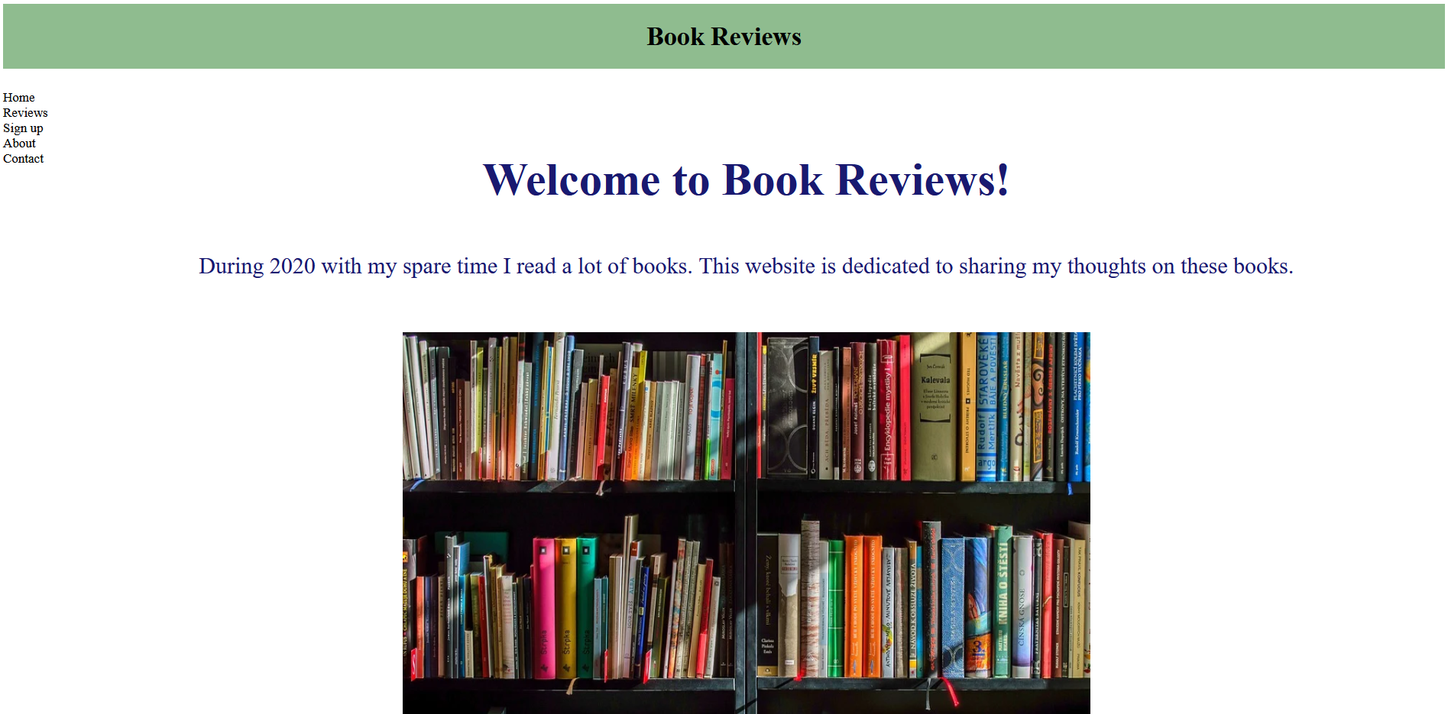
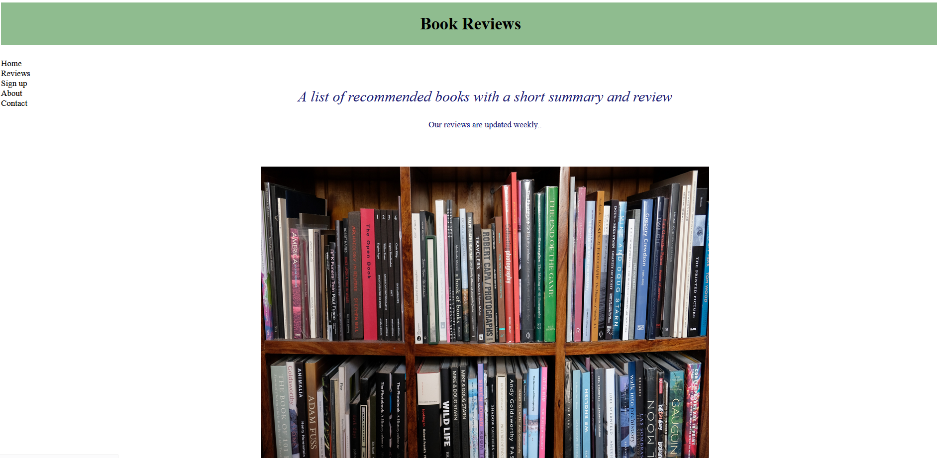
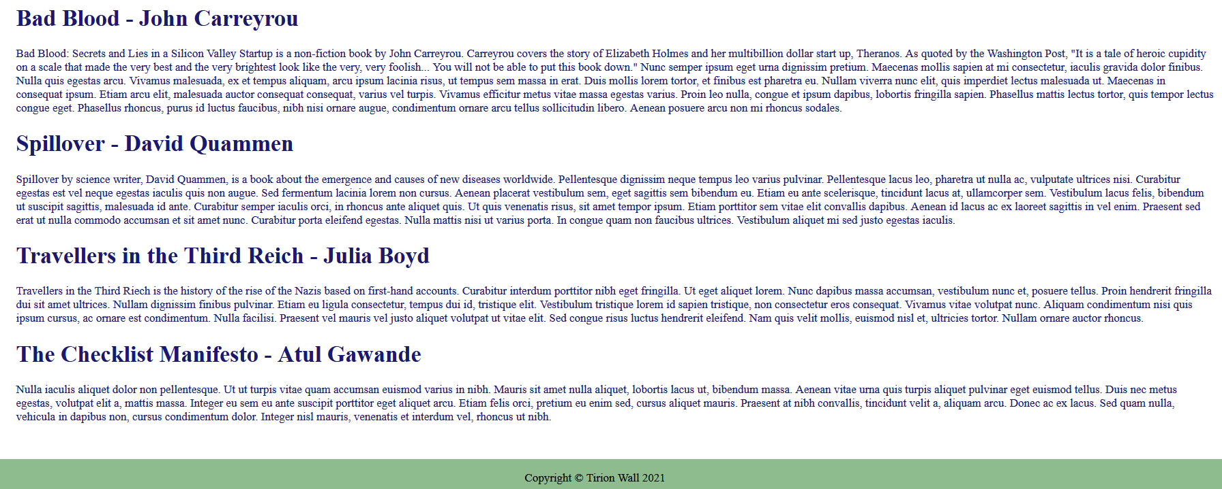

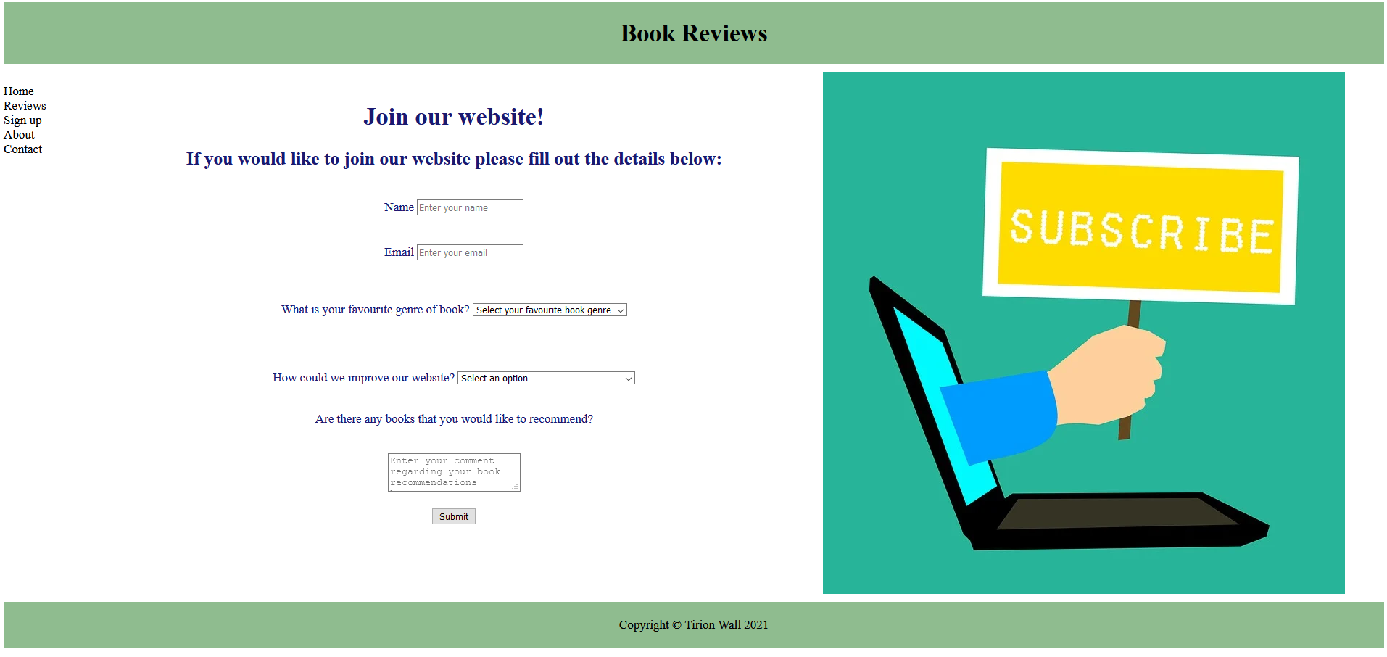

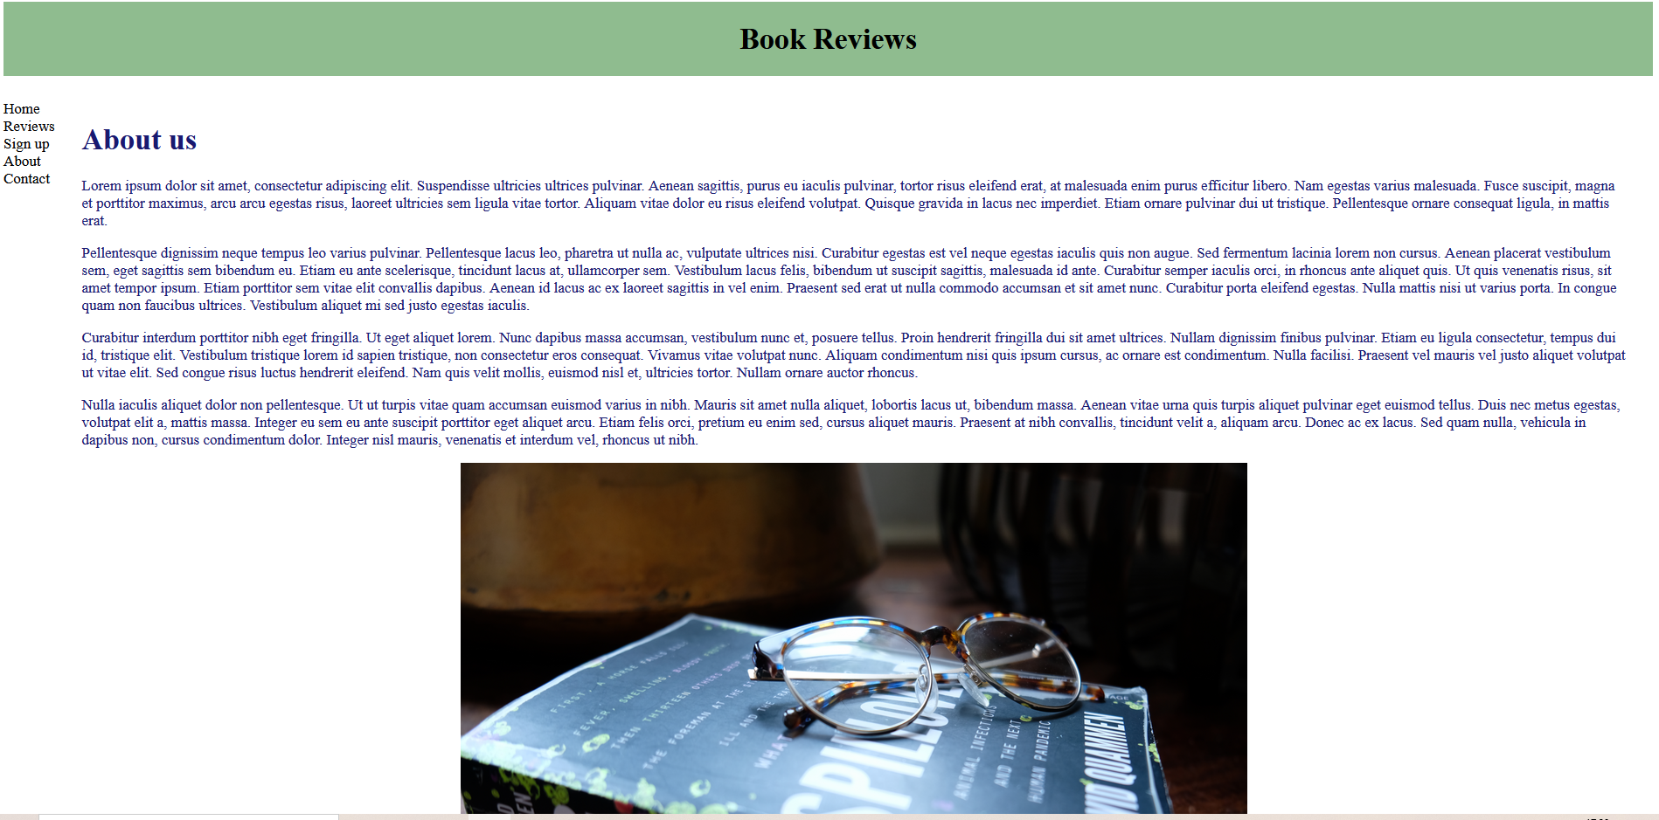

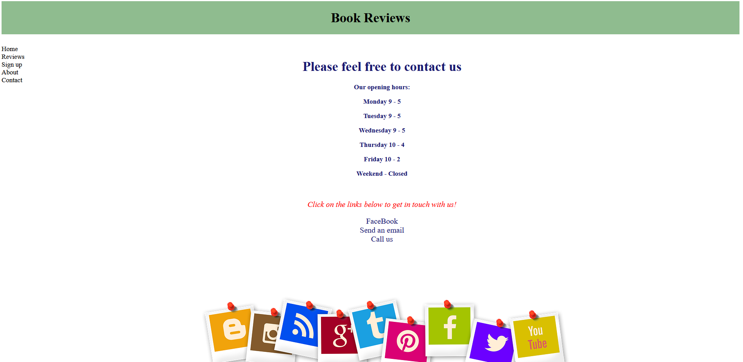

These are the results I received when I validated my home page HTML code via http://validator.w3.org/:
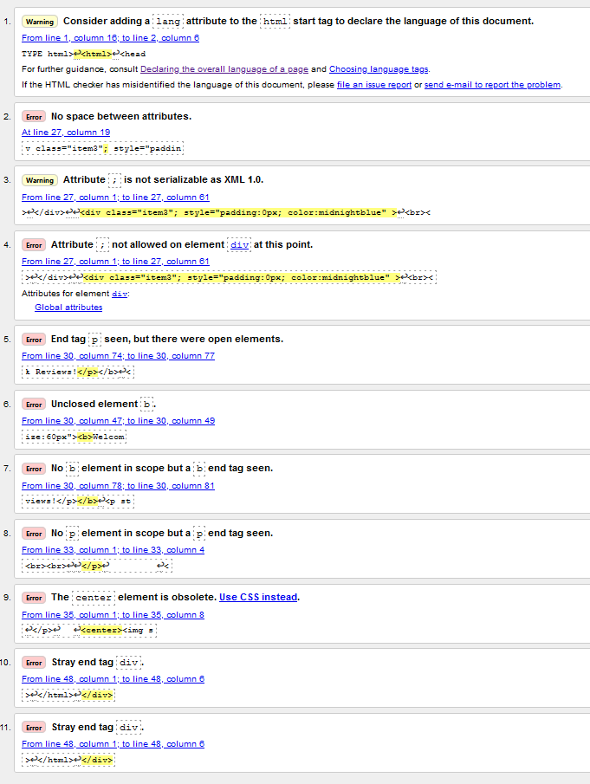
I corrected the errors in my HTML code by removing stray tags, I included quotation marks where I had previously forgotten them, I positioned tags in the right order and I removed “;” attributes. After correcting my errors, I am left with just one warning and one error. The warning is recommending that I include a lang attribute to the html start tag to declare the language, however, I have already done that at the top of my code as a comment. The error tells me that the centre element is obsolete for an image that I have used, I could fix that by using CSS instead but I am happy to keep it in my HTML.

I received the following results when I validated my CSS code:
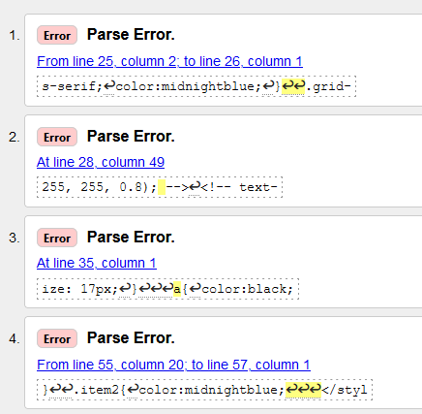

I corrected my errors by including a bracket that I had forgotten to include. The remaining parse errors I am unable to fix and I suspect the error is that I have not closed certain brackets and quotes.

Evaluation
- Web development can be defined as the work necessary for creating a website for either the internet or intranet. Three core qualities of a website are website usability, accessibility and search engine optimisation. I will now provide more detail of the significance of each of these core qualities:
Website usability describes how a user interacts with a website’s particular purpose/function and the ease of using the website for the user. To appreciate website usability’s role in web development I will address four fundamentals of website usability; 1. Performance, 2. Clarity and readability, 3. Clear navigation and 4. Satisfaction.
- Performance is a vital website usability factor. If it takes a while for a user to complete their intended task they are likely to leave and go to another website that offers what they are looking for and it’s likely they will not return to a website with poor performance. Interestingly, a large component of performance is accommodating for the very short window of patience users possess. According to Google, when a mobile site takes over three seconds to load, 53% of web visitors leave the website [1]. An example of how important performance is to users is that Firefox downloads increased by 15% (or 10 million) per year when Mozilla sped their page speed by only 2.2 seconds [2].
- Clarity and readability is important in website usability, as Fisher et al. 2005 report “Failure to understand what constitutes an effective Website will result in dissatisfaction from both the business and users’ perspective” [3]. Users do not want the website to be ambiguous, they want to feel in control and easily find what they are looking for. Keeping a website simple has other benefits to ensuring users are able to see what matters most e.g. the performance of the website will be faster without complex features and the code will therefore be clearer, meaning the website will be easier to update and fix. Examples of improving a website’s clarity and readability is keeping the font size legible and the colours visible to all. Well established websites would do well to keep consistent formats for their websites as not to confuse and frustrate regular users.
- On a similar note to clarity and readability, clear navigation is vital for website usability. Users go to websites with desired outcomes in mind and if they can’t find what they’re looking for they will leave which will in turn impact the website’s bounce rate. Users will spend longer exploring websites when they can clearly see what pages are available. For example, websites which sell products should organise their websites so that different products can be quickly and easily found from a clear, unambiguous navigation bar. This will increase the chances of them buying products as users feel like they have accomplished their goal.
- Lastly, user satisfaction is a hugely important website usability factor. According to Landingi, Solitaired developer Darshan Somashaker discovered that solitaire games increased by 15% per user and referral users increased by 3% with every 15% increase in customer satisfaction scores [4]. Satisfied users will trust in the website more and will also recommend websites to friends and family, increasing the website’s traffic and this is a cheaper way to bring in new users as opposed to paying for advertisements. A way of improving user satisfaction is for websites to provide feedback surveys so they can understand what their users like and don’t like and how they can improve. One study sought to characterise the role of satisfaction and website usability in developing customer loyalty and positive word of mouth (WOM). The authors were specifically focused on e-banking services and collected their data from web surveys using Spanish-speaking subjects. The subjects had previously used the e-banking services several times before and were asked to fill out surveys regarding the usability of the websites. The study showed that customer loyalty for e-banking websites is closely linked to satisfaction with previous interactions with the website. Their analysis also showed that customer loyalty and satisfaction is a key determinant of positive WOM [5].

Accessibility can be defined as how suitable a website is for any and all potential users, including people with disabilities. Accessibility in web development is incredibly important as websites should be accessible for all. “Internet without barriers is a communication space not hindered by sex, age, culture, or disability”[6]. According to Scope, there are more than 14 million disabled people in the UK [7], therefore if a website is inaccessible to those with disabilities then many people are excluded. There are several factors to consider when making websites as accessible as possible, one of these includes using alt tags which are HTML attributes that describe images and videos, the alt tag is then used by a screen reader to inform the user of the content. Other technologies that websites must support include speech recognition software which will turn speech into text for those with hearing impairment and specialist keyboards. More examples of creating accessible websites include descriptive links and content, carefully chosen font and colours for the visually impaired. Making websites as accessible as possible will maximise their number of users and potential business. ““Mobile accessibility” refers to making websites and applications more accessible to people with disabilities when they are using mobile phones and other devices.”[8] It’s more important than ever that websites are mobile compatible not only for people with disabilities, but for everyone. In 2020 over 53% of website traffic was through mobile phones [9] and according to TeamTreeHouse, mobile users purchase more than those using desktops [10], therefore websites that are not mobile compatible are missing out on users and sales. One study sought to measure website accessibility for the disabled by researching 182 local government websites in Poland. The study targeted things such as font icon size, positioning of information and how usable the websites were on mobile phone format. The study concluded that the Polish government in the municipality studied had made an effort to adapt their website services for the disabled. However, as the authors point out there were still barriers to overcome. Such as, overuse of grey text (this is very difficult for the visually impaired to read), complaints of content overload, complaints of excess info and background static which also increased website loading time. The authors conclude that education for website accessibility should be improved and a repeat study should be conducted in several years to measure whether a difference in accessibility has occurred. [11]

Search Engine Optimisation (SEO). Firstly, search engines (e.g. Google) direct users to websites. Search engine optimisation is therefore the increasing of quality/quantity of traffic to a website from a search engine. To fully explain the optimisation of search engines I must first explain how a search engine fundamentally works: The engines first use the search query to search the internet for relevant content (this is known as crawling), information is then stored and arranged so it is ready to be a relevant result to a search engine query (this is known as indexing), finally this indexed information is organised based on relevance to the search query (this is known as ranking) [12].
Any good website relies upon consistent website traffic. SEO is a means modifying a website for increasing website traffic, hence SEO is an integral part of web development. Regardless of how developed a website is, if it is not easily found by a search engine then the website will attract less users and will fundamentally be underperforming. Therefore, website developers must focus on several key components of their website as to please the search engines and get the best results. For example crawl accessibility, compelling content, keyword optimization, user experience, title URL and description and share worthy content [13]. All of these things are essential for the search engine to be able to identify the website as the most relevant and useful source to advertise. According to Moz.com “On average, 71.33% of searches result in a page one organic click. Page two and three get only 5.59% of the clicks.” [14], therefore meeting the SEO requirements and getting onto a search engine’s first page result is paramount if a website is to attract traffic. One 2016 study of search engine optimisation in Korea sought to understand SEO techniques when applied to library services. Specifically the website in question was a scientific site which provides digital scientific content aimed at a younger audience. Website traffic for this service was noted to have decreased over time and so they sought to use SEO techniques to boost website traffic again. The authors note that the sites use of multiple domains and lack of keyword optimisation were in part responsible for the reduced traffic. Areas of SEO which they focused on improving were “improved accessibility for search engines, increased relevance between site content and search engine keywords, and increased site credibility”. The result of these SEO changes led to increased use and traffic on the site. [15]

- My evaluation of my completed website
Useful (usability and utility): I designed my website to be as unconvoluted as possible, which I believed I achieved by keeping the content, colours and fonts simple. Although I believe that sometimes pomp and pageantry are necessary for particular websites- here I have decided to keep a very grounded website design. By keeping things simple, the look, feel and ease of use was improved and the content is easy to locate and understand. I also improved the performance by not including too many images and videos and ensured to refrain from using pop-ups. After researching and understanding more about methods of web development, I gained an appreciation for how important it is to make information on a website streamlined and most importantly, relevant. Therefore, whilst I was creating my website, I would always strive to keep information clear and concise. As a part of my design process, I included descriptive instructions e.g. on my Sign Up tab I told the users how to interact with the website. For example, “Enter your name”, “Select your favourite book genre”, “Enter your comment..” and included error messages such as “Please fill in this field” if the user did not fill out all necessary fields. To ensure the user did not mistake hyperlinks for regular text, I included a message instructing the user to click the links below. Additionally, when the user hovered their curser over these hyperlinks the colour of the text changes, unlike my regular content.
Search Engine Optimisation (SEO): A list of the on-page SEO techniques that I applied to my website:
- Title tags: I included title tags for each one of my website pages which included solid keyword searches, such as “Book Reviews”
- Internal links: I included internal links to my site via certain tabs and my nav bar.
- User experience: Users can easily access the information that they are looking for on my website by including clear and concise titles. It is also easy to contact me as I have included contact details and direct links, making it quicker and easier for the user.
- Compelling content: I included content to bring in the audience by writing captivating reviews. This also makes my content more share-worthy.
Accessibility: To make my website accessible to all, I used simple colours and clear font sizes. I used contrast.checker.com as a tool to check the contrast of the colours I used, ensuring that it’s clear for everyone. I made sure to include alt tags for my images in case the images were not visible. I made my website simple as to keep it easily understandable. On my Sign Up page I included a question asking “How could we improve our website?” – this allows the user to contribute to the shaping of future versions of the website.
Conclusions and recommendations for future improvements
In conclusion, I am satisfied with the general premise and structure of my website. However, I will now discuss what improvements I could make. My website should be made mobile compatible. Not only does this improve the use of my website for people with disabilities, it would improve the website for all users (large amount of website traffic are on mobile devices). Specifically, making my website more accessible for people with disabilities, I should use a screen reader so that people can hear the content out loud. Also, addition of a screen magnifier and alternative keyboard compatibility would increase the inclusivity of the website. Since a website of this nature (book reviewing) would be expected to expand in time and encompass more reviews – one add on could be a search bar for my website. This could allow the users to quickly find reviews for books and not scroll through unnecessary content. From a design perspective, in the future I would aim to minimise “dead space” on my website. Finally, I could use different media sources such as interesting videos in order to increase the likelihood of users sharing my content over social media platforms.

References
Evaluation References:
[1] D. An, “Find out how you stack up to new industry benchmarks for mobile page speed”, Think With Google, Feb. 2017. [Online]. Available: https://www.thinkwithgoogle.com/intl/en-gb/marketing-strategies/app-and-mobile/mobile-page-speed-new-industry-benchmarks/ [Accessed Apr. 20, 2021].
[2] “A Beginner’s Guide to Website Speed Optimization”, Kinsta, Apr. 13, 2021. [Online]. Available: https://kinsta.com/learn/page-speed/ [Accessed Apr. 20, 2021].
[3] J. Fisher, J. Bentley, R. Turner, A. Craig, “SME Myths: If We Put Up a Website Customers Will Come To Us – Why Usability Is Important”, BLED 2005 Proceedings, AIS Electronic Library, December 2005. [Online] Available: https://aisel.aisnet.org/cgi/viewcontent.cgi?article=1094&context=bled2005 [Accessed Apr. 20, 2021].
[4] Justyna, “The Importance of Customer Satisfaction”, Landingi, Nov. 21, 2018. [Online] Available: https://landingi.com/blog/customer-satisfaction/ [Accessed Apr. 20, 2021].
[5] L. Casaló V., C. Flavián and M. Guinalíu, "The role of satisfaction and website usability in developing customer loyalty and positive word-of-mouth in the e-banking services," The International Journal of Bank Marketing, vol. 26, (6), pp. 399-417, 2008. Available: https://search-proquest-com.ezproxy.uwtsd.ac.uk/scholarly-journals/role-satisfaction-website-usability-developing/docview/231408793/se-2?accountid=130472. DOI: http://dx.doi.org.ezproxy.uwtsd.ac.uk/10.1108/02652320810902433. [Accessed Apr. 20, 2021].
[6] [1] K. Król and D. Zdonek, "Local Government Website Accessibility—Evidence from Poland," Administrative Sciences, vol. 10, (2), pp. 22, 2020. Available: https://search-proquest-com.ezproxy.uwtsd.ac.uk/scholarly-journals/local-government-website-accessibility-evidence/docview/2386076625/se-2?accountid=130472. DOI: http://dx.doi.org.ezproxy.uwtsd.ac.uk/10.3390/admsci10020022. [Accessed Apr. 20, 2021].
[7] Scope, “Disability facts and figures”, SCOPE. [Online] Available: https://www.scope.org.uk/media/disability-facts-figures/ [Accessed Apr. 20, 2021].
[8] W3C, “Mobile Accessibility at W3C”, W3C, Jan. 2008. [Online] Available: https://www.w3.org/WAI/standards-guidelines/mobile/ [Accessed Apr. 20, 2021].
[9] N. Galov, “What Percentage of Internet Traffic Is Mobile in 2021?”, Hosting Tribunal. [Online] Available: https://hostingtribunal.com/blog/mobile-percentage-of-traffic/ [Accessed Apr. 20, 2021].
[10] J. McMillen, “10 Reasons Your Website Needs to be Mobile Optimized”, treehouse, Oct. 1, 2015. [Online] Available: https://blog.teamtreehouse.com/10-reasons-website-needs-mobile-optimized [Accessed Apr. 20, 2021].
[11] K. Król and D. Zdonek, "Local Government Website Accessibility—Evidence from Poland," Administrative Sciences, vol. 10, (2), pp. 22, 2020. Available: https://search-proquest-com.ezproxy.uwtsd.ac.uk/scholarly-journals/local-government-website-accessibility-evidence/docview/2386076625/se-2?accountid=130472. DOI: http://dx.doi.org.ezproxy.uwtsd.ac.uk/10.3390/admsci10020022. [Accessed Apr. 20, 2021].
[12] Moz, “How Search Engines Work: Crawling, Indexing, and Ranking”, Moz. [Online] Available: https://moz.com/beginners-guide-to-seo/how-search-engines-operate [Accessed Apr. 20, 2021].
[13] Moz, “The Beginner’s Guide to SEO”, Moz. [Online] Available: https://moz.com/beginners-guide-to-seo [Accessed Apr. 20, 2021].
[14] P. Petrescu, “Google Organic Click-Through Rates in 2014”, Moz Blog, Oct. 1, 2014. [Online] Available: https://moz.com/blog/google-organic-click-through-rates-in-2014 [Accessed: Apr. 20, 2021].
[15] [1] S. Lee et al, "Search engine optimization," Library Hi Tech, vol. 34, (2), pp. 197-206, 2016. Available: https://www-proquest-com.ezproxy.uwtsd.ac.uk/scholarly-journals/search-engine-optimization/docview/1794728594/se-2?accountid=130472. DOI: http://dx.doi.org.ezproxy.uwtsd.ac.uk/10.1108/LHT-02-2016-0014 [Accessed: Apr. 20, 2021].

Website References:
https://pixabay.com/photos/books-bookstore-book-reading-1204029/ Description: Photo of books. Website: pixabay. Posted by: LubosHouska
https://cdn.pixabay.com/photo/2018/01/21/14/33/subscribe-3096723_960_720.jpg Description: Subscribe image. Website: pixabay
https://cdn.pixabay.com/photo/2017/07/09/09/25/icon-2486501_960_720.png Description: Photo of social media logos. Website: pixabay
The other images on my website were taken by me.
I also used Lorem Ipsum generator for text: https://loremipsum.io/generator/?n=5&t=p
Quote on my Reviews tab by the Washington Post: https://www.bookdepository.com/Bad-Blood-John-Carreyrou/9781509868087

Appendices
CSS Code:

.item1 { grid-area: top; background-color: #8FBC8F;}
.item2 { grid-area: nav; }
.item3 { grid-area: main; }
.item4 { grid-area: right; }
.item5 { grid-area: bottom; background-color: #8FBC8F;}

.grid-container {
display: grid;
grid-template-areas:
'top top top top top top'
'nav main main main main right'
'bottom bottom bottom bottom bottom bottom';
grid-gap: 11px;

}
{

background-color: white;
padding: 12x;
font-family:Helvetica, sans-serif;
color:midnightblue;
}

.grid-container > div {
<!-- background-color: #FFFFFF; -->
<!-- text-align: center; -->
padding: 15px 0;
font-size: 17px;
}

a{
color:black;
text-decoration: none;
}
a:hover{
color:red;
}

.item2 ul{
padding:0;
list-style:none;
}

.contact{
font-size: 20px;
color:midnightblue;
font-weight: 500;
}

.item2{
color:midnightblue;
}

HTML Home page Code:
<!DOCTYPE html>
<html>
<head>
<meta charset="utf-8" />
<title>Book Reviews</title>
<link rel="stylesheet" type="text/css"
href="csstestfile.css">
</head>
<body>

<div class="grid-container">

<div class="item1">
<h1 style="text-align: center;">Book Reviews</h1>
</div>

<div class="item2">
<ul>
<li><a href="home.html">Home</a></li>
<li><a href="reviews.html">Reviews</a></li>
<li><a href="signup.html">Sign up</a></li>
<li><a href="about.html">About</a></li>
<li><a href="contact.html">Contact</a></li>
</ul>
</div>

<div class="item3" style="padding:0px; color:midnightblue" >
<br><br>

<p style="text-align: center; font-size:60px"><strong>Welcome to Book Reviews!</strong></p>
<p style="text-align: center; font-size:30px ">During 2020 with my spare time I read a lot of books. This website is dedicated to sharing my thoughts on these books.</p><br><br>

<center><img src="https://cdn.pixabay.com/photo/2016/02/16/21/07/books-1204029_960_720.jpg" alt="Photo of books" height="700" width="900"></center>

</div>

<div class="item5">
<p style="text-align: center;"> Copyright &copy; Tirion Wall 2021</p>
</div>

</div>

</body>
</html>

Reviews Page Code:
<!DOCTYPE html>
<html>
<head>
<meta charset="utf-8" />
<title>Book Reviews</title>
<link rel="stylesheet" type="text/css"
href="csstestfile.css">
</head>
<body>

<div class="grid-container">

<div class="item1">
<h1 style="text-align: center;">Book Reviews</h1>
</div>

<div class="item2">
<ul>
<li><a href="home.html">Home</a></li>
<li><a href="reviews.html">Reviews</a></li>
<li><a href="signup.html">Sign up</a></li>
<li><a href="about.html">About</a></li>
<li><a href="contact.html">Contact</a></li>
</ul>
</div>

<div class="item3"; style="padding:5px; color:midnightblue" >
<br><br>

<p style="text-align: center; font-size:30px"><em>A list of recommended books with a short summary and review</p></em>
<p style="text-align: center; ">Our reviews are updated weekly..</p><br><br>

</p>

<center><img src="work1.jpg" alt="Photo of books" height="700" width="900"></center>
<div class="takeme"; style="padding:20px; color:red" >
<strong><p ><em> Click on SIGN UP below to recieve weekly reviews</p></em></strong>
<a href="signup.html">SIGN UP</a></li>

</div>

<div class="item4"; style="padding: 20px ;"><br><br>
<h1>Bad Blood - John Carreyrou </h1>
<p>Bad Blood: Secrets and Lies in a Silicon Valley Startup is a non-fiction book by John Carreyrou. Carreyrou covers the story of Elizabeth Holmes and her multibillion dollar start up, Theranos. As quoted by the Washington Post, "It is a tale of heroic cupidity on a scale that made the very best and the very brightest look like the very, very foolish... You will not be able to put this book down." Nunc semper ipsum eget urna dignissim pretium. Maecenas mollis sapien at mi consectetur, iaculis gravida dolor finibus. Nulla quis egestas arcu. Vivamus malesuada, ex et tempus aliquam, arcu ipsum lacinia risus, ut tempus sem massa in erat. Duis mollis lorem tortor, et finibus est pharetra eu. Nullam viverra nunc elit, quis imperdiet lectus malesuada ut. Maecenas in consequat ipsum. Etiam arcu elit, malesuada auctor consequat consequat, varius vel turpis. Vivamus efficitur metus vitae massa egestas varius. Proin leo nulla, congue et ipsum dapibus, lobortis fringilla sapien. Phasellus mattis lectus tortor, quis tempor lectus congue eget. Phasellus rhoncus, purus id luctus faucibus, nibh nisi ornare augue, condimentum ornare arcu tellus sollicitudin libero. Aenean posuere arcu non mi rhoncus sodales. </p>

<h1>Spillover - David Quammen</h1>
<p>Spillover by science writer, David Quammen, is a book about the emergence and causes of new diseases worldwide. Pellentesque dignissim neque tempus leo varius pulvinar. Pellentesque lacus leo, pharetra ut nulla ac, vulputate ultrices nisi. Curabitur egestas est vel neque egestas iaculis quis non augue. Sed fermentum lacinia lorem non cursus. Aenean placerat vestibulum sem, eget sagittis sem bibendum eu. Etiam eu ante scelerisque, tincidunt lacus at, ullamcorper sem. Vestibulum lacus felis, bibendum ut suscipit sagittis, malesuada id ante. Curabitur semper iaculis orci, in rhoncus ante aliquet quis. Ut quis venenatis risus, sit amet tempor ipsum. Etiam porttitor sem vitae elit convallis dapibus. Aenean id lacus ac ex laoreet sagittis in vel enim. Praesent sed erat ut nulla commodo accumsan et sit amet nunc. Curabitur porta eleifend egestas. Nulla mattis nisi ut varius porta. In congue quam non faucibus ultrices. Vestibulum aliquet mi sed justo egestas iaculis. </p>

<h1>Travellers in the Third Reich - Julia Boyd</h1>
<p>Travellers in the Third Riech is the history of the rise of the Nazis based on first-hand accounts. Curabitur interdum porttitor nibh eget fringilla. Ut eget aliquet lorem. Nunc dapibus massa accumsan, vestibulum nunc et, posuere tellus. Proin hendrerit fringilla dui sit amet ultrices. Nullam dignissim finibus pulvinar. Etiam eu ligula consectetur, tempus dui id, tristique elit. Vestibulum tristique lorem id sapien tristique, non consectetur eros consequat. Vivamus vitae volutpat nunc. Aliquam condimentum nisi quis ipsum cursus, ac ornare est condimentum. Nulla facilisi. Praesent vel mauris vel justo aliquet volutpat ut vitae elit. Sed congue risus luctus hendrerit eleifend. Nam quis velit mollis, euismod nisl et, ultricies tortor. Nullam ornare auctor rhoncus. </p>

<h1>The Checklist Manifesto - Atul Gawande</h1>
<p> Nulla iaculis aliquet dolor non pellentesque. Ut ut turpis vitae quam accumsan euismod varius in nibh. Mauris sit amet nulla aliquet, lobortis lacus ut, bibendum massa. Aenean vitae urna quis turpis aliquet pulvinar eget euismod tellus. Duis nec metus egestas, volutpat elit a, mattis massa. Integer eu sem eu ante suscipit porttitor eget aliquet arcu. Etiam felis orci, pretium eu enim sed, cursus aliquet mauris. Praesent at nibh convallis, tincidunt velit a, aliquam arcu. Donec ac ex lacus. Sed quam nulla, vehicula in dapibus non, cursus condimentum dolor. Integer nisl mauris, venenatis et interdum vel, rhoncus ut nibh. </p>

</div>

</div>

<div class="item5">
<p style="text-align: center;"> Copyright &copy; Tirion Wall 2021</p>
</div>

</div>

</body>
</html>
</div>

Sign Up page Code:
<!DOCTYPE html>
<html>
<head>
<meta charset="utf-8" />
<title>Sign up</title>
<link rel="stylesheet" type="text/css"
href="csstestfile.css">
</head>
<body>

<div class="grid-container">

<div class="item1">
<h1 style="text-align: center;">Book Reviews</h1>
</div>

<div class="item2">
<ul>
<li><a href="home.html">Home</a></li>
<li><a href="reviews.html">Reviews</a></li>
<li><a href="signup.html">Sign up</a></li>
<li><a href="about.html">About</a></li>
<li><a href="contact.html">Contact</a></li>
</ul>
</div>

<div class="item3"; style="padding:20px; color:midnightblue" >

<h1 style="text-align: center;"> Join our website!</h1>
<h2 style="text-align: center;">If you would like to join our website please fill out the details below:</h2>

<br>
<form id="form" style="text-align: center;">
<div class="form">
<label for="name" >Name</label>
<input
type="text"
name="name"
placeholder="Enter your name"
required
/>
</div>
<br> <br>
<div class="form">
<label for="contact">Email</label>
<input
type="text"
name="contact"
id="contact"
placeholder="Enter your email"
required
/>
</div>
<br> <br>
<div class="form">
<p>What is your favourite genre of book?
<select id="dropdown" required>
<option disabled selected value>Select your favourite book genre</option>
<option value="sci-fi & fantasy">Sci-fi & Fantasy</option>
<option value="non-fiction">Non-Fiction</option>
<option value="fiction">Fiction</option>
<option value="populuar science">Popular Science</option>
<option value="politics">Politics</option>
<option value="romance">Romance</option>
<option value="classics">Classics</option>
<option value="food & drink">Food & Drink</option>
</select>
</div>
<br> <br>
<div class="form">
<p>How could we improve our website?
<select id="dropdown" required>
<option disabled selected value>Select an option</option>
<option value="sci-fi & fantasy">It's fine the way it is</option>
<option value="non-fiction">Review a larger selection of books</option>
<option value="fiction">Review more cook books</option>
<option value="populuar science">Review fiction</option>
<option value="politics">Include podcasts of your book reviews</option>
<option value="romance">Collaborate with others</option>
<option value="classics">Make the website more user friendly</option>
<option value="food & drink">Many things could be improved</option>
</select>
</p>
</div>

<div class="form">
<p><br>Are there any books that you would like to recommend?</p>
<br>
<textarea
id="comments"
class="input-textarea"
name="comment"
placeholder="Enter your comment regarding your book recommendations here..."
></textarea>
</div>

<div class="form">
<br> <button type="submit"class="submit-button">
Submit
</button>
</div>
<br>

</form>
</div>

<img
class="books-image"
src="https://cdn.pixabay.com/photo/2018/01/21/14/33/subscribe-3096723_960_720.jpg"
alt="Photo of thumbs up"
/>

<div class="item5"; style="padding: 5px ;">
<div class="item5">
<p style="text-align: center;"> Copyright &copy; Tirion Wall 2021</p>
</div>

About Us page Code:
<!DOCTYPE html>
<html>
<head>
<meta charset="utf-8" />
<title>About</title>
<link rel="stylesheet" type="text/css"
href="csstestfile.css">
</head>
<body>

<div class="grid-container">

<div class="item1">
<h1 style="text-align: center;">Book Reviews</h1>
</div>

<div class="item2">
<ul>
<li><a href="home.html">Home</a></li>
<li><a href="reviews.html">Reviews</a></li>
<li><a href="signup.html">Sign up</a></li>
<li><a href="about.html">About</a></li>
<li><a href="contact.html">Contact</a></li>
</ul>
</div>

<div class="item3"; style="padding:20px; color:midnightblue" >

<h1>About us</h1>
<p> Lorem ipsum dolor sit amet, consectetur adipiscing elit. Suspendisse ultricies ultrices pulvinar. Aenean sagittis, purus eu iaculis pulvinar, tortor risus eleifend erat, at malesuada enim purus efficitur libero. Nam egestas varius malesuada. Fusce suscipit, magna et porttitor maximus, arcu arcu egestas risus, laoreet ultricies sem ligula vitae tortor. Aliquam vitae dolor eu risus eleifend volutpat. Quisque gravida in lacus nec imperdiet. Etiam ornare pulvinar dui ut tristique. Pellentesque ornare consequat ligula, in mattis erat. </p>
<p> Pellentesque dignissim neque tempus leo varius pulvinar. Pellentesque lacus leo, pharetra ut nulla ac, vulputate ultrices nisi. Curabitur egestas est vel neque egestas iaculis quis non augue. Sed fermentum lacinia lorem non cursus. Aenean placerat vestibulum sem, eget sagittis sem bibendum eu. Etiam eu ante scelerisque, tincidunt lacus at, ullamcorper sem. Vestibulum lacus felis, bibendum ut suscipit sagittis, malesuada id ante. Curabitur semper iaculis orci, in rhoncus ante aliquet quis. Ut quis venenatis risus, sit amet tempor ipsum. Etiam porttitor sem vitae elit convallis dapibus. Aenean id lacus ac ex laoreet sagittis in vel enim. Praesent sed erat ut nulla commodo accumsan et sit amet nunc. Curabitur porta eleifend egestas. Nulla mattis nisi ut varius porta. In congue quam non faucibus ultrices. Vestibulum aliquet mi sed justo egestas iaculis. </p>
<p> Curabitur interdum porttitor nibh eget fringilla. Ut eget aliquet lorem. Nunc dapibus massa accumsan, vestibulum nunc et, posuere tellus. Proin hendrerit fringilla dui sit amet ultrices. Nullam dignissim finibus pulvinar. Etiam eu ligula consectetur, tempus dui id, tristique elit. Vestibulum tristique lorem id sapien tristique, non consectetur eros consequat. Vivamus vitae volutpat nunc. Aliquam condimentum nisi quis ipsum cursus, ac ornare est condimentum. Nulla facilisi. Praesent vel mauris vel justo aliquet volutpat ut vitae elit. Sed congue risus luctus hendrerit eleifend. Nam quis velit mollis, euismod nisl et, ultricies tortor. Nullam ornare auctor rhoncus. </p>
<p> Nulla iaculis aliquet dolor non pellentesque. Ut ut turpis vitae quam accumsan euismod varius in nibh. Mauris sit amet nulla aliquet, lobortis lacus ut, bibendum massa. Aenean vitae urna quis turpis aliquet pulvinar eget euismod tellus. Duis nec metus egestas, volutpat elit a, mattis massa. Integer eu sem eu ante suscipit porttitor eget aliquet arcu. Etiam felis orci, pretium eu enim sed, cursus aliquet mauris. Praesent at nibh convallis, tincidunt velit a, aliquam arcu. Donec ac ex lacus. Sed quam nulla, vehicula in dapibus non, cursus condimentum dolor. Integer nisl mauris, venenatis et interdum vel, rhoncus ut nibh. </p>
<center><img src="spillover.jpg" alt="Photo of Spillover" height="700" width="900"></center>
</div>

<div class="item5"; style="padding: 5px ;">
<div class="item5">
<p style="text-align: center;"> Copyright &copy; Tirion Wall 2021</p>
</div>

Contact page Code:
<!DOCTYPE html>
<html>
<head>
<meta charset="utf-8" />
<title>Book Reviews</title>
<link rel="stylesheet" type="text/css"
href="csstestfile.css">
</head>
<body>

<div class="grid-container">

<div class="item1">
<h1 style="text-align: center;">Book Reviews</h1>
</div>

<div class="item2">
<ul>
<li><a href="home.html">Home</a></li>
<li><a href="reviews.html">Reviews</a></li>
<li><a href="signup.html">Sign up</a></li>
<li><a href="about.html">About</a></li>
<li><a href="contact.html">Contact</a></li>
</ul>
</div>

<div class="item3" style="padding:0px; color:midnightblue" >
<br><br>

<p style="text-align: center; font-size:60px"><strong>Welcome to Book Reviews!</strong></p>
<p style="text-align: center; font-size:30px ">During 2020 with my spare time I read a lot of books. This website is dedicated to sharing my thoughts on these books.</p><br><br>

<center><img src="https://cdn.pixabay.com/photo/2016/02/16/21/07/books-1204029_960_720.jpg" alt="Photo of books" height="700" width="900"></center>

</div>

<div class="item5">
<p style="text-align: center;"> Copyright &copy; Tirion Wall 2021</p>
</div>

</div>

</body>
</html>

