

Lucy Bishop
Student ID number: 2110519

University of Wales Trinity Saint David

Post Graduate Certificate in Professional Learning: Teaching Pupils with Severe or Profound and Multiple Learning Difficulties

Module code: ECL T7001

Portfolio

Portfolio

Contents
Introduction 3
Figure 1. Individual Development Plan 3
Figure 2. Individual Educational Aims 6
Figure 3. One Page Profile 7
Figure 4. Behaviour Risk Assessment 8
Figure 5. Personal Support Plan 9
Figure 6. Timetable 14
Figure 7. Nannie’s Rules 15
Figure 8. Behaviour Watch 16

Introduction
This portfolio includes documents that will help to provide the reader with an understanding of the pupil who will be referred to as ‘E’. All documents in this portfolio have been considered to help build a picture of the learner and give the reader an insight to how the pupil functions emotionally, academically, behaviourally and socially. Documents have been selected to illustrate how the school supports the learner to make progress not only academically but socially and behaviourally with wellbeing always at the heart of decisions made. The most current documents have been selected for evidence in this portfolio which will give the truest representation of how the learner presents. All documents have been anonymised by removal of name, photograph and school the pupil attends.

Figure 1. Individual Development Plan

An Individual Development Plan (IDP) is a ‘single statutory plan’ which replaces different types of plans (in this case the ‘Statement of Special Educational Needs’). A new educational law came into force in Wales on 1st September 2021 - The Additional Learning Needs and Educational Tribunal (Wales) Act 2018 and changes how children and young people aged 0-25 have their needs assessed and monitored. Children and young people who have Additional Learning Needs (ALN) and who need additional learning provision will have an IDP – they are legal documents prepared by the local authority and it is their responsibility to ensure they have the support outlined in it. The IDP will contain details of the young person’s ALN, what is required from education, healthcare and social services, targets to promote the young person’s development and strategies to meet the targets. In the school I work at Teachers prepare the IDP documents, which get sent out to all parties involved – all agencies involved with the young person are invited to attend the ‘Educational Review’ meeting. Educational Review meetings are scheduled once a year and, in these meetings, the IDP is worked on collectively with input from all parties who have attended. The young person will attend if there is capacity and if this is in the best interest for them. In this case ‘E’ did not attend the review as it was not deemed they had capacity, however many people were involved to act in their best interests and set relevant and meaningful targets and discuss the best provisions for them, including Dad (see below for a list of attendees).
I have selected the most relevant pages of the finalised IDP which was issued 30th January 2023 and these include:
- Section 2A Description of the young person’s ALN
- Section 3A Record of information used to develop the IDP including who has been involved
- Section 3B Timeline of events; significant events to be noted in March 2021 E lost a close friend and in July 2022 was moved classes within the school and brother is leaving home for University
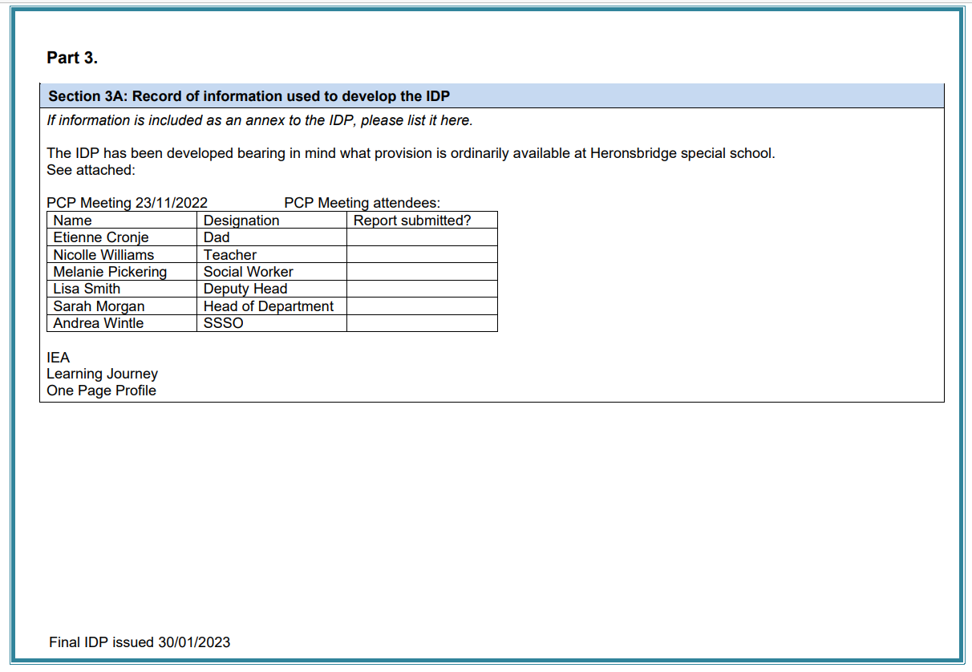
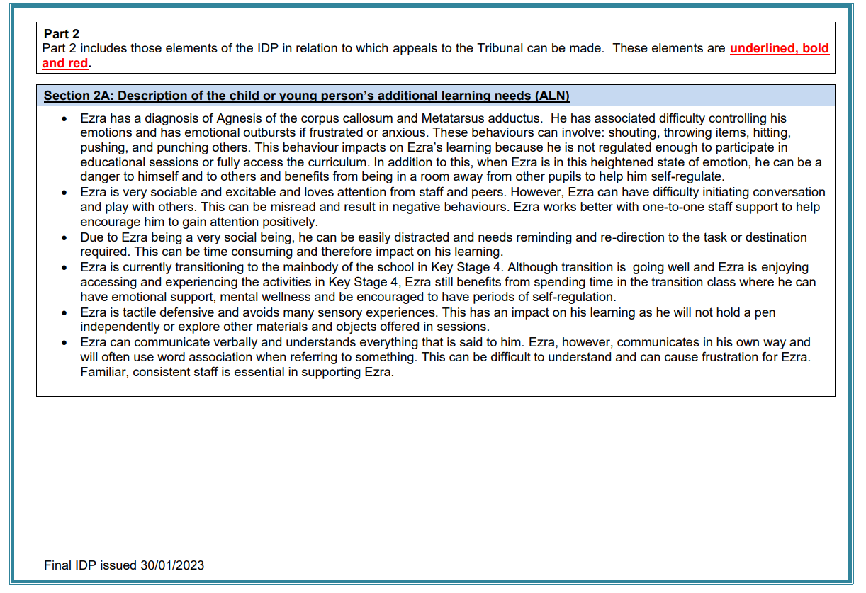
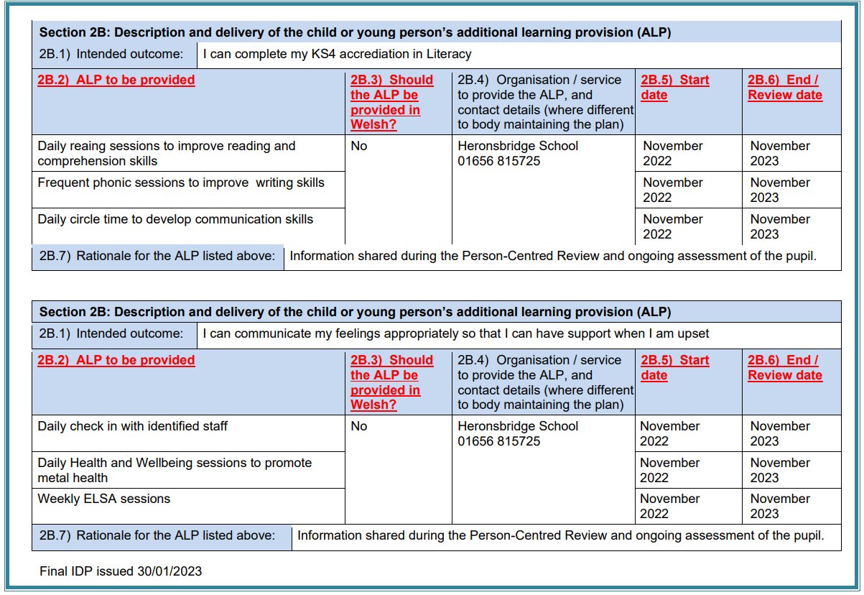
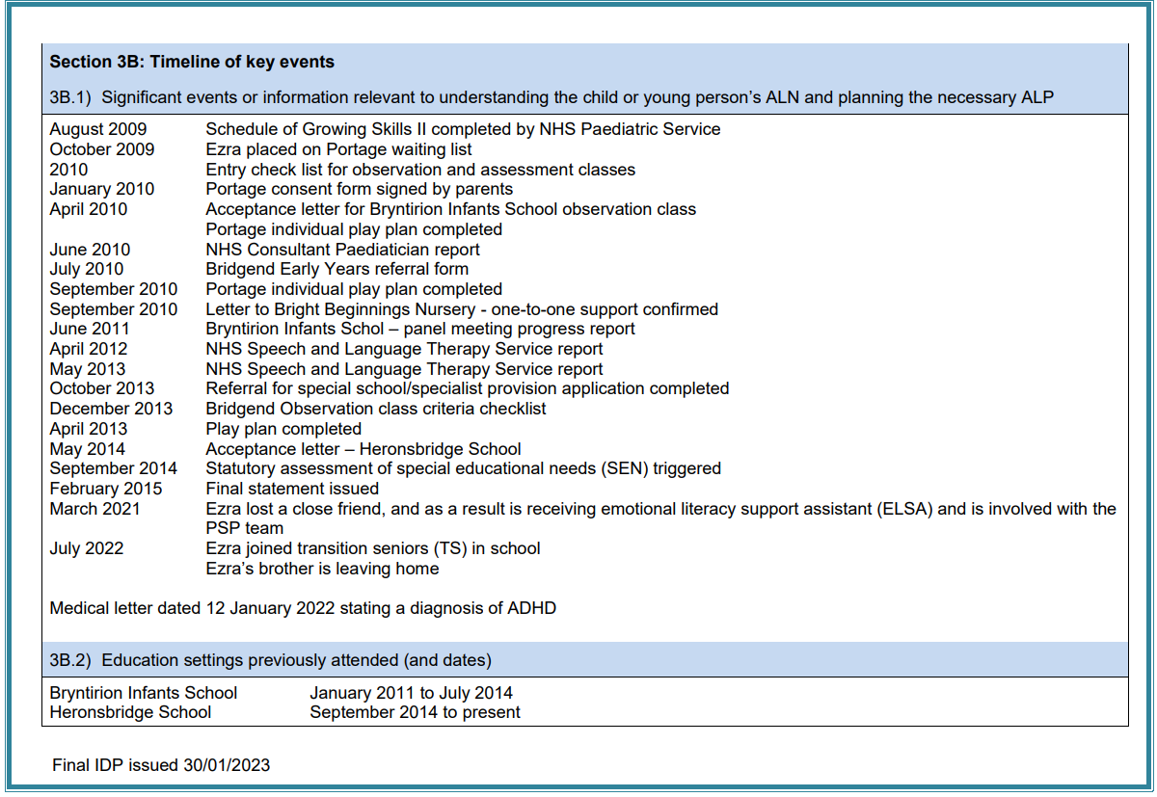

Figure 2. Individual Educational Aims

The Individual Educational Aims (IEA) include essential provisions specific to the learner and targets set by the teacher who (in most cases) has taught the learner from September through to July. Targets are drawn from the ‘instep’ assessment programme along with the Welsh Digital Competency Framework. IEAs are set in July and are ready for the new class teacher to use in September. Targets from the IEA can help inform the targets and next steps discussed in the annual Education Review and can be selected for the IDP. The IEA can help for a successful transition from one class to the next, and at a glance provide a good insight to the level the learner is working and functioning at.
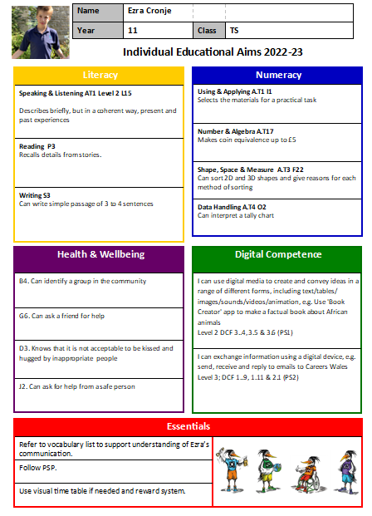

Figure 3. One Page Profile

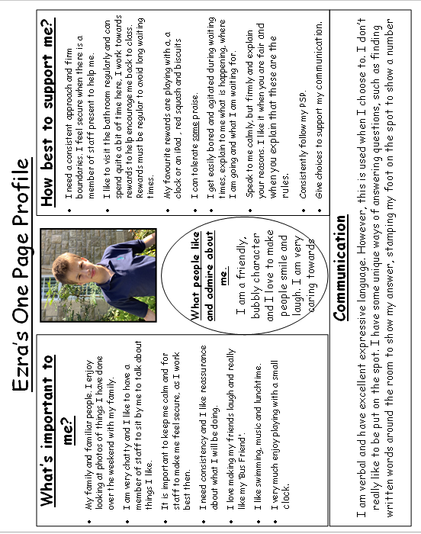
The one-page profile is written at the start of each academic year with members of staff in the current class and the learner. These at a glance give some very useful and important information about the learner if they are able to communicate- if they are not then staff who know them very well can advocate, and the school would ask for parental input. The one-page profile includes the following information: what’s important to me, how best to support me, what people admire about me and communication.

Figure 4. Behaviour Risk Assessment

Behaviour risk assessments are completed once a year during the first term in the school year, usually towards the end of the first half term to allow for observation of pupil by the team. It is paramount these are completed every year as the change of a class could potentially have a monumental impact on each learner. The team of staff that work with the pupils consider the impact of the behaviour and the likelihood, and using the behaviour matrix are able to rate the behaviour as a low, medium or high. If the pupil is rated as medium or above they will have personal support plan created for them which will identify the causes and triggers for behaviours, how to be proactive and how to deescalate such behaviours.

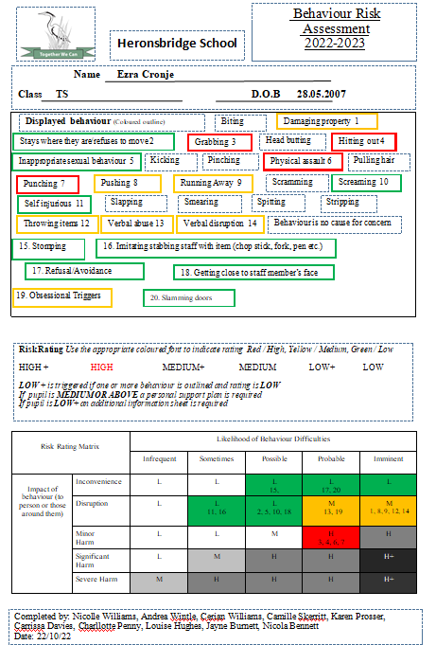

Figure 5. Personal Support Plan

Due to E being rated as displaying high risk behaviours a personal support plan (PSP) was created. Included as evidence is the full PSP minus the signing sheet to allow for anonymity. All staff members included in completing the behaviour risk assessment will also work together to create the PSP. Parent must be made aware of the PSP and must also sign it. PSPs are valuable documents for the learner as they work to ensure all staff working with the learner have a good understanding of who they are and why they are communicating with behaviours. The PSP includes: likes and dislikes, communication, descriptions of displayed behaviours, proactive, active and reactive measures to respond to displayed behaviours.

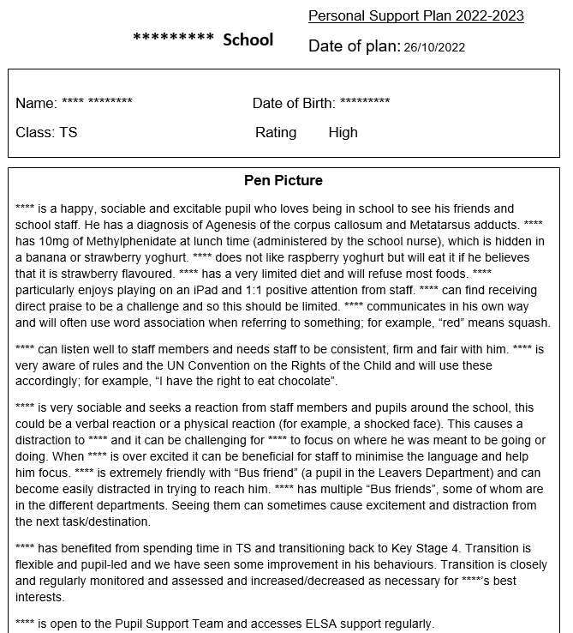
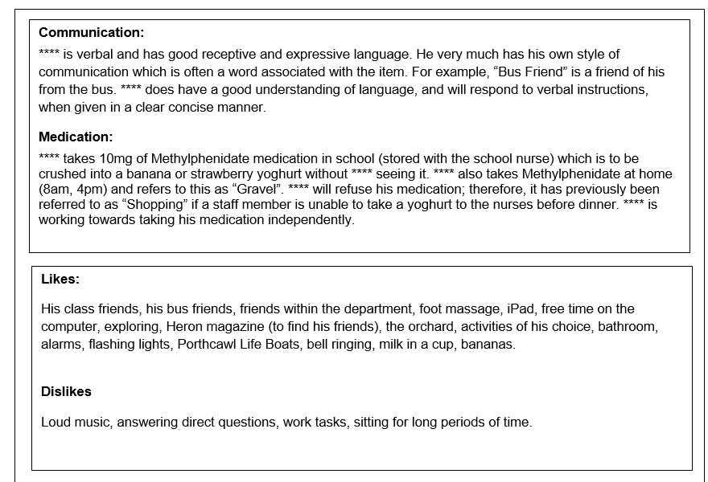
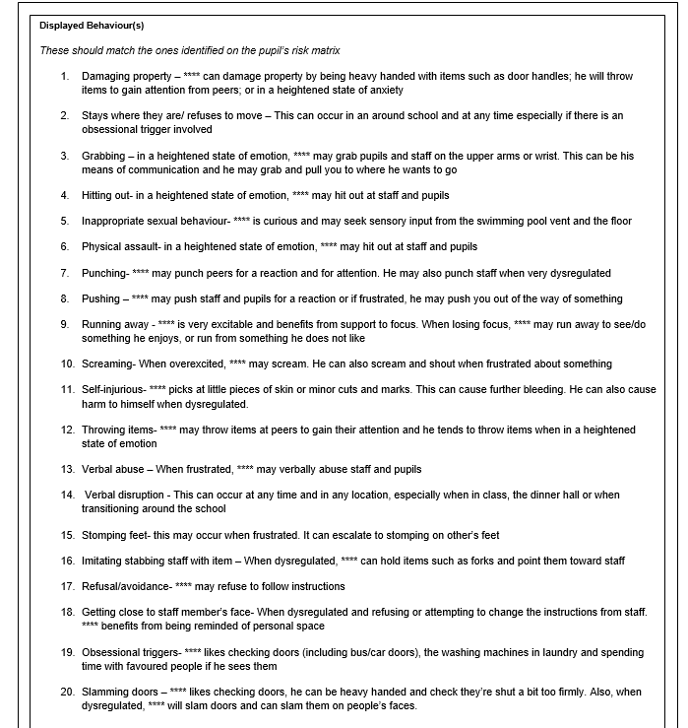

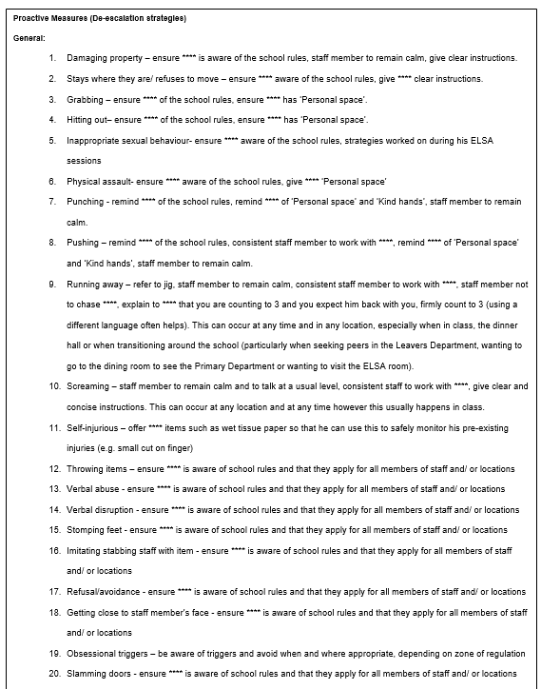

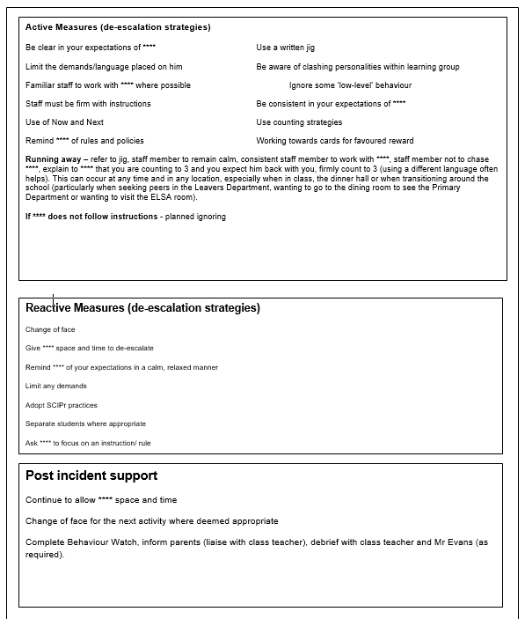

Figure 6. Timetable
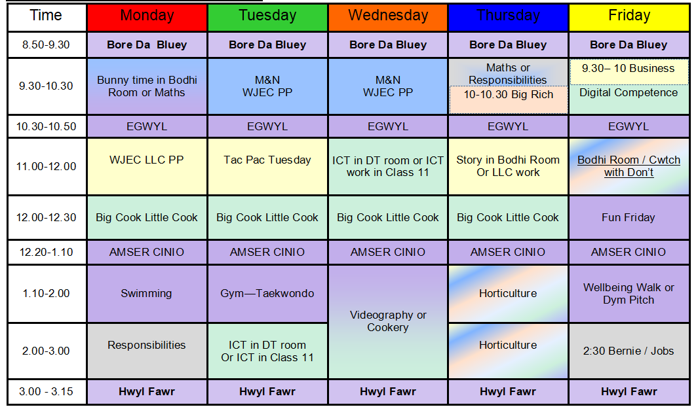

This document shows an individualised timetable created for E. The colours of each of the sessions relate to the Areas of Learning Experiences (AOLE) as follows:
Purple – Health and Wellbeing
Blue – Maths and Numeracy
Green – Science and Technology
Yellow – Language, Literacy and Communication
Pink – Expressive Arts
Grey – Humanities
Although many sessions will encompass many of the different areas of learning throughout the sessions are mostly colour coded with the most relevant AOLE.
Some further explanations of sessions on the timetable:
Bluey – The children’s TV programme
Big Cook Little Cook – The children’s TV programme
Responsibilities – include shredding, gardening and delivering things.
Big Rich- 1:1 Music lesson with the teacher known as ‘Big Rich’
Business – 1:1 session to chat with a favoured member of staff known as ‘Business’
Cwtch with Don’t – 1:1 relaxation session in the room named the ‘cwtch’ with a member of staff known as ‘Don’t’
Dym Pitch – football pitch
Bernie – the school mentor dog, pet therapy

Figure 7. Nannie’s Rules

This is the set of rules that Class use to establish boundaries with E. Nannies Nutella rules show a way of working with E. If E is able to tick off all of Nannie’s rules, he can have a spoonful of his favourite treat that he usually likes to enjoy with his Grandmother a home. Using Nannie is a way to connect with E, to inject a little bit of humour into the rules and reward and to also establish rules in a way that is not too direct.
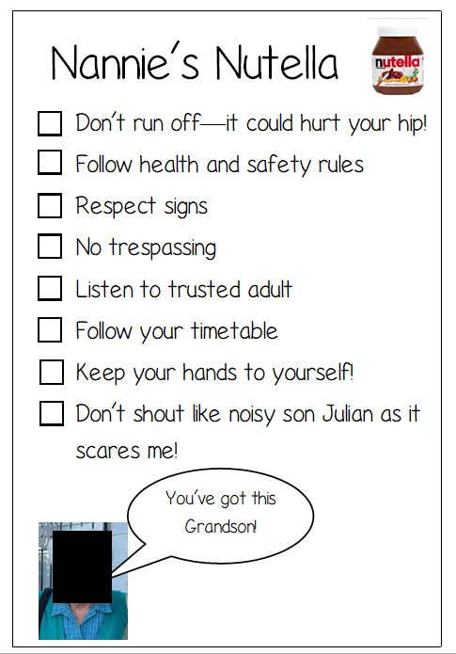

Figure 8. Behaviour Watch

Behaviour watch is a tool used by schools to report and log behaviours. Logging behaviours allows staff members to reflect on what happened, where, time of day and why. This is also a way to notify the Senior Leadership Team and Pupil Support Team of what is happening with our pupils and from this we are able to open conversations and discuss and implement provisions, support and therapies that will benefit the pupil. When we analyse and evaluate we are able to look for trends, this is a beneficial tool to reflect on whether what we are doing as practitioners is really working. Below shows a section of ‘ABC incidents’ that have been logged for E during this academic year to display the frequency of incidents. The number of incidents for the year totals 51.



